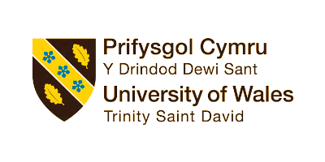

Programme: Certificate in Higher Education Skills for the Workplace

Module code and name: BMSW 4005_ Professional and Career development

Name of the Student: Aneliya Kirkova-Georgieva
ID Number: 2125657

Lecturer Name: Masud Ibrahim
Title: Task 3 – Reflective portfolio

- SWOT analysis and personal development plan
A personal SWOT analysis is a tool, through which we could improve individual self-awareness, as evaluate ourselves and our performance. It is described as “a method to guide decisions such as career choices and skills development for personal growth.” (Swart, 2022). Using this “structure of reflection” (Swart, 2022), as a starting point, individuals can begin to build a more comprehensive plan or Professional Development Plan (PDP) for personal growth and self-improvement.
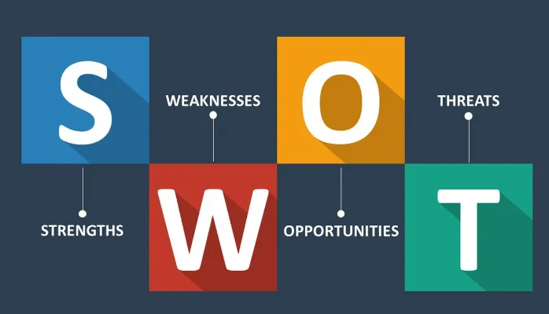
(Source: https://medium.com/thrive-global/how-to-complete-a-personal-swot-analysis-2f8769aebd5e)
Completing a Personal SWOT analysis helped me to identify my strengths, as good analytic, organizational and problem-solving skills, and my weaknesses, as lack of self-confidence and nervousness about public speaking. Based on that outcome, I would develop strategies to leverage my strengths and address my weaknesses, take advantage of opportunities, and mitigate threats. For example, I could taking public speaking or acting classes, attending a personal development workshop to gain new insights into myself and gain confidence, and regularly seek feedback from trusted sources to improve my self-awareness.
Additionally, I in order to remain on track with my career goals, I have established the need to update my PDP constantly, because it is a cyclical process, that “supports the idea that learning is a lifelong and life-wide activity” (The Open University, 2023) and requires continuous reflection, learning, and adjustment.

- Reflection of the learning style theories
Understanding your learning style can benefit you to tailor your studying and learning approaches to match your preferences, which can make the learning process more enjoyable and effective. It refers to an individual's preferred way of understanding information, “so that it can be understood easily”. (Prihatin and Ichsan, 2022) It is defined as a “way in which each learner begins to concentrate on, process, absorb, and retain new and difficult information” (Pashler et al., 2008, p.107).
There are several different learning style theories that attempt to categorize how individuals prefer to learn and process information. Some of the most well-known learning style theories are:
- VARK Learning Styles Model: The model refers to the main sensory modalities and identifies four primary learning styles, including Visual, Auditory, Reading/Writing, and Kinaesthetic. It suggests that people have a preferred learning mode that aligns with one or more of these categories
- Kolb's Learning Styles Theory (1984): This theory proposes that there are four different learning models, and “conceives of individuals’ learning processes as differing along two dimensions: preferred mode of perception and preferred mode of processing.” (Pashler et al., 2008, p.107)
- Honey and Mumford's Learning Styles Model (1986): This model is the most common used and proposes four different learning styles - Activist, Reflector, Theorist, and Pragmatist
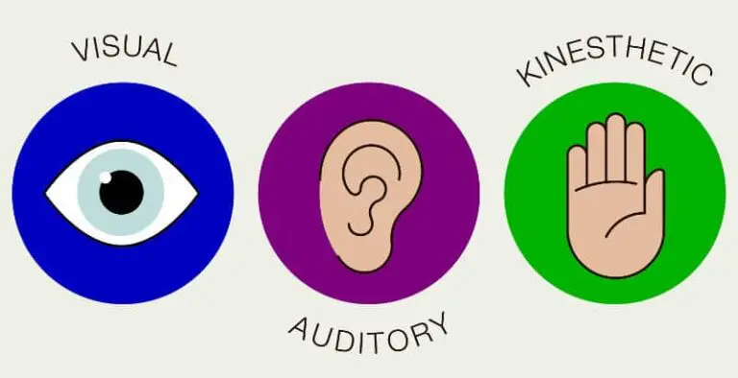
(Source: https://teachingenglishgames.com/how-to-teach-english-for-different-learning-styles/)
Based on VARK model, my personal learning style is a combination of visual, auditory and tactile, as the strongest one is a visual (50%), which means, it might affect the way I perform in my education or job and how I approach the tasks. People who have this learning style, prefer “emphasizing visual presentation of information” (Pashler et al., 2008). According to Prihatin (2022), they are defined as “good long-term planners and organizers”, with “careful attention to detail”. Leopold (2012) said, that” mind-mapping is a wonderful way for visual learners to brainstorm ideas and to map cause-effect sequences”.
Presently, I understand that as a visual learner, might find it helpful to use visual aids (diagrams, flowcharts) in work environment to help me to understand and retain important information, and to organize my thoughts and ideas. Therefore, I might be more effective at tasks that involve data analysis, as I am able to understand and interpret information more easily when it is presented in a visual format. Furthermore, I may be particularly skilled at tasks that require creative problem-solving or innovation, as I am able to generate and visualize ideas more easily than others. On the other hands, I could struggle in meetings or group discussions where information is presented in written form, since I might find it difficult to stay engaged.
In addition, as a visual learner I might benefit from working in an environment that has clear and organized visual cues, which could help me stay focused and organized, and can also reduce distractions and improve my productivity.
The next my preferred learning style is auditory, which is characterized by the fact that people who possess it, learn most effectively by hearing and listening. For the auditory learners is “easier to present properly when explaining, because they are easier to convey than to write” (Prihatin, 2022), i.e. they are more active and effective when discussing. I kind of agree with that because I commonly understand more effortless the spoken instruction than written; I delight listening, but at the same time, I cannot wait to talk and express myself or my point of view.
I have learned I would improve my learning process by reading information out loud, when I study new material or follow the instructions. Moreover, I may excel in roles that require strong communication skills, such as sales or customer service. My ability to listen and speak effectively could help me to build rapport with customers and colleagues, and to convey information clearly and persuasively. Additionally, I might be particularly effective at working in teams or collaborating with others, as I are able to listen to others' ideas and communicate my own effectively.
Although it is not my the strongest one in agreement with my survey, I believe that tactile learning style matches me the most accurately. I learned that kinaesthetic learners speak with gestures, by using hands, they are more active and learn best when they are allowed to move around and interact with their environment. That means, their learning process could be supported by including frequent breaks during study sessions (for moving around and stretching) or short walking at the lunch time at work.
According to Prihatin (2022), the kinaesthetic learners “tend to prefer practice, move or do something to be able to understand some information”. They often “need to touch or hold thing around them” (Niga and Janggo, 2023) and usually use a lot of body signals. That means they might be more effective at tasks that involve physical activity, repairing, or creating things with the hands.

- Assessment of the concepts have learned from this module
Reflection is an important tool for learning and workplace performance because it helps us learn from our experiences, encourages self-awareness, promotes critical thinking, enhances problem-solving skills, and improves workplace performance. It is defined as a “technique for aiding and reinforcing learning, used in education and professional development” (Moon, 1999, p.4)
There are many different models for reflection, but some of the most commonly used ones are:
- Gibbs' Reflective Cycle: This model involves six stages - Description, Feelings, Evaluation, Analysis, Conclusion, and Action Plan. It encourages individuals to explore their experiences in-depth and consider how they can use what they have learned to improve their future actions.
- Kolb's Experiential Learning Cycle: This model involves four stages - Concrete Experience, Reflective Observation, Abstract Conceptualization, and Active Experimentation. It emphasizes the importance of experiencing things first hand, reflecting on those experiences, and using what has been learned to inform future actions.

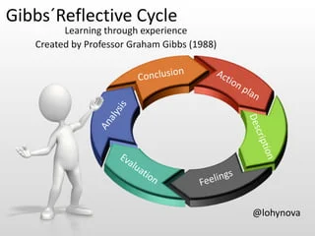
Source: https://www.slideshare.net/lohynova/gibbsreflective-cycle-77394157

For the purpose of this report is applied Gibbs’ Reflective Cycle, and are followed its involved six stages:
- Description
In my University I completed a module on Professional Career Development. The module covered topics such as career planning, employment goal setting, self-awareness, awareness of the trends in employment, and job search strategies. The main purpose was to realise the need of constantly improve ourselves, what specific skills and knowledge to gain, that in our turn to use for improving our employability skills and to achieve our professional goals. Additionally, we have learned how to present ourselves as the better skilled person than we have been before. The module was delivered at the university over a period of ten weeks and included lectures, readings, videos, and activity.
- Feelings
I initially felt a bit nervous about the upcoming tasks Open Book Assessment and particularly the Mock interview, but I was also excited to learn new strategies, and techniques for managing my career and how to become markable employee. Furthermore, it was really interesting for me to understand what a learning style is, which is my preferred style, and why is important to know it. As the module progressed, I felt more confident in my ability to apply what I was learning.
- Evaluation
Overall, I feel that the module was very informative and provided me with a good foundation for developing my career. I particularly appreciated the emphasis on employment’s goal setting and the practical tips for professionally creating a CV, preparing for an interview, and strategies for job searching. The assignments, especially the Mock interview, were challenging but also rewarding, as they would help me to apply what I was learning in a real-world context.
Subjectively, I feel like I learned a lot from the course, but I also feel like I could have done better. I wish I had taken more time to review the material and gain more knowledge from the module.
On reflection, I feel that I did reasonably well in the interview. I was able to answer most of the questions confidently and articulately, and I felt that I had made a good impression on the interviewer. However, there were also areas where I could have done better, such as providing more detailed examples of my past experience, demonstrating a stronger understanding of my career aspirations, and etc., that need to be improved on maximum level.

- Analysis:
As I reflect on the module, particularly after Task 1 Open Book Assessment, I comprehended that one of the major purposes of it, was to prepare us for the upcoming changes. Its main target was to try teaching us some specific skills that may help us reshape ourselves and how that could be professionally presented.
Moreover, I understood that in the next decade, technological innovation, automation, and artificial intelligence will influence both our lifestyle and workplace. I realized that one of the key takeaways for me, was the awareness of the trends in employment and the importance of taking a proactive approach to my career development.
Furthermore, searching through relevant literature and found, that according to latest research, “over half (47%) of all jobs fall into the "high-risk" category” (Tripathi, 2021). This means, it is quite possible these jobs roles might be automated within 2030, and 37% of people believe that will happen (PwC, 2018). Therefore, we must be conscious about those potential threats, we must keep in mind them when we are setting our future career goals. We must be aware of the need to constantly learn and upskill ourselves, and continuously develop professionally, in order to be well prepared for those shapes if we want to be successful employees in the near future.

- Conclusion
Overall, the module has met my expectation because it gave me cardinal guidelines, which helped me to make some significant takeaways that I will apply to your career development in the future. Within these ten weeks, I learned about the trends in future employment and gained knowledge about the requirements and selection process.
Moreover, I became more competent in creating successful job application and how to build confidence, during the interview. Based on what I have learned from the module, I must set my specific career goals and develop a plan to achieving those goals.

- Action Plan
My action plan includes setting specific career goals and developing a plan for achieving those objectives. I need clearly understanding about career path, that I need follow, when and what I have to do because it would help me to achieve my personal and professional aims.
Additionally, when I am aware about myself, about my weaknesses, I am able to take specific actions to improve the area I need, as well as to develop my current skills and even acquire new ones because if I want to be remarkable employee, I should be well prepared for the future changes in the workplace. I consider continuing learning about career development by attending workshops, reading books, and seeking out mentorship and guidance from experienced professionals in my field.

References:

Leopold, L., (2012). Prewriting tasks for auditory, visual, and kinesthetic learners. TESL Canada Journal, pp.96-96.
Moon, J. A. (1999) Reflection in learning & professional development: theory & practice. 11th edn., Abingdon: Routledge.
Niga, E. and Janggo, W.O., (2023). AN ANALYSIS OF STUDENTS’LEARNING STYLES OF ENGLISH IN LANGUAGE CLASSES AT CHATOLIC PRIVATE SCHOOL OF ST. JOHN PAUL II MAUMERE IN THE ACADEMIC YEAR OF 2018/2019. Edunipa Journal, 3(3), pp.49-74.
Pashler, H., McDaniel, M., Rohrer, D. and Bjork, R., (2008). Learning styles: Concepts and evidence. Psychological science in the public interest, 9(3), pp.105-119.
Pashler, H., McDaniel, M., Rohrer, D. and Bjork, R., (2008). Learning styles: Concepts and evidence. Psychological science in the public interest, 9(3), pp.105-119.
Prihatin, A.U. and Ichsan, I., (2022). THE INFLUENCE OF COLLEGE STUDENTS’LEARNING STYLE THE QUR’AN MEMORIZING METHOD IN UKM LPTQ UMY. Jurnal Tatsqif, 20(2), pp.141-161.
PwC, (2018), p.6, Available at: https://www.pwc.com/gx/en/services/people-organisation/workforce-of-the-future/workforce-of-the-future-the-competing-forces-shaping-2030-pwc.pdf ( Accepted: 26/03/23)
Swart, J. (2022), The Personal SWOT Analysis as a Coaching Tool., 16th December Available at: https://www.researchgate.net/publication/366588652_The_Personal_SWOT_Analysis_as_a_Coaching_Tool (Accessed: 15/03/23)
The Open University (2023), Career and employability, Develop your career, Available at: https://help.open.ac.uk/pdp (Accessed: 16/03/23)
Tripathi, M.A., Tripathi, R. and Yadav, U.S., (2021), Paradigm shift in the Human Resource Management: An Overview of Digital technologies transforming the dynamics of Work and the Emergence of Gig Work, International Journal of Mechanical Engineering, Vol (6) p.1628

