
Skills for the Workplace
Module Assignment Submission
Student Name: | Rachel Witheridge
Student Number: | 2106781
Module No: | BMSK4006
Module Title: | Part 2 Reflection

Statement of Confirmation of Authenticity
By the act of making this submission, the student declares that this is the work of the student named above. The work has not, in whole or in part, been knowingly presented elsewhere for assessment, or where assessment has been built on a previous assessment, this has been identified. Where materials have been used from other sources it has been properly acknowledged. If this statement is untrue, the student acknowledges that an assessment offence has been committed.
Attention is drawn to the plagiarism and unfair practice policies of both the University and of ILM.

Table of Contents
Part 2: Reflection on Skills developed during the Business Plan Project 3
2.1 Description 3
2.2 Feelings 4
2.3 Evaluation 4
2.4 Analysis 4
2.5 Conclusion 6
2.6 Action Plan 6
References 6

Part 2: Reflection on Skills developed during the Business Plan Project

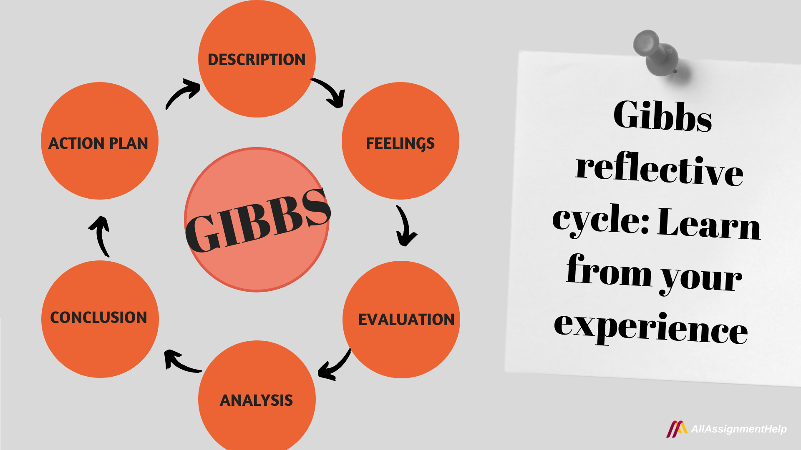

"Learning by Doing" is a book by American psychologist and sociologist Graham Gibbs. In essence, the 1988 invention of this paradigm was a reflecting cycle. It inspired readers to consider their experiences methodically. Experiences they may have had because of a certain task, circumstance, or occasion. It offered the notion of using a circle to organise one's reflection on every experience. Now, as part of the Gibbs reflective cycle, this circle has been rapidly gaining popularity. In the modern world, many people all around the world employ this cycle or loop.
The six components of the process, which is effectively a cycle or loop, are as follows:
- Description
- Feelings
- Evaluation
- Analysis
- Conclusion
- Action Plan
("Gibbs reflective cycle - Meaning and Stages to make your work easier", 2022)

2.1 Description
Ceri and I have developed a joint business strategy for a company named Bespoke Party Creations, a balloon and party decoration expert. Whether it's a straightforward personalised balloon, a garden party, or creating the ideal wedding environment, we love to create those memorable occasions. We had to look at the prices they charge, the products they provide, and how our business would be superior to those of many of our competitors. We have the ideal location, with enough room for manufacturing our personalised orders and parking for customers who desire to pick up their orders. Through thorough research, we identified a market need for a whole party setup that includes balloons, table decorations and centrepieces, and balloons that no other company can deliver.
Both Ceri and I are competent users of Facebook, Instagram, and Pinterest, so setting up a business account was not difficult. Due to our creativity, we were able to make our own flyers and business cards to post at local businesses.

2.2 Feelings
Ceri and I were both anxious to begin our new journey because we wanted to make sure we had the right knowledge about our competitors and how to price our own market. Determining the time commitments required from each of us and how we would cover one another in the event of illness or other absences. When compiling our cash flow worksheet and attempting to predict how much our business would grow over the following years, I was more anxious than Ceri. I felt more at ease since Ceri's husband, an accountant, was able to give her some advice.
When everything came together and we could see how our business would develop, we were both thrilled.

2.3 Evaluation
Reflection in business is important for several reasons. However, the following three are crucial for all business owners:
Stay on course - Business operations can become stressful. It's also quite simple to lose sight of the wider picture when things are tense, and you're preoccupied with managing and running your business. Self-reflection helps you stay on course.
Makes businesses perform better - Many business owners learn from their mistakes and failures, and regular business reflection enables them to do so more effectively. It's a technique to hold yourself responsible for your actions and make sure you're improving.
Allows you to enjoy yourself - Business reflection can be helpful to help you recall what you accomplished even if it is primarily focused on learning from your mistakes and better in the future. It's extremely simple to get sidetracked by brand-new objectives and difficulties and neglect to recognise your company's successes. (2022)
Because Ceri and I work well together, the entire process was successful. We did have many conversations about holidays and illnesses, and we have a large family that is ready to pitch in as and when necessary. Lack of backup can have a significant negative impact on our company when one of us needs to take time off or becomes ill, which is unavoidable.

2.4 Analysis
Creating thorough business analyses, planning, and monitoring, budgeting, and forecasting are some of the duties of a business analyst. Operational, project, enterprise, and competitive focus areas/levels of business functions are all applicable to the business analyst role. Each of these business analysis subfields significantly affects how well a company performs, and it helps to increase profitability and effectiveness throughout all phases of the business process and in all business operations. ("Business analyst - Wikipedia", 2022)
While finishing our cash flow spread sheet and determining whether we had the right information, I did experience some anxiety. To overcome this, I will research more competitors to see what they have to offer and how we can improve. Below is a SWOT analysis I carried out on myself to see what I can improve on, and work works well for me.

STRENGTHS  - Patient  - Versatile  - Determined  - Calm and Composed  - Efficiency | WEAKNESSES  - Being too Optimistic When Measuring our Market Size  - Acknowledge the Competition
OPPORTUNITIES  - Courses / learning  - Good time management | THREATS  - Competitor prices  - Loss in sales

I discovered that I have several strengths that will help our company by conducting a SWOT analysis. Opportunities that will enable me to develop and learn in order to improve our company weaknesses that I may address by understanding our competitors and avoiding overestimating the size of the market through information gathered. Threats that can be mitigated by learning more about our sales and those of our competitors.
Creating a business plan – we needed to keep in mind that we don't need to make our business plan like any other plans that are already out there. It only matters that we create a proposal that is distinctive and clearly conveys our ideas and personality.
Even while we might think that predicting large income potential and a wide range of markets for our possible investors sounds amazing, most of the time they won't find these projections to be as appealing.
("11 Important Business Plan Mistakes to Avoid in 2022", 2022)
Problem solving - We'll may encounter issues, and will need to find answers, in many cases can be in a hotel an hour before the event! Even though creating the goods for the consumer is still a very significant element of running a business, it the actual running of the business that it crucial.
Pricing - We must be conscious of all of our expenses and work and not hesitate to set prices appropriately. All of our time, from the initial correspondence to the final delivery, should be included in the final cost to our client.
("Starting a Balloon Business: Tips from the Pros", 2022)

2.5 Conclusion
Bespoke Party Creations is a unique balloon and party specialist. Attending classes to develop our skills and staying current with emerging trends is our key goal in being distinctive. Ceri and I both have savings, so we don't need a setup loan to start our firm. We'll start recouping our funds once we start earning money. Carrying out a competitor analysis will help us identify competitors in our industry and learning about their various marketing strategies. Offering Customers who buy 5 balloons or more in a single transaction will receive a 10% discount. This will be inspired to make more purchases as a result.
Due to our broad family structure, we have enough of support if assistance is required due to illness or any other absence. This will enable us to maintain our course for business.
We have a business licence and a seller’s permit. We have insurances in place to cover any damage to our buildings, including damage from fire or flooding, as well as damage to IT, printing, and other important equipment.

2.6 Action Plan
In order to think about what I need to learn to run our business successfully, I've established a personal growth plan.
What do I want to learn? | What do I have to do? | What support and resources do I need | How will I measure success? | Date and target review?
Time management | Take time out to attend courses to better our service | Support from family | Creating new ideas and reflect on sales | Every 6 months
Competitor marketing | Gather further information on our competitors | Ceri and I to conduct regular competitor analysis | Compare analysis and make changes accordingly | Every 6 months

References

(2022). Retrieved 20 July 2022, from https://teachable.com/blog/business-reflection
11 Important Business Plan Mistakes to Avoid in 2022. (2022). Retrieved 20 July 2022, from https://wisebusinessplans.com/business-plan-mistakes-to-avoid/#:~:text=11%20Common%20Pitfalls%20To%20Be%20Avoided%20In%20Preparation,Business%20Plan%20be%20Boring.%20...%20More%20items...%20
Business analyst - Wikipedia. (2022). Retrieved 20 July 2022, from https://en.wikipedia.org/wiki/Business_analyst
Gibbs reflective cycle - Meaning and Stages to make your work easier. (2022). Retrieved 20 July 2022, from https://www.allassignmenthelp.co.uk/blog/gibbs-reflective-cycle/
Starting a Balloon Business: Tips from the Pros. (2022). Retrieved 20 July 2022, from https://www.balloon-decoration-guide.com/starting-a-balloon-business.html

