Jack Banner (2200212)
2200212@student.uwtsd.ac.uk
Policing Terrorsim
BMPL5011
Evaluate the effectiveness of the Public Service response to a terrorist attack.

Contents
Event Overview 2
Intelligence Failings 2
Emergency Response 3
Police Service 3
Ambulance Service 3
Fire Service 3
Analysis of Emergency Response 5
Post Attack 5
Conclusion 6
Bibliography 7

Event Overview
The Manchester Arena bombing stands as one of the deadliest terror attacks in the history of the UK and the deadliest attack since the 7/7 bombings. Salman Abedi, the attacker motivated by the devastation caused by the Syrian civil war, detonated a suicide device inside the arena on the 22nd of May 2017 during an Ariana Grande concert. The result was the death of 22 people and the injury of a further 1,017. The significance of this attack, not only physically on those attending but on the minds of victims and the public alike, cannot be understated (Hind et al., 2021). The event is notorious for the horrific physical devastation and the perceived failings of the event security, emergency and intelligence services alike (Moore, 2023). The combination of these factors led to a government-launched enquiry, with the "Manchester Arena Inquiry" beginning on the 7th of September 2020. Chaired by Sir John Saunders, there would be a 3-part report covering "Volume 1: Security for the Arena", "Volume 2: Emergency Response", and "Volume 3: Radicalisation and Preventability" (Home Office, 2023).

Intelligence Failings
The failings of the British intelligence agencies were significant, especially considering that the discovery of Abedi's plan could have completely prevented the attack. Before the attack, the intelligence services had Abedi on their radar; however, he was never further investigated or referred to the "Prevent programme". These agencies work with vast amounts of data that serve the possibility of individuals slipping through the cracks. Despite this, there were other indicators of risk with Abedi that failed services failed to explore (Intelligence and Security Committee of Parliament, 2018). From a young age, the radicalisation process of Abedi would have started. His father was a Libyan national with connections to Islamic militias in the region, where Abedi himself also spent time. Abedi returned from Libya in the exact days before the attack; however, MI5 failed to conduct proper travel monitoring or to impose travel restrictions. Abedi was also flagged on multiple occasions for online engagement with extremist material, along with visits to a convicted extremist contact in prison, all of which should have qualified him for further investigation and preventative action (Bendek and Simon, 2020).
The investigations post-attack found two main things that round up the failings, the first being the speed at which the systems for identifying and intervening with potential threats occur. Abedi should have been investigated thoroughly and then referred to the prevention programme "CONTEST". The government designed the strategy to counter extremist narratives and support those vulnerable to radicalisation. Not only would continued investigation allow discovery of his plan, but utilising CONTEST when necessary could have stopped and reversed the radicalisation of the boy all together. MI5 had Abedi on their radar since 2014, supporting that earlier intervention could have diverted the attack (Malik et al., 2017).
Finally, there was also heavy criticism of the failures of inter-agency information sharing. MI5, local police forces, MI6 and international partners work with massive datasets. However, where the initial finding by MI5 placed him as a person of interest, this never made it past that individual services as it should have given his activities. Inter-agency cooperation allows more resources, options, and datasets, which would have given a more detailed insight but also allowed crucial preventative action. It would also provide options for improved surveillance domestically and abroad, engagement with those around Abedi and the employment of the CONTEST strategy (Saunders, 2023).

Emergency Response
The failures in our intelligence systems allowed the bombing to proceed; however, the actual emergency response to the incident also stood as one of the pivotal areas facing criticism in post-event inquiries. It is vital to underscore the complexity of responding to such unprecedented events and to look at the challenges faced. Despite this, in the case of the Manchester Arena bombing, there were existing procedures and guidance, like the JESIP principles, which the report will explore in more detail later. Overall, examining the initial responses from the police, fire, and ambulance services can shed light on the critical moments that define efficiency in emergency response, allowing for better readiness and avoidance of past mistakes (University of Bath, 2021).

Police Service
In the minutes after the blast, the police were the first responding service. They also took the spot as the leading service, with Chief Constable Ian Hopkins of the Greater Manchester Police Force acting as the gold incident commander overseeing the incident response (Britton, 2021). The initial stages of the police response were complicated due to the assumption of an active shooter scenario, causing a more cautious approach to prioritise the safety of responding units. After confirmation that there was no shooter, the police role turned toward command and coordination of victims and resources (Muktarsingh et al., no date).

Ambulance Service
The ambulance service performed well throughout the Manchester Arena bombing. The ambulance service typically relies on the broader operational context, with this incident being no exception. However, after receiving police clearance, paramedics arrived rapidly and performed to a high standard. Throughout their response, they provided vital aid to the injured, setting up triage points for different classifications of injury, providing lifesaving onsite aid and efficiently transporting casualties to nearby hospitals. The restraint of the service, however, was a result of the resources at their disposal and the overcapacity of NHS facilities (Skryabina et al., 2020) (Dark et al., 2021).

Fire Service
As already mentioned, in the opening stages of the emergency response, there was the mistaken belief that there was an active shooter situation. During this time, the other emergency services were assigned muster points at a safe distance, waiting for police clearance to move in. A breakdown in information sharing between the agencies led to the fire service not being called forward when the police deemed the area safe, leaving them waiting in their safety zone for an extended period before deploying to the scene. On arrival, they remained on the scene for a short amount of time before leaving (Gates, 2022).
The Joint Emergency Service Interoperability Programme (JESIP)
The Joint Emergency Service Interoperability Programme, or JESIP, have created the models and standards used in the UK for interoperability between services. The centre of this are three vital frameworks. The principles for joint working are provided as guidance for collaboration between services and lay out five principles. These are the co-location of service commanders, ensuring effective communication and efficient collaboration through coordination, risk understanding and situational awareness (Joint Emergency Services Interoperability Programme, 2022a).

JESIP also saw the introduction of the M/ETHANE acronym, which stands for the following:

- M - Major Incident
- Exact Location
- Type of Incident
- Hazards
- Access
- Number of Casualties
- Emergency Services

Designed for emergency services, the model allows responders to create a report to foster a joint understanding of what they're dealing with in any situation (Ball, 2016).

Finally, the joint decision model was developed to collate information available to responders, work around the differing priorities of partnering services and aid effective joint decision-making.

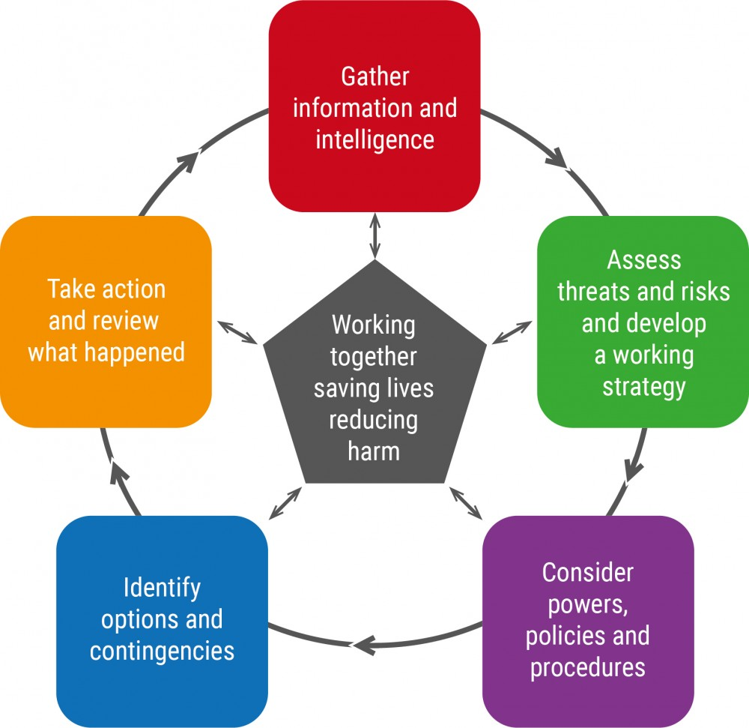

All the stages within the joint decision model reflect the individual national decision model that responders are already exposed to but encourage and allow inter-agency communication to make overarching decisions about response strategy. When used well, the JESIP models combine to allow smooth interoperability, the converse being the Manchester Arena Bombing response (Joint Emergency Services Interoperability Programme, 2022b).

Analysis of Emergency Response
In the period that followed the Manchester Arena bombing, investigation found that emergency response, while prompt, allowed critical gaps in relation to the procedures in adherence to the Joint Emergency Services Interoperability Programme's frameworks. The first of the issues came with the mistaken assumption of an active shooter scenario, impacting the response time of needed units in a critical time of urgency. The perceived threat affected all services; however, the delay of the fire services response past the point of their ability to significantly help is the highlight. That connects to the findings of a critical breakdown in communication and coordination among the responding services, underscoring the failure to utilise the guidance provided by the JESIP frameworks in the command positions (Kerslake, 2018).
The bombing also highlighted the failure to properly leverage the JESIP M/ETHANE model for accurate initial reporting and the Joint Decision Model to ensure cohesive inter-service decision-making. As an immediate example, look back at the false identification of an active shooter. It represents the entire failure in use of the model as the "hazard" section would have indicated the absence of continued threat on detonation of the device. Overall, the initial communication did not effectively convey the full scope of the incident through M/ETHANE, leading to varied interpretations and responses from the different emergency services. Furthermore, the decision-making process, guided by the Joint Decision Model, was hampered by insufficient real-time information sharing and joint situational awareness. The principles for joint working, further neglected, were disregarded with the lack of a co-located command post in the immediate aftermath of the attack. No co-located command post further complicated the already complicated nature of inter-service communication, as seen with the fire service commanders being left in the dark after the site was deemed safe. These factors combined to restrict the timely and coordinated deployment of resources, ultimately affecting the speed and efficiency of individual emergency aid being delivered to the victims and delaying the comprehensive assessment and joint response that JESIP advocates for (Saunders, 2022).

Post Attack
In the face of criticism and inquiries into the emergency response to the Manchester Bombing arena, forces made significant changes nationwide to address the identified shortcomings, enhancing preparedness and the response capabilities of the UK's civil protection services. One of the focus areas, as discussed, is the reinforcement of models devised by the Joint Emergency Services Interoperability Programme. With identified shortcomings, there was a clear need for improvement in communication, coordination, and joint decision-making among the emergency services in collaborative environments. Nationwide, we saw agencies holding more comprehensive and vigorous training to ensure that personnel are competent in the JEDIP frameworks, allowing for better integration of services. Training is critical in command roles, as individual responders on the ground can still perform their duty to a high standard; however, the failure of command to create structure through communication ultimately removes that ability (Davidson et al., 2022) (Power et al., 2023).
Additionally, one of the primary suggestions of inquiries for an array of major incidents of the past has been the establishment of clearer protocols regarding the setup of co-location command centres. This change is crucial, as allowing the primary commanders for the individual services, along with the specific incident commanders allows communication and inter-service planning in close proximity. This allows the command structure to foster direct communication and joint situational awareness from the earliest stages of an incident, the centre of the JESIP principles (College of Policing, 2023). Finally, there have been efforts to improve the integration and utilisation of national assets, such as the National Mutual Aid Telephony system which should allow police forces to support each other in taking emergency calls but failed completely on the day of the attack (Speed, 2018) (London Emergency Services Liaison Panel, 2021).

Conclusion
Overall, the lessons taken from the Manchester Arena bombing will help emergency services and the country to prepare, allowing responders to attack future incidents with haste and efficiency. We saw the failures of intelligence and the emergency services in properly utilising their set frameworks. A review of the process of intelligence processing would be beneficial, putting an emphasis on the quick intervention towards individuals showing warning indicators of radicalisation. To ensure that JESIP models, along with the upholding of proper interservice communication, it is essential to take a multifaceted approach moving into the future of emergency response. Firstly, there is a need for ongoing and rigorous training programs to be implemented for all emergency services personnel, especially among command positions, focusing on the practical application of JESIP principles, the M/ETHANE model, and the Joint Decision Model (JDM). Where forces nationwide are aware of and use the model, real-world application is rare. Despite this, in the occasions where large-scale multi-agency collaboration is needed, there is the lowest margin of error to result in catastrophic results. The push for legislative and policy changes aimed at enhancing public safety and emergency response has been comprehensive on all sides, representing a commitment. The British civil protection services are constantly learning and evolving, and where there stands criticism about the response to the Manchester Arena bombing, there still remains the spirit of improvement within the services (Manchester Arena Inquiry, 2021) (National Fire Chiefs Council, 2023) (Warnock and Johnson, 2020).

Bibliography

Ball, J. (2016) Can the JESIP ‘METHANE’ acronym work for risk and business continuity too? Available at: https://www.continuitycentral.com/index.php/news/business-continuity-news/1120-can-the-jesip-methane-acronym-work-for-risk-and-business-continuity-too (Accessed: 15 March 2024).
Bendek, E. and Simon, N. (2020) ‘The 2017 Manchester Bombing and the British-Libyan Jihadi Nexus’, CTC Sentinel , 13(5), pp. 28–39. Available at: https://ctc.westpoint.edu/the-2017-manchester-bombing-and-the-british-libyan-jihadi-nexus/ (Accessed: 14 March 2024).
Britton, P. (2021) Arena bomb inquiry: GMP sent inaccurate information to Kerslake Review. Available at: https://www.manchestereveningnews.co.uk/news/greater-manchester-news/ian-hopkins-information-kerslake-gmp-21064545 (Accessed: 15 March 2024).
College of Policing (2023) Command, control and coordination. Available at: https://www.college.police.uk/app/civil-emergencies/civil-contingencies/command-control-and-coordination (Accessed: 15 March 2024).
College of Policing (no date) SHARED SITUATIONAL AWARENESS -M/ETHANE. Available at: https://library.college.police.uk/docs/appref/JESIP-METHANE.pdf (Accessed: 15 March 2024).
Dark, P. et al. (2021) ‘Healthcare system impacts of the 2017 Manchester Arena bombing: evidence from a national trauma registry patient case series and hospital performance data’, Emergency Medicine Journal, 38(10). Available at: https://doi.org/10.1136/emermed-2019-208575.
Davidson, L. et al. (2022) ‘Advancing a social identity perspective on interoperability in the emergency services: Evidence from the Pandemic Multi-Agency Response Teams during the UK COVID-19 response’, International Journal of Disaster Risk Reduction, 77, p. 103101. Available at: https://doi.org/10.1016/j.ijdrr.2022.103101.
Gates, M. (2022) Manchester Inquiry: Emergency Response to Arena Bombing Went ‘Badly Wrong’. Available at: https://www.asisonline.org/security-management-magazine/latest-news/today-in-security/2022/november/manchester-inquiry-emergency-response-badly-wrong/ (Accessed: 15 March 2024).
Hind, D. et al. (2021) ‘The psychosocial response to a terrorist attack at Manchester Arena, 2017: a process evaluation’, BMC Psychology, 9(1). Available at: https://doi.org/10.1186/s40359-021-00527-4.
Home Office (2023). Manchester Arena Inquiry reports. Available at: https://www.gov.uk/government/collections/manchester-arena-inquiry-reports (Accessed 13 March 2024).
Intelligence and Security Committee of Parliament (2018) The 2017 Attacks: What needs to change? Westminster, Manchester Arena, London Bridge, Finsbury Park, Parsons Green. Available at: https://isc.independent.gov.uk/wp-content/uploads/2021/01/20181122_ISC_2017_Attacks_Report_Press_Notice.pdf (Accessed: 13 March 2024).
Joint Emergency Services Interoperability Programme (2022a) Principles for joint working. Available at: https://www.jesip.org.uk/joint-doctrine/principles-for-joint-working/ (Accessed: 15 March 2024).
Joint Emergency Services Interoperability Programme (2022b) The Joint Decision Model (JDM). Available at: https://www.jesip.org.uk/joint-doctrine/the-joint-decision-model-jdm/ (Accessed: 15 March 2024).
Kerslake, B. (2018) The Kerslake Report: An independent review into the preparedness for, and emergency response to, the Manchester Arena attack on 22nd May 2017. Available at: https://www.jesip.org.uk/uploads/media/Documents%20Products/Kerslake_Report_Manchester_Are.pdf (Accessed: 15 March 2024).
London Emergency Services Liaison Panel (2021) Major Incident Principles . Available at: https://www.london.gov.uk/sites/default/files/leslp_mip_v11.5_dec_2021_-_public.pdf (Accessed: 15 March 2024).
Malik, N. et al. (2017) Understanding CONTEST: The Foundation and The Future. Available at: https://henryjacksonsociety.org/wp-content/uploads/2017/07/FINAL-CONTEST.pdf (Accessed: 14 March 2024).
Manchester Arena Inquiry (2021) PREPAREDNESS & RESPONSE: GMFRS and NWFC. Fire expert’s response to the list of central issues. Available at: https://files.manchesterarenainquiry.org.uk/live/uploads/2021/09/09193630/INQ041857_1-25.pdf (Accessed: 15 March 2024).
Moore, J. (2023). Manchester Arena Inquiry latest: Volume 2 report focuses on uncoordinated response of emergency services. Available at: https://www.ifsecglobal.com/security/manchester-arena-inquiry/ (Accessed 13 March 2024).
Muktarsingh, N. et al. (no date) The mistakes made during the Manchester Arena terror attack. Available at: https://news.sky.com/story/the-mistakes-at-manchester-arena-how-emergency-services-responded-to-terror-attack-12736564 (Accessed: 15 March 2024).
National Fire Chiefs Council (2023) Major incidents 2023 review. Available at: https://nfcc.org.uk/wp-content/uploads/2023/10/Major-incidents-2023-review-0.1-line-numbers.pdf (Accessed: 15 March 2024).
Power, N. et al. (2023) The Psychology of Interoperability: A Systematic Review of Joint Working Between the UK Emergency Services, crestresearch.ac.uk. Available at: https://crestresearch.ac.uk/resources/the-psychology-of-interoperability-a-systematic-review/ (Accessed: 15 March 2024).
Saunders, J. (2022) Manchester Arena Inquiry Volume 2: Emergency Response. (HC 757-I). London: The Stationery Office.
Saunders, J. (2023) Manchester Arena Inquiry Volume 3: Radicalisation and Preventability. (HC 1137). London: The Stationery Office.
Skryabina, E.A. et al. (2020) ‘The role of emergency preparedness exercises in the response to a mass casualty terrorist incident: A mixed methods study’, International Journal of Disaster Risk Reduction, 46(1), p. 101503. Available at: https://doi.org/10.1016/j.ijdrr.2020.101503.
Speed, R. (2018) Manchester Arena attack: National Mutual Aid Telephony system failed. Available at: https://www.theregister.com/2018/03/27/nmat_failure_manchester_attack/ (Accessed: 15 March 2024).
University of Bath (2021) 'University of Bath research shows how to improve emergency services’ response to terrorist incidents', 26 May [Press release]. Available at: https://www.bath.ac.uk/announcements/university-of-bath-research-shows-how-to-improve-emergency-services-response-to-terrorist-incidents/ (Accessed: 15 Mar. 2024).
Warnock, A. and Johnson, L. (2020) A PUBLIC INQUIRY INTO THE DEATHS OF 22 THAT LOST THEIR LIVES AT THE MANCHESTER ARENA ON 22nd MAY 2017: OPENING STATEMENT ON BEHALF OF GMCA. Available at: https://files.manchesterarenainquiry.org.uk/live/uploads/2020/09/30161552/INQ035482-Opening-statement-on-behalf-of-GMCA-dated-28082020.-1.pdf (Accessed: 15 March 2024).

