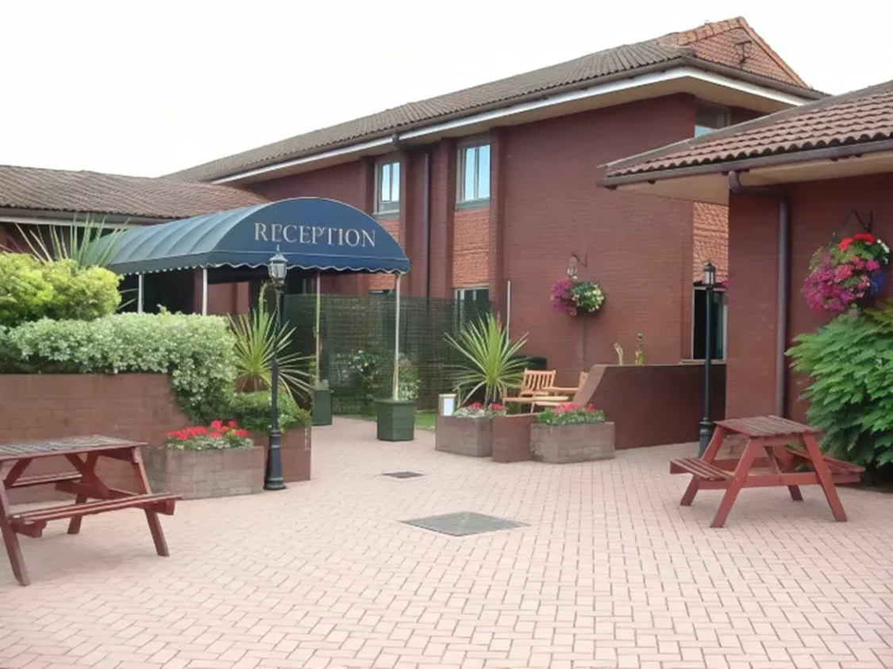(Trip, 2024).
BMIH6004 Hotel Placement – Managing Hotel Administration LEVEL 6
Leonardo Hotel East Midland Airport

Module Lead Jessica Newport BA (Hons), MBA
Augusta Roxana Toth (2226559)
words Count: 1770
Year 3
During my placement at Leonardo Hotel East Midlands Airport, I had the opportunity to observe and take part in the daily operations of the hotel's Front Desk Department. This experience provided me with valuable insight into the world of hospitality management and helped me better understand the importance of customer service, teamwork, and communication in a busy hotel environment (Oaki, 2023). The Front Desk acts as the first and last point of contact for guests, and its role is vital in shaping their overall experience.

The Front Desk team at Leonardo Hotel is responsible for a wide range of services, including guest check-in and check-out, managing reservations, handling payments, resolving guest concerns, and providing information about hotel amenities and local attractions. The reception also coordinates closely with other departments such as housekeeping, maintenance, and F&B to ensure smooth service delivery (Strahl, 2024). One thing that impressed me was how professionally the team handled busy periods, particularly during airport flight delays or group check-ins, maintaining calm and delivering excellent guest service even under pressure.

When I began my placement, I had set three learning objectives that I hoped to achieve:
- Improve my communication and customer service skills – I wanted to feel more confident interacting with guests, especially handling complaints or special requests. During my time at the front desk, I learned how to greet guests warmly, answer common queries effectively, and resolve minor issues diplomatically. For example, I once assisted in resolving a double-booking issue calmly by offering a room upgrade and complimentary breakfast, which turned a potential complaint into a positive review.
- Understand the day-to-day operations of hotel reception – I aimed to understand how systems like Opera (PMS) are used to manage bookings, check-ins, and guest preferences. I was able to shadow the reception team and later perform basic tasks such as issuing room keys, confirming bookings, and updating guest profiles. This gave me a hands-on understanding of the importance of accuracy and attention to detail in administrative tasks (Campbell, 2024).

- Develop my teamwork and multitasking abilities – The front desk is a dynamic environment where multitasking is essential. I learned to work alongside colleagues, prioritise tasks, and stay organized. For example, during a busy morning shift, I had to coordinate wake-up calls, manage guest check-outs, and help with luggage storage—all while maintaining a friendly attitude and a professional appearance (Patil, 2023).

Section 1: Role Reflection

During my placement at Leonardo Hotel East Midlands Airport, I worked as a Front Desk Assistant where I encountered several high-pressure situations that evaluated and developed my skills in communication, organisation, and guest service. Using Gibbs’ Reflective Cycle (1988), I reflected on specific experiences that helped me grow both professionally and personally.

One of the most challenging periods was during a large conference hosting around 120 attendees. On that day, the hotel’s car park became full, and many of the conference guests blocked other parked vehicles, creating frustration among leisure guests who had just arrived from the airport for their holidays. We received numerous complaints, and I had to assist in finding alternative parking options while maintaining calm and providing reassurance to upset guests.

Another issue occurred when a guest called in advance to arrange a birthday surprise for a loved one. Unfortunately, a colleague misheard the date and passed on the wrong information to housekeeping. The room was decorated a day early, causing embarrassment when the guest arrived and found nothing special prepared on the correct day. Although I wasn't personally responsible, I was involved in resolving the guest’s disappointment, offering a gesture of goodwill, and ensuring the room was prepared properly the following day.

Additionally, there was a situation where a group of 20 guests arrived much earlier than expected. Their rooms were not ready, and we had to quickly coordinate with housekeeping to prioritise certain rooms for immediate cleaning. I prepared key cards swiftly and offered the group complimentary tea in the lounge while they waited. Despite the pressure, we managed to manage the situation smoothly, which left the guests feeling valued and cared for.

At the time, I felt overwhelmed, especially during the conference incident, where guest frustration was very visible. I also felt a sense of responsibility to help resolve the miscommunication about the birthday surprise, even though it wasn’t my error. However, I also felt proud that I was able to step up during the early group arrival and contribute positively to a stressful situation (Hullat, 2024).

These incidents made me realise that front desk work requires constant problem-solving and the ability to stay composed when things do not go as planned. While not everything was within my control, I learned how much of a difference initiative-taking communication, empathy, and quick thinking can make. In the parking and group arrival situations, teamwork played a major role in finding timely solutions and preventing further dissatisfaction.

My organisation, time management, and teamwork skills were critical in handling these challenges. Clear communication between departments, particularly with housekeeping, was essential. I also learned that attention to detail and confirming information (such as dates for guest surprises) is vital to avoid miscommunication. These experiences gave me a better understanding of how even small errors at the front desk can impact guest experience, and how important it is to double-check and clarify all guest requests.

This period taught me that the front office is a dynamic environment where unexpected problems can occur at any time. While systems and planning help, flexibility, composure, and communication are the real tools that keep the service running smoothly. I saw firsthand how front desk staff serve as the face of the hotel and how critical our role is in shaping a guest’s overall experience.

To improve further, I plan to:
- Strengthen my communication skills, especially around confirming guest requests and dates accurately.
- Take more initiative in liaising between departments, particularly during busy periods or special events (Michalis, 2023).
- Continue developing my confidence in problem-solving, learning to prioritise calmly under pressure.
- Practice assertive but polite communication with guests when managing complaints or difficult situations.

Section 2: Discussion of Key Hotel Administration Issues – Focus on Software Systems
During my placement at Leonardo Hotel East Midlands Airport, I experienced firsthand the challenges that come with poor integration between core hotel systems—specifically Opera PMS, the CRM platform, and the housekeeping tools. One key issue was the lack of real-time synchronisation between departments, which led to duplicated work, delays in service, and guest dissatisfaction. For example, there were occasions when guests were checked into rooms that were not yet cleaned, or when returning guests' preferences were not recognised due to missing CRM data. These situations created pressure on staff and affected the overall guest experience.

At times, I found myself manually cross-checking information between different systems just to ensure accuracy. This was time-consuming and increased the risk of error. I also noticed that not all staff were fully trained on system features; many relied on basic functions of Opera PMS and were hesitant to use CRM tools because they were unfamiliar or found them confusing. This experience echoed what I learned in the Hospitality Operations Management module, where technology is described as a key tool to improve service efficiency, but only if it is used effectively.
One of the most intense periods of my placement was during the Download Festival, when the hotel was fully booked for four consecutive days. The front desk operated under extreme pressure, with continuous guest traffic, tight check-in and check-out windows, and frequent special requests. Every reservation had to be managed with precision, as even the smallest error, such as a wrong room type or check-in date, could result in serious guest dissatisfaction, with no spare rooms available to resolve issues easily.

This period demanded a high level of diligence, accuracy, and focus, especially when handling group bookings, pre-payments, and guest identification. Receptionists had to remain organised and calm, despite long queues and occasional complaints. I had to balance efficiency with friendliness, making sure each guest felt welcome while staying on top of the administrative workload. This experience improved my stress management, multi-tasking, and problem-solving skills, and helped me understand how critical it is to maintain clear communication between the front desk, housekeeping, and management during high-demand periods.

Academic sources support what I observed. Buhalis and Leung (2018) emphasise the importance of integrated systems for real-time data sharing and service consistency, while (Piccoli, 2017) points out how a lack of training and high implementation costs often slow down digital transformation in hotels. From my perspective, integration was not just a technical issue it impacted daily operations, team communication, and guest satisfaction.

What I Learned and How I Grew
These experiences helped me develop critical skills:
- Technical proficiency: I became much more confident in using Opera PMS and started understanding how different systems should work together.
- Problem-solving and decision-making: Real situations forced me to think quickly and act calmly under pressure.
- Guest communication: I learned how to adapt my approach based on guest needs, whether they were business travellers, families, or international groups.
- Teamwork and leadership observation: Watching supervisors delegate tasks effectively showed me the importance of leadership in managing complex situations.

While I made good progress, I recognise that I still have areas to work on:
- I want to deepen my understanding of how integrated systems function behind the scenes (PMS, CRM, housekeeping apps).
- I aim to build more confidence in making decisions independently, especially in fast-moving situations.
- I plan to stay updated on emerging technologies in hospitality, such as AI-powered tools and mobile check-in systems, to better prepare for the future of the industry.

My front desk placement at Leonardo Hotel East Midlands Airport was an eye-opening and rewarding experience that gave me a true understanding of the fast-paced and unpredictable nature of hotel operations. Working during large conferences and major events like the Download Festival exposed me to high-pressure situations where adaptability, guest service, and teamwork were essential.

These peak periods tested my ability to manage large volumes of guests, solve problems quickly, and remain calm and professional, even when faced with complaints, overbooked parking, or last-minute group arrivals. I developed practical skills in system use, guest communication, time management, and interdepartmental coordination. I also gained valuable insight into how leadership, clear communication, and proper planning contribute to smooth front desk operations.

Most importantly, this experience gave me the confidence to handle real-world challenges and strengthened my passion for hospitality. It confirmed my interest in pursuing a front office or guest services role in the future, where I can continue to grow and contribute to delivering excellent guest experiences, even in the most demanding situations.

References:
- Buhalis, D., & Leung, R. (2018). Smart hospitality – Interconnectivity and interoperability towards an ecosystem. International Journal of Hospitality Management, 71, 41–50. Available at: https://www.sciencedirect.com/science/article/abs/pii/S0278431917301974/ (Accessed 20 May 2025).
- Campbell, K. (2024) Handling Guest Complaints in a Way That Wins. Available at: https://www.cvent.com/en/blog/hospitality/handling-guest-complaints/ (Accessed 20 May 2025).
- Hulatt, L. (2024) Guest Relations in the Hospitality Industry. Available at: https://www.studysmarter.co.uk/explanations/hospitality-and-tourism/hotel-management/guest-relations/ (Accessed 20 May 2025).
- Indeed (2024) What is Operational Supervision? A Manager’s Guide. Available at: https://www.indeed.com/hire/c/info/operational-supervision/ (Accessed 19 May 2025).
- Ivanov, S., & Webster, C. (2019). Adoption of AI and Robotics in the Hospitality Industry. In Robots, Artificial Intelligence and Service Automation in Travel, Tourism and Hospitality (pp. 19-45). Emerald Publishing. Available at: https://www.emerald.com/insight/content/doi/10.1108/978-1-78756-687-320191013/full/html/ (Accessed 20 May 2025).
- Kuo, Y. F., Chen, J. Y., & Tseng, C. Y. (2017). Investigating an innovative service with hospitality robots. International Journal of Contemporary Hospitality Management, 29(5), 1305–1321. Available at: https://www.researchgate.net/publication/315541261_Investigating_an_innovative_service_with_hospitality_robots/ (Accessed 20 May 2025).
- McLeod, S. (2025) Gibbs Reflective Cycle. Available at: https://www.simplypsychology.org/gibbs-reflective-cycle.html/ (Accessed 19 May 2025).
- Michalis, B. (2023) 10 Hotel Staff Training Strategies for Success in a Tight Labor Market. Available at: https://www.canarytechnologies.com/post/hotel-staff-training-strategies/ (Accessed 19 May 2025).
- Oaki (2023) Hotel front office: tasks, duties and responsibilities. Available at: https://oaky.com/en/blog/hotel-front-office/ (Accessed 19 May 2025).
- Patil, V. (2023) Hotel Opera System – Complete Guide To Grow Your Business. Available at: https://hotelweb.io/blog/hotel-opera-system// (Accessed 19 May 2025).
- Piccoli, G., Lui, T. W., & Grün, B. (2017). The impact of IT-enabled customer service systems on service customization. Journal of Business Research, 80, 103–113. Available at: https://dds.cct.lsu.edu/ddslab/pdf/piccoliLuiGruen.pdf/ (Accessed 20 May 2025).
- Strahl, S. (2024) Transforming hotel front desk services for a better guest experience. Available at: https://hospitalityinsights.ehl.edu/hotel-front-desk-guest-experience/ (Accessed 19 May 2025).
- Trip (2024) Leonardo Hotel East Midlands Airport. Available at: https://in.trip.com/hotels/castle-donington-hotel-detail-6385877/jurys-inn-east-midlands-airport-on-site/review.html (Accessed 19 May 2025).

