
LCBB6004: Strategic Management and Sustainability

BS (Hons) Business Management

Component 1: Coursework- Written Report

Student ID: 2246905

Student Name: TUDORITA TATIANA BADESCU

Module Leader/ Lecturer: Dr. Anupam Mazumdar, Dr Prithwa Bhattacharya

Executive summary
The report’s purpose was to conduct a strategic analysis of Jaguar Land Rover, a major automotive manufacturer in the UK. The analyses were done from the internal and external perspective through the use of PESTLE, Porter’s Five Forces, VRIO, Value Chain, Resource-Based View and SWOT frameworks. Through the identification of main macroeconomic challenges of inflation, consumer behaviour and supply chain uncertainties, the report suggested four major strategic alternatives. The alternatives were related to strengthening EV leadership, investing in digital transformation, global expansion and AI adoption.

Table of Contents
1. Introduction 4
2. Strategy analysis 5
2.1 External environmental audit 5
2.2 Internal environment audit 9
2.3 SWOT analysis 12
3. Strategy formation 13
4. Conclusion 14
5. Recommendations 15
6. References 16

1. Introduction
Strategic management is identified as a major supporting factor towards business success and smooth operations, as required by the management and external environment (Mukonori and Qutieshat, 2025; Rodrigues et al., 2021). Quantive (2025) puts strategic management as the overall corporate plan, actions and the big decisions undertaken in the process to achieve long-term goals. Within this, strategies related to corporate, business, functional, operating and competitive can be found to make the decisions more inclusive of the internal and external environment associated with the business. Alharbi (2024) represented the aspect of strategic management is emphatically related to the automotive sector, based on its rapidly changing external environment and internal decisions. In the automotive sector, Jaguar Land Rover (JLR) has made a significant impact in national contributions. JLR’s vision is to become the most desirable brand, as it provides distinction with modernist design and emotional connection with automobiles (Jaguar Land Rover Automotive PLC, 2025). Considering the case of Jaguar Land Rover, this report provides a discussion of the strategy analysis from various landscapes, such as external environment, internal environment and the organisational capabilities. These analyses will provide an insight into the strategic alternatives that can be adopted by the brand whilst also suggesting actionable visions. The analysis of the current strategic formulation in the organisation will pave the way for this report to highlight the key alternatives.

2. Strategy analysis

2.1 External environmental audit
The analysis of the external factors close to the strategic decisions (Shatilo, 2020), hence Jaguar Land Rover must evaluate them precisely. The use of PESTLE and Porter’s Fives Forces has been deemed necessary by this report.
PESTLE analysis
Political: While perceiving the external environment from a political viewpoint, Brexit’s impact is visible on the sourcing and manufacturing. In this case, Jolly (2021) shared that Brexit has forced the UK automotive sector to manufacture or source 70% of materials from other counties, which has also decreased to 50% effective by January 2024. On the other hand, government support has also become a major external element to the growth of the sector through its infrastructure and digital policies.
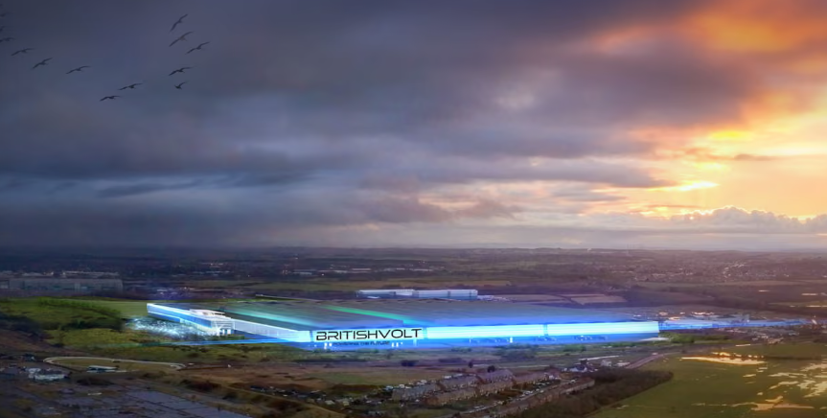
Figure 1: Battery production facility in Northumberland, UK
(Source: Jolly, 2021)
Economic: The UK government and corporate investments in automotive infrastructure is highlighting an improvement, as it is creating more than 1,700 jobs recently (Leggett, 2025). On the other hand, the impact of rising labour costs and the lack of skilled workforce has also weakened the production and operations for the automotive industry (Brady, 2023).
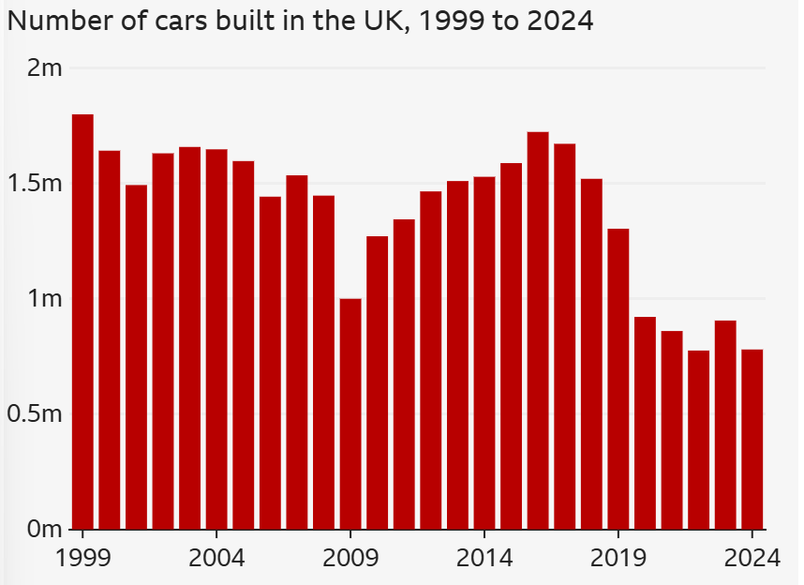
Figure 2: Declining car manufacturing in the UK
(Source: Leggett, 2025)
Social: It is studied by Mandys and Taneja (2024) that consumers are increasingly demanding green and sustainable fossil fuel automobiles, directly influencing their decisions in the market. Alongside this, British consumers are also concerned with heritage brands representing their culture and history while making purchase decisions.
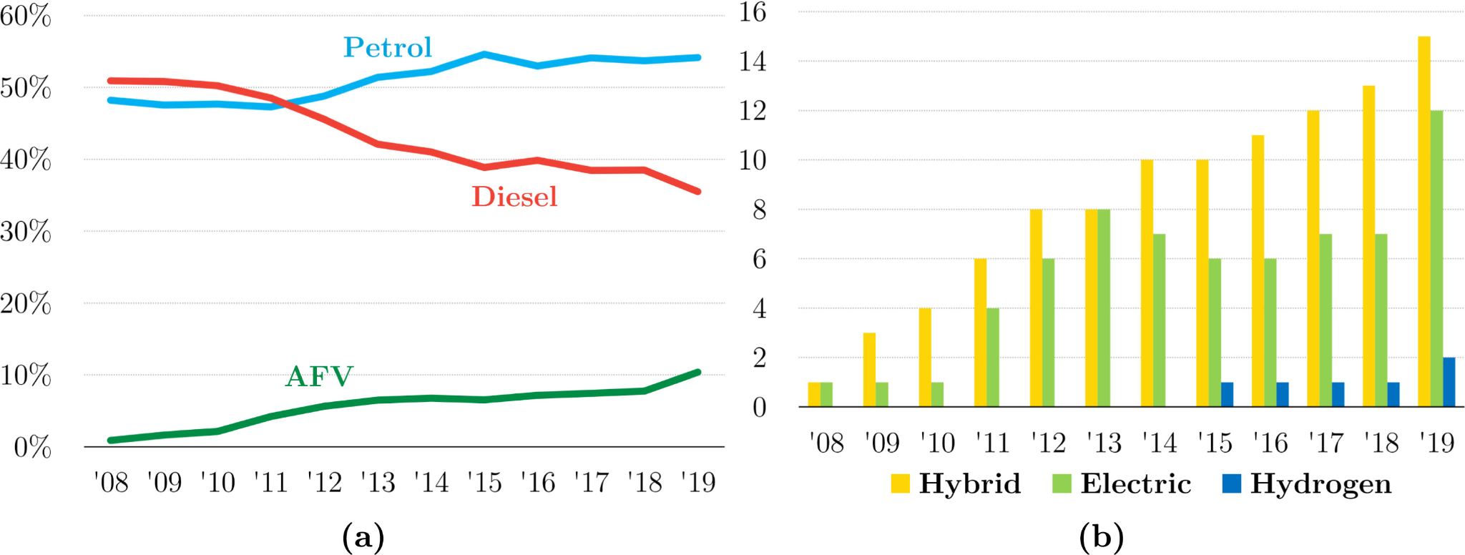
Figure 3: Rise in green automobile choices
(Source: Mandys and Taneja, 2024)
Technological: Technically, the production of eclectic vehicles and growth with the market demand has become very crucial in the automotive sector. However, a focus on EV production has slowed down other automobile production by 11.8% in 2024 (SMMT, 2025). Thus, a concern to transform with the market demand has become crucial.
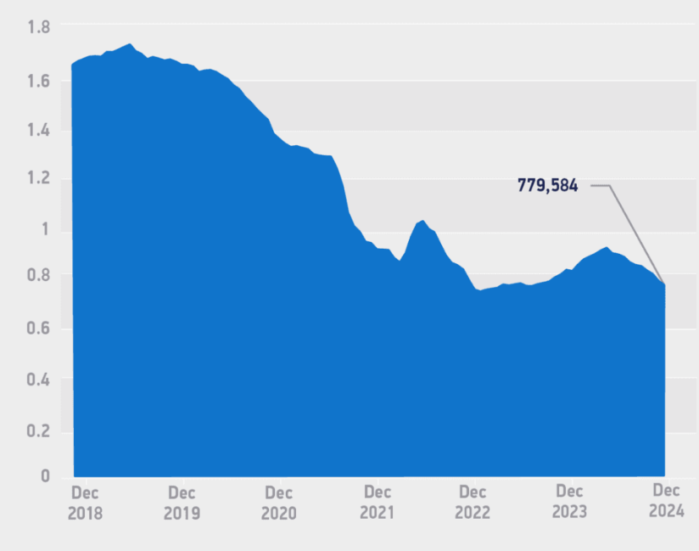
Figure 4: UK car production rate over the years
(Source: SMMT, 2025)
Legal: The recent developments and policy changes have influenced automotive manufacturing in terms of units and transformation. The implications of the Automated Vehicles Act 2024 is also identified on the aspects of limited deployment of self-driving vehicles as of now (Legislation UK, 2024).
Environmental: The sector is also influenced by the Net Zero Policy for mobility and transport of vehicles considering the production with greater focus on carbon reduction process and equipment (SMMT, 2024). It has also emphasised the improvisation of supply chain and sourcing for car manufacturers.

Porter’s Five Forces
Bargaining power- Buyers: The report by Deloitte (2025) indicates a rapid rise in consumer demand towards automobiles with a rise of 4.2% in sales in 2024. With positive demand for cars, the sector is perceiving a high bargaining power with the influence from ongoing economic uncertainty.
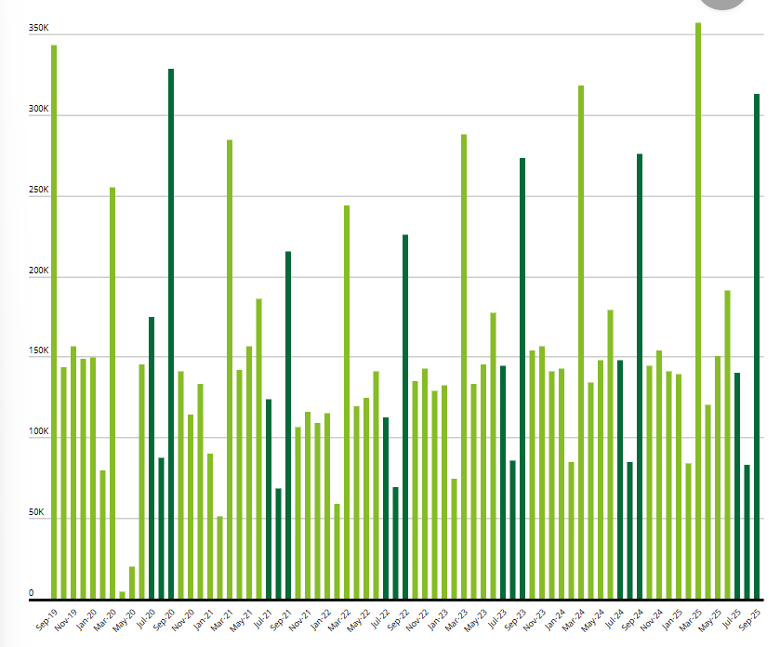
Figure 5: UK car sales between 2019-2024
(Source: Deloitte, 2024)
Bargaining power- Suppliers: With rising complexities, the car manufacturers in the UK are affected by the aspects of supply chain issues such as high energy costs and competition (Kelly, 2025). Higher energy costs are straining the power of businesses in achieving raw materials easily.
Threat of substitutes: While Jaguar Land Rover positions itself as a luxury brand, it is competed by alternatives such as Mercedes, Audi, and BMW in the European market (Winton, 2023). Consumers are readily provided with choices and alternatives on the same price point in the market.
Threat of new entrants: New entrants in the luxury sport and SUV category are partially concerning for Jaguar Land Rover. With its positioning and market dominance, JLR marks itself safe from new entrants.
Competitive rivalry: Winton (2023) aligned the competitive scale for JLR by listing Mercedes, Audi, and BMW as intense European competitors in the market. The development of such factors remains critical for the performance of the brand.

2.2 Internal environment audit
The analysis of the internal environment will also be insightful to foster strategic decisions (Mousa, Auso and Gurler, 2024). With the application of Value Chain analysis, VRIO analysis and Resource-Based View, the internal environment can be fostered.
Value Chain Analysis
Jaguar Land Rover has perceived its future decisions and market performance through its “Reimagine” strategy (Jaguar Land Rover Automotive PLC, 2025b). Through this, vital strategies and actions were undertaken considerably.
- Primary activities
Inbound logistics: JLR has strengthened its supply chain network by adding new suppliers. Jessen (2025) highlighted JLR’s move in bringing 50 new industry experts to strengthen EV production sourcing.
Operations: JLR has multiple manufacturing plants established in major UK locations for domestic supply such as Solihull, Halewood and Wolverhampton. Whereas, Slovakia is also selected as a manufacturing location for its global supply of automobiles.
Outbound logistics: JLR has secured distribution and supply networks in major regions around the globe to reach its target markets. Through dealerships and manufacturing units in top locations, JLR is able to meet global demands.
Marketing and sales: For marketing and promotional purposes, JLR’s partnership with Accenture and Spark44 has facilitated personalisation, multi-platform targeting and creative marketing activities in the market (Accenture, 2021).
After-sales service: For after-sales services, globalised service centres in primary locations are well connected with technology and communication. Alongside this, loyalty programs are also a major factor in the overall service for the customers.
- Support activities
Firm infrastructure: From a strategic perspective, JLR’s Reimagine strategy is fostering digital infrastructure to support the EV transformation and other industrial demands for the brand. Within this strategic perception of the brand, aspects such as collaboration with innovators has also supported the infrastructural development and improvement over the years (Jaguar Land Rover Automotive PLC, 2025b). This has also supported the reduction of the carbon footprint through co-creation and innovation.
Human resource management: The automotive manufacturer employs more than 30,000 employees globally while investing heavily on their upskilling and alignment with its strategic motive of bringing electric vehicles in the market with commendable force. JLR’s partnership with Warwick Manufacturing Group (WMG) remains crucial for the training and development of the employees related to digital and EV skills (Warwick Business Partnerships, 2023). Specific industry skills related to engineering and data roles have been facilitated through training programs and apprenticeships conducted by the brand.
Technology: The strategic orientation of JLR is fostering the development of technology to support the transformation of EV vehicles in the organisation. Technology aiding sustainability, innovation and environment commitment remained the main concern from the organisation.
Procurement: Strategic partnership has become a major factor in supporting the procurement of core materials. Also the domestic supply network in the UK has fostered the further landscape.

Resource-based View
Barney’s model, the Resource-Based View can be utilised to differentiate the key sources that can foster competitive advantage. Mailani et al. (2024) and Ristyawan, Putro and Siallagan (2023) suggested the use of this framework to determine a company’s sustainable advantage in terms of customer innovation and supply chain improvement. The identification of JLR’s tangible and intangible resources will help determine its advantage over rivals.

 | Resource | Strategic value
Tangible resources | Manufacturing plants | Advanced manufacturing facilities around the UK and globe have supported faster production.
Tangible resources | Financial backing | Tata Group's financial backup has supported easy supply chain development
Tangible resources | Research and development | Supporting the fast-paced and strategic growth of the business.
Tangible resources | Human resources | Trained and skilled workforce supporting the achievement of strategic vision and goals.
Tangible resources | Technology infrastructure | Allows the production of multiple electric and hybrid models based on market demand.
Intangible resources | Brand equity | Providing iconic and heritage values to the public seeking the same in the UK market.
Intangible resources | Strategic vision | The long-term vision regarding the transformation towards electric vehicles remains essential.
Intangible resources | Engineering expertise | Provides distinct and unique design of vehicles in the market.
Intangible resources | Supplier trust | Long-term relationship development provides ease of distribution and procurement of materials.
Table 1: Resource-Based View of JLR

VRIO Analysis

Resource | Valuable | Rare | Inimitable | Organised | Competitive advantage
Human resources | Yes | No | No | Yes | Temporary competitive advantage
Supplier network | Yes | Yes | Yes | Yes | Sustained competitive advantage
Research and development | Yes | Yes | No | Yes | Competitive parity
British heritage | Yes | Yes | Yes | Yes | Sustained Competitive advantage
Table 2: VRIO analysis

2.3 SWOT analysis
Strengths | Weaknesses
- JLR has a strong brand heritage and global reputation in the automotive sector (Jaguar Land Rover Automotive PLC, 2025a).  - JLR also has a strong supplier network.  - A strong strategic vision towards EV transformation (Jaguar Land Rover Automotive PLC. 2025b).  - Advanced research and development technology. | - High production costs affect the workforce and operations (Brady, 2023).  - Limited production units on a global scale as compared to rivals.  - Lack of product portfolio diversity.
Opportunities | Threats
- Rising demand for EV in the global and domestic market (Hossain et al., 2024; Mandys and Taneja, 2024).  - Government support towards EV infrastructure.  - Emerging market expansion for greater reach. | - Intense EV competition in the global market (Kelly, 2025).  - Macroeconomic instability in terms of labour costs, labour availability and inflation (Brady, 2023).  - Supply chain issues such as sourcing of batteries (Rejeb, Rejeb and Süle, 2025).
Table 3: SWOT Analysis

3. Strategy formation
Reviewing the internal and external environment through the perspectives of various frameworks and tools, it is clarified that JLR requires the development of strategic visions and activities. The influence on the long-term performance of the organisation emerges from the strategic choices that can be identified from the impact of the internal as well as external environment. The exposure to these factors has encouraged the identification of the following strategic options for the organisation:
Strengthen EV leadership: The foremost strategic vision that can emerge from the above discussion is the strengthening of EV leadership considering the latest demand and the future outlook. The aspects of regulatory changes for the adoption of cleaner vehicles in the market, changing consumer behaviour towards EV and the rising technological adoption among the top automotive companies in the market have substantially affected the strategic vision (Bryła, Chatterjee and Ciabiada-Bryła, 2022; McKinsey & Company, 2021). Thus, the foremost consideration for the organisation can be associated with the strengthening of the EV leadership in domestic as well as international markets.
Invest in digital transformation: Another major strategic factor related to the JLR’s market conditions and external changes is the investment in digital technology and smart mobility. The aspect of technological investment for the organisation can be perceived in the development of market performance and the rise of autonomous driving. Investing in digital technology has emerged as a significant strategic option for the automotive sector regarding the consumer demand towards extensive services, connection and personalisation of the vehicles (Mekala, 2025; Wang, 2024). Thus, this can also be identified as a major strategic factor in driving sustained growth for JLR in the market.
Global expansion: Considering the macroeconomic uncertainties and internal weaknesses of JLR in maintaining competitive power, the focus of global expansion can bring extensive factors for the organisation. This helps identify that the role of global expansion is a major competitive action for automotive businesses in gaining global leadership and maintaining balance in their economic conditions (Dakić, Stupavský and Todorović, 2024; McKinsey & Company, 2025). Addressing the needs of resilience and economical balance through global expansion also brings significant opportunities for the automotive brand in continuing its global reputation.
AI adoption in operations: The last strategic option for the organisation can be found in terms of technological efficacy through the adoption of artificial intelligence. JLR can consider the development of AI for its R&D and customer analysis to increase the effectiveness of marketing and product portfolio. S&P Global (2025) and Kabir et al. (2025) suggested the development of AI as a futuristic choice in developing the safety, customer experience and operational efficiency. Thus, the strategic choice of AI adoption remains crucial for the organisation.

4. Conclusion
The above report has provided a critical discussion of the strategic analysis of Jaguar Land Rover considering its internal and external environment. From the exploration of its current strategic choices and market performance in the domestic landscape, it was understood that the requirement of various strategic choices regarding the future performance remains crucial. The analysis of the external environment through PESTLE and Porter’s Five Forces has revealed that the macroeconomic factors such as inflation, consumer behaviour and supply chain uncertainties due to political changes and regulations have affected the overall decisions. On the other hand, the analysis of the internal environment through VRIO, Resource-Based View and Value Chain Analysis has revealed the factors of internal capabilities and efficacy of JLR in handling the core functions of the market. The efficacy of the brand was also highlighted through SWOT has also helped design the aforementioned strategic visions for the organisation. The strategic choices of technological development, global expansion, digital investment and EV leadership were considered vital for the performance of the organisation. The foremost consideration for the organisation is associated with the performance of the internal capacities. The strategic choices mentioned above must be linked with the organisational procedures and operations by the management to an extensive note.

5. Recommendations
In order to successfully execute its strategic choices on the way to achieving electric vehicle (EV) leadership, digital transformation, global expansion, and artificial intelligence (AI), Jaguar Land Rover (JLR) needs to be an integrated and staged player. To enhance the EV leadership, it is necessary to speed up the process of creating its Modular Longitudinal Architecture (MLA) and Electric Modular Architecture (EMA) platforms and collaborate with Tata Chemicals and the UK Battery Industrialisation Centre to ensure the sustainability of battery supply chains. Secondly, the understanding of digital transformation adoption may be associated with the integration of information-based operations, over-the-air software updates, and connected vehicle technologies with the help of strategic partnerships with NVIDIA and TCS. In parallel, JLR’s AI adoption should focus on predictive maintenance, intelligent manufacturing, and personalised customer interfaces to enhance operational efficiency and consumer engagement. Effective governance, cross-functional coordination, and workforce upskilling are essential to sustain these initiatives, ensuring technological readiness and cultural alignment with JLR’s “Reimagine” strategy. This integrated implementation framework will enable JLR to consolidate its competitive advantage, achieve sustainable growth, and position itself as a leader in the global premium EV market. The growth and efficiency of the brand must be associated with these steps and stages, considering the uncertainties of the market.

6. References
Accenture (2021) Jaguar Land Rover transforms global marketing communications model. Available at: https://newsroom.accenture.com/news/2021/jaguar-land-rover-transforms-global-marketing-communications-model (Accessed: 4 November 2025)
Alharbi, I.B. (2024) ‘STRATEGIC MANAGEMENT: A COMPREHENSIVE REVIEW PAPER’, International Journal of Professional Business Review, 9(3), pp. 1–43.
Bryła, P., Chatterjee, S. and Ciabiada-Bryła, B. (2022) ‘Consumer Adoption of Electric Vehicles: A Systematic Literature Review’, Energies, 16(1), pp. 1–16.
Dakić, P., Stupavský, I. and Todorović, V. (2024) ‘The Effects of Global Market Changes on Automotive Manufacturing and Embedded Software’, Sustainability, 16(12), pp. 1–31.
Deloitte (2025) Automotive sector quarterly update. Available at: https://www.deloitte.com/uk/en/Industries/consumer/research/consumer-tracker/automotive-sector.html (Accessed: 3 November 2025)
Hossain, S., Alam, R.S., Hena, H. and Imane El Hebabi (2024) ‘Trends in Global Electric Vehicle Adoption: Analyzing Regional Sales and Stock Dynamics’, International Journal of Multicultural and Multireligious Understanding, 11(11), pp. 275–298.
Jaguar Land Rover Automotive PLC (2025a) Corporate. Available at: https://www.jlr.com/ (Accessed: 2 November 2025)
Jaguar Land Rover Automotive PLC (2025b) Reimagine strategy. Available at: https://www.jlr.com/reimagine (Accessed: 3 November 2025)
Jessen, J. (2025) Green skills: How JLR is strengthening EV supply chains. Available at: https://sustainabilitymag.com/articles/how-jlrs-50-new-specialists-will-strengthen-ev-supply-chains (Accessed: 3 November 2025)
Jolly, J. (2021) UK carmakers have three years to source local electric car batteries. Available at: https://www.theguardian.com/politics/2021/jan/03/uk-carmakers-have-three-years-to-source-local-electric-car-batteries (Accessed: 2 November 2025)
Kabir, F., Rahman, A., Siam, K., Mobin, A. and Khan, H. (2025) ‘The Impact of Artificial Intelligence on Business Transformation: Enhancing Decision-Making, Operational Efficiency, and Customer Experience’, IJSAT, 16(1), pp. 1–14.
Kelly, M. (2025) UK automotive market under stress, but moving towards return to growth. Available at: https://www.automotivelogistics.media/lean-logistics/uk-automotive-market-under-stress-but-moving-towards-return-to-growth/647504 (Accessed: 3 November 2025)
Legislation UK, (2024) Automated Vehicles Act 2024. Available at: https://www.legislation.gov.uk/ukpga/2024/10/contents (Accessed: 3 November 2025)
Mailani, D., Hulu, M.Z.T., Simamora, M.R. and Kesuma, S.A. (2024) ‘Resource-Based View Theory to Achieve a Sustainable Competitive Advantage of the Firm: Systematic Literature Review’, International Journal of Entrepreneurship and Sustainability Studies, 4(1). pp.1-15.
Mandys, F. and Taneja, S. (2024) ‘Demand for green and fossil fuel automobiles’, Transportation Research Part A: Policy and Practice, 190. pp.1-10.
McKinsey & Company (2021) A new ‘ERA’: An action plan for the European automotive industry. Available at: https://www.mckinsey.com/features/mckinsey-center-for-future-mobility/our-insights/a-new-era-an-action-plan-for-the-european-automotive-industry (Accessed: 5 November 2025)
McKinsey & Company (2021) Why the automotive future is electric. Available at: https://www.mckinsey.com/industries/automotive-and-assembly/our-insights/why-the-automotive-future-is-electric (Accessed: 5 November 2025)
Mekala, K. (2025) UK automotive's digital revolution: What the SMMT’s 10-point plan needs for digital retail. Available at: https://www.tomorrowsjourney.co.uk/industry-insights/uk-automotives-digital-revolution-why-the-smmts-10-point-plan-needs-digital-retail (Accessed: 5 November 2025)
Mousa, K.M., Auso, A. and Gurler, S. (2024) ‘Strategic Planning and Organizational Performance: An Empirical Study on the Manufacturing Sector’, Sustainability, 16(15), pp. 1–17.
Mukonori, S. and Qutieshat, A. (2025) ‘The major drivers of sustainable strategic management practices (SSMP) in the food industry: a systematic literature review’, Cogent Business & Management, 12(1), pp. 1–14. Available at: https://doi.org/10.1080/23311975.2025.2569802.
Quantive (2025) Strategic management explained: Concepts, examples, and trends for business success. Available at: https://quantive.com/resources/articles/strategic-management (Accessed: 2 November 2025)
Rejeb, A., Rejeb, K. and Süle, E. (2025) ‘Key issues in electric vehicle battery supply chains based on English-language news articles: a machine learning approach.’, Energy Nexus, 20, pp. 1–19.
Ristyawan, M.R., Putro, U.S. and Siallagan, M. (2023) ‘Decision making mechanism in resource based theory: A literature review, synthesis, and future research’, Cogent Business & Management, 10(2), pp. 1–28.
Rodrigues, M., Alves, M. do C., Oliveira, C., Vale, J. and Silva, R. (2021) ‘The Impact of Strategy, Environment, and the Management System on the Foreign Subsidiary: The Implication for Open Innovation’, Journal of Open Innovation: Technology, Market, and Complexity, 7(1), pp. 1–23.
S&P Global (2025) AI in the automotive industry: Trends, benefits, & use cases (2025). Available at: https://www.spglobal.com/automotive-insights/en/blogs/2025/07/ai-in-automotive-industry (Accessed: 6 November 2025)
Shatilo, O. (2020) ‘The Impact of External and Internal Factors on Strategic Management of Innovation Processes at Company Level’, Ekonomika, 98(2), pp. 85–96.
SMMT (2024) Leading Net Zero Emissions. Available at: https://www.smmt.co.uk/automotive-intelligence/leading-net-zero/ (Accessed: 3 November 2025)
SMMT (2025) Vehicle production dips amid EV transformation and intense market pressure. Available at: https://www.smmt.co.uk/vehicle-production-dips-amid-ev-transformation-and-intense-market-pressure/ (Accessed: 2 November 2025)
Wang, Q. (2024) ‘Study on the Impact of Autonomous Driving Technology on the Economy and Society’, SHS Web of Conferences, 208, pp. 1–12.
Warwick Business Partnerships (2025) Driving the future of mobility: How WMG partnered with industry to build a new home of automotive innovation. Available at: https://warwick.ac.uk/business/case-studies/wmg-jaguar-tata-motors/ (Accessed: 4 November 2025)
Winton, N. (2023) Ailing Jaguar Land Rover has options, but none look tempting. Available at: https://www.forbes.com/sites/neilwinton/2023/01/09/ailing-leaderless-jaguar-land-rover-has-options-but-none-look-tempting/ (Accessed: 3 November 2025)

