Student Name | Lorine Aikpaojie
Student ID | 2532537
Programme | MSc Public Health and Social Care in Practice
Module Title | Community Care and Management of Longer-term Conditions
Module Code | LCHS7003
Assignment Title | Component 1 Information Booklet of Long-term Condition Management

Table of Contents
Introduction 1
Prevalence 1
Aetiology 2
Impact of the long-term condition 3
Existing Interventions 4
Current theoretical perspectives 5
Political health and social care improvement agendas 6
Recommendations 8
References 11

Figure 1:Cost of managing the burden 2
Figure 2: Pathogenesis 2
Figure 3: Illustration of DESMOND 4
Figure 4: WHO Global Diabetes Compact Workstreams 6
Figure 5: Path to Remission Programme 7

Introduction
This long-term condition is one of the classifications of diabetes, which Lu et al. (2024) define as a heterogeneous syndrome characterised by defined hyperglycaemia. In this regard, type 2 diabetes is specifically characterised by a non-autoimmune heterogeneously progressive loss of adequate islet β cell insulin secretion, which occurs frequently in the presence of metabolic syndrome and insulin resistance (Lu et al., 2024). Gieroba, Kryska and Sroka-Bartnicka (2025) provide a simpler definition of the condition as a chronic and complex multisystemic metabolic disorder characterised by dysfunction of the pancreatic beta cells and insulin resistance, which results in elevated blood glucose levels. Global prevalence estimates suggest that more than 530 million adults were living with diabetes in 2021 (Duncan, Magliano and Boyko, 2025). Worse still is that this figure is expected to exceed 780 million by 2045 (Duncan, Magliano and Boyko, 2025). Therefore, the condition demands clinical priority to reduce its prevalence.
This booklet will examine the prevalence of type 2 diabetes mellitus as a global public health problem and further narrow the scope to the UK population. This will also entail an investigation of the burden caused by this condition and discuss UK policies and recommendations to help mitigate the prevalence.

Prevalence
Ong et al. (2023) note that type 2 diabetes mellitus represents a predominant form of diabetes globally as it constitutes about 90% of all diabetes cases. The burden has risen substantially over the last few decades because of demographic ageing, urbanisation, and associated lifestyle changes (Ong et al., 2023).
Globally, the International Diabetes Federation estimates that over 530 million adults were living with diabetes in 2021, which is a figure projected to exceed 780 million by 2045 (Duncan, Magliano and Boyko, 2025). The prevalence varies considerably by region, with the highest rates observed in the Middle East, North Africa, and the Western Pacific, while low- and middle-income countries now account for more than three-quarters of global cases (Duncan, Magliano and Boyko, 2025). This distribution reflects genetic susceptibility, as well as the rapid epidemiological transition occurring in these regions.
The prevalence of type 2 diabetes has similarly increased in the United Kingdome, as recent data from Diabetes UK reports that more than 3.8 million people are currently living with diabetes (McCloskey, 2025). Around 90% of this population has type 2 diabetes while a further estimated 1 million individuals have undiagnosed type 2 diabetes (McCloskey, 2025). The condition imposes a substantial burden on the National Health Service, as Martin et al. (2025) posit that approximately 10% of the NHS budget is attributed to diabetes care.
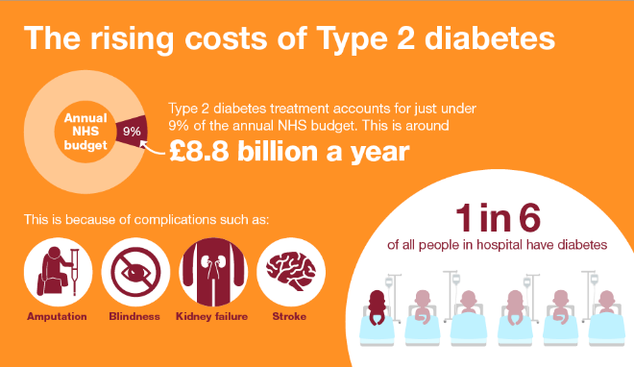
Figure 1:Cost of managing the burden
Source: NHS England (2025)
McCloskey (2025) notes that regional disparities exist, as higher prevalence rates are observed in areas of greater socioeconomic deprivation, as well as among individuals of South Asian, African, and Caribbean descent, who develop the condition at younger ages and lower body mass indices compared to the white European population.

Aetiology
- Genetic factors, Age, and Ethnicity
- Lifestyle risks
Lu et al. (2024) suggest that the aetiology of type 2 diabetes is multifactorial, as it involves an interplay of genetic predisposition and environmental factors. At the core of its pathogenesis is the progressive development of insulin resistance in peripheral tissues, particularly skeletal muscle, adipose tissue, and the liver, coupled with relative insulin deficiency resulting from pancreatic beta-cell dysfunction (Gieroba, Kryska and Sroka-Bartnicka, 2025). Lu et al. (2024) highlight that genetic heritability is well established, albeit no single gene accounts for most of the risk. Instead, multiple common variants contribute modestly to overall susceptibility.
Ong et al. (2023) assert that modifiable risk factors are the principal drivers of the rising prevalence. Reed, Bain and Kanamarlapudi (2021) elucidate that obesity, particularly central adiposity, is the most significant modifiable risk factor, as excess adipose tissue promotes systemic inflammation and impairs insulin signalling. Physical inactivity and diets high in refined carbohydrates and saturated fats further exacerbate insulin resistance (Reed, Bain and Kanamarlapudi, 2021).

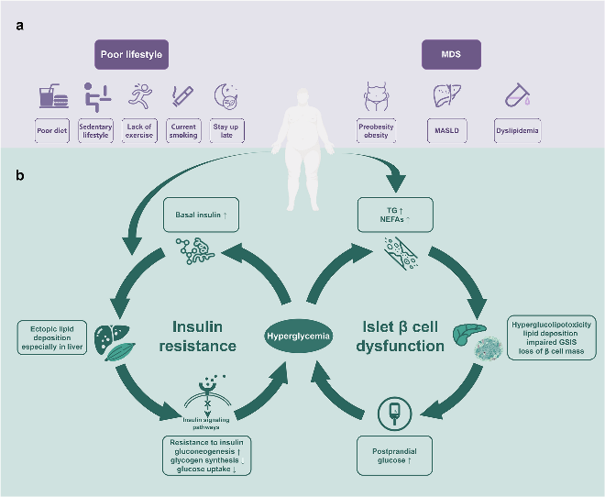
Figure 2: Pathogenesis
Source: Lu et al. (2024)
Additional risk factors include chronic stress, insufficient sleep, and gestational diabetes, which establishes a significantly elevated lifetime risk for the mother and increased risk for the offspring (Reed, Bain and Kanamarlapudi, 2021). Non-modifiable risk factors include advancing age, family history, and ethnicity, with certain groups experiencing disproportionately higher risk independent of lifestyle factors (Gieroba, Kryska and Sroka-Bartnicka, 2025). Collectively, these aetiological elements affirm that type 2 diabetes is a complex, heterogeneous condition arising from the convergence of genetic vulnerability and obesogenic environments.

Impact of the long-term condition
Physical Impacts
From a physical perspective, the condition is characterised by progressive beta-cell decline that necessitates ongoing treatment intensification (Gieroba, Kryska and Sroka-Bartnicka, 2025). McCloskey (2025) highlights that the cumulative effect of chronic hyperglycaemia leads to macrovascular complications, including coronary artery disease and stroke, and microvascular ramifications such as retinopathy, nephropathy, and neuropathy. These complications are associated with considerable morbidity, reduced functional capacity, and premature mortality (Lu et al., 2024).
Furthermore, the physical burden is compounded by the demands of self-management, which include glucose monitoring, medication adherence, dietary restriction, and regular physical activity (Garg and Duggal, 2022). For many individuals, this constant vigilance results in treatment fatigue, which may inadvertently contribute to suboptimal glycaemic control and accelerated disease progression (Reed, Bain and Kanamarlapudi, 2021).
Psychological Impacts
Psychologically, the diagnosis and management of type 2 diabetes are associated with elevated rates of distress, depression, and anxiety (Teli, Thato and Rias, 2023). Diabetes distress, which de Wit, Pouwer and Snoek (2022) highlight is distinct from major depressive disorder, arises from the relentless pressure of self-care and the fear of complications.
Existing evidence indicates that such psychological morbidity is often under recognised in routine clinical practice, although it directly impairs self-efficacy and adherence (Duncan, Magliano and Boyko, 2025). Socially, Garg and Duggal (2022) highlight that individuals may experience stigma related to lifestyle assumptions, which can erode self-esteem and lead to withdrawal from social activities. Ong et al. (2023) further warn that employment may be affected by the need for flexible working arrangements or by the development of disabling complications, which could contribute to financial insecurity and reduced social participation.
Social Impacts
The implications for families involved in care provision are equally substantial. Family members frequently undertake informal caregiving roles, which include assisting with dietary planning, medication organisation, and providing emotional support (Thirsk and Schick-Makaroff, 2021). While such involvement can improve outcomes, it also carries a cost. Spouses and adult children often report heightened anxiety, disruption to their own employment and leisure activities, and a sense of indirect burden (Teli, Thato and Rias, 2023).
In some cases, family dynamics are strained by divergent views on disease management, with conflicts arising over lifestyle modifications or adherence to treatment. The evidence suggests that caregivers of individuals with diabetes-related complications, particularly those requiring dialysis or amputation, experience levels of psychological distress comparable to those of the patients themselves (Thirsk and Schick-Makaroff, 2021). When families are from socioeconomically deprived backgrounds or minority ethnic groups with higher disease prevalence, these burdens may be amplified by limited access to resources and cultural barriers to care (de Wit, Pouwer and Snoek, 2022).

Existing Interventions
Within the UK, the NHS provides a range of evidence-based treatments structured around the National Institute for Health and Care Excellence (NICE) guidelines (Barry et al., 2023). The provision of structured education programmes is central to management. An example of such is the Diabetes Education and Self-Management for Ongoing and Newly Diagnosed (DESMOND) programme, which aims to enhance self-management skills from diagnosis (Leicester Diabetes Centre, 2025).
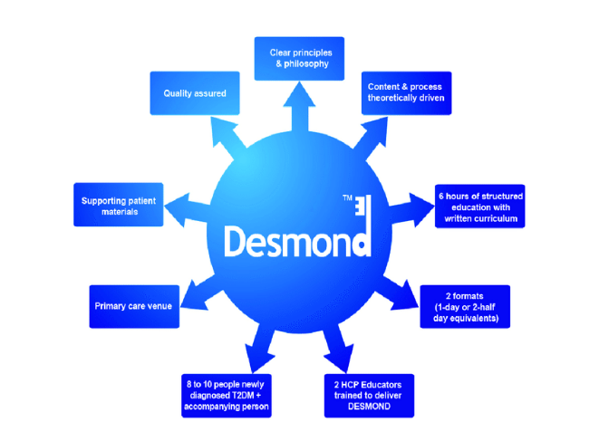
Figure 3: Illustration of DESMOND
Source: Leicester Diabetes Centre (2025)
First-line pharmacological therapy is typically metformin, with subsequent intensification involving agents such as sodium-glucose cotransporter-2 inhibitors or glucagon-like peptide-1 receptor agonists, which are now favoured for their demonstrated cardiovascular and renal protective benefits (Gieroba, Kryska and Sroka-Bartnicka, 2025). Insulin therapy is introduced when glycaemic targets are not met with oral agents.
Comprehensive care is delivered through multidisciplinary teams, including specialist nurses, dietitians, and podiatrists, who address the full spectrum of physical and psychological needs (Teli, Thato and Rias, 2023). Technology such as continuous glucose monitoring is increasingly being made available to support safe and effective self-management. Despite these provisions, challenges remain in equitable access, particularly regarding newer therapies and structured education (Ong et al., 2023). This highlights the need for continued integration of biomedical, psychological, and social support within diabetes care pathways.

Current theoretical perspectives
Contemporary theoretical perspectives on improving outcomes for patients with type 2 diabetes increasingly emphasise the need for structured, system-level approaches that integrate clinical care with public health strategies. For instance, the NHS England Children and Young Adults Diabetes Programme provides a comprehensive national framework for improving outcomes across the 0 to 25 years age group in the UK (NHS England, 2024). This model is structured around four key areas of focus identified through analysis of national audit data and engagement with patients, families, and clinicians.
Misra et al. (2022) elucidate that the first priority addresses diabetes health inequalities, which entails recognising that children and young people from deprived areas and minority ethnic groups experience higher HbA1c levels and are less likely to access recommended technologies such as continuous glucose monitors. The second focus targets variation in treatment and outcomes across different integrated care systems, which aims to standardise the delivery of key health checks and treatment targets (NHS England, 2024).
Thirdly, the framework prioritises the transition from paediatric to adult services because this is a period during which outcomes often decline with increased rates of diabetic ketoacidosis and reduced completion of essential health checks (Tian et al., 2025). Finally, the programme gives specific attention to type 2 diabetes in young people, as it is an aggressive condition with earlier onset of complications that requires tailored intervention strategies (NHS England, 2024). This framework is implemented through regional clinical networks and supported by transformation funding, which enables integrated care systems to develop locally responsive strategies while maintaining national consistency in quality improvement (Misra et al., 2022).
At the international level, the World Health Organization (2024) Global Diabetes Compact represents a significant theoretical advance in how diabetes outcomes are conceptualised and measured. This framework was launched in 2021 and operates through six workstreams addressing access to essential medicines, technical products, prevention, country support, research, and governance (World Health Organization, 2024). Critically, the Compact has established five core metrics with specific target levels for United Nations member states.
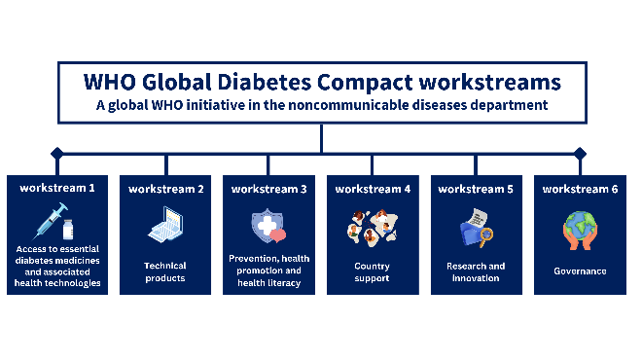
Figure 4: WHO Global Diabetes Compact Workstreams
Source: WHO (2024)
These include diagnosing at least 80 per cent of people with diabetes, achieving HbA1c below 8.0 per cent in 80 per cent of diagnosed individuals, maintaining blood pressure below 140/90 mmHg in 80 per cent, ensuring that at least 60 per cent of people aged 40 years and over receive statin therapy, and guaranteeing continuous access to insulin and monitoring equipment for every person with type 1 diabetes (World Health Organization, 2024).
Tian et al. (2025) opine that these targets represent a departure from purely process-oriented measures by focusing on achievable, measurable outcomes that can drive policy and resource allocation. The Compact explicitly aims to reduce health inequalities by providing a framework that countries can adapt to their specific contexts while maintaining accountability through standardised metrics (World Health Organization, 2024).
Both frameworks share a commitment to person-centred care and recognise that improved outcomes require attention to the structural determinants of health. The NHS England (2024) model stands out in its practical and system-level implementation through integrated care systems, as well as its focus on addressing disparities and inequalities.
However, its applicability may be limited to the UK context given its reliance on the specific structure of the NHS. In contrast, the WHO (2024) Global Diabetes Compact offers broader applicability across diverse healthcare settings but faces challenges in implementation given the varying capacities of national health systems. Ultimately, both frameworks acknowledge that effective diabetes management extends beyond pharmaceutical interventions to encompass education, peer support, and the integration of care across primary and secondary settings.

Political health and social care improvement agendas
Duncan, Magliano and Boyko (2025) elucidate that current political health and social care agendas for type 2 diabetes management in the UK exemplify a clear alignment with the government’s overarching priorities. However, evidence by Martin et al. (2025) reveals significant challenges in translating policy intent into equitable outcomes. The recent NHS 10 Year Health Plan has established three strategic shifts, which include moving care from hospital to community settings, transitioning from analogue to digital systems, and fundamentally changing the focus from sickness to prevention (Alderwick, 2025). These shifts collectively inform the developmental initiatives being rolled out across integrated care systems.
At the national level, the NHS Type 2 Diabetes Path to Remission Programme exemplifies the prevention agenda in practice. This initiative, which is delivered jointly by NHS England and Diabetes UK, offers a 12-month low-calorie diet replacement intervention to individuals diagnosed within the preceding six years who meet body mass index criteria (NHS England, 2025). Over 30,000 people have started the programme since its pilot in 2020, with 2024-25 figures showing over 13,000 new enrolments nationally (National Health Executive, 2025).
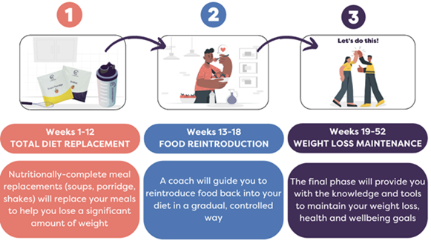
Figure 5: Path to Remission Programme
Source: NHS England (2025)
One in three of those who completed the programme achieved remission of their diabetes, with average weight loss approaching sixteen kilograms (National Health Executive, 2025). The initiative is now available in every local health area, which demonstrates successful national scale-up of an evidence-based intervention. Furthermore, Barron et al. (2025) highlight that the NHS Diabetes Prevention Programme, which targets individuals with non-diabetic hyperglycaemia, has demonstrated associations with reduced incidence of type 2 diabetes and other long-term conditions. Completers of this programme have shown a 21 per cent lower incidence of developing two or more long-term conditions at 24 months compared to non-attenders (Barron et al., 2025).
Local implementation of these national agendas reveals both successes and persistent challenges. For instance, primary care teams in NHS Northeast London (2025) have achieved 73.1 per cent completion of eight essential annual health checks for people with type 2 diabetes. This observation significantly exceeds the national average of 57.6 per cent. This success is attributed to dedicated community-based clinics that bring care closer to patients’ homes.
Similarly, the Birmingham and Solihull Integrated Care System has allocated £318,000 from its Fairer Futures Fund to community organisations delivering culturally informed diabetes management programmes in West Birmingham, where diabetes-related death rates are nearly double the national average (NHS Birmingham and Solihull, 2025). Early outcomes from these grassroots projects show 52 per cent of attendees achieving reduced blood glucose levels and 61 per cent achieving weight loss (NHS Birmingham and Solihull, 2025). This demonstrates that community-led and culturally tailored interventions can achieve meaningful improvements.
However, critical examination of implementation reveals substantial inequities that current political agendas have not yet resolved. Research has demonstrated that access to continuous glucose monitoring technology varies significantly by ethnicity and deprivation level, with people from Black African, Black Caribbean, and South Asian backgrounds less likely to receive these devices even when accounting for local prescribing patterns (Jani-Friend, 2026). This persists despite national guidance recommending such technology for all individuals with type 1 diabetes and selected individuals with type 2 diabetes.
Furthermore, Jani-Friend (2026) acknowledges that people with type 1 diabetes in the poorest areas die eight years earlier than those in the richest areas, while Black and South Asian people are up to four times more likely to develop type 2 diabetes before age 40. These disparities indicate that while national frameworks establish clear priorities, local implementation remains inconsistent, and the social determinants of health lie largely outside the direct reach of NHS interventions (Martin et al., 2025). Therefore, the effectiveness of developmental initiatives depends on political will, dedicated funding, and the capacity of local systems to address the intersecting factors of ethnicity, socioeconomic status, and geography that continue to shape diabetes outcomes.

Recommendations
For self-management to be genuinely person-centred, Alderwick (2025) opines that services must move beyond the provision of structured education programmes as a one-time intervention. Although there is evidence that sustained and flexible support is required, Jani-Friend (2026) elucidates that access to follow-up and ongoing coaching remains inconsistent.
A key recommendation is the integration of diabetes specialist nurses and dietitians into primary care networks with sufficient capacity to offer continuity of relationship. This would enable care to be responsive to changing life circumstances, such as bereavement, employment disruption, or the emergence of comorbidities, which frequently derail self-management efforts (Teli, Thato and Rias, 2023). Furthermore, the current model of annual care reviews often fails to create space for the individual to articulate their priorities (Tian et al., 2025). Reconfiguring consultations to incorporate shared decision-making tools would allow clinical decisions regarding medication intensification or technology use to align more closely with the person’s own values and capacity.
de Wit, Pouwer and Snoek (2022) highlight that psychological support remains a notable deficiency in current provision, as diabetes distress is highly prevalent yet rarely screened for systematically within routine care. Commissioning pathways that embed psychological practitioners within multidisciplinary diabetes teams would enable early identification and intervention. This would help in preventing the erosion of self-efficacy that occurs when distress is unrecognised (de Wit, Pouwer and Snoek, 2022). Such integration is particularly critical for individuals from socioeconomically deprived backgrounds or minority ethnic groups, who experience higher rates of distress yet lower access to psychological services. Alderwick (2025) opines that culturally adapted self-management support that is delivered in community settings by peer educators or link workers has demonstrated effectiveness and should be scaled through existing social prescribing frameworks.
End-of-life care for individuals with type 2 diabetes remains inadequately addressed within current clinical guidance. Barry et al. (2023) opine that although the focus on intensive glycaemic control is appropriate in earlier stages of the condition, it often persists inappropriately into advanced illness. For individuals with progressive frailty, cancer, or end-stage organ failure, the goals of care should shift towards symptom management, quality of life, and avoidance of treatment burden (Teli, Thato and Rias, 2023).
Recommendations include the routine introduction of advance care planning discussions within diabetes reviews for individuals identified as frail or with multiple long-term conditions. National guidance should be updated to provide clear protocols for de-escalation of glucose-lowering therapies when the risks outweigh the benefits (Duncan, Magliano and Boyko, 2025). Palliative care teams would benefit from enhanced training in diabetes management to provide informed support, while diabetes specialist teams should be integrated into palliative care planning to ensure safe and compassionate deprescribing.
Finally, structural barriers to person-centred care require attention. Alderwick (2025) highlights that current commissioning mechanisms often disincentivise the time-intensive work of shared decision-making and advance care planning. Payment models that recognise outcomes valued by patients, such as quality of life and treatment burden, would better support the delivery of care aligned with individual priorities. Achieving these improvements will require a sustained commitment to workforce development, with training that emphasises communication skills, cultural humility, and the integration of psychosocial care into routine practice (Reed, Bain and Kanamarlapudi, 2021).

References
Alderwick, H. (2025) ‘Government’s 10-year plan for the NHS in England’, BMJ, 390(4 July), p. r1396. Available at: https://doi.org/10.1136/bmj.r1396
Barron, E. et al. (2025) ‘Association between the english national health service diabetes prevention programme and incident multiple long-term conditions’, Nature Medicine, 31(10 September), pp. 3825–3831. Available at: https://doi.org/10.1038/s41591-025-03922-1
Barry, E. et al. (2023) ‘Explaining the UK’s ‘high-risk’ approach to type 2 diabetes prevention: findings from a qualitative interview study with policymakers in England’, BMJ Open, 13(2), p. e066301. Available at: https://doi.org/10.1136/bmjopen-2022-066301
de Wit, M., Pouwer, F. and Snoek, F. J. (2022) ‘How to identify clinically significant diabetes distress using the Problem Areas in Diabetes (PAID) scale in adults with diabetes treated in primary or secondary care? Evidence for new cut points based on latent class analyses’, BMJ Open, 12(3), p. e056304. Available at: https://doi.org/10.1136/bmjopen-2021-056304
Duncan, B. B., Magliano, D. J. and Boyko, E. J. (2025) ‘IDF diabetes atlas 11th edition 2025: global prevalence and projections for 2050’, Nephrology Dialysis Transplantation, (28 August). Available at: https://doi.org/10.1093/ndt/gfaf177
Garg, P. and Duggal, N. (2022) ‘Type 2 diabetes mellitus, its impact on quality of life and how the disease can be managed-a review’, Obesity Medicine, 35(October), p. 100459. Available at: https://doi.org/10.1016/j.obmed.2022.100459
Gieroba, B., Kryska, A. and Sroka-Bartnicka, A. (2025) ‘Type 2 diabetes mellitus – conventional therapies and future perspectives in innovative treatment’, Biochemistry and Biophysics Reports, 42(June), p. 102037. Available at: https://doi.org/10.1016/j.bbrep.2025.102037
Jani-Friend, I. (2026) Study reveals inequity in access to diabetes tech. Available at: https://www.diabetes.org.uk/about-us/news-and-views/cgm-study-access-inequity-in-diabetes-tech (Accessed: 20 March 2026).
Leicester Diabetes Centre (2025) About Us — DESMOND. Available at: https://www.desmond.nhs.uk/about-us (Accessed: 20 March 2026).
Lu, X. et al. (2024) ‘Type 2 diabetes mellitus in adults: pathogenesis, prevention and therapy’, Signal Transduction and Targeted Therapy, 9(1). Available at: https://doi.org/10.1038/s41392-024-01951-9
Martin, A. et al. (2025) ‘Economic evaluation of NHS England’s type 2 diabetes path to remission pilot scheme: evidence from real-world data and patient simulation modelling’, PharmacoEconomics, 10(18 December), pp. 289–304. Available at: https://doi.org/10.1007/s41669-025-00622-x
McCloskey, E. (2025) How many people in the UK have diabetes? Available at: https://www.diabetes.org.uk/about-us/about-the-charity/our-strategy/statistics (Accessed: 20 March 2026).
Misra, S. et al. (2022) ‘Characteristics and care of young people with type 2 diabetes included in the national diabetes audit datasets for England’, Diabetic Medicine, (22 August). Available at: https://doi.org/10.1111/dme.14940
National Health Executive (2025) New NHS diet helps record number put type 2 diabetes into remission. Available at: https://www.nationalhealthexecutive.com/articles/new-nhs-diet-helps-record-number-put-type-2-diabetes-remission (Accessed: 20 March 2026).
NHS Birmingham and Solihull (2025) Grassroots projects transform the lives of those living with diabetes. Available at: https://www.birminghamsolihull.icb.nhs.uk/news-and-events/news/grassroots-projects-transform-lives-those-living-diabetes (Accessed: 20 March 2026).
NHS England (2024) Children and Young Adults (0 to 25 years) diabetes toolkit. Available at: https://www.england.nhs.uk/long-read/children-and-young-people-diabetes-toolkit/ (Accessed: 20 March 2026).
NHS England (2025) NHS type 2 diabetes path to remission programme. Available at: https://www.england.nhs.uk/long-read/children-and-young-people-diabetes-toolkit/ (Accessed: 20 March 2026).
NHS Northeast London (2025) NHS in east London leading the way on diabetes care. Available at: https://northeastlondon.icb.nhs.uk/news/nhs-in-east-london-leading-the-way-on-diabetes-care/ (Accessed: 20 March 2026).
Ong, K. L. et al. (2023) ‘Global, regional, and national burden of diabetes from 1990 to 2021, with projections of prevalence to 2050: a systematic analysis for the Global Burden of Disease Study 2021’, The Lancet, 402(10397), pp. 203–234. Available at: https://doi.org/10.1016/s0140-6736(23)01301-6
Reed, J., Bain, S. and Kanamarlapudi, V. (2021) ‘A review of current trends with type 2 diabetes epidemiology, aetiology, pathogenesis, treatments and future perspectives’, Diabetes, Metabolic Syndrome and Obesity: Targets and Therapy, Volume 14(August), pp. 3567–3602. Available at: https://doi.org/10.2147/dmso.s319895
Teli, M., Thato, R. and Rias, Y. A. (2023) ‘Predicting factors of health-related quality of life among adults with type 2 diabetes: a systematic review’, SAGE Open Nursing, 9(January). Available at: https://doi.org/10.1177/23779608231185921
Thirsk, L. M. and Schick-Makaroff, K. (2021) ‘Family interventions for adults living with type 2 diabetes mellitus: a qualitative meta-synthesis’, Patient Education and Counselling, 104(12), pp. 2890–2899. Available at: https://doi.org/10.1016/j.pec.2021.04.037
Tian, X. et al. (2025) ‘The research progress and future directions in the pathophysiological mechanisms of type 2 diabetes mellitus from the perspective of precision medicine’, Frontiers in Medicine, 12(5 March). Available at: https://doi.org/10.3389/fmed.2025.1555077
World Health Organization (2024) The Global Diabetes Compact: progress in supporting its workstreams. Available at: https://www.who.int/publications/i/item/9789240103092 (Accessed: 20 March 2026).

