
Author: Mr Bernad Mrsic (2133762)
09/08/2023 2133762@student.uwtsd.ac.uk
Understanding and engaging in the customer experiance
BMSW5103
Lecturer: Mushfiqur Rahman
Table of Contents
Executive Summary 1
Introduction 2
Company Context (Lidl GB) 4
Mission statement 5
Customer Relationship Management Problem 5
Evidence of CRM Problem 5
Expected Benefits of Addressing the Problem 6
Internal Factors Contributing to CRM Problem 6
External Factors Contributing to CRM Problem 8
Increasing Customer Expectations 9
Models Review 10
A Critical Appraisal of the Quality Competitive Index Model (QCI): 10
A Critical Examination of the (IDIC) Model: Identify, Differentiate, Interact, and Customize 12
Model Selection and Application 13
Benefits: 13
Challenges: 14
7 P’s Analysis of Lidl GB 15
Recommendations 17
Conclusion 17
Reference list 18

Executive Summary

This executive summary provides an overview of the importance of quality processes, such as Total Quality Management (TQM) and service quality measurement frameworks like SERVQUAL, along with Customer Relationship Management (CRM) efforts, in improving customer experience and driving company success.
Total Quality Management (TQM) places emphasis on the ongoing enhancement of processes, the contentment of customers, and the active participation of employees. These efforts result in improved customer happiness, decreased expenses, heightened operational effectiveness, heightened staff commitment, and a competitive edge.
SERVQUAL helps identify service gaps and enables companies to address deficiencies in service quality, customize services, and improve customer experience. CRM efforts contribute to customer insights, enhanced communication, customer retention, and loyalty.
Delivering an excellent customer experience through these strategies can lead to increased revenue, higher customer lifetime value, reduced costs, competitive edge, and a positive brand image.
The case study focuses on Lidl UK, a German discount supermarket operating in the UK. Lidl UK has faced challenges in developing a robust CRM strategy, resulting in inconsistent customer experiences and difficulties in personalizing interactions. Online reviews and customer feedback highlight the need for improved CRM.
Addressing the CRM problem can yield significant benefits for Lidl UK, including better understanding of customer preferences, improved product offerings, targeted marketing campaigns, brand loyalty, positive word-of-mouth promotion, and enhanced reputation.
Internal factors contributing to the CRM problem at Lidl UK include inadequate data management, lack of integration among departments, poor communication, insufficient training, ineffective leadership, and inadequate customization of CRM systems.
In conclusion, implementing quality processes like TQM, using frameworks like SERVQUAL, and focusing on CRM efforts are crucial for improving customer experience and driving company success. Addressing the CRM problem at Lidl UK can lead to significant benefits and better customer relationships.

Introduction

Quality processes like Total Quality Management (TQM) and service quality measurement frameworks like SERVQUAL, along with Customer Relationship Management (CRM) efforts, have a most important role in the success of a company. They contribute significantly to improving customer experience and can have a direct positive impact on the company's bottom line.
Total Quality Management (TQM) is an all-encompassing methodology that prioritises ongoing enhancement, customer contentment, and staff engagement across all facets of an organization's activities. This statement underscores the need of maintaining high standards across all phases of manufacturing or the provision of services.
Implementing TQM helps a company:
- Enhance Customer Satisfaction: By delivering consistent quality products or services, TQM improves customer satisfaction and loyalty.
- Reduce Costs: TQM emphasizes process improvement and waste reduction, leading to cost savings over time.
- Increase Efficiency: Streamlined processes and reduced defects lead to increased operational efficiency.
- Employee Engagement: TQM encourages employees to take ownership of quality, fostering a culture of collaboration and innovation.
- Competitive Advantage: Consistently producing top quality products or services to differentiate the company from its competitors.
SERVQUAL:
The SERVQUAL framework is extensively employed in the assessment of service quality, encompassing five distinct dimensions: tangibles, reliability, responsiveness, assurance, and empathy.
By understanding and improving these dimensions, companies can:
- Identify Service Gaps: SERVQUAL helps identify gaps between customer expectations and perceived service quality.
- Customer-Centric Improvement: Addressing deficiencies in each dimension directly improves customer experience.
- Tailored Service: Companies can customize services to meet customer preferences and expectations.
CRM Efforts:
Customer Relationship Management (CRM): CRM involves strategies, processes, and technology to manage and nurture customer relationships.
CRM efforts contribute to:
- Customer Insights: CRM systems collect and analyse customer data, providing insights for targeted marketing and personalized experiences.
- Enhanced Communication: CRM enables personalized and timely interactions, building stronger customer relationships.
- Retain and Upsell: By understanding customer needs, companies can retain existing customers and identify upselling opportunities.
- Customer Loyalty: Effective CRM fosters customer loyalty through personalized attention and improved problem resolution.
Bottom-Line Benefits of Excellent Customer Experience:
Delivering an excellent customer experience through TQM, SERVQUAL, and CRM efforts can lead to several tangible bottom-line benefits:
- Increased Revenue: Customers who are content with their experience are more inclined to engage in repeat purchases and advocate for the brand, so contributing to the expansion of revenue.
- Higher Customer Lifetime Value: Improved customer retention and loyalty increase the long-term value of each customer.
- Reduced Costs: Quality processes minimize defects, service failures, and customer complaints, which can reduce operational and customer support costs.
- Competitive Edge: A reputation for exceptional customer service sets the company apart from competitors, attracting new customers.
- Positive Brand Image: Consistently delivering high-quality experiences builds a positive brand image, attracting more customers and investors.
In conclusion, quality processes like TQM and frameworks like SERVQUAL, combined with effective CRM efforts, contribute significantly to a company's success. By improving customer experiences, these strategies lead to various bottom-line benefits, including increased revenue, customer loyalty, reduced costs, and a stronger brand presence. (Greenberg, 2009)

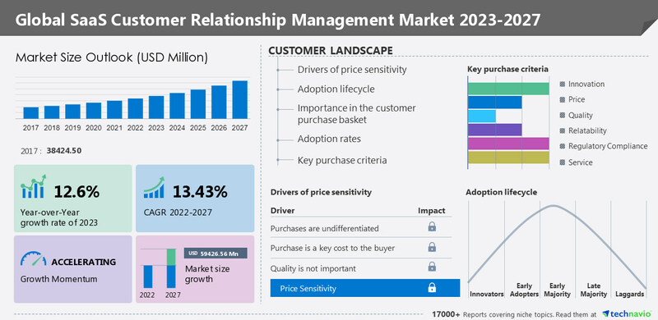
Graph curtesy of (PRNewswire, 2023)
Technavio predicts that the worldwide market for SaaS CRM would increase by USD 59,426.56 million between 2022 and 2027. During the forecast period, the market is anticipated to expand at a CAGR of 13.43%. Additionally, growth momentum will increase. During the projection period, North America will be responsible for 52% of the market expansion. (PRNewswire, 2023)

Company Context (Lidl GB)

Lidl is a prominent cheap supermarket of German origin, which currently manages an extensive network of more than nine thousand locations around the European continent. Lidl in Germany possesses a perceived upscale reputation that appeals to individuals belonging to the middle socioeconomic level. However, it is widely perceived by consumers in Great Britain that Lidl is a retailer positioned in the lower end of the market, appealing mostly to low-income families.
After opening its first shop in 1994, Lidl GB has expanded to over 960 locations and 13 regional distribution centres across Britain, employing more than 31,000 people.
Lidl work closely with the vendors to bring customers the best possible rates on the highest quality goods, and they take great delight in doing so. In addition, Lidl place a premium on supporting local economies, which is why they purchase over 65% of goods from within the United Kingdom.
Lidl UK is a prominent supermarket chain operating across the United Kingdom. Known for its emphasis on high-quality products at competitive prices, Lidl has managed to establish a significant presence in the UK's retail industry. The company's commitment to offering cost-effective alternatives has led to a loyal customer base and consistent growth. However, like any organization, Lidl UK faces challenges in maintaining and enhancing its customer relationships. (Shastri, 2022)
By looking at customer review Trustpilot have a very low rating of 1.7starrs for Lidl customer satisfaction based on 4004 reviews. (Trustpilot, 2019)
Mission statement:
“To offer our customers the best value for money by operating our business in a simple and sustainable way.” (Lidl, 2022)
Customer Relationship Management Problem:
Lidl UK, despite its success, has encountered challenges in developing a robust Customer Relationship Management (CRM) strategy. A key issue lies in the company's struggle to effectively engage and communicate with its customers, resulting in an inconsistent customer experience. The lack of a well-defined CRM system has led to difficulties in personalizing interactions and addressing customer needs comprehensively. (Hans Ruediger Kaufmann and Fateh, 2017)
Lidl's adoption of SAP's inventory management based on retail price highlights the importance of organizational change management in reconciling business operations and software functionality. Software customization can be risky, and organizations should have project governance processes. Executive misalignment and resource commitment can also derail projects. SAP software is successful, with 80% of retailers in the Forbes Global 2000 being SAP customers. Organizations like Lidl must work hard to reconcile these differences. (Kimberling, 2018)

Evidence of CRM Problem:
Online reviews and customer feedback shed light on Lidl UK's CRM problem. Many customers express frustration regarding the inconsistency in service quality and personalized attention. Complaints often revolve around challenges in finding assistance in stores, difficulties with returns and exchanges, and limited avenues for providing feedback. These sentiments are indicative of a disconnect between Lidl UK and its customers, highlighting the need for improved CRM (Gray, 2020).
Lidl, a German retailer, spent 500 million Euros ($580 million USD) on a failed SAP software upgrade in the past, but the problem has since been fixed. (Kimberling, 2018)
Which? polled 3,007 adults in the UK in October 2022 to find out which grocery stores they shopped at most frequently. Deltapoll carried out the surveying remotely.
Everything from price to online ordering to delivery times and product quality is considered in the annual study. The figures reflect both offline and online sales.
Yonder, working on behalf of Which? polls around 2,000 customers every quarter to gauge their level of confidence in various brands. Trust is calculated as the percentage of customers who report having a moderate to high level of confidence in each industry minus the percentage who report having little to no confidence in that industry.
According to Which? 59% of consumers are avoiding more expensive brands because of rising prices, and 88% are concerned about the cost of food. When groceries go on sale, a large percentage of consumers stock up to take advantage of the savings.
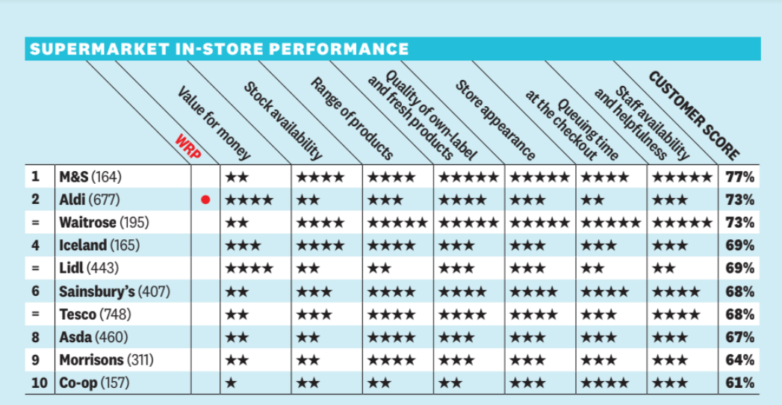
(Which, 2023)

Expected Benefits of Addressing the Problem:
Addressing the CRM problem can yield significant benefits for Lidl UK. Firstly, an enhanced CRM strategy would enable the company to compile and use analytic tools on customer data more effectively. This approach data-driven would facilitate better understanding of customer preferences, leading to improved product offerings and targeted marketing campaigns. Secondly, a personalized customer experience can foster brand loyalty, encouraging repeat purchases and positive word-of-mouth promotion. Thirdly, efficient resolution of customer issues can reduce negative reviews and enhance the company's reputation.
Lidl, a leading discount brand in the UK, has gained significant market share in the UK grocery market. With over 15 million customers, the company has expanded its network to over 960 stores. According to Claire Farrant, the marketing director, it is important to note that the company's dedication to sustainability is not compromised when it comes to customers, thereby addressing the common idea that affordability is synonymous with less accountability. The contribution of Lidl's international purchasing power and its constrained product assortment has been helpful in this regard. However, it is imperative to emphasise the significance of collaborating with other retailers for the purpose of achieving additional transformation. The company’s latest brand campaign did not directly address environmental concerns, but Farrant emphasizes that small changes can lead to bigger and better things. (The Chartered Institute of Marketing, 2019)
Internal Factors Contributing to CRM Problem:
Lidl UK faces customer relationship management (CRM) problems due to various internal factors, including inadequate data management, lack of integration, poor communication among departments, inadequate training, ineffective leadership, inadequate customization, a lack of clear CRM strategy, resistance to change, data security and privacy concerns, inadequate metrics and analysis, ineffective customer segmentation, and lack of continuous improvement. These issues can lead to inaccurate insights, hinder personalized customer interactions, and create disjointed customer experiences. Lidl UK should focus on addressing these internal factors through proper leadership, training, technology implementation, and a commitment to a customer-centric culture. To address these challenges, Lidl UK should focus on a comprehensive approach that includes proper leadership, training, technology implementation, and a commitment to a customer-centric culture. To understand Lidl UK's specific and detailed CRM challenges and solutions, it would be best to refer to their official communications or industry report from 2021. (Lidl GB, 2021)

External Factors Contributing to CRM Problem:
Economic conditions, competitive landscape, technological advancements, changing consumer preferences, regulatory changes, supply chain disruptions, social and cultural trends, political factors, public relations and reputation, and global events can all impact Lidl UK's CRM strategies. Economic downturns, recessions, intense competition, and technological advancements can lead to decreased consumer spending and changing shopping behaviours. Rapid technological advancements can impact CRM systems and strategies, and failure to adapt to these changes could result in customer dissatisfaction. Regulatory changes, such as GDPR, can affect data protection and privacy, leading to legal issues and damage to customer trust.
Supply chain disruptions, such as global events, transportation issues, natural disasters, and sourcing challenges, can lead to out-of-stock items, delayed deliveries, increased cost, and customer frustration. Social and cultural trends, political factors, public relations and reputation, and global events can also impact customer perceptions and loyalty. Effective crisis management and communication are crucial for maintaining a positive CRM approach.
Increasing Customer Expectations:
Lidl UK can capitalize on the growing demand for seamless e-commerce and digital services by focusing on improving product quality and expanding its product offerings. To meet environmental concerns, Lidl UK should reduce packaging waste, promote locally sourced products, and implement energy-efficient practices. Additionally, the company should invest in improving digital platforms, utilizing customer data for personalized recommendations and promotions, and offering tailored discounts based on shopping history.
Excellent customer service is crucial, and Lidl should invest in training staff and offering multiple channels for support, such as social media and chatbots. A well-designed store layout, transparency in product sourcing, pricing, and business practices, and engagement with the local community through initiatives like charity partnerships and community events can foster a positive image and strong customer loyalty. Regularly seeking customer feedback and adapting based on suggestions demonstrates a commitment to improvement. Finally, Lidl should prioritize rigorous quality control measures to maintain customer trust and ensure the safety and quality of its products.
Competition:
The UK retail market is highly competitive, with rivals offering sophisticated CRM strategies. Lidl UK must keep up to retain its market share.
Online Reviews and social media:
Negative customer reviews on platforms like social media can significantly impact Lidl UK's reputation, potentially deterring new customers. (Trustpilot, 2019)
Conclusion:
Lidl UK's CRM problem reflects the challenges that many companies face in an era where customer relationships are paramount. By addressing this issue, Lidl UK can not only improve its customer satisfaction and loyalty but also drive business growth through tailored marketing efforts and enhanced brand reputation. A well-implemented CRM strategy, supported by robust internal processes and responsive customer service, can position Lidl UK for continued success in the competitive UK retail landscape.

Models Review

A Critical Appraisal of the Quality Competitive Index Model (QCI):

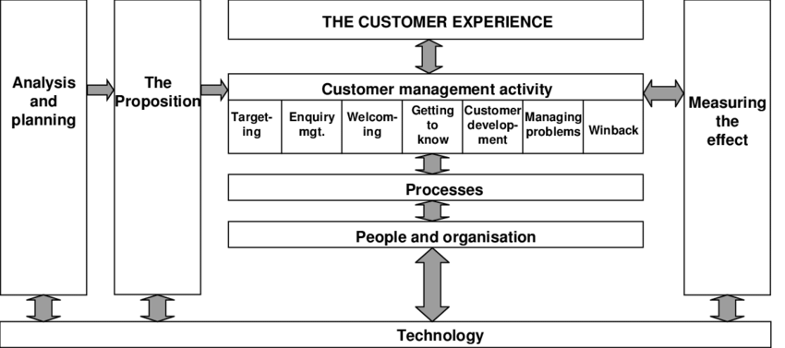
Image curtesy of www.researchgate.net/

The Quality Competitive Index (QCI) model is a valuable tool for evaluating countries' competitiveness based on their quality infrastructure. It offers a multidimensional approach, quantitative assessment, and potential policy implications for academic research. The model captures multiple dimensions of competitiveness, including factors related to institutions, human capital, and innovation, providing a holistic view of a company's competitiveness. It employs quantitative data to rank companies, facilitating benchmarking and data-driven decision-making.
However, the QCI model has weaknesses, such as data reliability and availability, simplistic weighting, lack of contextual nuance, static nature, and limited sectoral analysis. The model relies heavily on data from various sources, which may introduce biases that compromise its credibility. Additionally, the model's use of equal weighting assumes that each dimension contributes equally to competitiveness, which may not consider the varying degrees of influence that different indicators might have on a country's overall competitiveness.
Additionally, the model's lack of temporal sensitivity hinders its ability to capture dynamic changes in competitiveness, resulting in a static snapshot that does not accurately reflect real-time competitiveness. A more sectoral analysis could provide deeper insights into the areas that require targeted interventions.
In conclusion, the QCI model is commendable for its multidimensional approach, quantitative assessment, and potential policy implications, but it also has its limitations. Researchers should exercise caution and employ additional analytical tools to ensure a comprehensive evaluation of a country's competitiveness landscape.

A Critical Examination of the (IDIC) Model: Identify, Differentiate, Interact, and Customize

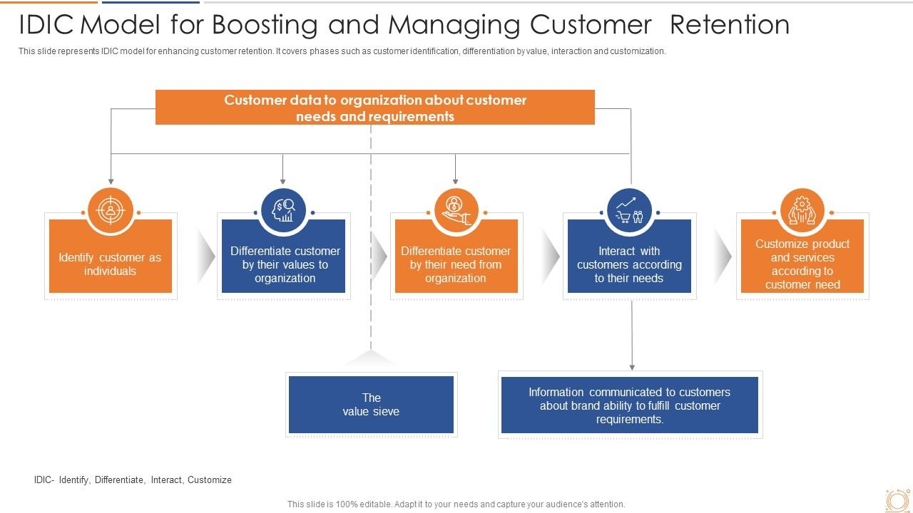

The IDIC model, a comprehensive approach to understanding and catering to customer needs, has several limitations that warrant a critical review of its effectiveness and practicality. (Bergeron, 2004) highlights the importance of identifying customer segments and understanding their unique characteristics, but the model tends to oversimplify the process. The challenge lies in the accuracy and depth of customer profiling, which the model does not adequately address. The rapid pace of technological advancements and changing consumer behaviours make it difficult to maintain a static customer profile, rendering the identification process an ongoing challenge.

The differentiation stage of the IDIC model aims to create tailored offerings for different customer segments, but this raises questions about the feasibility of delivering highly personalized products or services, particularly for businesses operating at scale. The resources required to achieve true differentiation can be substantial, leading to a potential trade-off between customization and profitability. Additionally, overemphasis on differentiation might lead to market fragmentation and dilution of the brand's core value proposition. (Bishop, 2013)

Interaction is undoubtedly a crucial element in modern customer engagement strategies, but the model lacks insights into the complex dynamics of customer engagement across various touchpoints. In the digital age, customer interactions are not confined to traditional channels, and the model's focus on direct interactions may neglect the power of indirect, digital interactions through social media, online reviews, and other influential platforms.

Customize, the final stage of the IDIC model, envisions tailoring offerings to individual customer preferences. While the concept is appealing, achieving elevated levels of customization can be operationally challenging and financially taxing. Businesses aiming to implement the IDIC model should be prepared to critically assess its components and adapt them to their unique circumstances. (Buttle, 2008)

Model Selection and Application

Customer Relationship Management (CRM) systems enhanced with Artificial Intelligence (AI) offer numerous benefits and present certain challenges. Here's an evaluation of both:

Benefits:

Enhanced Customer Insights: The utilisation of artificial intelligence in customer relationship management (CRM) enables the analysis of extensive quantities of customer data, hence offering significant insights into customer behaviour, preferences, and trends. This facilitates firms in customising their marketing, sales, and customer service tactics in order to more effectively address customer demands.
Personalization: AI-driven CRM enables personalized customer interactions by analysing historical data and real-time interactions. This leads to improved customer experiences, higher customer satisfaction, and increased customer loyalty.
Automated Lead Scoring and Segmentation: AI can automate the process of identifying and scoring leads based on various criteria, streamlining sales efforts, and ensuring that sales teams focus on leads with higher conversion potential.
Predictive Analytics: AI algorithms can predict future customer behaviour and trends, allowing businesses to proactively address customer needs, forecast demand, and make informed strategic decisions.
Efficient Customer Support: The utilisation of AI-driven chatbots and virtual assistants has the potential to offer immediate customer service, effectively addressing frequently encountered inquiries and problems at any time of the day. This capability not only enhances customer happiness but also alleviates the burden on human agents by reducing their workload.
Workflow Automation: Artificial intelligence has the capability to automate mundane and repetitive operations, including as data entry, scheduling, and follow-ups. This automation enables people to allocate their time and efforts towards more complex and intellectually demanding jobs that necessitate creativity and critical thinking.
Cross-Selling and Upselling: AI can analyse customer purchasing patterns to suggest relevant additional products or services, increasing revenue opportunities for the business.

Challenges:

Data Quality and Privacy Concerns: AI requires high-quality data for accurate insights. If CRM data is outdated, incomplete, or inaccurate, it can lead to flawed AI outcomes. Privacy concerns also arise when handling sensitive customer data.
Integration Complexities: Integrating AI technologies with existing CRM systems can be challenging and require significant technical expertise. Ensuring smooth data flow and compatibility is essential.
Initial Investment: Implementing AI-enhanced CRM systems involves upfront costs for software, hardware, and training. Smaller businesses might find it difficult to justify these costs.
User Adoption and Training: Employees may resist adopting new AI technologies, necessitating thorough training to ensure proper utilization and integration into daily workflows.
Algorithm Bias: Artificial intelligence (AI) algorithms have the potential to unintentionally sustain biases that exist within historical data. The potential consequences of such practises include the generation of discriminating or inequitable results, which can have detrimental effects on customer relations and the overall reputation of the organisation.
Overreliance on Automation: While automation can increase efficiency, excessive reliance on AI may result in reduced personal interactions, leading to decreased customer satisfaction in certain scenarios.
Constant Evolution: AI technologies evolve rapidly, requiring businesses to continuously update and adapt their CRM systems to stay competitive. This can strain resources and necessitate ongoing training.
In conclusion, AI-enhanced CRM systems offer significant advantages in terms of customer insights, personalization, and efficiency. However, businesses must carefully navigate challenges related to data quality, integration, privacy, bias, and user adoption to harness the full potential of these technologies effectively.

7 P’s Analysis of Lidl GB

To effectively study Lidl's marketing strategy, one might employ a 7 P's analysis, which aims to evaluate fundamental yet consequential factors. Initially, the 7 Ps consisted of only 4 P's, which were designed to tackle certain concerns to enhance a firm's comprehension of its internal processes. The 4Ps consist of four fundamental elements, namely product, pricing, place, and promotion. Nevertheless, because of the restricted scope of the 4 P's, an additional three elements were introduced to create the 7 P's framework. This expansion seeks to embrace certain service traits that are not addressed by the original 4 P's.
Product (Quality, brand name, service line, warranty, capabilities, facilitating goods, tangible clues, price, personnel, physical environment, and process of service delivery):
- The brand name is highly regarded due to its positioning as one of the most affordable grocery merchants in the industry. Aldi serves as the primary competitor in the value supermarket segment.
- The merchandise available for purchase at Lidl has a considerable degree of similarity to the products offered by other grocery chains, such as Tesco or Asda. Nevertheless, a notable contrast lies in the many brand labels associated with the merchandise available at Lidl establishments.
- The affordability of Lidl's items may lead consumers to have a pessimistic opinion of their quality.
Price (Level, discounts and allowances, payment terms, customers own perceived value, quality/price interaction and differentiation):
- Lidl possesses a notable competitive edge through the implementation of astute pricing techniques. Lidl made its entry into the market by positioning itself as a supermarket that prioritises value, distinguishing itself from other competitors in the business.
- All monetary transactions are settled prior to departing the establishment at the designated cashier stations and recently introduced self-checkout stations.
- Consumers may harbour the perception that the goods offered at a remarkably low price are of inferior quality; yet this commonly proves to be unfounded.

Place (Location, accessibility, distribution channels and distribution coverage):

- Lidl possesses an extensive network of retail establishments throughout the United Kingdom and Europe. However, the operational scope of supermarkets varies among countries, encompassing several categories within the business, spanning from value-oriented offerings to premium, high-end goods.
- To maintain consistent inventory levels, the company has established multiple distribution centres around the United Kingdom and Europe.
- Ensuring the maintenance of stock levels is of utmost importance for businesses that operate under a business model focused on maximising sales volume within a limited timeframe. This underscores the necessity of establishing retail outlets in proximate locations to national distribution facilities.

Promotion (Advertisements, personal selling, sales promotion, publicity, personnel, physical environment, facilitating goods, tangible clues, and process of service delivery):

- Lidl has introduced the Lidl Plus loyalty scheme in the United Kingdom in 2022, since the company perceives its price strategy to be insufficient in motivating consumers.
- Lidl frequently implements in-store promotional activities; nonetheless, the extent of their price reductions is somewhat modest when compared to other retailers, primarily due to the already competitive pricing structure they maintain.

People (Personnel training, discretion, commitment, incentives, appearance, interpersonal behaviour, attitudes, and customer behaviour/degree of involvement):

- Employees are typically remunerated with a highly appealing compensation yet requiring them to exert significant effort during their work hours. The quantification of scanned things is frequently employed as a metric for assessing performance.
- Stringent training standards are implemented to guarantee that personnel possess the necessary skills to efficiently scan things and effectively address all customer requirements.
- Consumers may perceive a lack of attentiveness from personnel due to their perceived high workload and time constraints associated with fulfilling their employment responsibilities.
Process (Policies, procedures, mechanisation, employee discretion, customer involvement, customer direction and flow of activities):

- The primary operational strategy of Lidl revolves around the procurement and retailing of a wide range of products at competitive prices.
- The level of consumer engagement in the various processes and procedures of Lidl is quite low, resulting in limited influence over the company's business operations.
Physical (Environment, furnishings, colour, layout, noise level, facilitating goods and tangible clues):

- A significant proportion of Lidl stores adhere to a linear and conventional layout. The purpose of this initiative is to facilitate prompt and convenient access for consumers to locate and acquire their desired goods, hence expediting the purchasing process.
- Lidl frequently showcases its brand colours, namely yellow and blue, in various locations within their stores or their immediate vicinity. This information will enable consumers to ascertain the presence of a local Lidl establishment.

Recommendations

Upon analysing Lidl's existing market tactics, it is evident that three recommendations can be proposed to enhance Lidl's market share in the UK grocery industry. There are three recommendations that can be made.

- To enhance the functionality of their website, it is recommended to incorporate the capability to process click and collect orders, as well as facilitate delivery services. This strategic move would serve to enhance their market share within the United Kingdom.
- The objective is to create and execute a strategy for introducing high-end branded products, with the aim of appealing to a hitherto untapped consumer segment and establishing a more equitable competitive position against prominent grocery chains.
- Implement robust barriers to entry to dissuade other companies from entering the grocery sector in the United Kingdom, hence mitigating the risk of encroachment on Lidl's market share.
To maintain a competitive position in the grocery industry in the United Kingdom and further enhance their market share, Lidl should employ the afore mentioned techniques. Moreover, this may lead to the adoption of a blend of generic methods, such as the incorporation of high-end brands, alongside their existing business framework, indicating the implementation of a differentiation strategy. Nevertheless, should Lidl choose to implement alternative methods, it is imperative for them to take measures to prevent the alienation of their existing consumer base, as failure to do so may result in a decline in their market share. Additionally, it is recommended that Lidl persists in its efforts to establish additional locations in the United Kingdom, thereby enhancing its market reach and convenience. This strategic move would enable the company to attain comparable visibility to that of its prominent counterparts in the grocery industry.

Conclusion

Customer Relationship Management (CRM) refers to a strategic approach employed by businesses to effectively identify and oversee clients with the aim of maximising their long-term worth. A comprehensive emphasis on customer relationship management (CRM) necessitates that marketers transcend the mere objective of persuading clients to make a certain purchase on a particular occasion. Instead, they should adopt a more expansive approach aimed at cultivating enhanced long-term relationships with customers.
The overarching objective should be to enhance these associations with the aim of achieving higher profitability through augmenting repeat purchase rates and diminishing client acquisition expenses. It is crucial to note that comprehending the client's response to customer relationship management solutions necessitates the application of distinct theoretical frameworks compared to understanding their response to advertising and price promotions. Most of the research pertaining to customer relationship management (CRM) has mostly concentrated on delineating the necessary actions that organisations must undertake to cultivate and sustain enduring connections with their consumers.

Reference list

Amir Khanlari (2015). Strategic customer relationship management in the age of social media. Hershey, Pa.: Business Science Reference.
Bergeron, B. (2004). Essentials of CRM. John Wiley & Sons.
Bishop, T. (2013). Principles of Marketing Management. [online] World Technologies. Available at: https://www-vlebooks-com.ezproxy.uwtsd.ac.uk/Product/Index/338591?page=0&startBookmarkId=-1 [Accessed 9 Aug. 2023].
Buttle, F. (2008). Customer Relationship Management. Second ed. Routledge.
Gray, S. (2020). Lidl Plus - an excellent loyalty programme but a strategic mistake ? [online] www.linkedin.com. Available at: https://www.linkedin.com/pulse/lidl-plus-excellent-loyalty-programme-strategic-mistake-steve-gray [Accessed 4 Aug. 2023].
Greenberg, P. (2009). CRM at the Speed of Light. 4th ed. McGraw-Hill.
Hans Ruediger Kaufmann and Fateh, M. (2017). Socio-economic perspectives on consumer engagement and buying behavior. Hershey: Business Science Reference.
Kimberling, E. (2018). Lessons from an SAP Failure at Lidl - Third Stage Consulting Group. [online] Third Stage Consulting Group. Available at: https://www.thirdstage-consulting.com/lessons-from-an-sap-failure-at-lidl/ [Accessed 4 Aug. 2023].
Lidl (2022). About Lidl GB - Lidl Great Britain. [online] corporate.lidl.co.uk. Available at: https://corporate.lidl.co.uk/ [Accessed 9 Aug. 2023].
Lidl GB (2021). https://corporate.lidl.co.uk/content/download/49515/file/LidlGB_TheGoodFoodReport_20192020_.pdf. [online] corporate.lidl.co.uk. Lidl GB. Available at: https://corporate.lidl.co.uk/content/download/49515/file/LidlGB_TheGoodFoodReport_20192020_.pdf [Accessed 4 Aug. 2023].
PRNewswire (2023). SaaS customer relationship management (CRM) market 2023-2027: A descriptive analysis of parent market, five forces model, market dynamics, and segmentation - Technavio. [online] Yahoo Finance. Available at: https://finance.yahoo.com/news/saas-customer-relationship-management-crm-200000826.html [Accessed 9 Aug. 2023].
Shastri, A. (2022). Extensive Marketing Strategy of Lidl - 2023 | IIDE. [online] www.iide.co. Available at: https://iide.co/case-studies/marketing-strategy-of-lidl/#About_Lidl [Accessed 4 Aug. 2023].
The Chartered Institute of Marketing (2019). Big on sustainability, Lidl on price | CIM Exchange. [online] www.cim.co.uk. Available at: https://www.cim.co.uk/content-hub/editorial/big-on-sustainability-lidl-on-price-discounter-challenges-perceptions-of-responsibility/.
Trustpilot (2019). Lidl. [online] Trustpilot. Available at: https://uk.trustpilot.com/review/www.lidl.co.uk [Accessed 4 Aug. 2023].
Which (2023). » Low cost and luxury win through as big supermarkets fall out of favour in annual Which? satisfaction survey. [online] https://press.which.co.uk/whichpressreleases/low-cost-and-luxury-win-through-as-big-supermarkets-fall-out-of-favour-in-annual-which-satisfaction-survey/. Available at: https://press.which.co.uk/whichpressreleases/low-cost-and-luxury-win-through-as-big-supermarkets-fall-out-of-favour-in-annual-which-satisfaction-survey/ [Accessed 9 Aug. 2023].

