

Introduction to Physiology
(BMHP5003_LON)

Assessment component 2

Lecturer: Noura Mohamed Student: Meliha Drenk
Student ID: 1922136
Group: 2
Table of contents

Introduction…………………………………………………………………………………...2
Case study……………………………………………………………………………………2
Health assessment……………………………………………………………………….….3
Recommendations………………………………………………………………...…………5
Conclusion……………………………………………………………….……………………7
References……………………………………………………………...…………………….8
Appendix 1.…………………………………………………………….………………….….9
Appendix 2……………………….………………………………………………….………10

Introduction

This is a health assessment report which will be focusing on Diabetes. A health assessment report is crucial in getting to know the general health status of an individual, a group of people or a community. In the report, the mental, psychological and physical state of the body will be examining in order for one to take a bold or reactive step towards their health. The presence of a health assessment report puts a patient in a position to make decisions that are informed concerning their health. A big percentage of deaths due to conditions such as Type 2 diabetes could be prevented if people took on a healthy diet. A health assessment provides input on how to eat a healthy diet and exercise regularly. Also it provides strategies on how to manage medication that have an aim of preventing a chronic disease from growing.

Case study
The population in the questionnaire was an individual called Patient A, 45-year-old woman. The individual is found to be a constant smoker because she smokes between 1 and 9 cigarettes in a day. This exposes her to chronic diseases like diabetes, cancer, heart disease etc. The individual also admits to constant drinking where she takes between 3 and 6 units of alcohol in a day. It can be said that Patient A is addicted to alcohol because the recommended units of alcohol to be taken in a day by a woman is 2-3 units while for men it is 3-4 units. Alcohol addiction is consequential to diabetes, high blood pressure, liver disease and heart disease.
Patient A has a blood pressure of 140/90, which can be viewed as high. Therefore, putting the patient at risk to diseases such as stroke and heart attack. The normal blood pressure is 120/80 though it varies from one health professional to another. The good thing is that Patient A has no history of heart attack and stroke in both her health records and family line. With a height of 170cm and weight of 70kg this individual has a Body Mass Index of 24.2 which means that she is almost overweight. Considering that she exercises once a month and consumes frozen meals most part of the week, it will be clever if she starts exercising more and picking up a healthy lifestyle in order to avoid lifestyle diseases.

Health assessment
The physiological conditions of an individual simply mean how the body functions in matters related to nutrition, movement and reproduction. A physiological condition of a human body implies that the body functioning is normal and has no pathogens that can cause an illness. When there is a malfunction in the human body with the body organs being affected, a physiological disorder such as diabetes is developing (Greener, 2018). Human physiology revolves around various biological systems such as circulatory system, endocrine system and the immune system. The focus is the endocrine system because it discusses about diabetes.
The endocrine system is made up of endocrine glands that secrete hormones which transport signals all over the body in order to respond to something. The most common endocrine glands are pituitary, pancreas and thyroid. The endocrine system relates so much with energy metabolism with the pancreas playing a very important role. The pancreas secretes a hormone called insulin that help in energy metabolism. The primary function of the pancreas is to regulate blood glucose levels. It has receptors which check the concentration of glucose running in the blood. In people with diabetes, the pancreas isn’t able to function correctly- the blood glucose levels are either too high or too low.
If the blood glucose levels are high (hyperglycaemia) the pancreas releases hormone called insulin. The insulin causes body cells to absorb glucose from the blood and lower the blood sugar levels. The insulin also causes leftover glucose to be converted into glycogen (this is the stored form of glucose).
However, if the blood glucose levels are low (hypoglycaemia) the pancreas releases glucagon. It causes glycogen to be converted back into glucose which increases the blood glucose levels in the body (NHS, 2020). People who have no diabetes have the insulin and glucagon hormone collaborating to maintain balance in the blood glucose level. This means that if one has diabetes there will be an imbalance between insulin and glucagon and thus, poor functioning of the body.
In people with Type 1 diabetes, the pancreas doesn’t produce enough or any insulin. This increases the blood sugar levels that’s why they need to lower it by inserting insulin in their blood stream. This can be done with insulin injections and insulin pumps.
People with Type 2 diabetes are resistant to insulin. The pancreas produces more insulin to meet the body's needs but the body cells cannot use it. As a result, the blood sugar levels increase. To normalize it, people with type 2 take pills - Metformin or Glucophage.
Another pancreas hormone is Leptin. Leptin and Insulin regulate each other. Leptin is a hormone that gives signal to the brain (hypothalamus) for the amount of food intake - that we are full. People with type 2 have huge appetite because their body doesn’t produce enough leptin. This leads to obesity, excess levels of circulating insulin and insulin resistance (Pietrangelo, 2020).
The liver and the kidney are other organs in the body responsible for energy metabolism. The liver takes part in regulating the levels of blood glucose by drawing glucose from the blood in response to the presence of insulin. With a BMI of 24.2, Patient A will need to exercise more in order to maintain a healthy frame. The liver’s response to exercise is to regulate the blood glucose levels since exercise forces glycogen found in the muscles to be used as a source of energy. This prompts glucose to be released by the liver into the blood.
The family of patient A has a history of cholesterol which is an organic chemical substance. Cholesterol insulates the nerve fibers in the body to produce hormones that are responsible for sending signals throughout the body. A huge amount of cholesterol in the blood is harmful for it makes one open to coronary heart disease. The relationship between the liver and cholesterol is seen by the liver regulating the levels of cholesterol in the blood. The liver is responsible for releasing cholesterol into the blood and at the same time removing it.
The liver is prone to non-alcoholic fatty disease which is a condition related to diabetes that is characterized with excess fat building up in the liver. The non-alcoholic fatty disease is common with people who have types of diabetes (1 and 2). People who have diabetes and its related conditions (obesity, hypertension and high cholesterol) are at a risk of this disease (Moini, 2019). The fact that patient A consumes more than the recommended amount of alcohol in a day, she is at risk of developing diseases that are brought forth due to unhealthy consumption of alcohol such as liver cirrhosis.
The function of the kidney is to release epinephrine which is a hormone that triggers the body to respond to different situations in the body. Epinephrine increases the blood pressure and thus, releasing glucagon that helps in raising blood sugar levels that in the end aid in movement. It is important to note that the main function of the kidney is to filter blood and keep it balanced. However, this is not the case with an individual who has diabetes. Due to high levels of blood sugar, the kidney may fail to work. This slows down its function of filtering out waste therefore, leading to kidney damage (nephropathy). When the filtration process by the kidneys is threatened due to high levels of blood sugar, excess glucose is produced which leads to too much blood filtration. This eventually leads to unused glucose that is otherwise referred to as diabetic kidney disease (Pietrangelo, 2020).
Kidney disease (nephropathy) is mostly caused by high blood pressure and the poor management of blood sugar. The poor management of blood sugar is characterized by an unhealthy diet as characterized by Patient A whose diet consists of frozen meals 3 to 4 a week. With people who have diabetic kidney disease, their blood has excess glucose.

Recommendations
There are 2 most common types of diabetes: Type 1 and Type 2. Around 8% of people with diabetes have Type 1 diabetes. It is diagnosed in children and young adults. Around 90% of people with diabetes have Type 2 diabetes (NHS, 2020). It is characterised with insulin resistance. This type diabetes is acquired by unhealthy lifestyle, stress or family history. Type 1 and Type 2 diabetes are two completely different illnesses however they both have similar symptoms that indicate if you have type 1 or 2. In both types, an individual may feel very thirsty, extreme exhaustion, have a bad vision and a weak bladder. Type 1 diabetes has many recommendations which can help improve one’s lifestyle even with diabetes. Health organisations have recommendations that can help control diabetes and maintain a normal and healthy blood sugar level. These recommendations include but are not limited to limiting alcohol intakes, eating healthy, maintaining a healthy weight and exercising often. Type 2 diabetes also consists of similar recommendations to type 1 diabetes. However, type 2 diabetes is reversible. By following the recommendations, some people can reverse it and maintain a healthy blood sugar concentration without needing to take metformin or medicine tablets (MFMER,2021).
Although neither type of diabetes can be cured, there are treatments for both which help you maintain regular blood sugar levels. In Type 1 diabetes it cannot be reversed, and it can only be maintained through the use of treatments. However, in Type 2 diabetes you can reverse it by taking medicine and changing your lifestyle choices which can lead you to maintain a normal glucose levels without needing to take medicine. But, Type 2 is an ongoing disease so even if you reverse it, you will still have it permanently. Type 2 can become Type 1.
In the case of Patient A, it is recommended that she maintains healthy levels of cholesterol so as to avoid diabetes. This could be achieved by knowing what type and the amount of cholesterol in her body system. Lipoprotein are molecules that transport cholesterol around the body and there are of 3 types. The Low-density lipoprotein (bad cholesterol), the high-density lipoprotein (good cholesterol) and triglycerides that brings a balance between LDP and HDP. In the UK, the average total cholesterol level for men is 5.5mmol/l and 5.6mmol/l for women (David, 2018). However, the National Institute for Health and Clinical Excellence recommends a total cholesterol level of less than 5.0mmol/l and an LDL cholesterol of less than 3.0mmol/l for adults (MFMER, 2021). The recommended treatments for high cholesterol include eating a balanced diet. This is done by eating more fruits and vegetables, reducing the intake of red meat and sugar and cutting down on fats. One is also advised to do multiple physical activities regularly. Another recommendation is to replace frozen food with fresh and consume less sugar and refined carbs. Also Patient A should reduce her alcohol consummation and reduce her tobacco intake otherwise she is risking to her own health. To avoid this, she has to go for regular check-ups and to live a stress-free lifestyle.

Conclusion
In can be concluded that Diabetes is a lifestyle and chronic disease that completely affects how the body functions. A big population of people living in the United Kingdom are affected by Diabetes with almost 5 million people having diabetes. People with diabetes use a device called Glucometer to measure their glucose levels. Also, those with Type 1 diabetes may also choose to use CGMs (continuous glucose monitor). These devices measure your blood sugar every few minutes using a sensor inserted under the skin. These sensors are usually placed for a couple weeks and after they need to be replaced. Normal glucose levels are between 4-7 mmol /l. It is advised that people should go for check-up when they have signs with diabetes and want to maintain a healthy lifestyle to keep diabetes at a controlled level.

References
David, F., (2018) ‘Highlights from the Diabetes UK Professional Conference 2018’. Practical Diabetes, Vol. 35, no. 3, 2018, pp. 104-105a. Available at:
https://wchh.onlinelibrary.wiley.com/doi/full/10.1002/pdi.2173 (Accessed: 3rd September 2021).
Greener, M., (2018). ‘Diabetes UK Nutrition Guidelines: Reinforcing The Foundations of Diabetes Care’. Practical Diabetes, Vol. 35, no. 3, 2018, pp. 101-103. Available at:
https://wchh.onlinelibrary.wiley.com/doi/10.1002/pdi.2172 (Accessed: 3rd September 2021).
Mayo Foundation for Medical Education and Research (MFMER), (2021). ‘Diabetes – Symptoms’. Available at: https://www.mayoclinic.org/diseases-conditions/diabetes/symptoms-causes/syc-20371444 (Accessed: 2nd September 2021).
Mayo Foundation for Medical Education and Research (MFMER), (2021). ‘Type 1 Diabetes’. Available at: https://www.mayoclinic.org/diseases-conditions/type-1-diabetes/diagnosis-treatment/drc-20353017 (Accessed: 4th September 2021).
Moini, J. (2019) ‘Pathophysiology of Diabetes’ Epidemiology of Diabetes. pp. 25-43. Available at: https://www.sciencedirect.com/science/article/pii/B9780128168646000031 (Accessed: 4th September 2021).
NHS, (2020). ‘Diabetes’. Available at: https://www.nhs.uk/conditions/diabetes/. (Accessed: 5th September 2021).
NHS, (2020). ‘Understanding medicine’ Type 2 Diabetes. Available at: https://www.nhs.uk/conditions/type-2-diabetes/understanding-medication/ (Accessed: 4th September 2021).
Pietrangelo, A. (2020). ‘Understanding Type 2 Diabetes’. Available at: https://www.healthline.com/health/type-2-diabetes (Accessed: 6th September 2021).


Appendix 1

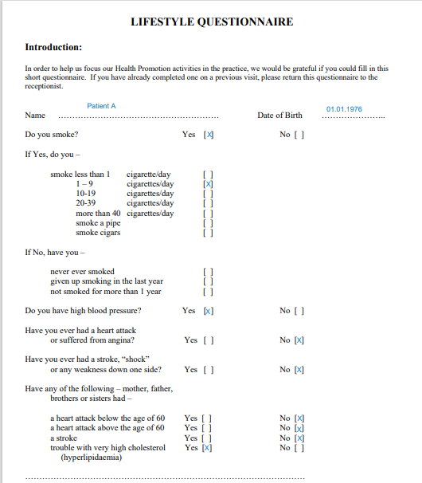
Appendix 2

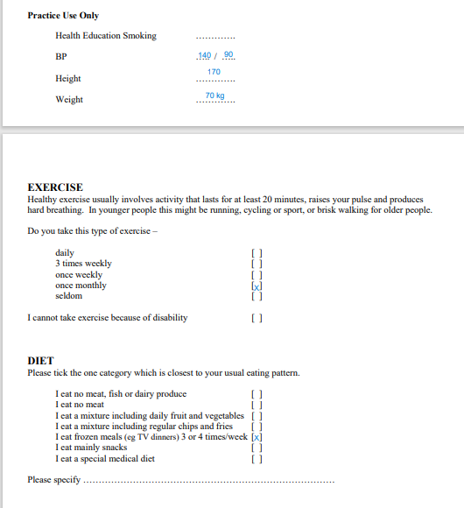
z



