
Pixels and Passion: Indie game renaissance and its influence on game culture and design
Dissertation and final major project proposal

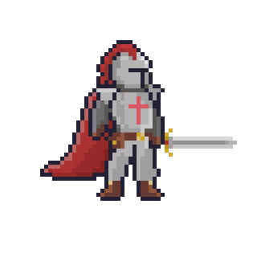
Rory Evans (2218702)
Contents Page
1. Introduction ………………………………………………………………………………………………….……….2
2. SMART Objectives …………………………………………………………………………………………….…….3
3. Project Rationale ……………………………………………………………………………………………….……3
4. Project Success Requirements ………………………………………………………………….....………...4
5. Deliverables …………………………………………………………………………………………………….…….4
6. Ethical Considerations ………………………………………………………………………………….……..…4
7. Existing examples in the field …………………………………………………………….…………………….5
8. Topic familiarity ………………………………………………………………………………………………….…..6
9. Brief Literature Review …………………………………………………………………………………………....7
10. Research Methodology ………………………………………………………………………………………….7
11. Conclusion………………………………………………………………………………………………………….7
12. References…………………………………………………………………………………………………………8-9

Introduction
With the new renaissance of indie games comes with it the resurgence of pixel art in modern games [Figure 1]. Currently there is a lack of understanding of how a specific aesthetic may impact the videogames overall success, and how developers can balance the modern innovation of video games and nostalgic art styles into their games.
The aim of this project is to create a 2.5D pixel-based video game or level slice. I want to explore the resurgence of pixel-based games in the modern era, including aspects such as nostalgia, retro appeal, artistic expression, the indie game movement, modern technology, community and market trends.
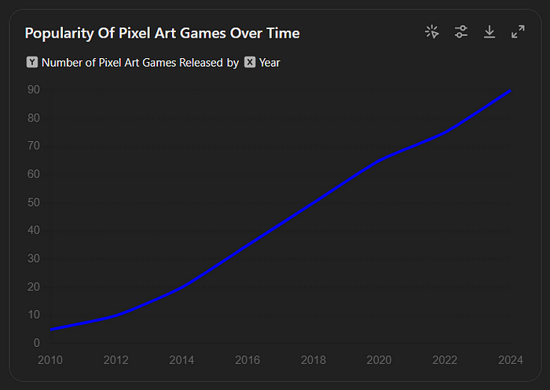
My aim in this project is to explore the best practices for pixel art in video games and how they elevate the video game and the players experience. I will also be investigating the aesthetic appeal of pixel-based games and their art influences with game success.

[Figure 1: Indie Games Association 2024, shows the increase in over time the popularity of pixel art games] [1]
“Pixel graphics, once a necessity due to technological limitations, have made a striking comeback in the modern gaming world. This revival is not just a nod to nostalgia but also a testament to the timeless appeal of pixel art” [2]

SMART Objectives
Specific, products I want to study 3 successful case studies of indie games that have used pixel art in their video game and find out how it has been a success to identify common aspects of their development.
Measurable, conduct suitable surveys to key target audience (videogame players, artist) to help understand the player preferences and what styles are most appealing to the target audience.
Achievable, work within the constraints of my ability as an artist and game developer to create a successful prototype that will be able to relate to my research and findings.
Relevant, what’s trending currently and what type of expectations would there be for my prototype to be successful.
Time, set hard milestones and project phases to emphasise the importance of working within the industry standards and procedures.

Why is this project worth doing?
This project is worth pursuing because of the recent shift in indie games popularity with interest in nostalgia and the cultural impact pixel art has had throughout video game history, not only to the players and aesthetic appeal based on semiotics, but also to the developers and why pixel games have become a more accessible way into the video game industry. This investigation will also highlight the gap in existing studies utilising player psychology and aesthetic appeal. This study will also be useful as I intend to create pixel games as a future career.

Discussion on what the project needs to be to be a success
Research – Thorough primary research on existing 2D/3D hybrid games, art appeal including pixel art. This study will also analysis user responses through questionnaires and playtesting. Secondary research will utilise relevant papers/journals, blogs and books.
Community Engagement – Relevant response from players and developers including playtesting and surveys. I will also be focusing on the contextual research as quantitative and qualitative to ensure I can analyse and use the feedback strategically to the benefit of the project and dissertation.
Design iterations – Include early development details on iterations on how the prototype will align with the target audience.
Analysis – Project analysis throughout at different development stages using feedback, research and milestones to ensure a viable project plan.
Description of deliverables
For my project the following will include:
Video game prototype: A functional 2D/3D prototype game or level slice, that embodies to the functional principles of the research and findings.
Dissertation Report: A report on the projects research and thesis on the integration of pixel art into video game design, the cultural impact of nostalgia and retro appeal and the impact of aesthetics on player engagement.
Community Feedback: An overall community feedback analysis including feedback, insights, interviews, surveys and playtests based on quantitative and qualitative data.
Ethical Issues
Ethical issues that need to be considered in the project will include video game violence that may have a potential impact on players/play testers. Ensuring that the project has warnings before gameplay and doesn’t promote or glorify violence will be the necessary steps taken to ensure that any players won’t be harmful to them. I will also be taking into consideration that no triggering content that will cause any distress to player. I will also be collecting consenting data from play testers for feedback, but not using any personal information to protect data privacy.
Existing examples in the field
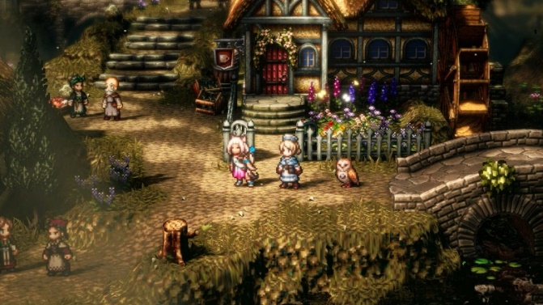
Octopath Traveler – Developed by Square Enix as a RPG, is known as a HD 2D game combining the retro aesthetic with high-definition effects. This serves as a good example of how retro style games still have a viable appeal with over 3 million copies sold worldwide in 2022. [3]

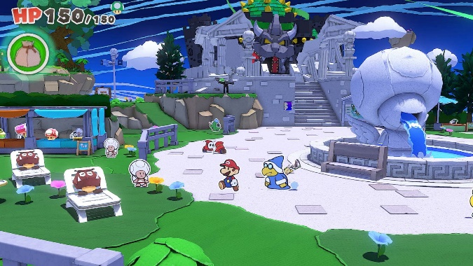
Paper Mario: Origami King – A role playing game created by Intelligent Systems in 2020, a fan favourite among Mario fans mixes both components of 2D styled characters for nostalgic reference to the original Super Mario games and 3D environments to polish the game into a more modern style. [4]
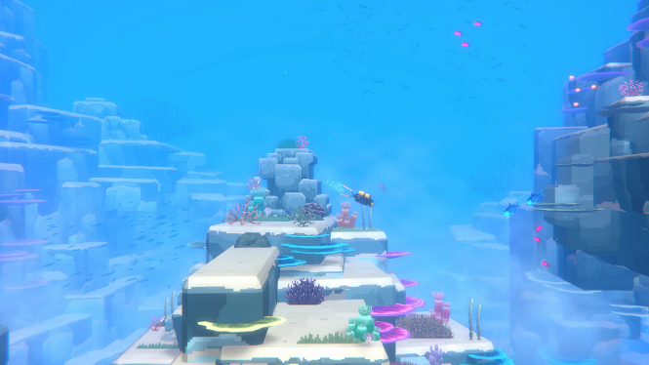
Dave the Diver – A game created by indie developer Mintrocket that uses 2D pixel characters and 3D poly environments. The game also uses pixel art to narrate the story and characters. [5]

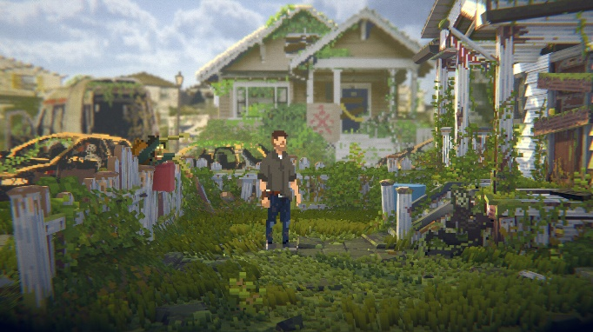
Long Gone - Is an indie developed video game by Hillfort Games, which combines the hybrid 2D/3D style. The game uses a 2D assets and uses depth to create a 3D perspective. The game also highlights interesting use of pixel art in game to give it stylistic realism aesthetic [6]


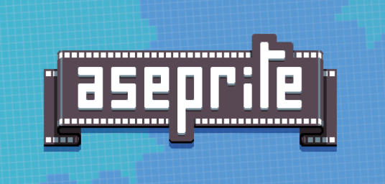
Topic Familiarity
[Figure 3: Unreal Engine, a tool used by game developers as a game engine] [8]
[Figure 2: Aseprite, a pixel-art tool to create 2D graphics] [7]
I will be using Unreal Engine 5 [7] as the game engine for my prototype, I’ve worked on UE5 for over two years now so I have a developed understanding of how the engine works and can be utilised for my project. There is also a very extensive number of resources for further learning that will be easily accessible that will assist with the overall project. For asset creation, I’ve decided to use Aseprite [6]. Again, there is a lot of material regarding tutorials for aseprite and feel this is the best suited programme for creating assets using sprite cards which is easily integrated into UE5 using sprites. I will also be looking into using other technologies/programmes for 2D/3D art for example, Crocotile 3D [8].
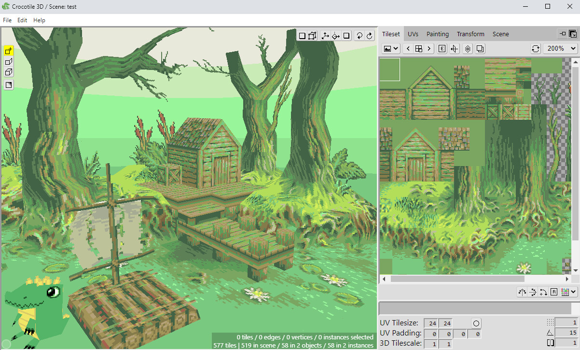

[Figure 4: Crocotile 3D, a tile-based 3D modelling application, a tool for creating low poly assets and pixel textures] [9]

Brief Literature Review
“The Art of Game Design: A Book of Lenses” by Jesse Schell [10]
“Critical Play: Radical Game Design” by Mary Flanagan [11]
“Game Feel: A Game Designer's Guide to Virtual Sensation” by Steve Swink [12]
“Level up” by Scott Rodgers [13]
“Pixel Logic - A Guide to Pixel Art” by Michafrar [14]
“Pixel Art for Game Developers” by Daniel Silber [15]
“Handmade Pixels - Independent Video Games and the Quest for Authenticity” by Jesper Juul [16]
“Research on the Application of Pixel Art in Game Character Design” by Tubagus Zufri & Dodi Hilman [17]

Selection of Models & Concepts
This investigating will use both primary and secondary research these include
Primary – Will be research that I will conduct myself via interviews, surveys, playtesting with players, artists and developers. And three case studies that include Stardew Valley[19], Dave the Diver[5], Octopath Traveller[3] and Celeste [18]
Secondary – Will include books in the brief literature review in relation to pixel art and retro aesthetics in video game design. Key areas of research will be nostalgic appeal, player engagement, colour theory, semiotics, and cultural impact in game design.

Conclusion
The project explores the rise of pixel art in modern video games by indie game developers and I aim to create a hybrid 2.5D pixel game level slice. It will focus on nostalgic aesthetic, player engagement and success, retro appeal and market trends. Using case studies, qualitive and quantitative research from surveys, community feedback to gage player preferences, and explore game design fundamentals to ensure the best outcome for a video game prototype.

References
[1] Indie Games Association, Popularity of Pixel Art Games Over Time," 2024
[2] Mindfig Studios, “The Art of Pixel Graphics: Reviving Retro Aesthetics in Modern Games,” Medium, Jun. 20, 2024. https://medium.com/@mindfig.llp/the-art-of-pixel-graphics-reviving-retro-aesthetics-in-modern-games-81dd1306c788
[3] Square Enix and ACQUIRE Corp. OCTOPATH TRAVELER™. (2019). Square Enix. Accessed:Oct,18,2024.[Online].Available: https://store.steampowered.com/app/921570/OCTOPATH_TRAVELER/
[4] Intelligent Systems. (2020). Paper Mario: Origami King [Video game]. Nintendo. https://www.nintendo.com/en-gb/Games/Nintendo-Switch-games/Paper-Mario-The-Origami-King-1782440.html#Overview
[5] MINTROCKET. DAVE THE DIVER. (2023). MINTROCKET. Accessed: Oct, 19, 2024. [Online]. Available: https://store.steampowered.com/app/1868140/DAVE_THE_DIVER/
[6] Hillfort Games. Long Gone. Hillfort Games. Accessed: Oct. 22, 2024. [Online]. Available: https://store.steampowered.com/app/1977610/Long_Gone/
[7] David Capello. Aseprite. (2016). Igara Studio. Accessed: Oct. 22, 2024. [Online]. Available: https://store.steampowered.com/app/431730/Aseprite/
[8] Unreal Engine 5. (2022). Epic Games.
[9] Alex Hanson-White. Crocotile 3D. (2020). Alex Hanson-White. Accessed: Oct. 22, 2024. [Online]. Available: https://store.steampowered.com/app/1244040/Crocotile_3D/
[10] J. Schell, The Art of Game Design: A Book of Lenses. Burlington, MA: Morgan Kaufmann, 2008.
[11] M. Flanagan, Critical Play: Radical Game Design. Cambridge, MA: MIT Press, 2009.
[12] S. Swink, Game Feel: A Game Designer's Guide to Virtual Sensation. Burlington, MA: Morgan Kaufmann, 2008.
[13] S. Rogers, Level Up! The Guide to Great Video Game Design. Chichester, West Sussex: Wiley, 2010.
[14] Michafrar, Pixel Logic - A Guide to Pixel Art, self-published, 2019.
[15] D. Silber, Pixel Art for Game Developers. Boca Raton, FL: CRC Press, 2015.
[16] J. Juul, Handmade Pixels - Independent Video Games and the Quest for Authenticity. Cambridge, MA: MIT Press, 2019.
[17] T. Zufri and D. Hilman, "Research on the Application of Pixel Art in Game Character Design," Journal of Design and Creative Technologies, vol. 3, no. 1, pp. 15-27, 2021.
[18] Maddy Makes Games Inc. and Extremely OK Games, Ltd. Celeste. (2018). Maddy Makes Games Inc. Accessed: Oct. 24, 2024. [Online]. Available: https://store.steampowered.com/app/504230/Celeste/
[19] ConcernedApe. Stardew Valley. (2016). ConcernedApe. Accessed: Oct. 23, 2024. [Online]. Available: https://store.steampowered.com/app/413150/Stardew_Valley/

