

THE ROLE OF CONTENT MARKETING IN BUILDING CUSTOMER TRUST: A CASE STUDY OF STARBUCKS
Student Name :- Sakshi Bipinbhai Kalani
Student ID :- 2423623
Director of supervisor :- Xavier Matieni
Term :- February 2025

Table of Contents
1 Introduction 3
Background of the study 3
Aim 4
Objectives 4
Research questions 4
Rationale 5
2 Literature Review 6
3 Methodology 8
Research design 8
Population, sampling & sample size 9
Data Collection 10
Data analysis techniques 10
Ethical considerations 10
4 Expected findings 11
5 Limitations 11
6 Timeframe 12
7 Conclusion 13
References 14

1 Introduction

Background of the study
Over the past few years, Starbucks still claims itself as a major coffeehouse brand in the world, and the number of employees employed all around the world has been reported to be about 361,000 people as of September 29, 2024 (Macro Trends, 2025). This scope of operations highlights the broad scope of Starbucks and its intricate marketing background where digital-content strategies are required to perform in many markets. Meanwhile, the scholarship underlines that brand authenticity is also a significant factor in developing consumer trust in digitally mediated brands -consumer relationships (Lin et al. 2023). Further, the implication of organisational complexity can also be seen in the way content-marketing messages are consistently and credibly developed, delivered and received by the consumers through various channels.
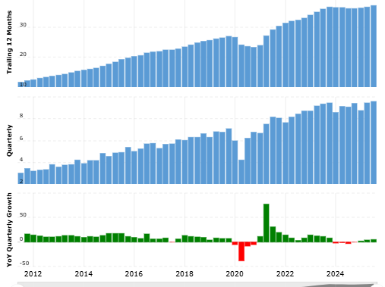
Figure 1: Revenue forecast of Starbucks
(Source: Macro Trends, 2025)
Furthermore, the financial performance of Starbucks supports the interests of successful content-marketing in stimulating brand loyalty and consumer engagement. In 2024, the company indicated a set of annual consolidated revenues of around US: 36.18 billion (Macro Trends, 2025). With consumers overwhelmed with brand communications in a marketplace, the research demonstrates that content marketing needs to overcome the feature and value propositions, but also the transparency and authenticity as the trust-building mechanisms (Yadav et al. 2024). The combination of global scale, the substantial base of revenues, and the necessity to establish the trust by means of content marketing impel this research of how particular dimensions of content-marketing, complications of authenticity, and digital touch points contribute to the consumer trust and loyalty to the Starbucks case. Thus, the investigation will assess various facets of content marketing, depending on particular digital touch points, which may be plausible in terms of analysing the market penetration potential of Starbucks.

Aim
The primary aim of this study is to examine how content marketing strategies of Starbucks manipulates customer trust and loyalty based on AI-driven personalisation and digital storytelling.

Objectives
- To assess the extent to which Starbucks uses content marketing techniques to facilitate customer trust and brand loyalty.
- To determine which content marketing dimensions, including storytelling, personalisation, and value-based communication, has the strongest predictive power of consumer trust among the different digital and cultural touchpoints.
- To examine the role of consumer scepticism and perceived authenticity in mediating the association between content marketing by Starbucks and the formation of customer trust.
- To determine the role of AI-based personalisation, as well as sustainability storytelling in the content marketing of Starbucks in creating long-term commitments

Research questions
1 How does Starbucks use content marketing strategies to foster customer trust and brand loyalty?
2 Which dimensions of content marketing most significantly predict customer trust, and how do these vary across different cultural or digital touchpoints of Starbucks?
3 How do consumer scepticism and perceived authenticity moderate the effect of Starbucks’ digital content marketing on customer trust formation?
4 How can AI-driven personalisation and sustainability storytelling in Starbucks’ content marketing enhance long-term relationship commitment and customer retention?

Rationale
The increased importance of content marketing in the digital age requires the global brands such as Starbucks to not just control what they do but also ensure the credibility and trustworthiness of their communications. The base of investments that Starbucks puts in its digital ecosystem is large: in Q2 FY2024 the company achieved 34.3 million active Rewards members within the U.S. and mobile ordering contributed to 31% of transactions settled by the companies within the U.S. (Starbucks, 2025). Such a level of digital interaction makes it more difficult to make sure that the content marketing created by Starbucks could bring about actual consumer trust and not merely create impressions. Similar to other past studies, brand authenticity is an important antecedent of consumer trust in online marketing situations. Besides, a substantial reach may be ineffective in providing long-term loyalty unless authenticity is incorporated into content marketing.
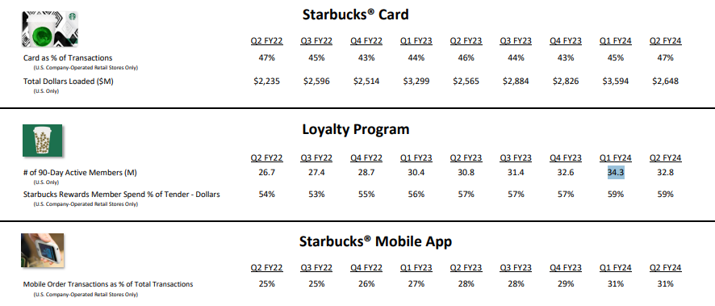
Figure 2: Starbucks Card, Loyalty & Mobile Dashboard
(Source: Starbucks, 2025)
Additionally, even though Starbucks invests more than US100 million on advertisements and content in various media platforms every year, at a global level, this amount does not ensure efficiency in growing trust and long-term relationships (Media Radar, 2025). Researchers posit that a large amount of marketing messages needs to have trust building systems like transparency, substantial engagement and consistency between brand values and consumer anticipations (Pattanaik, 2024). Moreover, exploring how content marketing dimensions (storytelling, personalisation, sustainability) mediate through scepticism and authenticity. This becomes imperative to Starbucks should the organisation be to transform the mass communication activities to a greater degree of customer loyalty, although not through a single visit.

2 Literature Review
Content Marketing as a Driver of Consumer Trust and Brand Loyalty
Content marketing is very crucial in determining the relationship between the brand and the consumer since it incorporates emotional attachment and genuineness in communication. Matthews and Ferrero-Regis (2024) suggest that the content focuses on stories to create consumer confidence by personalising brand messages and instead of transactional persuasion, consumers are motivated to engage with it emotionally. In the same way, Ofosu-Boateng and Jose (2025) focus on the fact that enduring consumer trust serves as a precondition of long-term loyalty in cases when brand stories are constantly accompanied by the reliability and mutual values. Starbucks shows it by its community-oriented campaigns and open sustainability communication that builds relational trust. More importantly, good content marketing does not just mean visibility of the brand but also building a lasting emotional connection, the customers become lifetime promoters who internalise the values of the brand.
Moreover, researchers have postulated that the effectiveness of content marketing in terms of loyalty depends on the consistency of the message and its ethical nature. Yuan et al. (2024) argue that empathetic communication promotes the willingness of the consumer to stick to socially responsible brands. Otis (2024) mentions that transparency signals included in digital content have the effect of generating high credibility perceptions. The ethical narrative of Starbucks goes hand in hand with these theoretical considerations and demonstrates how loyalty that is based on trust can be attained not through persuasive rhetoric, but through a genuine conversation. As a result, trust is introduced as a mediating factor between the quality of content and ethically expressed communication and brand loyalty in digitally flooded markets.
Dimensions of Effective Content Marketing (Storytelling, Personalisation, and Value-Driven Communication)
A successful content marketing approach involves a combination of various dimensions; storytelling, personalisation, and communication based on value to create customer trust. As an illustration, Starbucks has a total of 38,038 locations worldwide as of Q4 2023, which indicates the scope of its physical and digital touch-point ecosystem in which personalised and value-driven material can be distributed (Starbucks, 2023). Secondly, uniformity in communication channels strengthens consumer trust due to the decreased cognitive dissonance (Ibrahim Awwad et al. 2025). In line with this, On the other hand, perceived honesty is reinforced by authenticity that is obtained with the help of consumer-generated and employee stories (Saleem and Hawkins, 2021). Starbucks has been applying these values by means of cohesive digital narrative in a manner that applies ethical sourcing and inclusiveness. Mechanisms that make these dimensions work together will make customers feel that Starbucks is a coffee brand, but a lifestyle partner with similar values.
Personalisation is also a key success factor in improving engagement and perceived value. Lin et al. (2023) discovered that value-based and transparent messaging is an important contributor to trust in online business. In the same vein, Cheung and To (2021) find that the value perception of the consumers is strengthened when the communication has measurability in terms of its ethical effect. The synergy between technology and trust can be explained by the example of Starbucks that integrates personalized loyalty offers and sustainability updates through its app. The difficulty is to keep these dimensions coherent and at the same time to not over-personalise the product and make it intrusive. Therefore, content marketing requires a balanced approach of personal relevancy, ethical disclosure and authenticity of the message.
Theoretical underpinnings
This paper will primarily discuss Relationship Marketing Theory, Trust-Commitment Theory, and Brand Authenticity Theory, which cumulatively describes the process in which content marketing can help construct and maintain consumer trust. Baehaqi et al. (2023) argue that relationship marketing focuses on the long-term emotional interactions and building value co-creation which increase customer retention beyond transactional interactions. In the same way, as revealed by Hanif et al. (2024), trust and commitment are primary mediators that change the satisfaction into long-term loyalty in digital ecosystems. Quite to the contrary, consumer-brand trust is based on perceived authenticity. A combination of these theories provides a reason to analyse the communication on the storytelling, personalisation, and sustainability of Starbucks as the tool strengthening loyalty via the relationship based on trust.
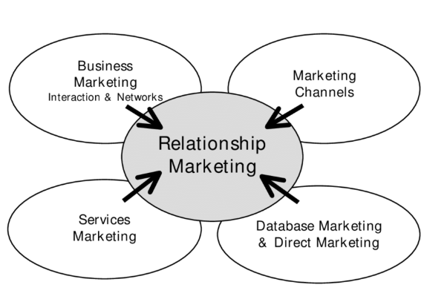
Figure 3: Relationship Marketing
(Source: Hanif et al. 2024)
Literature gap
The current literature has discussed how content marketing can contribute to consumer trust and loyalty but only a few studies combine authenticity, AI-based personalisation and sustainability storytelling in a unified framework of analysis. Secondary data-based research on the mitigating roles of consumer scepticism on these relationships in international coffee retail environments like Starbucks has not been done yet.

3 Methodology

Research design
The present study belongs to the qualitative secondary research type as it critically analyzes the manner in which the approach of content marketing developed by Starbucks leads to creating customer trust and loyalty through the notion of authenticity, AI personalisation and sustainability storytelling. As opined by Adex et al. (2024), secondary research allows an affordable and time-efficient access to the pre-existing organisational data and academic literature. Information has been obtained through corporate Starbucks reports, journal articles and market analysis obtained in the public, which in combination give credible information on global marketing practices. The methodology promotes a thematic and comparative analysis, which makes sure that it adheres to the interpretivist philosophy. According to ERBAS (2023) qualitative secondary analysis enables the provision of contextual insights into the managerial views in large organisations like Starbucks.
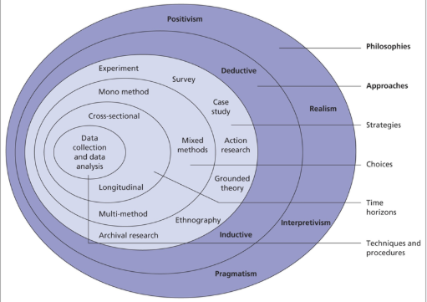
Figure 4: Research Onion
(Source: Alturki, 2021)

Population, sampling & sample size
The subject population in this case will be employees and managers of Starbucks who are engaged in marketing and communication processes in various markets. As the study is secondary, a sample of 30 employees and managers is selected relying on the existing interview transcripts, case studies, and corporate reports that are accessible in the public domain. Etikan and Beedell (2021) consider purposive sampling to be suitable in cases when the participants are those with certain expertise that is pertinent to the issue under investigation. Thus, with the help of this purposive sample, one can gain specific knowledge regarding the strategic purpose and execution of content marketing campaigns. The data present genuine managerial insights, meaning that it would be valid in the ability to represent the dynamics of organisational communication at Starbucks.

Data Collection
Secondary data will be gathered through company reports and annual reports, case studies on marketing, academic journals and digital analytics reports. The official publications of Starbucks, including sustainability and investor reports, reflect quantitative information on the performance of brand communication which is theoretically supported by peer-reviewed literature. According to Bednarek (2024) secondary sources increase the level of analysis as they incorporate various perspectives of the contexts. The data extraction is implemented in the framework of structured document review procedure in order to determine themes associated with storytelling, personalisation, and trust formation. Data reliability is also provided by using only credible and up-to-date sources (2020-2025) and factoring in the insights provided by corporations, academic, and industry materials to obtain the most comprehensive interpretation.

Data analysis techniques
Thematic analysis is a technique that is used to determine, classify and infer patterns that repeat across the secondary data gathered. According to Braun and Christou (2022), thematic analysis is a qualitative process that is flexible and reveals the meaning in textual datasets by using systematic coding. The major themes are authenticity, transparency, trust, and digital engagement which are based on the official documents of Starbucks and backed by the academic discourse. The possible cross-comparison of the themes makes it possible to identify the connection between content marketing dimensions and consumer trust. The synthesis of findings is in the form of narration to show theoretical alignment to the Relationship Marketing and Trust-Commitment theories. The method is both analytical and interpretive in the secondary data.

Ethical considerations
In this study, no ethical infractions occur during the research process since the research ethics guidelines of the University of Wales Trinity Saint David are followed. No direct human involvement is involved in the study since secondary data will be used, which rules out the possible privacy risks. However, copyright and intellectual property rights are highly honored. Accurate citation, transparency and misrepresentation of data are ethical research requirements as highlighted by Bhardwaj and Mittal (2024). References to all types of secondary materials are done in UWTSD Harvard style. Also, the data in the corporate reports of Starbucks is provided only for academic purposes, guaranteed confidentiality and credibility without compromising the professionalism in interpreting the data.

4 Expected findings
It is hoped that the research will identify that the content marketing of Starbucks, especially storytelling, AI-based personalisation, and sustainability messaging, help to boost customer trust and loyalty by increasing their perceived authenticity. It can also indicate that consumer scepticism dilutes such effects and brands have to balance persuasion and transparency. Authentic brand stories have a major impact on trust and long-term interaction in an online environment, as Mehta (2024) puts forward. Theoretically, this study is relevant to Relationship Marketing and Brand Authenticity theories, as the content design is related to the relational outcomes. In a practical view, it provides some insight to marketers on the use of data-driven storytelling in a manner that is ethically sound to continue relationships with customers in a competitive global market.

5 Limitations
The fact that the study is based on secondary data is also a limitation because it does not allow having direct control over the validity of the data and their context. Therefore, interpretations are based on the quality and depth of given sources. The 30 employees and managers of Starbucks are a small sample, and they might not be reflective of the whole organisational set up and the global market diversity. According to Baldwin et al. (2022), secondary research is usually associated with a problem of the inconsistency and irrelevance of data collected and analyzed among studies. In addition, the qualitative interest does not allow generalising findings, but it allows increasing the level of contextual richness and interpretative validity in comprehending trust-based content marketing approaches of Starbucks.

6 Timeframe
6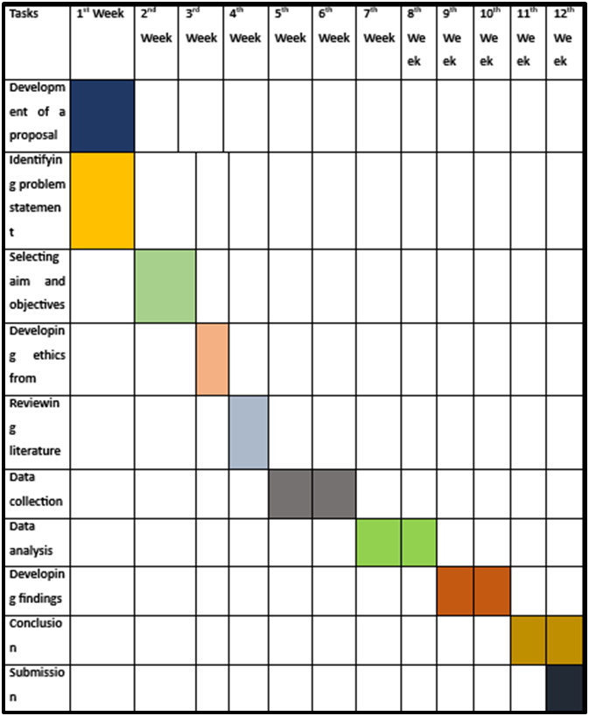
Figure 5: Timeframe for conducting the research

(Source: Self-developed)

7 Conclusion
The study concludes that successful content marketing that is based on authenticity, openness, and technology development is a key ingredient in building customer confidence and loyalty to a brand. The case of Starbucks illustrates how storytelling, personalisation by AI and sustainability communication have reinforcement effects of relational engagement. Through synthesising secondary information, the study brings to the fore the possibility of digital content changing the consumer perception of transactional to the emotional relationship. The results highlight the managerial need to balance persuasive communication and credibility and moral responsibility. In the end, the proposal will offer a model of examining how content marketing works as a strategic and relational tool of long-term customer loyalty.

References
Adex, B.O., Gbenga, O.I., Isola, S.A. and Esther, A.O., (2024). Impact of Information and Communication Technology on Effective Financial Management: Experience from Nigerian Small and Medium Enterprises. Journal of Accounting, Finance, and Contemporary Management Research, 1(2), pp.116-135. https://jafacomar.lautech.edu.ng/index.php/jafacomar/article/download/24/21
Alturki, R., (2021). Research Onion for Smart IoT‐Enabled Mobile Applications. Scientific programming, 2021(1), p.4270998. https://onlinelibrary.wiley.com/doi/pdf/10.1155/2021/4270998
Baehaqi, M., Cahyono, R.S. and Riptiono, S., (2023). Determining value co-creation behaviour toward customer loyalty and customer retention on the SRC’s business platform. Matrik J. Manaj. Strategi Bisnis Dan Kewirausahaan, 17(1), pp.48-60. https://www.academia.edu/download/106361387/48987.pdf
Baldwin, J.R., Pingault, J.B., Schoeler, T., Sallis, H.M. and Munafò, M.R., (2022). Protecting against researcher bias in secondary data analysis: challenges and potential solutions. European Journal of Epidemiology, 37(1), pp.1-10. https://journals.sagepub.com/doi/pdf/10.1177/16094069231180160
Bednarek, R., (2024). Balancing Depth and Breadth to Understand Macro Phenomena: Some Advice for Analyzing Global Qualitative Datasets. The Journal of Applied Behavioral Science, 60(3), pp.553-570. https://journals.sagepub.com/doi/pdf/10.1177/00218863241260435
Beedell, A., (2021). From abstract concept to active participants: Reflections on a purposive sample. Crossing Conceptual Boundaries, 11(1), pp.8-17. https://uel-repository.worktribe.com/OutputFile/458228
Bhardwaj, P. and Mittal, K., (2024). Ethics in Research Publication: Challenges and Considerations. Ethical Frameworks in Special Education: A Guide for Researchers (Volume 2nd), p.141. https://www.researchgate.net/profile/Ravindra-Kushwaha-2/publication/383271882_Ethical_Frameworks_in_Special_Education_Volume_2nd/links/66c5d59184297b4b3ba688d6/Ethical-Frameworks-in-Special-Education-Volume-2nd.pdf#page=151
Cheung, M.F. and To, W.M., (2021). The effect of consumer perceptions of the ethics of retailers on purchase behavior and word-of-mouth: The moderating role of ethical beliefs. Journal of business ethics, 171(4), pp.771-788. https://www.academia.edu/download/89973108/s10551-020-04431-620220820-1-1ya92zj.pdf
Christou, P.A., (2022). How to use thematic analysis in qualitative research. Journal of Qualitative Research in Tourism, 3(2), pp.79-95. https://www.academia.edu/download/104208431/How_to_use_thematic_analysis_in_qualitative_research.pdf
ERBAS, E., (2023). How Narrative Analysis is Useful in Questioning How The Strategicity of a Strategy Comes From? A Strategy-As-Practice Perspective. Journal of Tourism & Gastronomy Studies, 11(1), pp.695-715. https://jotags.net/index.php/jotags/article/download/1497/2672
Hanif, R., Astuti, W. and Sunardi, S., (2024). The mediating role of customer satisfaction in the effect of perceived enjoyment on customer Trust in Online Investment Application. Innovation Business Management and Accounting Journal, 3(1), pp.18-29. https://ejournal.trescode.org/index.php/ibmaj/article/download/59/93
Ibrahim Awwad, R., Ibrahim, B., George, C., Hamdan, S. and Nair, K., (2025). Facts or belief: examining the effect of the cognitive dissonance on brand switching, purchase regret and satisfaction level. Global Knowledge, Memory and Communication, 74(3/4), pp.1209-1222. https://www.researchgate.net/profile/Blend-Ibrahim/publication/369977764_Facts_or_belief_examining_the_effect_of_the_cognitive_dissonance_on_brand_switching_purchase_regret_and_satisfaction_level/links/643ec9b52eca706c8b6990d3/Facts-or-belief-examining-the-effect-of-the-cognitive-dissonance-on-brand-switching-purchase-regret-and-satisfaction-level.pdf
Lin, F.L. and Ku, T.H., (2023). Effect of digital brand experience on luxury fashion brand authenticity, attachment and loyalty. South African Journal of Business Management, 54(1), pp.1-8. https://www.scielo.org.za/pdf/sajbm/v54n1/22.pdf
Lin, H.C., Liu, X., Huang, Y. and Chen, H.Y., (2023). Determinants of continued use of tourism and hospitality e-commerce platforms and the role of information transparency. Current Issues in Tourism, 26(19), pp.3140-3159. https://www.researchgate.net/profile/Hsien-Cheng-Lin/publication/365739276_Determinants_of_continued_use_of_tourism_and_hospitality_e-commerce_platforms_and_the_role_of_information_transparency/links/63877be7fee13e4fe52e6f23/Determinants-of-continued-use-of-tourism-and-hospitality-e-commerce-platforms-and-the-role-of-information-transparency.pdf
Macro Trends, (2025) Starbucks Revenue 2011-2025 Macro Trends [Online] Available at: https://www.macrotrends.net/stocks/charts/SBUX/starbucks/revenue [Accessed on: 3rd November 2025]
Macro Trends, (2025) Starbucks: Number of Employees 2011-2025 Macro Trends [Online] Available at: https://www.macrotrends.net/stocks/charts/SBUX/starbucks/number-of-employees [Accessed on: 3rd November 2025]
Matthews, R. and Ferrero-Regis, T., (2024). Future of sustainable fashion communications: from marketing messages to the mediation of mutable meanings. In Mediating Sustainability in the Consumer Society 4(1), pp. 100-128 https://www.taylorfrancis.com/chapters/edit/10.4324/9781003392705-8/future-sustainable-fashion-communications-rachel-matthews-tiziana-ferrero-regis
Media Radar, (2025) Starbucks Coffee Advertiser Profile Media Radar [Online] Available at: https://advertisers.mediaradar.com/starbucks-coffee-advertising-profile [Accessed on: 3rd November 2025]
Mehta, D., (2024). Sustainable Branding and Communication: Influencing Consumer Choices Through Authentic Narratives. Journal of Jurivox, 1(2), pp.75-85. https://researchcorridor.org/index.php/jj/article/download/180/171
Ofosu-Boateng, I. and Jose, L.M., (2025). Narrating Authenticity: A Qualitative Exploration of How Brand Storytelling Shapes Consumer Trust and Loyalty in Ghana’s Emerging Market. Open Journal of Social Sciences, 13(9), pp.258-277. https://www.researchgate.net/profile/Ibrahim-Ofosu-Boateng/publication/395754430_Narrating_Authenticity_A_Qualitative_Exploration_of_How_Brand_Storytelling_Shapes_Consumer_Trust_and_Loyalty_in_Ghana's_Emerging_Market/links/68da78399383755fd707c715/Narrating-Authenticity-A-Qualitative-Exploration-of-How-Brand-Storytelling-Shapes-Consumer-Trust-and-Loyalty-in-Ghanas-Emerging-Market.pdf
Otis, A., (2024). The effects of transparency cues on news source credibility online: an investigation of ‘opinion labels’. Journalism, 25(1), pp.198-217. https://journals.sagepub.com/doi/pdf/10.1177/14648849221129001
Pattanaik, D., (2024). Public Perception of Corporate Environmental Commitments: How Communication Shapes Trust. Journal of Jurivox, 1(2), pp.63-74. https://researchcorridor.org/index.php/jj/article/download/179/170
Saleem, F.Z. and Hawkins, M.A., (2021). Employee-generated content: the role of perceived brand citizenship behavior and expertise on consumer behaviors. Journal of Product & Brand Management, 30(6), pp.819-833. https://www.researchgate.net/profile/Matthew-Hawkins/publication/350773257_Employee-generated_content_the_role_of_perceived_brand_citizenship_behavior_and_expertise_on_consumer_behaviors/links/642c2c0f20f25554da0b9f3d/Employee-generated-content-the-role-of-perceived-brand-citizenship-behavior-and-expertise-on-consumer-behaviors.pdf
Starbucks, (2023) Starbucks Reports Q4 and Full Year Fiscal 2023 Results Starbucks [Online] Available at: https://s203.q4cdn.com/326826266/files/doc_news/Starbucks-Reports-Q4-and-Full-Year-Fiscal-2023-Results-2023.pdf [Accessed on: 4th November 2025]
Starbucks, (2025) Starbucks Card, Loyalty & Mobile Dashboard Starbucks [Online] Available at: https://s203.q4cdn.com/326826266/files/doc_downloads/supplemental-financial/2024/q2-fy24-digital-ir-dashboard.pdf [Accessed on: 3rd November 2025]
Yadav, O.P., Teotia, R. and Baliyan, R., (2024). Digital Transformation and Consumer Behavior: A Marketing Perspective. Digital Economy of India, 12(2), p.41. https://www.researchgate.net/profile/Aman-Ullah-23/publication/383025108_DIGITAL_ECONOMY_OF_INDIA_RECENT_DEVELOPMENTS_AND_EMERGING_PERSPECTIVES/links/66b88681299c327096be45a4/DIGITAL-ECONOMY-OF-INDIA-RECENT-DEVELOPMENTS-AND-EMERGING-PERSPECTIVES.pdf#page=50
Yuan, J., Shahzad, M.F., Waheed, A. and Wang, W., (2024). Sustainable development in brand loyalty: Exploring the dynamics of corporate social responsibility, customer attitudes, and emotional contagion. Corporate Social Responsibility and Environmental Management, 31(2), pp.1042-1051. https://www.researchgate.net/profile/Muhammad-Shahzad-155/publication/374230659_Sustainable_development_in_brand_loyalty_Exploring_the_dynamics_of_corporate_social_responsibility_customer_attitudes_and_emotional_contagion/links/6874e7c76e247f362b191ba7/Sustainable-development-in-brand-loyalty-Exploring-the-dynamics-of-corporate-social-responsibility-customer-attitudes-and-emotional-contagion.pdf

