Name: Laurice Keogh
Student No: 2117545
Course: ACCA4023 Introduction to web and database concepts (Web Report)
Date: 02/05/2022
Table of Contents
Introduction 1
Requirements 1
Implementation 2
Validation 7
Evaluation (A) 9
Evaluation (B) 10
References 13
Appendices 13
Home HTML 13
Shop HTML 17
Healing Properties HTML 21
About Us HTML 29
Contact Us 32
Crystal CSS 34

Introduction
This report begins with an overview of my website including details like what the website is about and who it would be used by. The next section is about implementation, and this includes screenshots of each web page that I have created on the website. The following section is for validation where I have used online HTML and CSS validators and responded to any errors that have been picked up. The final written section of this report is the evaluation where I have assessed the quality of the website I have produced. I have researched the importance of certain features in a website and summarised my findings. I then use my research to effectively explore how effective my website is. At the end of this document, I have included references to any sources used in either the production of my website or the evaluation section of this report. This is followed by an appendices including all HTML and CSS used in the production of my website.

Requirements
I have created a website called “Laurice’s Crystal Shop”. This has been designed based on a fictional organisation, and I chose this concept because of my personal interest in crystals. The website is intended for use by people who have an interest in crystals, whether they are looking for information on crystal healing properties or whether they are looking to order some crystals for themselves. The purpose of the website is to allow the user to view stock, order crystals online, and also research what the healing properties are for each crystal. The users are also able to contact the store using the information displayed on the contact us page or follow the google maps that’s embedded into the page to visit the store in person. This is an important concept of the website because customers might have questions or require more information before they place an order. It is a requirement that all website pages follow the same theme for consistency. I have used a pink theme and the same showcase image throughout the webpages, and this is important because the user can recognise that they are still on the same website. All text on the website is from the font family Arial, Helvetica, San-serif because these fonts are recognisable on most web browsers and size 16 is used for most text because is a reasonable size for everyone to be able to read the writing without difficulty.

Implementation
Home
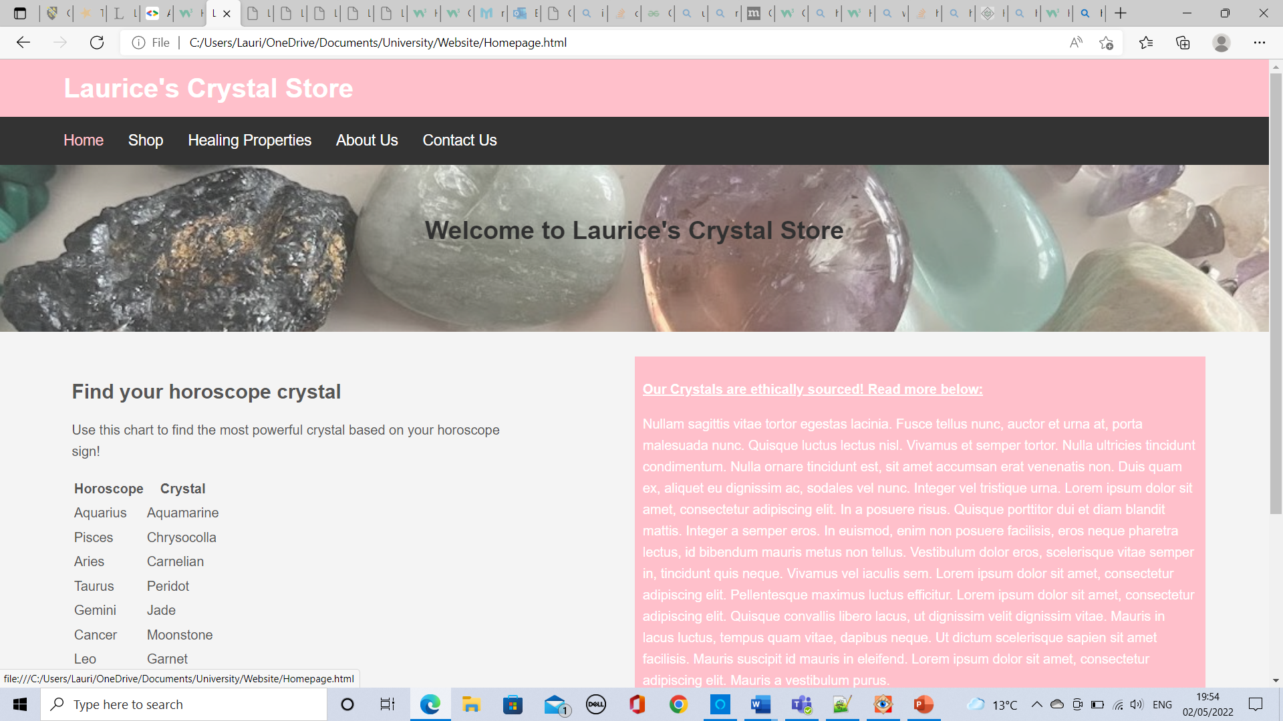
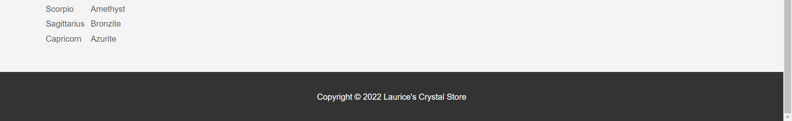
Shop
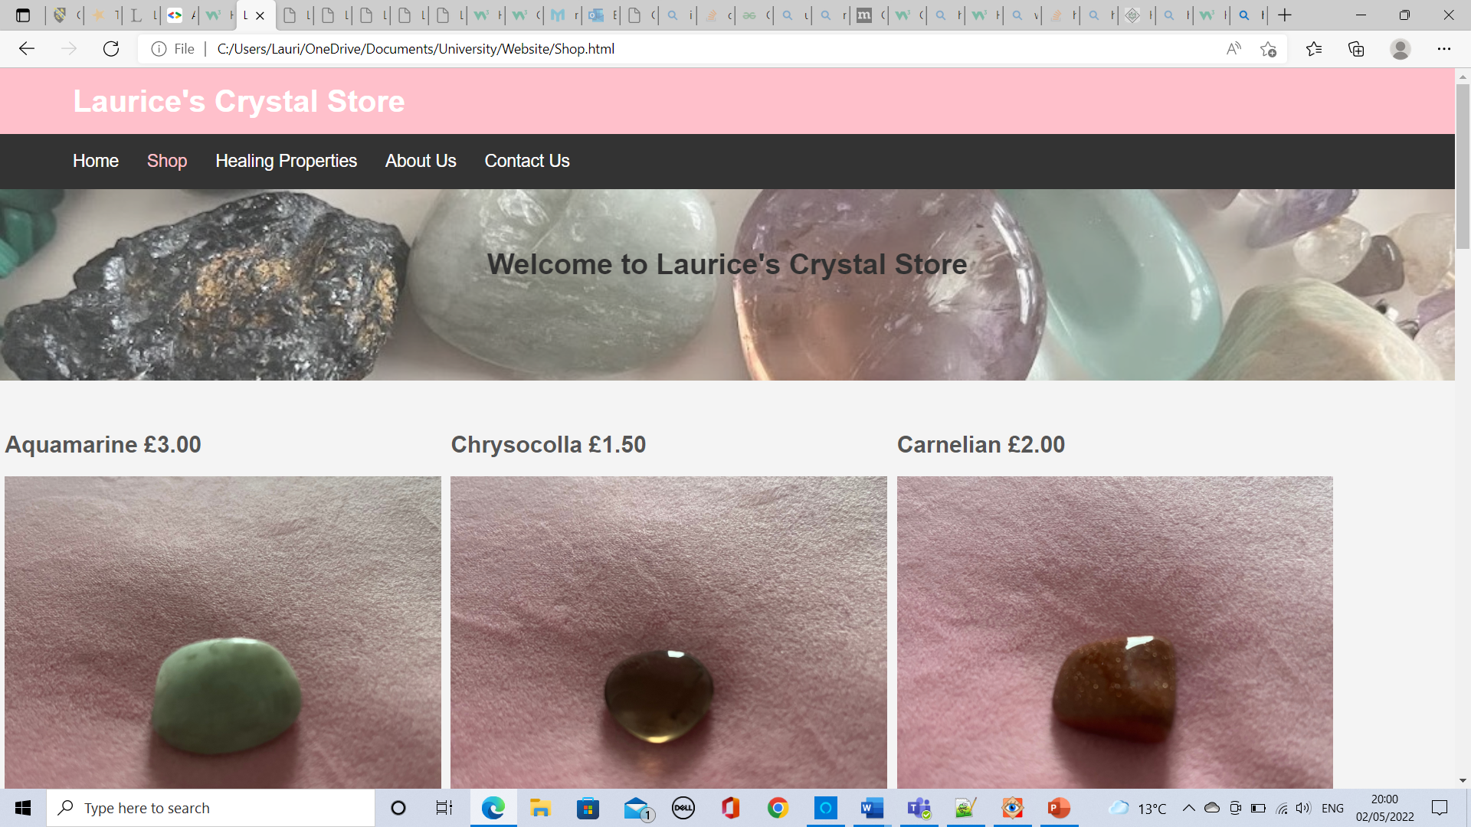
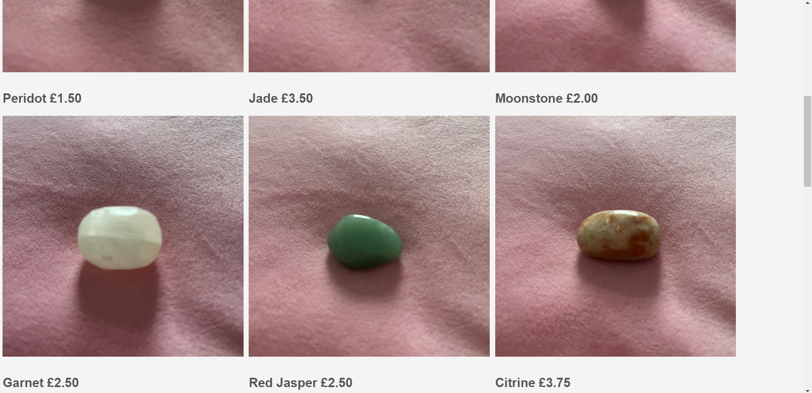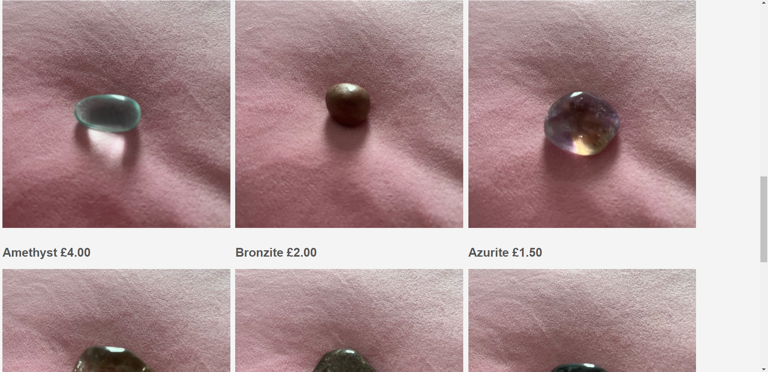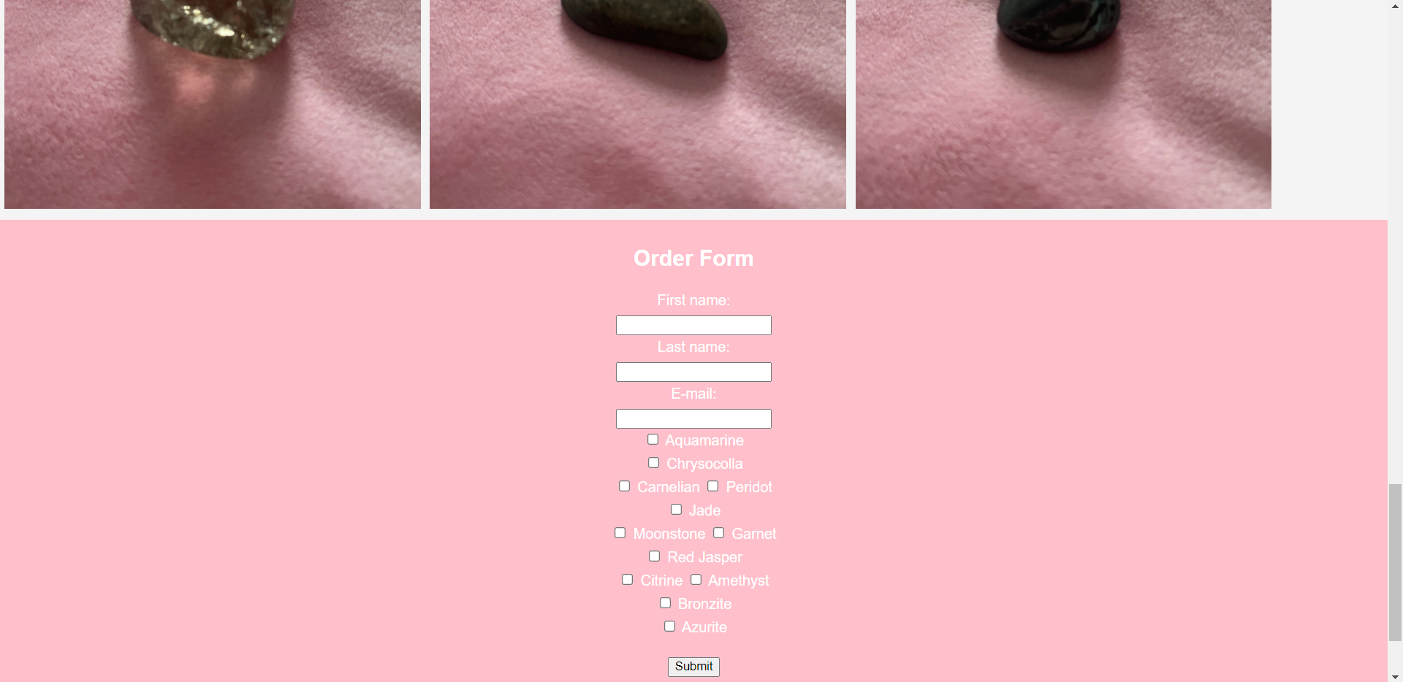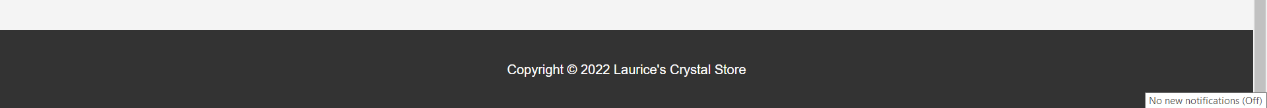
Healing properties (cropped)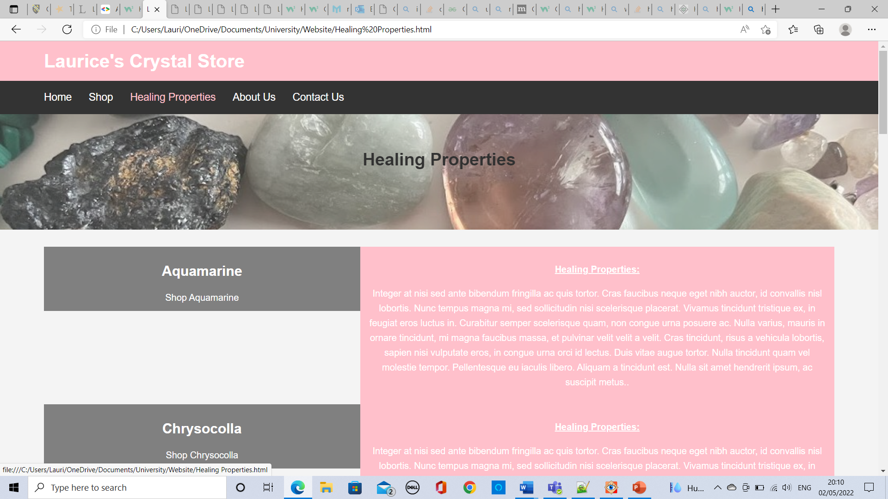 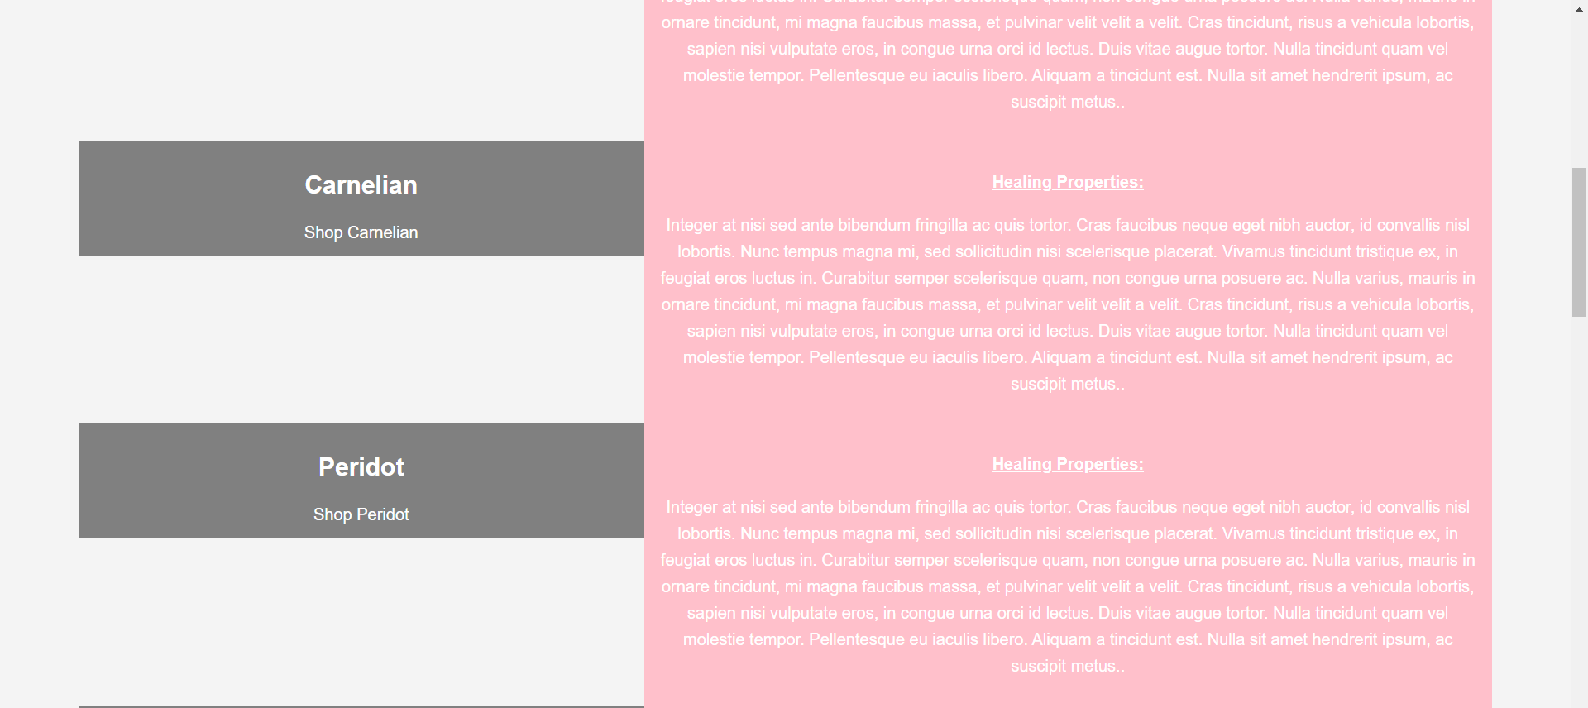 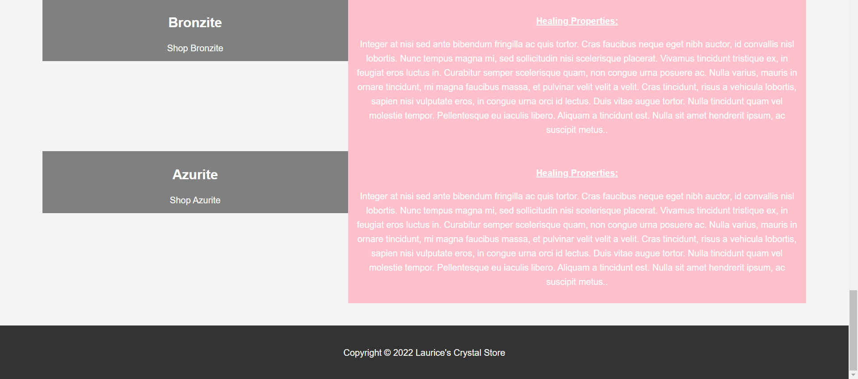
About us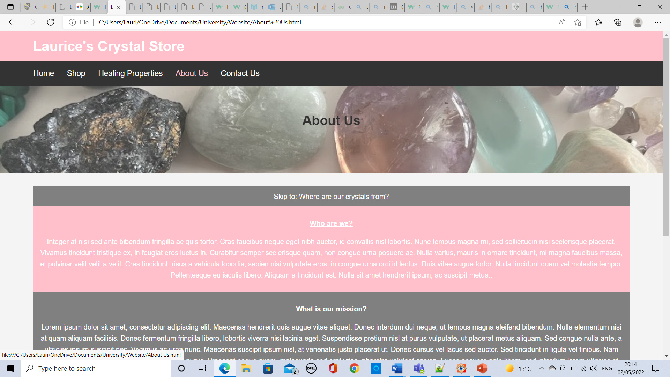 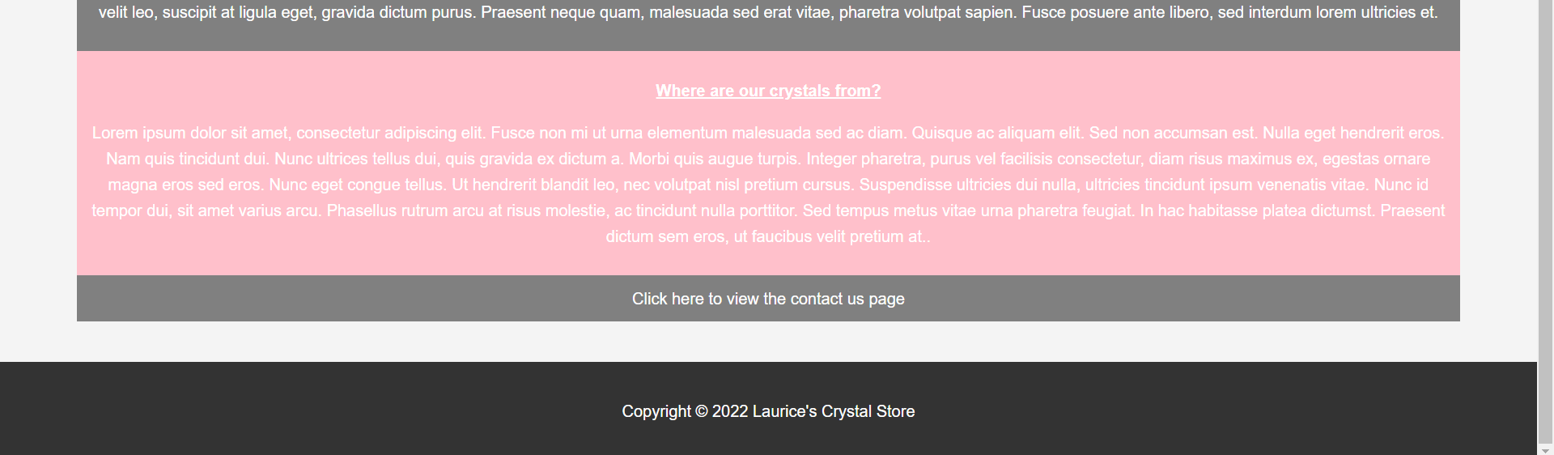
Contact us
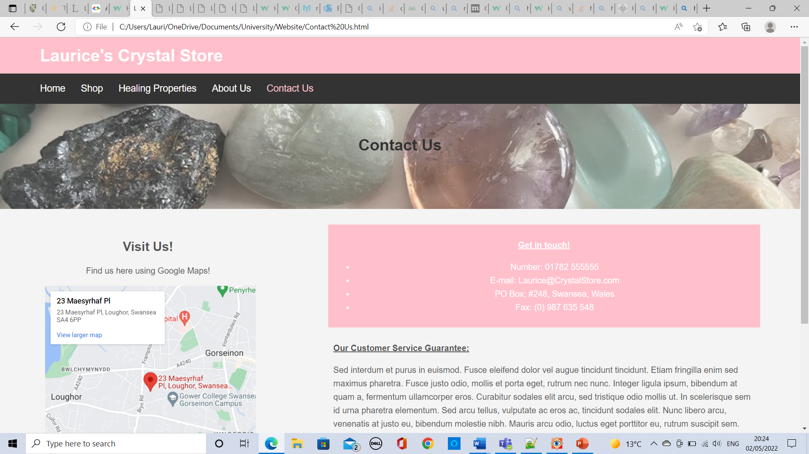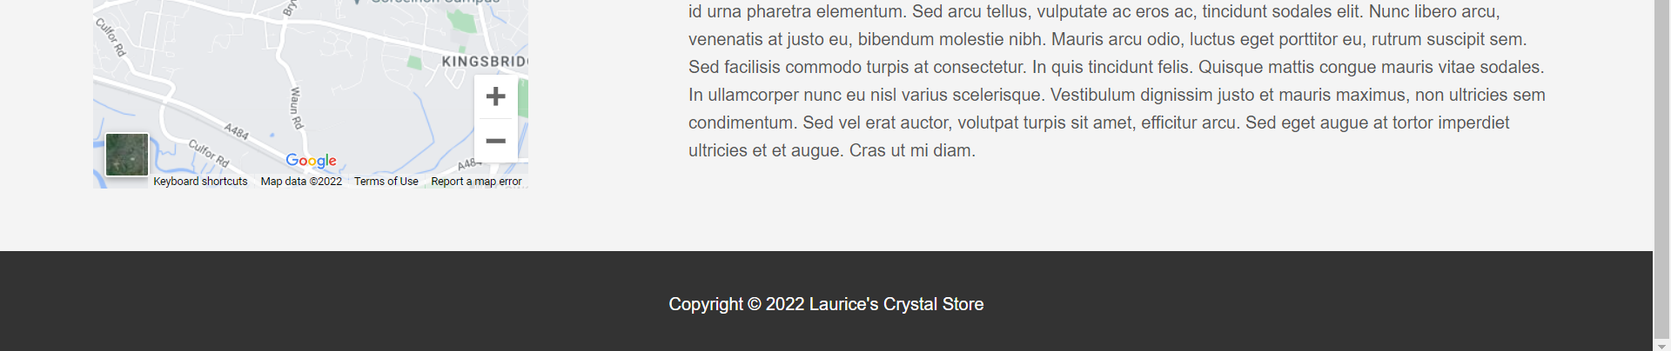

Validation
HTML Validation
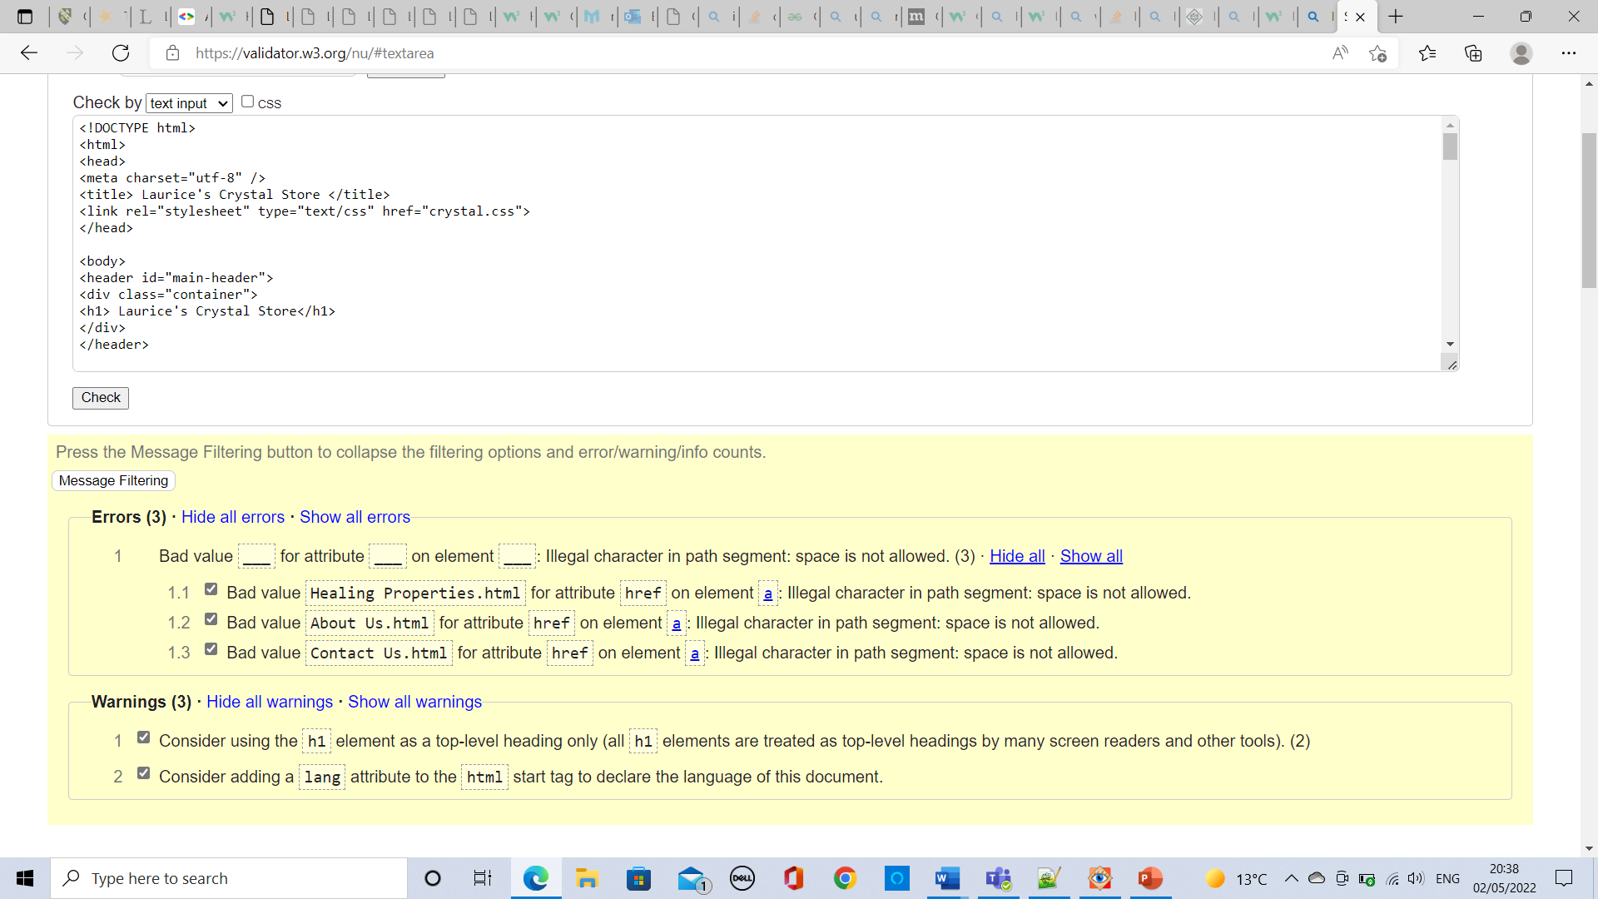
I entered the home page HTML into an online HTML validator. It told me that I had 3 errors and 3 warnings. All three errors were about the webpage names where the space character isn’t allowed. To rectify this error, I changed 3 of the webpage names for example, “About Us.html” changed to “AboutUs.html” etc. and there were no longer any errors in the validation. One of the warnings was suggesting that I declared what language the html webpage is so I changed “<html>” to “<html lang=“en”>” which got rid of the warning in the online validator. The other two warnings on the page were about my use of h1. The validator says that h1 is treated as a top-level heading, so I changed the second occurrence of “h1” to “h2” and one warning message went away. The first instance of h1 I have left the same despite the warning because of the design of the webpage purposes. If I were to change both instances of “h1” to “h2” then all warning and error messages would have disappeared, instead only one warning message remains on the validation of my code.
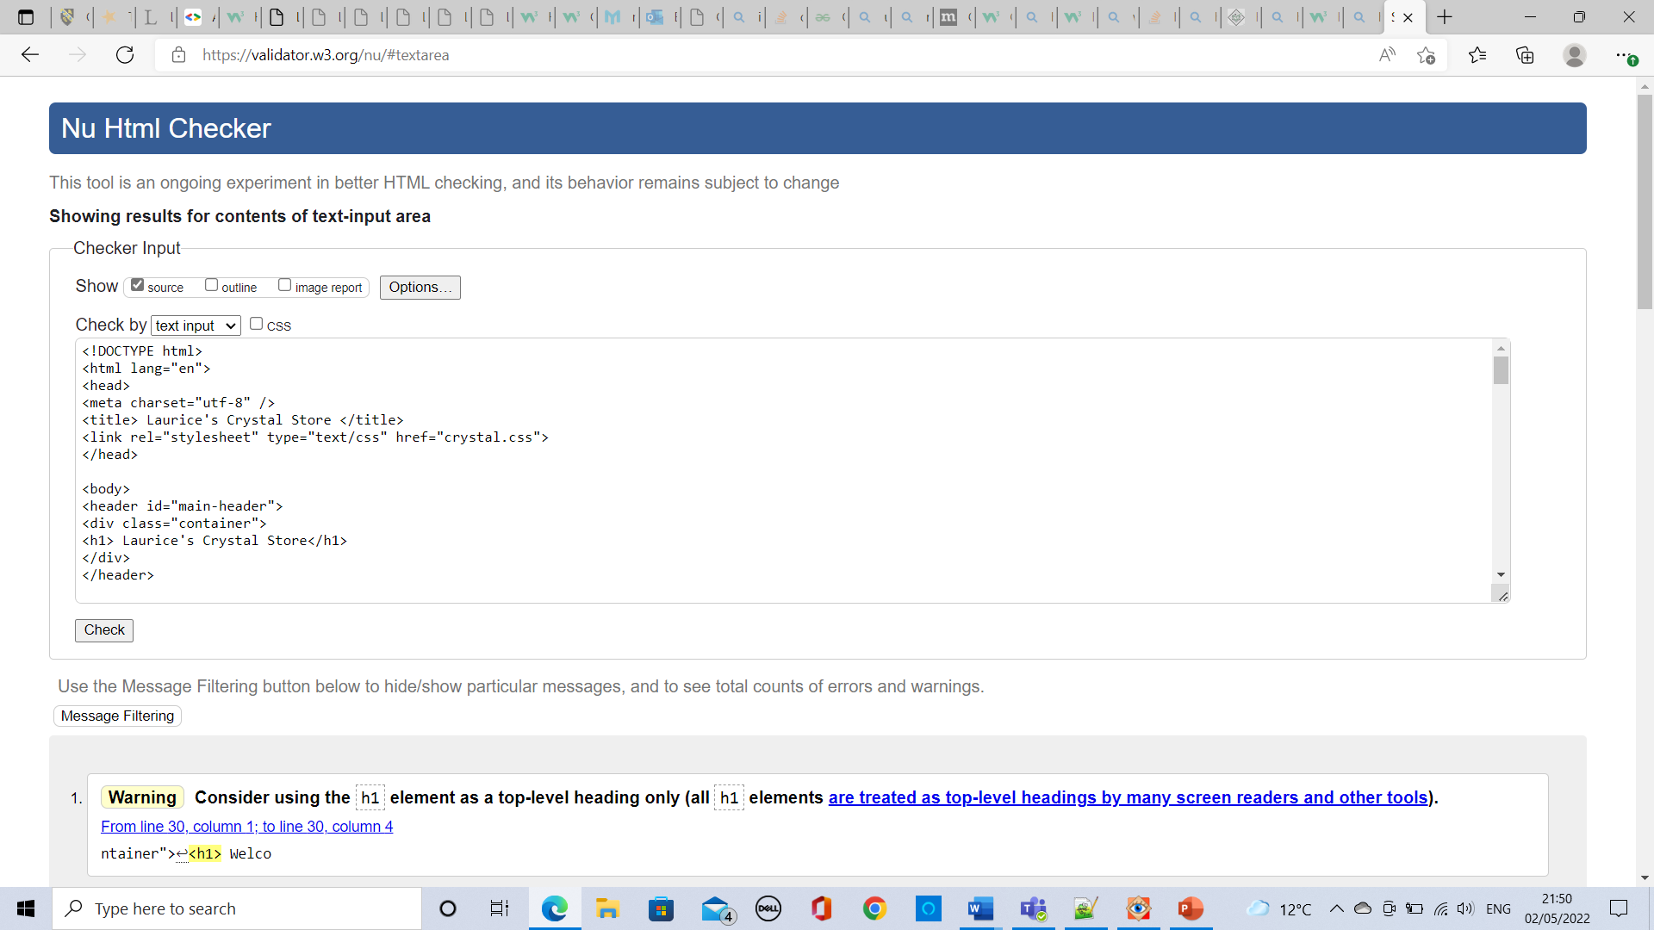
CSS Validation
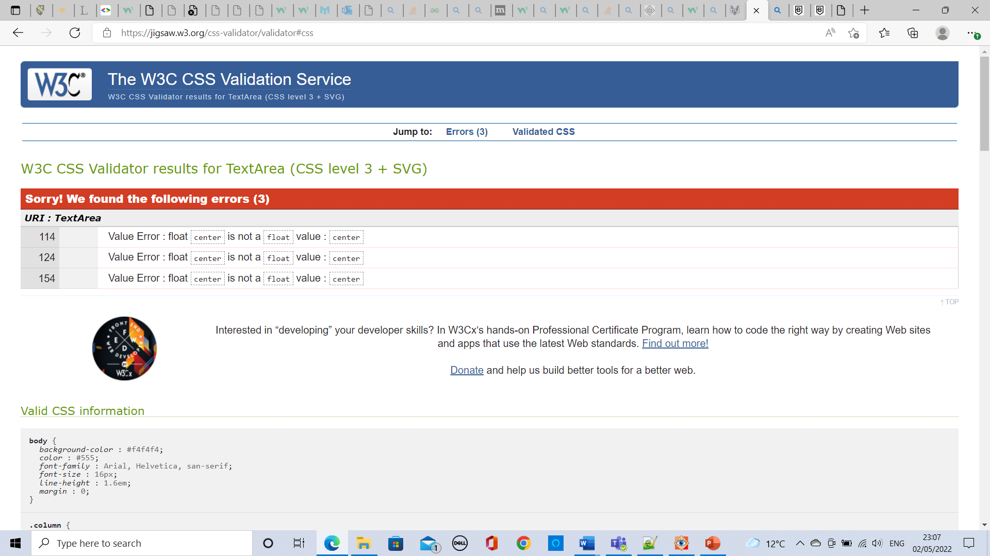
I entered the CSS content into the CSS online validator, and I received 3 errors relating to the same issue. I had tried to have the float as “center” when that is not a float option. I did some research on appropriate float positions and I changed all three occurrences of “center” to “none”. When I re-entered my CSS into the online validation, I received no errors.
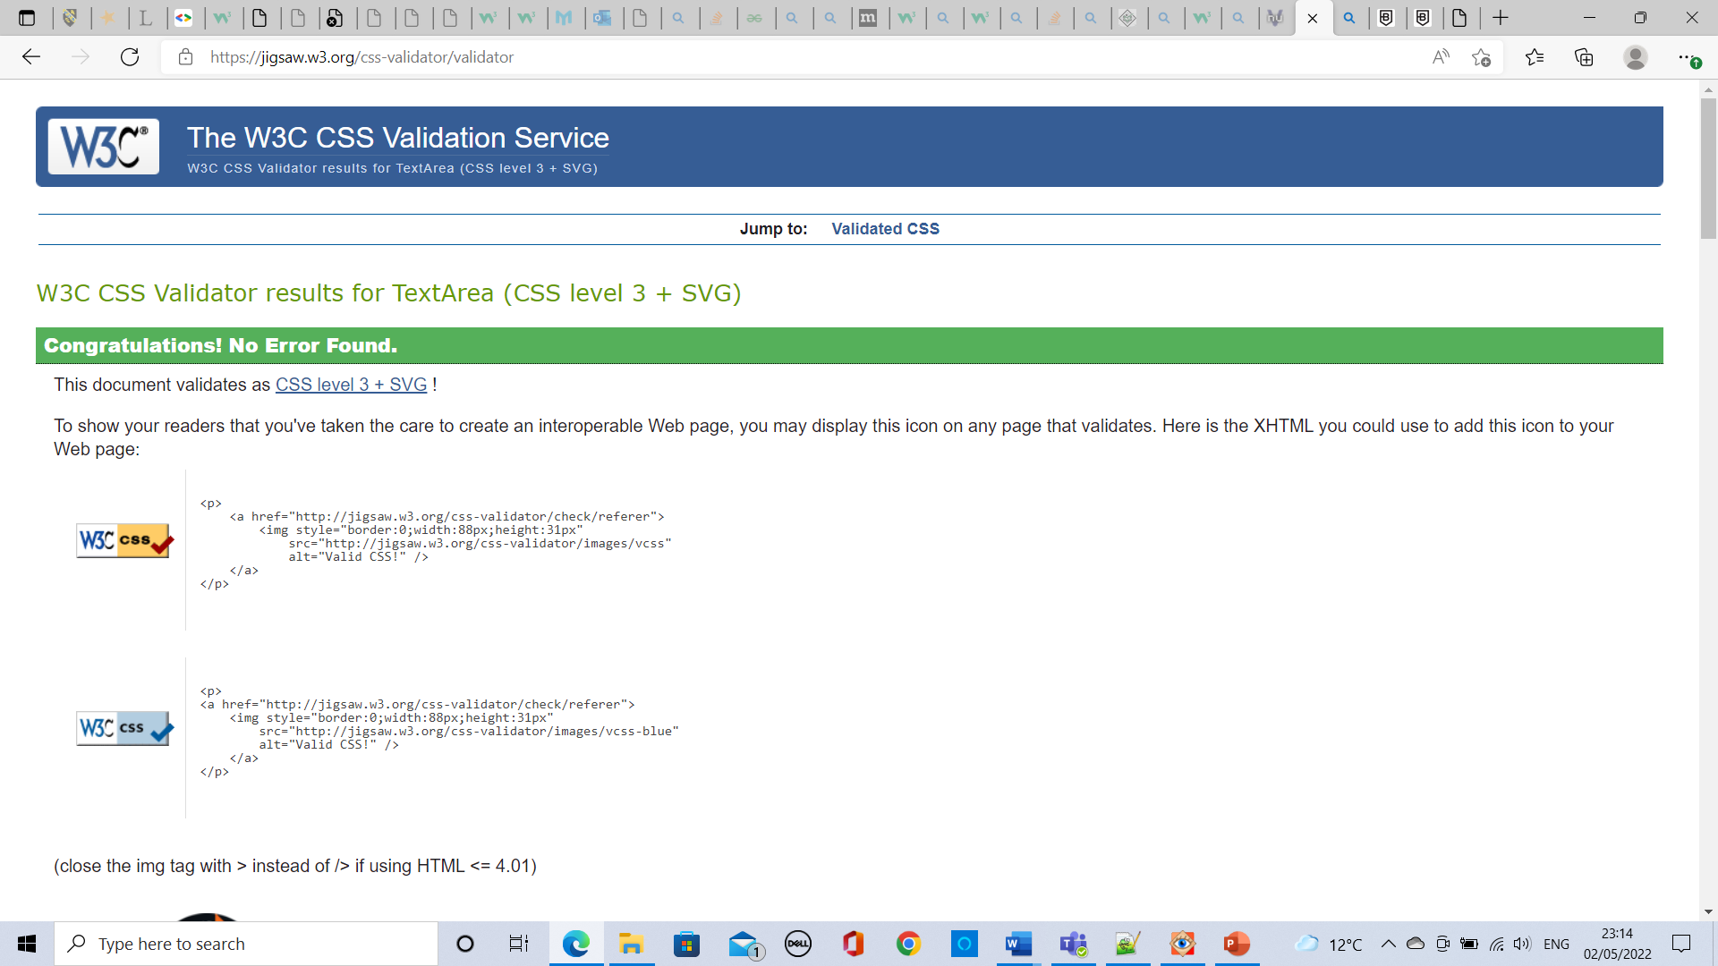

Evaluation (A)
During this evaluation I will assess what makes ‘a good website’. I am going to explore search engine optimisation, usefulness, and accessibility of a website. I will then analyse my own website looking for elements of these features in order to determine the quality of my work.
The first important element of a website that I researched was about the usefulness particularly on ecommerce websites. I discovered that there are two things that can make a website useful to the user. The first thing is that [1] “the quality and the organisation of the information provided” must be of a high standard which means information must be relevant and appear in a professional format. This is because a user is going to be looking for trustworthy website if they are online shopping and supplying their personal information. The more detail and information displayed on a website, the better. [1] The second thing that contributes to the usefulness of a website to the user is the “quality of customer service”. This means that the company needs to be reachable so that if there are any questions or concerns from a potential customer then these worries can be settled quickly allowing the customer to carry on with their purchases and use of the site. Based on this information it is incredibly important that the website includes multiple contact methods to suit different customers. The functionality of a website is also important to how useful a website is considered. If the website is about selling products, then customers want to know key information such as how much products are going to cost as this is a financial factor that would impact on the customer being able to make an informed decision on whether to buy from this website. They are also going to want to be able to place orders easily. A useful shopping website might include features such as having an account where they can view all of the information held from shipping status to payment.
The second feature important to web development is Search engine optimisation. SEO can use On-page optimisation. This is when SEO uses a range of techniques that can be used by a website to gain more traction and [2] “visibility on search engine’s results pages”. The more SEO that is included in a website, then the more site visits there will be. These SEO techniques include [2] “keywords, appropriate content, internal link structure”. These features are often included in the website link, website heading, in the main body of the webpage or as a [2] “meta keyword” in the html code. SEO is important during web development because it can bring a company revenue if customers find the website from a search engine. It is important to have appropriate SEO because it will ensure the correct target audience can find your page.
The third feature important to web development is a websites accessibility. Websites should be made as accessible as possible to allow use of the website by people that have disabilities and cannot navigate a webpage in the same way as others. Having an accessible website is positive for the business because it means that more people are able to access their services, keeping their customer reach optimised. Accessibility can be considered when writing html. [3] Alt descriptions are an important feature to have available because it allows people with impaired to no sight to have the contents of a webpage read to them in full detail enabling their experience of the webpage to be the same. This also allows viewers to still have a good website experience if the web browser doesn’t allow for the viewing of images, as they are able to read what the images would be about. The website developer should [3] “provide longer descriptions of images, image map links, and applets” such as when graphs are displayed to give a complete understanding of what is being shown. If there are any videos or sound on a website, it is important that “visual representations” are available such as captions to ensure that the “auditory information” is still accessible to those with auditory issues. [3] It is also useful for accessibility purposes to have “auditory representations of all visual information” This could mean that any alt text is able to be read out loud to describe an image. Furthermore, a website with good accessibility should have a screen reader function to be able to read out the contents of the entire page as this would help those with vision issues. For accessibility purposes a good website should keep its layout despite the width of the screen being used, which allows for the same experience no matter the users device type.

Evaluation (B)
In this section I will evaluate my website’s usefulness, search engine optimisation, and accessibility.
A website’s usefulness is most commonly determined by the quality of information on a webpage and its relevance. On the home page the customer can view the company pledge to ethical collection of crystals which is going to make the user feel at ease straight away. There is plenty of information about the company and its values on the About Us webpage which is seen as useful to a user of my website because they can see the company’s core values, allowing the user to see the professionalism of the company. A useful website has good ease of use and is easy to navigate which is true for my website because there is a navigation bar across the page allowing the user to visit clearly labelled pages of the website. The functionality of a commerce website should include easy ordering which is also relevant to my website because in the shop webpage the customer is able to enter their details and select which products they would like to purchase. It is important for a commerce website to include as much information as possible about products which is true for my website because on the shop webpage there are pictures for visual representation and there is also the price. The user can also view the healing properties of each crystal on the healing properties webpage. The look and feel of a website are important to the usefulness of a website because if the user deems the website unprofessional or messy then they aren’t likely to continue using the website. My website is useful because the same pink theme is continued throughout all websites, and this is effective at letting the user know that they are still using the same site. Included in the contact us section are multiple ways of contacting the store and this would help deem my website useful because the customer is able to request more information using their preferred method of communication, and this is good at convincing customers to shop at the website if any concerns can be eliminated through contact with the business directly. I deem my website functional because orders can be placed through the website and information can be found on the products and the company which is the main aim of the website. To improve the usefulness of this website in the future I would add a feature where customers could log in to view their information, and I would also allow a basket feature for the customer to order items in a more familiar method.

During the production of my website, I included SEO techniques. Words from the website links are picked up as SEO which means that if someone searched “HealingProperties” into a search engine then my website if published would be able to be found.
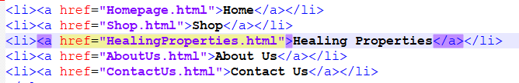Webpage headings are also picked up as SEO which means that if “Laurice’s crystal store” was typed into a search engine that the homepage would become more likely to be clicked on by the user. 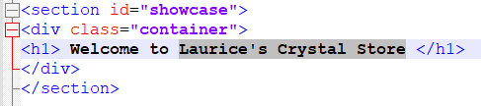Meta keywords can also be picked up as SEO which means that if something from the html/main body of the website was typed into the search engine such as “Who are we?” would increase the chances of the “About Us” section being clicked.
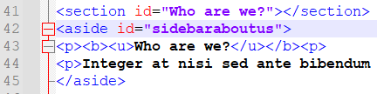

[4] With reference to WCAG 2.1 I understand that a website with good accessibility must be perceivable, operable, understandable, and robust.
My website is perceivable because I have included [4] alt text descriptions for images used in my site and this would allow a visually impaired individual to understand what is being displayed. [4] There is no audio on my website, so I haven’t included needed to provide any captions. The correct mark up has been used throughout the html code and this can be seen through the use of <button> for a button etc. This allows for the content to be described correctly to the user if they cannot see the page. Throughout the website the text has been made clearly visible, using black text on white backgrounds, and using white text on pink backgrounds. The font size doesn’t get any smaller than 16 which is a reasonable size for people with a small visual impairment to still be able to read the contents. The page is responsive to the user’s device because I used CSS for different sections of the pages, and this allows for consistency no matter the users device. I could improve the perceivability of my website by [4] disabling style sheets but unfortunately this wasn’t possible for this assignment.
A website with good accessibility should be operable. I have included links within my webpages like on the “about us” page where the user can skip to a specific question on that page. Another example of this is on the healing properties page where they can click the link to buy a specific crystal and it takes the user to the position of that crystal in the shop. Users are able to navigate the pages through a navigation bar which is standard in most websites, and this allows for ease of use through familiarity. [4] All links within my website have been clearly labelled and this allows the user to understand exactly where the links are going to take them. I think that the operability of my website can be improved by allowing customers to navigate the site using a [4] keyboard only because some people with motor issues cannot use a mouse so therefore my website is excluding these individuals from using my site.
A website that has good accessibility will be understandable. I believe that my website fits these criteria because I have declared the [4] html language as English and only used lorem ipsum in my work for longer pieces of information for the purpose of this assignment. I haven’t used any acronyms in my website, and this means that the user should have a full understanding about the content. The navigation of my website is understandable because it uses a top menu bar which is common in websites, all pages are labelled so that the user can understand what the pages are about, and my website also follows a consistent theme of pink and has the same showcase image across the page which helps the user understand that they are still on my website. I have used a form in the “shop” page for the user to place an order and I have ensured that all sections of the field are appropriately labelled so that the user understands what information they should input and where. I think I could improve the understanding of my website by using [4] shorter sentences because some phrases are considerably long, and this allows for confusion and misunderstanding.
The final quality that makes a good accessible website is it being Robust. My website is robust because I have used correct html and CSS, and it has been validated using an online checker. However, I think my website needs to improve its robustness the most as it doesn’t include any [4] ‘assistive technologies’. My website allows for keyboard input and mouse navigation. To improve the accessibility of my website I would need to make the website compatible with other devices such as roller balls, or voice recognition. This would allow for full interaction with my website by people who have disabilities. I also think that a screen reader function is essential to the accessibility of a website, and this is something that my website is lacking, and excluding those who are blind from using my website.

References
[4] Accessibility Community. (2018, October 10). Understanding WCAG 2.1. Retrieved from Gov.uk: https://www.gov.uk/service-manual/helping-people-to-use-your-service/understanding-wcag?msclkid=3bfb9f8acabb11ec89f6b319a3691eaf
[1] Benslimane, Y. (12 October 2006). Linking commercial website functions to perceived usefulness: A full disposal hull approach. 12.
[3] Chrisholm, W. (22 May 2014). Results of Accessibility Analysis of HTML and the implications for Future Information Technologies. 5.
[2] Giomelakis, D. (10 Jul 2015). Investigating Search Engine Optimisation Factors in Media Websites: The case of Greece. 23.

Appendices

Home HTML
<!DOCTYPE html>
<html>
<head>
<meta charset="utf-8" />
<title> Laurice's Crystal Store </title>
<link rel="stylesheet" type="text/css" href="crystal.css">
</head>

<body>
<header id="main-header">
<div class="container">
<h1> Laurice's Crystal Store</h1>
</div>
</header>

<nav id="navbar">
<div class="container">
<ul>
<li><a href="Homepage.html">Home</a></li>
<li><a href="Shop.html">Shop</a></li>
<li><a href="HealingProperties.html">Healing Properties</a></li>
<li><a href="AboutUs.html">About Us</a></li>
<li><a href="ContactUs.html">Contact Us</a></li>
</ul>
</div>
</nav>

<section id="showcase">
<div class="container">
<h1> Welcome to Laurice's Crystal Store </h1>
</div>
</section>

<div class="container">
<section id="main">
<h2>Find your horoscope crystal</h2>
<p>Use this chart to find the most powerful crystal based on your horoscope sign!
</p>
<table>
<tr>
<th>Horoscope</th>
<th>Crystal</th>
</tr>
<tr>
<td>Aquarius</td>
<td>Aquamarine</td>
</tr>
<tr>
<td>Pisces</td>
<td>Chrysocolla</td>
</tr>
<tr>
<td>Aries</td>
<td>Carnelian</td>
</tr>
<tr>
<td>Taurus</td>
<td>Peridot</td>
</tr>
<tr>
<td>Gemini</td>
<td>Jade</td>
</tr>
<tr>
<td>Cancer</td>
<td>Moonstone</td>
</tr>
<tr>
<td>Leo</td>
<td>Garnet</td>
</tr>
<tr>
<td>Virgo</td>
<td>Red Jasper</td>
</tr>
<tr>
<td>Libra</td>
<td>Citrine</td>
</tr>
<tr>
<td>Scorpio</td>
<td>Amethyst</td>
</tr>
<tr>
<td>Sagittarius</td>
<td>Bronzite</td>
</tr>
<tr>
<td>Capricorn</td>
<td>Azurite</td>
</tr>
</table>
</section>

<aside id="sidebar">
<p><b><u>Our Crystals are ethically sourced! Read more below:</u></b><p>
<p>Nullam sagittis vitae tortor egestas lacinia. Fusce tellus nunc, auctor et urna at, porta malesuada nunc. Quisque luctus lectus nisl. Vivamus et semper tortor. Nulla ultricies tincidunt condimentum. Nulla ornare tincidunt est, sit amet accumsan erat venenatis non. Duis quam ex, aliquet eu dignissim ac, sodales vel nunc. Integer vel tristique urna. Lorem ipsum dolor sit amet, consectetur adipiscing elit. In a posuere risus. Quisque porttitor dui et diam blandit mattis. Integer a semper eros. In euismod, enim non posuere facilisis, eros neque pharetra lectus, id bibendum mauris metus non tellus. Vestibulum dolor eros, scelerisque vitae semper in, tincidunt quis neque. Vivamus vel iaculis sem. Lorem ipsum dolor sit amet, consectetur adipiscing elit. Pellentesque maximus luctus efficitur. Lorem ipsum dolor sit amet, consectetur adipiscing elit. Quisque convallis libero lacus, ut dignissim velit dignissim vitae. Mauris in lacus luctus, tempus quam vitae, dapibus neque. Ut dictum scelerisque sapien sit amet facilisis. Mauris suscipit id mauris in eleifend. Lorem ipsum dolor sit amet, consectetur adipiscing elit. Mauris a vestibulum purus. </p>
</aside>

</div>

<footer id="main-footer">
<p> Copyright &copy; 2022 Laurice's Crystal Store </p>
</footer>

</html>

Shop HTML
<!DOCTYPE html>
<html>
<head>
<meta charset="utf-8" />
<title> Laurice's Crystal Store </title>
<link rel="stylesheet" type="text/css" href="crystal.css">
</head>

<body>
<header id="main-header">
<div class="container">
<h1> Laurice's Crystal Store</h1>
</div>
</header>

<nav id="navbar">
<div class="container">
<ul>
<li><a href="Homepage.html">Home</a></li>
<li><a href="Shop.html">Shop</a></li>
<li><a href="HealingProperties.html">Healing Properties</a></li>
<li><a href="AboutUs.html">About Us</a></li>
<li><a href="ContactUs.html">Contact Us</a></li>
</ul>
</div>
</nav>

<section id="showcase">
<div class="container">
<h1> Welcome to Laurice's Crystal Store </h1>
</div>
</section>

<section id="Row1">
<div class="row">
<div class="column">
<h1>Aquamarine £3.00</h1>
<img src="Pictures/Aquamarine.jpg" alt="Aquamarine" style="width:100%">
</div>
<div class="column">
<h1>Chrysocolla £1.50</h1>
<img src="Pictures/Chrysocolla.jpg" alt="Chrysocolla" style="width:100%">
</div>
<div class="column">
<h1>Carnelian £2.00</h1>
<img src="Pictures/Carnelian.jpg" alt="Carnelian" style="width:100%">
</div>
</div>
</section>

<section id="Row2">
<div class="row">
<div class="column">
<h1>Peridot £1.50</h1>
<img src="Pictures/Peridot.jpg" alt="Peridot" style="width:100%">
</div>
<div class="column">
<h1>Jade £3.50</h1>
<img src="Pictures/Jade.jpg" alt="Jade" style="width:100%">
</div>
<div class="column">
<h1>Moonstone £2.00</h1>
<img src="Pictures/Moonstone.jpg" alt="Moonstone" style="width:100%">
</div>
</div>
</section>

<section id="Row3">
<div class="row">
<div class="column">
<h1>Garnet £2.50</h1>
<img src="Pictures/Garnet.jpg" alt="Garnet" style="width:100%">
</div>
<div class="column">
<h1>Red Jasper £2.50</h1>
<img src="Pictures/Red Jasper.jpg" alt="Red Jasper" style="width:100%">
</div>
<div class="column">
<h1>Citrine £3.75</h1>
<img src="Pictures/Citrine.jpg" alt="Citrine" style="width:100%">
</div>
</div>
</section>

<section id="Row4">
<div class="row">
<div class="column">
<h1>Amethyst £4.00</h1>
<img src="Pictures/Amethyst.jpg" alt="Amethyst" style="width:100%">
</div>
<div class="column">
<h1>Bronzite £2.00</h1>
<img src="Pictures/Bronzite.jpg" alt="Bronzite" style="width:100%">
</div>
<div class="column">
<h1>Azurite £1.50</h1>
<img src="Pictures/Azurite.jpg" alt="Azurite" style="width:100%">
</div>
</div>
</div>
</section>

<aside id = "sidebarshop">
<h1>Order Form</h1>
<form action=”mailto:LauriceCrystalStore@crystalstore.com”>
<label for="fname">First name:</label><br>
<input type="text" id="fname" name="fname"></br>
<label for="lname">Last name:</label><br>
<input type="text" id="lname" name="lname"></br>
<label for="email">E-mail:</label><br>
<input type="email" id="email" name="email"></br>
<input type="checkbox" id="Aquamarine" name="Aquamarine" value="Aquamarine">
<label for="Crystal1">Aquamarine</label><br>
<input type="checkbox" id="Chrysocolla" name="Chrysocolla" value="Chrysocolla">
<label for="Crystal2">Chrysocolla</label><br>
<input type="checkbox" id="Carnelian" name="Carnelian" value="Carnelian">
<label for="Crystal3">Carnelian</label>
<input type="checkbox" id="Peridot" name="Peridot" value="Peridot">
<label for="Crystal4">Peridot</label><br>
<input type="checkbox" id="Jade" name="Jade" value="Jade">
<label for="Crystal5">Jade</label><br>
<input type="checkbox" id="Moonstone" name="Moonstone" value="Moonstone">
<label for="Crystal6">Moonstone</label>
<input type="checkbox" id="Garnet" name="Garnet" value="Garnet">
<label for="Crystal7">Garnet</label><br>
<input type="checkbox" id="Red Jasper" name="Red Jasper" value="Red Jasper">
<label for="Crysta8">Red Jasper</label><br>
<input type="checkbox" id="Citrine" name="Citrine" value="Citrine">
<label for="Crystal9">Citrine</label>
<input type="checkbox" id="Amethyst" name="Amethyst" value="Amethyst">
<label for="Crystal7">Amethyst</label><br>
<input type="checkbox" id="Bronzite" name="Bronzite" value="Bronzite">
<label for="Crysta8">Bronzite</label><br>
<input type="checkbox" id="Azurite" name="Azurite" value="Azurite">
<label for="Crystal9">Azurite</label>
<p></p>
<input type="submit" value="Submit">
</form>
</aside>

<footer id="main-footer">
<p> Copyright &copy; 2022 Laurice's Crystal Store </p>
</footer>

</html>

Healing Properties HTML
<!DOCTYPE html>
<html>
<head>
<meta charset="utf-8" />
<title> Laurice's Crystal Store </title>
<link rel="stylesheet" type="text/css" href="crystal.css">
</head>

<body>
<header id="main-header">
<div class="container">
<h1> Laurice's Crystal Store</h1>
</div>
</header>

<nav id="navbar">
<div class="container">
<ul>
<li><a href="Homepage.html">Home</a></li>
<li><a href="Shop.html">Shop</a></li>
<li><a href="HealingProperties.html">Healing Properties</a></li>
<li><a href="AboutUs.html">About Us</a></li>
<li><a href="ContactUs.html">Contact Us</a></li>
</ul>
</div>
</nav>

<section id="showcase">
<div class="container">
<h1>Healing Properties</h1>
</div>
</section>

<div class="container">

<aside id="sidebarhealing">
<h1>Aquamarine</h1>
<a href="shop.html#Row1">Shop Aquamarine</a>

</aside>

<aside id="sidebarhealing2">
<p><b><u>Healing Properties:</u></b><p>
<p>Integer at nisi sed ante bibendum fringilla ac quis tortor. Cras faucibus neque eget nibh auctor, id convallis nisl lobortis. Nunc tempus magna mi, sed sollicitudin nisi scelerisque placerat. Vivamus tincidunt tristique ex, in feugiat eros luctus in. Curabitur semper scelerisque quam, non congue urna posuere ac. Nulla varius, mauris in ornare tincidunt, mi magna faucibus massa, et pulvinar velit velit a velit. Cras tincidunt, risus a vehicula lobortis, sapien nisi vulputate eros, in congue urna orci id lectus. Duis vitae augue tortor. Nulla tincidunt quam vel molestie tempor. Pellentesque eu iaculis libero. Aliquam a tincidunt est. Nulla sit amet hendrerit ipsum, ac suscipit metus..</p>
</aside>
</div>

<div class ="container">

<aside id="sidebarhealing">
<h1>Chrysocolla</h1>
<a href="shop.html#Row1">Shop Chrysocolla</a>
</aside>

<aside id="sidebarhealing2">
<p><b><u>Healing Properties:</u></b><p>
<p>Integer at nisi sed ante bibendum fringilla ac quis tortor. Cras faucibus neque eget nibh auctor, id convallis nisl lobortis. Nunc tempus magna mi, sed sollicitudin nisi scelerisque placerat. Vivamus tincidunt tristique ex, in feugiat eros luctus in. Curabitur semper scelerisque quam, non congue urna posuere ac. Nulla varius, mauris in ornare tincidunt, mi magna faucibus massa, et pulvinar velit velit a velit. Cras tincidunt, risus a vehicula lobortis, sapien nisi vulputate eros, in congue urna orci id lectus. Duis vitae augue tortor. Nulla tincidunt quam vel molestie tempor. Pellentesque eu iaculis libero. Aliquam a tincidunt est. Nulla sit amet hendrerit ipsum, ac suscipit metus..</p>
</aside>
</div>

<div class ="container">

<aside id="sidebarhealing">
<h1>Carnelian</h1>
<a href="shop.html#Row1">Shop Carnelian</a>
</aside>

<aside id="sidebarhealing2">
<p><b><u>Healing Properties:</u></b><p>
<p>Integer at nisi sed ante bibendum fringilla ac quis tortor. Cras faucibus neque eget nibh auctor, id convallis nisl lobortis. Nunc tempus magna mi, sed sollicitudin nisi scelerisque placerat. Vivamus tincidunt tristique ex, in feugiat eros luctus in. Curabitur semper scelerisque quam, non congue urna posuere ac. Nulla varius, mauris in ornare tincidunt, mi magna faucibus massa, et pulvinar velit velit a velit. Cras tincidunt, risus a vehicula lobortis, sapien nisi vulputate eros, in congue urna orci id lectus. Duis vitae augue tortor. Nulla tincidunt quam vel molestie tempor. Pellentesque eu iaculis libero. Aliquam a tincidunt est. Nulla sit amet hendrerit ipsum, ac suscipit metus..</p>
</aside>
</div>

<div class ="container">

<aside id="sidebarhealing">
<h1>Peridot</h1>
<a href="shop.html#Row2">Shop Peridot</a>
</aside>

<aside id="sidebarhealing2">
<p><b><u>Healing Properties:</u></b><p>
<p>Integer at nisi sed ante bibendum fringilla ac quis tortor. Cras faucibus neque eget nibh auctor, id convallis nisl lobortis. Nunc tempus magna mi, sed sollicitudin nisi scelerisque placerat. Vivamus tincidunt tristique ex, in feugiat eros luctus in. Curabitur semper scelerisque quam, non congue urna posuere ac. Nulla varius, mauris in ornare tincidunt, mi magna faucibus massa, et pulvinar velit velit a velit. Cras tincidunt, risus a vehicula lobortis, sapien nisi vulputate eros, in congue urna orci id lectus. Duis vitae augue tortor. Nulla tincidunt quam vel molestie tempor. Pellentesque eu iaculis libero. Aliquam a tincidunt est. Nulla sit amet hendrerit ipsum, ac suscipit metus..</p>
</aside>
</div>

<div class ="container">

<aside id="sidebarhealing">
<h1>Jade</h1>
<a href="shop.html#Row2">Shop Jade</a>
</aside>

<aside id="sidebarhealing2">
<p><b><u>Healing Properties:</u></b><p>
<p>Integer at nisi sed ante bibendum fringilla ac quis tortor. Cras faucibus neque eget nibh auctor, id convallis nisl lobortis. Nunc tempus magna mi, sed sollicitudin nisi scelerisque placerat. Vivamus tincidunt tristique ex, in feugiat eros luctus in. Curabitur semper scelerisque quam, non congue urna posuere ac. Nulla varius, mauris in ornare tincidunt, mi magna faucibus massa, et pulvinar velit velit a velit. Cras tincidunt, risus a vehicula lobortis, sapien nisi vulputate eros, in congue urna orci id lectus. Duis vitae augue tortor. Nulla tincidunt quam vel molestie tempor. Pellentesque eu iaculis libero. Aliquam a tincidunt est. Nulla sit amet hendrerit ipsum, ac suscipit metus..</p>
</aside>
</div>

<div class ="container">

<aside id="sidebarhealing">
<h1>Moonstone</h1>
<a href="shop.html#Row2">Shop Moonstone</a>
</aside>

<aside id="sidebarhealing2">
<p><b><u>Healing Properties:</u></b><p>
<p>Integer at nisi sed ante bibendum fringilla ac quis tortor. Cras faucibus neque eget nibh auctor, id convallis nisl lobortis. Nunc tempus magna mi, sed sollicitudin nisi scelerisque placerat. Vivamus tincidunt tristique ex, in feugiat eros luctus in. Curabitur semper scelerisque quam, non congue urna posuere ac. Nulla varius, mauris in ornare tincidunt, mi magna faucibus massa, et pulvinar velit velit a velit. Cras tincidunt, risus a vehicula lobortis, sapien nisi vulputate eros, in congue urna orci id lectus. Duis vitae augue tortor. Nulla tincidunt quam vel molestie tempor. Pellentesque eu iaculis libero. Aliquam a tincidunt est. Nulla sit amet hendrerit ipsum, ac suscipit metus..</p>
</aside>
</div>

<div class ="container">

<aside id="sidebarhealing">
<h1>Garnet</h1>
<a href="shop.html#Row3">Shop Garnet</a>
</aside>

<aside id="sidebarhealing2">
<p><b><u>Healing Properties:</u></b><p>
<p>Integer at nisi sed ante bibendum fringilla ac quis tortor. Cras faucibus neque eget nibh auctor, id convallis nisl lobortis. Nunc tempus magna mi, sed sollicitudin nisi scelerisque placerat. Vivamus tincidunt tristique ex, in feugiat eros luctus in. Curabitur semper scelerisque quam, non congue urna posuere ac. Nulla varius, mauris in ornare tincidunt, mi magna faucibus massa, et pulvinar velit velit a velit. Cras tincidunt, risus a vehicula lobortis, sapien nisi vulputate eros, in congue urna orci id lectus. Duis vitae augue tortor. Nulla tincidunt quam vel molestie tempor. Pellentesque eu iaculis libero. Aliquam a tincidunt est. Nulla sit amet hendrerit ipsum, ac suscipit metus..</p>
</aside>
</div>

<div class ="container">

<aside id="sidebarhealing">
<h1>Red Jasper</h1>
<a href="shop.html#Row3">Shop Red Jasper</a>
</aside>

<aside id="sidebarhealing2">
<p><b><u>Healing Properties:</u></b><p>
<p>Integer at nisi sed ante bibendum fringilla ac quis tortor. Cras faucibus neque eget nibh auctor, id convallis nisl lobortis. Nunc tempus magna mi, sed sollicitudin nisi scelerisque placerat. Vivamus tincidunt tristique ex, in feugiat eros luctus in. Curabitur semper scelerisque quam, non congue urna posuere ac. Nulla varius, mauris in ornare tincidunt, mi magna faucibus massa, et pulvinar velit velit a velit. Cras tincidunt, risus a vehicula lobortis, sapien nisi vulputate eros, in congue urna orci id lectus. Duis vitae augue tortor. Nulla tincidunt quam vel molestie tempor. Pellentesque eu iaculis libero. Aliquam a tincidunt est. Nulla sit amet hendrerit ipsum, ac suscipit metus..</p>
</aside>
</div>

<div class ="container">

<aside id="sidebarhealing">
<h1>Citrine</h1>
<a href="shop.html#Row3">Shop Citrine</a>
</aside>

<aside id="sidebarhealing2">
<p><b><u>Healing Properties:</u></b><p>
<p>Integer at nisi sed ante bibendum fringilla ac quis tortor. Cras faucibus neque eget nibh auctor, id convallis nisl lobortis. Nunc tempus magna mi, sed sollicitudin nisi scelerisque placerat. Vivamus tincidunt tristique ex, in feugiat eros luctus in. Curabitur semper scelerisque quam, non congue urna posuere ac. Nulla varius, mauris in ornare tincidunt, mi magna faucibus massa, et pulvinar velit velit a velit. Cras tincidunt, risus a vehicula lobortis, sapien nisi vulputate eros, in congue urna orci id lectus. Duis vitae augue tortor. Nulla tincidunt quam vel molestie tempor. Pellentesque eu iaculis libero. Aliquam a tincidunt est. Nulla sit amet hendrerit ipsum, ac suscipit metus..</p>
</aside>
</div>

<div class ="container">

<aside id="sidebarhealing">
<h1>Amethyst</h1>
<a href="shop.html#Row4">Shop Amethyst</a>
</aside>

<aside id="sidebarhealing2">
<p><b><u>Healing Properties:</u></b><p>
<p>Integer at nisi sed ante bibendum fringilla ac quis tortor. Cras faucibus neque eget nibh auctor, id convallis nisl lobortis. Nunc tempus magna mi, sed sollicitudin nisi scelerisque placerat. Vivamus tincidunt tristique ex, in feugiat eros luctus in. Curabitur semper scelerisque quam, non congue urna posuere ac. Nulla varius, mauris in ornare tincidunt, mi magna faucibus massa, et pulvinar velit velit a velit. Cras tincidunt, risus a vehicula lobortis, sapien nisi vulputate eros, in congue urna orci id lectus. Duis vitae augue tortor. Nulla tincidunt quam vel molestie tempor. Pellentesque eu iaculis libero. Aliquam a tincidunt est. Nulla sit amet hendrerit ipsum, ac suscipit metus..</p>
</aside>
</div>

<div class ="container">

<aside id="sidebarhealing">
<h1>Bronzite</h1>
<a href="shop.html#Row4">Shop Bronzite</a>
</aside>

<aside id="sidebarhealing2">
<p><b><u>Healing Properties:</u></b><p>
<p>Integer at nisi sed ante bibendum fringilla ac quis tortor. Cras faucibus neque eget nibh auctor, id convallis nisl lobortis. Nunc tempus magna mi, sed sollicitudin nisi scelerisque placerat. Vivamus tincidunt tristique ex, in feugiat eros luctus in. Curabitur semper scelerisque quam, non congue urna posuere ac. Nulla varius, mauris in ornare tincidunt, mi magna faucibus massa, et pulvinar velit velit a velit. Cras tincidunt, risus a vehicula lobortis, sapien nisi vulputate eros, in congue urna orci id lectus. Duis vitae augue tortor. Nulla tincidunt quam vel molestie tempor. Pellentesque eu iaculis libero. Aliquam a tincidunt est. Nulla sit amet hendrerit ipsum, ac suscipit metus..</p>
</aside>
</div>

<div class ="container">

<aside id="sidebarhealing">
<h1>Azurite</h1>
<a href="shop.html#Row4">Shop Azurite</a>
</aside>

<aside id="sidebarhealing2">
<p><b><u>Healing Properties:</u></b><p>
<p>Integer at nisi sed ante bibendum fringilla ac quis tortor. Cras faucibus neque eget nibh auctor, id convallis nisl lobortis. Nunc tempus magna mi, sed sollicitudin nisi scelerisque placerat. Vivamus tincidunt tristique ex, in feugiat eros luctus in. Curabitur semper scelerisque quam, non congue urna posuere ac. Nulla varius, mauris in ornare tincidunt, mi magna faucibus massa, et pulvinar velit velit a velit. Cras tincidunt, risus a vehicula lobortis, sapien nisi vulputate eros, in congue urna orci id lectus. Duis vitae augue tortor. Nulla tincidunt quam vel molestie tempor. Pellentesque eu iaculis libero. Aliquam a tincidunt est. Nulla sit amet hendrerit ipsum, ac suscipit metus..</p>
</aside>
</div>

<footer id="main-footer">
<p> Copyright &copy; 2022 Laurice's Crystal Store </p>
</footer>

</html>

About Us HTML
<!DOCTYPE html>
<html>
<head>
<meta charset="utf-8" />
<title> Laurice's Crystal Store </title>
<link rel="stylesheet" type="text/css" href="crystal.css">
</head>

<body>
<header id="main-header">
<div class="container">
<h1> Laurice's Crystal Store</h1>
</div>
</header>

<nav id="navbar">
<div class="container">
<ul>
<li><a href="Homepage.html">Home</a></li>
<li><a href="Shop.html">Shop</a></li>
<li><a href="HealingProperties.html">Healing Properties</a></li>
<li><a href="AboutUs.html">About Us</a></li>
<li><a href="ContactUs.html">Contact Us</a></li>
</ul>
</div>
</nav>

<section id="showcase">
<div class="container">
<h1>About Us</h1>
</div>
</section>

<div class="container">

<aside id="sidebaraboutus2">
<a href="#Where are our crystals from?">Skip to: Where are our crystals from?</a>
</aside>

<section id="Who are we?"></section>
<aside id="sidebaraboutus">
<p><b><u>Who are we?</u></b><p>
<p>Integer at nisi sed ante bibendum fringilla ac quis tortor. Cras faucibus neque eget nibh auctor, id convallis nisl lobortis. Nunc tempus magna mi, sed sollicitudin nisi scelerisque placerat. Vivamus tincidunt tristique ex, in feugiat eros luctus in. Curabitur semper scelerisque quam, non congue urna posuere ac. Nulla varius, mauris in ornare tincidunt, mi magna faucibus massa, et pulvinar velit velit a velit. Cras tincidunt, risus a vehicula lobortis, sapien nisi vulputate eros, in congue urna orci id lectus. Duis vitae augue tortor. Nulla tincidunt quam vel molestie tempor. Pellentesque eu iaculis libero. Aliquam a tincidunt est. Nulla sit amet hendrerit ipsum, ac suscipit metus..</p>
</aside>

<section id="What is our mission?"></section>
<aside id="sidebaraboutus2">
<p><b><u>What is our mission?</u></b><p>
<p>Lorem ipsum dolor sit amet, consectetur adipiscing elit. Maecenas hendrerit quis augue vitae aliquet. Donec interdum dui neque, ut tempus magna eleifend bibendum. Nulla elementum nisi at quam aliquam facilisis. Donec fermentum fringilla libero, lobortis viverra nisi lacinia eget. Suspendisse pretium nisl at purus vulputate, ut placerat metus aliquam. Sed congue nulla ante, a ultricies ipsum suscipit nec. Vivamus ac urna nunc. Maecenas suscipit ipsum nisl, at venenatis justo placerat ut. Donec cursus vel lacus sed auctor. Sed tincidunt in ligula vel finibus. Nam velit leo, suscipit at ligula eget, gravida dictum purus. Praesent neque quam, malesuada sed erat vitae, pharetra volutpat sapien. Fusce posuere ante libero, sed interdum lorem ultricies et.</p>
</aside>

<section id="Where are our crystals from?"></section>
<aside id="sidebaraboutus">
<p><b><u>Where are our crystals from?</u></b><p>
<p>Lorem ipsum dolor sit amet, consectetur adipiscing elit. Fusce non mi ut urna elementum malesuada sed ac diam. Quisque ac aliquam elit. Sed non accumsan est. Nulla eget hendrerit eros. Nam quis tincidunt dui. Nunc ultrices tellus dui, quis gravida ex dictum a. Morbi quis augue turpis. Integer pharetra, purus vel facilisis consectetur, diam risus maximus ex, egestas ornare magna eros sed eros. Nunc eget congue tellus. Ut hendrerit blandit leo, nec volutpat nisl pretium cursus. Suspendisse ultricies dui nulla, ultricies tincidunt ipsum venenatis vitae. Nunc id tempor dui, sit amet varius arcu. Phasellus rutrum arcu at risus molestie, ac tincidunt nulla porttitor. Sed tempus metus vitae urna pharetra feugiat. In hac habitasse platea dictumst. Praesent dictum sem eros, ut faucibus velit pretium at..</p>
</aside>

<aside id="sidebaraboutus2">
<a href="Contact Us.html#Contact Us Page">Click here to view the contact us page</a>
</aside>

</div>

<footer id="main-footer">
<p> Copyright &copy; 2022 Laurice's Crystal Store </p>
</footer>

</html>

Contact Us
<!DOCTYPE html>
<html lang="en">
<head>
<meta charset="utf-8" />
<title> Laurice's Crystal Store </title>
<link rel="stylesheet" type="text/css" href="crystal.css">
</head>

<body>
<header id="main-header">
<div class="container">
<h1> Laurice's Crystal Store</h1>
</div>
</header>

<nav id="navbar">
<div class="container">
<ul>
<li><a href="Homepage.html">Home</a></li>
<li><a href="Shop.html">Shop</a></li>
<li><a href="HealingProperties.html">Healing Properties</a></li>
<li><a href="AboutUs.html">About Us</a></li>
<li><a href="ContactUs.html">Contact Us</a></li>
</ul>
</div>
</nav>

<section id="showcase">
<div class="container">
<h1>Contact Us</h1>
</div>
</section>

<div class="container">
<section id="maincontactus">
<h1>Visit Us!</h1>
<p>Find us here using Google Maps!</p>
<iframe src="https://www.google.com/maps/embed?pb=!1m14!1m8!1m3!1d9898.71803810446!2d-4.053612!3d51.665704!3m2!1i1024!2i768!4f13.1!3m3!1m2!1s0x486ef3a2b7f75081%3A0xbd42a22eed6cf773!2s23%20Maesyrhaf%20Pl%2C%20Loughor%2C%20Swansea%20SA4%206PP!5e0!3m2!1sen!2suk!4v1650897755084!5m2!1sen!2suk" width="400" height="400" style="border:0;" allowfullscreen="" loading="lazy" referrerpolicy="no-referrer-when-downgrade"></iframe>
</section>

<aside id="sidebarcontactus">
<p><b><u>Get in touch!</u></b><p>
<ul>
<li>Number: 01782 555555</li>
<li>E-mail: Laurice@CrystalStore.com</li>
<li>PO Box: #248, Swansea, Wales</li>
<li>Fax: (0) 987 635 548</li>
<ul>
</aside>

<article id="articlecontactus">
<p><b><u>Our Customer Service Guarantee:</u></b><p>
<p>Sed interdum et purus in euismod. Fusce eleifend dolor vel augue tincidunt tincidunt. Etiam fringilla enim sed maximus pharetra. Fusce justo odio, mollis et porta eget, rutrum nec nunc. Integer ligula ipsum, bibendum at quam a, fermentum ullamcorper eros. Curabitur sodales elit arcu, sed tristique odio mollis ut. In scelerisque sem id urna pharetra elementum. Sed arcu tellus, vulputate ac eros ac, tincidunt sodales elit. Nunc libero arcu, venenatis at justo eu, bibendum molestie nibh. Mauris arcu odio, luctus eget porttitor eu, rutrum suscipit sem. Sed facilisis commodo turpis at consectetur. In quis tincidunt felis. Quisque mattis congue mauris vitae sodales. In ullamcorper nunc eu nisl varius scelerisque. Vestibulum dignissim justo et mauris maximus, non ultricies sem condimentum. Sed vel erat auctor, volutpat turpis sit amet, efficitur arcu. Sed eget augue at tortor imperdiet ultricies et et augue. Cras ut mi diam.</p>
</article>
</div>

<footer id="main-footer">
<p> Copyright &copy; 2022 Laurice's Crystal Store </p>
</footer>

</html>

Crystal CSS
body{
background-color:#f4f4f4;
color:#555;
font-family:Arial, Helvetica, san-serif;
font-size:16px;
line-height:1.5em;
margin:0;
}

.column {
float: left;
width: 30%;
padding: 5px;
}

.row::after {
content: "";
clear: both;
display: table;
}

.container{
width:90%;
margin:auto;
overflow:hidden;
}

#main-header{
background-color:pink;
color:#fff;
}

#navbar{
background-color:#333;
color:#fff;
}

#navbar ul{
padding:0;
list-style:none;
}

#navbar li{
display:inline;
}

#navbar a{
font-size:18px;
padding-right:25px;
}

a{
color:white;
text-decoration:none;
}

a:hover{
color:pink;
}

#main-footer{
background-color:#333;
color:#fff;
text-align:center;
padding:20px;
margin-top:40px;
}

#main{
float:left;
width:40%;
padding:10px;
box-sizing:border-box;
}

#maincontactus{
float:left;
width:30%;
padding: 10px;
box-sizing:border-box;
text-align:center;
}

#articlecontactus{
float:right;
width:60%;
padding: 10px;
box-sizing:border-box;
text-align:left;
}

#sidebar{
float:right;
width:50%;
background-color:pink;
color:#fff;
padding:10px;
box-sizing:border-box;
}

#sidebarcontactus{
float:right;
width:60%;
background-color:pink;
color:#fff;
padding:10px;
box-sizing:border-box;
text-align:center;
}

#sidebaraboutus{
float:none;
width:100%;
background-color:pink;
color:#fff;
padding:10px;
box-sizing:border-box;
text-align:center;
}

#sidebaraboutus2{
float:none;
width:100%;
background-color:grey;
color:#fff;
padding:10px;
box-sizing:border-box;
text-align:center;
}

#sidebarhealing2{
float:right;
width:60%;
background-color:pink;
color:#fff;
padding:10px;
box-sizing:border-box;
text-align:center;
}

#sidebarhealing{
float:left;
width:40%;
background-color:grey;
color:#fff;
padding:10px;
box-sizing:border-box;
text-align:center;
}

#sidebarshop{
float:none;
width:100%;
background-color:pink;
color:#fff;
padding:10px;
box-sizing:border-box;
text-align:center;
}

#showcase{
background-image:url("HomepageShowcase.jpg");
background-size:1600px;
opacity:0.8;
background-position:center right;
min-height:200px;
margin-bottom:30px;
text-align:center;
background-repeat: no-repeat;
}

#showcase h1{
color:black;
font-size:30px;
line-height:1.6;
padding:30px;
}

@media (max-width:600px) {
#main{
width:100%;
float:none;
}

#sidebar{
width:100%;
float:none;
}

#navbar li{
display:block;
}

}

