



A Virtualized Enterprise Network for NOSS2026: A Technical Scenario

Zoe Clark
97011450
BSc Degree Apprenticeship Computing (Computer Networks & Cybersecurity)
ACCA5023

Contents
Introduction 2
1. Research and Design Considerations 2
1.1 Hypervisors and Enterprise Virtualisation 2
1.2 IP Addressing and Network Structure 4
1.3 Routing Between Network Segments 5
1.4 Network Services in an Enterprise Environment 7
2. Technical Documentation 8
2.1 Selecting a Hypervisor 8
2.2 Building and Deploying the environment 11
2.3 Designing and Configuring IP Addressing 13
2.4 Testing, Validation and Troubleshooting 15
3. A Reflection 19
3.1 Technical Reflection – Deployment and Testing 19
3.2 Personal Reflection 19
Conclusion 20
Tables 21
References 22
Appendix A: AWS EC2 Exploration 25
Appendix B: Renaming VMs 27

Introduction

This report presents research, design and deployment of a virtualised network for NOSS2026, a multinational organisation operating across Swansea and London. A hypervisor was selected for a virtual network of two Windows and two Debian virtual machines (VMs), two local area networks and a point-to-point link. Hypervisors, Internet Protocol (IP) addressing, routing and network services research topics are considered alongside basic topology and future network service enhancements. Images authors own.

Research and Design Considerations

Hypervisors and Enterprise Virtualisation
Hypervisors dividing and allocating hardware resources to allow multiple operating systems (OS) to run on single physical hosts. Type 1 bare-metal hypervisors run directly on hardware with no host OS layer. Type 2 hosted hypervisors run through a host OS. Host configuration and prioritisation of virtual resource requests through this layer introduces latency, impacting performance [1] (Table 1).
Table 1: Type 1 and 2 Hypervisors [2].
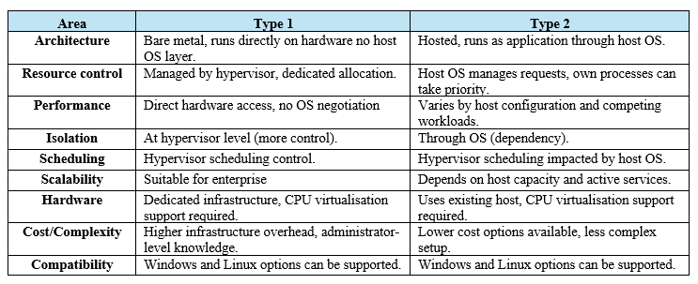

Type 1 offers direct resource allocation, providing stronger isolation between guest systems. Higher infrastructure overhead and administrator-level knowledge are required. Scheduling across virtual machines affects CPU time and memory distribution regardless of type [1] [3]. Virtualisation provides computational isolation between guest systems on shared hardware. Systems with different roles can be serviced and monitored independently [4].
Alternative models e.g. container-based virtualisation shares the host OS kernel while maintaining isolation of processes [5]. System behaviour and performance, therefore, depends not only on hardware capacity but also on resource allocation and scheduling.
The hypervisor must be compatible with and provide cross-system support between Windows and Debian. S-DC provides services to both across the SWANSEA.ACCA domain.
Performance being workload dependent, suitability depends on configuration and intended use rather than classification alone. Windows Server 2022 requires significantly more RAM, storage and processing overhead than Debian. Host capacity must support the combined demands of the host system, its services and all virtual machines running alongside each other (Table 2).
Table 2 – Hypervisor considerations [2] [6].
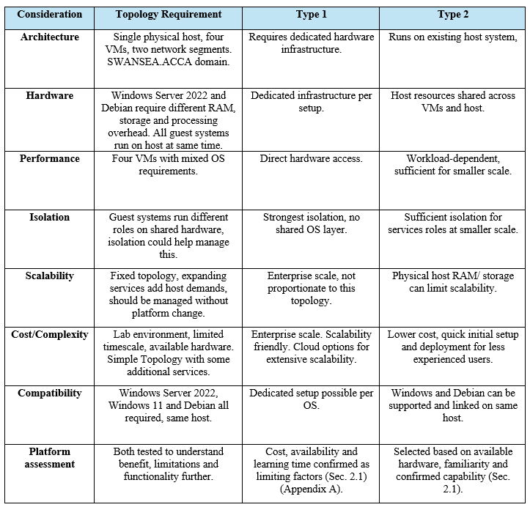

Type 2 initially appeared suitable, however assessing platform through themed criteria, research and practical experimentation helped avoid assumptions (Sec. 2.1).

IP Addressing and Network Structure
Assigning IP addresses to network connected devices enables data, broken into packets, containing source and destination addresses to be routed between nodes (sent and delivered). They are dynamically issued by internet providers or assigned by Dynamic Host Configuration Protocol (DHCP) servers (Sec. 1.4), for efficiency. Or manually configured as static, for stability [7].
IPv4 address length (Fig. 1) limits available addresses against growing global demand across allocation frameworks. Private IPv4 allowed internal networks scalability without impacting public address availability, using Network Address Translation (NAT) to map internal addresses to externally routable ones, useful for large enterprises [8] [9].
Introducing larger IPv6 (also with NAT) helped resolve address limitations (Fig.1). IPv4 is still used due to existing infrastructure compatibility, creating hybrid setups involving different software, hardware and protocols [10].
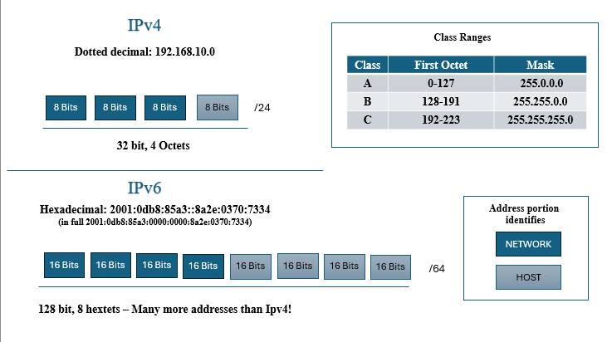
Figure 1: Logically structured IPv4 and IPv6 address formats [11] [12].
Subnetting by class enables logical separation of networks, limits broadcast scope, improving control over usage (Fig.1).
Classless addressing subnets within boundaries for sizing by requirement (Fig 2). When directing at the default gateway, incorrect mask configuration between network and host section misidentifies networks, or if hosts are local or remote. Default gateway misconfiguration means packets cannot be forwarded outside networks (Fig. 1). Checks and tests (traceroute, ping, ipconfig) can help identify communication issues and point of failure.

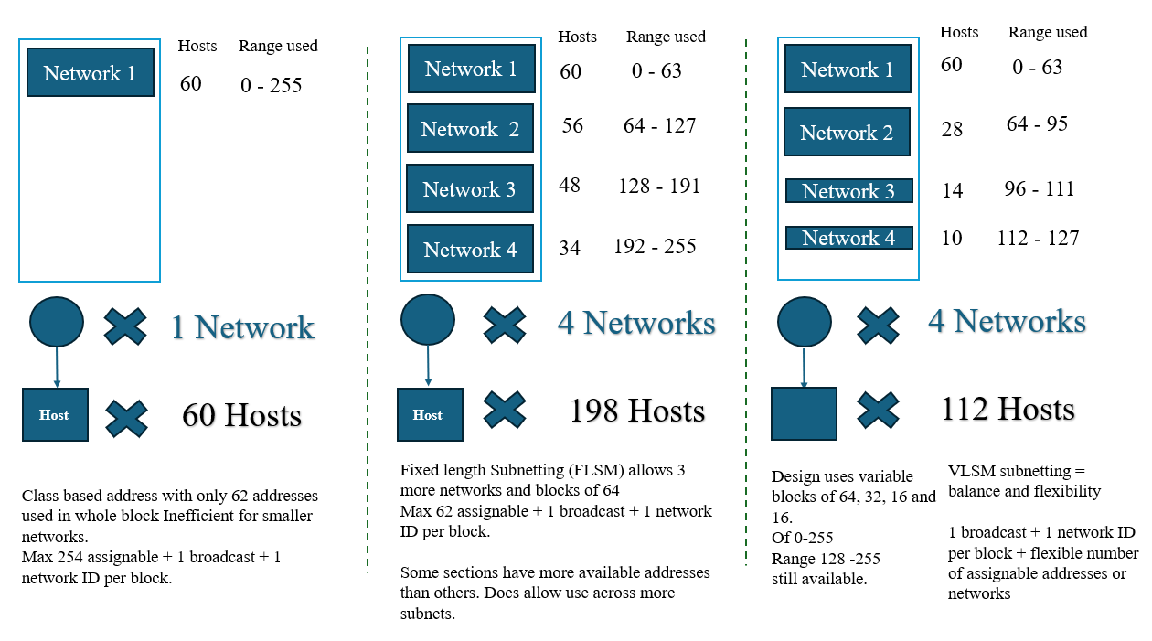
Figure 2: Benefits of classless subnetting, subdividing a single network increases availability and flexibility [11].

IP addressing infers geographic origin, accuracy is impacted by translation, proxies and Virtual Private Networks (VPNs), altering or masking origin IP addresses [13].

Routing Between Network Segments
Routing controls which IP networks can communicate, paths traffic follows and when traffic must leave local networks to reach connected networks.
Switches forward traffic to individual local network devices using layer 2 device-specific MAC addresses, routers forward packets between networks using layer 3 IP addressing and routing tables to determine the next hop [14] [15].
Static and dynamic routing differ in how routes are established, maintained and controlled. Static routing requires manual configuration, giving administrators direct control but changes mean manual updates. A default route (0.0.0.0/0) forwards unmatched traffic via a single gateway and exit point. Dynamic routing automates routing through protocol exchanges, reducing administration but adding protocol overheads (Table 3).

Table 3: Static and dynamic routing comparison [6][16][17].
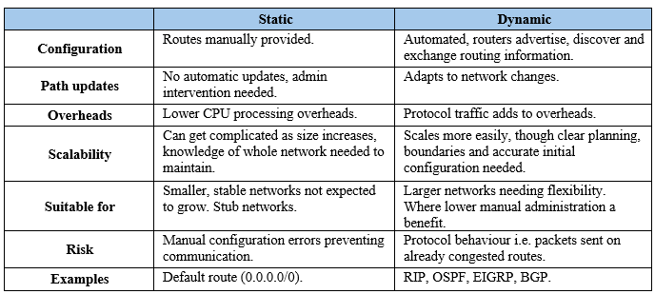

Some dynamic protocols select a ‘best path’ regardless of congestion, leaving alternative paths unused, limitations Software Defined Networking (SDN) considers [18].
This topology has a single route between networks suiting static routing. Dynamic routing adds configuration overhead without additional path routing benefits. Dynamic pprotocols vary in how they determine best paths, selection can be dependent on network characteristics and scale (Table 4).

Table 4: Routing protocol comparison [19].
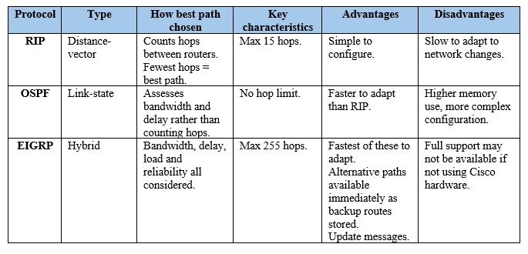

A Debian server acts as a DHCP relay, forwarding client broadcast requests to the Windows DHCP server. To function, routing must be correct across boundaries, incorrect or missing routes affect all services and connectivity, including domain authentication (Sec. 1.4).

Network Services in an Enterprise Environment
Network services ensure both users and the systems they connect to can verify identity, reach services reliably and communicate securely.
VPNs are encrypted tunnels between clients and gateways across untrusted networks allowing secure remote access. Incorrectly configured settings or authentication introduces vulnerabilities [20] [21].
DHCP automates IP address allocation. Correct ranges reduce errors, ensures predictable addressing and supports correct distribution of settings to clients. DHCP cannot verify server or client identity, so additional controls are needed [22] [23] [24].
Windows Active Directory Domain Services (AD DS) centralises authentication through domain logon, group policy and structured user management. It depends on the Domain Name System (DNS) to locate domain controllers and service records. Clients depend on DHCP to obtain DNS server addresses [25]. Misconfiguration consequences of any can prevent login or cause service disruption [26].
Certificate Authorities (CAs) issue digital certificates, verifying identities, supporting encrypted communication. Presented certificates are validated, checking in a chain of trust revocation status and other details (Fig. 3). Root Authorities validate intermediate certificates, which then validate end-user certificates before accepting connections. Authenticating and validating identities, not guaranteeing identities can be trusted [27] [28].
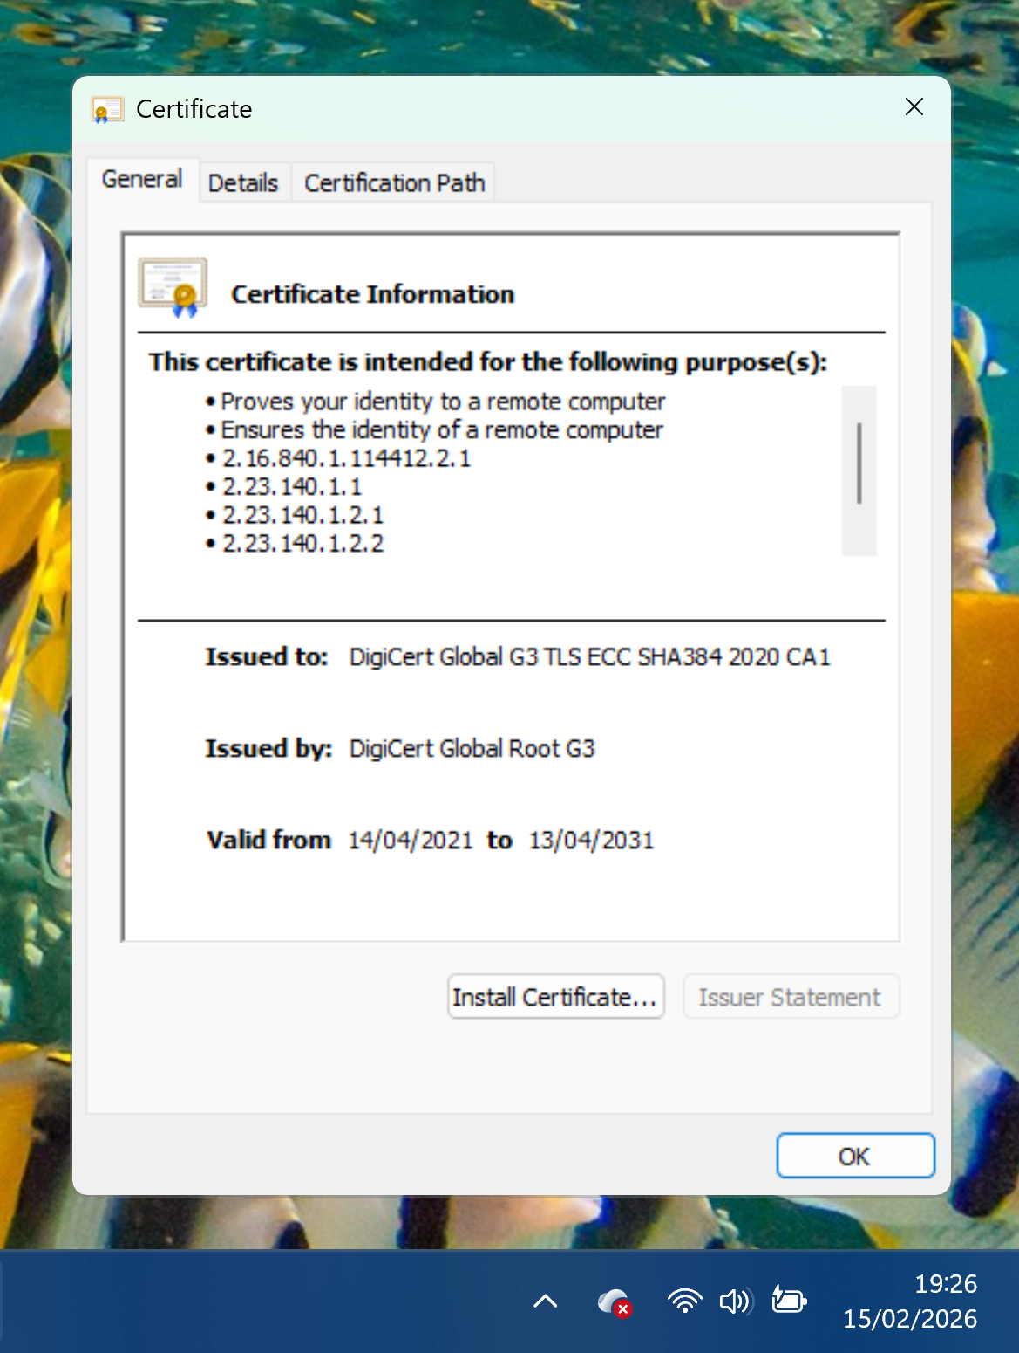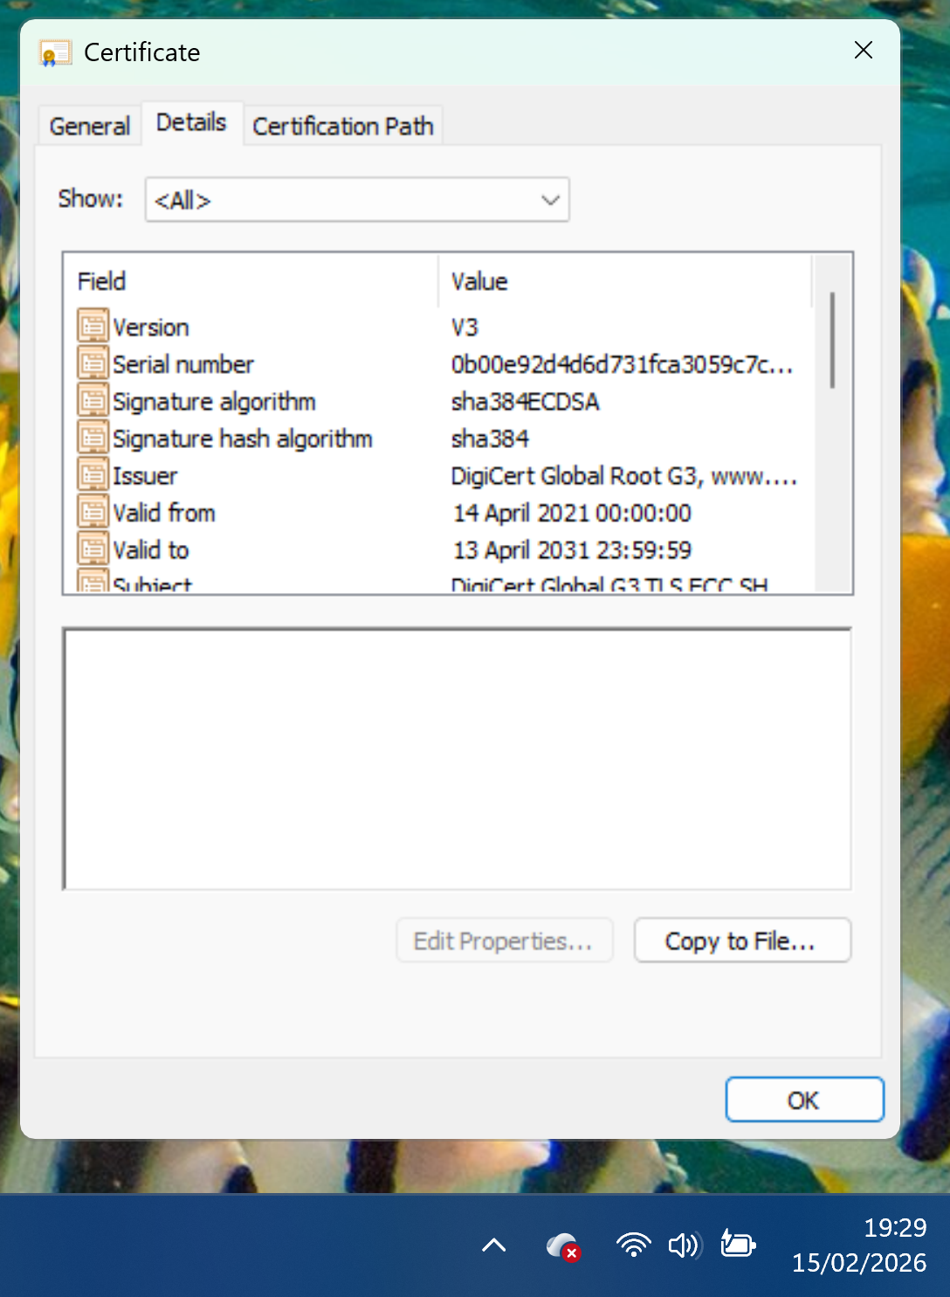
Figure 3: CA DigiCert issued certificate. Shows issuer, validity period, signature algorithm and validation [29].
Active Directory Certificate Services (AD CS) acts as a private CA within Windows domains, issuing and managing certificates for users and services [30]. Secure key storage, controlled renewal and revocation maintain trust. CA services and AD DS both depend on DNS. As both are hosted on S-DC London traffic reaches it only via the point-to-point link, a misconfigured single path could prevent certificate validation, disrupting authentication across SWANSEA.ACCA.

2. Technical Documentation

2.1 Selecting a Hypervisor
Selection analysis was supported by exploration and reflection, decisions were drawn from criteria considerations to challenge preferences (Table 1, Table 5).

Table 5: Hypervisor selection process [31].
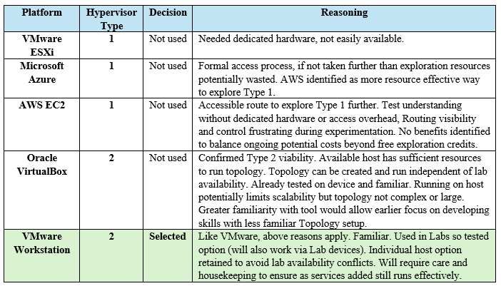

Assessing VM demands on hypervisors, Microsoft Windows Server 2022, Windows 11 and Debian ISO images were downloaded early from official sources with requirements and file sizes noted (Fig 4 and Fig. 5).
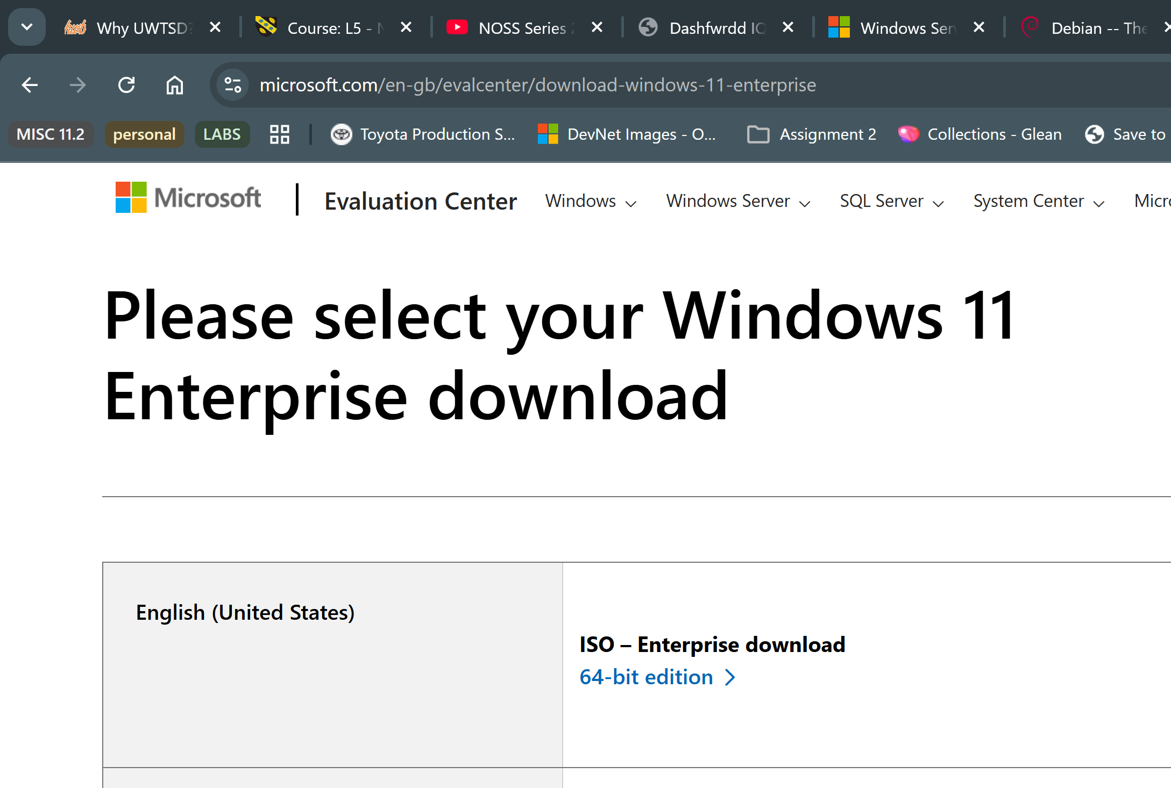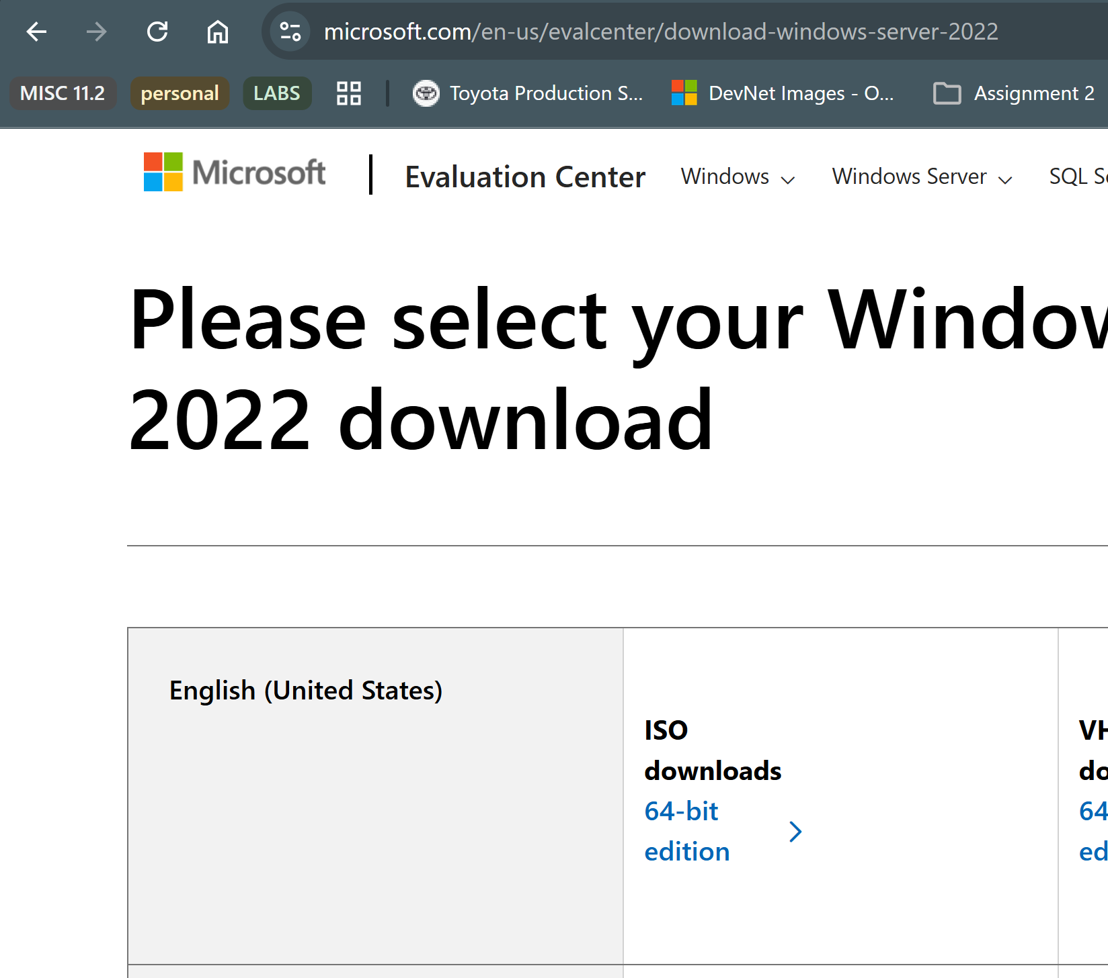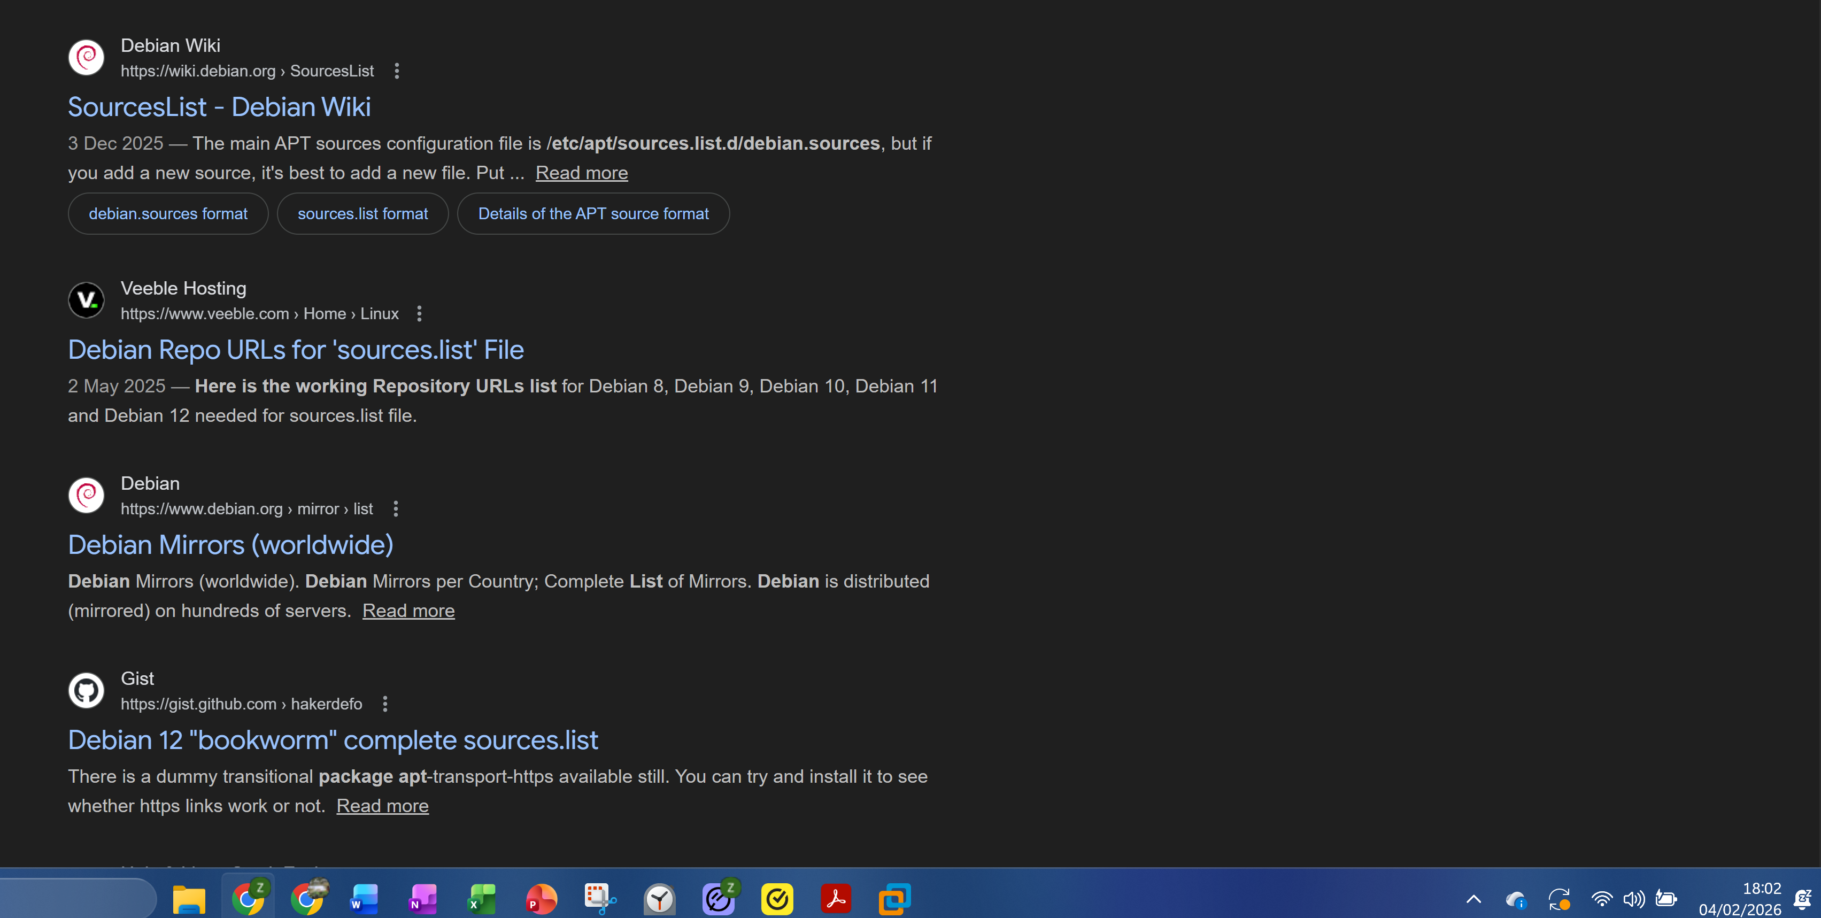
Figure 4: Locating OS images for VM deployment tests in labs.
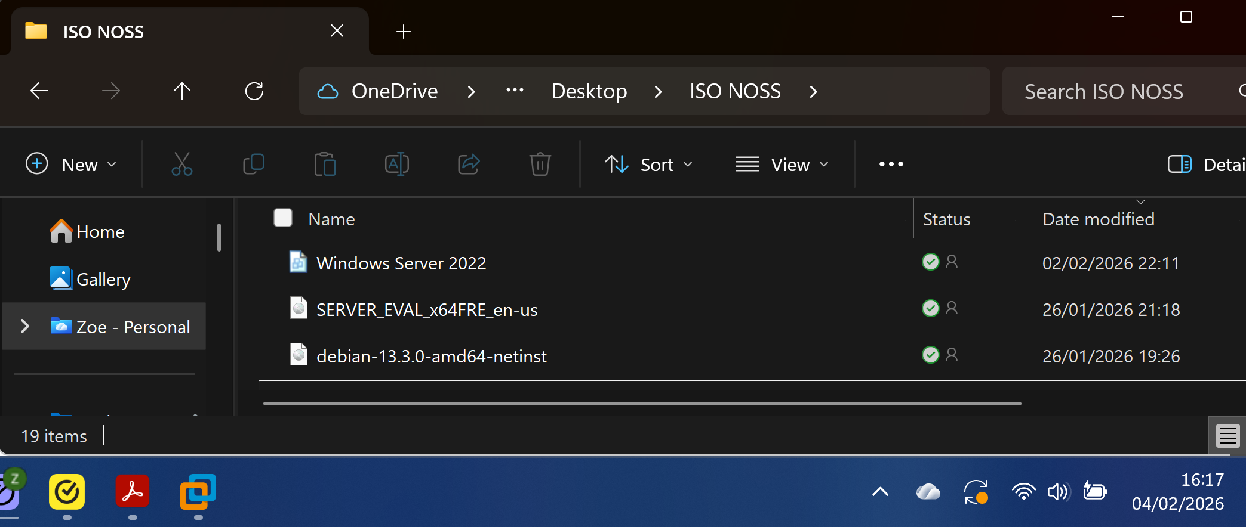
Figure 5: Downloads for VMs, also used during early exploration and familiarisation during labs and independent study).

Section 1.1 identified Type 1 suitability for larger scale environments with dedicated infrastructure (Tables 1 and 2). Dedicated hardware was not practical or available within timescales, excluding VMware ESXi.
Azure required access requests, and setup time before experimentation. Resource investment did not justify against a small topology and short deployment timeframe. Azure remains of interest for independent exploration.
AWS EC2 free testing (limited) and extensive documentation, provided an exploration option for Type 1 style virtualization without hardware investment. Cloud based instances running on providers Nitro Type 1 hypervisor (Fig. 6, Appendix A). Benefits, including provider support, did not balance costs. (Table 5).
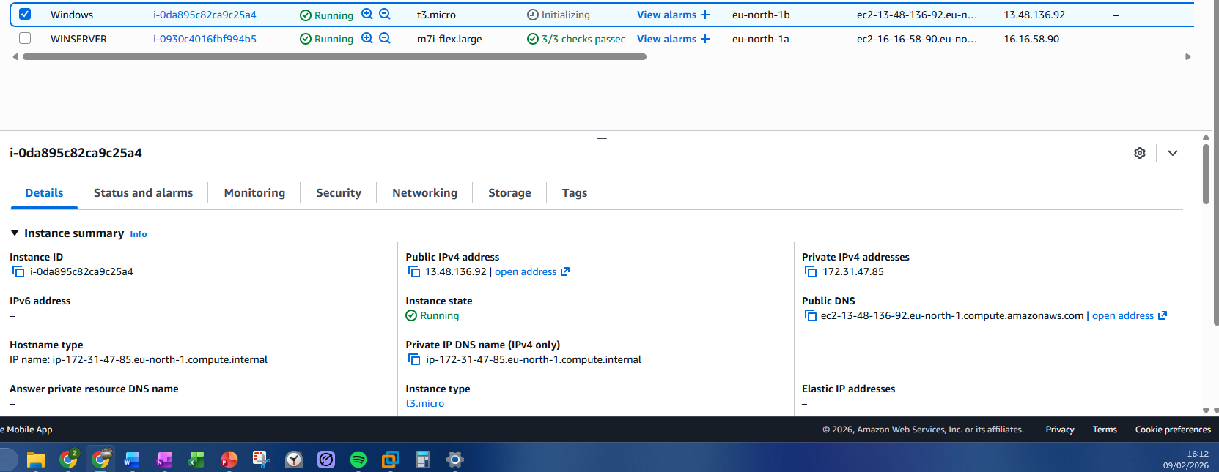
Figure 6: AWS experimentation. Windows VMs added easily from provider resources. Layouts needed further familiarisation over time.

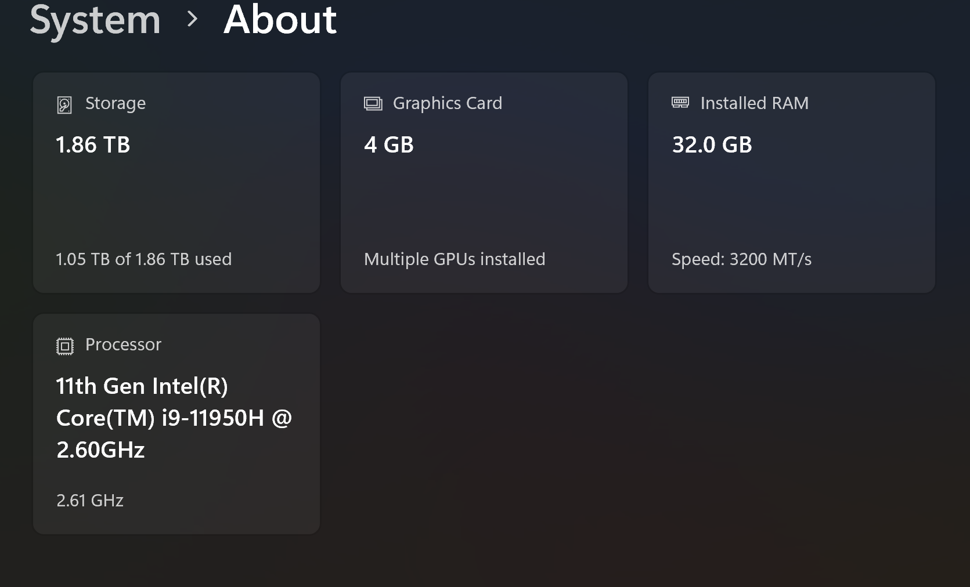
Figure 7: Host system showing sufficient RAM and Storage as confirmed in module lab sessions
Focus shifted to Type 2. VirtualBox and VMware Workstation Pro were explored successfully in labs, demonstrating either could be used on the host. VMware Workstation Pro was selected (Table 5), allowing focus to shift to deployment sooner.
The host capacity (Fig. 7) ensures additional availability for enhanced topology services to be added without redesigning or hypervisor changes. Critical when resource demands increase with additions. To actively manage risks, non-essential host software will be reduced, updates scheduled during low-demand periods, VMs snapshotted and backed up to cloud to ensure greater stability and reliability of performance. Copies held on a Lab machine and Hard Drive are manageable at this scale support continuity in case of host failure.

2.2 Building and Deploying the environment
OS images were downloaded during hypervisor selection (Sec. 2.1, Fig. 4 and Fig. 5). Module guidance, Debian guidance and Linux commands along with prior experience configuring Windows VMs in VirtualBox supported deployment steps.
VMs were created in VMware Workstation Pro with ISO images attached. hardware resources and RAM allocations per machine (Fig. 8).
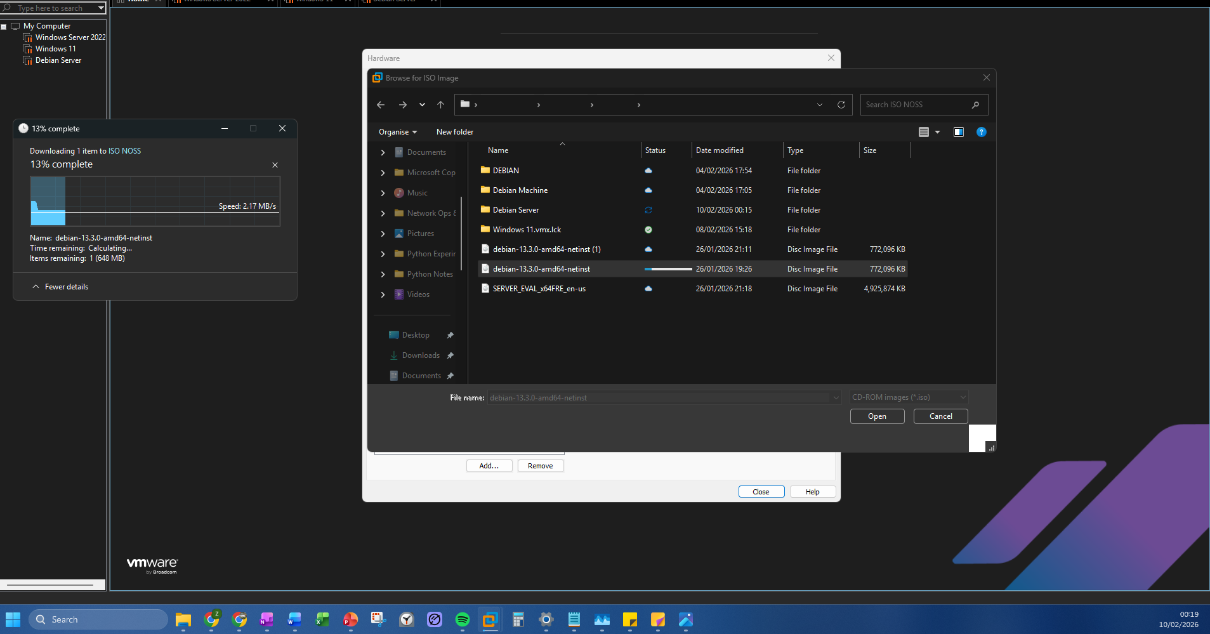
Figure 8: Setting up Virtual devices on VMware Workstation Pro. Images shows Debian Client image being added.

To avoid overallocation of host resources, allocation was by demand, S-DC as domain controller had the largest. Debian Server is CLI and Linux based that had much less. Clients both had GUI overheads but no services so allocated less. Machines renamed for easier reference against topology (Fig. 9).
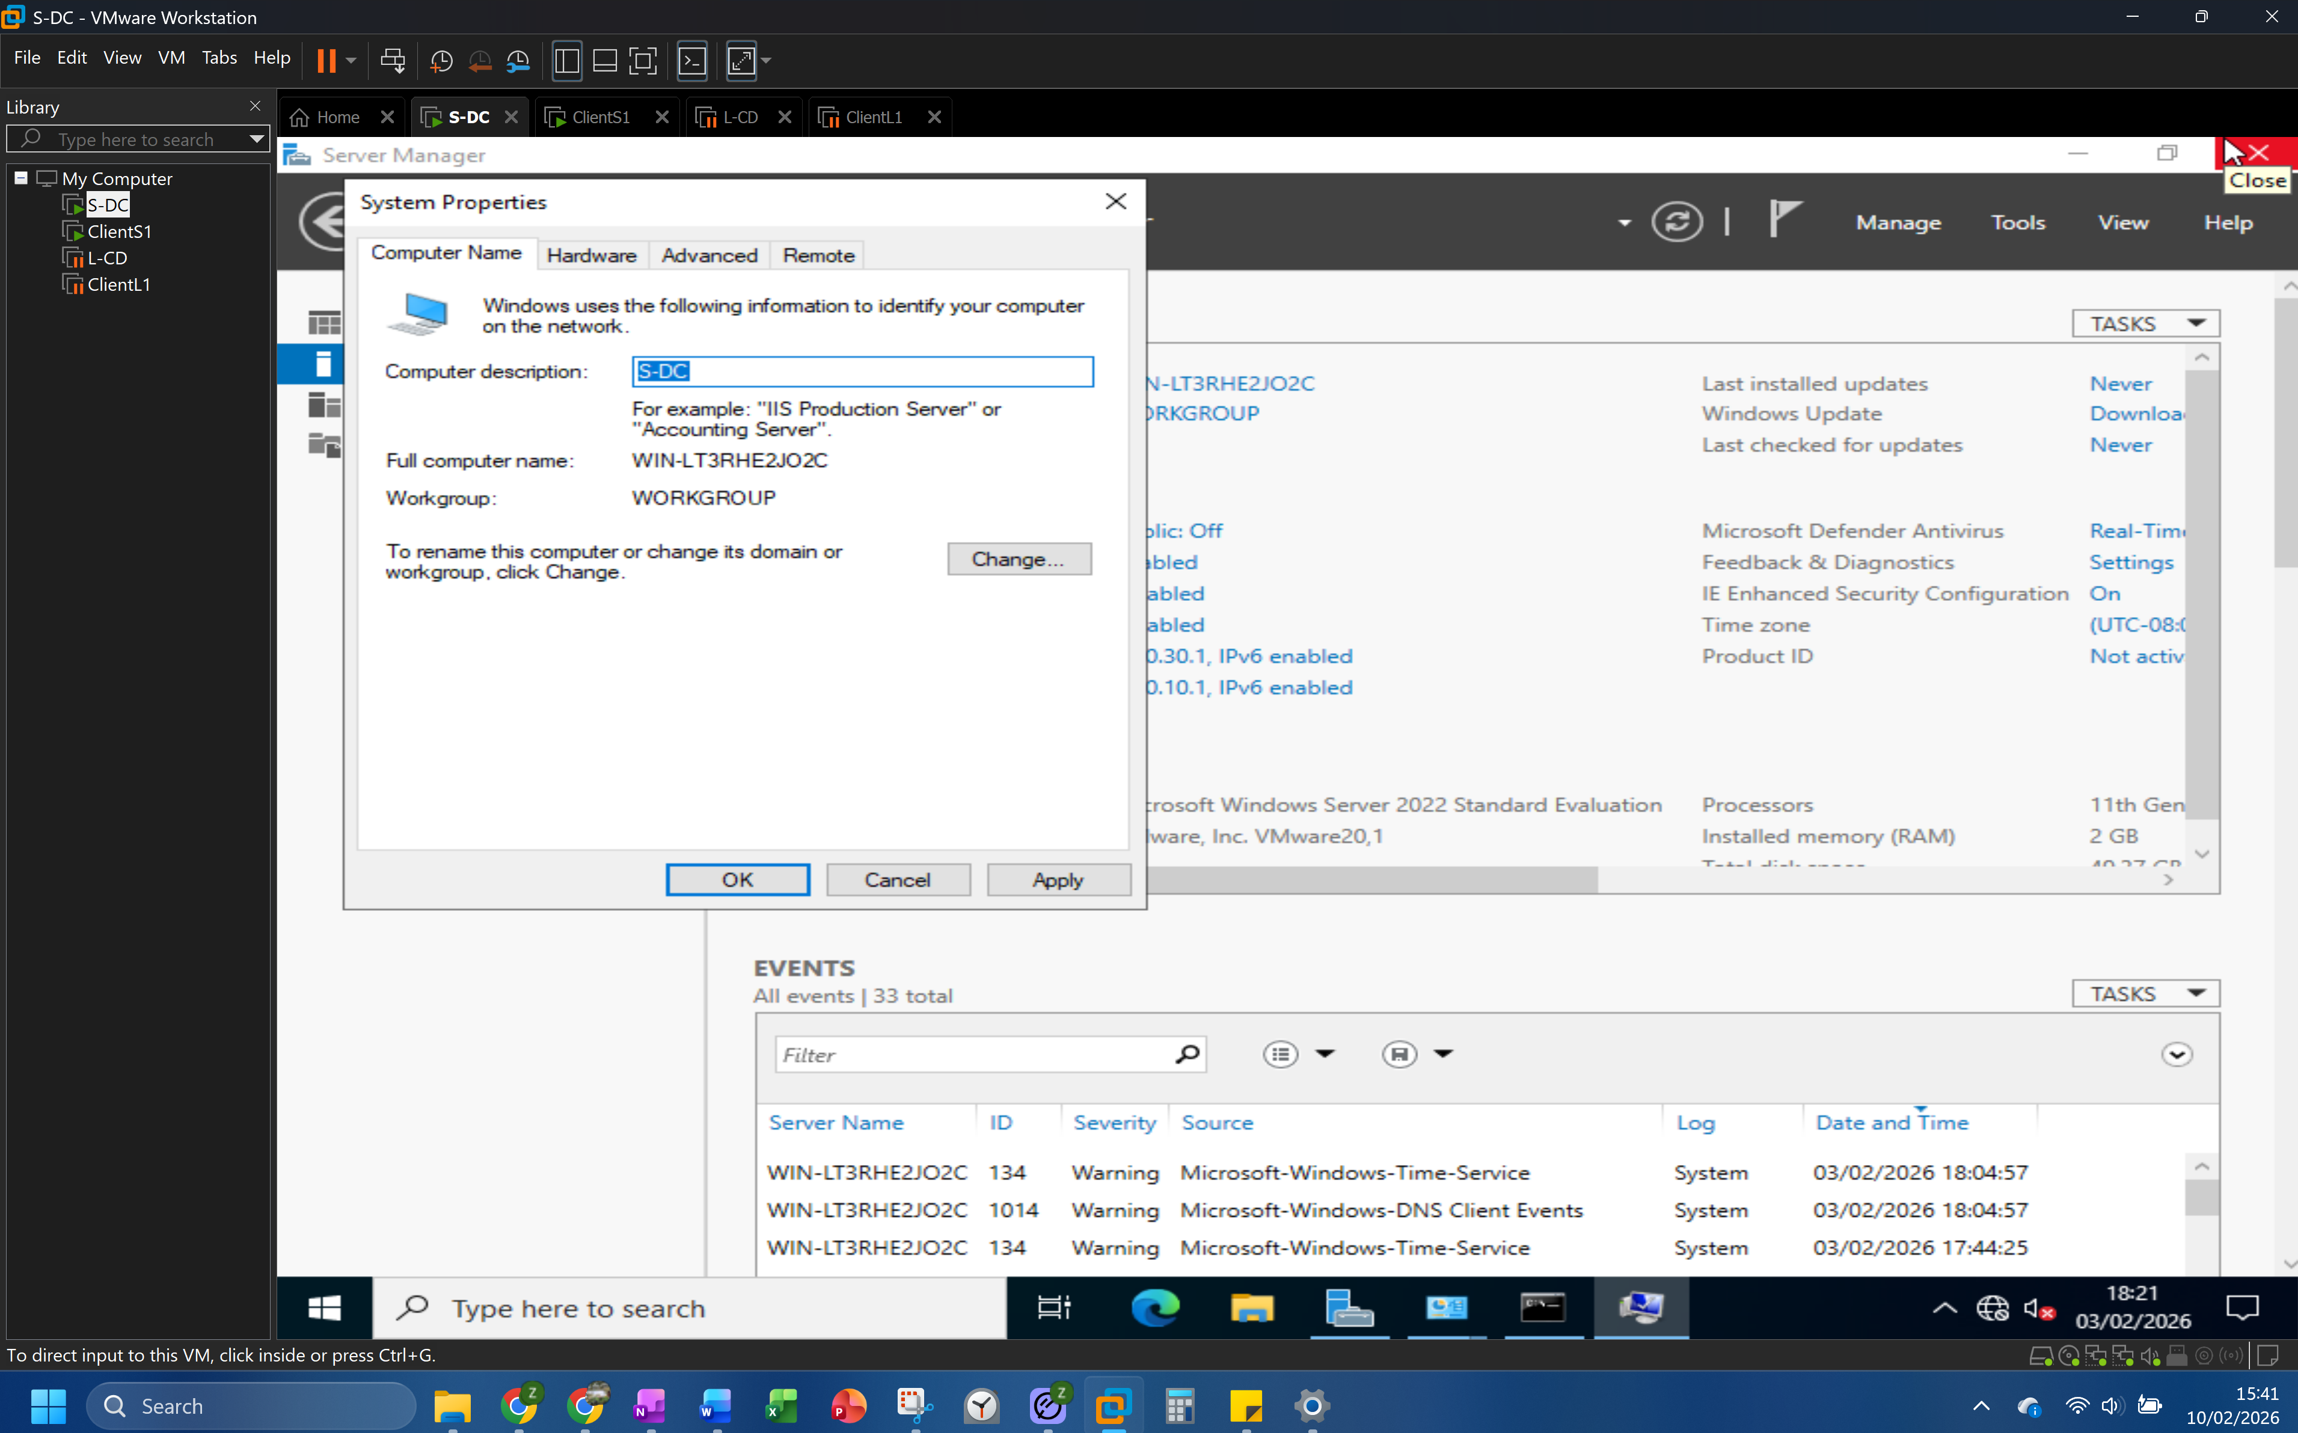
Figure 9: Devices Renamed to match topology.
Debian installations were updated via apt on installation with sources configured from Debian repositories. Adding Open-VM-tools improved functionality such as mouse clicks. SSH was configured on the Debian server for easier command input than the CLI.

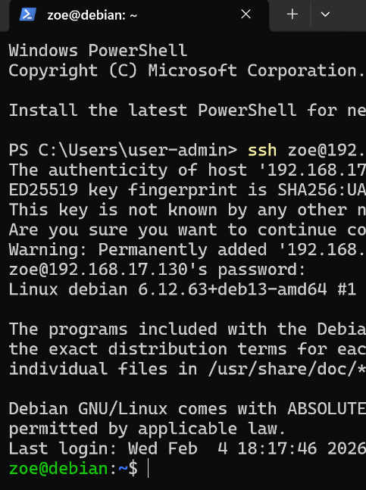
Figure 10: SSH connection from Windows host to Debian server.

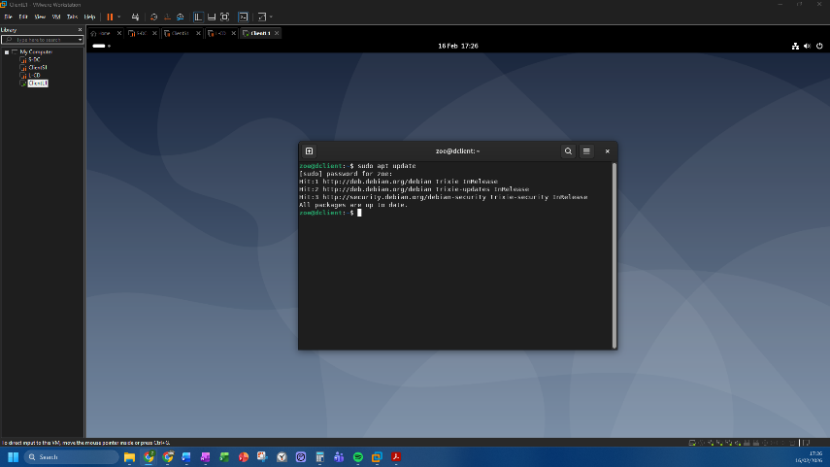
Figure 11: Ensuring latest updates are installed on Debian Client.

Network adapters added and interfaces configured. Windows via Control Panel Network and Sharing Centre, Debian via file source /etc/network/interfaces.d/*. Initially in labs and exploration, the standard IP addressing scheme was used for testing. Then later replaced with a scheme designed specifically for this deployment.

2.3 Designing and Configuring IP Addressing
A Variable Length Subnet Masking (VLSM) addressing scheme was designed using the 10.0.0.0/16 Class A private address range.
Subnet blocks were calculated, just enough for fixed point to point, some scalability per segment using logic shown in Figure 2. Non-sequential address blocks were used for individual segments, to identify between London, Swansea and the point to point (between servers) segments (Table 6).
Table 6: Own Addressing scheme using subnets
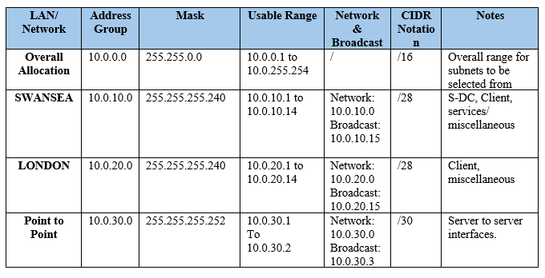
Subnet sizes were calculated for individual segments rather than the same size block/ mask as the point to point required only 2 usable addresses. A smaller block with less usable addresses further reduces waste. The larger Swansea and London blocks allow for easier addition of further hosts without redesign, balanced with keeping the number of unused addresses low.
Segmenting Swansea and London into subnets limits broadcast traffic to each segment and restricts lateral movement, supporting performance and security. Remaining address space within the /16 is retained for additional subnets as the topology expands (Table 6).
IP addresses were configured and connectivity confirmed on all devices (Sec.2.4. Fig. 12 and Fig. 13). Default gateways were added to assist routing. As S-DC acts as the gateway for the Swansea segment, no default gateway is required on the internal adapter (Fig 12).

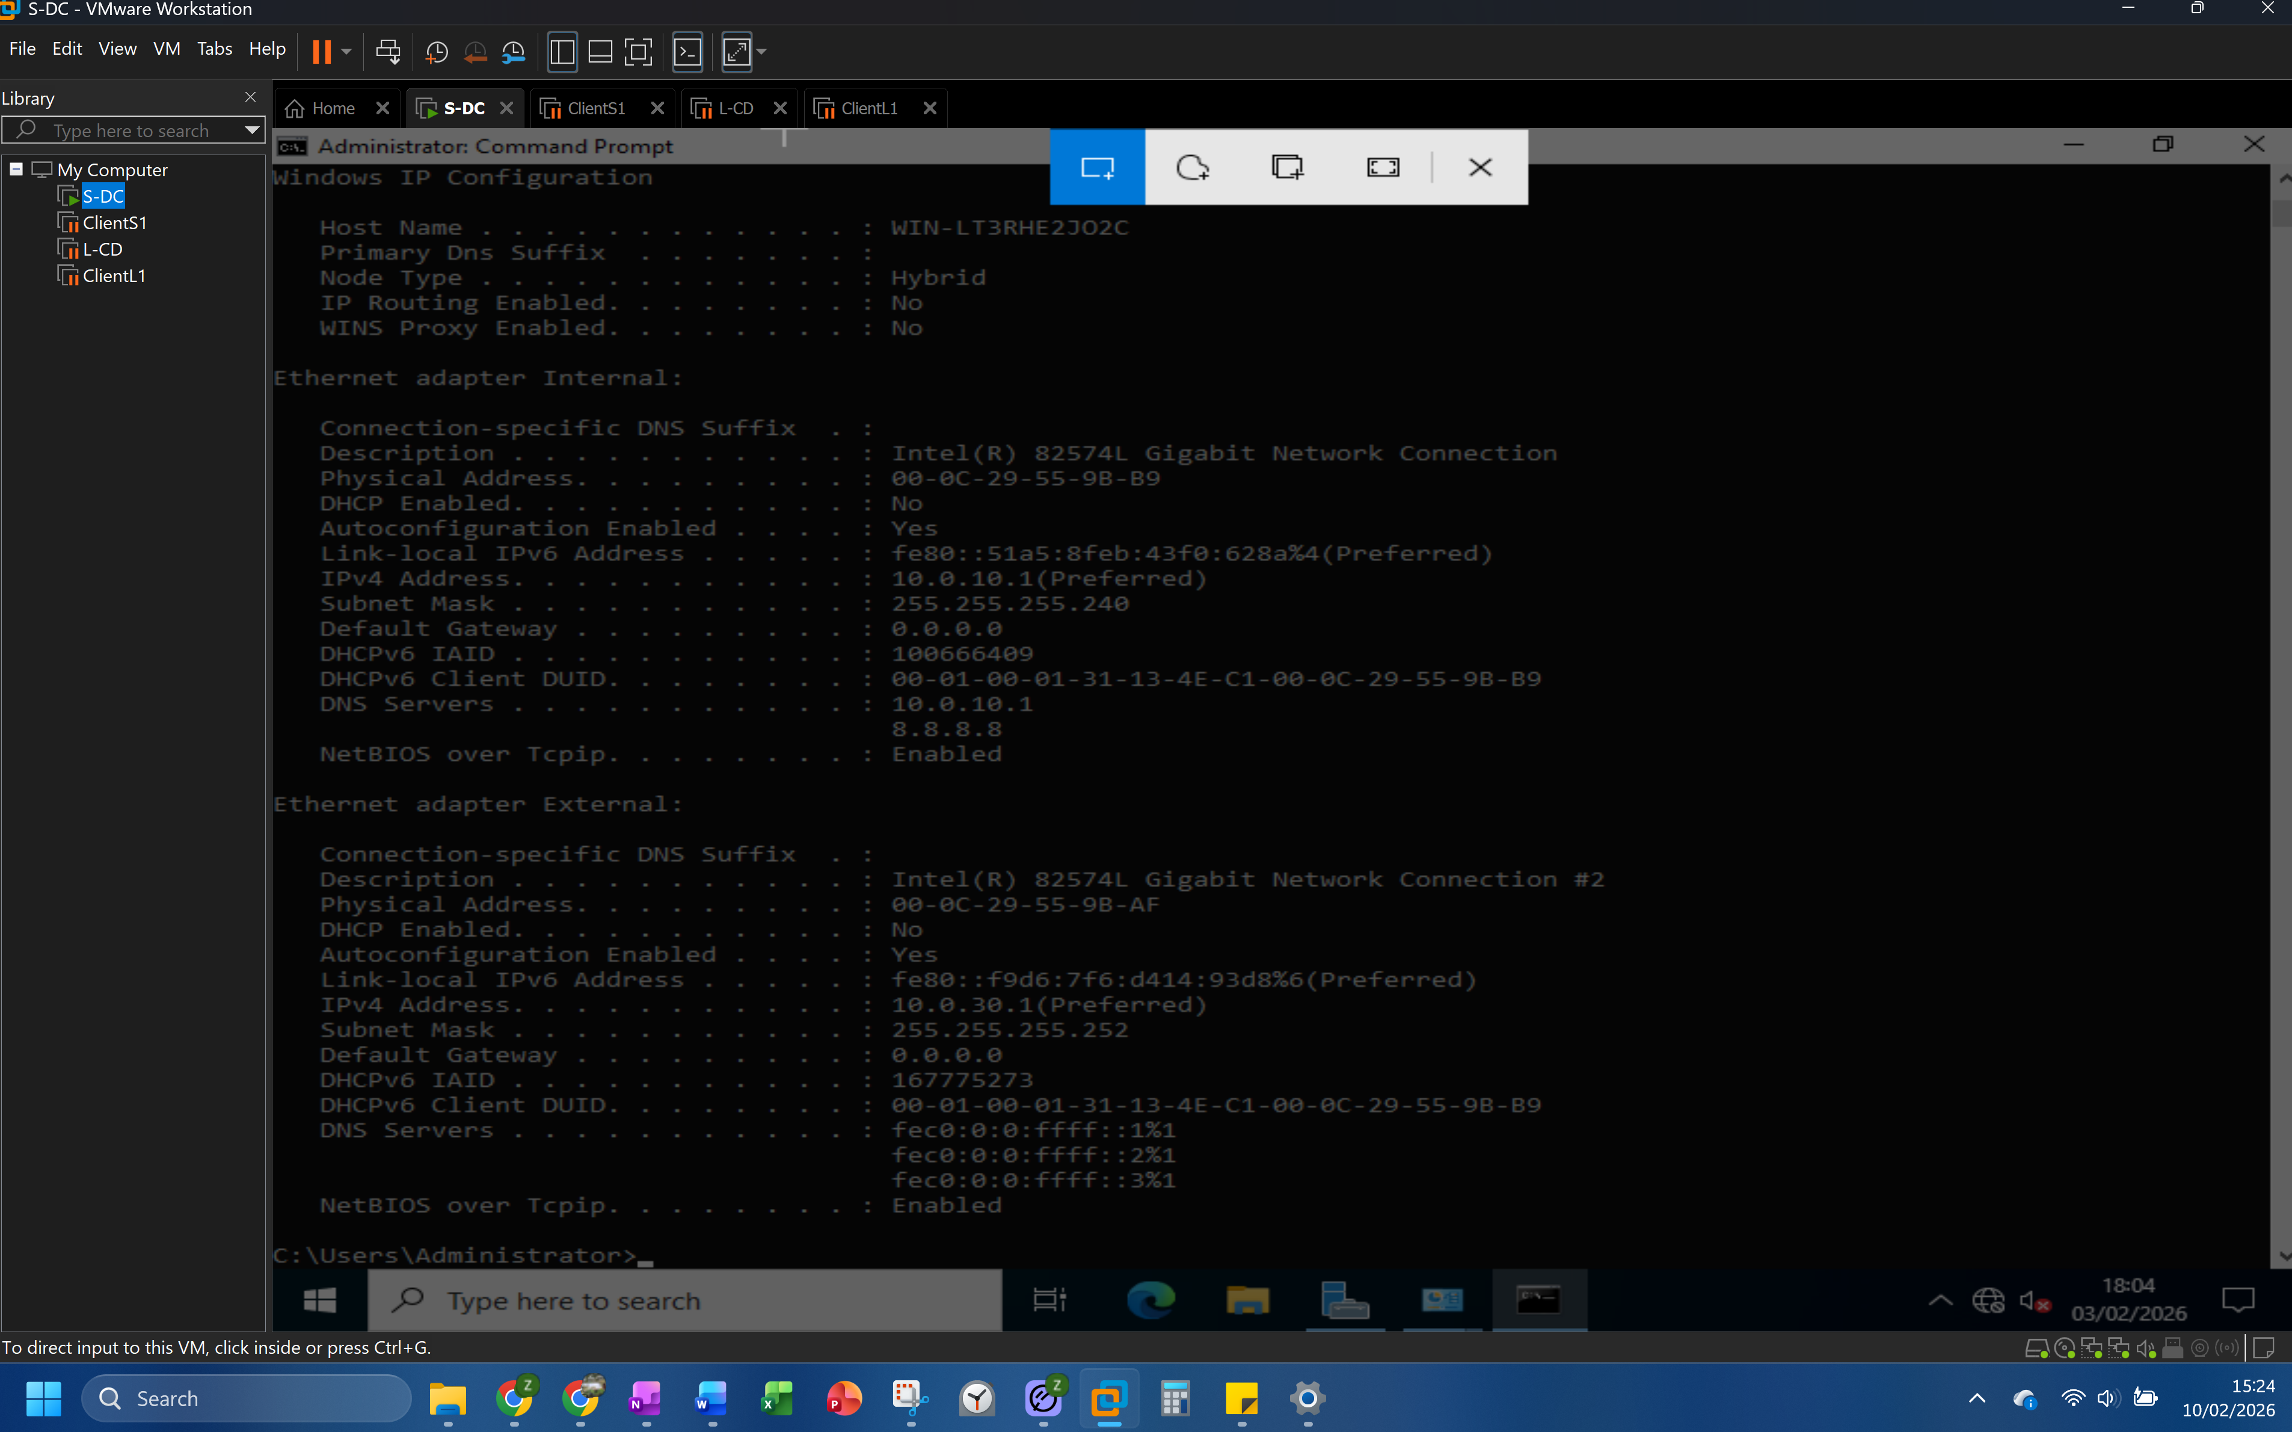
Figure 12: ipconfig shows configuration in progress for S-DC. No default gateway on internal adapter as this is the Swansea segment gateway.

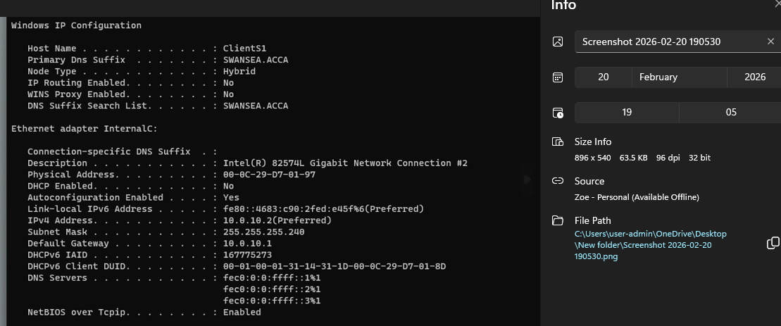
Figure 13: ClientS1 ipconfig confirming address assignment

2.4 Testing, Validation and Troubleshooting

Connectivity tests were performed, pinging devices in sequence from self to the next device along in sequence, to identify any communication issues and the point they occur.
During testing, the first ping failed from ClientS1 to S-DC. The server did not respond to the client. Methodical retracing of configuration steps, considering common causes first, quickly identified an easily resolved issue. S-DC firewall was not fully switched off. Human error, despite prior knowledge and intent, producing the same impact as technical faults or misconfiguration.
ClientS1 VM froze on initial loading twice. On closing host applications, Task Manager provided no clues, so to refresh settings the host was rebooted. This resulted in a Windows update notification. Following update completion, the VM reinstalled successfully. This confirmed that Host OS prioritising, system readiness and update status can affect performance and reliability especially during high demand. The resulting checks then picked up a further key issue.
S-DC was initially deployed, (error, not intent) with insufficient storage and adapter configuration. While working at this stage this risked failure later. Once rebuilt with correct specifications and verified, the original VM was removed to avoid conflicts and the new one renamed. The type of errors could be reduced by using checklists and renaming being prioritised.

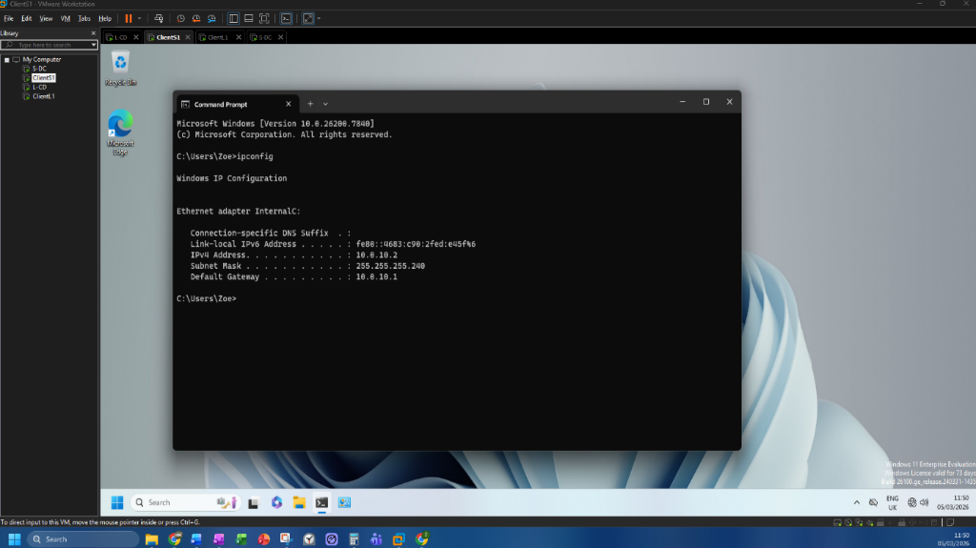
Figure 14: Interface configuration on Windows ClientS-1, using S-DC default gateway.

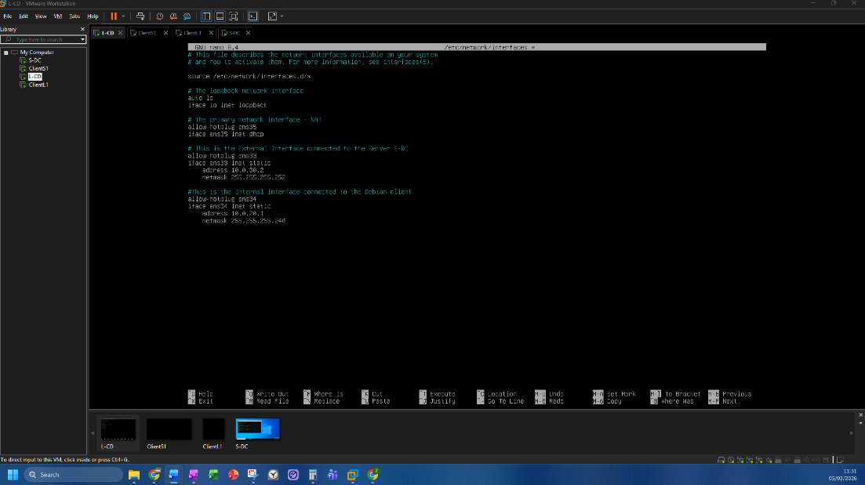
Figure 15: Interface configured via CLI on London Debian server, L-CD

Noted is additional adapters remained on client VMs from the exploration phase and an error with ClientS1 given 3 interfaces (server S-DC needs 3, client 1). Resolving before next stages is crucial to avoid confusion and conflicts from redundant interfaces, especially when adding network services.

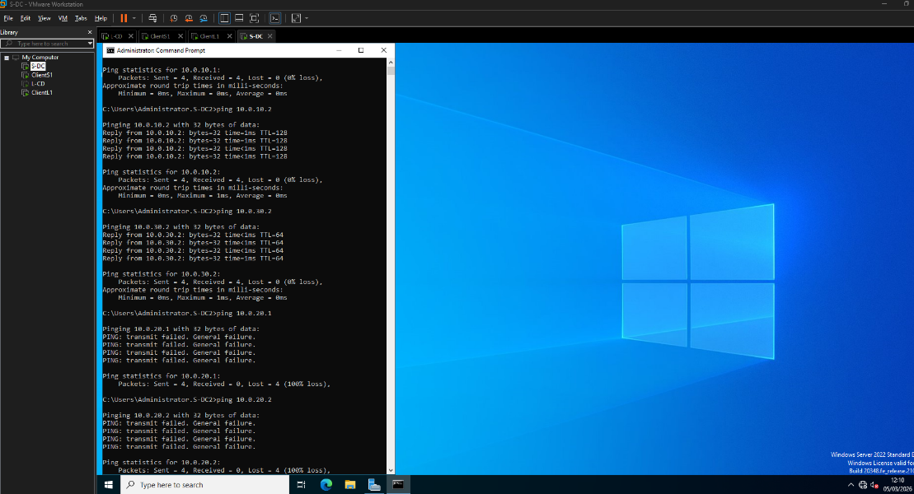
Figure 16: Pings from S-DC. “General Failure” message confirms does not know which interface to send traffic to outside of network (routing.)

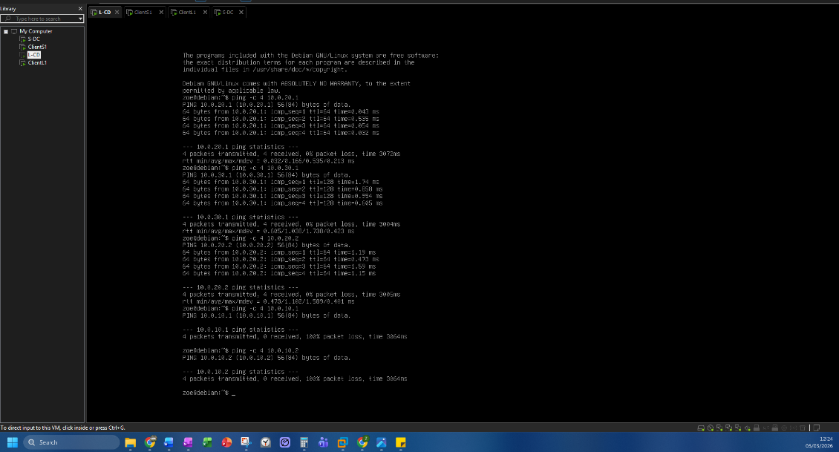
Figure 17: Pings from L-CD
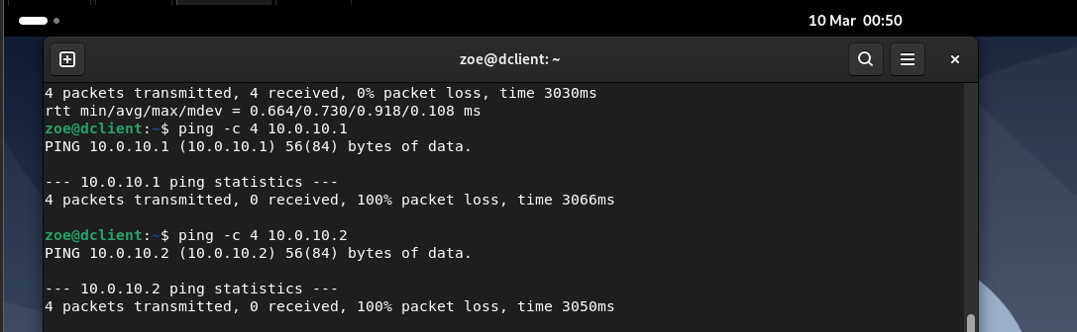
Figure 18: Pings from Client L-1

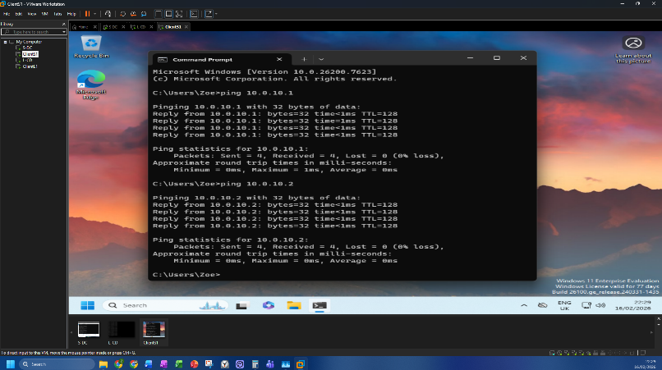
Figure 19: Pings from Client S1
Cross-network testing between Swansea and London segments failed, as expected (Fig 16) routing in the next stage is expected to enable connectivity.

3. A Reflection

3.1 Technical Reflection – Deployment and Testing

Time invested building understanding and deepening knowledge proved valuable despite tight timeframes. Research, planning and practical exploration and considering potential issues informed decisions, smoothing deployment. Preparation reduces rather than eliminates errors. Human and technical errors still occur, therefore troubleshooting, clarifying expected behaviours and common issues are part of deployment processes.
A methodical approach supported initial checks (step-by-step ping checks) and worked as a troubleshooting approach. This helps pinpoint location, conditions and context as a starting point for investigation. Understanding the design, choices and functionality of the tools helped awareness of common issues.
Information gathering underpinned, informing from preparation onwards. Technical documentation and community resources supported further exploration and resolution. Tasks impact each other, grouping and clear flow aids overall completion.

3.2 Personal Reflection

Hypervisor selection became manageable by assessing across criteria (Table 2). Exploring alternative options, including AWS experimentation, challenged familiar choices and potential bias.
Designing an IP addressing scheme provided scope for skills but introduced risks of addressing conflicts and boundary overlaps. Taking a calculated risk on an optional choice aided confidence with successful configuration and ping tests.
A Trello Kanban board assisted time management. The process of organising, assisting planning and action aided reflection on required steps, equipment, research etc., resulting in timely completion of initial deployment.
Prior experiences with VMware Workstation Pro, VirtualBox, Azure and AWS in enterprise environments helped however valuable perspectives in design and deployment along with the AWS experimentation has strengthened professional understanding and use.

Conclusion
In an enterprise environment, platform choice could consider organisational scale, available expertise and long-term support capacity. Dedicated hardware or alternative infrastructure models could remove performance limitations associated with a shared host. This implementation provides a functioning foundation for further development outside of the scope here.
The virtualised network for NOSS2026 has been successfully deployed. Initial exploration of the required network services for the enhanced topology has begun. Further deployment has paused here to focus on developing understanding before further implementation.

Figures

Figure 1: Logically structured IPv4 and IPv6 address formats [11] [12]. 4
Figure 2: Benefits of classless subnetting, subdividing a single network increases availability and flexibility [11]. 5
Figure 3: CA DigiCert issued certificate. Shows issuer, validity period, signature algorithm and validation [29]. 8
Figure 4: Locating OS images for VM deployment tests in labs. 9
Figure 5: Downloads for VMs, also used during early exploration and familiarisation during labs and independent study). 10
Figure 6: AWS experimentation. Windows VMs added easily from provider resources. Layouts needed further familiarisation over time. 10
Figure 7: Host system showing sufficient RAM and Storage as confirmed in module lab sessions 11
Figure 8: Setting up Virtual devices on VMware Workstation Pro. Images shows Debian Client image being added. 12
Figure 9: Devices Renamed to match topology. 12
Figure 10: SSH connection from Windows host to Debian server. 13
Figure 11: Ensuring latest updates are installed on Debian Client. 13
Figure 12: ipconfig shows configuration in progress for S-DC. No default gateway on internal adapter as this is the Swansea segment gateway. 15
Figure 13: ClientS1 ipconfig confirming address assignment 15
Figure 14: Interface configuration on Windows ClientS-1, using S-DC default gateway. 16
Figure 15: Interface configured via CLI on London Debian server, L-CD 17
Figure 16: Pings from S-DC. “General Failure” message confirms does not know which interface to send traffic to outside of network (routing.) 17
Figure 17: Pings from L-CD 18
Figure 18: Pings from Client L-1 18
Figure 19: Pings from Client S1 18
Figure 20:Example of AWS support material available 25
Figure 21: Launching an AWS instance 25
Figure 22: AWS setup exploration: Built in security features and prompts. 26
Figure 23: Windows Server running. Time difference from Fig 22 shows efficient setup even for novices 26
Figure 24: Renaming Swansea Windows server S-DC. 27
Figure 25: Renaming Swansea Windows 11 client ClientS1. 27
Figure 26: Renamed London Debian Server L-CD. 28
Figure 27: Renamed London Debian Client, ClientL1. 28

Tables
Table 1: Type 1 and 2 Hypervisors [2]. 1
Table 2 – Hypervisor considerations [2] [6]. 2
Table 3: Static and dynamic routing comparison [6][16][17]. 5
Table 4: Routing protocol comparison [19]. 5
Table 5: Hypervisor selection process [31]. 7
Table 6: Own Addressing scheme using subnets 12

References
[1] C. Xiong et al., “DCS3: A dual-layer co-aware scheduler with stealing balance and synchronized priority in virtualization environments,” IEEE Trans. Comput., vol. 75, no. 1, pp. 365–379, Jan. 2026.
[2] Amazon Web Services, “The difference between Type 1 and Type 2 hypervisors,” AWS. [Online]. Available: https://aws.amazon.com/compare/the-difference-between-type-1-and-type-2-hypervisors/. Accessed: Feb. 9, 2026.
[3] R. Queiroz, T. Cruz, and P. Simões, “Testing the limits of general-purpose hypervisors for real-time control systems,” Microprocess. Microsyst., vol. 99, Art. no. 104848, Mar. 2023.
[4] F. Lesniak, T. Harbaum, and J. Becker, “Low-latency inter-domain communication on the Xen hypervisor,” in Proc. IEEE 16th Int. Symp. Embedded Multicore/Many-core Syst.-on-Chip (MCSoC), 2023, pp. 340–345.
[5] P. Melo, G. J. da Silva, A. B. Vanderlei, D. Beserra, and J. Araujo, “Performance evaluation of containerized virtualization platforms,” SN Comput. Sci., vol. 6, Art. no. 771, 2025.
[6] N. Kaliyamurthy, “Network Operating Systems and Services (ACCA5023),” lecture notes, University of Wales Trinity Saint David, Jan.–Mar. 2026.
[7] NordVPN, “Types of IP addresses,” NordVPN Blog. [Online]. Available: https://nordvpn.com/blog/types-of-ip-addresses/. Accessed: Jan. 27, 2026.
[8] J. K. Smith, “How web companies can deal with IP address exhaustion,” Forbes Tech Council, Oct. 14, 2024. [Online]. Available: https://www.forbes.com/councils/forbestechcouncil/2024/10/14/how-web-companies-can-deal-with-ip-address-exhaustion/. Accessed: Jan. 27, 2026.
[9] M. S. Gill, “Network address translation for inbound connections in paradigm of private network,” Int. J. Adv. Res. Comput. Sci., vol. 7, no. 3, p. 235, 2016.
[10] A. Hsu, N. Feamster, P. Pearce, and F. Li, “The impact of IP version on household internet speed: A comparative study,” Proc. ACM Meas. Anal. Comput. Syst., vol. 9, no. 3, Art. no. 64, 2025.
[11] Microsoft, “TCP/IP addressing and subnetting,” Microsoft Learn. [Online]. Available: https://learn.microsoft.com/en-us/troubleshoot/windows-client/networking/tcpip-addressing-and-subnetting. Accessed: Jan. 27, 2026.
[12] IBM, “IPv4 and IPv6 address formats,” IBM Documentation. [Online]. Available: https://www.ibm.com/docs/en/ts4500-tape-library?topic=functionality-ipv4-ipv6-address-formats. Accessed: Feb. 1, 2026.
[13] A. Zilberman et al., “A survey on geolocation on the internet,” IEEE Commun. Surv. Tutor., vol. 27, no. 5, pp. 3339–3381, 2025.
[14] Cloudflare, “What is a network switch?” Cloudflare Learning Center. [Online]. Available: https://www.cloudflare.com/en-gb/learning/network-layer/what-is-a-network-switch/. Accessed: Feb. 1, 2026.
[15] Cisco Systems, “Network switch vs. router: What’s the difference?” Cisco. [Online]. Available: https://www.cisco.com/c/en_uk/solutions/small-business/resource-center/networking/network-switch-vs-router.html. Accessed: Jan. 27, 2026.
[16] O. Starkova, K. Nikolchev, K. Herasymenko, Y. Ahafonov, and M. Yastrebov, “Virtualization of network functions for the implementation of modern routing methods,” in Proc. 2021 IEEE 8th Int. Conf. Problems of Infocommunications: Science and Technology (PIC S&T), Kharkiv, Ukraine, Oct. 2021, pp. 620–624.
[17] Cisco Systems, “Routing – Static Routes Configuration,” Cisco. [Online]. Available: https://www.cisco.com/c/en/us/td/docs/security/secure-firewall/management-center/device-config/760/management-center-device-config-76/routing-static.html. Accessed: Feb. 4, 2026.
[18] R. Chaudhary and N. Kumar, “EnFlow: An energy-efficient fast flow forwarding scheme for software-defined networks,” IEEE Trans. Intell. Transp. Syst., vol. 22, no. 8, pp. 5293–5309, 2021.
[19] P. Singh and T. Sood, “A comparative analytical survey on RIP, EIGRP and OSPF,” in Proc. 2023 2nd IEEE Delhi Sect. Flagship Conf. (DELCON), 2023. doi: 10.1109/DELCON57910.2023.10127233.
[20] D. Bringhenti, R. Sisto, and F. Valenza, “Automating VPN configuration in computer networks,” IEEE Trans. Dependable Secure Comput., vol. 22, no. 1, pp. 561–578, 2025.
[21] N. Khantamonthon, P. Patpituck, and K. Chimmanee, “Guidelines for organizations on protecting against cyber threats through the use of virtual private networks (VPN),” in Proc. 2025 9th Int. Conf. Information Technology (InCIT), 2025, pp. 215–221.
[22] A. AbdulGhaffar, S. K. Paul, and A. Matrawy, “An analysis of DHCP vulnerabilities, attacks, and countermeasures,” in Proc. 2023 Biennial Symp. Communications (BSC), 2023, pp. 119–124.
[23] Microsoft, “DHCP overview,” Microsoft Learn, Feb. 11, 2025. [Online]. Available: https://learn.microsoft.com/en-us/windows-server/networking/technologies/dhcp/dhcp-top. Accessed: Feb. 11, 2026.
[24] A. Jony and M. N. Islam, “An effective technique to automatically detect and neutralize rogue DHCP server,” in Proc. 2023 Int. Conf. Information and Communication Technology for Sustainable Development (ICICT4SD), 2023, p. 244.
[25] Microsoft, “DNS and AD DS,” Microsoft Learn. [Online]. Available: https://learn.microsoft.com/en-us/windows-server/identity/ad-ds/plan/dns-and-ad-ds. Accessed: Feb. 15, 2026.
[26] Z. Moric, V. Dakic, J. Redzepagic, and F. Otocan, “Penetration testing and exploitation of Active Directory configuration vulnerabilities,” in Proc. 2024 4th Intelligent Cybersecurity Conf. (ICSC), 2024, pp. 118–126. doi: 10.1109/ICSC63108.2024.10895772.
[27] K. Jeziorski, D. McFadden, and R. Lennon, “Verification of Certificate Authorities (CAs) and integration with cloud providers for enhanced security,” in Proc. 2023 Cyber Research Conference – Ireland (Cyber-RCI), 2023.
[28] M. Awad, A. El Allam, K. Salameh, and R. Al Mazrouei, “Phishing for legitimacy: The use of SSL certificates to ensnare Internet users,” in Proc. 2022 Int. Conf. Electrical and Computing Technologies and Applications (ICECTA), 2022, pp. 313–317.
[29] DigiCert, “DigiCert Global G2 TLS RSA SHA256 2020 CA1 certificate,” DigiCert. [Online]. Available: https://cacerts.digicert.com/DigiCertGlobalG2TLSRSASHA2562020CA1-1.crt. Accessed: Feb. 16, 2026.
[30] Microsoft, “Certification authority role,” Microsoft Learn. [Online]. Available: https://learn.microsoft.com/en-us/windows-server/identity/ad-cs/certification-authority-role. Accessed: Feb. 13, 2025.
[31] B. Đorđević, S. Gucunja, N. Kraljević, and N. Davidović, “Performance comparison of different hypervisor versions of the type-2 hypervisor VirtualBox,” in Proc. 2023 10th Int. Conf. Electrical, Electronic and Computing Engineering (IcETRAN), 2023.
[32] S. Chaudhary and R. Johari, “ORuML: Optimized Routing in wireless networks using Machine Learning,” International Journal of Communication Systems, vol. 33, no. 11, 2020.
[33] DigiCert, “What’s the difference between client certificates vs server certificates?,” DigiCert FAQ. [Online]. Available: https://www.digicert.com/faq/public-trust-and-certificates/whats-the-difference-between-client-certificates-vs-server-certificates. Accessed: Feb. 9, 2026.
[34] Debian, “Debian Installer FAQ, ” Debian Wiki. [Online]. Available:https://wiki.debian.org/DebianInstaller/FAQ. Accessed: Feb. 2, 2026.
[35] Debian, “Debian Installer Modify/CD, ” Debian Wiki. [Online]. Available: https://wiki.debian.org/DebianInstaller/Modify/CD#Installing_From_the_New_Image. Accessed: Feb. 2, 2026.
[36] Debian, “Debian GNU/Linux Installation Guide, ” Debian. [Online]. Available: https://www.debian.org/releases/stable/amd64/. Accessed: Feb. 2, 2026.
[37] Debian, “SourcesList, ” Debian Wiki. [Online]. Available: https://wiki.debian.org/SourcesList#Commonly_used_APT_sources. Accessed: Feb. 14, 2026.
[38] TechTalks-GreenHouse, "NOSS Series 2025 Parts 1–4.1," YouTube, 2025. [Online video]. Available: https://www.youtube.com/@TechTalks-GreenHouse . Accessed: Feb. 1, 2026.
[39] Debian, "Package Search: open-vm-tools," Debian Packages. [Online]. Available: https://packages.debian.org/search?keywords=open-vm-tools. Accessed: Feb. 14, 2026.
[40] IONOS, "Netsh," IONOS Digital Guide. [Online]. Available: https://www.ionos.co.uk/digitalguide/server/tools/netsh/#c282082. Accessed: Feb. 9, 2026.
AI Usage
ChatGPT prompt used to check above references list for variables in punctuation
Prompt “Can you please check the list for any punctuation inconstancies and list updates required?”
Answer:
Reference List – Specific Punctuation/Formatting Updates
[2] Access date formatting inconsistent; extra period after URL
[7] Extra period after bracket
[8] Extra period after bracket
[15] Extra period after bracket
[28] Missing period at end
[29] URL missing https://
[30] Minor quotation consistency

Appendices

Appendix A: AWS EC2 Exploration

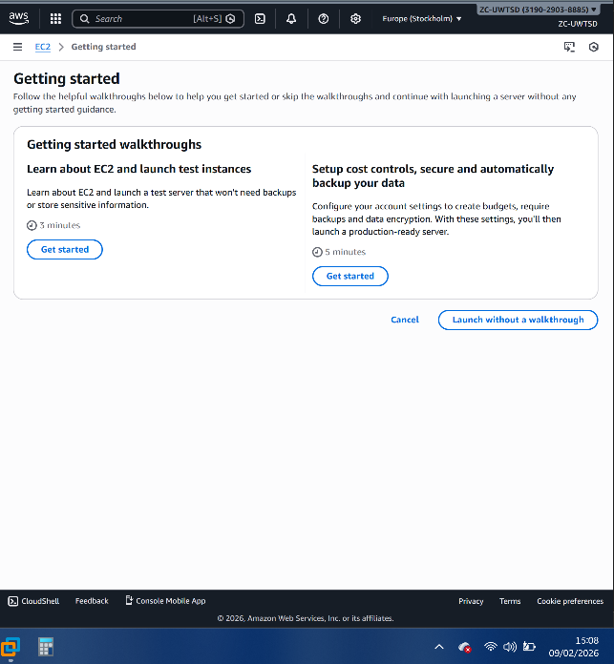
Figure 20:Example of AWS support material available

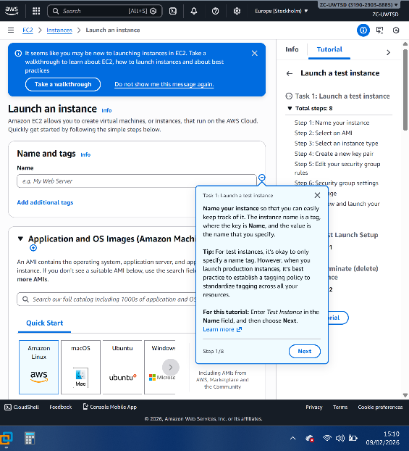
Figure 21: Launching an AWS instance

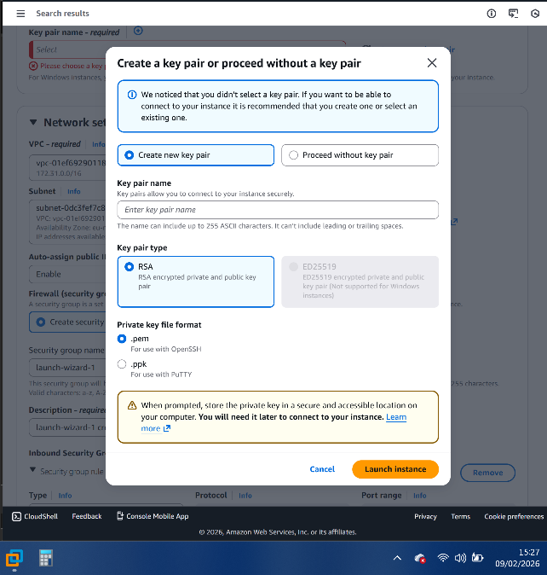
Figure 22: AWS setup exploration: Built in security features and prompts.

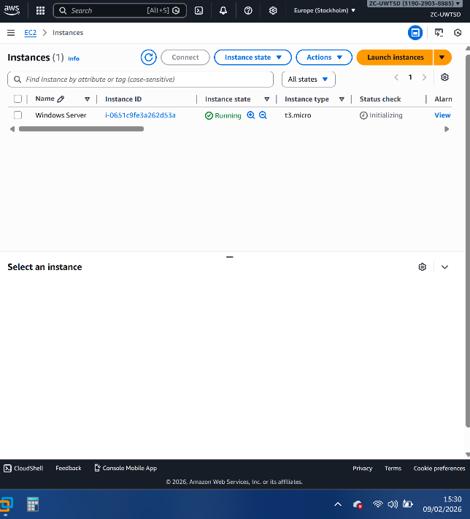
Figure 23: Windows Server running. Time difference from Fig 22 shows efficient setup even for novices

Appendix B: Renaming VMs
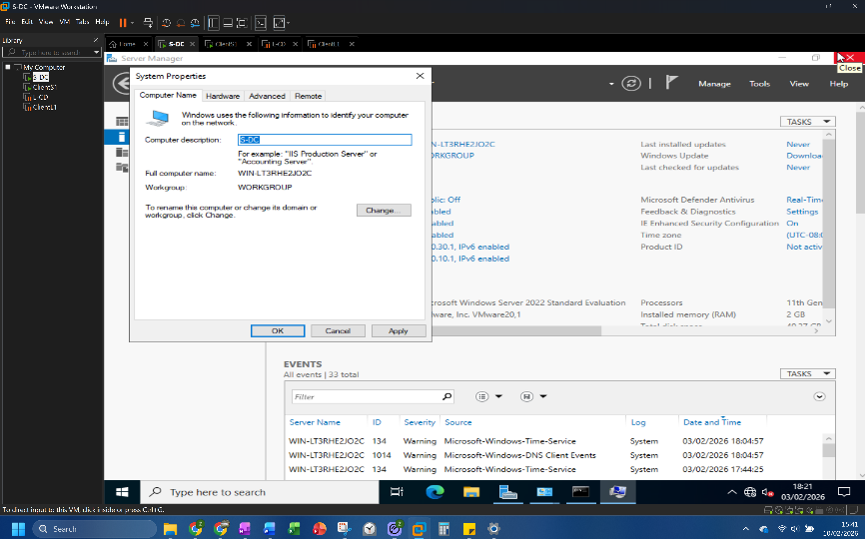
Figure 24: Renaming Swansea Windows server S-DC.

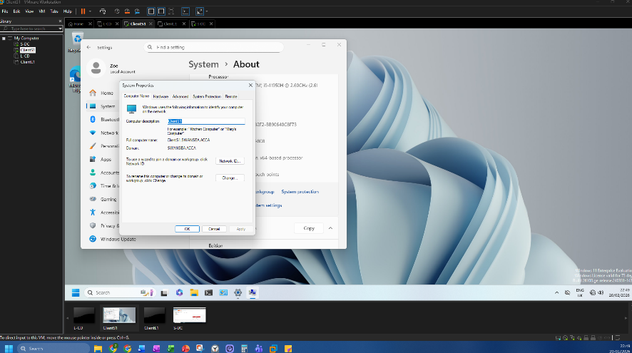
Figure 25: Renaming Swansea Windows 11 client ClientS1.

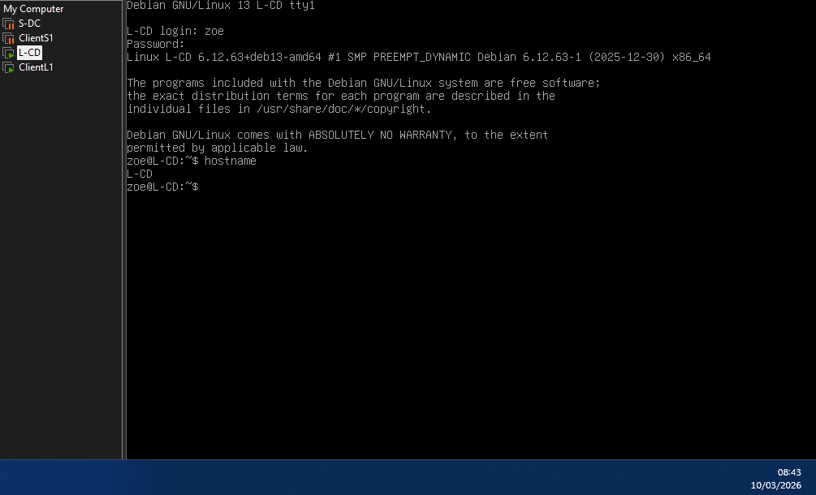
Figure 26: Renamed London Debian Server L-CD.

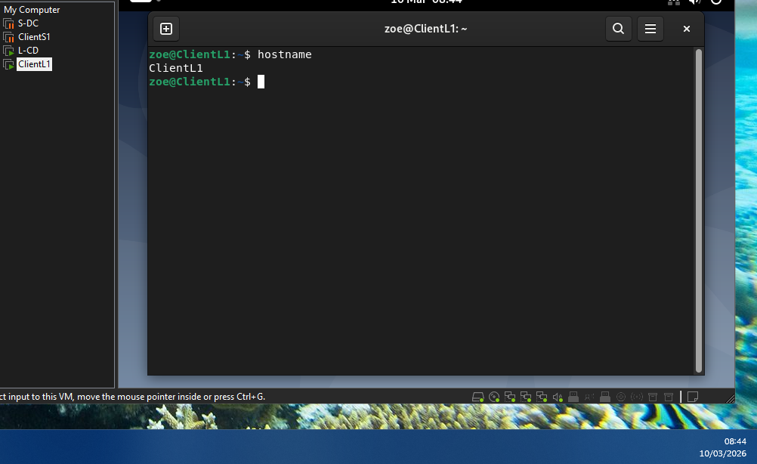
Figure 27: Renamed London Debian Client, ClientL1.

