A marketing plan is written for

Marriott Hotel
__________________________________________

Student Name

________________ Victor Badaluta _______________

Student ID number
_______2212187________

Marketing Essentials BMIH4005

Lecturer

______________Ruth Taylor-Davies______________

Table of Contents
Introduction 3
Situation analysis 4
Objective 6
Strategy 6
Marketing mix 7
Action 10
Control 10
Conclusion 11
Reference 12
Appendix 14

Introduction
A hotel with a big staff and a significant quantity of resources is represented by the Marriot brand. It began operations in 1927, and as of now, they provide its services in over 131 nations worldwide. They have more than 150,00 personnel to provide service to their enormous number of consumers. They have numerous other brands than the hotel sector, but the hotel services they provide are where they shine. This study outlines Marriott's marketing strategy, and the company's headquarters are located in the United States of America. This marketing strategy will illustrate all of Marriott International's marketing strategies, and it is being built to present a distinct picture of the company's marketing operations. In addition to this, the paper illustrates a PESTLE analysis as well as other internal elements that have an impact on the decision-making process. In addition to that, it incorporates Marriott International's system for digital marketing. In conclusion, the report provides a summary of the marketing plan that was developed as well as some effective recommendations for how Marriott International can enhance its existing image and brand value and create a one-of-a-kind position or place in the minds of its respective target audiences.

Situation analysis
5C’s
Company: Considering things from Marriott International's point of view, a SWOT analysis is provided.
Strength  Superior quality, knowledgeable and helpful personnel, and a fantastic physical location. | Weakness  Conventional hotel management databases and insufficient research and development
Opportunity  A massive consumer base and an ever-increasing commercial clientele | Threats  Bigger rivals, stricter laws, and game-changing innovations

Customers: Marriott International divides its potential customers into a wide variety of subgroups to better serve their needs. They focus mostly on appealing to groups that make regular trips to the United Kingdom. In addition, they focus on attracting clients who are in the region to attend business meetings.
Competitors: The strengths and weaknesses of a company may be better understood by using Porter's five forces model, which also assists in making decisions that are efficient and suitable for the organization (Fan et al., 2015). To begin, it highlights the relevance of the suppliers' negotiating power, both implicitly and overtly, which is a significant and important factor (Ghauri, 2014). Because Marriott International offers its guests a diverse selection of services—for example, restaurant service, bar service, gaming facilities, and other facilities—the hotel's guests have a constant need for procurement activities. As a result, the company performs these tasks daily. Therefore, suppliers have a significant amount of importance in this context given that they have the control mechanism of the firm's product. This enables the company to better serve its clients. In addition, the satisfaction of consumers is the primary focus of any company. Therefore, both the company's customers and the company's supplier of these things have a significant influence on the business. Second, there are a substantial number of businesses operating in the hotel sector in the United Kingdom. These businesses provide their services in the same regions or places as other businesses in the hotel industry. There is a risk that clients may stop staying at Marriott International hotels if they are not provided with adequate service, which might result in the loss of business for Marriott International's competitors. The increased number of hotels means that alternatives to Marriott International are more readily accessible, which in turn increases the consumers' ability to barter for better prices. Fourthly, the hospitality business is expanding at such a rapid rate, which is why the number of new entrants is increasing on a day-to-day basis. This should be brought to the attention of Marriott International. Last but not least, the presence of a large number of national and global hotel chains contributes to the competitive nature of these markets; thus, there is a great deal of competition among businesses in this area.
Collaborators: Customers are the most crucial issue for every company, particularly in business-to-business dealings (Smith & Zook, 2020). Therefore, the firm needs to determine what consumers, franchisors, and partners want from the company in terms of whatever condition, price and location, profit and share (Kotler et al., 2020). Therefore, it is extremely vital for the firm to be aware of the preferences of its clients, franchisors, and business partners and to behave following those preferences (Clow & Baack, 2013). Customers, business partners, and franchisors are all highly important to Marriott International, and the company gives careful consideration to their requirements and wishes. With the use of their hotels' review, suggestion, and complaint mechanisms, Marriott International can learn about the wants and needs of its consumers. In addition, they provide a quarterly service that assesses the degree of contentment of partners, franchisors, and consumers and compiles customer complaints and recommendations for Marriott International. Their needs may be met with the assistance of the appropriate innovation processes and the growth of the product mix (Chaffey and Ellis- Chadwick, 2019). It is possible for businesses, with the assistance of the research and innovation process, to develop more products, add those products to their product mix, and so expand the product mix offered by Marriott International. With the assistance of their advertising channels, such as social media marketing, website marketing, and influencer marketing, Marriott International engages those products and services to their stakeholders. Additionally, Marriott International tries to make customers aware of their new products and service and increase the brand value of the customers.
Climate: The majority of the macroenvironmental factors that affect a company's decision-making process only do so indirectly (Harper et al., 2021). Perspectives on law, the economy, technology, political stability, and social variables all have a role in shaping each given company's macro environment (Jobber and Ellis-Chadwick, 2020). PESTLE analysis is the best tool for assessing the macro environment in which Marriott International operates (Marcussen et al., 2017).
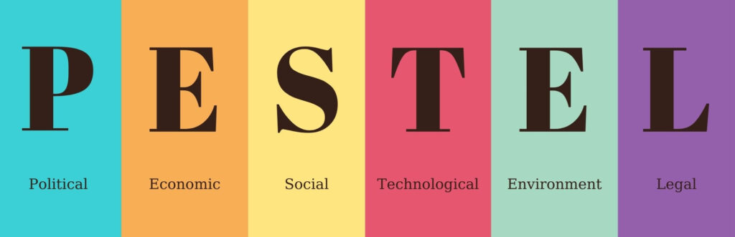
Figure: PESTLE Analysis
Marriott International finds a "balanced" economic environment in the nations where they do business. A person in one of these nations may expect to earn more than $10,000 a year. In addition, the political situation in such nations is rather stable, which is crucial for commercial success. In the fields of law and society, Marriott International has several issues to deal with. Many laws are being enacted by governments today to safeguard the environment and the legal rights of consumers.

Objective
The primary goals of this marketing plan are to provide an overview of the marketing strategies that will be put into action and to achieve some degree of market power via the use of this plan.

Strategy
The distinctive accommodation amenities, outdoor facilities, fitness centre facilities, reservation services, and dining establishment facilities are the primary components of the value proposition presented by Marriott International. These are detailed in the strategy for marketing the product. However, this customer value proposition has to be presented to the consumers since it was developed just for them. The company's marketing plans serve as the blueprint for establishing the company's marketing strategy and achieving a competitive edge over the company's competitors (Ghauri, 2014). One may convey a value proposition in a variety of different ways (Bowie et al., 2017). With the assistance of this particular marketing channel, businesses endeavour to secure a favourable and distinguishable position or location in the minds of their clientele (Housden, 2008). The promotion of digital media is something that Marriott International has to become involved with. The use of social media generates a significant amount of consumer traffic for businesses, allowing such businesses to connect with a large number of customers, communicate their value offer to those customers, and capture their attention (Ryan, 2012). Sheraton utilizes social media marketing, internet marketing, and email marketing as channels for spreading information about the value offer. This allows Sheraton to make more effective use of the digital communications at its disposal. Customers are drawn to the exclusive and one-of-a-kind amenities provided by Marriott International, which can be found in the hotel rooms, restaurants, and bars of its properties, thanks to the company's internet marketing efforts. They may promote new deals to both their existing customers and possibly new customers by sending emails to those customers. Therefore, the value offer will be linked with desirable consumer categories via these various activities, and Marriott International will be able to attract those customers. Bowman's strategy clock is something that Marriott International may use to its advantage; with its aid, it will be able to depict its strategic posture in the hypothetical clock and comprehend the many approaches that are associated with this model (Smith and Zook, 2020). Because it provides visual representations, managers can readily put such strategies into action.

Marketing mix
The marketing mix consists of the firms' controllable parts, which allow them to exert influence over the market and attempt to shape it following their preferences (Essien et al., 2016).



Figure: The product mix

Product
For Marriott International, providing a comfortable place to sleep is their primary offering. Business suits, family rooms, presidential please, and VIP suits are standard fares at their moderately upscale hotels.
Price
As their highest tier of hotels is a three-star grade, they provide consumers with pricing that falls somewhere in the middle. The cost of a night in one of their hotel rooms often begins at one hundred dollars and may reach a high of one thousand dollars.
Place
The hotel's locations are its USP (unique selling proposition), giving it an advantage over other hotels that provide similar services. They operate a hotel network that can be found in more than 70 countries, and there are more than 463 of their hotels located throughout the globe.
Promotion
Marketing efforts for Marriott International are spread across several platforms, including traditional TV commercials, social media, and the company's website.

Action
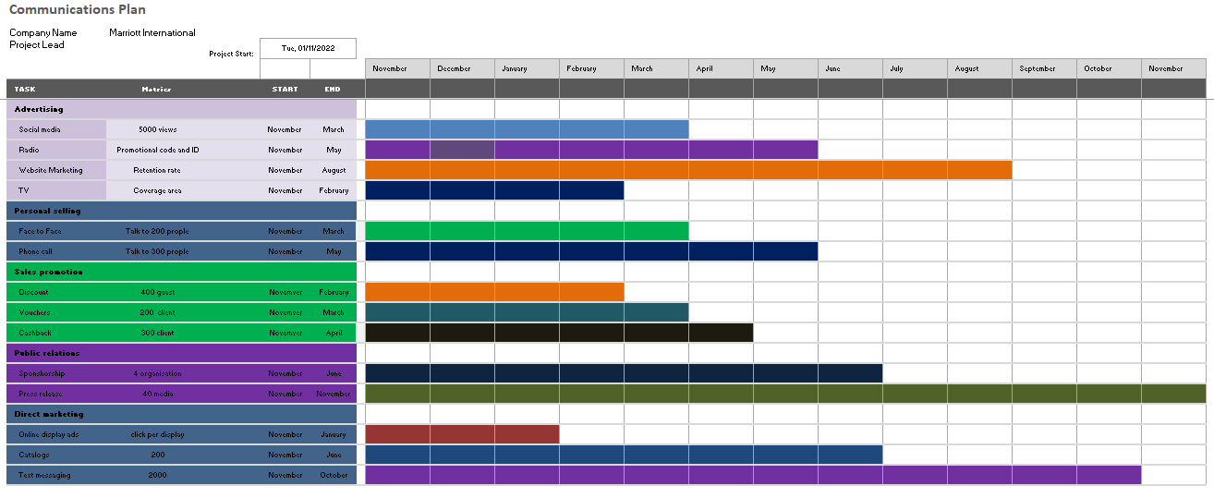
Marriott International makes use of a variety of distribution methods and publications in its marketing efforts. Since November is the month with the biggest number of guests, they should begin putting their promotional strategy into action in November to maintain their marketing efforts into the next November month. It will increase the number of consumers who visit the hotel as well as the number of customers who are aware of the hotel.

Control
Marriott International's distinctive in-room amenities and central London location set it apart from the competition. It offers a wide range of supplementary services meant to surprise and please its clientele, hence boosting the company's image. This hotel, rated as a "three-star," still provides high-quality care to its guests. It's useful for housing, drinking, and getting about town. The retention rate, the conversion rate, and the key performance indicators may all be used to evaluate their effectiveness. With the aid of acquisition and satisfaction rates, they may determine the number of new clients and their general disposition. In addition, the asset-liability ratio, asset turnover rate, income statement, and cash flow may all be used to evaluate the business's profitability.

Conclusion
Marriott International has significant obstacles in implementing its marketing strategy due to the rapid evolution of the business environment brought on by globalization and technological progress. To carry out their desired marketing strategy, Marriott International management needs to introduce more technical progress in hotel administration. In addition, they conduct a survey form to gauge consumer happiness and get more feedback. In addition, they need to improve the channel for client feedback through which they respond to complaints and suggestions. In addition, they need to put more effort into building a dedicated following on social media and via celebrity endorsement. They should, however, also take part in offline advertising to raise awareness of their service and increase their clientele.

Reference
Bowie, D. Buttle, F. Brookes, M & Marcussen, A (2017), Hospitality Marketing. 3rd ed, Routledge, London
Capobianco, N., Basile, V., Loia, F. and Vona, R., 2021. Toward a sustainable decommissioning of offshore platforms in the oil and gas industry: a PESTLE analysis. Sustainability, 13(11), p.6266.
Chaffey, D and Ellis- Chadwick, F. (2019) Digital Marketing. 7th edition, Pearsons, London.
Clow, K & Baack, D (2013), Integrated Advertising, Promotion and Marketing Communications. 6th edition, Pearson, London
Fan, S., Lau, R.Y. and Zhao, J.L., 2015. Demystifying big data analytics for business intelligence through the lens of the marketing mix. Big Data Research, 2(1), pp.28-32.
Ghauri, P N (2014) International Marketing, 4th Ed, McGraw Hill, London
Habib, A., Hossain, S. and Essien, D.D., 2016. Assessing the Effect of Training on Employees' Performance in Nigeria Hotel Industry: A Case Study of Sheraton Hotel and Resorts Lagos. Singaporean Journal of Business, Economics and Management Studies, 51(3785), pp.1-13.
Housden M (2008), Marketing Research & Information, Butterworth Heinemann, Oxford.
Jobber, D. and Ellis-Chadwick, F (2020), Principles and practice of marketing. 9th ed. London
Kotler, P., Armstrong, G., Harris, L. and He, H., 2020. Principles of marketing. 8th European ed, London: Pearson Education Limited. Recommended
Kotler, P and Kartajaya, H. Marketing 4.0 Moving from Traditional to Digital (2017) Wiley. New York.
Ryan, D. (2012) Understanding Digital Marketing: Marketing Strategies for Engaging the Digital Generation. Kogan Page, London
Smith PR & Zook ZE (2020) Marketing Communications. 7th ed, Kogan Page, London
Sun, S., Tong, K.T. and Law, R., 2017. Chinese hotel guest perception of international chain hotels under the same hotel brand in different travel destinations: The cases of intercontinental and Sheraton. Journal of Vacation Marketing, 23(2), pp.172-188.
Thomas, P.J.M., Sandwell, P., Williamson, S.J. and Harper, P.W., 2021. A PESTLE analysis of solar home systems in refugee camps in Rwanda. Renewable and Sustainable Energy Reviews, 143, p.110872.

Appendix


