Driving Change and Building Business Cases
BMHR7014

Daniel Owen 2106804
Executive summary (200 Words)
Table of contents (Box of contents)
Introduction (250 words)
I aim to critically evaluate the impact and effects of Hybrid working on the bank and roster team within Hywel Dda University Health Board.
53% of employees are likely to prioritise health and wellbeing over work than before the pandemic and 52% of Gen Z and Millennials are likely to consider changing employers this year, up 3% year over year. Understanding and meeting employee’s expectations requires a mind shift change. Creating a culture that embraces flexibility and prioritises employee well-being will provide a competitive advantage. (Great Expectations: Making Hybrid Work Work, 2022)
83% of workers prefer a hybrid work model, but other factors also matter to wether they thrive onsite or off. Leaders must move beyond physical locations to shape the future of workforce. (SMITH et al., 2022)
I have been tasked with introducing Hybrid Working within my teams.
Through the introduction of hybrid working I aim to:
- Critically evaluate literature on Hybrid Working
- Identify suitable survey techniques in gaining employee opinions
- Critically analyse, present and discuss the findings of the survey
- To make a recommendation on how Hybrid working can be implemented within Hywel Dda
The outcome of this work is not only to introduce hybrid working within my teams, but to ensure they are supported and have the resources needed to improve their work/life balance.
Literature review (550 words)
The aim is to introduce Hybrid working practice to not only provide additional flexibility to employees but also support them with the challenges and struggles, understanding these and empowering employees through training and resource provisions. (Great Expectations: Making Hybrid Work Work, 2022)
The benefits to employees include (Planning for hybrid working | CIPD, 2022):
- Improved work/life balance
- More time with family and friends
- Reduction of commuting time and costs associated
- IT upskilling
- Higher level of motivation
Research is still ongoing on the impact of Hybrid working, initial research suggests that Hybrid working offers employees the ‘best of both worlds’ – greater work life balance while still maintaining social connection and bonds with employees (Planning for hybrid working | CIPD, 2022).
A guide to hybrid working is set by personnel today, remembering the basics of introduction, what does it mean to work hybrid? Setting out the eligibility for hybrid working and expectation on attending work vs remote working, understanding each individual will have a different viewpoint and need (Simpson, 2022).
Introduction of Hybrid working has mainly taken place during the pandemic, this is putting pressure on people teams as there is no template to follow, so most teams are living in a live test environment, so it’s important to remember that and ensure review’s take place to ensure this works for employees and also the business. A framework to follow allows managers and employees to understand the requirements. (Penny, 2022)
Creating a unique and employee led model can lead to better uptake:
- Listen to employees
- Delve into the data
- Make a plan
- Communicate
- Test, Learn, iterate and evolve
Hybrid working will mean different things to different people, ensuring that they are listened to will provide a better engagement, asking employees how they want to work, creating a questionnaire to ensure these issues are covered is something I will implement to improve Hybrid working within the team (Penny, 2022).

Research Design (400 words)
Deciding on the research method and how the data will be collected will have the biggest impact on the research project, the choices are:
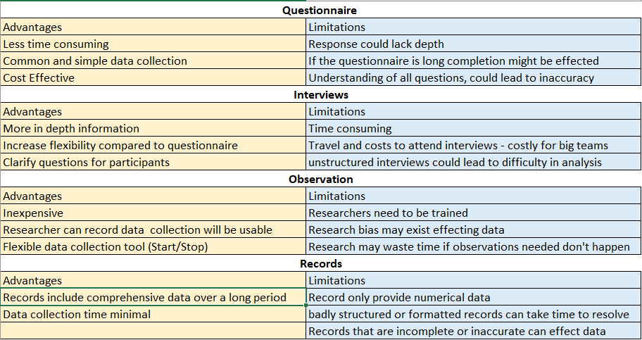
(Bhatia, 2022)
Understanding how the survey will look from a participant viewpoint is vital to improve engagement, the survey I have created is in relation to the current work around Hybrid working and what we can do to further support the team in its introduction permanently, I also included the rational and privacy info in the email I shared with the team (Parrott, 2022)
Choosing between qualitative or qualitative data will need to be something I take into account also, I’ve included a simple breakdown below:
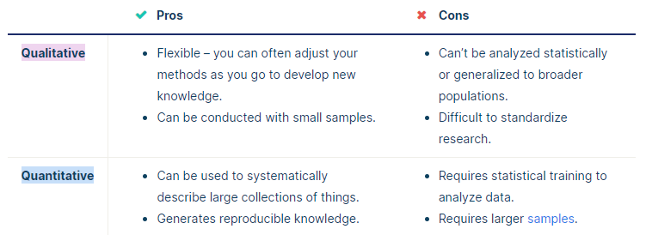
(Research Methods | Definitions, Types, Examples, 2022)
I will be using a mix of primary and secondary data to conclude my research, I will be using secondary data from trusted sources that include CIPD, Personal Management through my literature review, this will be supplemented with Primary data from my team and how they feel Hybrid working effects and impacts them (Research Methods | Definitions, Types, Examples, 2022).
I’ve decided to use a questionnaire with both qualitative and quantitative data to allow a better understanding and more rounded data collection (mixed research method). This will also allow analysis of the data from closed and open questions to provide additional insight into answers from the team.
A questionnaire but with open and closed questions to reduce the limitations of the findings, I will also do some pre-work with the team and engaging with them while the questionnaire is live to support them with any questions they are not sure of.

Findings/Results (1000 words)

Conclusion (300 words)
References
2022 Work Trend Index: Annual Report. 2022. Great Expectations: Making Hybrid Work Work. [online] Available at: <https://clouddamcdnprodep.azureedge.net/gdc/gdc3Ps8ze/original> [Accessed 29 August 2022].
SMITH, C., SILVERSTONE, Y., WHITTALL, N., SHAW, D. and MCMILLAN, K., 2022. The Future of Work | Accenture. [online] Accenture.com. Available at: <https://www.accenture.com/us-en/insights/consulting/future-work> [Accessed 29 August 2022].
Parrott, C., 2022. Best practices for a survey introduction | SurveyMonkey. [online] SurveyMonkey. Available at: <https://www.surveymonkey.com/curiosity/survey_introduction/> [Accessed 29 August 2022].
CIPD. 2022. Planning for hybrid working | CIPD. [online] Available at: <https://www.cipd.co.uk/knowledge/fundamentals/relations/flexible-working/planning-hybrid-working> [Accessed 29 August 2022].
Simpson, S., 2022. Writing a hybrid working policy: a guide for HR. [online] Personnel Today. Available at: <https://www.personneltoday.com/hr/hybrid-working-policy-hr-guide/> [Accessed 29 August 2022].
Penny, C., 2022. Hybrid working in 2022: An ultimate guide for HR leaders - Sage Advice United Kingdom. [online] Sage Advice United Kingdom. Available at: <https://www.sage.com/en-gb/blog/hybrid-working-hr-guide/> [Accessed 29 August 2022].
Bhatia, M., 2022. A Complete Guide to Quantitative Research Methods - Atlan | Humans of Data. [online] Atlan | Humans of Data. Available at: <https://humansofdata.atlan.com/2018/06/quantitative-research-methods/> [Accessed 29 August 2022].
Scribbr. 2022. Research Methods | Definitions, Types, Examples. [online] Available at: <https://www.scribbr.com/category/methodology/> [Accessed 29 August 2022].

How to critically evaluate a board range of evidence to develop a costed business case
How to undertake research in the area of people management
How to plan for change
How to build and agile and change ready workforce
Different change management approached and how they can impact culture in different ways
How change affects people in different way and how they can be motivated and embrace change
Methodology overview of how you conducted your primary research
Findings – Analysis of findings
Conclusions – what have you concluded are the key points of interest for the orginisation
Conclusion (300-400)
Recommendations (300-400)
Reference List (Havard Referencing)

