


School of Applied Computing / Ysgol Cyfrifiadura Gymhwysol

BSc (Hons) Applied Computing

2024/25

An Investigation Into Referencing by Developing a Referencing Application

Joachim Manlongat / 119187

Contents
Problem Statement 5
Referencing 5
History of Referencing 6
Range of Academic Referencing 7
Vancouver Referencing 7
Harvard Referencing 7
APA Referencing 7
MLA Referencing 7
Current Referencing Tools 8
Issues 8
MyBib 8
Mendeley 9
Scribbr 10
Reference Technology Platforms 11
Web 11
Mobile 11
Desktop 11
Programming Language, Environments and Approaches 12
Object-Oriented Programming 12
C# 12
NoSQL: LiteDB 12
Conclusion 13
Aim 14
Objective 14
Project Planning 15
GANTT Chart 15
Work Breakdown Structure 18
Methodology 19
Philosophy 19
Phenomenology 19
Approach 19
Strategy 19
Choice 19
Time Horizon 20
Data Collection 20
References 21
Appendix 23
Appendix 1 – Questionnaire 23
Appendix 2 – Ethics Form 24

Problem Statement
Amongst various referencing applications, there are current tools available that have features yet to be fulfilling according to the client. The issue is with the dissatisfaction of current available tools for submitting and saving referencing. This often results in manually submitting a referencing instead of using a tool that is supposedly providing a faster way of making a reference list. [1]
This research project will investigate the nature of academic citation management applications. The research will adopt the position that these include a wealth of functionality which can see bewildering to some users and that this might be improved by concentrating on a single citation standard. [1] With the availability of tools for referencing found online, there is yet to be a referencing tool that meets the expectations which is causing deficit infrastructure for a development requirement.
There is primary research to be made that must be provided for insights as to how to improve referencing. A prerequisite for implementing solutions to provide a better referencing tool, further study is required to identify the referencing styles to create an outcome. This may refer to existing sources, research and publications whilst such discussions have yet to illustrate any useful solutions to the problem that needs to be addressed. The push for this project came from a questionnaire with the client where dissatisfaction with the current range of academic reference tools have been expressed.
(For the questionnaire and ethics form see appendix 1 and 2)

Referencing
Referencing is a key part of academic writing practices and there is more that come from referencing the secondary research used. [5] We cite information we find, whether it is online, book, journal article or website, this is to give a clear insight where that idea has originated from. [3] In the case of whether the work has been paraphrased, summarised or directly quoted, it demonstrates the idea of knowledge. It gives attention to detail as well as providing credibility and integrity, an example of good academic practice and for further research to be acknowledged. [2]
A well-written reference with In-text citations has another advantage. The standard of format prompt authors and readers to immediately engage with the work and the ideas of others. [4] Referencing, in context, is a demonstration of breadth and depth of research, an assessment of acknowledgment of other people’s work. [3]
Flexibility in the use of in-text allows historians, or other academics to adapt the format to the specific requirements of the collection that they have researched. [2]

History of Referencing
In History, has for several years employed endnotes to ensure that references to archival material which has diverse formats that are not always easy to cite unambiguously, could be accommodated. [4] [5] However, this lost some of the immediacy of being able to identify authors or archives directly in the text while reading the article.
Prior to the 50’s, most indexing was done manually by independent subject specialists. This required specialists who understood the terminologies to go through articles, journals, and academic papers and document any citations. This was a time-consuming and tedious effort prone to human errors. [7]
Post World War II, the US government invested millions of dollars into research and development. [7] Traditional methods of indexing were inefficient, that subject specialists struggled to keep up with the increasing volume of research. Researchers complained of the processing time, specifically the bottleneck caused by manual citation indexing. Also, the independent nature of the subject specialists gave rise to inconsistent terminology across different fields of research which made it difficult to connect information. [7] [15]

Range of Academic Referencing
Referencing styles are preferred by academic disciplines because they work better with the kind of texts that are most used in that discipline. [8] Various referencing styles has its origins but are widely adopted in certain academics of different sectors. [15]

Vancouver Referencing
Vancouver is a numeric style with each given a number which corresponds to the order in which it appear in the text. [8] If the same source is referred to again in the text, the same number is used. At every point in the text where a particular work is referred to by quoting or paraphrasing, references are numbered, the reference list comprises a single numbered list of citations with full details.

Harvard Referencing
Harvard referencing uses an author-date system. The author-date style offers an efficient and clear method of providing citations of published sources, which appear in a reference list at the end of the chapter or book. The method works well when the citations are to published books or journal articles. It doesn’t however, work well if the citations are from unauthored sources. [9]

APA Referencing
APA referencing is a variant on Harvard. Many of the conventions are similar, with the author-date system used that directs readers to a full reference list entry. This reference is recommended by the American Psychological Association and used in many social sciences. [13]

MLA Referencing
The Modern Language Association referencing uses the author’s last name and the page number from which the context of quotation is taken. MLA depicts by the name that is predominantly used in arts and humanities. [23]

Current Referencing Tools
To gain a wider understanding of currently available referencing tools and to identify a potential solution for the library, an investigation has been conducted of these referencing tools. As expected, each result was in full swing as varying cases for each website offer features that have similar desires for the user to interact with. Referencing tools are software that records any reference that you input and linked to a wording process, allowing you to add citations and formatting them.

Issues
The issue with these current tools is the inaccuracies of the referencing style. The result involves reorganising the referencing by hand. To consider the current tools online, we will take the idea of the quick input of referencing and saving it for future management. These applications have the basic idea all settled out, which helps keep track of what you have read and allows organisation of research.

MyBib
MyBib is a free bibliography and citation generator that makes accurate citations for anyone to copy straight into their academic papers. MyBib is useful for students that are writing papers and are citing sources in various format. The website acts as a time saver while ensuring consistency with other citation styles.

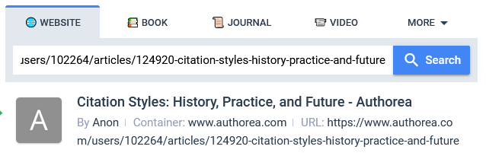
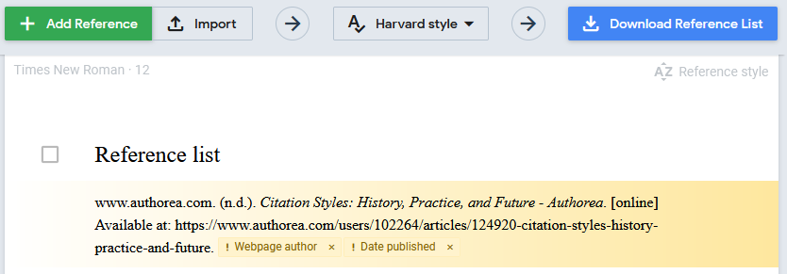
MyBib would lay out an output for entry of a link to a citation however, it still requests more information such as entering URL for searching said reference.
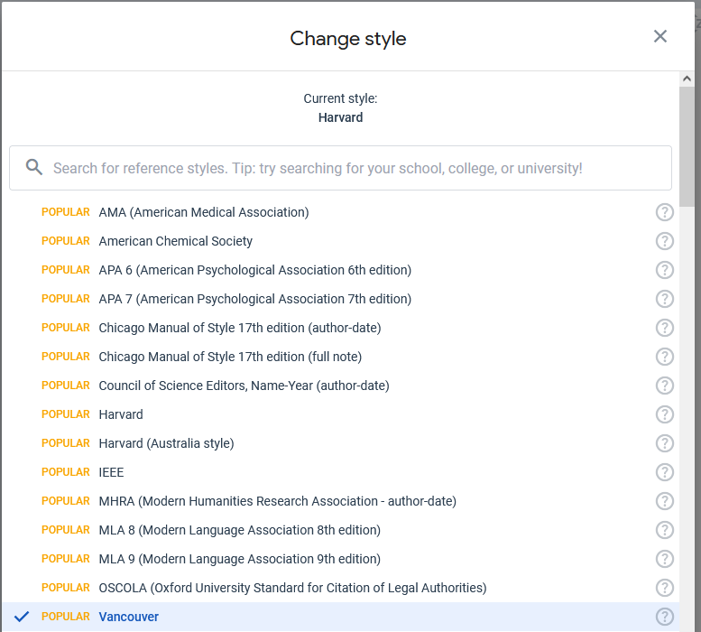

Mendeley
Mendeley is a free reference manager that can help organise research and discover the latest research. It is used to manage and share research papers and to generate bibliographies for scholarly articles. Mendeley allows quick insert citations to reference materials in its library. It automatically generates a bibliography for your paper using all the materials cited.
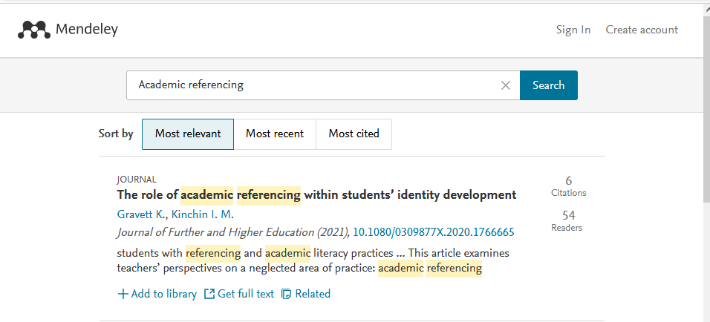
The issues with Mendeley that shows no support for footnote citations followed by recognising highlights and annotations made when using PDF. Mendeley is also its own proprietary which limits collaboration with reading tools. [16]

Scribbr
The Scribbr is an AI-powered assisted application. It is a free platform that focus on looking up sources by its title, URL, ISBN or DOI. The reference tool has been widely used to automate necessary information to generate reference for academic research.
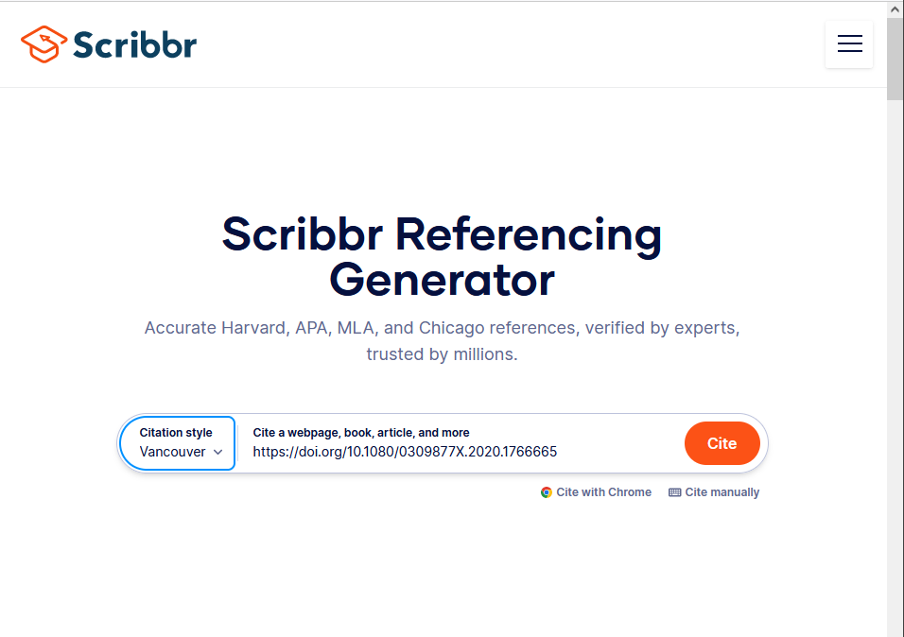
The output are as follows, it generates an entry after using the appropriate GUI and automates a result. This result would include the author, title, type, date and its citation (in this case, the DOI). The concept would include these features in an application for desktop.
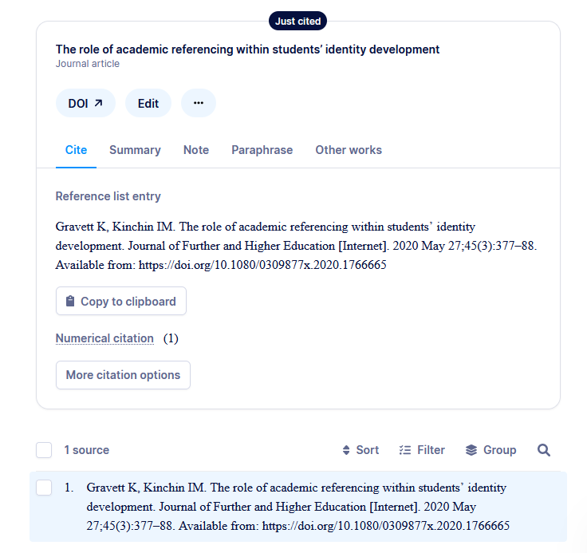

Reference Technology Platforms
To produce a solution that is effective and meets the requirements of the library it is important to first consider the range of platforms and technologies currently available to design, develop and produce the solutions they require.

Web
A web application is a software that runs in the browser. Which require internet to connect with clients for convenience. If the application is run on the web, it can be enabled for any device that requires internet. Traditionally, there is no need for downloading, the availability of interactions with the content provided including functionalities in data, user authentication and updates. [17]

Mobile
Mobile design may refer to the tools that are installed and running on a smartphone or tablet. Mobile tools can be downloaded and used anywhere; allowing greater accessibility that can provide convenience with quick access. [11] There are two operating systems that outshine: iOS and Android. Phones are a popular device used for applications thus, demand is high.

Desktop
A desktop application is a type of computer program designed to run on a specific device, such as a desktop or laptop. It is an application that runs locally on the user's computer, as opposed to a web application that runs in a web browser. [18]
Desktop applications typically allow users to work offline, while web applications require internet connection. With their ability to integrate with browsers and offline access, they remain indispensable. For users who need access to data regardless of network availability, desktop applications may be a better choice. The choice between desktop and web applications depends on the specific needs. For this project, it is worth mentioning that desktop applications still have a lot to offer, especially when data and performance is necessary. Although desktop apps allow the work to be offline, the installation process on the other hand must be manual which involves re-installing. If it were the case of a cloud and using a web app, this would not be the case as it requires a login and no further installation.

Programming Language, Environments and Approaches

Object-Oriented Programming
OOP is a programming paradigm that is fundamental to many programming languages, including Java and C#. OOP is a recognized programming paradigm, but programming languages differ in how they interpret and implement. [19]

C#
C# is a general-purpose programming language created by Microsoft that runs on the .NET Framework and can be used to develop web, desktop and mobile applications. C# relates to the C-family of programming languages alongside C and C++, C# benefits the simplicity while utilising similar syntax from the rest.
While using OOP in C#, objects can be managed without interacting with their inner attributes, describing object behaviour through declaration of classes. [14] Applications that use OOP can be made simpler to test and read, enable response to any occurring issues, and generally a leaner approach to writing code.

NoSQL: LiteDB
NoSQL databases are designed to handle unstructured or semi-structured data. They are often used for big data applications that require high scalability and performance. [21] Data stores allow applications to store and retrieve data quickly and efficiently.
LiteDB is considered a simple and fast NoSQL database solution. LiteDB allows using C# classes directly with JSON, allowing easy interoperability between the database and using the data submitted. [20]

Conclusion
The purpose and aim of the literature review was to investigate the currently available reference tools and find a solution for the client and collaborate with them of an application that suits their needs. This can be achieved by a software, an application that offers a quick tool for finding references according to feedback on prior experience to using referencing tools.
Considering the popularity of other references for academic writing, Vancouver will be used as a demonstration that the application can provide results effectively. For this case, Vancouver is going to be used as an example for the application used in making a reference app. For this application in using C#, it should be generating a Vancouver reference that can be saved into a database that can be manageable.
Having considered the available platforms for development it is believed that a desktop application would be the suitable choice. In comparison to web, desktop tools are designed for specific hardware, it will outperform despite having to install it over. Instead of web, by having it all in place, it should not be the issue if the client is using one device.
Among other languages, C# gains popularity for developing applications. Its core concepts help build an interactive environment and provide functionalities that the dynamic platform such as what the referencing tool requires. [12] To develop a desktop application, these results underscore the need for continued research in the area, as well as the development to produce a referencing tool to support and fulfil the client’s needs. By addressing this, C# by choice, will be utilised for the duration of the project. C# is suitable because of the availability of resources, since the program is windows based, C# can gain an advantage with .NET and features that has windows support. This applies to all college computers that have windows available.

Aim
The aim is to design a referencing application as a solution towards the issues that exist with the currently available reference tools. A singular referencing style (Vancouver) is recommended for the project, with the requirement to provide a concrete demonstration of a desktop application.

Objective
- Develop a prototype
- Evaluate the nature of the references, types and capabilities of application
- Investigate how client expectations are influencing the application
- To discuss the client experience and expectations and make recommendations to develop an application

Project Planning

GANTT Chart
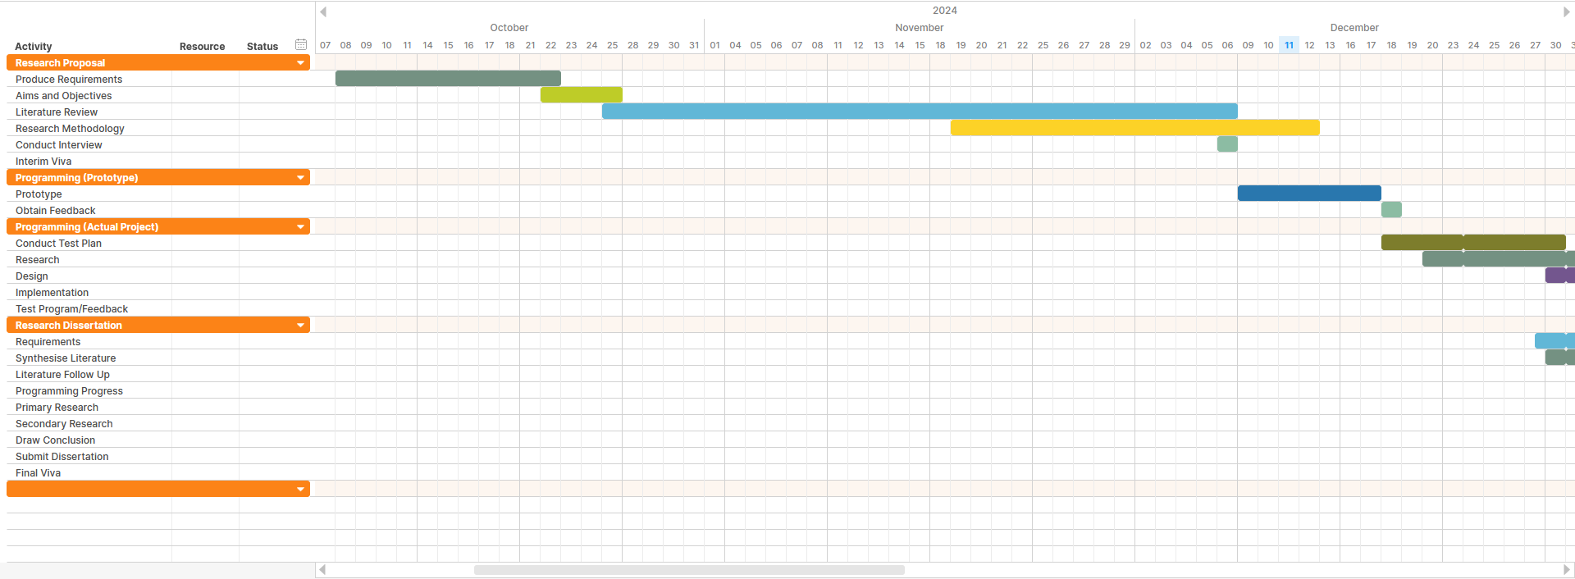

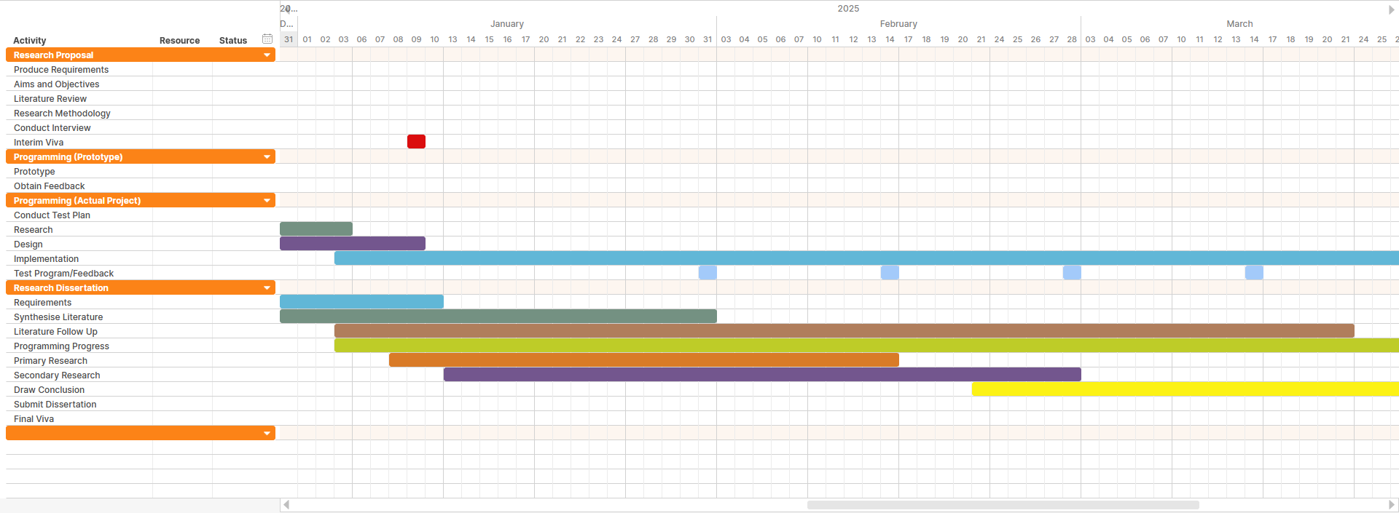

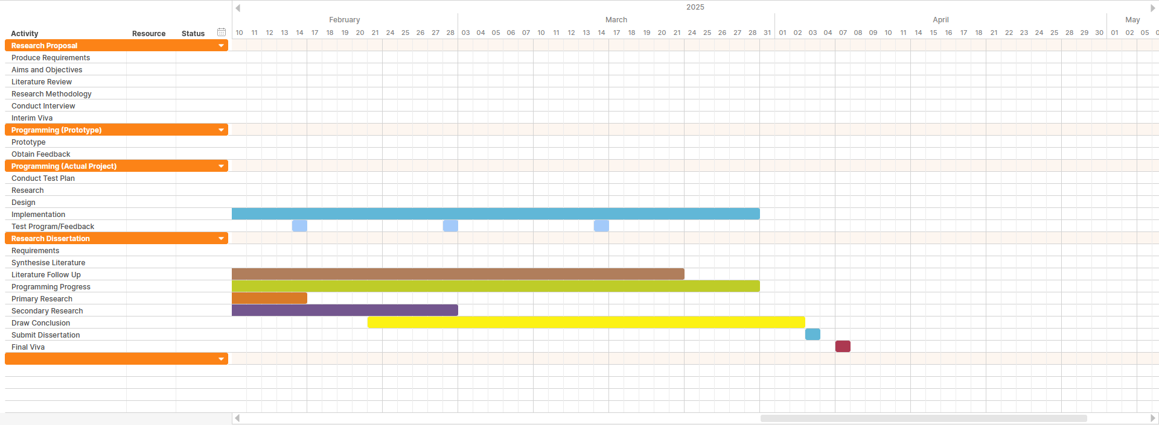

Work Breakdown Structure
Follow up used from the GANTT chart to illustrate a diagram of the project proposal and project development.

Methodology

Philosophy
Research Philosophy is related to a set of beliefs on the nature of the investigation of reality. Often studied in the context of epistemology and ontology. [25] The selection philosophical stance may impact the gathering of data and its analysis. This project will adopt a Phenomenological approach.

Phenomenology
Phenomenology is concerned as a philosophy of experience. This brings out the meaning and value what the experience was. Phenomenology manifests in our own experience or, the way we perceive and understand from experience. [26] This approach is suitable as this project will be primarily interested in user reactions to developed software.

Approach
Inductive is an ideal approach as the reasoning tests what already exists and then this will be taken into research to find what’s needed for this research project. Taking a research approach are the steps from broad assumptions to detailed methods of data collection, analysis, and interpretation. [25] By analysing from an interview and observation though feedback by means of creating an application that suits or fulfils their need.

Strategy
The strategy can determine the path of which the client may be assessed for a further in-depth analysis undergoing this project. Based on user experience, action research aims to investigate a problem and solving the issue, it prioritises reflection and bridges the gap between theory and practice. [24] This can be acknowledged for qualitative reasoning as a research method for collecting data. [25]

Choice
The mono method is required, this includes the use of qualitative data gathering within the research to achieve different aims. [25] Arguably, this choice may be considered weak due to one research type, however, this should be provided given that the experience is sufficient from the client for providing a solution. Given that mono method is the choice, time is limited for that matter.

Time Horizon
The time horizon for this research project will be cross-sectional. [25] With the use of GANTT charts this can include schedules and adjustments over a short period followed by a work breakdown structure for breaking down the projects into smaller, more manageable tasks. The project scope will also determine the time taken for the project to be examined as time is restricted given the circumstances of fulfilling this project.

Data Collection
For the study it will include data collection of non-numerical data such as questions taken from an interview to gather analysis, this is to generate ideas for the research. In qualitative research, interviews give participants the power to define the nature of their experiences and perspectives, enabling an understanding of phenomena. [22] The questions for the interview would ask about the referencing applications available and their experiences of it, followed up by what they would like the application to their current situation of dealing. The insight is the data provided to produce an application based on what the client wants and how it will be used effectively. [23]
(For the questions see appendix 1)

References
[1] Pressbooks. 3. Challenges in Citing Sources. No Date Found. [Accessed on 11/11/24] Available from: https://ohiostate.pressbooks.pub/choosingsources/chapter/other-challenges-in-citing-sources/
[2] Rezwanur Rahman. Referencing – an Academic Obligation. No Date Found. [Accessed on 11/11/24] Available from: https://pdfs.semanticscholar.org/6e63/230244c7961297213ecc7620d60bbbe35c76.pdf
[3] University of Leeds. Referencing Explained. No Date Found. [Accessed on 07/11/24] Available from: https://library.leeds.ac.uk/info/1402/referencing/47/referencing-explained#:~:text=Referencing%20correctly%3A,your%20ideas%2C%20arguments%20and%20opinions
[4] Stephanie Decker. Change of referencing style. 2017. [Accessed on 07/11/24] Available from: https://www.tandfonline.com/doi/full/10.1080/00076791.2017.1386762
[5] Fiona Gardiner. The Importance of Citations and Referencing for Students. 2023. [Accessed on 07/11/24] Available from: https://www.universitylibrarian.com/blog/the-importance-of-citations-and-referencing-for-students
[7] petal.org. A brief history of Academic Citation Styles. 2022. [Accessed on 07/11/24] Available from: https://www.petal.org/blog/articles/a+brief+history+of+academic+citation+styles
[8] University of Reading. Styles of referencing. No Date Found. [Accessed on 07/11/24] Available from: https://libguides.reading.ac.uk/citing-references/referencingstyles
[9] Oxford Academic. Referencing Styles. No Date Found. [Accessed on 08/11/24] Available from: https://academic.oup.com/pages/authoring/books/preparing-your-manuscript/referencing-styles
[10] Scott County Library. Reference Tools. No Date Found. [Accessed on 08/11/24] Available from: https://www.scottcountymn.gov/882/Reference-Tools
[11] Vlad Kremenchuck. Desktop vs mobile design: which one to focus on? 2023. [Accessed on 10/11/24] Available from: https://beetrootacademy.com/blog/desktop-vs-mobile-design-which-one-to-focus-on
[12] M Watson. What is C# used for? 2023. [Accessed on 10/11/24] Available from: https://stackify.com/what-is-c-used-for/
[13] University of Toledo. APA Style Reference Citations. No Date Found. [Accessed on 08/11/24] Available from: https://www.utoledo.edu/library/help/guides/docs/apastyle.pdf
[14] M. H. Alvi. A Manual for Referencing Styles in Research. 2016. [Accessed on 07/11/24] Available from: https://www.researchgate.net/profile/Mohsin-Alvi/publication/308786787_A_Manual_for_Referencing_Styles_in_Research/links/57f14ed008ae8da3ce4ec234/A-Manual-for-Referencing-Styles-in-Research.pdf

[15] Kate Williams. Mary Davis. Referencing & Understanding Plagiarism. 2nd Edition. Oxford Brookes University. Macmillan Education UK. 2017. [Accessed on 07/11/24] Available from: https://books.google.co.uk/books?hl=en&lr=&id=_Y9KEAAAQBAJ&oi=fnd&pg=PR5&dq=referencing+styles&ots=Ritv9pQm9d&sig=YUGupq6y6bWVH2biDBXT44ZlgVk&redir_esc=y#v=onepage&q=referencing%20styles&f=false
[16] Medium. Why you should not use Mendeley as a reference manager. 2016. [Accessed on 16/12/24] Available from: https://gagarine.medium.com/3-reasons-you-shouldn-t-use-mendeley-8f00d609bd12
[17] Jose Gomez. Web Apps Vs. Desktop Apps: Understanding the Differences. 2024. [Accessed on 12/12/24] Available from: https://www.koombea.com/blog/web-apps-vs-desktop-apps/
[18] WhatFix. What Is a Desktop Application? +Challenges, Use Cases 2022. [Accessed on 12/12/24] Available from: https://whatfix.com/blog/desktop-application/
[19] GeekForGeeks. Introduction of Object-Oriented Programming. 2023 [Accessed on 12/12/24] Available from: https://www.geeksforgeeks.org/introduction-of-object-oriented-programming/
[20] LiteDB. No Date Found. [Accessed on 12/12/24] Available from: https://www.litedb.org/
[21] GeekForGeeks. Introduction to NoSQL. 2024 [Accessed on 12/12/24] Available from: https://www.geeksforgeeks.org/introduction-to-nosql/
[22] L Busetto. W Wick. C Gumbinger. How to use and assess qualitative research methods. 2020 [Accessed on 12/12/24] Available from: https://neurolrespract.biomedcentral.com/articles/10.1186/s42466-020-00059-z
[23] C Vijai. K Natarajan. M Elayaraja. Citation Tools and Reference Management Software for Academic Writing. 2019. [Accessed on 11/11/24] Available from: https://papers.ssrn.com/sol3/papers.cfm?abstract_id=3514498
[24] SIUE. Learn the Importance of Action Research in Education at SIUE. 2024. [Accessed on 17/12/24] Available from: https://online.siue.edu/degrees/education/msed/advanced-teaching-strategies/the-importance-of-action-research/
[25] Thesismind. Analysis of Saunders Research Onion. 2019. [Accessed on 12/12/24] Available from: https://thesismind.com/analysis-of-saunders-research-onion/
[26] J Emiliussen et al. We are all in it!: Phenomenological Qualitative Research and Embeddedness. 2021. [Accessed on 12/12/24] Available from: https://journals.sagepub.com/doi/full/10.1177/1609406921995304

Appendix

Appendix 1 – Questionnaire
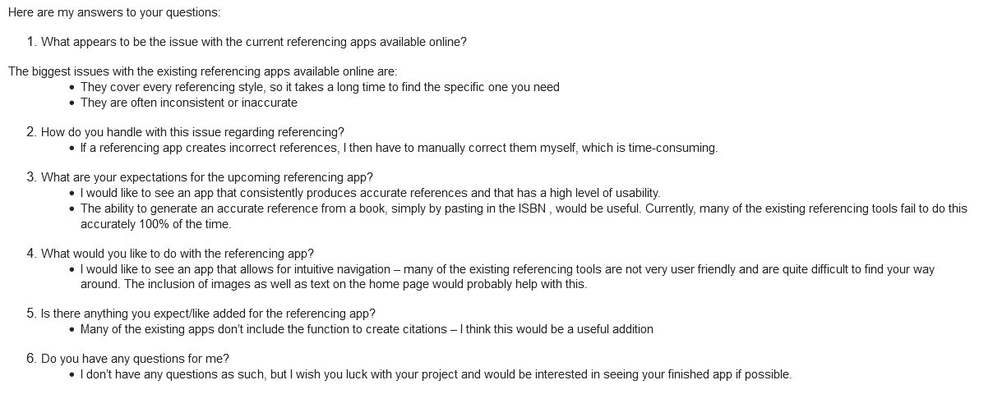

Appendix 2 – Ethics Form

Ethics Approval Form

Before you complete this form, please take time to carefully consider the following questions:

Have you considered yet whether there are any problematic ethical issues in your proposed research project? If you have not you should talk to your Course Tutor or Supervisor.

Have you already completed an Ethics Approval Form? Yes – then you do not need to complete this form

No – please complete this form in as much detail as you can

Name: | Joachim Manlongat
Project/Research Title: | An Investigation Into Referencing by Developing a Referencing Application
Name of Supervisor: | Andrew Green
School/Dept. | NPTC Group
Faculty: | School of IT
Proposed Start Date: |  | End Date: | 18/12/24

1. Summary of planned research (please indicate below the purpose of your planned project/research, together with your aims, main research questions and research design – you should continue onto a separate sheet if necessary)
The purpose of this planned project is to design and develop a referencing application alternative for a client.
The aim is to design a referencing application as a solution towards the issues that exist with the currently available reference tools. A singular referencing style (Vancouver) is recommended for the project, with the requirement to provide a concrete demonstration of a desktop application.
Objectives
- Develop a prototype
- Evaluate the nature of the references, types and capabilities of application
- Investigate how client expectations are influencing the application
- To discuss the client experience and expectations and make recommendations to develop an application

2. Methodology (You need to be clear about the methodology you intend to use in your study; this could include any number of methods, so either tick those shown below (where appropriate) or put the details in the box marked *)

 | Interviews |  | Participant Observation |  | Use of personal data
 | Focus groups | / | Questionnaire |  | Literature Review
 | Performance |  | Presentation |  | Other (state below)*

3. Participants - Does your proposed project/research involve human participants?

/ | 1. Yes, as a primary source* |  | 2. Yes, as a secondary source* |  | No- go to section 4

*If you have ticked yes, it is likely you will need an Advanced CRB check before undertaking your study

If yes, indicate who your participants are:

 | Early years/Pre-School children | / | Adults - give details below
 | School age children |  | Vulnerable people - give details below
 | Young People aged 17-18 | Staff of NPTC Group – Neath College
 | Unknown at this stage

4. Ethical issues - you should tick all that apply

 | Administration of drugs incl. alcohol |  | Deprivation
 | Unpleasant stimuli in any manner or form |  | Active deception or withholding information
 | Collection of highly personal information |  | Payment

5. Are there any ethical concerns other than those listed above? (Continue onto a separate sheet if necessary)

N/A

6. If there are any ethical concerns, please state how you intend to minimise any risk of harm or distress that could be caused (continue onto a separate sheet if necessary)

N/A

You should enclose any materials (e.g. questionnaire, interview schedule), plus the Consent Form, and the Debriefing Sheet when submitting the Ethics Approval Form to your supervisor.

Student Signature: J. Manlongat_______________________________________Date: 18/12/2018

**********************************************************************************
 | Advanced CRB check required |  | CRB confirmation received - Date:_______________
 | Recommendation of approval given at Faculty Level
 | Approval not given at Faculty level – forwarded for discussion at the next meeting of the University Ethics Committee
Comments:

Signature: (Assistant Dean/Head of School) _______________ ____________ Date: ________________

Faculty recommendation endorsed by the Ethics Committee | Chair’s Initials |  | Date

