March 2025

Student
Ana-Maria Ifrim
2412153
university of wales trinity saint davids
Effective Teamworking and Communication Module (BMSW4009)

Table of Contents

1. Introduction 2
2. Main Findings 2
2.1. Belbin’s Team Roles 2
2.2. Transactional Theory 4
2.3. Bruce Tuckman Theory 4
2.4. Shannon and Weaver Model 5
2.5. Thomas-Kilmann Theory 6
3. Conclusions 7
4. References 8
5. Appendices 9
Appendix 1: Belbin’s Questionnaire 9
Appendix B: Thomas-Kilmann Conflict Questionnaire 18
6. List of Figures 25
Figure 1. Belbin’s Team Roles 25
Figure 2. PAC Model 26
Figure 3. Team Development Stages 26
Figure 4. Shannon-Weaver Model 27

Reflective Report

Introduction
Teamwork is one of the most important soft skills that an employer is looking for, as teams are at the core of the organisational efforts of a company. No matter the industry, effective teamwork is critical for success (Parker, 2008). A teamwork refers to a collaborative effort of a group working together to achieve a specific goal, combining the diverse skills, talents and perspectives. It involves cooperation, communication, trust and respect between team members (Mullins and McLean, 2019).
Reflecting on my natural role within teams I find my preferred role an Implementor, my secondary role a Completer/ Finisher and my model of conflict handling as Compromising. This resulted from the Belbin’s questionnaire, Thomas Kilmann Questionnaire and the analysis performed during the Effective Teamworking and Communication module.

Main Findings
Throughout the lectures I had the opportunity to learn about effective teamworking, the issues that can affect relationships, Belbin’s Team Roles, Transactional Theory, Bruce Tuckman’s Theory, Thomas-Kilman Conflict Modes and Shannon and Weaver Model of Communication. Exploring all this theory helped me analyse my team role, be aware of my traits and the improvement I need to make.

Belbin’s Team Roles
The term "Team Role" refers to an individual's natural inclination to behave, contribute, and interact with others in specific ways in the workplace (Belbin, 2010, p.21). There are nine types of behaviours in which people engage that contributes to the effectiveness of a team as follows:
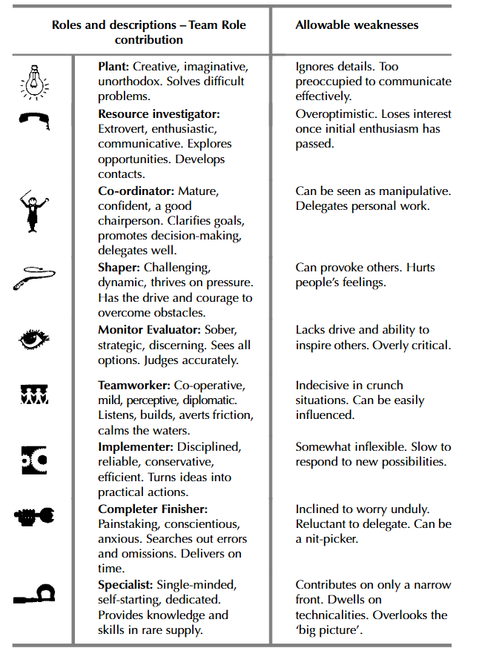
Figure 1. Belbin’s Team Roles
Following the results of Belbin’s Questionnaire (see Appendix A), I discovered that my preferred role within a team is Implementor, followed by Completer Finisher, despite of perceiving myself more of a Coordinator or a Plant.
As from my experience, because of my Completer-Finisher traits I faced challenges in communicating with the team due to my obsession on having everything organized, well written and on time. I felt I have put pressure on my team, but the final result was worthy.
Due to my Implementor role within the team we were able to implement our ideas, be organised, manage our time efficiently and create good content for our presentation.

Transactional Theory
According to Transactional Theory (Eric Berne, 1958) there are 3 states in which we are placing ourselves when communicating, as presented in picture below:
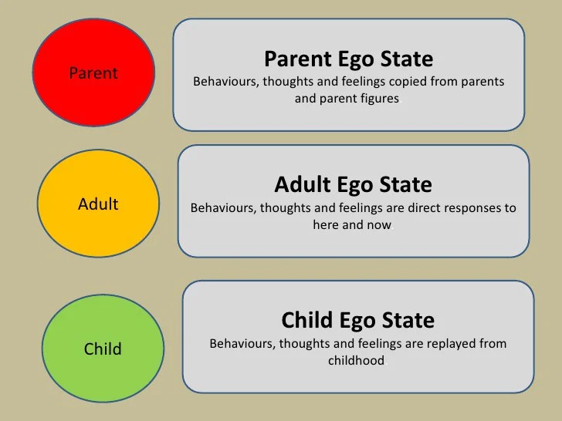
Figure 2. PAC Model
During my collaboration with my colleagues I felt that my state was mostly Adult, being objective, problem-solving oriented and handling conflict in a compromising style. There were, also, some situation when I switched to Parent state, specifically when we got stuck in the Storming stage and I considered we need to get things moving and start Performing.

Bruce Tuckman Theory
According to Tuckman (1965) there are 4 stages of group development detailing how teams progress from their initial formation to achieving high performance. Later, with Mary Ann C. Jensen (1977), he added a fifth stage: adjourning.
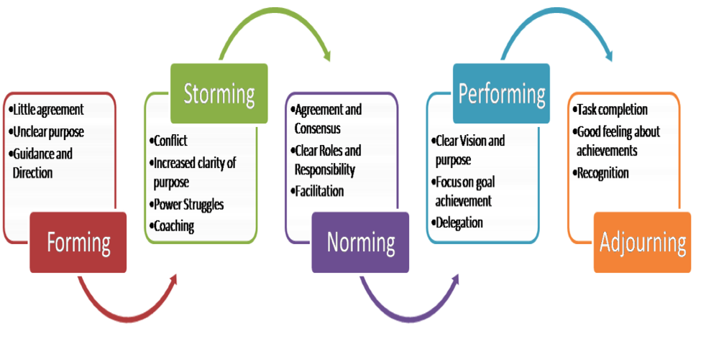
Figure 3. Team Development Stages
During our collaboration for group presentation, we moved smoothly from stage to stage. In the Forming stage we got to know each other and delegate the leader, having more of a formal communication. Then we moved to Storming, where we got stuck for a while with conflicts about choosing the study case and assigning the tasks. Once we settled our conflicts, we then moved to Norming where everyone was assigned a task, understood their responsibilities and we progressed to Performing. In this stage everyone became proactive, flexible when needed to adapt to content changes and performance driven. In the Adjourning stage we spent less time together as we finished our first presentation, but then we started to communicate and reassemble the team and start preparing for our second group presentation.

Shannon and Weaver Model
The Shannon and Weaver Model of Communication (1949) outlines the process of information transfer, focusing on a linear flow from a source to a destination through a channel, with potential noise disrupting the message.

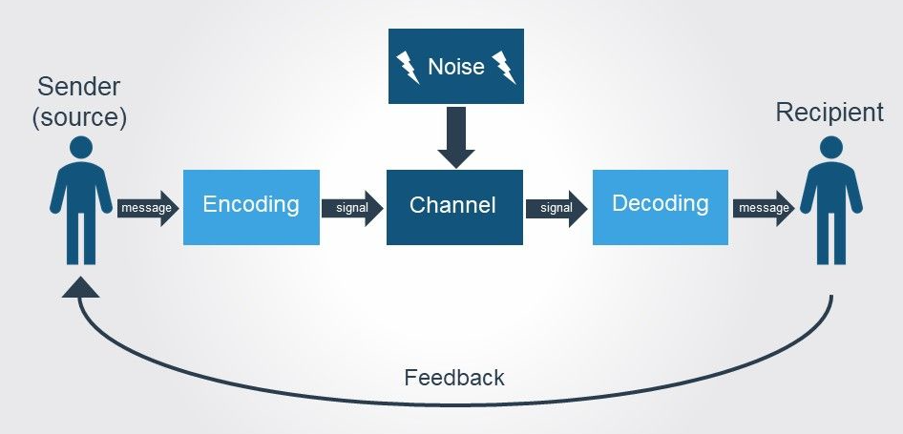
Figure 4. Shannon-Weaver Model
While working with my team we mostly use as channel for communication online apps. This proved to be detrimental to us as we were missing the most important part of communication, which is the body language. As a result, we got stuck in Storming state and had conflicts.

Thomas-Kilmann Theory
Thomas-Kilmann conflict mode instrument (Kilmann and Thomas, 1977) is a self-assessment questionnaire used to understand individuals preferred style of handling conflict, based on the five modes as follows:
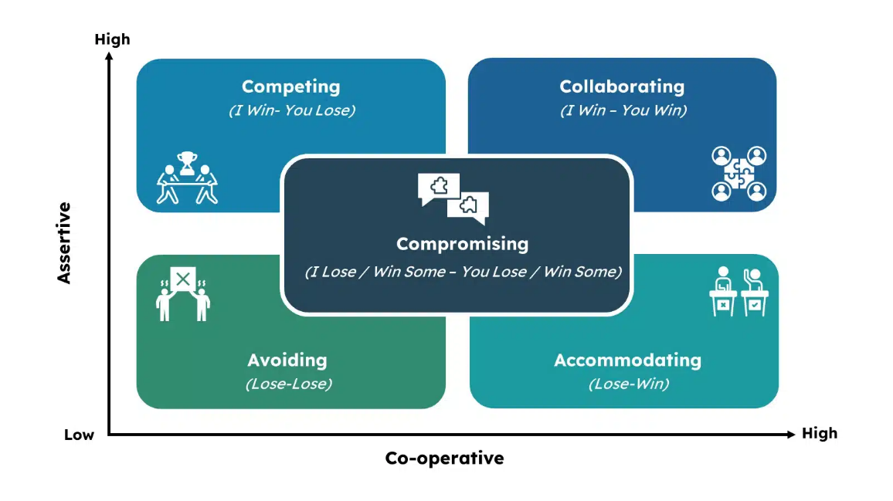
Figure 5. Thomas-Kilmann Conflict Modes
By completing this questionnaire resulted that my style of handling conflict is Compromising (see Appendix B). This was a reinforcement of how I perceive myself as I always seek compromise so all members of the team feal heard and satisfied, but I consistently keep in mind the goal achievement. This was also my experience this term when I had to approach conflict, help everyone feel content with the tasks and consistently lead them to performing and achieving our goal.

Conclusions
Concluding, effective teamwork is essential for the success of any organization.
By following theories like Belbin’s Team Roles, Transactional Theory, Bruce Tuckman, Shannon-Weaver Communication Model and Thomas-Kilmann conflict modes, I have gained valuable insights into my role within a team as an Implementor and Completer-Finisher. This report highlights the importance of understanding individual roles and communication styles to encourage collaboration and enhance team performance.
By recognizing the challenges I face, particularly in relation to communication and conflict resolution, it facilitated my effective teamworking. Therefore, I propose the following action plan:
- Enhance communication skills by supporting face-to-face communication, scheduling in-person or video meetings and practice active listening to encourage dialogue and ensure all team members feel heard.
- Improve flexibility by become more adaptable during the Storming stage to prevent conflicts from escalating and discussing beforehand potential obstacles.
- Expand my conflict handling skills by reflecting on past conflicts and analysing which strategies were effective or ineffective.
- Foster trust, respect, and open communication within the team by encouraging regular feedback.
By implementing this action plan, I aim to enhance my effectiveness within teams, improve collaboration and contribution to achieving our collective goals.

References

Belbin, R.M. (2010) Team roles at work. 2nd ed. London: Routledge.
Berne, E. (1958) ‘“The analysis of games”, in Transactional analysis: a new and effective method of group therapy’, American Journal of Psychotherapy, 12: 735–43.
Kilmann, R.H. and Thomas, K.W. (1977), "Developing a forced choice measure of conflict handling behaviour: the mode instrument", Education and Psychological Measurement, Vol. 37, pp. 309-25.
Mullins, L.J. and McLean, J.E. (2019) Organisational behaviour in the workplace. Twelfth edition. Harlow, United Kingdom: Pearson Education Limited.
Parker, G.M. (2008) Team players and team work : new strategies for developing successful collaboration. 2nd ed. San Francisco, CA: Jossey-Bass.
Tuckman, B.W. (1965) ‘Developmental sequence in small groups’, Psychological bulletin, 63(6), pp. 384–399. Available at: https://doi.org/10.1037/h0022100.
Tuckman, B.W. and Jensen, M.A.C. (1977) ‘Stages of Small-Group Development Revisited’, Group & organization studies, 2(4), pp. 419–427. Available at: https://doi.org/10.1177/105960117700200404.
Shannon, C.E., and Weaver, W. (1949) ‘The mathematical theory of communication’, University of Illinois Press.

Appendices

Appendix 1: Belbin’s Questionnaire
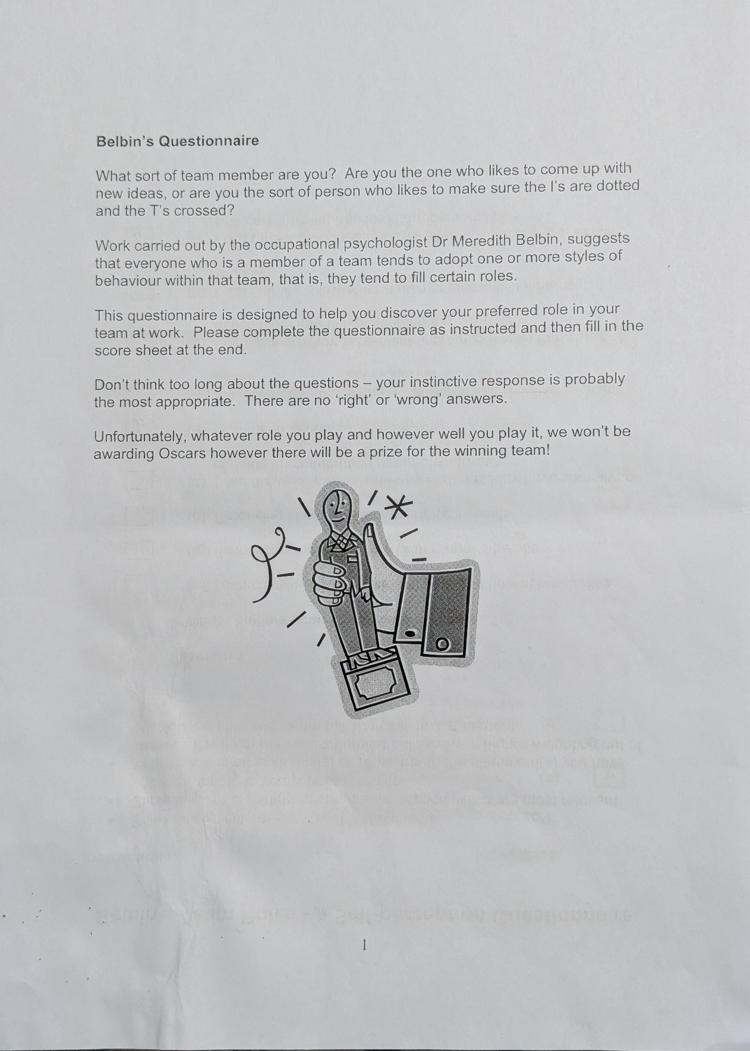
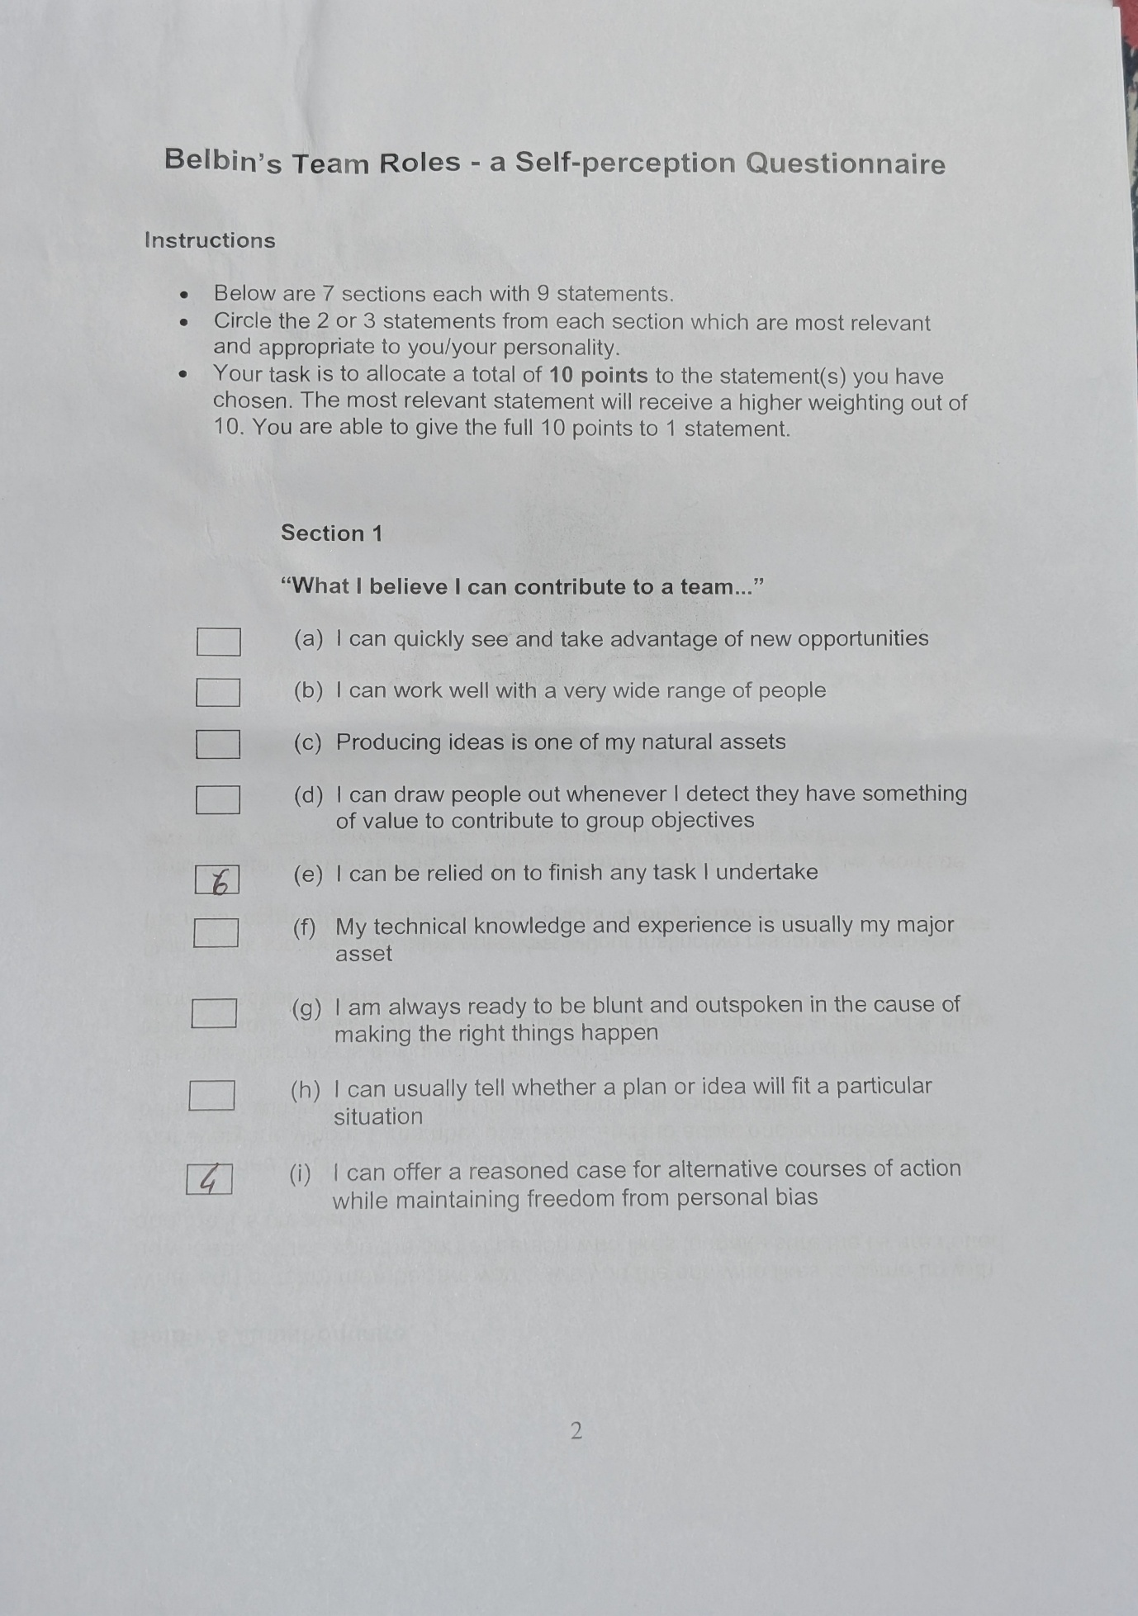

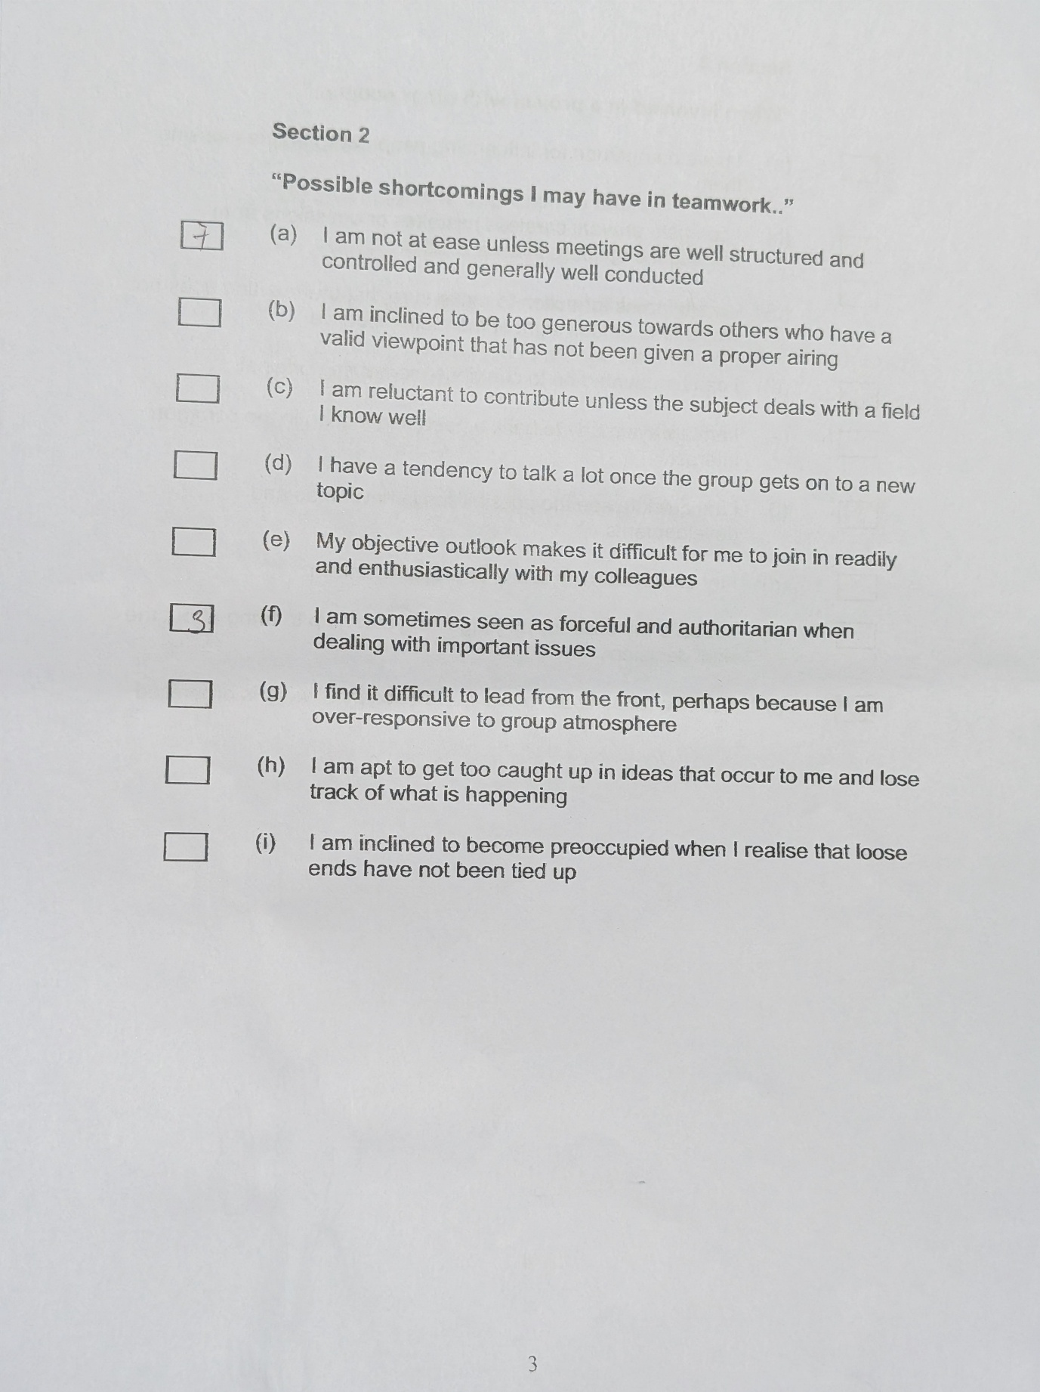

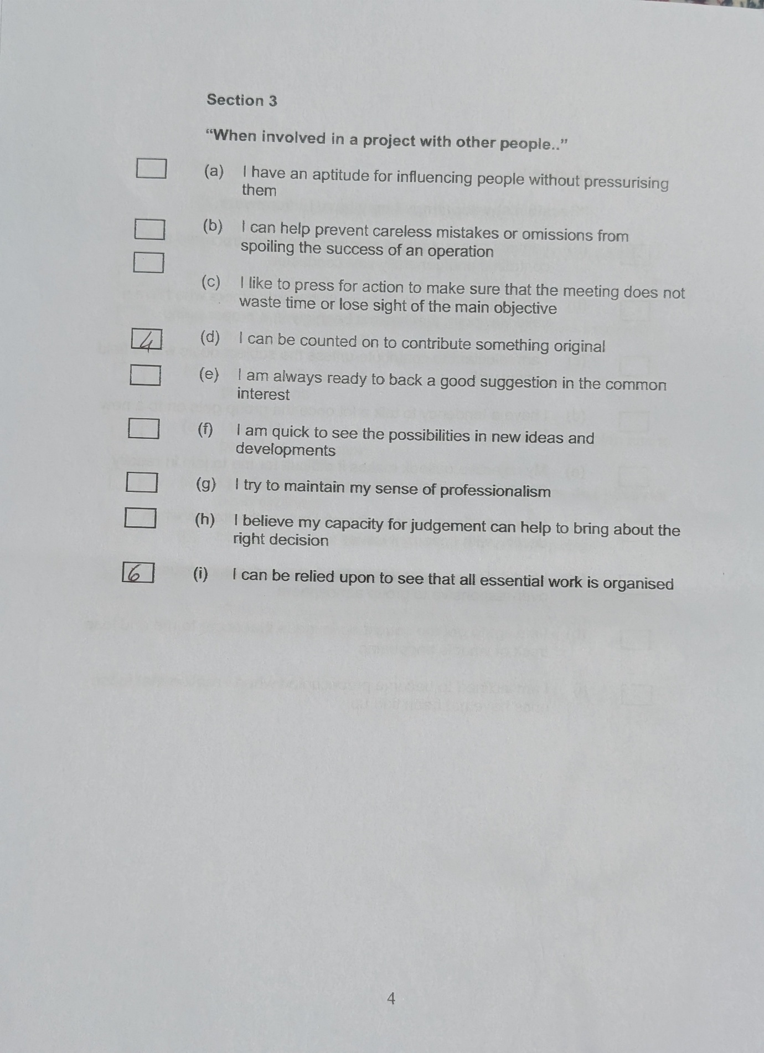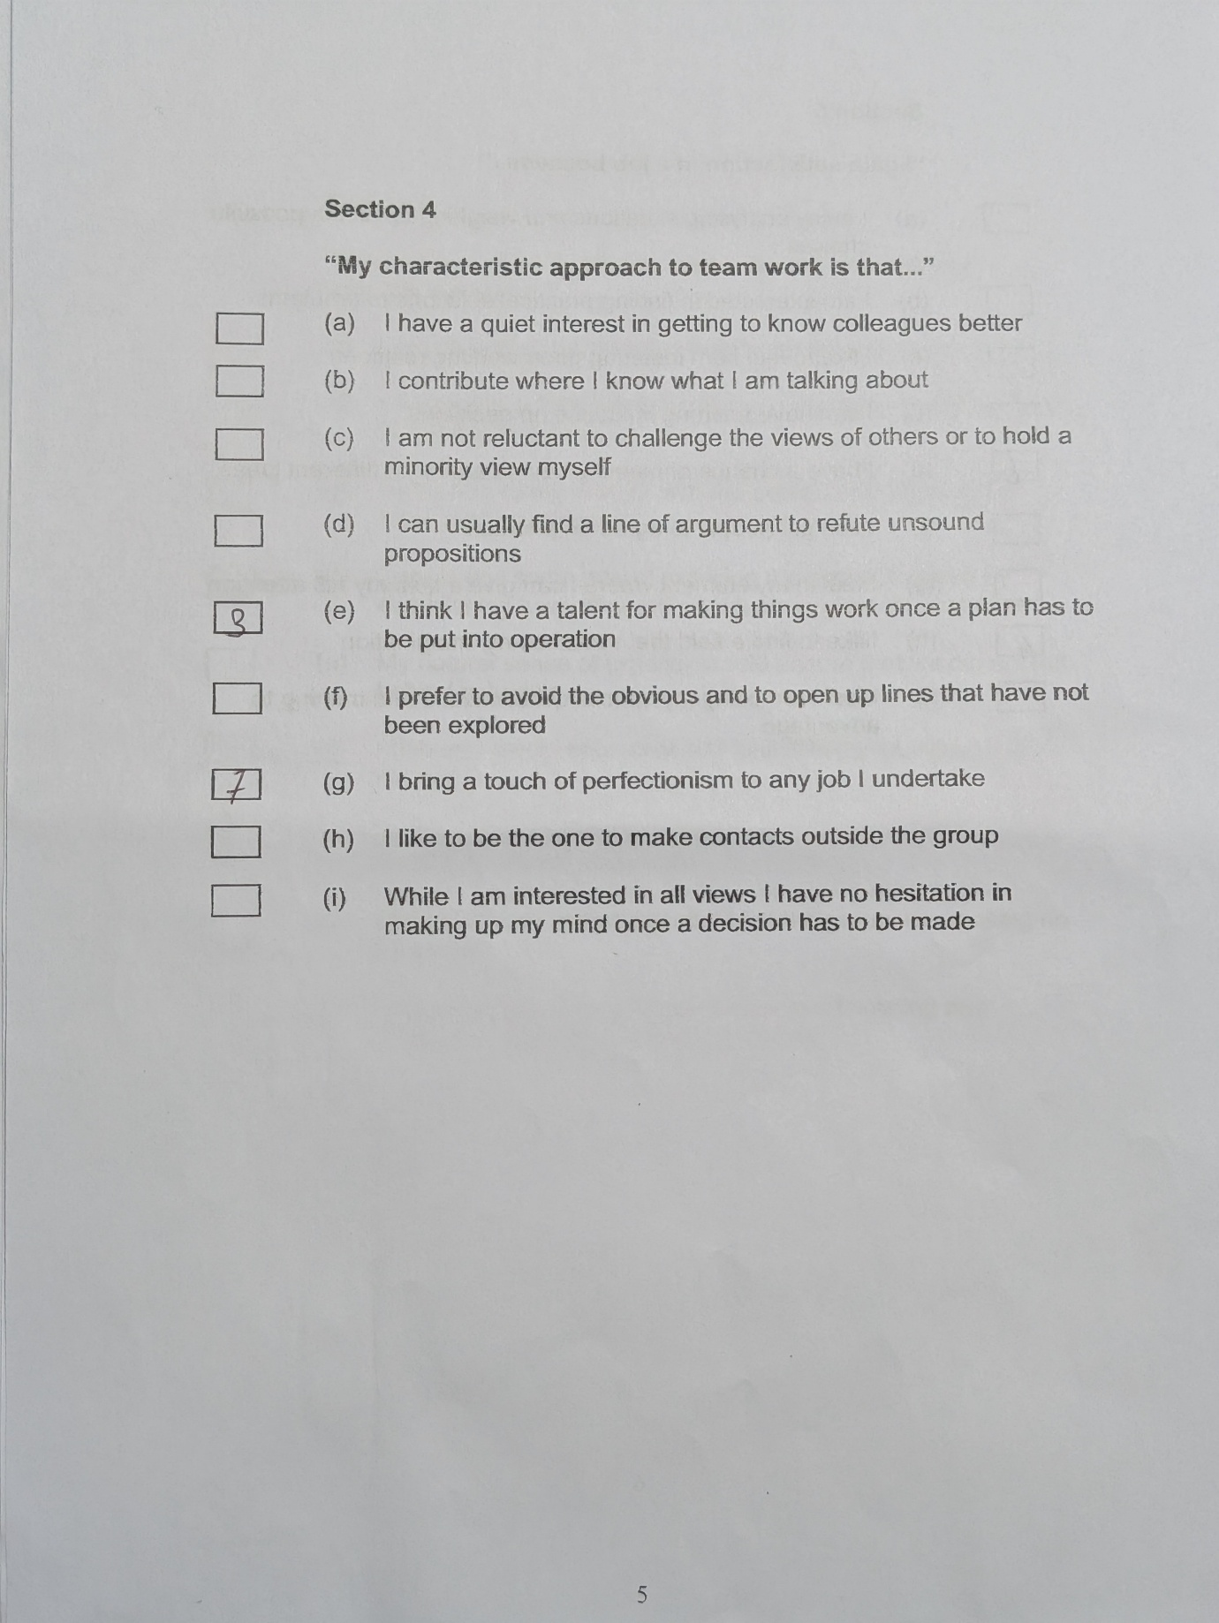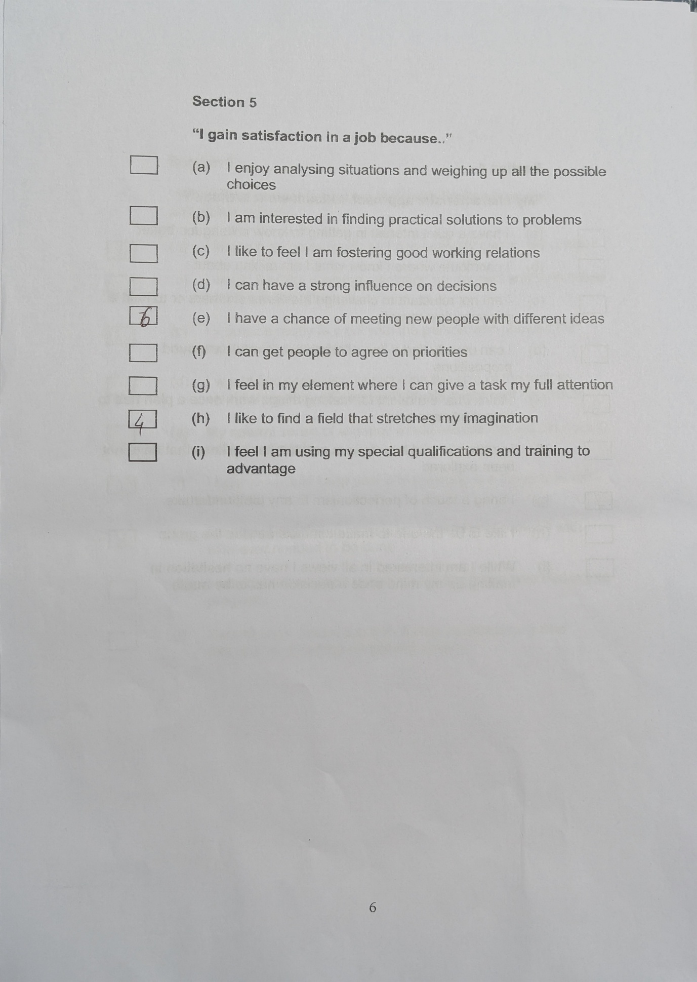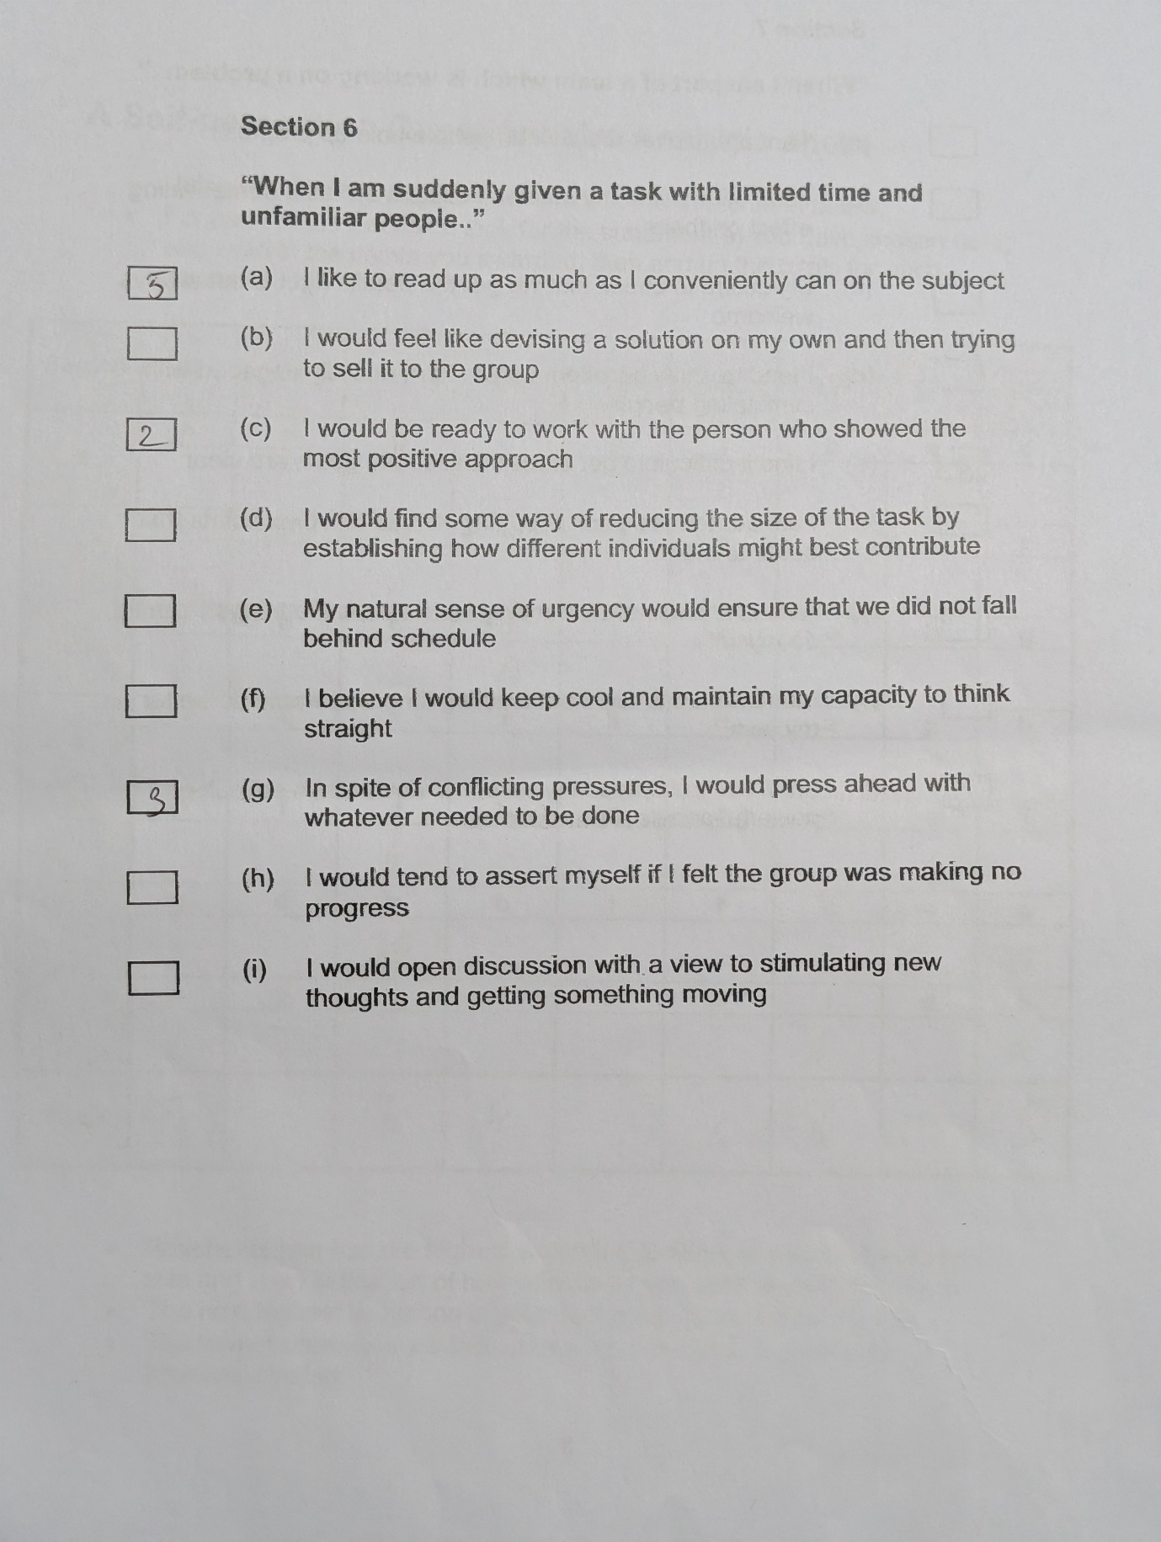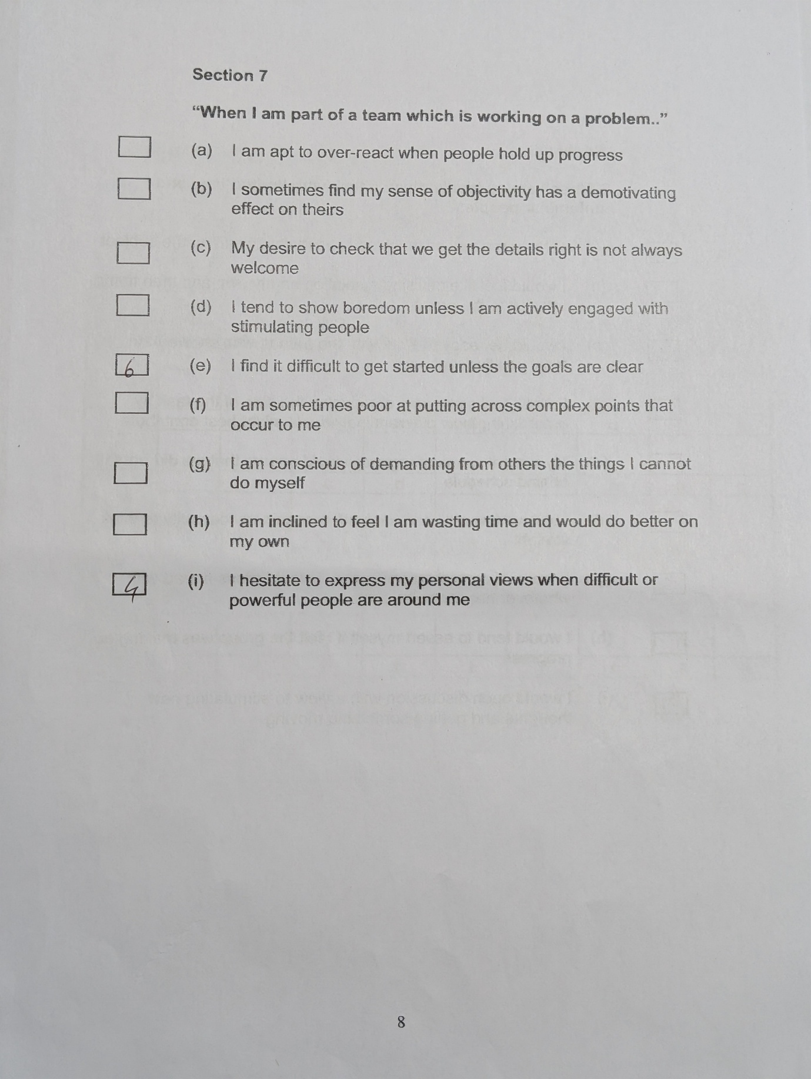
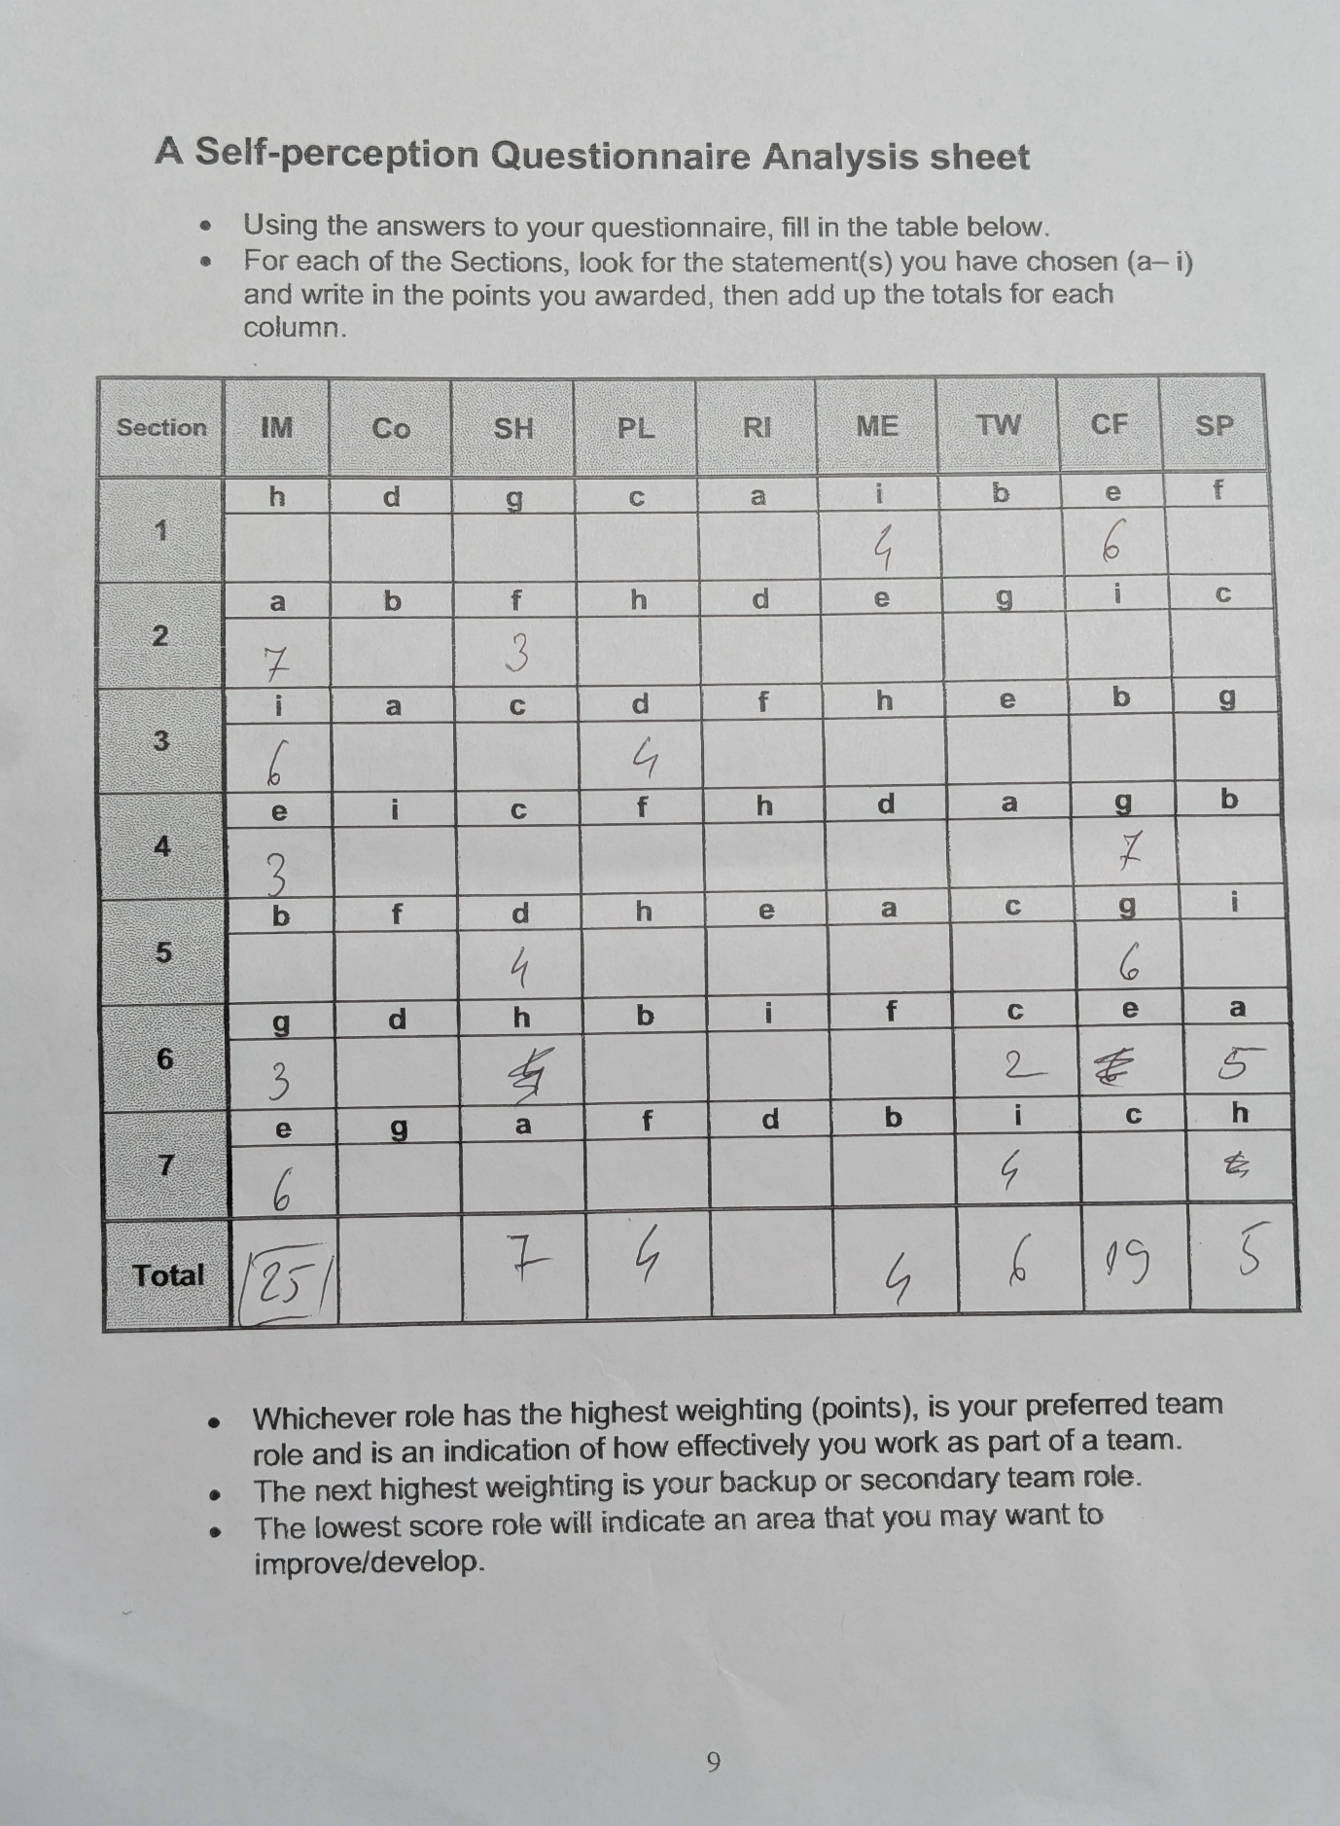

Appendix B: Thomas-Kilmann Conflict Questionnaire

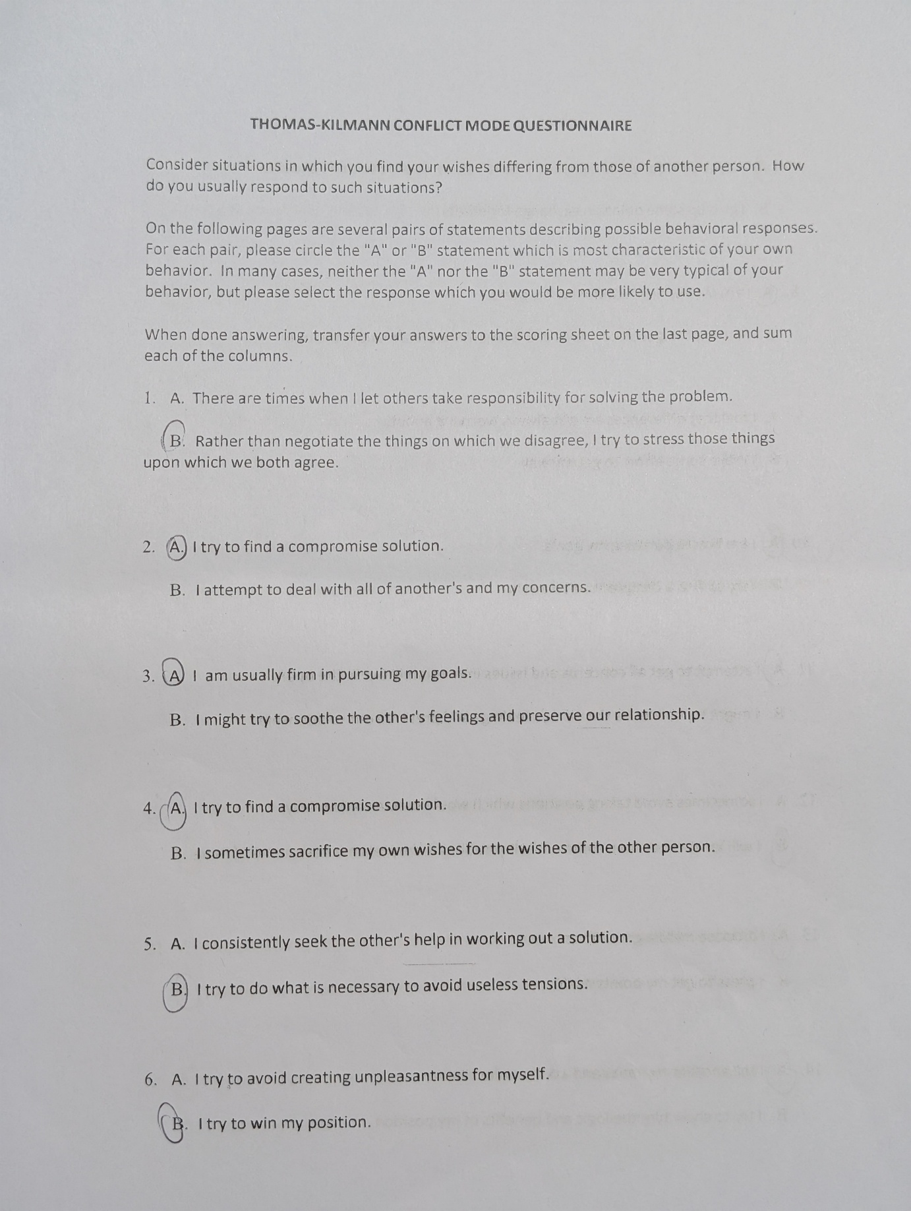
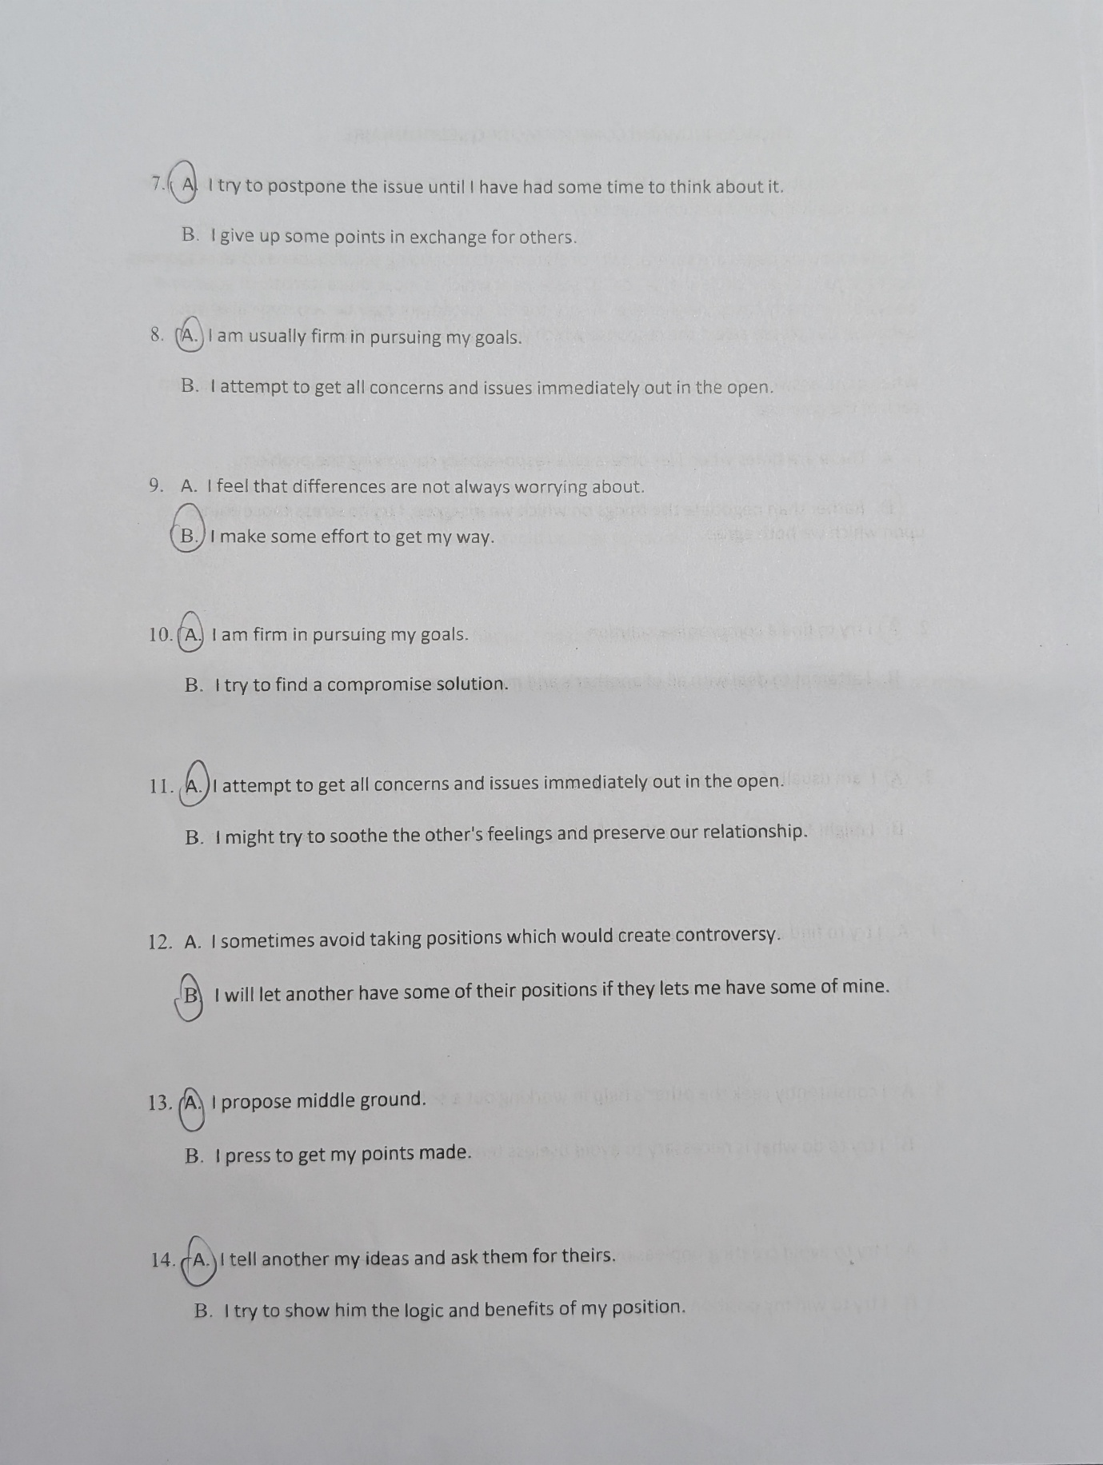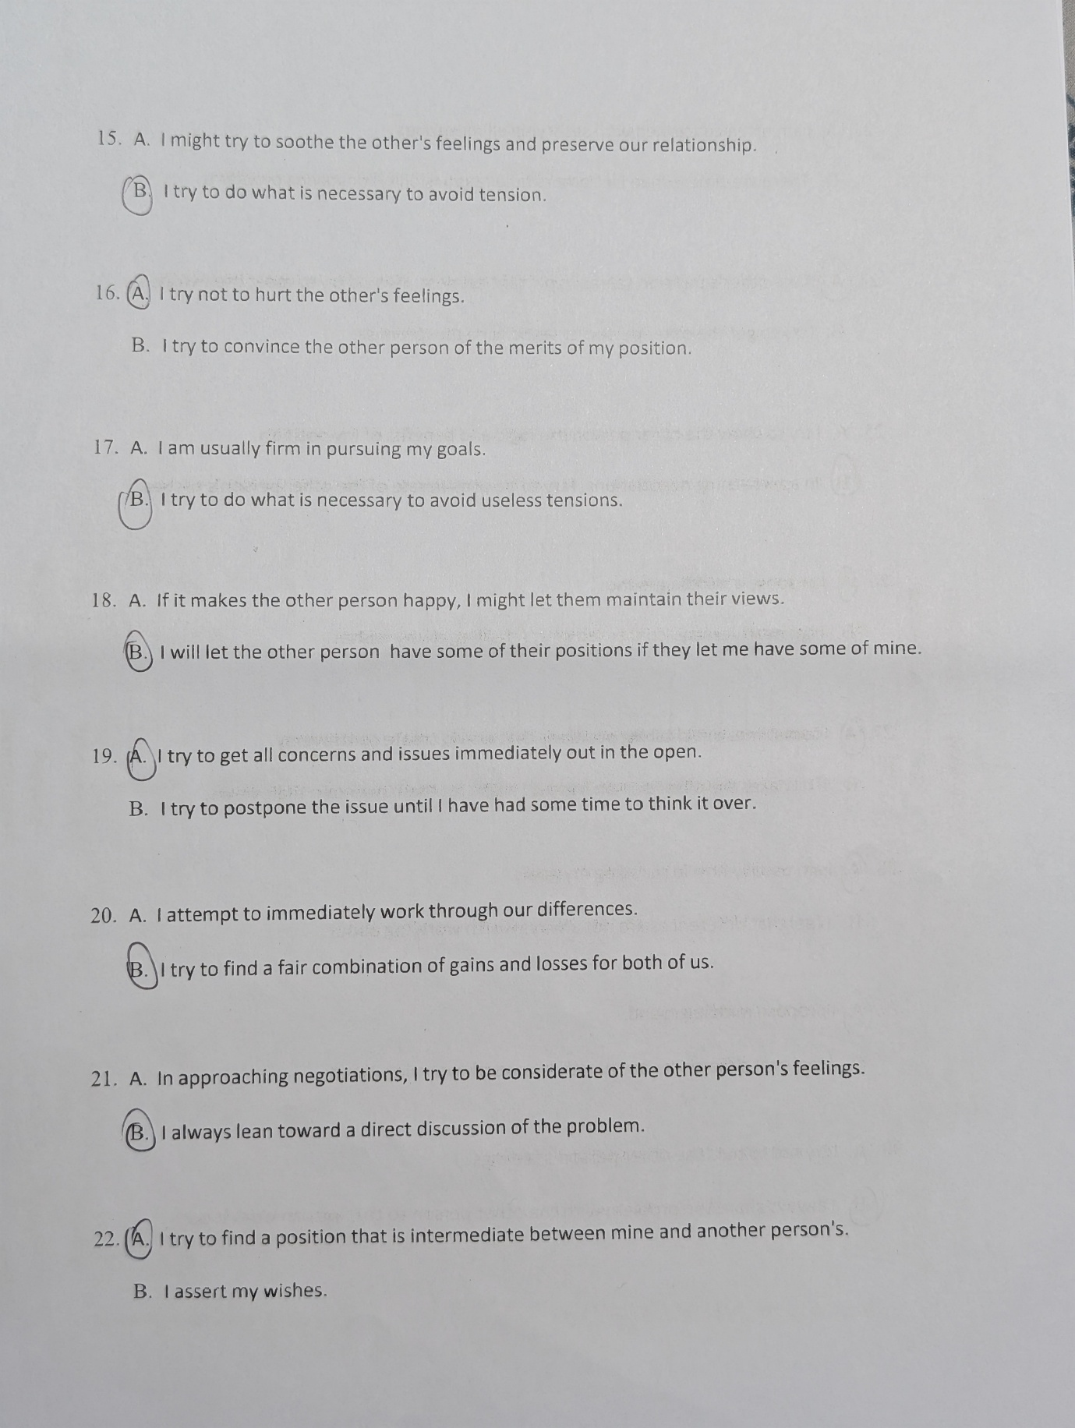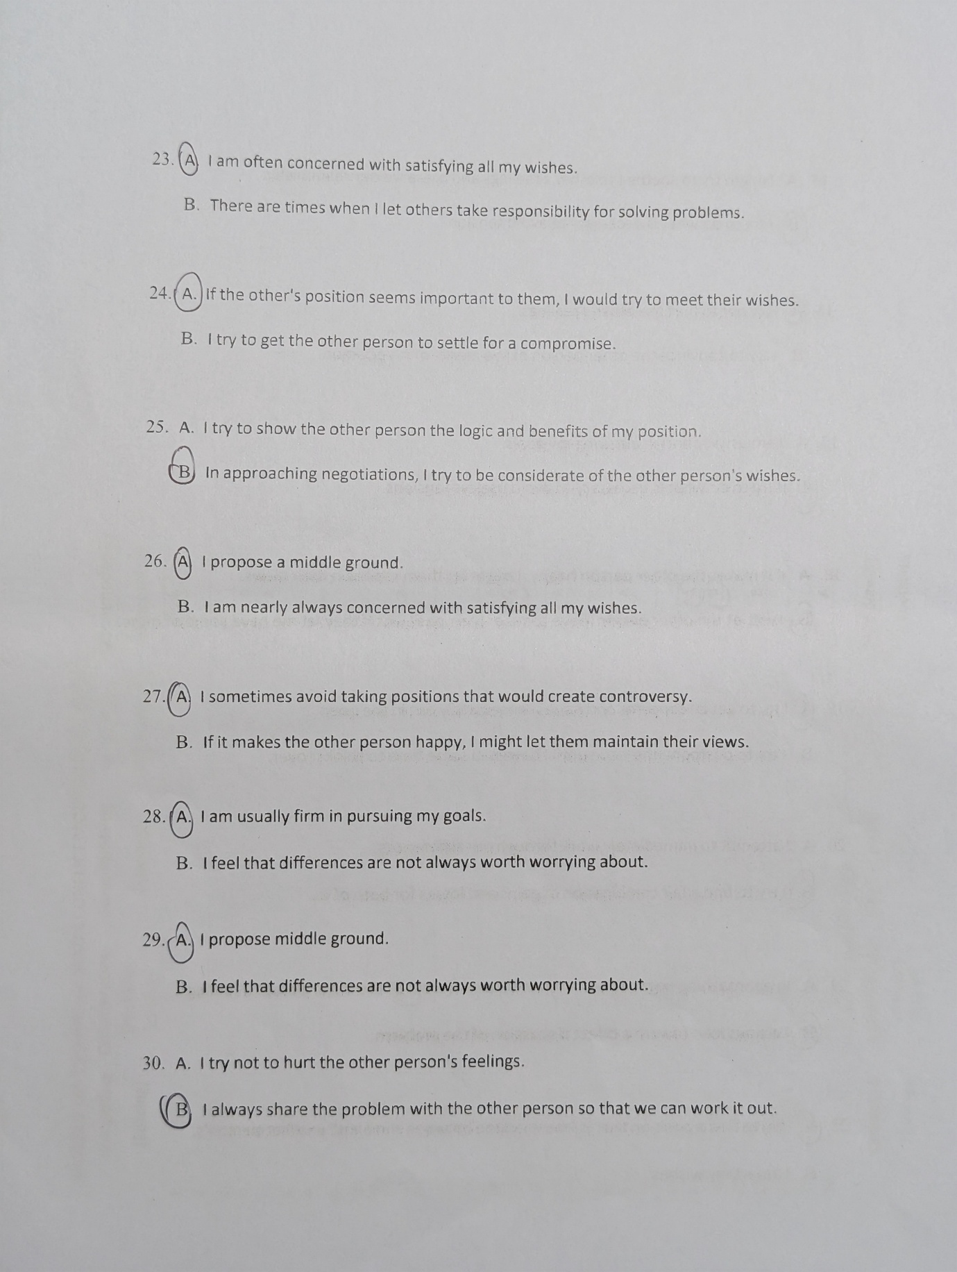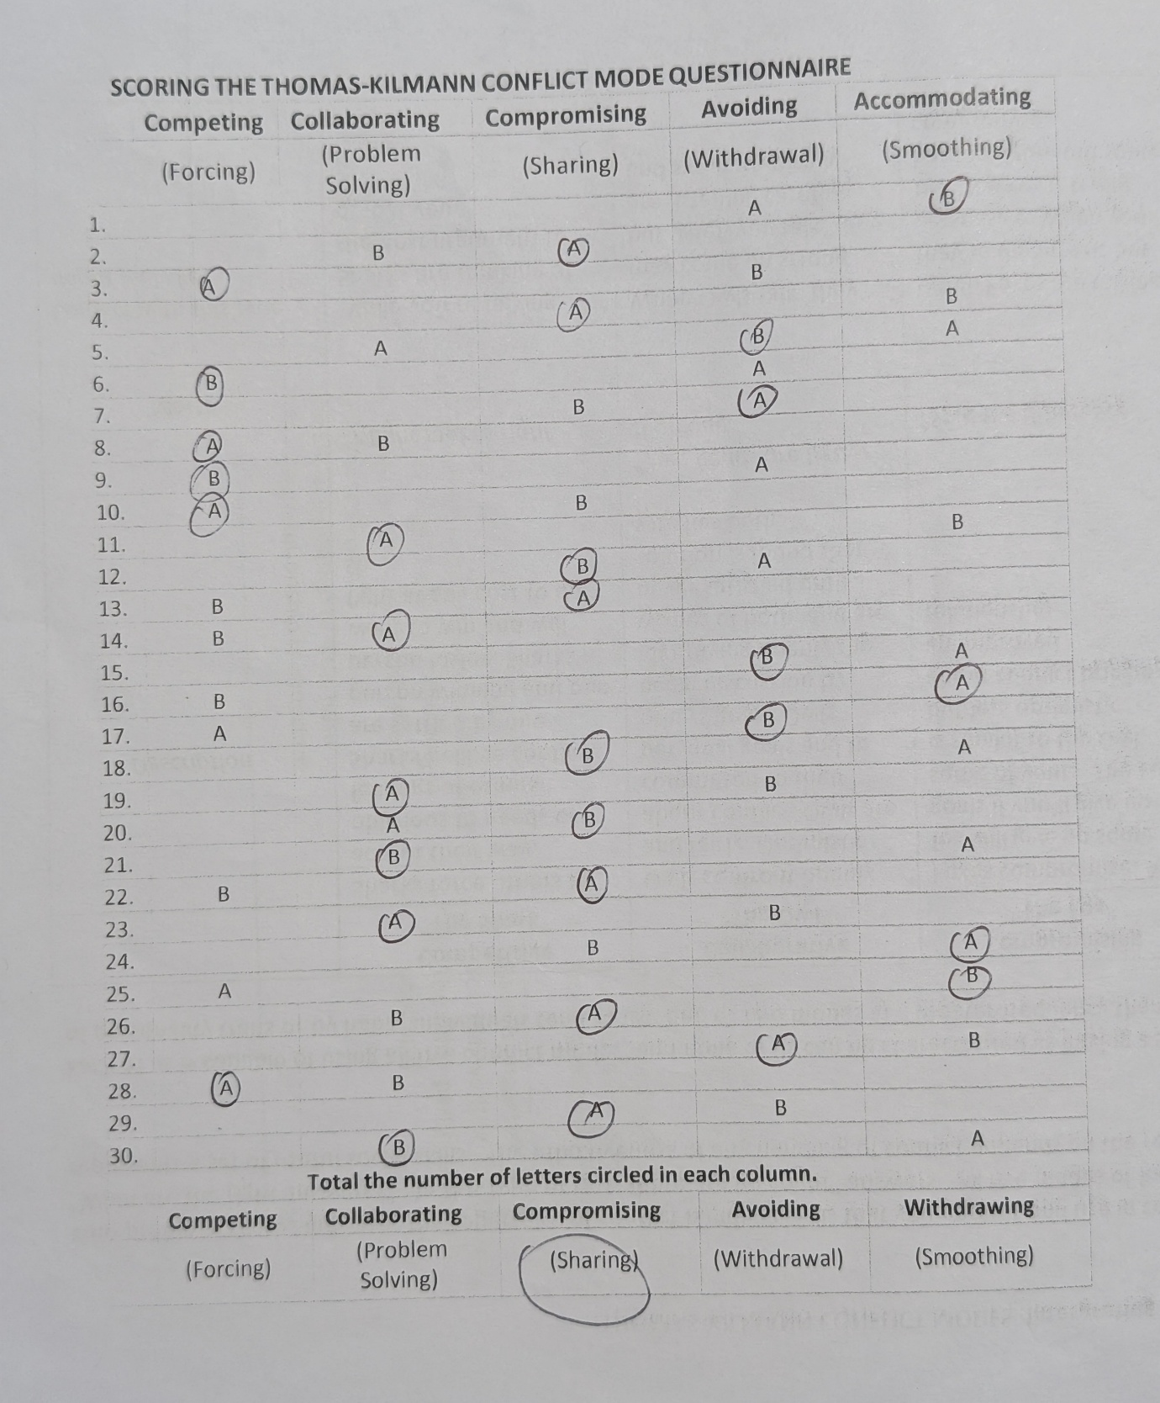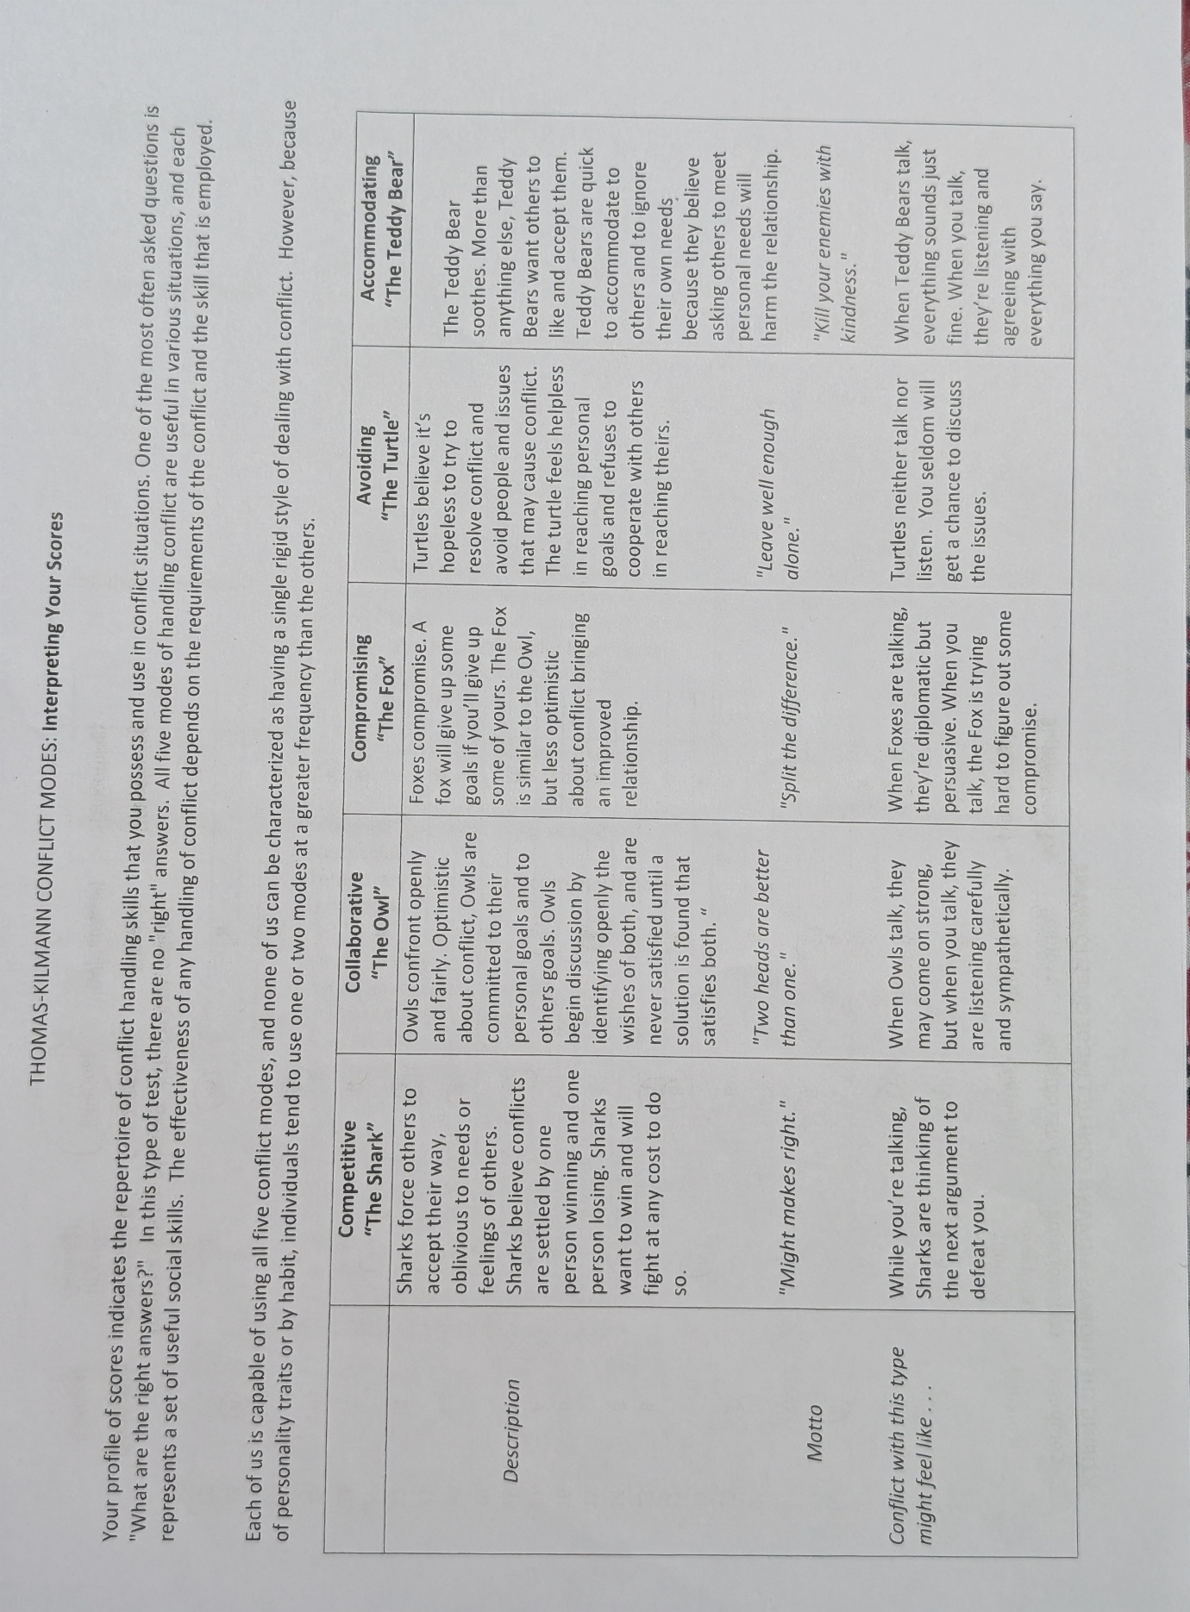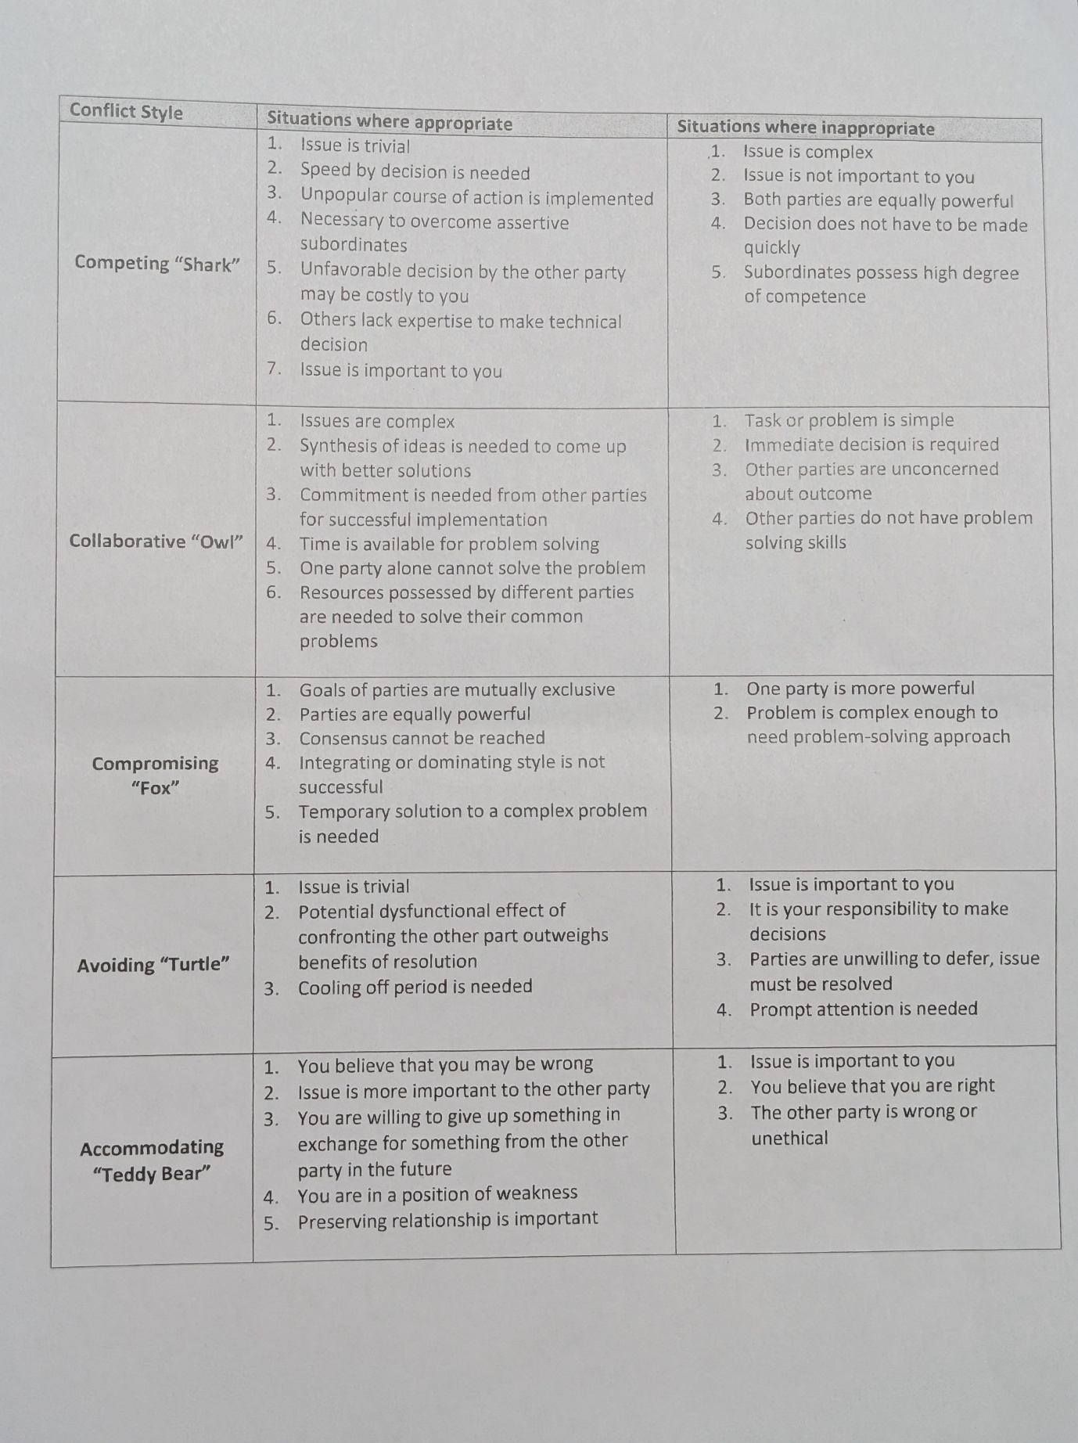

List of Figures

Figure 1. Belbin’s Team Roles

Figure 2. PAC Model

Figure 3. Team Development Stages

Figure 4. Shannon-Weaver Model

Figure 5. Thomas-Kilmann Conflict Modes

