Emma Keating 3CO02 Principles of Analytics
Q1. Explain what evidence-based practice is and provide two examples of how Company X could apply it. (AC 1.1)
Evidence based practice is a decision-making process that allows businesses to make decisions using the best available, up to date, validated and current evidence of information. When evidence-based practice is applied it prevents decisions being made using unreliable, biased and outdated information. The quality of the evidence is crucial and should always be trustworthy data taken from the organisations records rather than using personal opinions or gut instincts. I have many years of experience using this method within my previous employment and would be confident that this method would ensure Company X can make continual improvements and innovations for their customers. Examples of how I would apply this method if I was successful for the position would be to investigate employee retention and gather data from all leaver surveys evaluating whether improvements can be made to retain staff longer. The results can sometimes show improvements to staff well-being; employee pay or hours worked. Another example I would use would be analysing the data of staff absences taken from the payroll or HR records, again this could be a well-being improvement or looking into the hours worked ensuring that there is nothing impacting the absences from a work point of view. With both examples decisions can be made from genuine data taken from trustworthy records to give an unbiased decision if improvements need to be made.
Please see below a 6-step process that I follow in my practice as published by the Chartered Institute of Personnel and Development (CIPD) to ensure that evidence-based process is followed:
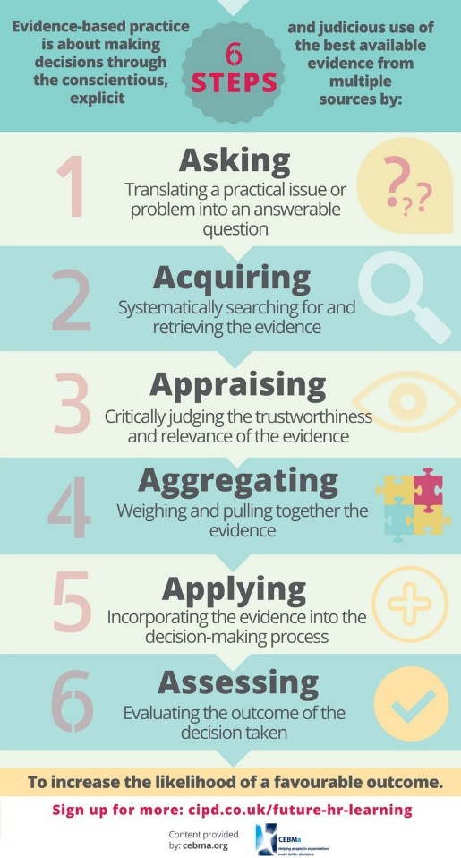
(Galli, 2017)

Q2. Explain the importance of using data at Company X to accurately determine problems and issues. (AC 1.2)
In my experience I have learnt that it is very important to use data within a business analysis process to determine any decision making is made fairly, accurately and unbiasedly. The data used if I was successful at Company X would be gathered from authentic sources such as HR records, staff surveys, sales records and any other organisational reliable data. In my current position as a Sales Manager at Bluestone Resort Wales, I work closely with the Commercial Team assisting in gathering daily report data to track sales, ensuring that sales targets are made and to analyse if any improvements can be made. I have successfully in the past increased accommodation sales profits by looking at the sales data to see any opportunities of dates of breaks that are selling well so that there is a valid reason to increase the sales price with the demand shown. If decisions are made without using data resources, it could be at risk to the business if evidence is not used to prove changes are required and these changes may need to be reverted if they fail possibly causing a loss to the business. I also have experience within the HR Department leading investigations and disciplinaries which may be beneficial to the role. For me to lead these employee meetings fairly and unbiasedly I gather information from payroll records, HR records and previous meeting notes before making any decisions.
Q3. Explain the different types of data measurements that people professionals at Company X could use. (1.3)
Depending on the clients’ requirements and brief, if I was successful with your role at Company X I would gathering information from the organisation, practitioners, scientific literature or stakeholder sources to ensure that the evidence sources are reliable. The methods I would then use would either be qualitative, quantitative or a specific to assist the client.
Qualitative Data would be required for example if number analysis would not be relevant but employee personal opinions such as a staff survey, exit interview notes or interview feedback would. In my previous roles I have experience of reviewing annual staff survey feedback to investigate the data of their own opinions of well-being within the business. If the employees are aware of the well-being programme and if this is working for the business or could there be improvements? If they are not aware of the well-being and the scores came back low, I made recommendations to apply a well-being app so that the information was easier for the staff to use. The following year after improvements were made the scores were better.
Quantitative Data could be required if a client needed measurable statistics to analyse information. I have daily use of this method working in a Sales target driven role currently. To prepare for a weekly meeting, I am required to analyse the daily, weekly and yearly reports comparing year on year so that the business can make financial decisions based on whether the yearly target will be achieved or not.
At times a client may require a combination of the data sources to make decisions as they may need measurable and personal opinions for example if they are looking at restructuring a Team. The payroll financial details along with the sales figures and employee surveys may be used together.
Q4. Explain how the application of policies and procedures can inform Company X’s decisions. (AC 1.6)
As a Line Manager currently to a Team of eighteen it is essential that I follow the companies’ policies and procedures to align with the other 900 employees in the business. By following the business policy, I can be fair, consistent and avoid any issues that could arise from unfair treatment. The policies are shown on the first day of the employees’ induction at my current workplace which is very beneficial to ensuring that everyone is aware of the expectations and obligations that the business should follow. If a disciplinary needs to take place due to a breach of the company policy this is applied fairly and conducted by myself as their line manager with the assistance of a HR representative to take meeting notes. As an example of the implications of not following procedure, within my workplace a member of staff has been given an additional staff discount by their Line Manager which has been seen by other team members as unfair treatment as they have all paid the full price. This has now been escalated to HR and all staff members have been honoured with a reimbursement for the amount extra they have paid. By one Line Manager treating a staff member outside of the policy, this has had an impact on all other staff and a cost to the business which could have been avoided if the policy was followed correctly.
Q5. Explain how the people professionals at Company X can create value for their people, their organisation and their wider stakeholders. (AC 2.1)
People professionals will be supporting Company X in many ways to ensure business goals are met creating value for the company and if I were success for the role, I would suggest the following is implemented if it isn’t already.
HR from the very start of the recruitment process of employees should be offering fair and consistent training plans, regular 1:1 conversations, Personal Development Plans, Key Performance Indictors and performance reviews. All of these should be recorded and if any areas need improvement they can be monitored and the correct support given to the employee to ensure that the business is not affected with possible loss. The employee’s well-being is also important which can be discussed in the 1:1 conversation.
HR with the support of the Departments Line Managers at Company X could be implementing an incentive scheme to offer employees clear goals of targets that are expected of them and rewarding the employees when the goals are met to add maximum value to the organisation. HR will be creating value for the stakeholders by ensuring the organisation is run smoothly avoiding any issues and meeting yearly profit targets.
Q6. Imagine that you have been successful in your application for the role at Company X. Summarise the ways that you could be customer focused and standards driven in your new role, drawing on your previous experience, as necessary. (AC 2.2)
As a hardworking, reliable, trustworthy individual that is confident in using my own initiative working alone or as part of a team I am looking forward to starting my new role as People Analytics Administrator at Company X. From my previous experience working for the past eleven years as a Sales Manager at Bluestone Wales Resorts, I will continue to promote high standards of customer satisfaction as have learnt that it is important to listen and understand the customers’ needs and expectations. The ways in which I will implement this is through customer satisfaction surveys and look to make improvements where I can by supporting clients making recommendations using data. An important part of high standards to customer satisfaction is responding quickly to any customer complaints. By analysing whether some of the complaints are repetitive can sometimes lead to changes being made to processes possibly reducing customer dissatisfaction which I have previously assisted to improve net promoter scores. Training may need to be improved or refreshed to employees and by implementing a staff survey to client’s companies this may help to look at what support if any is needed rather than assume it needs planning.
I worked on many projects at Bluestone Wales Resorts to make improvements and increase turnover such as building new phases of accommodation to add value to the yearly income prior to decisions being made I have asked guests in a survey what size lodges would be most popular to their families collecting the data to review at the planning stage. I have implemented improvements to activities from analysing data seeing a drop in revenue which has seen an increase within months to the secondary spend. Regularly I assist the HR Team in investigations and disciplinaries where I have collected the data from the People Services Teams to review prior to the meetings to give an unbiased view as an independent Manager.
Q7. The excel table inserted below shows the hours of overtime worked over a four-week period for one of Company X’s clients, Blue Mountain Patisserie.
- calculate the average number of overtime hours worked by each employee during the four-week period.
- calculate the average overtime hours as a percentage of the normal working hours.

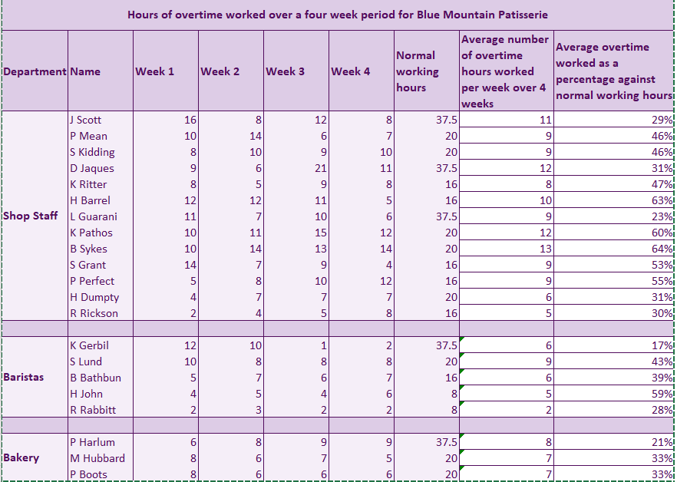

- analyse the results and provide written comments on any issues that the data has revealed suggesting any potential problems and solutions. (AC 1.4)
After reviewing and analysing the excel table of overtime for your client ‘Blue Mountain Patisserie’ I was firstly concerned that there may be a possibility of the company being in breach of the ‘Working Time Regulations Act 1998.’ Employees J Scott, D Jaques, L Guarani and K Gerbil have each totalled over 48 hours per week on occasions in the four-week period of data reported and unless they have opted out of the ‘Working Time Regulations 1998’ themselves in writing the company is at risk of receiving financial fines and penalties. If the employees have not opted out, I would suggest closely monitoring that employees are not in a position of working more than 48 hours per week. As the data only covers a four-week period, I would recommend that further data covering a six-month period be available to analyse whether ‘Blue Mountain Patisserie’ employees are regularly working overtime. It will be helpful to source data as to why the overtime is required, is this a busier month than others, do the employees need further training and support to reduce labour time or has there been high absences and additional hours are only required temporarily. If the data then shows that it is a more permanent requirement for overtime, alternative options could be discussed such as if the part time employees contracted to 16 or 20 hours per week could be offered an increase in their contracted hours to work full time which could reduce the need for overtime. For example, within the shop staff there are five employees with 16 hours and five employees with 20 normal working hours per week contracted that could be skilled to cover more than one role. If it is not possible to increase the part-time employees’ hours, there may be a need to recruit additional staff or restructure offering a multi-role to the Baristas and Bakery staff working less hours as the shop area is requiring the highest hours of overtime compared to the baristas and bakery staff. I would also recommend an employee survey being distributed to all employees with questions targeted on their well-being to monitor a healthy work life balance. If direct questions are asked such as “Do you feel your current workload makes you feel stressed?” “Are you happy with your hours worked” this will all be helpful to consider if a restructure of the workforce is required after analysing further data of why the overtime is required to ensure that employees are aware of the well-being policy and that their voice counts as part of the process of possible changes. Another data analyse that could be run is looking at how busy the shop, barista and bakery areas are in their working hours as the results of this could show that they are open early in the morning, but the custom is not required until later in the day hence why the overtime is required. It may need changes to the opening hours to satisfy the customer’s needs.

Q8. Finally, present your findings using at least two different types of diagrammatic forms (for example, pie charts, bar graphs, or line graphs) to make the information easier to understand. (AC 1.5)

