Film Popularity, Ratings and Viewer Behaviour
Business Intelligence Analysis of the Letterbox Movie Classification Dataset

Programme | BA (Hons) Business Management
Module | Data Handling and Business Intelligence
Module code | LCBB5014
Assessment | Component 2 Coursework: Individual Report
Lecturer | Dr Xavier Matieni
Student name | Roger Aznar Montero
Student ID
Word count | 2,116 words (main report only)
Submission deadline | 14 August 2026, 2:00 PM

1. Introduction
Business intelligence (BI) turns operational data into information that can support better decisions. In media and entertainment, audience activity data can guide content acquisition, marketing, localisation and scheduling, but only when the underlying records are prepared and interpreted correctly (Chen, Chiang and Storey, 2012; Ragazou et al., 2023). This report analyses the Letterbox Movie Classification Dataset supplied for LCBB5014 (University of Wales Trinity Saint David (UWTSD), 2026). The original file contains 10,000 film records and variables covering titles, directors, genres, original language, runtime, average rating and engagement measures such as watches, likes and fans.
The purpose is to identify patterns associated with film popularity and audience evaluation. The work follows an applied BI workflow consistent with the data understanding, preparation, modelling and evaluation stages of CRISP-DM (Chapman et al., 2000), while treating the analysis as a process of turning data into useful knowledge (Fayyad, Piatetsky-Shapiro and Smyth, 1996). Microsoft Excel procedures were used for filtering, duplicate checks, category standardisation, descriptive statistics and visualisation. The statistical analysis comprised an independent-samples t-test, Pearson and Spearman correlations, and multiple linear regression. The corresponding output tables are included in Appendix C. The specific objectives are to: prepare a reliable analytical file; summarise ratings, runtime and engagement; compare genres and language groups; test whether English and non-English films differ in average rating; examine relationships among runtime, watches, likes and fans; and assess whether fans, likes and runtime predict average rating. The final section translates the results into practical recommendations while recognising that observational associations do not establish causation.

2. Data Cleaning and Preparation
The CSV file was imported and the automatically generated index field was removed because it did not contain business information. Data types were checked so that rating, runtime, watches, likes, fans and rating-count fields were numeric. Text fields were trimmed to reduce accidental category duplication, and original-language labels were reviewed for consistent spelling and capitalisation. Genres and studios were stored as text representations of lists; these were parsed into standard lists so each film could be assigned to all relevant genres during aggregation. Twenty-four records used “Unknown” rather than a list for genre, so these were retained and recoded consistently as an Unknown category rather than deleted.
No null values were present in the numerical or categorical variables. However, 31 exact duplicate film records were found after excluding the index and were removed, producing a final analytical sample of 9,969 films. Repeated titles were not automatically deleted because remakes, re-releases and films sharing a title may be legitimate separate observations. Runtime ranged from 2 to 907 minutes, while watches, likes and fans contained very large but plausible values. These cases were retained because removing commercially successful or unusually long films would distort the entertainment market. Logarithmic scales were used in engagement charts to make the highly skewed distributions readable. This approach protects data integrity: systematic data cleaning and documentation reduce the risk that errors and inconsistencies distort downstream analysis (Steorts, 2023; Côté et al., 2024).

3. Descriptive Statistics and Summary
Table 1 summarises the main numerical variables after cleaning. The mean and median average rating were both approximately 3.27 stars, indicating a comparatively balanced rating distribution. Ratings nevertheless ranged from 1.08 to 4.71. Runtime averaged 103.18 minutes, with a median of 99 minutes; the difference between these values reflects a small number of very long productions. Figure 1 confirms that most films are concentrated around the central rating range rather than at the extremes.
Table 1. Descriptive statistics for the cleaned dataset (n = 9,969)
Variable | Mean | Median | SD | Minimum | Q1 | Q3
Average rating | 3.27 | 3.27 | 0.53 | 1.08 | 2.95 | 3.62
Watches | 170,559 | 18,465 | 458,941 | 2 | 2,990 | 108,531
Likes | 43,828 | 3,405 | 151,739 | 0 | 458 | 20,150
Fans | 1,657 | 24 | 9,382 | 0 | 2 | 284
Runtime (minutes) | 103.2 | 99.0 | 38.1 | 2.0 | 89.0 | 113.0
Source: Author’s analysis of the supplied LCBB5014 dataset.
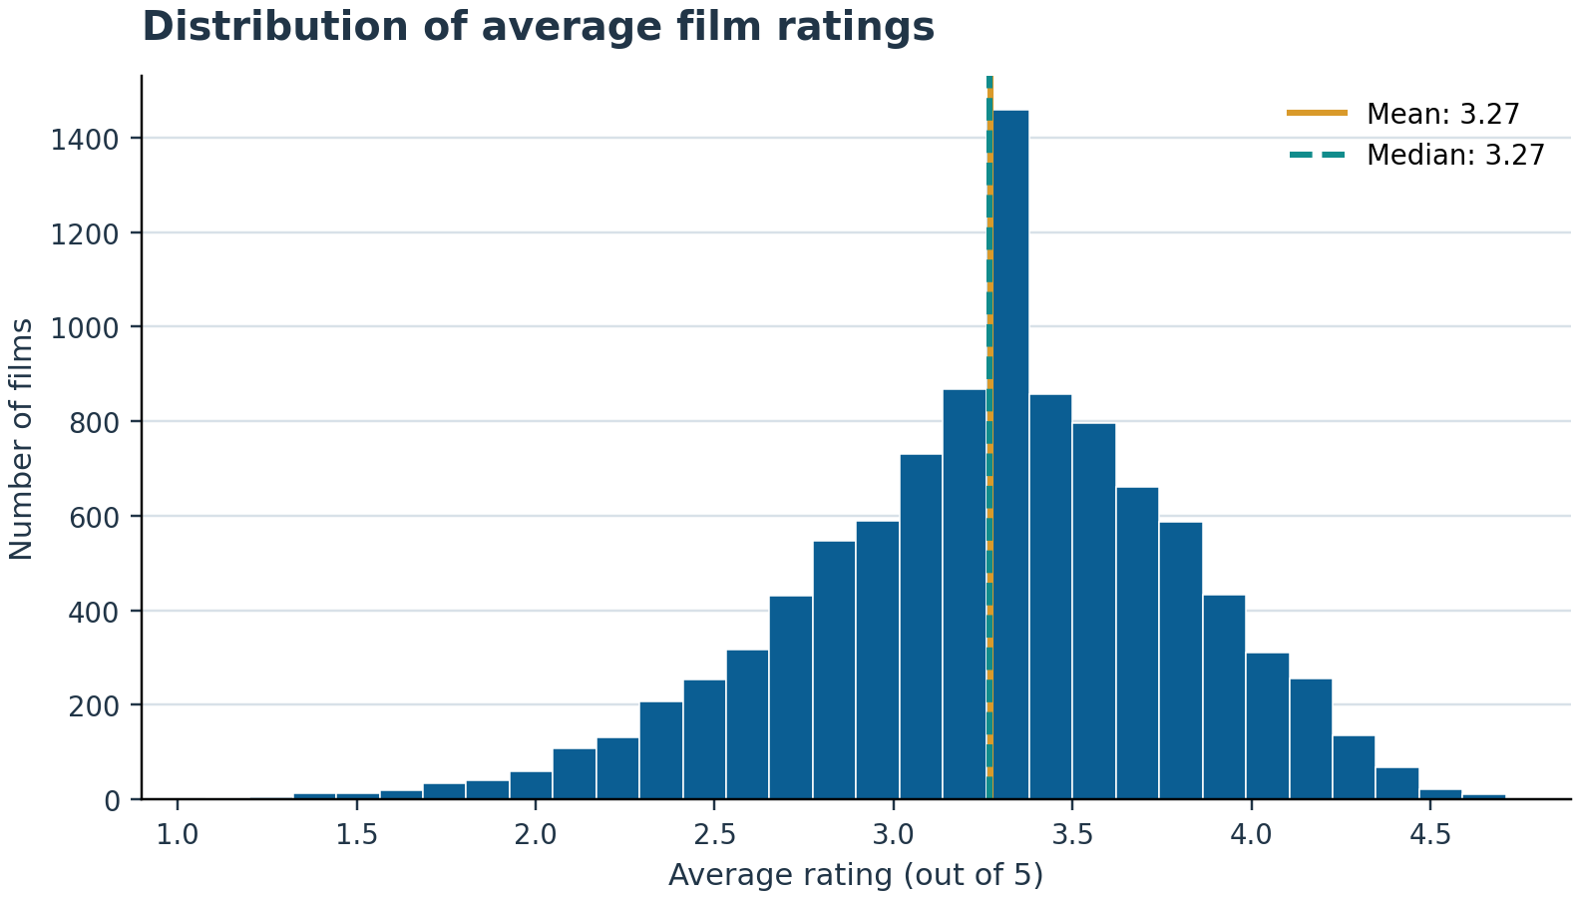
Figure 1. Distribution of average film ratings after duplicate removal.
Engagement variables were strongly right-skewed. The mean number of watches was 170,559, but the median was only 18,465. Likes showed a similar difference between the mean of 43,828 and median of 3,405. Fans were even more concentrated: the mean was 1,657, while the median film had only 24 fans. These gaps show why the median is important alongside the mean. A small group of highly visible films raises the arithmetic average and represents a “long-tail” market in which attention is unevenly distributed. Tukey (1977) and Shakeel et al. (2022) emphasise the value of exploratory statistics and visualisation for revealing distributional features before formal modelling.
The dataset contained 57 original-language categories. English dominated with 8,046 films, or 80.7% of the cleaned sample. The next largest groups were Italian (396), Japanese (308), French (290), Korean (145) and Spanish (114). Genre membership was multi-label: Drama appeared most frequently (4,405 films), followed by Comedy (2,925), Thriller (2,303), Action (2,068) and Horror (1,805). Because a film can belong to several genres, genre totals exceed the number of films. This structure is analytically useful because it reflects how viewers and platforms actually browse content, although it means genre averages are not mutually exclusive. Overall, the descriptive results establish a diverse catalogue but also reveal major imbalance by language and engagement level. The interquartile range for rating was 2.95 to 3.62, while the middle 50% of runtimes fell between 89 and 113 minutes. These relatively compact central ranges contrast with the much wider engagement ranges. Frequency tables and boxplots were therefore preferred to a simple list of averages because they reveal both the dominant categories and the dispersion hidden by aggregate values. For BI users, this distinction matters when setting benchmarks: comparing a niche release with the catalogue-wide mean could produce a misleading performance judgement.

4. Trend Analysis and Visualisation
Genre analysis identified a clear distinction between critical appreciation and audience scale. Among genres containing at least 100 films, Documentary had the highest mean rating at 3.64, followed by History at 3.53, War at 3.50, Music at 3.46 and Drama at 3.45. By contrast, Action averaged 3.07, Science Fiction 3.04 and Horror 3.01. These values do not imply that every documentary outperforms every action film; they describe average patterns across overlapping genre labels. Figure 2 visualises the leading rating categories and highlights that prestige, factual and historically oriented content tends to receive stronger evaluations in this dataset.
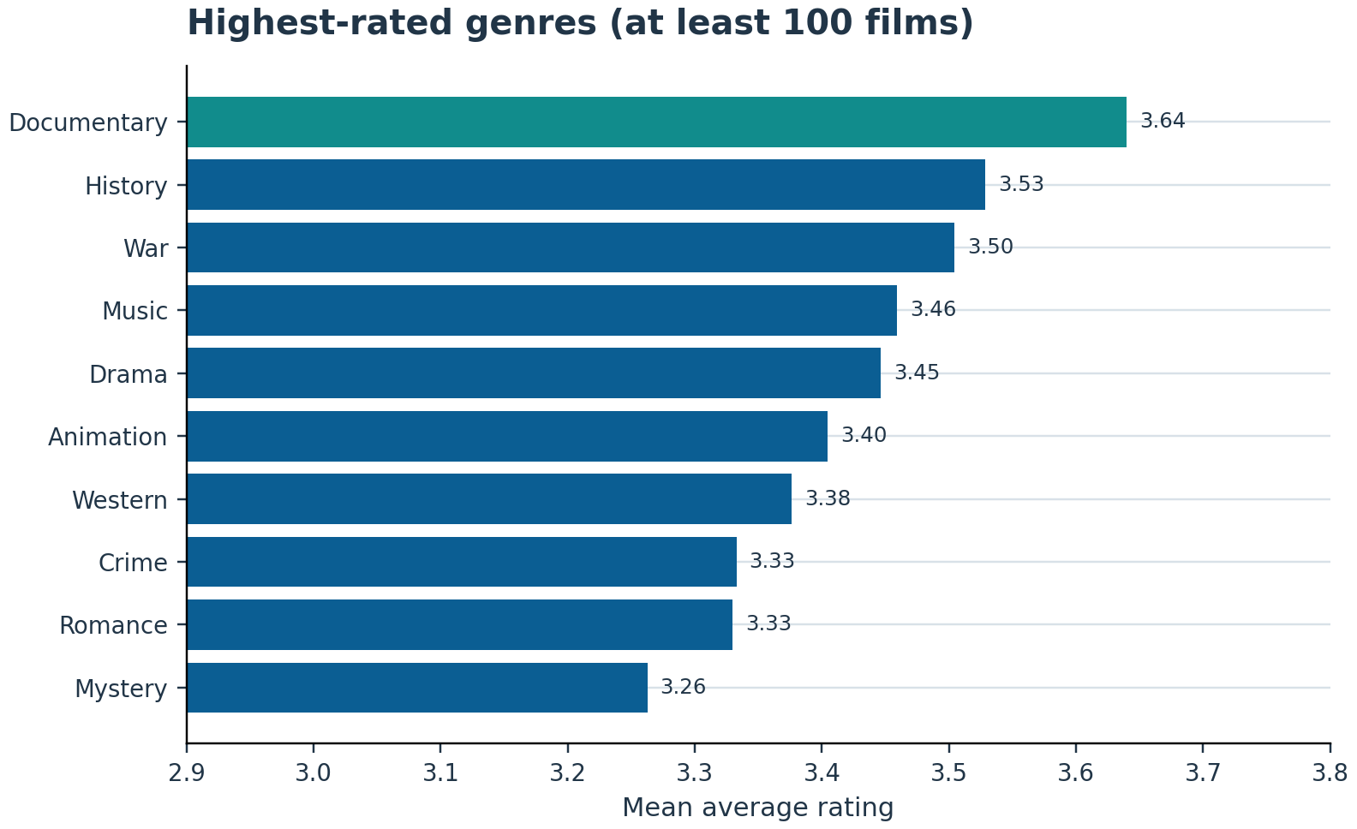
Figure 2. Highest-rated genres, restricted to categories with at least 100 films.
Popularity followed a different pattern. Family films had the highest median watches among the major genres at approximately 70,837, followed by Adventure at 50,062 and Fantasy at 40,927. Documentary, despite its high average rating, had only 4,606 median watches and 920 median likes. This gap suggests that satisfaction and reach are separate BI outcomes. A film may perform well with a smaller, committed audience without generating mass visibility. Therefore, media managers should not use one metric as a universal definition of success.
The watches-likes scatter plot in Figure 3 shows a very strong positive relationship, even when log scales are used to reduce the influence of blockbuster titles. Films seen by more users normally attract more likes because liking is an action available after exposure. Runtime displayed a weaker association with engagement. Figure 4 shows considerable variation in fans at nearly every runtime, although the general tendency is upward. Extremely long films are uncommon and do not automatically produce large audiences.
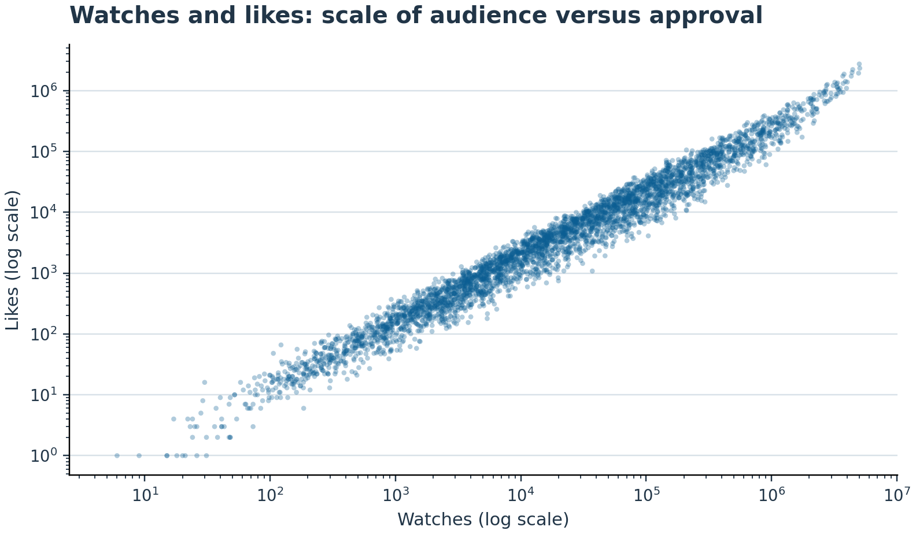
Figure 3. Watches and likes on logarithmic scales (random sample of 4,000 films).
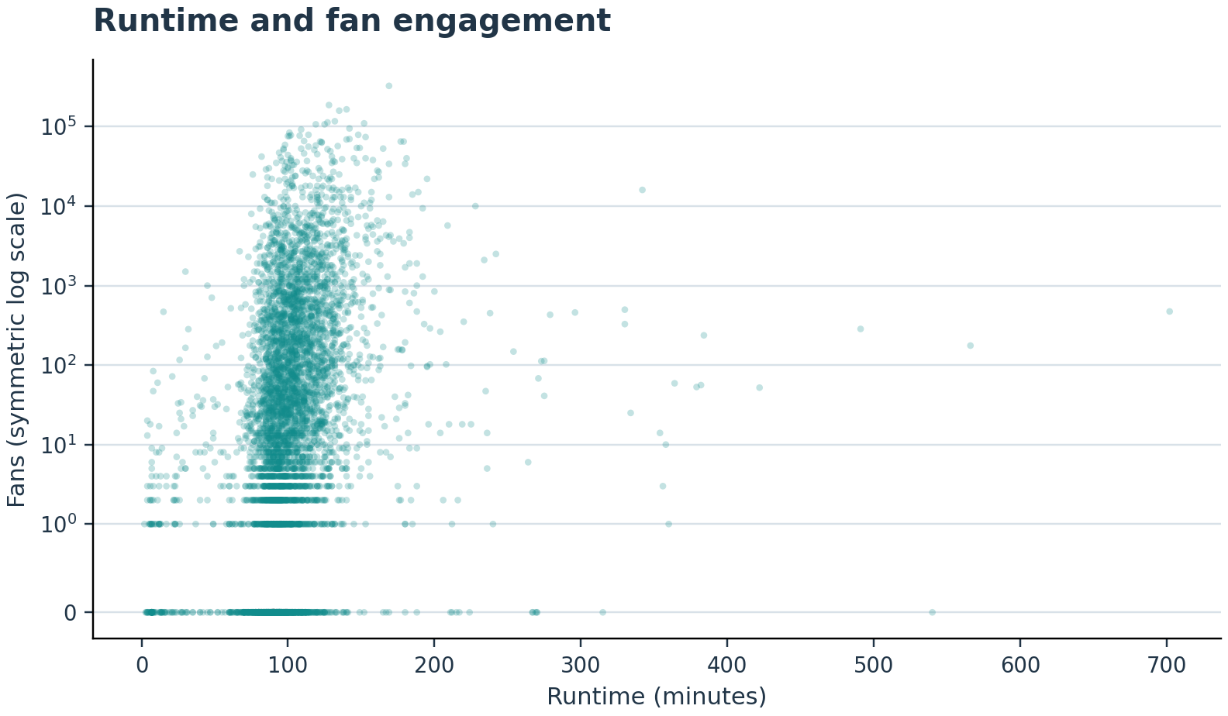
Figure 4. Runtime and fan engagement (random sample of 5,000 films).
Language also revealed an important pattern. English films had a mean rating of 3.21, compared with 3.51 for non-English films. Japanese and French films both averaged approximately 3.60, while “No spoken language” films averaged 3.64. Some smaller language groups achieved even higher averages, but their limited sample sizes make direct ranking unreliable. The pattern may reflect selective international distribution: non-English titles reaching Letterbox users may be a more curated group of recognised films. It may also reflect differences in genre, era or audience composition. Consequently, the result supports further segmentation rather than the conclusion that language itself causes higher ratings. English-language films also had substantially higher average likes because they dominate the catalogue and include many globally distributed blockbusters. This reinforces the need to compare both rate-based outcomes, such as average rating or likes per watch, and absolute volumes. A dashboard that only displays totals would systematically favour the largest language group and could understate the value of smaller international segments.

5. Statistical Analysis Using SPSS
An independent-samples t-test examined whether average ratings differed between English and non-English films. Levene’s test was significant (p < .001), indicating unequal variance, so the Welch version of the t-test was interpreted. English films (n = 8,046, M = 3.21, SD = 0.52) were rated significantly lower than non-English films (n = 1,923, M = 3.51, SD = 0.46), t(3218.03) = -24.79, p < .001. The mean difference was -0.30 stars, with a 95% confidence interval from -0.32 to -0.27. Cohen’s d was -0.58, representing a moderate practical difference rather than merely an effect produced by the large sample. Figure 5 presents the distributions by group. The result rejects the null hypothesis of equal means, but it should be interpreted as an association because other variables were not controlled in this test.
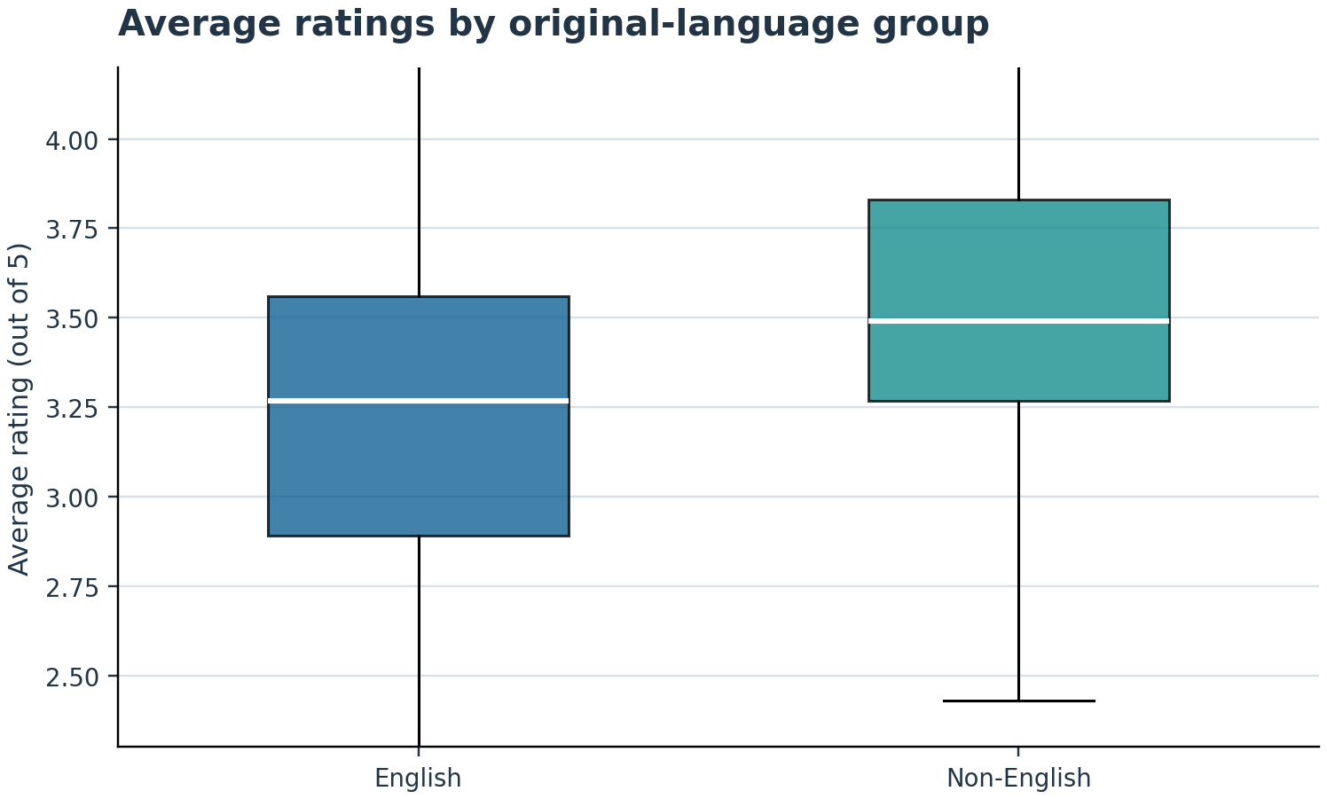
Figure 5. Average-rating distributions for English and non-English films; outliers hidden for readability.
Table 2. Summary of inferential results
Analysis | Statistic | Significance | Interpretation
Welch t-test | t(3218.03) = -24.79 | p < .001 | Non-English films rated 0.30 stars higher; d = 0.58
Pearson correlation | Watches–Likes r = .951 | p < .001 | Very strong positive association
Pearson correlation | Runtime–Fans r = .088 | p < .001 | Weak positive linear association
Multiple regression | F(3, 9965) = 402.70 | p < .001 | R² = .108; likes strongest predictor
Source: Author’s analysis of the supplied LCBB5014 dataset.
Correlation analysis then examined numerical relationships. Watches and likes had an extremely strong Pearson correlation (r = .951, p < .001), confirming that exposure and positive engagement move closely together. Fans and likes were also strongly related (r = .800, p < .001). Runtime had only weak Pearson relationships with watches (r = .146) and fans (r = .088), although the corresponding Spearman coefficients were stronger at .362 and .390. This difference indicates non-normality and a monotonic relationship affected by extreme values. Average rating correlated positively but modestly with likes (r = .290), fans (r = .251) and runtime (r = .187). Statistical significance must therefore be separated from strength: with nearly 10,000 observations, small effects can produce very low p-values (Field, 2024).
A multiple linear regression predicted average rating from fans, likes and runtime. The overall model was significant, F(3, 9965) = 402.70, p < .001, and explained 10.8% of rating variance (R² = .108; adjusted R² = .108). All predictors were significant. Standardised coefficients showed likes as the strongest predictor (β = .224, p < .001), followed by runtime (β = .153, p < .001) and fans (β = .058, p < .001). In unstandardised terms, the predicted equation was: rating = 3.012 + 0.00000325(fans) + 0.000000777(likes) + 0.002106(runtime). Variance inflation factors were below 3, suggesting no severe multicollinearity in this specification. However, engagement variables were skewed and the model leaves 89.2% of rating variation unexplained. Given the modest R² and the large proportion of unexplained variance, the regression should be viewed as a useful but limited predictive benchmark, not a complete theory of film quality. Diagnostic interpretation also considered the form of the data. Popularity counts were heavily right-skewed and residuals were not perfectly normal, which is common in large platform datasets. Scatter plots and Spearman correlations were therefore used as robustness checks alongside Pearson coefficients. The direction of the principal relationships remained positive. For operational use, the model should be re-estimated on a holdout sample and compared with transformed or non-linear alternatives before it is deployed for forecasting; this is important because predictive usefulness should be tested beyond the data used to develop the model (Shmueli and Koppius, 2011). IBM's SPSS procedures report coefficients, confidence intervals and significance tests, but managerial interpretation must still assess effect size, assumptions and business relevance (IBM, 2026).

6. Insights, Recommendations and Limitations
The analysis indicates that successful films cannot be defined by one measure. Reach is represented by watches, active approval by likes, loyalty by fans and perceived quality by average rating. These measures are related but not interchangeable. Entertainment businesses should therefore build dashboards that display them together and allow filtering by genre, language and runtime. A dimensional warehouse with consistent film, genre, language and audience-engagement dimensions would support repeatable comparisons across campaigns and release periods (Kimball and Ross, 2013; Al-Okaily et al., 2022).
Three actions are recommended. First, use genre portfolios rather than a single content strategy: high-reach Family, Adventure and Fantasy titles can support audience acquisition, while highly rated Documentary, History, War and Drama content can strengthen reputation and retention. Second, expand subtitling, dubbing and targeted promotion for selected non-English films. Their higher mean rating suggests an opportunity, but decisions should also consider sample size, territory and marketing exposure. Third, optimise runtime by audience segment rather than assuming longer is better; runtime had only a weak relationship with engagement and a modest regression effect.
The principal limitations are the cross-sectional design, lack of release year, budget, marketing spend, country availability and viewer demographics, and the unequal representation of languages. Genre labels overlap, and platform engagement may reflect selection bias. Future analysis should add time variables, use train-test validation, examine interactions between genre and language, and consider models designed for skewed counts. These improvements would support more accurate forecasting and more responsible BI decisions.

References
Al-Okaily, A., Al-Okaily, M., Teoh, A.P. and Al-Debei, M.M. (2022) ‘An empirical study on data warehouse systems effectiveness: the case of Jordanian banks in the business intelligence era’, EuroMed Journal of Business, 18(4), pp. 489–510. Available at: https://doi.org/10.1108/EMJB-01-2022-0011
Chapman, P., Clinton, J., Kerber, R., Khabaza, T., Reinartz, T., Shearer, C. and Wirth, R. (2000) CRISP-DM 1.0: Step-by-step data mining guide. SPSS Inc. Available at: https://public.dhe.ibm.com/software/analytics/spss/documentation/modeler/14.2/es/CRISP-DM.pdf (Accessed: 20 July 2026).
Chen, H., Chiang, R.H.L. and Storey, V.C. (2012) ‘Business intelligence and analytics: From big data to big impact’, MIS Quarterly, 36(4), pp. 1165–1188. Available at: https://doi.org/10.2307/41703503
Côté, P.-O., Nikanjam, A., Ahmed, N., Humeniuk, D. and Khomh, F. (2024) ‘Data cleaning and machine learning: a systematic literature review’, Automated Software Engineering, 31, article 54. Available at: https://doi.org/10.1007/s10515-024-00453-w
Fayyad, U., Piatetsky-Shapiro, G. and Smyth, P. (1996) ‘From data mining to knowledge discovery in databases’, AI Magazine, 17(3), pp. 37–54. Available at: https://doi.org/10.1609/aimag.v17i3.1230
Field, A. (2024) Discovering statistics using IBM SPSS Statistics. 6th edn. London: SAGE Publications Ltd.
IBM (2026) IBM SPSS Statistics documentation. Available at: https://www.ibm.com/docs/en/spss-statistics/32.0.0 (Accessed: 20 July 2026).
Kimball, R. and Ross, M. (2013) The data warehouse toolkit: The definitive guide to dimensional modeling. 3rd edn. Indianapolis, IN: John Wiley & Sons.
Ragazou, K., Passas, I., Garefalakis, A. and Zopounidis, C. (2023) ‘Business intelligence model empowering SMEs to make better decisions and enhance their competitive advantage’, Discover Analytics, 1, article 2. Available at: https://doi.org/10.1007/s44257-022-00002-3
Shakeel, H.M., Iram, S., Al-Aqrabi, H., Alsboui, T. and Hill, R. (2022) ‘A comprehensive state-of-the-art survey on data visualization tools: research developments, challenges and future domain specific visualization framework’, IEEE Access, 10, pp. 96581–96601. Available at: https://doi.org/10.1109/ACCESS.2022.3205115
Shmueli, G. and Koppius, O.R. (2011) ‘Predictive analytics in information systems research’, MIS Quarterly, 35(3), pp. 553–572. Available at: https://doi.org/10.2307/23042796
Steorts, R.C. (2023) ‘A primer on the data cleaning pipeline’, Journal of Survey Statistics and Methodology, 11(3), pp. 553–568. Available at: https://doi.org/10.1093/jssam/smad017
Tukey, J.W. (1977) Exploratory data analysis. Reading, MA: Addison-Wesley.
University of Wales Trinity Saint David (UWTSD) (2026) Letterbox Movie Classification Dataset [CSV dataset]. LCBB5014 Data Handling and Business Intelligence module page.

Appendices

Appendix A: Data Cleaning Log
Cleaning check | Outcome
Original records | 10,000
Removed technical index field | Unnamed: 0
Missing values | 0 across all variables
Exact duplicates removed | 31
Final analytical records | 9,969
Genre values recoded as Unknown | 24
Distinct original languages | 57
Distinct parsed genres | 28
Outlier policy | Retained plausible extreme values; log scales used for visualisation
Source: Author’s analysis of the supplied LCBB5014 dataset.

Appendix B: Categorical Frequency and Trend Tables
Table B1. Most frequent genres and associated metrics
Genre | Films | Mean rating | Median watches | Median likes
Drama | 4405 | 3.45 | 22,273 | 4,206
Comedy | 2925 | 3.20 | 30,656 | 5,275
Thriller | 2303 | 3.17 | 25,360 | 4,014
Action | 2068 | 3.07 | 22,731 | 3,722
Horror | 1805 | 3.01 | 14,576 | 3,003
Crime | 1518 | 3.33 | 21,994 | 3,976
Adventure | 1445 | 3.12 | 50,062 | 6,425
Romance | 1370 | 3.33 | 31,572 | 5,864
Science Fiction | 1262 | 3.04 | 28,018 | 4,576
Fantasy | 993 | 3.15 | 40,927 | 7,065
Mystery | 833 | 3.26 | 35,412 | 6,408
Family | 716 | 3.18 | 70,836 | 9,388
Animation | 689 | 3.40 | 35,266 | 6,028
History | 449 | 3.53 | 23,843 | 4,653
Documentary | 427 | 3.64 | 4,606 | 920
Source: Author’s analysis of the supplied LCBB5014 dataset.
Table B2. Largest original-language groups
Original language | Films | Mean rating | Median watches | Mean likes
English | 8046 | 3.21 | 24,236 | 49,507
Italian | 396 | 3.31 | 2,853 | 5,163
Japanese | 308 | 3.60 | 14,670 | 43,362
French | 290 | 3.60 | 20,794 | 21,884
Korean | 145 | 3.42 | 5,182 | 36,848
Spanish | 114 | 3.45 | 9,093 | 18,157
German | 96 | 3.50 | 5,188 | 15,193
No spoken language | 94 | 3.64 | 10,406 | 12,223
Chinese | 65 | 3.52 | 6,402 | 7,349
Danish | 60 | 3.48 | 3,874 | 11,271
Cantonese | 58 | 3.57 | 12,371 | 24,883
Russian | 43 | 3.67 | 7,485 | 17,024
Swedish | 32 | 3.79 | 25,232 | 26,313
Polish | 20 | 3.50 | 20,969 | 10,000
Dutch | 20 | 3.43 | 5,454 | 3,541
Source: Author’s analysis of the supplied LCBB5014 dataset.

Appendix C: Statistical Output Tables
Table C1. Group statistics for language comparison
Group | N | Mean | Std. deviation | Std. error mean
English | 8,046 | 3.212 | 0.524 | 0.006
Non-English | 1,923 | 3.510 | 0.461 | 0.011
Source: Author’s analysis of the supplied LCBB5014 dataset.
Table C2. Independent-samples test (Welch result)
Levene F | Levene Sig. | t | df | Sig. (2-tailed) | Mean difference | 95% CI lower | 95% CI upper
27.858 | < .001 | -24.793 | 3218.03 | < .001 | -0.298 | -0.322 | -0.275
Source: Author’s analysis of the supplied LCBB5014 dataset; unequal variances assumed because Levene’s test was significant.
Table C3. Pearson correlation matrix
Variable | Runtime | Watches | Likes | Fans | Average rating
Runtime | 1.000 | 0.146 | 0.129 | 0.088 | 0.187
Watches | 0.146 | 1.000 | 0.951 | 0.672 | 0.249
Likes | 0.129 | 0.951 | 1.000 | 0.800 | 0.290
Fans | 0.088 | 0.672 | 0.800 | 1.000 | 0.251
Average rating | 0.187 | 0.249 | 0.290 | 0.251 | 1.000
Source: Author’s analysis. All off-diagonal correlations shown are significant at p < .001.
Table C4. Multiple regression model summary and coefficients
Predictor | B | Std. Beta | t / model F | Sig. | VIF
Constant | 3.0124 | — | 209.769 | < .001 | —
Fans | 0.000003254 | .058 | 3.684 | < .001 | 2.77
Likes | 0.000000777 | .224 | 14.163 | < .001 | 2.80
Runtime | 0.0021 | .153 | 15.994 | < .001 | 1.02
Model summary: R² = 0.108; adjusted R² = 0.108; F(3, 9965) = 402.70, p < .001.

