Katarzyna Kolowrocka
1805961

Reflection on the teamwork - poster presentation
BMSW5001

Contents
1.0 Introduction 2
2.0 Main findings 2
2.1. Gibbs model reflection 2
2.1 .1 Description of the poster presentation 2
2.1.2 Feelings and thoughts about the experience 5
2.1.3 Evaluation of the experience 5
2.1.4 Analysis to make sense of the situation 6
2.1.5 Conclusion 6
2.1.6 Action plan 6
2.2 Personal values, attitudes, beliefs aligned with the organisational examples used during presentation. 7
3.0 Conclusion 8
4.0 Appendix 1 9
5.0 Reference List 10

1.0 Introduction

The purpose of this paper is to reflect on a group poster presentation.
Reflection is an important part of study programme and students are encouraged to think about and reflect on their own experiences through the learning process (Chwaraeteg, 2018). This method of learning helps to explore theories and apply them to day-to-day practice in a more structured way. It helps to think about activities in a new way which can help solve problems and approach challenges differently.

2.0 Main findings

2.1. Gibbs model reflection

To reflect on the presentation, I have used the Reflective Cycle Model (Gibbs, 1988), developed by Graham Gibbs in 1988. It provides a framework to encourage individuals to examine past experiences, (www.ed.ac.uk) and allow them to learn from specific situations. The model covers six stages: (Dye, 2011)
- Description
- Individual’s Feelings and thoughts
- Evaluation
- Analysis
- Conclusion
- Action plan.

2.1 .1 Description of the poster presentation

Our team was formed to create a poster to be presented on 19th November 2019. I was assigned to the team of four members: Carl, Salman and Osman.
The different sections of the subject were divided between us, so each member researched one element of the topic. Each team member put considerable effort and researched well the assigned subject. In two weeks, our group were able to produce an appealing poster (Image 1), that was presented to the group of students.

My contribution to the task was:
- Plan, organise work,
- Design, create and print the poster.
- Create supportive Power Point slides, that everybody could see a context from the distance.
My individual part of the presentation was to describe, how values contribute to an organisational success.
The presentation itself ran smooth. Unfortunately, I read out my speakers notes instead of memorising them.

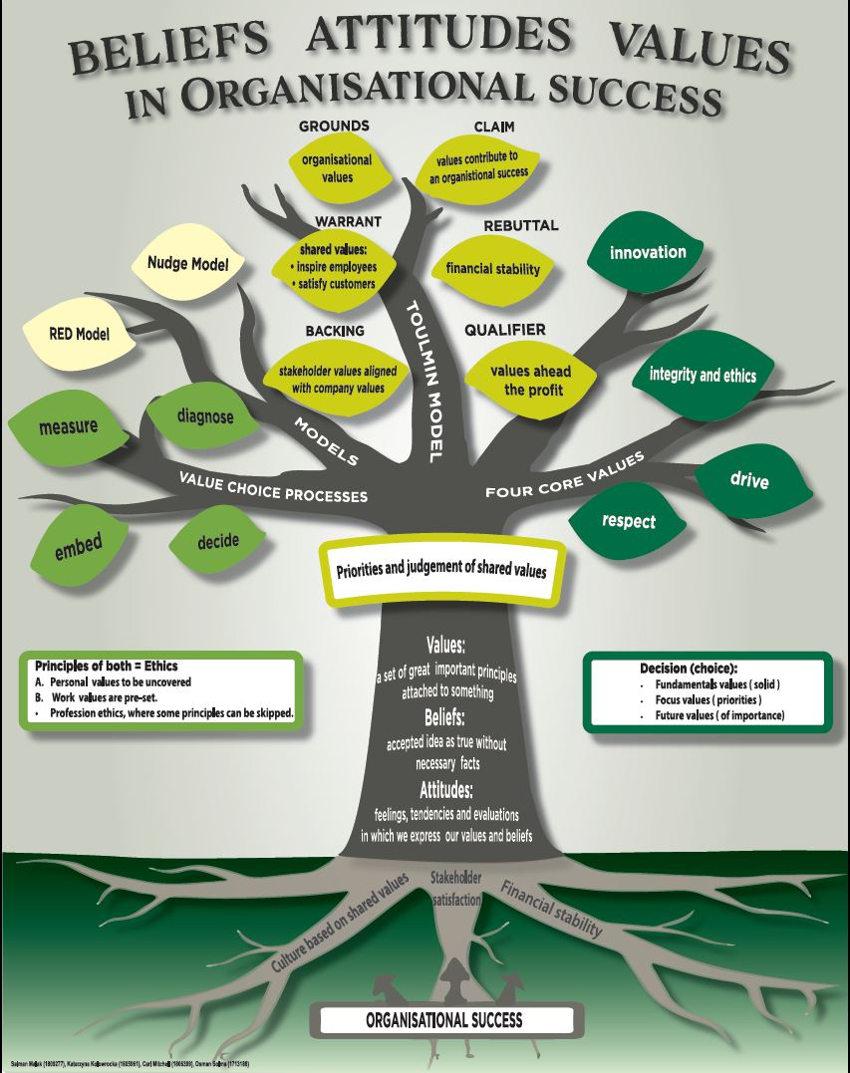Image 1. Poster

2.1.2 Feelings and thoughts about the experience

According to Tarkowski (2017) to deliver effective presentation, a presenter should appear confident and relaxed. Preparation and knowledge are essential for minimising anxiety which may present as a trembling voice.
I am not comfortable at public speaking; therefore, I need to practise before presentations. Unfortunately, I spent long hours organising teamwork and creating the poster, that I did not have enough time to learn my speaker notes and practise my individual part. At the presentation I read out my notes. Therefore, I failed to maintain eye contact with the audience, this lowered value of my performance. After presentation, I felt frustrated, because investing numerous amounts of hours completing teamwork lowered the value of my individual part.

2.1.3 Evaluation of the experience

This stage of Gibbs Model allows a reflection of negative and positive impacts of the experience.
What went well
The good thing about the activity was, that each team member produced high quality individual work for the agreed deadline.
The poster was created by one individual, hence looked coherent. Team avoided conflict or disagreement. The poster was completed quicker, there was no need to discuss each step and finding consensus with others team members. Working in a team requires many meetings. We saved time, as no need to meet with each other.
What went poorly
The final poster turned out better than expected, although if other members contributed more in creating it and provide different ideas then the project could be seen from the different perspectives, that could benefit the outcome.
Organising everything by myself I thought was a great idea. When I had to focused on tasks for whole team, I could not spend enough time improving my individual part and practice before presentation.

2.1.4 Analysis to make sense of the situation

I searched through literature on the teamwork and found things that helped me understand the situation.
According to Belbin’s theory of team roles (Belbin, 2010), I am completer/finisher. They are described as perfectionists and their biggest weakness is, that they find it hard to delegate. I am willing to do everything by myself to ensure everything is of a high standard.
For good management and leadership, delegating is essential. (https://hbr.org). Leader must trust their employees and this trust is shown through delegation. They cannot do everything by themselves.

2.1.5 Conclusion

By looking at both negative and positive impacts of the experience, I have drawn the following conclusion. Through reflection, I learned, how I approached the task and what I could do better or different next time (Bassot, 2016).
Completing and presenting the poster activity, highlighted my weaknesses and strengths. My biggest weakness is that I do not delegate. Each member of the group knows how to produce Power Point slides. If I had delegated this task to another member of the team, I would have an extra two hours, that I could focus on practising my presentation topic.

2.1.6 Action plan

Next time I will trust my peers and allow them to participate more in tasks.
For future group projects each member should be tasked with different responsibilities, according to Belbin’s team roles and individual’s strengths.
In future projects the team could find a solution that utilises everyone’s strengths and ensures team members contribute equally.
I have found a poster example on a website (Image 2), where everyone was involved. It also looks coherent and attractive.

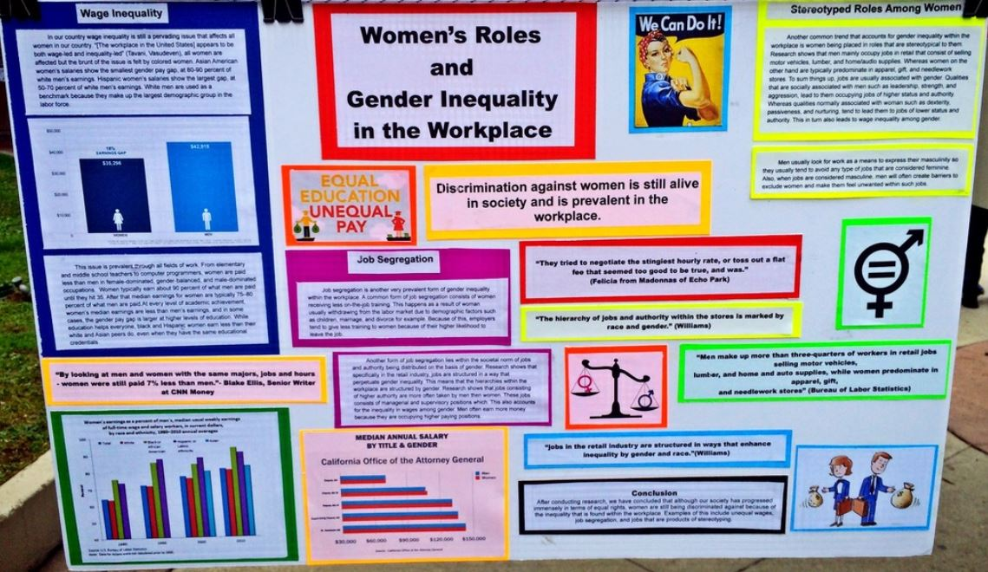
Image 2 Example of poster that each team member could contribute to. (www.pinterest.co.uk)

2.2 Personal values, attitudes, beliefs aligned with the organisational examples used during presentation.

Arguments for my individual topic of the presentation I backed up with organisational examples, such as:
- Whole Foods
- Google.
Both companies created meaningful values which appeal to me.
Examples are displayed in table 1, appendix 1.

I identified my core values first, before I choose the organisations for my presentation. I felt comfortable to write and talk about those organisations, because my personal values are consistence with their values. I enjoyed to research about those companies. I engaged better whit audience and felt confident when providing evidence that values are contribute to organisational success.

3.0 Conclusion

In conclusion, I found the group presentation to be a very educational experience, highlighting the importance of being able to work well in a team.
Overall, I found Gibbs’ model helpful in focusing on each of the different areas of the experience in order to evaluate my strengths, such as good teamwork and time management, as well as areas that I would like to improve. Belbin’s theory helped me illuminate and understand my weaknesses. The main aspect that I would like to improve is my delegating skills, which will enable me to spend more time on my individual task.

4.0 Appendix 1
Table 1 Organisational values versus personal values.
VALUE | ORGANISATIONAL VALUES | MY VALUES
Financial gain is secondary objective | GOOGLE (www.google.com)  Never sold Placement in Search Engine to anyone and advertising on webpage is relevant to the content.  ‘You can make money without doing evil’ | When I was running my business - “The Garden Cafe”, I put emphasis on good quality product, rather than achieve high profit.
Customer satisfaction | WHOLE FOODS (Cheretis and Mujtaba, 2014): ’We Satisfy and Delight Our Customers - Our customers are the lifeblood of our business and our most important stakeholder. We strive to meet or exceed their expectations on every shopping experience’.  GOOGLE (www.google.com)  ‘Focus on the user and all else will follow’ | Customer satisfaction was the highest priority at ‘The garden café’. Those attitudes helped me to attract customers and keep them loyal.
Helping others | WHOLE FOODS (Cheretis and Mujtaba, 2014): is very serious about their efforts to support the local community (Breuer and Ludeke-Freud, 2017)To exemplify grocery chain commitment to local communities, Whole Foods give low-interest loans to independent local farmers, suppliers to support their businesses.  ‘We Care About Our Communities and The Environment -- We serve and support a local experience. The unique character of each store is a direct reflection of a community’s people, culture, and cuisine’. | I am passionate to help others. Not just only I backed cakes and financial supported Charities Actions. I also worked as a carer to help elderly and disabled people in their daily tasks.
Development and Growth | WHOLE FOODS (Cheretis and Mujtaba, 2014): invest in personnel growth: ‘We Promote Team Member Growth - Our success is dependent upon the collective energy, intelligence, and contributions of all our Team Members’  GOOGLE (www.google.com)  constantly developing and improving products. Company added the ability to search news archives, academic journals, images and books. Company mission is to facilitate access to information for the entire world, and in every language: ‘There’s always more information out there’.  ‘The need for information crosses all borders.’ | Self-improvement and gaining new experience is one of the most important value in my life. I constantly try different professions just to learn new skills. For example: along with University Course, I plan to volunteer to police forces to develop leadership skills and gain confidence dealing with conflicts.

5.0 Reference List

Bassot, B., (2016), The Reflective Journal, 2nd Edition. London: Palgrave
Belbin, M., (2010). Management teams: why they succeed or fail. 3rd ed. Oxford: Butterworth-Heinemann.
Breuer, H., Lüdeke-Freund, F., (2017), ‘Values-Based Innovation Management: Innovating by What We Care About’, London: Palgrave.
Cheretis, D., Mujtaba, B., (2014), Maximizing Long-Term Value and Conscious Capitalism at Whole Foods, Vol. 79, Iss 3, Corpus Christi: Society for the Advancement of Management.
Chwaraeteg (2018), Developing Yourself as a Team Leader : https://chwaraeteg.pembrokeshire.ac.uk/mod/scorm/player.php?a=7&currentorg=&scoid=14&sesskey=ZgIHgSMEPS&display=popup&mode=normal 2019/ accessed:28/11/2019
Gibbs, G., (1988), Learning by Doing: A guide to teaching and learning methods, Oxford: Oxford Polytechnic
https://www.ed.ac.uk/reflection/reflectors-toolkit/reflecting-on-experience/gibbs-reflective-cycle accessed 22/11/2019
https://hbr.org/2012/07/why-arent-you-delegating accessed 24/11/2019
https://www.pinterest.co.uk/pin/347973508698428518 accessed 22/11/2019
https://www.google.com/about/philosophy.html accessed 05/11/2019
Dye, V. (2011) ‘Reflection, Reflection, Reflection. I’m thinking all the time, why do I need a theory or model of reflection?’, in McGregor, D. and Cartwright, L., Developing Reflective Practice: A guide for beginning teachers. Maidenhead: McGraw-Hill Education
Jasper, M. (2013) Beginning Reflective Practice. 2nd edition. Andover: Cengage Learning.

Oke, A. E., Olatunji, S. O., Awodele, A. O., Akinola, J. A.,Kuma-Agbenyo, M. (2016), ‘Importance of Team Roles Composition to Success of Construction Projects’, Vol. 8, Iss. 2, International Journal of Construction Project Management.

Tarkowski,R., (2017), ‘Reflections: Improving Medical Students’ Presentation Skills’, Vol.32, Iss. 4, Journal of Cancer Education

