Initial exercises for Functions (3)

1a. We will write a program to add two numbers using a function.

First, write code in main() to allow the user to enter the numbers to be added (floats).

Also set up a simple menu system - for now, we'll just have one menu choice - "1. Add your numbers" (later we'll add a few more)

Your main() code might look something like this:

void main()
{
float value1, value2, total;
int choice;

printf("Welcome to the calculator program\n\n");

printf("Enter your first number: "); //enter first number
scanf("%f", &value1);

printf("and your second number: "); //enter second number
scanf("%f", &value2);

printf("\n\nMenu - what would you like to do?\n\n"); //Menu
printf("1. Add your numbers\n");

printf("\nEnter your choice: "); //Choose menu option
scanf("%d", &choice);

switch (choice)
{
case 1:
//Function call will go here

break;

default:
printf("Option not available");
}

}

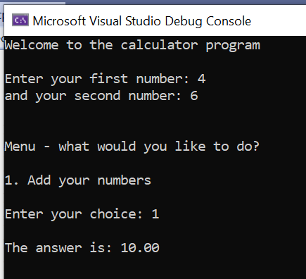
Write a function to add two numbers.

When the user chooses 1:
- call the function
- pass the two numbers entered by the user into it
- add the numbers in the function
- return the answer to main()
- print the answer on the screen.

Sample output:

1b Add code to extend the menu to allow the user to choose subtract, multiple or divide (as shown below). Use a separate function for each.

BUT, do not write 2 x subtract functions. Menu items 2 and 3 should both use the same subtract function (think carefully how the arguments are passed). Similarly, items 5 and 6 should both use the same divide function.

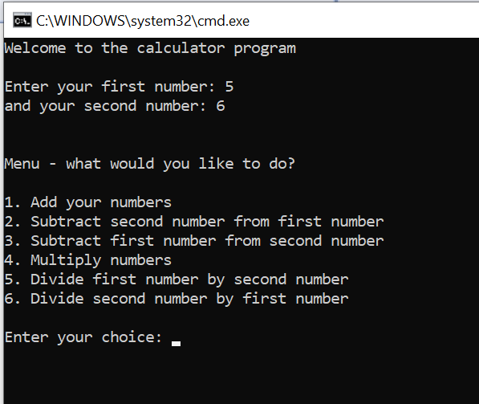

Sample output (all with 5 and 6 as the numbers used)

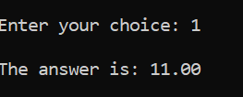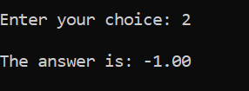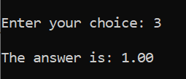

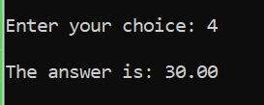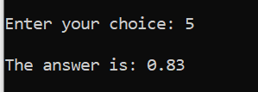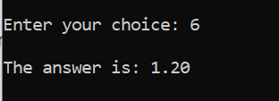

1c (Extra) Add a last option to raise the second number to the power of the first number.

You could use library function pow() from the math.h library to help you.

Sample output (shown below with 5 and 6, so - 5 x 5 x 5 x 5 x 5 x 5 ):

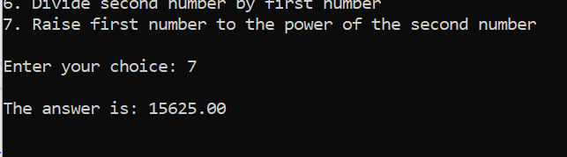

2. Create a function (call it enterprice() ) to allow the user to enter a price and return it to main(). (Note: no parameters to pass, only a return). After the price is returned to main(), print it out.

Your main code might look something like this:

void main()
{
float userprice;
printf("Welcome to my program\n\n");

//function call goes here

printf("\nYour price was entered as: \x9c %.2f\n\n", userprice);
}

Sample output:

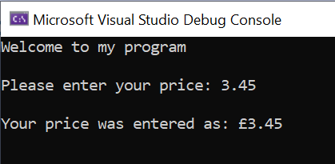
main()
enterprice()
main()

3. Write a function to allow the user to enter their age. Call your function enterage(). (No parameters to pass, only a return)

The age must be between 0 and 120 (write a while loop in the function for this)

Once a valid age has been entered, return age to main and print it on the screen

Your main code will look something like this:

void main()
{
int userage;

//function call goes here

printf("\nYour age was entered as: %d\n\n", userage);
}

Sample output:

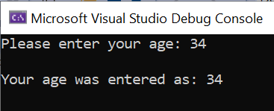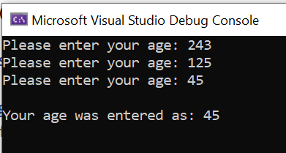
enterage()

main()

4. Create a function to allow the user to enter a letter (char) and return it to main() (note: no parameters to pass, only returns). Call your function enterletter()

Allow the user to enter two letters, the initials for their first name and surname (use your function twice to get the required letters) Return each letter in turn to main(), and print them on the screen.

Your main() code might look something like this:

void main()
{
char initial1, initial2;

//function calls here
//

printf("\nYour initials were entered as: %c %c\n\n", initial1, initial2);

}

Sample output:

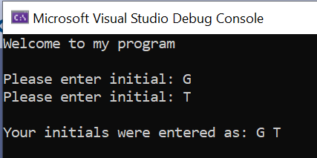
main()

enterletter()
enterletter()

main()

