

Harvesting Sustainable Energy – Design and Implementation of a Hydro Turbine Battery Charging Circuit
By
Adam Cross
Supervisor: Stephen Mosey
Second Marker: Stalin Jacob

Project submitted as part of the requirements for the award of BEng (Hons) Electrical and Electronic Engineering
April 2024
DECLARATION
I, Adam Cross declare that I am the sole author of this Project; that all references cited have been consulted; that I have conducted all work of which this is a record, and that the finished work lies within the prescribed word limits.
This work has not previously been accepted as part of any other degree submission.

FORM OF CONSENT
I, Adam Cross hereby consent that my Project, submitted in candidature for the BEng (Hons) Electrical and Electronic Engineering degree, if successful, may be made available for inter-library loan or photocopying (subject to the law of copyright), and that the title and abstract may be made available to outside organisations.

Abstract
This report presents the design and evaluation of an engineering project focused on developing an independent micro-hydro turbine circuit to convert underutilised water flow into electrical energy. The generated power will be stored in 18650 lithium-ion batteries for use in small external electrical devices, such as LED lights. Integration of a microcontroller programmed in C enables user control and battery capacity indication.
Key criteria include achieving stable voltage output within USB specifications, maintaining a budget under £100, ensuring compatibility with household pipework, achieving a battery charging efficiency of 60% or higher, supporting USB-A output port standards, and regulating input voltage for safe battery charging.
The final prototype comprises two parts: a breadboard and a copper stripboard. The microcontroller circuitry is situated on the breadboard, while the battery charging and USB-A output components are soldered onto the copper stripboard to accommodate enhanced current capacity.
Testing confirmed the prototype’s capability to regulate a DC input voltage from 5.5V to 31.9V, safely charging two parallel 2600mAh lithium-ion batteries at 4.2V. The average battery charging efficiency was measured at 65.88%. Additionally, the USB-A output port delivered a continuous 5.08V at 633mA (equivalent to 3.24W) to an external device, achieving an efficiency of 73.5% as a standalone system.
In conclusion, the project successfully achieved its aims and objectives, despite encountering challenges with the specific micro-hydro turbine. Recommendations for improvement include transitioning the prototype to a PCB and exploring alternative turbine options that meet manufacturer specifications. These steps aim to optimise the circuit’s design and functionality for future applications.

Table of Contents
Abstract 3
Table of Contents 4
Table of Figures 7
Table of Tables 10
Abbreviations 11
1 Introduction 12
1.1 Aim 12
1.2 Objectives 12
1.3 Evaluation Criteria 13
2 Research & Review of Literature 14
2.1 Microturbines 14
2.2 Industrial Micro-Hydro Turbines 15
2.2.1 DC Generators 16
2.3 Comparative Project Analysis 17
2.3.1 Paper 1 17
2.3.2 Paper 2 18
2.3.3 Paper 3 19
2.4 Power Supplies 20
2.4.1 Buck Converter 21
2.4.2 Boost Converter 21
2.5 Voltage Converter Types 22
2.6 Literature Review Conclusion 22
3 Research and Development Methodology 23
3.1 Data Collection 23
3.2 Software Selection 24
3.3 Hardware Selection 24
3.4 Materials and Tools 25
4 Project Management 26
4.1 Time Management: 26
4.2 Resource Plan 28
4.2.1 Personnel 28
4.2.2 Materials and Equipment 28
4.2.3 Projected Cost 29
4.2.4 Risk Management 30
4.2.5 Use of Workspaces 30
5 Project Design 31
5.1 Character Selection Matrix 31
5.1.1 Micro-Hydro Turbine Part Selection Matrix 32
5.1.2 Buck Converter Part Selection Matrix 33
5.1.3 Boost Converter Part Selection Matrix 34
5.1.4 Battery Part Selection Matrix 35
5.2 Block Diagram 36
5.3 Circuit Design 37
5.3.1 External Modules 38
5.3.2 Battery Load Sharing 40
5.4 Software Flow Charts 42
5.5 Writing The Software Program 45
5.5.1 Voltage Divider Circuit 45
5.5.2 Analogue to Digital Software 46
5.6 Testing Microcontroller Theory 47
5.6.1 Unit Testing USB Output 48
5.6.2 Unit Testing Battery Capacity Indication 49
6 Bill of Materials 50
7 Implementation and System Testing 51
7.1 Testing Prior to Final Installation 51
7.1.1 Programming Microcontroller 51
7.1.2 Testing and Setup of TP4056 and MT3608 Modules 51
7.2 Testing and Setup of LM2596 51
7.2.1 Micro-Hydro Turbine Voltage Output at Varying Flow Rates 51
7.2.2 Testing Turbine Current Drive Capacity 53
7.3 Testing Final Installation 53
7.3.1 Efficiency and Maximum Current Output of USB Output 53
7.4 Testing LM2596 Buck Converter and TP4056 Battery Charging Operation 54
7.4.1 Testing Load Sharing Operation 55
7.5 Testing of Circuit with Turbine Connected 56
7.6 Testing Battery Capacity Indication and USB On/Off Switch 57
7.7 Fuses 57
7.8 Final Prototype 58
8 Evaluation and Conclusion 59
8.1 Recommendations 60
9 Reflection 61
10 Bibliography 62
11 References 63
12 Appendices 67
Appendix A: Product Design Specification 67
Appendix B: Gantt Chart 69
Appendix C: Project Pictures 70
Appendix D: Software Code 84

Table of Figures
Figure 1 – Waterwheel Turbine Design [4] 14
Figure 2 - Micro-Hydro Turbine [7] 15
Figure 3 - 300W Micro-Hydro Turbine [8] 16
Figure 4 - 5000W Micro-Hydro Turbine [9] 16
Figure 5 - Block diagram of charging system [12] 17
Figure 6 - Typical charging characteristics of Li-ion battery with a CC/CV [12] 17
Figure 7 - Charging of three Li-ion cells [12] 18
Figure 8 - Charger assembly [13] 18
Figure 9 - Buck-boost battery charging adapter [13] 19
Figure 10 - Solar panel charging circuit [14] 20
Figure 11 – Buck Converter Circuit [16] 21
Figure 12 - Boost Converter Circuit [16] 21
Figure 13 - Project Gantt Chart 27
Figure 14 - System Block Diagram 36
Figure 15 - Circuit Schematic 37
Figure 16 - LM2596 Schematic Diagram [17] 38
Figure 17 - TP4056 Schematic Diagram [38] 39
Figure 18 - MT3608 Schematic Diagram [22] 39
Figure 19 - TP4056 Load Sharing Schematic Diagram 40
Figure 20 - Load Sharing Test (Battery with no charging supply) 41
Figure 21 - Load Sharing Test (during charging phase) 41
Figure 22 - Initialisation Flowchart 43
Figure 23 - Battery Capacity Flowchart 44
Figure 24 – Initialising ADC (software) 46
Figure 25 - Setting Voltage Thresholds (software) 46
Figure 26 - Battery Capacity Indication (software) 47
Figure 27 - Microcontroller Circuit Testing 47
Figure 28 - USB Output OFF (high-side transistor switching) 48
Figure 29 - USB Output ON (high-side transistor switching) 48
Figure 30 - Battery Level Indicator (fully charged) 49
Figure 31 - Battery Level Indicator (20% charge) 49
Figure 32 – Relationship between Flow Rate and Output Voltage of Micro-Hydro Turbine (MHT) 52
Figure 33 - Relationship Between Battery Charge Voltage and Current at Various Circuit Input Voltages 55
Figure 34 - Microcontroller Breadboard Circuitry 58
Figure 35 - Power Components Copper Stripboard Circuitry 58
Figure 36 - Complete Circuit Including Batteries and Micro-Hydro Turbine 58
Figure 37 - Project Gantt Chart 69
Figure 38 - Using PICkit 3 to Program Microcontroller 70
Figure 39 - Temporary Circuit to Test Functionality 70
Figure 40 - Testing Battery Voltage 71
Figure 41 - Battery Connected to TP4056 - Measuring Board Output 71
Figure 42 - Setting Output Voltage of MT3608 Boost Converter 71
Figure 43 - Measuring Current Output of MT3608 Boost Converter 72
Figure 44 - Turbine Testing - 82.5Ω Load Resistance 72
Figure 45 - Turbine Testing - Voltage Output 82.5Ω Load 72
Figure 46 - Turbine Testing – 44.6Ω Load Resistance 73
Figure 47 - Turbine Testing – Voltage Output 44.6Ω Load 73
Figure 48 - Turbine Testing – 39.6Ω Load Resistance 73
Figure 49 - Turbine Testing – Voltage Output 39.6Ω Load 74
Figure 50 - Beamex DC Power Supply 74
Figure 51 - Testing Supply Voltage to Circuit 75
Figure 52 - Testing Battery Charge Current 75
Figure 53 - LM2596 Buck Converter Output Voltage 76
Figure 54 - Battery Voltage During Charging Process 76
Figure 55 - Voltage Input MT3608 Boost Converter 77
Figure 56 - Voltage Output MT3608 Boost Converter 77
Figure 57 - Drain-Source Resistance of Load Sharing MOSFET During Charging Process 78
Figure 58 - Drain-Source Resistance of USB Output Port MOSFET When Turned On 78
Figure 59 - USB-A Port Voltage Output 79
Figure 60 - Testing of Circuit with Turbine Connected (50% flow rate) 79
Figure 61 - Testing of Circuit with Turbine Connected (100% flow rate) 79
Figure 62 - Battery Voltage Test (79% Charged) 80
Figure 63 - Battery Capacity LED Indication (3 LEDs with 4th Flashing Intermittently) 80
Figure 64 - Battery Voltage Test (59% Charged) 81
Figure 65 - Battery Capacity LED Indication (2 LEDs with 3rd Flashing Intermittently) 81
Figure 66 - Soldering Copper Stripboard 82
Figure 67 - Copper Stripboard Soldering and Track Cutting 82
Figure 68 - Soldering Pins to External Modules 83

Table of Tables
Table 1 - Buck Converter Comparison [17], [18], [19], [20] 22
Table 2 - Boost Converter Comparison [21], [22], [23], [24] 22
Table 3 - Material Cost Estimate 29
Table 4 - Equipment/Software Cost Estimate 29
Table 5 - Total Cost Estimate 29
Table 6 - Micro-Hydro Turbine Part Selection Matrix [7], [29], [30] 32
Table 7 - Buck Converter Part Selection Matrix [17], [18], [19], [20] 33
Table 8 - Boost Converter Part Selection Matrix [21], [22], [23], [24] 34
Table 9 - Battery Part Selection Matrix [32], [33], [34], [35] 35
Table 10 - Bill of Materials 50
Table 11 - Micro-Hydro Turbine Voltage Output at Various Flow Rates 52
Table 12 - Testing Maximum Current of Turbine 53
Table 13 - Testing Circuit Current and Efficiency 54
Table 14 - Testing of LM2596 Buck Converter and TP4056 Charging Modules 54
Table 15 - Turbine Charging Test Results 56

Abbreviations
MCU Microcontroller
PIC Programmable Integrated Circuit
MHT Micro-Hydro Turbine
NiMH Nickel-Metal Hydride
Li-ion Lithium Ion
CC/CV Constant Current/Constant Voltage
PWM Pulse-Width Modulation
IC Integrated Circuit
DCP Dedicated Charging Port
ADC Analogue to Digital Converter

Introduction
This report documents and evaluates an engineering project aimed at exploring and designing an independent micro-hydro turbine circuit capable of converting underutilised water flow into electrical energy. The project focuses on the integration of a microcontroller programmed in C to provide user control and feedback of battery status.
In examining the household setting, consideration was given to opportunities for energy reutilisation. With the heating system engaging multiple times throughout the day and water consistently in circulation for various domestic tasks such as bathing and showering, the opportunity to convert this flow into a renewable energy source emerged.

Aim
The aim of this project is to explore and design an independent micro-hydro turbine circuit capable of converting underutilised water flow into electrical energy. This harnessed energy will be stored and used to power small electrical devices, such as LED lights.

Objectives
To achieve the aim of the project, the following objectives need to be met:
- By May 2024, design and develop a standalone circuit equipped with a micro-hydro turbine and battery system capable of supplying a stable power output within the USB specification range of 4.75V to 5.25V [1].
- Maximum product dimensions to be below 30cm x 30cm x 30cm, to enhance portability.
- Achieve a total project cost of less than £100, that meets specified requirements by the project deadline.
- Design the product to meet international safety standard outline in IEC 61010-1:2010. Ensure compliance with the RoHS Directive for lead-free solder usage. Additionally, ensure compatibility with USB Battery Charging Specification Revision 1.2 for dedicated charging port configuration and adhere to WEEE guidelines for responsible waste management.
- The finished product will interface with household pipework, using standardised ½” or ¾” BSP (British Standard Pipe) fittings, ensuring compatibility and functionality.
- Utilise a microcontroller programmed in C to seamlessly integrate hardware and software for the prototype

Evaluation Criteria
Successfully achieving all project objectives is paramount to ensure the development of a fully functional micro-hydro turbine battery charging circuit with USB output functionality. Additionally, adherence to the following criteria and further requirements set out in Appendix A: Product Design Specification is essential for project success.
- The battery charging process must achieve an efficiency of 60% or higher. Given that most battery charging modules utilise linear regulators, this presents a potential limitation on efficiency.
- The circuit must allow the user to turn the USB output on/off
- The USB Type-A port must support a minimum current delivery of 500mA at 5V, in compliance with USB 2.0 standards. Ideally, aim for an increased current output of up to 900mA at 5V, aligning with USB 3.0 specifications.
- The circuit must incorporate battery capacity indication for the user’s benefit.
- The circuit must regulate input voltage up to 30V to safely charge Li-ion batteries at 4.2V via a dedicated charger.
In the chapters ahead, the report will detail the design and development process of the micro-hydro turbine circuit and explore the existing research relevant to battery charging and micro-hydro power generation. It will include a comparative analysis of relevant literature and outline the research and development methodology, project management strategies, project design, bill of materials, and implementation and system testing phases. Finally it will conclude with outcomes, conclusions, and recommendations for future projects.

Research & Review of Literature
The literature review delves into the various aspects of renewable energy technology, with a primary emphasis on micro-hydro turbines (MHTs), exploring their design, applications, and associated technologies. Section 2.1 introduces microturbines, tracing their historical evolution and efficiency. Section 2.2 shifts focus to industrial MHTs, highlighting their significance in providing electricity to remote areas. Additionally, the review explores the role of DC generators in converting mechanical energy to electrical energy. In Section 2.3, a comparative analysis of renewable energy sources for lithium-ion battery charging is conducted, which features specific papers on solar charge controllers, multi-stage buck-boost battery chargers, and photo-voltaic panel applications. Furthermore, the review also introduces power supplies, focusing on switch-mode power supplies and buck and boost converters. Finally, it presents comparative tables of various converter models.

Microturbines
Hydro energy technology is a significant avenue for harnessing renewable energy, utilising the kinetic energy of flowing water to convert linear motion into a rotary motion, used to rotate the shaft of a generator to produce electricity. Among the earliest mechanisms employed for harnessing the energy of flowing water for practical purposes was the waterwheel design, shown in Figure 1 below. Research by Hameed et al. [2] delves into the design and analysis of water wheel hydroelectric power, specifically the efficiency of under and overshot designs. However, as noted by Lewis et al. [3] advancements in hydro energy through many inventors and engineers have led to various turbine designs, each with its unique features and efficiencies.
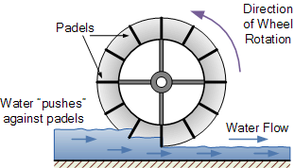
Figure 1 – Waterwheel Turbine Design [4]
A turbine design that is readily available on the market today for use in small projects like this one is a crossflow turbine. It consists of a cylindrical cage composed of numerous blades and is attached to a horizontal shaft used to drive a generator. As Widiyanto et al. [5] and Keawsuntia [6] have demonstrated in their studies, the design of small crossflow hydro turbines provides approximately 80% efficiency, comparable to Pelton, Francis and Kaplan turbine designs to name a few. Figure 2 below shows a typical DC micro-turbine, based upon the crossflow design.
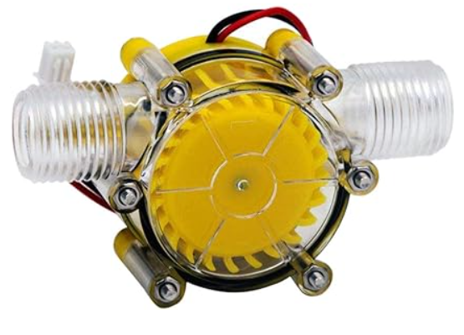
Figure 2 - Micro-Hydro Turbine [7]

Industrial Micro-Hydro Turbines
MHTs are often used in remote or rural areas where access to the main power grid is limited. They can provide a reliable source of electricity for lighting, small appliances and other basic needs in off-grid communities. Typically, industrial-grade MHTs entail a substantial investment, often ranging from hundreds to thousands of pounds.
Examples of where they are used include:
- Agricultural operations.
- Rural villages and communities.
- Mountainous and hilly regions.
- Isolated cabins and lodges [8].
An example of an industrial MHT is depicted in Figure 3, showcasing a rated output of 300W, a flow rate ranging between 3-5 (l/s) and an efficiency of 70%. Noteworthy specification of this model include a rotary speed of 1500RPM, which is a crucial factor directly influencing the power output. The model further exhibits a voltage output of 230VAC or 110VAC at a current of 1.3A [8].
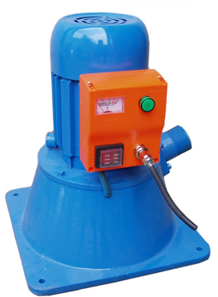
Figure 3 - 300W Micro-Hydro Turbine [8]
Figure 4 illustrates another micro hydro turbine specifically designed for remote locations, boasting a rated voltage output of 400VAC, a current of 12.5A, and power output of 5000W.
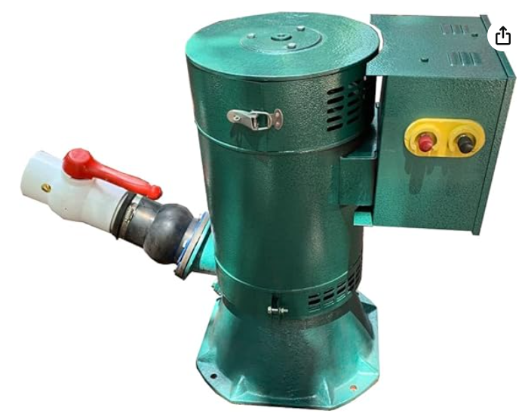
Figure 4 - 5000W Micro-Hydro Turbine [9]

DC Generators
In the conversion process from mechanical to electrical energy, a small DC generator plays a pivotal role. Research by Keream, S. S. [10] and Bhatia, A [11] outlining the working principles of DC generators highlights that DC generators operate on the principle of electromagnetic induction, converting mechanical energy into electrical energy. The shaft of the generator contains a rotor or armature, containing coils of wire. This rotates inside the stator, a stationary magnetic field typically produced by the use of permanent magnets in small DC generators. As the rotor turns, a changing magnetic flux induces an electromotive force (EMF) in the rotor coils, generating alternating current. A commutator split ring and carbon brushes act as a mechanical rectifier, reversing the rotor coil connections by during each half turn to reverse the direction of current flow to produce a direct current (DC) output. Brushes maintain contact with the commutator to carry output current to the load [11].

Comparative Project Analysis
The integration of renewable energy sources as a potential power source for lithium-ion battery charging is not a new phenomenon but there are only a handful of journals and papers published that explore their use.

Paper 1
One such paper by Raghavendra and Padmavathi [1], explores the design and implementation of a low cost, versatile and efficient solar charge controller for lithium-ion batteries. While solar energy constitutes the primary focus of the study, its principles provide a valuable foundation for drawing parallels between charge control mechanisms and protection systems to be used in the design of a microturbine-driven charging system.
The key components of the design, shown in Figure 5 are a 10 watt peak, 21VDC photo-voltaic panel, LM2596 DC-DC buck converter, PIC microcontroller and TP4056 Li-ion battery charging IC. The battery used in this experiment are 18650 3.7V 2200mAh batteries.
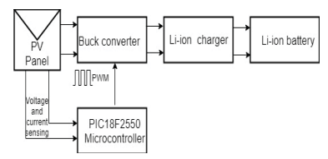
Figure 5 - Block diagram of charging system [12]
As depicted in Figure 6, the TP4056 IC employs constant current-constant voltage charge technique. The battery cell undergoes constant current charging its voltage approaches the maximum threshold of 4.2V. Subsequently, the charger transitions to constant voltage charging, wherein the charging current diminishes while the voltage is maintained close to 4.2V [12].
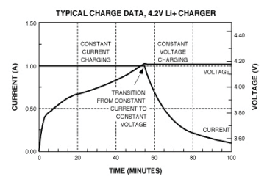
Figure 6 - Typical charging characteristics of Li-ion battery with a CC/CV [12]
In their tests, three Li-ion cells were charged at 0.2C, 0.3C and 0.4C respectively. The C rating denotes the time required to charge or discharge the battery, with 1C representing the total battery current in 1 hour. It was observed when charged at 0.4C that the TP4056 IC maintained a charge current of 0.9A, with charge termination at 0.09A (1/10th), taking approximately 180 minutes, as shown in Figure 7.
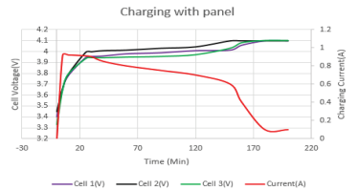
Figure 7 - Charging of three Li-ion cells [12]

Paper 2
Another interesting example written and published in ‘Practical Electronics’ magazine, which covers a wide range of practical applications related to electronics, is a multi-stage buck-boost battery charger. Authored by Tim Blythman [13], the article focuses on the use of a charging adaptor interfaced with a buck-boost LED driver, primarily tailored for use with 12V and 24V lead-acid type batteries. While the specifications of this design surpass the requirements of the current project in terms of current and voltage capacity, as well as overall complexity, its examination promises to yield valuable insights and enhance understanding.
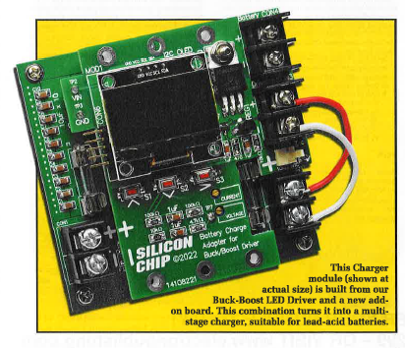
Figure 8 - Charger assembly [13]
The features and specifications of this design are as follows:
- Input voltage: 11.3V to 35V DC up to 10A
- Output voltage: 7V to 34V DC
- Charge current: 8A
- Adjustable charge current, voltage and time
- OLED display for battery status and configuration
Figure 9 shows the various components used in the design of the charging adaptor. A notable aspect observed in the design is the inclusion of a Schottky diode (D6), placed in the charging path to prevent battery discharge back into the driver circuit when the power supply is off. This protection technique will be carefully considered during the development of the charging circuit for this project. The design further incorporates a PIC16F1459 microcontroller, to monitor input, output and battery voltage. The PIC adjusts the output via PWM for various charge modes. The configuration of this system is facilitated through external pushbuttons and the integrated OLED display, underlining the design’s user-friendly attributes.
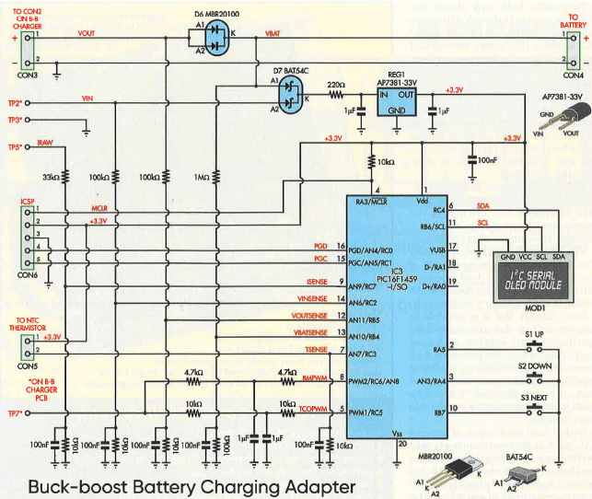
Figure 9 - Buck-boost battery charging adapter [13]

Paper 3
Arrohman and Fikriyyah’s [14] paper in the ‘Journal of Natural Sciences and Mathematics Research,’ explores the research and development of a photo-voltaic panel for generating electricity to charge cell phone batteries.
The photo-voltaic panel employed in this study exhibits a maximum output of 220mA at 5V DC and is interfaced with a micro USB TP4056 lithium-ion standalone battery charger, designed for a 3.7V lithium-ion battery. Although Figure 10 provides a glimpse into the circuit design and identifies specific points for the measurement of current and voltage, its vagueness complicates interpretation. A notable limitation of the study’s design is the lack of voltage regulation and the necessary voltage conversion. This somewhat compromises the study’s capacity to yield reliable and conclusive outcomes.
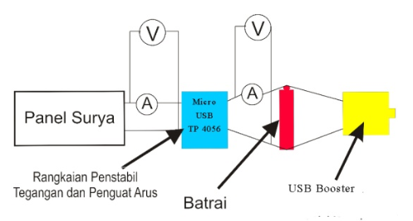
Figure 10 - Solar panel charging circuit [14]
Their data collection method involves measuring light intensity and exploring its impact on both solar panel voltage and current output, as well as the voltage and current output of the TP4056 charging module. However, the test methods lack clarity, raising concerns about the reliability of the study’s findings.
An observed drop in the current output from the photo-voltaic panel suggests the presence of a factor influencing its current drive capabilities. One potential contributor could be the internal resistance of the multimeter, employed in-series for current measurement. When measuring the specified 220mA 5V DC solar panel in this configuration, the recorded current ranged from 0.0010A to 0.0040A at a voltage between 4.5V to 5V DC. Following the TP4056 board, the voltage stabilises at 4V DC, yet the current but remains below 0.002A, which as indicated in the study, provides a mere 1.1% efficiency. It is important to note that without more information, it is challenging to draw definitive conclusions about the internal resistance of the multimeter or other components that could be affecting the circuit.
The design under consideration could potentially be enhanced with the integration of a buck-boost converter. This could serve to augment the current drive capacity of the solar panel, thereby ensuring an adequate power supply to the TP4056 board to enhance the battery charging process. Furthermore, this study sheds light on the importance of employing precise measurement techniques, such as incorporating a shunt resistor in the measurement setup when assessing the current drive capacity of low power devices.

Power Supplies
While linear power supplies dissipate surplus voltage as heat, switch-mode power supplies (SMPS) regulate output voltage through rapid on-and-off switching of the input voltage. This high-frequency switching enables more efficient voltage conversion, leading to minimized energy loss [15].

Buck Converter
Buck converters step down DC input voltage to produce a lower output voltage. The fundamental structure is commonly utilised in converters known as Non Isolated Point of Load (NIPOL or POL). They are widely employed to produce locally regulated power supplies within distributed power architectures [16].
The switching element of a buck converter is executed by a MOSFET which rapidly switches on and off to regulate the output voltage. During the ON state, where the input voltage is higher than the output voltage, current flows through the inductor, storing energy in its magnetic field. In the subsequent OFF state, this stored energy is released through the diode to the load.
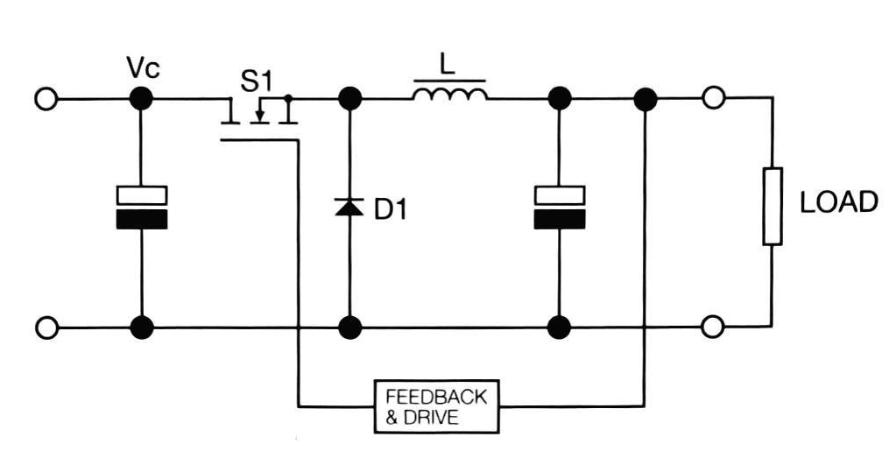
Figure 11 – Buck Converter Circuit [16]

Boost Converter
Boost converters, unlike buck converters, step up DC input voltage to generate a higher output voltage. During the ON state of the MOSFET switching element ‘S1’ shown in Figure 12, the inductor stores energy from the input. In the subsequent OFF state, the stored energy is released through a diode to the output capacitor. In practical applications, it is common to achieve output voltages up to five times the input voltage [16].
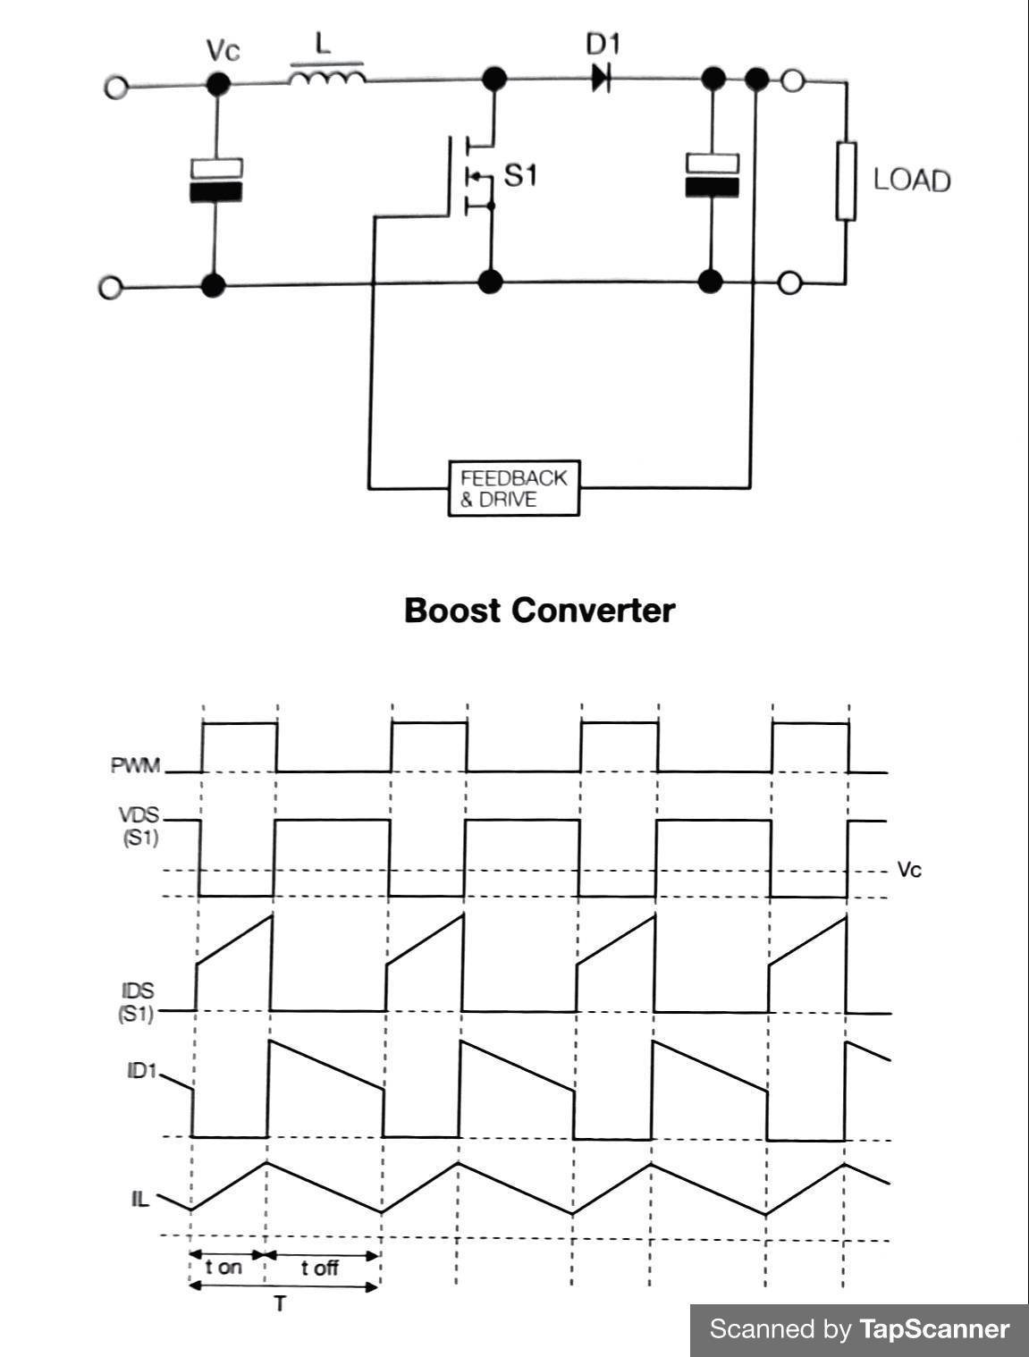
Figure 12 - Boost Converter Circuit [16]

Voltage Converter Types
Table 1 and Table 2 below contain four widely used buck and boost converters respectively providing a comparative overview of different buck and boost converters discussed in the literature review. Each table compares efficiency, voltage input/output range and current drive capacity that are all very much applicable selection criteria for this project.
Table 1 - Buck Converter Comparison [17], [18], [19], [20]
Table 2 - Boost Converter Comparison [21], [22], [23], [24]

Literature Review Conclusion
In conclusion, this literature review has provided a comprehensive examination of micro-hydro turbine technology. Through tracing the historical evolution from traditional waterwheel designs to modern crossflow turbines, discussing their efficiency, as well as highlighting the significance of industrial MHTs in supplying electricity to remote areas, the review has shed light on the pivotal role of MHTs in the renewable energy sector. Furthermore, the comparative analysis highlights the significance of dedicated lithium-ion battery charging modules, such as the TP4056 IC, which employs constant current-constant voltage charge technique. However, limitations related to voltage regulation and conversion were apparent in the review, indicating areas for further research and development. Additionally, the introduction of power supplies, focusing on buck and boost converters has expanded knowledge on their principles and the inclusion of comparative tables of various converter models further aids in the decision-making processes for the project.

Research and Development Methodology
In developing the methodology for this project, the focus was on designing and implementing a prototype hydro turbine circuit to harness renewable energy. Unlike traditional research studies with defined problems, this project adopts a mixed-method approach by integrating aspects of pragmatism and positivism paradigms to contribute to robust understanding. This chapter provides a detailed account of the procedures undertaken to conceptualise, design and construct the hydro turbine circuit in order to provide a comprehensive guide for replicating the process and adapting the technology for similar renewable energy projects [25].
The adoption of a pragmatist approach stems from its problem-solving orientation and its focus on finding a solution to a real-world problem. This approach provided the project with flexibility to select methods based on their practical outcomes, emphasising a results-driven mindset.
Concurrently, integrating a positivism perspective serves to empirically observe the circuit’s behaviour, particularly focusing on visual components such as LED lights, while systematically measuring outcomes, including power output and efficiency under various conditions, to gather quantitative data. Moreover, a positivist approach frequently endeavours to derive findings that can be generalised to a broader context. Given the potential applicability of this project to various renewable power sources, including wind and solar, the insights gained extend beyond the specific conditions of this prototype testing, offering broader practical relevance.
The positivist approach introduces potential limitations due to the controlled nature of experiments, which may not fully capture the variability present in real-world conditions involving water flow. To address this concern, testing of the circuit will be conducted at varying flow rates and/or pressures, aiming to simulate real-world use scenarios and enhance the external validity of the study.
Throughout the research phase, diverse data sources, including books, datasheets and peer-reviewed papers, will be analysed to gain the applicable knowledge to make informed design choices, ensuring the integrity of the information. While web pages may be consulted, it is crucial to assess their reliability rigorously. This analysis will encompass both qualitative and quantitative data.

Data Collection
Quantitative data was obtained through a combination of software simulations and practical measurements, focusing on power output and efficiency. Initial data collection occurred during the design phase, using Proteus and EasyEDA to validate and refine design concepts before actual construction. Practical measurements involved the use of a multimeter to measure voltage and current throughout the circuit, confirming it functionality post-construction. Additionally, the micro turbine’s voltage output was systematically tested across varying flow rates, resulting in a comprehensive table of results to evaluate its performance.

Software Selection
Following extensive research and recommendations from peers and lecturers with electrical design experience, it has become apparent that two primary software options stand out for designing and simulating throughout this project: Proteus and EasyEDA.
EasyEDA provides a user-friendly interface for schematic design, PCB layout and simulation, while Proteus offers advanced simulation capabilities, allowing for in-depth testing and validation of the circuits functionality before physical implementation.
Proteus will work in tandem with MPLAB X IDE and XC8 compiler. These programs facilitate the simulation, programming and testing phases of the PIC microcontroller using the C programming language.

Hardware Selection
The following components play essential roles in the overall functionality of the circuit:
Micro Hydro Turbine:
- Role: Converts water flow into mechanical energy, generating power.
- Reason for use: Core component for harnessing renewable energy from water, aligning with the project's objective.
PIC Microcontroller (PIC16F877A):
- Role: Central processing unit, controls and coordinates the operation of the circuit.
- Reason for use: Meets all requirements, over-specified for the task but allows for future development. 10-bit A/D converter, popularity and simplicity for programming novices, abundant analog and digital I/O, cost-effectiveness.
LEDs:
- Role: Visual indicators to convey information about the circuit's status or functionality.
- Reason for use: Provide a visual representation of the battery status, aiding user feedback.

Resistors:
- Role: Control the flow of electric current in the circuit, set voltage levels, protect components.
- Reason for use: Essential for configuring the electrical characteristics of the circuit, ensuring proper operation and preventing damage.
Transistors and MOSFETs:
- Role: Act as switches or amplifiers, controlling the flow of current in specific sections of the circuit.
- Reason for use: Enable efficient switching and control of electrical signals, separates power circuit from microcontroller to provide more power output.

Materials and Tools
Materials and tools to be used will be a range of electrical and electronic equipment, please refer to section 4.2.2 Materials and Equipment

Project Management

Time Management:
Project management, specifically time management is a key aspect for any project’s success. It establishes a necessary structure for progression and ensures a clear direction. A rudimentary tool such as a ‘to do list’ can assist a project leader greatly, however for more extensive projects, a sophisticated project schedule is essential to provide the planning and direction a larger scale project requires. Assigning tasks with specified completion dates creates a progressive workflow, ensuring that work is conducted in a organised manner. This approach prevents tasks from being neglected, which is crucial for the success of a project [26].
For a project such as the design and implementation of a hydro turbine battery charging circuit, it is imperative to have scheduled tasks with associated deadlines, as certain tasks serves as foundational prerequisites for others. Failure to complete these foundational tasks in a timely manner may impede progress and compromise the overall project objective. For example, prior to building the circuit on a breadboard, the design must be tested and simulated to ensure its functionality.
Various project scheduling methods of developing a project schedule exist, with the Gantt chart being the most widely recognised approach in the industry [27], hence its application within this project. It provides the opportunity to assess the completion time of a task as opposed to the initial allocated time.
Figure 13 illustrates the Gantt chart created with spreadsheet software for this project. The Gantt chart focused on completion dates for major project checkpoints rather than delving into smaller individual tasks, a choice made to avoid potential overwhelm. To manage the smaller foundational tasks within each major checkpoint, a checklist was created. In the event that this approach did not meet expectations, the Gantt chart could be revised to incorporate more detailed information.

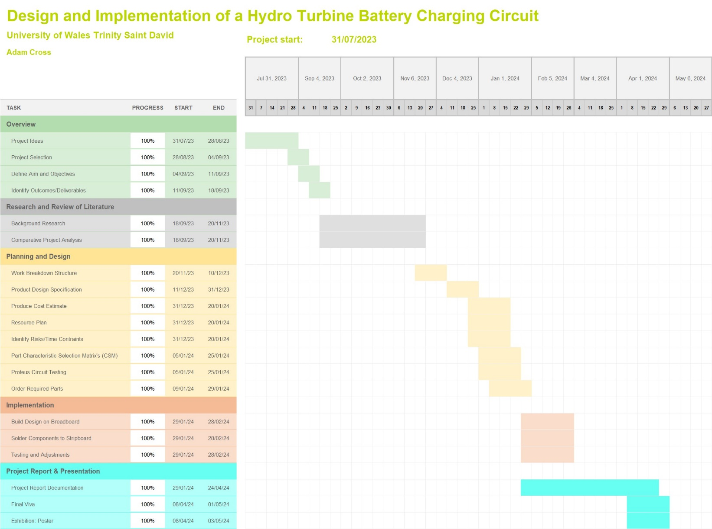
Figure 13 - Project Gantt Chart

Resource Plan
A resource plan is a fundamental component of effective project management, contributing to the overall success of the project by guiding resource allocation and mitigating risks.

Personnel
It is important to address the personnel involved in the project to provide clarity of roles and responsibilities, to manage the risk, and ultimately contribute to the success of the project.
Adam Cross, designated as the project manager, is responsible for the overall project and is tasked with:
- Adhering to the project plan timetable.
- Submitting project assessment components by the specified date and time.
- Presenting and responding to questions about the project during vivas.
- Promptly reporting any issues to project supervisor.
Stephen Mosey, the designated project supervisor, supports the project manager by:
- Guiding the student in refining achievable goals.
- Advising on literature sources, research design and methodology.
- Monitoring progress, providing feedback on drafts, and ensuring project resources are available.

Materials and Equipment
Table 3 and Table 4 below include a comprehensive list of the materials and equipment resources necessary for the successful execution of the project. These lists form the basis for budgeting and cost estimation and were created to ensure the project stays within budgetary constraints.
Table 3 - Material Cost Estimate
The budget has a equipment and software cost of £0, as the required components for this project are already available. The project benefits from pre-existing tools and software that is freely accessible or provided free of charge by University of Wales Trinity Saint David.
Table 4 - Equipment/Software Cost Estimate

Projected Cost
As delineated in Table 5, the projected project expenditure totalled £81.71. This estimate includes costs for both material and equipment, with an additional 10% allocated for miscellaneous expenses, such as small hardware and consumables not explicitly categorised. Additionally, a contingency provision of 20% was incorporated in to the total cost to mitigate potential risks and uncertainties.
Table 5 - Total Cost Estimate

Risk Management
As part of a contingency plan, it is imperative to identify potential risks that may impact the project. Key risks directly related to the project include:
- Sickness: Adequate contingency weeks have been allocated, demonstrated in the project Gantt chart to mitigate this risk. This creates a buffer that accommodates for unexpected disruptions without causing significant delays to the overall project timeline.
- Resource constraints: Whether concerning budgetary limitations, parts availability, or skilled personnel. To mitigate this risk a thorough resource plan was conducted, this identified the main parts and equipment required, the personnel involved, and assesses the availability of workspaces to complete the project. Please refer to section Resources
- Scope creep: To prevent the project’s scope expanding beyond the initially defined boundaries, the project scope was clearly defined and a change control process was implemented to asses and approve any alterations to the scope.
- Lack of motivation or clarity: To address the human factor, clear goals and objectives have been established to provide a comprehensive understanding of what needs to be achieved. Additionally, the Gantt chart has been employed to break down the project in to smaller, manageable tasks.
- Technical risk – Mitigating technical risks is crucial to avoid complications arising from limited technical knowledge. Thorough background research, initial concept model designs, and simulation testing were undertaken to enable early detection and mitigation of potential issues. The circuit sections were incrementally developed, breaking down the project into manageable sections to prevent minor issues from escalating. Where challenges arose, expertise was sought after from lecturers and the project supervisor who hold thorough knowledge of the field.

Use of Workspaces
In order to ensure seamless project execution, careful consideration has been given to the availability of workplaces. The project will be conducted at the following locations:
- University of Wales Trinity Saint David – IQ206: Meetings, individual research, report writing and project implementation and testing.
- Remote work (home): Virtual meetings, individual research, report writing, project implementation and testing.
- Eastman Chemical Company – Electrical workshop: Project implementation and testing.

Project Design
The design phase plays a pivotal role in the development process it transforms conceptual ideas in to tangible solutions. This section will delve into the design considerations and methodology to ensure successful creation of the product.
One key component that guides the design process is a Product Design Specification (PDS). This document serves as a comprehensive blueprint, outlining essential requirements, performance criteria and constraints that the final product must adhere to. See Appendix A: Product Design Specification.

Character Selection Matrix
During the design stage, a selection matrix tool was employed as a pivotal component. The chosen tool, a weighted decision matrix, proved to be a powerful quantitative technique. Its purpose was to systematically evaluate and compare the specifications of each part based on a predefined set of criteria derived from the PDS, aiming to identify the most suitable part for the given task.
In this approach, each criterion was assigned a weight according to its significance, graded on a scale of 1 to 5. A rating of 1 denoted the least importance, while 5 indicated the highest relevance to the project. Subsequently, each part underwent comparative rating against one another and the set criteria, with scoring ranging from 1 (poor) to 5 (excellent).
The assigned weight for each criterion was multiplied by the corresponding score for each part, and the sum of the results was used to calculate the total score for each part. This facilitated a quantitative comparison, highlighting the part with the highest score as the most favourable option, showing its alignment with the project goals and criteria outlined in the PDS.

Micro-Hydro Turbine Part Selection Matrix
In Table 6 below, a selection matrix compares three economically viable micro-hydro turbines for potential integration in to the battery charging circuit. The analysis results show that the GeKLok F50 unregulated 0 to 80VDC model, with a score of 195, is the most suitable for meeting the project requirements. Its broad voltage output not only enables the generation of more power compared to alternative options but also aligns with the specifications mandated by ‘The Water Supply (Water Fittings) Regulations’ [28]. This includes compliance with water pressure and flow rate standards consistent with those supplied to households, particularly in Welsh regions by Dŵr Cymru Welsh Water. ADD REFERENCE TO DATASHEET FOR EACH
Table 6 - Micro-Hydro Turbine Part Selection Matrix [7], [29], [30]

Buck Converter Part Selection Matrix
In Table 7 below, a selection matrix is presented for assessing the suitability of various buck converters. The chosen buck converter will step down the unregulated voltage of the micro-hydro turbine to a regulated 5VDC output to supply the charging circuit. The outcome of this quantitative analysis identify the LM2596 buck converter as the optimal selection, possessing the highest weighted score of 146. This is attributed to its performance in wide voltage regulation, availability, cost and current drive capability – all of which seamlessly align with the specified design requirements.
Table 7 - Buck Converter Part Selection Matrix [17], [18], [19], [20]

Boost Converter Part Selection Matrix
Table 8 below presents a selection matrix of various boost converters to determine their suitability. Tasked with stepping up the battery voltage of 3.7V nominal to 5V DC to power the microcontroller and USB output charging port. With the highest weighted score of 165, the MT3608 boost converter emerges as the optimal selection, due to efficiency, wide voltage ranges, current drive capability, availability and cost.
Table 8 - Boost Converter Part Selection Matrix [21], [22], [23], [24]

Battery Part Selection Matrix
Table 9 compares rechargeable batteries types for a project requiring 5V DC output for USB charging and a microcontroller. 18650 li-ion batteries were chosen due to their 3.7V nominal voltage and large capacity. While, NiMH batteries are considered easier to charge, Li-ion batteries offer advantages such as higher energy density, flatter discharge curves and longer cycle life [31]. A charger specifically designed for Li-ion batteries will be required to ensure safety and longevity, especially considering the risk of overcharging.
Table 9 - Battery Part Selection Matrix [32], [33], [34], [35]

Block Diagram
The presented block diagram in Figure 14 provides an overview of the key components integral to the system design. It servers as a vital tool for visually conveying and communicating the system structure. Testing of the turbine’s real-life voltage output will determine the necessity of overvoltage protection. As observed during the literature review, lithium-ion batteries demand sophisticated charging methods. To address this, the TP4056 Li-ion battery charging IC will be utilised to safely charge two 18650 3.7V lithium-ion batteries in parallel. This not only enhances current capacity but also ensures a safer and more efficient charging process by maintaining balanced cell conditions and uniform aging.
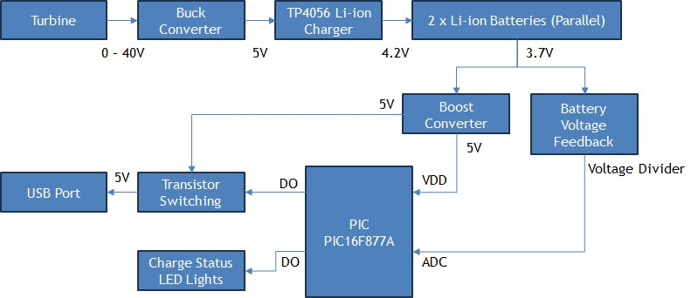
Figure 14 - System Block Diagram

Circuit Design
Figure 15 illustrates the complete circuit design, including battery charging and microcontroller circuitry.
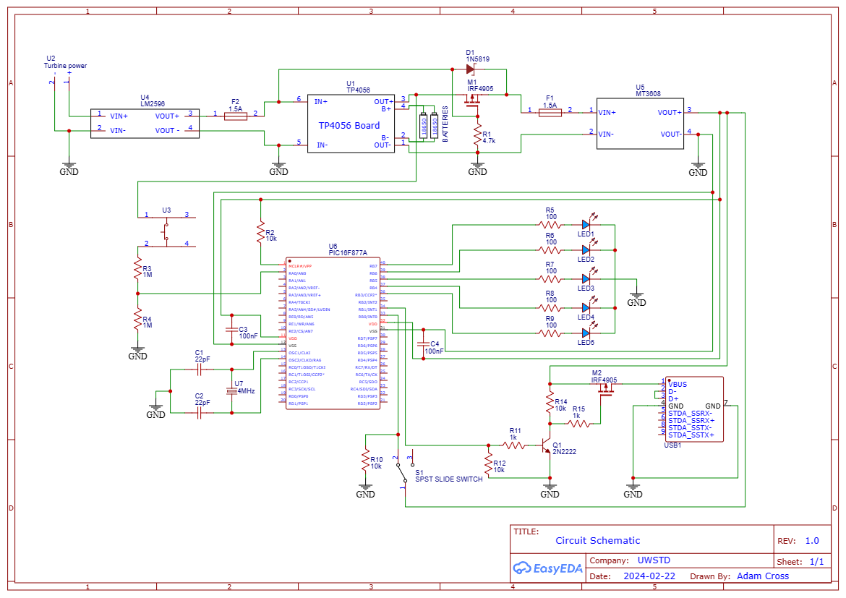
Figure 15 - Circuit Schematic
The circuit is anticipated to consume approximately 1A of total current. To safeguard against overcurrent, two 1.5A fuses are employed: one positioned at the circuit's input and another at the output to the boost converter module. These fuses serve to shield the circuit from potential damage to its components and prevent operational failure.
Incorporating 100nF decoupling capacitors across the supply pins of the microcontroller aids in voltage stabilisation by mitigating transient spikes and high-frequency noise inherent in the power supply, particularly those originating from switch mode power supplies. Additionally, they serve to counteract minor voltage drops that may occur during sudden fluctuations in current demand.

External Modules
Three external modules were chosen for this project to control voltages and charge the 18650 batteries:
- LM2596 – DC-DC buck converter
- TP4056 – Dedicated lithium-ion battery charger
- MT3608 – DC-DC boost converter

LM2596 Module
Chosen following the character selection matrix process. This module will be used to step down the turbine voltage to 5V in order to power the TP4056 charging module. The operation of a buck converter was discussed in the literature review, highlighting its ability to step down input voltages while maintaining high efficiency (refer to ….). Specifically, the adjustable version of the module allows for precise control of the output voltage through the use of a voltage divider and variable resistor ‘R2’ in the feedback loop [17].
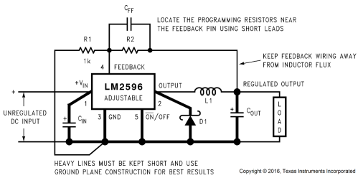
Figure 16 - LM2596 Schematic Diagram [17]

TP4056 Module
Based on findings from the literature review, the TP4056 module emerged as a prevalent and well-tested choice for lithium-ion charging. Consequently, it was selected as the preferred solution in this project.
This module has two status outputs indicating charging process and completion. Default charge current is set at maximum 1A via a 1.2KΩ resistor, within the batteries’ specified 2.4A tolerance [36]. Charge cutoff at 4.2V protects the battery. Additionally, the chosen TP4056 breakout board integrates two crucial chips: DW01A and 8205A. These work together to provide protection, monitoring and management of the battery. DW01A protects the battery from overcharge, over-discharge, reverse polarity and short circuits, while the 8205A chip regulates the charge current through a pair of N-channel MOSFETs [37].
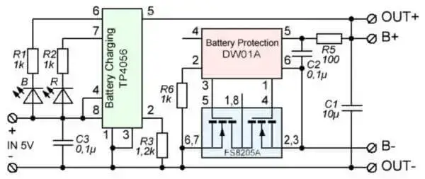
Figure 17 - TP4056 Schematic Diagram [38]

MT3608 Module
Selected after comparing with other buck converters using the character selection matrix, refer to Table 8. In the literature review, the operation of boost converters was explored, revealing them as switch mode power supplies capable of regulating output voltage efficiently. The MT3608 IC has a high switching frequency of 1.2MHz and an adjustable output voltage, facilitated by the voltage divider feedback circuit, containing an adjustable potentiometer.
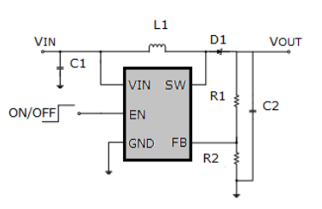
Figure 18 - MT3608 Schematic Diagram [22]

SPICE Models for External Modules
Despite several attempts, difficulties were encountered in generating accurate SPICE models for simulating these modules within Proteus. Despite exploring various resources and documentation, these modules were not able to be rigorously tested in a simulation environment prior to circuit construction. Nevertheless, prior research had confirmed their suitability for the task.

Battery Load Sharing
The TP4056 module, a dedicated CC/CV linear charger for lithium-ion batteries with a fixed charge voltage 4.2V, terminates the charging cycle when current drops to 1/10th of the battery capacity in mAh [37]. However, if a load is connected to the battery, this will change the current detected by the TP4056, as a result it may not terminate the charging process, posing safety risks due to potential overcharging.
To address this issue, a solution involving a switch is needed, in the form of a P-channel MOSFET, Schottky diode and pull down resistor. This configuration automatically disconnects the battery from the load when the turbine power source supplies the TP4056. The TP4056 can therefore continue to charge the battery without a load connected. The load is supplied directly through a Schottky diode which prevents current flowing from the battery to the supply while also providing a low-resistance path for the supply to power the circuit. When the turbine stops supplying the circuit, the MOSFET is turned on, connecting the load to the battery. Refer to the schematic diagram in Figure 19 below for a visual representation.
A P-channel MOSFET was chosen due to its ability to disconnect the load from the battery when the gate is pulled high, and in particular the IRF4905 was chosen due to its high current capability and very low on-resistance of 20mΩ which will prevent a large voltage drop [39]. The selection of the 1N5819 Schottky diode was based on its low forward voltage drop of 0.45V, a continuous current rating of 1A (with a surge capacity of 25A), and fast switching characteristics [40].
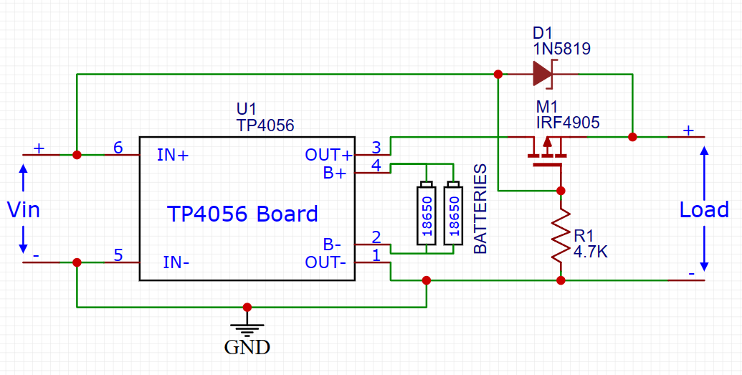
Figure 19 - TP4056 Load Sharing Schematic Diagram
To test this circuit, a simulation was carried out whereby a switch was used to mimic the turbine supply being ON or OFF. A voltmeter measured load voltage, and an ammeter measured current draw between the battery and MOSFET. As anticipated, with no turbine supply, the gate of the MOSFET is pulled low, facilitating current flow from the battery to the load.
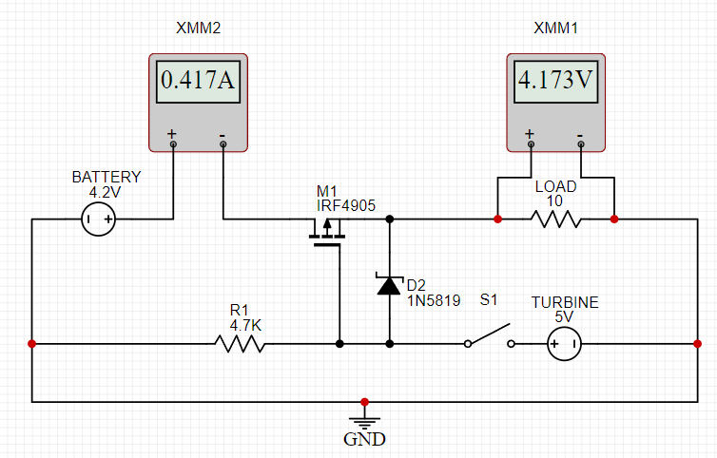
Figure 20 - Load Sharing Test (Battery with no charging supply)
When the turbine is supplying the circuit (switch S1 closed), the gate of the MOSFET is pulled high, preventing it from conducting, subsequently disconnecting the battery from the load (indicated by the nano amp load shown on multimeter ‘XMM2’). Current then flows through the Schottky diode to power the load.
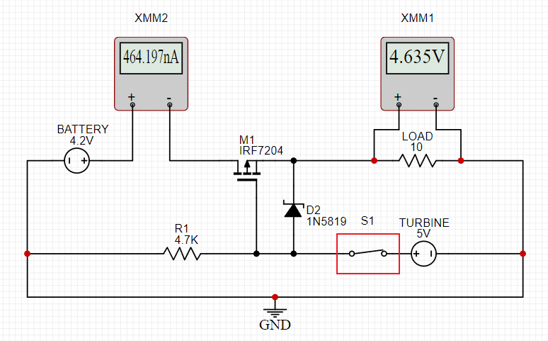
Figure 21 - Load Sharing Test (during charging phase)

Software Flow Charts
This section covers the design of flowcharts, used to form the basic program structure to follow when writing the microcontroller program in C programming language. Flowcharts provide a visual representation of the logical flow of a program, making it easier to understand and communicate the structure and functionality of the software.
Below in Figure 22 is the main flowchart, outlining the initialisation process. This includes setting the clock frequency, initialising I/O ports, defining battery thresholds for the ADC process, and monitoring the status of the on/off switch controlling the USB output port. A switch connected to an input pin on the PIC will be used to control the on/off status of the USB output port. Additionally, configuring all unused ports as output ports and setting them to a low logic level serves to prevent potential interference caused by floating voltage inputs on any of the pins.
Figure 23 illustrates the logic for implementing a battery capacity measurement system utilizing a voltage divider circuit. The selected RS 18650 batteries come equipped with a built in over-discharge cut off at 2.8V [36]. Thus, the voltage thresholds for indicating battery capacity were conservatively set between 3.2V and 4.2V, representing 0% and 100% capacity. The approach involves employing five LED lights to provide the user with a visual indication of battery capacity based upon programmed voltage thresholds (20% increments) set in the microcontroller program. If the detected voltage falls between two thresholds, the LED corresponding to the next voltage threshold will intermittently flash for 0.5 seconds. This indicates to the user that the battery has not yet reached that specific charge capacity.

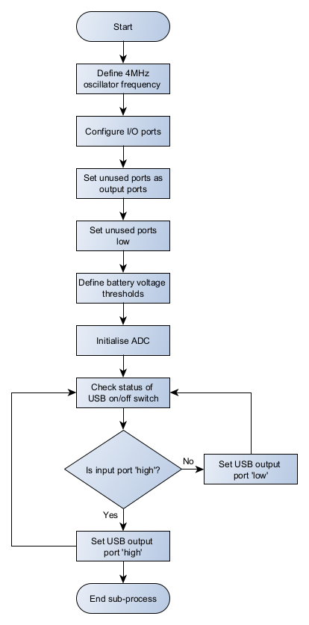
Figure 22 - Initialisation Flowchart

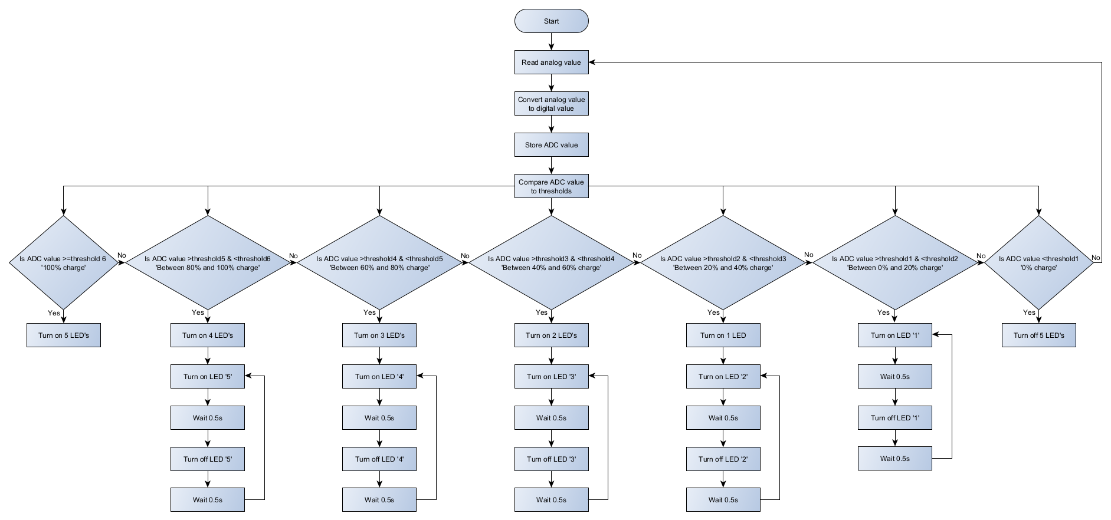
Figure 23 - Battery Capacity Flowchart

Writing The Software Program
The software flowcharts introduced in the preceding section, '6.4 Software Flow Charts,' served as valuable guides during the development of the software program. This section offers a concise overview of the code, which is written in the C programming language and implemented using the MBLAB IDE software.
The complete software code can be found in Appendix D.

Voltage Divider Circuit
Shown in Figure 15, a design choice was made to create a voltage divider circuit to measure battery voltage, consisting of two 1MΩ resistors. These values were chosen to keep output impedance relatively low to reduce noise sensitivity and inaccuracies, while reducing current draw from the battery.
The following equation was used to determine the output voltage of the voltage divider circuit,
$$Vout=Vin × \frac{R2}{R1+R2}$$
100% battery capacity of 4.2V will provide an output voltage to the PIC of,
$$Vout=4.2V × \frac{1MΩ}{1MΩ+1MΩ}$$
$$Vout=2.1V$$
0% battery capacity of 3.2V will provide an output voltage to the PIC of,
$$Vout=3.2V × \frac{1MΩ}{1MΩ+1MΩ}$$
$$Vout=1.6V$$
Current draw through the voltage divider circuit,
$$I=\frac{4.2V}{20×{10}^{6}Ω}$$
$$I≈2.1µA$$

Analogue to Digital Software
Figure 24 shows a snippet of the code used to initialise the ADC module. ‘ADCON0’ selects ADC channel 0 and turns on the ADC module while ‘ADCON1’ sets the voltage reference to use VDD and VSS. The 10-bit ADC value is split across two registers ‘ADRESH,’ containing 2 most significant bits and ‘ADRESL,’ containing the 8 least significant bits, which are combined to form the complete ADC result.
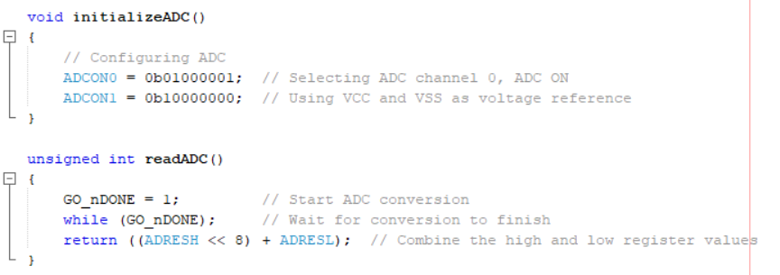
Figure 24 – Initialising ADC (software)
The digital representation of the analog voltage input measured by the ADC is stored in a variable ‘adcValue.’ Six voltage thresholds at 20% increments were set, see Figure 25, using the following formula,
$$Threshold=\frac{voltage}{VDD}×maximum ADC value$$
During software testing, it was observed via Proteus simulation, that the voltage measured on the ADC pin from the voltage divider circuit was slightly lower than anticipated at each voltage threshold. This discrepancy may be attributed to tolerances in the resistors used. Therefore each threshold was set 0.02 volts lower to account for this discrepancy.
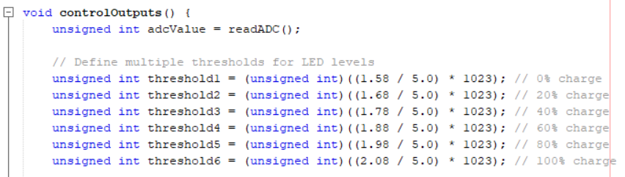
Figure 25 - Setting Voltage Thresholds (software)

The code snippet in Figure 26 controls the LED lights indicating battery capacity. When the ‘adcValue’ is greater than or equal to threshold 6 (equivalent to a battery voltage of 4.2V), all five LED light outputs illuminate.
When the ‘adcValue’ falls between two thresholds, the LED lights up to the lower threshold illuminate continuously. Simultaneously, the LED associated with the higher threshold flashes intermittently for 0.5 seconds. The flashing indicates to the user that the battery capacity is above the lower threshold (e.g. 60%) but below the higher threshold (e.g. 80%).
If the ‘adcValue’ falls below the lowest threshold, equivalent to 3.2V, all LEDs remain off. This state indicates a critically low battery level.
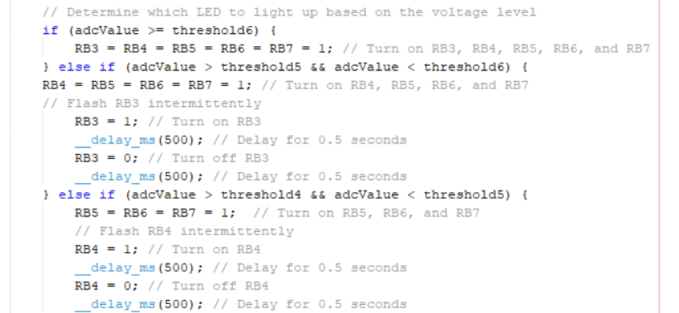
Figure 26 - Battery Capacity Indication (software)

Testing Microcontroller Theory
Figure 27 illustrates the microcontroller circuit designed in Proteus to be tested to ensure correct functionality. The simulation of the microcontroller was driven by a C programming file created in MPLAB IDE.
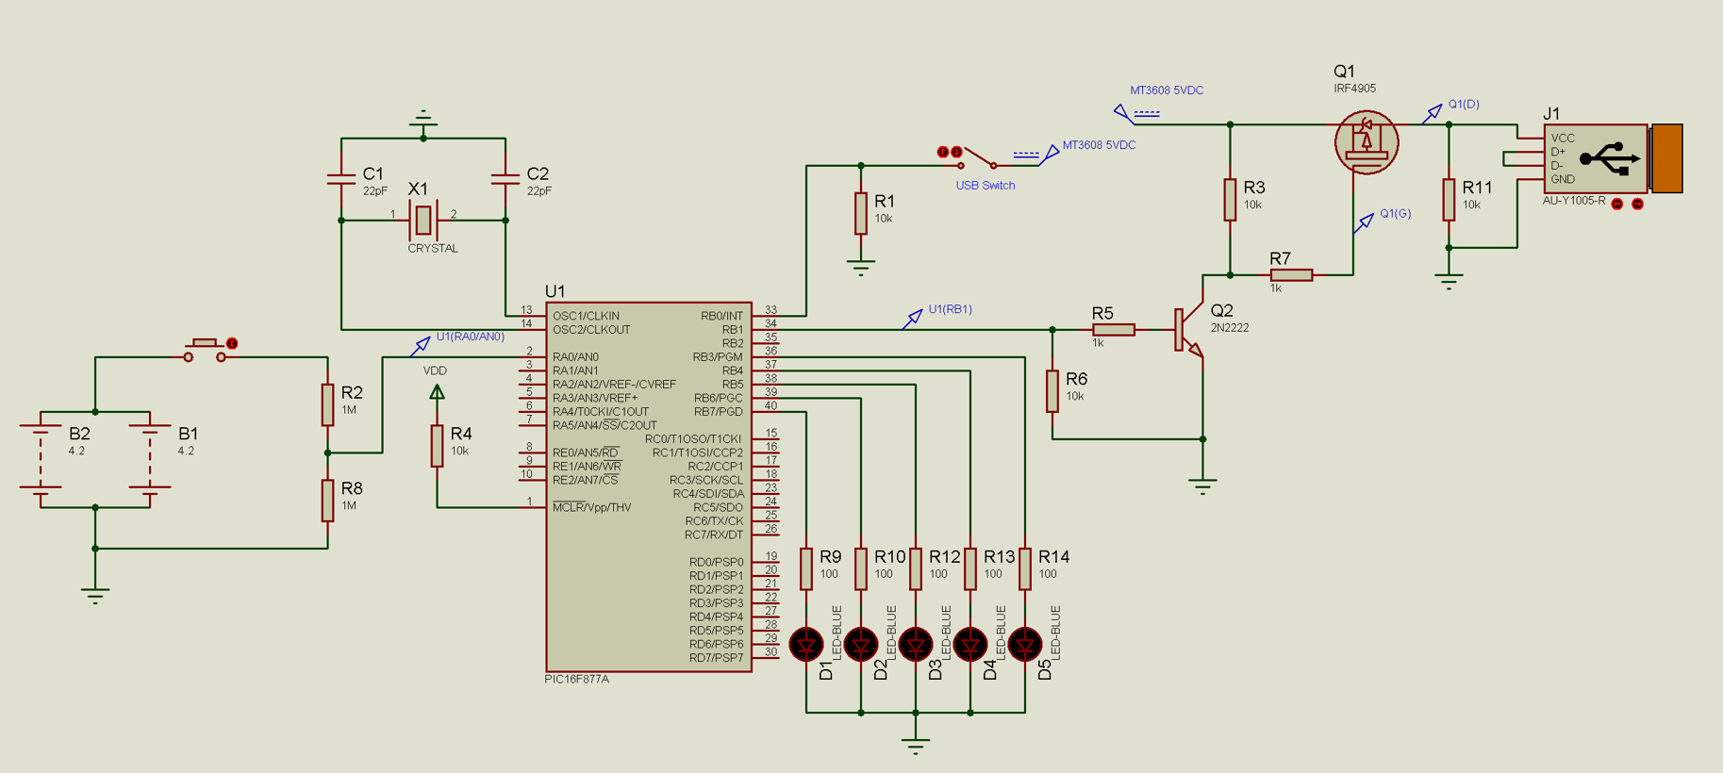
Figure 27 - Microcontroller Circuit Testing

Unit Testing USB Output
Shown in Figure 28 is a high-side switching configuration employed to control the power delivery to the USB output. Chosen over low-side switching due to several factors. Firstly, its application is considered safer as it maintains a continuous connection between the ground reference and the load. Secondly, it offers ease of interfacing and control with the positive output voltage of the PIC to drive the gate of the MOSFET. Furthermore, it facilitates the use of a low amperage switch and thus is more cost effective, as the switch is tasked solely with managing an input to the PIC, alleviating the need to handle higher-power switching. A IRF4905 P-channel MOSFET was chosen due to its high current capability and very low on-resistance of 20mΩ which will prevent a large voltage drop [39]. When the USB output switch is OFF, input RB0 on pin 33 is low, which sets output RB1 on pin 34 low. NPN transistor ‘Q2’ base is therefore low, blocking the path to ground, thus the gate of MOSFET Q1 is held high at 5VDC, blocking current flow between source and drain to the USB output port.
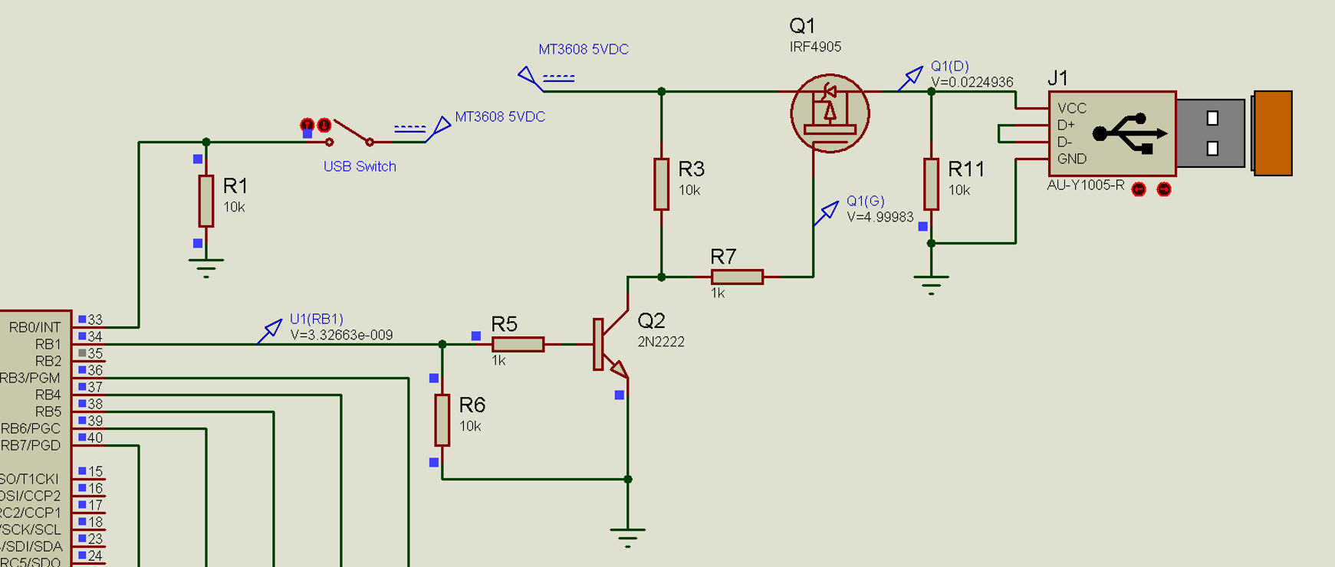
Figure 28 - USB Output OFF (high-side transistor switching)
Contrarily, when the USB switch is ON, a high signal on pin RB0 sets output port RB1 high, activating transistor 'Q2.' This action pulls the MOSFET gate low, allowing current flow through the MOSFET to the USB output port. Voltage probes were used as visual indicators during testing to prove circuit functionality.
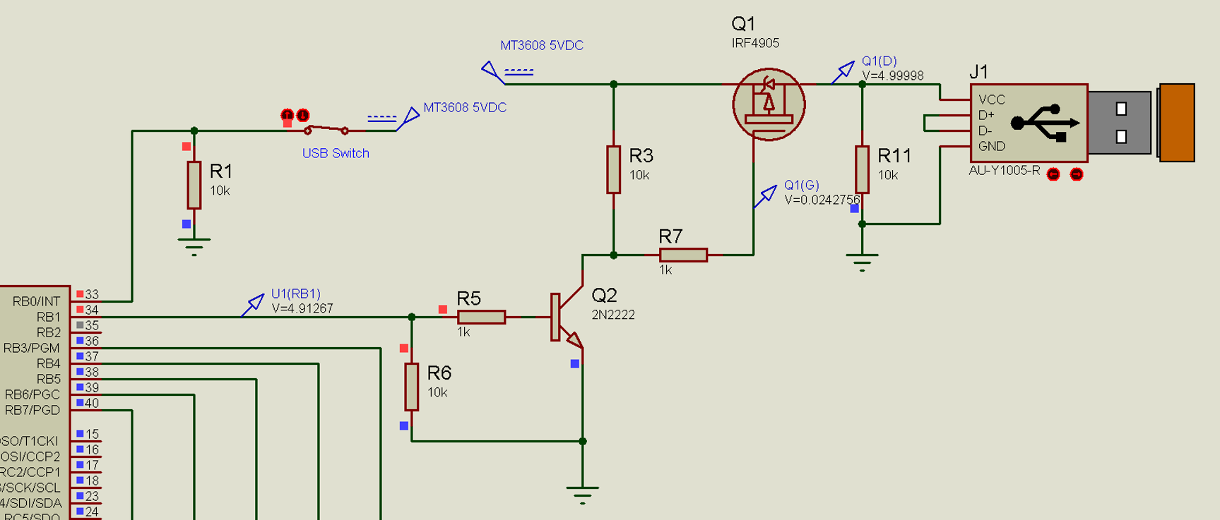
Figure 29 - USB Output ON (high-side transistor switching)

Unit Testing Battery Capacity Indication
Each voltage threshold was tested to ensure correct functionality. Illustrated in Figure 30, when the batteries are at full capacity and the momentary push button is pressed, the battery level is indicated as full, all 5 LED lights illuminate.
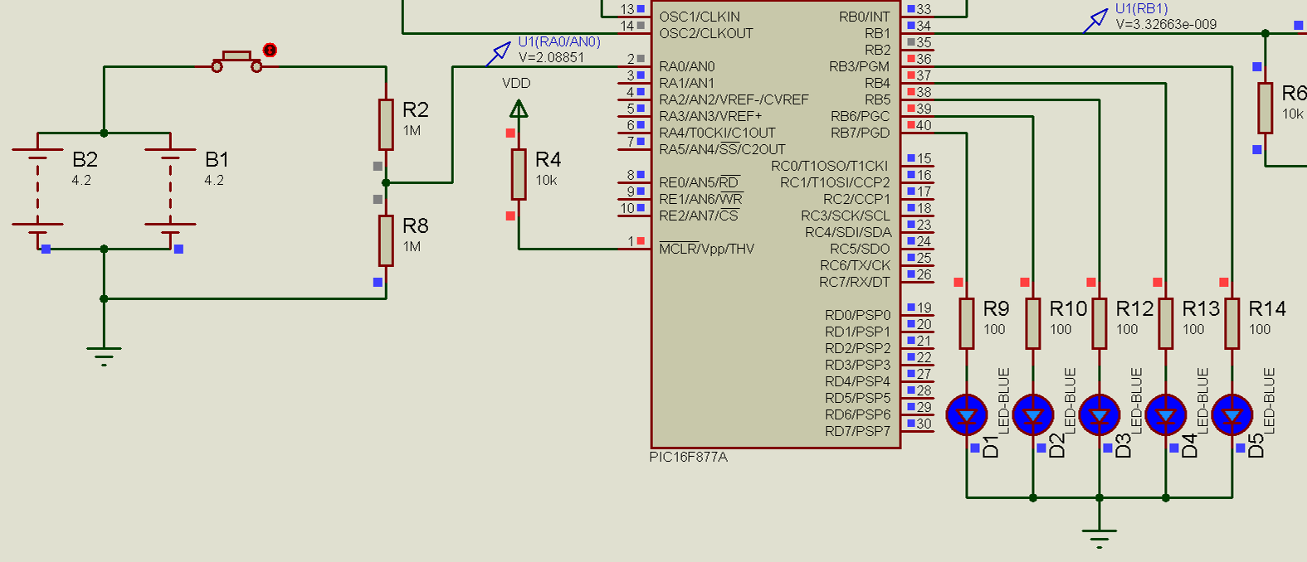
Figure 30 - Battery Level Indicator (fully charged)
When battery voltage is 3.4V (20%), LED ‘D1’ remains illuminated while LED ‘D2’ pulses ON and OFF for 0.5 seconds to indicate that the battery status is between 20% and 40% charge.
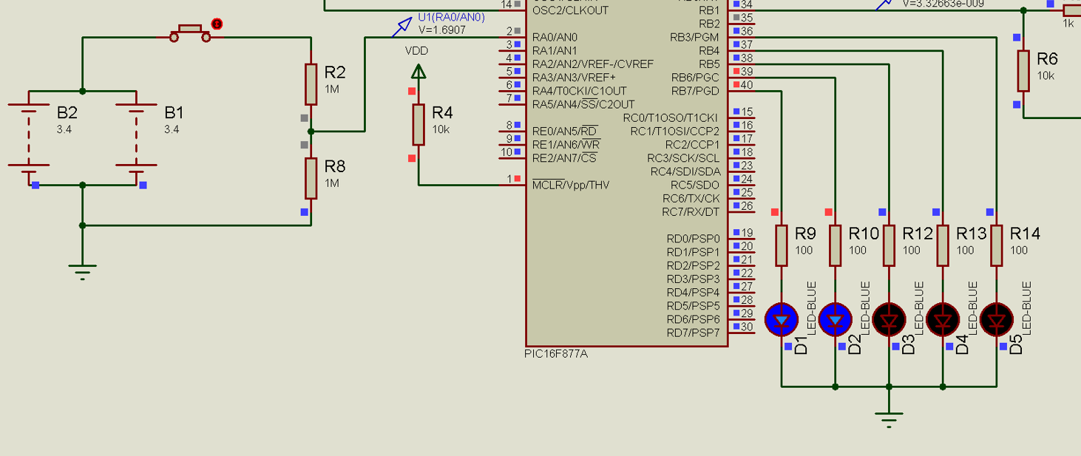
Figure 31 - Battery Level Indicator (20% charge)

Bill of Materials
Table 10 displays the bill of materials. The total cost amounts to £85, slightly exceeding the estimated cost of £81. This variance is attributed to the purchase of PCB-protected 18650 batteries. While these batteries were relatively expensive, they ensured safety during the project, as charging unprotected Li-ion batteries can pose safety hazards.
Table 10 - Bill of Materials

Implementation and System Testing
Testing is essential for validating system functionality. The testing process involves two phases: testing individual components and modules to measure variables and confirm their functionality prior to building the circuit, followed by testing the system as a whole to assess integration.

Testing Prior to Final Installation

Programming Microcontroller
In the process of building and testing the circuit, a temporary setup was constructed on a breadboard and tested (see Appendix C – Figure 38 and Figure 39). The microcontroller programming was facilitated using MPLAB IDE and IPE, alongside a PICkit3 programmer [41].
During testing a an issue was identified with PIN RB3, which was found to be outputting 1.4V instead of the expected 5V. Subsequent testing with a substitute PIC revealed that the code executed without issues, indicating that RB3 was not the root cause of the problem. Therefore a decision was made to change the PIN assignment on the original microcontroller, to one that demonstrated correct functionality. Consequently, the C program was adjusted to accommodate this, with the LED output shifted to pin RB2.

Testing and Setup of TP4056 and MT3608 Modules
The two 18650 batteries were connected in parallel to the TP4056 charging IC, with the circuit board output connected to the MT3608 boost converter. At a battery voltage of 3.64V, the boost converter potentiometer was adjusted to achieve a 5.1V output. To assess current capacity, a 5Ω 25W power resistor was employed as a load, and the boost converter’s maximum output current was measured at 964mA. Further testing with lower resistance values revealed that the MT3608 module could no longer maintain 5V output across the load. For a overview of the experimental setup, refer to Figures 41-43.

Testing and Setup of LM2596

Micro-Hydro Turbine Voltage Output at Varying Flow Rates
To ascertain the output voltage of the micro-hydro turbine (MHT) across different flow rates, a 1-litre container was filled, and the elapsed time was recorded.
By applying the formula below, the flow rate in liters per minute (L/min) was calculated,
$$Flow rate \text{(L/min)}=\frac{Change in volume}{Time taken} ×60$$
The following table presents the data obtained from the test, see Table 11 below.
Table 11 - Micro-Hydro Turbine Voltage Output at Various Flow Rates
Accompanying Table 11 is a scatter graph illustrating the relationship between flow rate and output voltage obtained during testing.

Figure 32 – Relationship between Flow Rate and Output Voltage of Micro-Hydro Turbine (MHT)
The analysis of Table 11 and Figure 32 reveals that the turbine initiates voltage output at approximately 1.9 L/min, indicating its minimum operational flow rate. During testing, the maximum flow rate achieved was 11.62 L/min, yielding a voltage output of 31.24V. The accompanying trendline on the graph illustrates the general trend of the data, suggesting a potential voltage output of up to 40V at higher flow rates. Considering that the average flow rate in the UK typically ranges between 10 L/min and 15 L/min [42], it is expected that the turbine will produce 28V or more in such conditions.

Testing Turbine Current Drive Capacity
The turbine’s maximum current output is advertised by the manufacturer as 0-150mA at 12V [7], corresponding to a claimed power output of 1.8W. To verify this claim, the appropriate load resistance for testing was determined using the formula:
$$Resistance (R)= \frac{Voltage (V)}{Current (I)}$$
$$\frac{12V}{0.150A}=80Ω$$
To replicate this resistance, the closest available power resistors were selected, resulting in a load resistance of 82.5Ω. Subsequent tests were conducted at 44.6Ω and 39.6Ω where the voltage output dropped to undesirable levels. The outcomes of these tests are presented in Table 12 below.
Table 12 - Testing Maximum Current of Turbine
The results suggest discrepancies in the manufacturer’s specifications, with the actual measured power output falling significantly short of the claimed 1.8W. However, it remains uncertain under what flow rate conditions the manufacturer conducted their testing. Therefore, there exists the potential for increased power output under improved water flow conditions. Refer to Figures 44-49 for testing procedure.

Testing Final Installation

Efficiency and Maximum Current Output of USB Output
To test maximum current output of the circuit via the USB port, various load resistors, including values of 13Ω, 8Ω and 5Ω, were connected across the USB output pins. Simultaneously, the voltage across the load resistor was monitored to determine the current output, while also observing the current and voltage draw from the batteries.
The test results shown in Table 13, enabled the overall efficiency of the circuit to be evaluated, with maximum efficiency recorded at 73.5%.
Additionally, testing using a 8Ω load resistor revealed that the circuit could consistently supply 5.08V at 633mA from the batteries to the load. However, upon using a 5Ω load resistor, the TP4056 over-discharge protection mechanism was triggered, leading to an almost complete power cut-off in the circuit.
Table 13 - Testing Circuit Current and Efficiency

Testing LM2596 Buck Converter and TP4056 Battery Charging Operation
Table 14 and Figure 33 below displays the outcomes of a test conducted using a calibrated DC power supply. The Beamex DC power supply was utilised to test a range of input voltages to the circuit, with the aim to examine and adjust the output voltage regulation of the LM2596 DC buck converter. The DC power supply’s range spans from 0 to 32VDC, akin to the no-load voltage output of the turbine, as assessed in section 8.2.1.
The test was carried out at two different levels of battery state of charge. The results demonstrate that the LM2596 and TP4056 combination operates effectively across a wide range of circuit input voltages, employing CC/CV charging technique to safely charge the Li-ion batteries. Within the input voltage range of 5.5-31.9VDC, the buck converter consistently maintained an output voltage of 5-5.1VDC to power the TP4056 battery charging module. However, when the input voltage fell below 5.5VDC, the buck converter couldn’t sustain at output voltage above the 5VDC threshold required by the TP4056 module. Consequently, the battery charge current and voltage began to decrease, as indicated in Table 14 and Figure 33.
Table 14 - Testing of LM2596 Buck Converter and TP4056 Charging Modules

Figure 33 - Relationship Between Battery Charge Voltage and Current at Various Circuit Input Voltages
For photos of testing procedure, refer to Appendix C – Figures 50-54.

Testing Load Sharing Operation
During this test, the operation of the load sharing circuit was also evaluated. When voltage was applied to the TP4056 circuit, the Schottky diode equalised the potential between the gate and source pins of the MOSFET. Subsequently , the resistance across the drain and source pins of the MOSFET was measured at 922KΩ. This confirmed its successful role as a switch to disconnect the batteries from the load side of the circuit during the charging process. Power instead passes through the Schottky diode to supply the load while the TP4056 module charges the batteries independently.
At a supply voltage of 12V and 270mA, the TP4056 charged the batteries at 4.1V and 510mA. When an 8Ω load was introduced across the USB-A output port, drawing 5.08V at 633mA (equivalent to 3.24W), the batteries continued to charge at 4.1V and 510mA. This required a circuit supply voltage of 12V and 641mA, an increase of 4.45W in power consumption. This gives a circuit efficiency during charging of 72.2%.
Upon removal of the supply voltage, the batteries seamlessly powered the circuit through the load sharing MOSFET, with a drain-to-source resistance tested at less than 1Ω.
Refer to photos of testing in Appendix C – Figures 55-59.

Testing of Circuit with Turbine Connected
The current drive capability of the selected turbine was evaluated in section 8.2.2 and found to be significantly below the manufacturer’s specifications. Consequently, it became evident that the turbine’s load response was not going to be able to meet the demands imposed by the charging circuit.
Nevertheless, the turbine was connected to the circuit through the LM2596 buck converter and TP4056 modules to assess its charging performance. The battery voltage before testing stood at 3.81V. The turbine voltage was measured at approximately 4.8V at both 50% and 100% flow rates.
At 50% flow rate, the battery charging current was measured at 33mA, while at 100% flow rate, it reached 78mA. Despite the turbine’s ability to charge the batteries, it falls short of meeting the intended charging specifications due to discrepancies with the manufacturer’s claimed specifications.
Had the turbine met its advertised specifications of 12V and 150mA (equivalent to 1.8W) [7], as detailed in section 8.4, the circuit would have charged efficiently. This would have resulted in a battery charge current of approximately 320mA. With this supply power, the 5200mAh battery (2x2600mAh) would have charged from 0% to 100% in approximately 16.25 hours, assuming no efficiency losses.
Refer to photos of testing in Appendix C – Figure 60 and Figure 61.
Table 15 - Turbine Charging Test Results

Testing Battery Capacity Indication and USB On/Off Switch
With the batteries connected to the circuit, the user can press and hold a button to check the remaining battery capacity at any time. Each LED light indicates a 20% capacity interval from 3.2V to 4.2V. As shown in Appendix C – Figures 62-65, at a battery voltage of 3.986V, just shy of 80% charge, three LED lights illuminate continuously, while the fourth LED corresponding to the next voltage threshold flashes intermittently for 0.5 seconds. Likewise, the same test was carried out at a battery voltage of 3.795V, where two LEDs illuminated and the third (60% threshold) flashed intermittently for 0.5 seconds.
The USB switch, integrated into the breadboard alongside the microcontroller circuitry, enables the user to toggle the USB-A output port on and off. When switched on, the microcontroller output triggers the transistor, pulling the gate voltage of the MOSFET low, allowing current to flow between the MT3608 boost converter connected to the source and USB-A port connected to the drain of the MOSFET. Conversely, when the switch is off, the microcontroller output is low, deactivating the transistor, which equalises the potential between the gate and source pins of the MOSFET, effectively turning it off.

Fuses
During testing, the initially selected PTC resettable fuses, chosen for their ease of resetting without the need for replacement post fault clearance, exhibited a large increase in resistance, particularly when powering the USB-A port. This led to a substantial voltage drop at the input of the boost converter, impacting the circuit's functionality. Consequently, it was decided to desolder these fuses and replace them with 1.5A glass tube through-hole fuses.

Final Prototype
Figures 34-36 below show the completed project. Microcontroller circuitry was mounted on a breadboard for ease of assembly, given its low current requirements. Whereas all power components were soldered onto a copper stripboard to ensure reliable connections and handle higher currents, as breadboard connections can be less dependable.
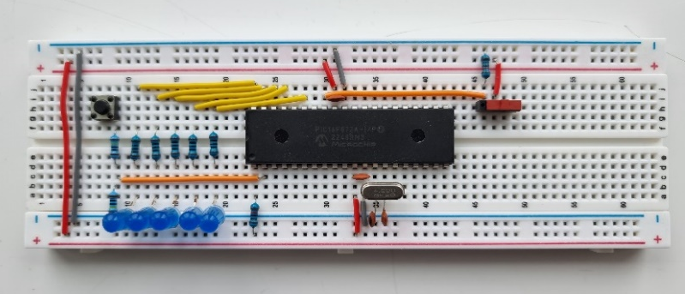
Figure 34 - Microcontroller Breadboard Circuitry
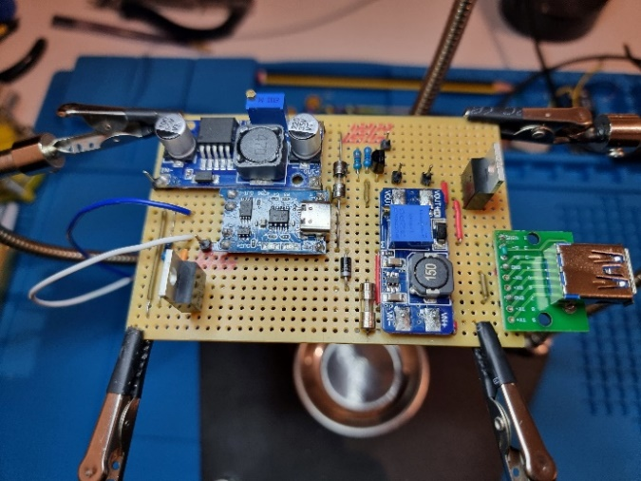
Figure 35 - Power Components Copper Stripboard Circuitry
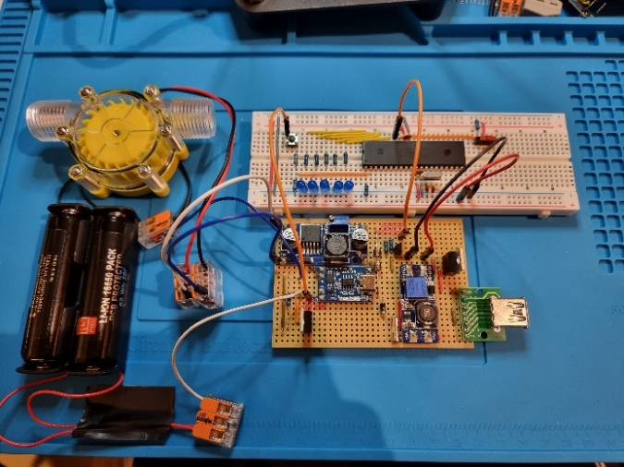
Figure 36 - Complete Circuit Including Batteries and Micro-Hydro Turbine

Evaluation and Conclusion
Overall, all objectives and evaluation criteria have been successfully achieved, leading to the fulfilment of the project's aim. The crossflow design micro-hydro turbine studied in the literature review is capable of converting water flow energy into useable electrical energy, however certain exceptions arose due to the chosen turbine not meeting the specifications set out by the manufacturer.
The system fulfils the requirements outlined in Appendix A: Product Design Specification and meets the project’s objectives through the following features:
Technical Performance:
- Testing with a DC power supply has demonstrated the circuit design's capability to charge Li-ion batteries via a turbine input ranging from 5.5VDC to 31.9VDC at an average efficiency of 65.88%. This satisfies the evaluation criterion of 60% efficiency, with the TP4056 IC as the limiting factor due to its nature as a linear regulator.
- The USB Type-A output port has been tested under battery power to maintain an output within the USB specification range of 4.75v to 5.25V [1]. Tested at 5V and 633mA continuously, satisfying the minimum threshold set at 500mA.
- The circuit complies with the USB Battery Charging Specification Revision 1.2 [1]. By shorting the D+ and D- data lines of the USB-A output port, it functions as a dedicated charging port (DCP), providing power to connected devices, without the need to negotiate power requirements, as is typical with USB data transfer ports.
- The chosen micro-hydro turbine has a ½” BSP thread, ensuring compatibility with household pipework.
User Interface:
- User control over the USB-A output is facilitated by a toggle switch operated by the microcontroller.
- The circuit incorporates visual battery capacity indication for the user’s benefit in the form of five LED lights marking each 20% voltage threshold, controlled via a microcontroller 10-bit ADC module.
Compliance and Safety:
- The prototype is portable with maximum product dimensions below 30 cubic centimetres.
- All work was carried out safely and in compliance with applicable standards. Test equipment complied with IEC 61010-1:2010, and lead-free solder was used to comply with the RoHS Directive.
Project Management:
- The project is under budget at £85.42, which is within £4 of the expected expenditure.
- The work was completed in a timely manner, in line with the Gantt chart targets.
The TP4056 Li-ion battery charging IC, selected based on the findings of the literature review, whereby two of the three examined papers employed the CC/CV module, performed as anticipated. It safely charged the 2600mAh batteries in parallel, reaching a charge voltage of 4.18V, with calculations estimating the charge time from 0% to 100% capacity, based on the turbine’s manufacturer-specified specifications of 12V and 150mA, resulting in a projected duration of 16.25 hours.
Minor challenges emerged during both the design phase (Section 5) and testing phase (Section 7) of the project. Though they were effectively resolved or mitigated, these issues could have been avoided with better attention to detail and more extensive research. Particularly the discrepancies encountered with the micro-hydro turbine, which failed to meet the manufacturer’s specifications, this could have been pre-emptively addressed with more comprehensive investigation.

Recommendations
There are certainly some improvements that could be undertaken to expand on this project. These are:
- With more time and resources, the prototype could be transitioned to a printed circuit board (PCB) and placed in a housing for better aesthetics and to make the design more compact.
- To enhance support for charging modes through the USB-A output port in compliance with the USB Battery Charging Specification Revision 1.2 [1], consider integrating the TPS2514 dedicated charging port controller [43] into the design. This IC facilitates automatic switching of D+ and D- data line connections to accommodate all the charging schemas.
- Considering the turbine's failure to meet manufacturer specifications, exploring alternative, better-suited turbine options is recommended. Investing in a higher-quality turbine that aligns closely with project requirements could ensure smoother system operation.

Reflection
Throughout this project, I've had the opportunity to apply and expand upon the skills and knowledge gained during my electrical and electronic engineering degree. While the project initially seemed daunting, particularly due to its predominately electronic nature, it ultimately provided a valuable learning experience. As an electrical and instrument technician at Eastman Chemical Company, my experience lies in electrical and instrumentation circuits, making the electronics aspects unfamiliar to me.
Despite the initial challenge, I embraced the opportunity to acquire new skills. Particularly in software development using the C programming language and programming microcontrollers, areas I hadn’t explored previously. This phase proved to be the most demanding aspect, requiring extensive learning both beforehand and during the process, along with overcoming the documented issues.
Balancing work and university studies during this busy period proved challenging, highlighting the importance of effective project planning and time management skills for success. While I am very pleased with the prototype’s outcome, given the chance to revisit the project, I would aim to enhance the circuit's functionality by utilising the spare I/O pins of the microcontroller for potential future expansions.
Overall, this experience has been immensely valuable, offering significant learning opportunities that will undoubtedly contribute to my career advancement.

Bibliography
A Beginners Guide to the Microchip PIC – Nigel Gardner
The Essential Guide to Power Supplies – XP Power
PIC C – An introduction to programming the Microchip PIC in C - Nigel Gardner
Practical Electronics: Components and Techniques - J. M. Hughes - Google Books

References
[1] R. Petrie, “USB Power Delivery Specification Revision 2.0, Version 1.3 Universal Serial Bus Power Delivery Specification.”
[2] J. A. Hameed, A. T. Saeed, and M. H. Rajab, “Design and analysis of hydroelectric generation using waterwheel,” in 2018 9th International Renewable Energy Congress (IREC), 2018, pp. 1–6. doi: 10.1109/IREC.2018.8362443.
[3] B. J. Lewis, J. M. Cimbala, and A. M. Wouden, “Major historical developments in the design of water wheels and Francis hydroturbines,” in IOP Conference Series: Earth and Environmental Science, Institute of Physics Publishing, 2014. doi: 10.1088/1755-1315/22/1/012020.
[4] “Waterwheel Design and the Different Types of Waterwheel.” Accessed: Jan. 05, 2024. [Online]. Available: https://www.alternative-energy-tutorials.com/hydro-energy/waterwheel-design.html
[5] P. Widiyanto, P. Irasari, and M. F. Hikmawan, “Suitability Analysis of Cross-Flow Turbine and Synchronous Generator Characteristics for Very Low Head Hydro Power Application,” in 2019 International Conference on Sustainable Energy Engineering and Application (ICSEEA), 2019, pp. 42–47. doi: 10.1109/ICSEEA47812.2019.8938642.
[6] Y. Keawsuntia, “Electricity generation from micro hydro turbine: A case study of crossflow turbine,” in 2011 International Conference & Utility Exhibition on Power and Energy Systems: Issues and Prospects for Asia (ICUE), 2011, pp. 1–4. doi: 10.1109/ICUEPES.2011.6497731.
[7] “Micro Hydro Generator, F50 0-80V.” Accessed: Dec. 29, 2023. [Online]. Available: https://www.amazon.co.uk/dp/B09958LLP4?ref=ppx_yo2ov_dt_b_product_details&th=1
[8] E. McCambridge, “Micro-hydro generation | Department of Agriculture, Environment and Rural Affairs.” Accessed: Feb. 09, 2024. [Online]. Available: https://www.daera-ni.gov.uk/articles/micro-hydro-generation
[9] “SBQ Outdoor Generators, 400V 5000W micro hydro generator turbine .” Accessed: Feb. 09, 2024. [Online]. Available: https://www.amazon.co.uk/SBQ-Outdoor-Generators-generator-three-phase/dp/B09TXMGDVZ/ref=sr_1_3?keywords=micro+hydro+turbine&qid=1706713606&sr=8-3
[10] S. Settar, Eng. S. Keream, K. Mohammed, and M. Sahib, “Analysis Study In Principles Of Operation Of DC Machine,” Journal of Advanced Research in Dynamical and Control Systems, vol. 10, pp. 2323–2329, Oct. 2018.
[11] A. Bhatia, Direct Current Generators: Quick Book. CreateSpace Independent Publishing Platform, 2015. [Online]. Available: https://books.google.co.uk/books?id=qKcqrgEACAAJ
[12] N. K. Raghavendra and K. Padmavathi, “Solar Charge Controller for Lithium-Ion Battery,” in 2018 IEEE International Conference on Power Electronics, Drives and Energy Systems (PEDES), 2018, pp. 1–5. doi: 10.1109/PEDES.2018.8707743.
[13] T. Blythman, “Practical Electronics,” Practical Electronics , pp. 24–25, Oct. 2023.
[14] D. A. Arrohman and N. A. Fikriyyah, “Implementation of Micro Usb Charger TP4056 and Battery Indicator LED in Portable Solar Charge,” Journal of Natural Sciences and Mathematics Research, vol. 4, no. 1, pp. 6–10, Jun. 2018, doi: 10.21580/JNSMR.2018.4.1.10956.
[15] S. Maniktala, Switching Power Supplies A - Z. Elsevier Science, 2012. [Online]. Available: https://books.google.co.uk/books?id=zMVTv6py7woC
[16] Gary Bocock, The Essential Guide to Power Supplies, Issue 1. XP Power, 2014.
[17] “LM2596 SIMPLE SWITCHER ® Power Converter 150-kHz 3-A Step-Down Voltage Regulator,” 2023, Accessed: Dec. 30, 2023. [Online]. Available: www.ti.com
[18] “Datasheet 0.8A 150KHz 80V Buck DC to DC Converter XL7015”, Accessed: Dec. 30, 2023. [Online]. Available: www.xlsemi.com
[19] “LMR51430 SIMPLE SWITCHER® Power Converter 4.5-V to 36-V, 3-A, Synchronous Buck Converter,” 2022, Accessed: Dec. 30, 2023. [Online]. Available: www.ti.com
[20] “LM2675 SIMPLE SWITCHER ® Power Converter High Efficiency 1-A Step-Down Voltage Regulator Typical Application,” 2016, Accessed: Jan. 04, 2024. [Online]. Available: www.ti.com
[21] “LM1577/LM2577 SIMPLE SWITCHER ® Step-Up Voltage Regulator Check for Samples: LM1577, LM2577,” 1999, Accessed: Dec. 30, 2023. [Online]. Available: https://www.ti.com/lit/ds/symlink/lm2577.pdf?ts=1703910524967
[22] “MT3608 High Efficiency 1.2MHz 2A Step Up Converter”, Accessed: Dec. 30, 2023. [Online]. Available: https://www.olimex.com/Products/Breadboarding/BB-PWR-3608/resources/MT3608.pdf
[23] “TPS6120x Low Input Voltage Synchronous Boost Converter”, Accessed: Dec. 30, 2023. [Online]. Available: https://www.ti.com/lit/ds/symlink/tps61200.pdf
[24] L. Technology Corporation, “LT1308 - Single Cell High Current Micropower 600kHz Boost DC/DC Converter,” 1998, Accessed: Jan. 04, 2024. [Online]. Available: https://www.analog.com/media/en/technical-documentation/data-sheets/1308i.pdf
[25] J. Arthur, M. Waring, R. Coe, and L. V Hedges, Research Methods and Methodologies in Education. SAGE Publications, 2012. [Online]. Available: https://books.google.co.uk/books?id=oaFE0nBzR_sC
[26] K. Wills, Essential Project Management Skills. CRC Press LLC, 2018. [Online]. Available: https://books.google.co.uk/books?id=MWgywQEACAAJ
[27] M. Clayton, How to Manage a Great Project: On budget. On target. On time. Pearson Education, 2014. [Online]. Available: https://books.google.co.uk/books?id=qcC7AgAAQBAJ
[28] “The Water Supply (Water Fittings) Regulations.” [Online]. Available: http://www.dwrcymru.com/en/My-Water/Water-
[29] “DC Micro-hydro Generator.” Accessed: Dec. 29, 2023. [Online]. Available: https://www.amazon.co.uk/Micro-hydro-Generator-Hydroelectric-Efficiency-intelligent/dp/B0836R8LB1
[30] “Micro-hydro Generator, F50 12V .” Accessed: Dec. 29, 2023. [Online]. Available: https://www.amazon.co.uk/Micro-hydro-Water-Flow-Pump-Hydroelectric/dp/B08D6Q2532
[31] P. Horowitz and W. Hill, The Art of Electronics. Cambridge University Press, 2015. [Online]. Available: https://books.google.co.uk/books?id=LAiWPwAACAAJ
[32] “Ansmann AA NiMH Rechargeable AA Batteries, 2.85Ah, 1.2V .” Accessed: Mar. 21, 2024. [Online]. Available: https://docs.rs-online.com/8d0d/0900766b81666e7a.pdf
[33] “RS PRO, 3.7V, 18650, Lithium-Ion Rechargeable Battery, 2.6Ah.” Accessed: Mar. 21, 2024. [Online]. Available: https://docs.rs-online.com/9c01/A700000008874176.pdf
[34] “Ansmann 200mAh NiMH 9V Rechargeable Battery.” Accessed: Mar. 21, 2024. [Online]. Available: https://docs.rs-online.com/d1c6/0900766b80d491d3.pdf
[35] “RS PRO NiMH Rechargeable C Batteries, 4Ah.” Accessed: Mar. 21, 2024. [Online]. Available: https://docs.rs-online.com/e01b/0900766b81580c55.pdf
[36] “Speciality Size Rechargeable Batteries RS PRO, 3.7V, 18650, Lithium-Ion Rechargeable Battery, 2.6Ah”, Accessed: Mar. 10, 2024. [Online]. Available: https://uk.rs-online.com/
[37] “NanJing Top Power ASIC Corp. TP4056 1A Standalone Linear Li-lon Battery Charger with Thermal Regulation in SOP-8 DESCRIPTION”, Accessed: Jan. 18, 2024. [Online]. Available: https://dlnmh9ip6v2uc.cloudfront.net/datasheets/Prototyping/TP4056.pdf
[38] “Lithum Battery Charger with Protection TP4056 - MicroUSB [5163] : Sunrom Electronics.” Accessed: Mar. 14, 2024. [Online]. Available: https://www.sunrom.com/p/lithum-battery-charger-with-protection-microusb
[39] “IRF4905PbF HEXFET ® Power MOSFET.” Accessed: Feb. 22, 2024. [Online]. Available: https://www.infineon.com/dgdl/Infineon-IRF4905-DataSheet-v01_01-EN.pdf?fileId=5546d462533600a4015355e329b1197e
[40] “1N5819 Schottky Diode.” Accessed: Feb. 22, 2024. [Online]. Available: https://www.mouser.co.uk/datasheet/2/389/1n5817-1848842.pdf
[41] “PICkitTM 3 Programmer/Debugger User’s Guide,” 2010, Accessed: Apr. 07, 2024. [Online]. Available: https://ww1.microchip.com/downloads/en/DeviceDoc/51795B.pdf
[42] “The complete guide to water pressure.” Accessed: Mar. 14, 2024. [Online]. Available: https://www.plumbnation.co.uk/blog/the-complete-guide-to-water-pressure
[43] “TPS251xx USB Dedicated Charging Port Controller,” 2013, Accessed: Apr. 14, 2024. [Online]. Available: www.ti.com
[44] “Battery Charging Specification Revision 1.2,” Mar. 2012.

Appendices

Appendix A: Product Design Specification
Design Brief
The goal of this project is to design and develop an independent micro-hydro turbine circuit capable of converting underutilised water flow into electrical energy. The resulting product will store the energy via a portable battery and use it to power small electrical devices, such as LED lights
Design Requirements
Power Output
- The hydro turbine must generate a voltage greater than 5V to charge the battery system.
- Maintain a stable power output within the USB specification range of 4.75V to 5.25V from the battery circuit to power both the microcontroller and external device via USB, even under varying water flow conditions.
- Ensure the USB Type-A port supports a minimum current delivery of 500mA at 5V, in compliance with USB 2.0 standards. Ideally, aim for an increased current output of up to 900mA at 5V, aligning with USB 3.0 specifications.
- The battery must have a minimum capacity of 1000mAh.
Dimensions
- The product’s maximum dimensions should not exceed 30cm x 30cm x 30cm.
Cost
- The total cost should not exceed £100, inclusive of all materials and components.
Safety Compliance
- The product design must comply with IEC 61010-1:2010 – Safety requirements for electrical equipment for measurement, control and laboratory use.
- Lead free solder must be used to construct the circuit in order to comply with RoHS (Restriction of Hazardous Substances Directive), in particular IPC J-STD-006 which provides the requirements for soldering materials.
- The project must adhere to ‘The Waste Electrical and Electronic Equipment Regulations 2013,’ to reduce the amount of waste electrical and electronic equipment (WEEE) incinerated or sent to landfill sites.
- If any component within the device has the capability to generate more than 50 volts, in accordance with of IEC 61010-1:2010, the implementation of overvoltage protection is mandatory to ensure safety.
Compatibility and Integration
- Adhere to the USB Battery Charging Specification Revision 1.2, which mandates the shorting up to a maximum of 200Ω series impedance of the D+ and D- data lines in the USB connector for DCP implementation [44].
- Ensure the finished product interfaces seamlessly with household pipework, using standardised ½” or ¾” fittings for compatibility and functionality.
- Utilise a microcontroller to facilitate integration of hardware and software via programming.
- The final design should incorporate clear visual indication to inform users about the system’s status, distinguishing between a low battery condition or active power generation.
- The turbine must withstand pressures ranging from a minimum of 1bar at a flow rate of 9 L/min [28] to a maximum of 5.5bar.
Materials and Construction
- The micro-hydro turbine must be constructed of a corrosion-resistant material, such as plastic, to ensure longevity and durability in water systems.

Appendix B: Gantt Chart
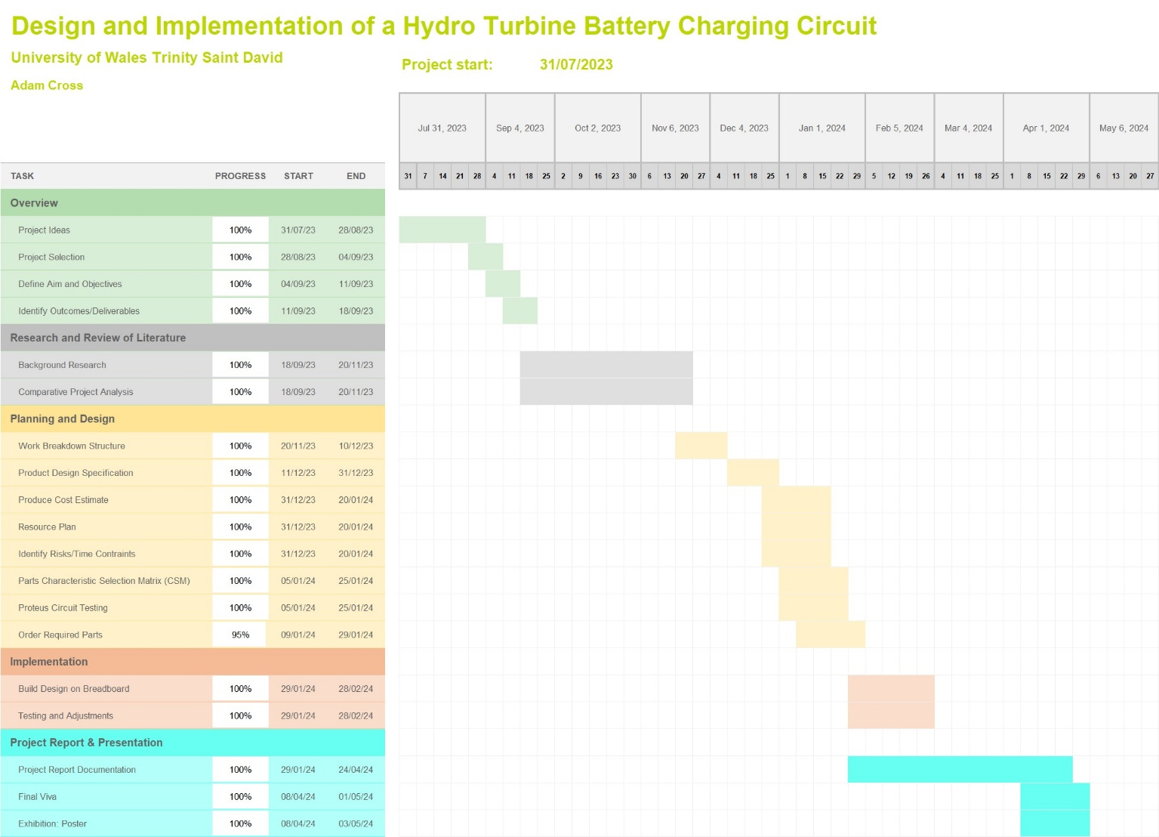
Figure 37 - Project Gantt Chart

Appendix C: Project Pictures
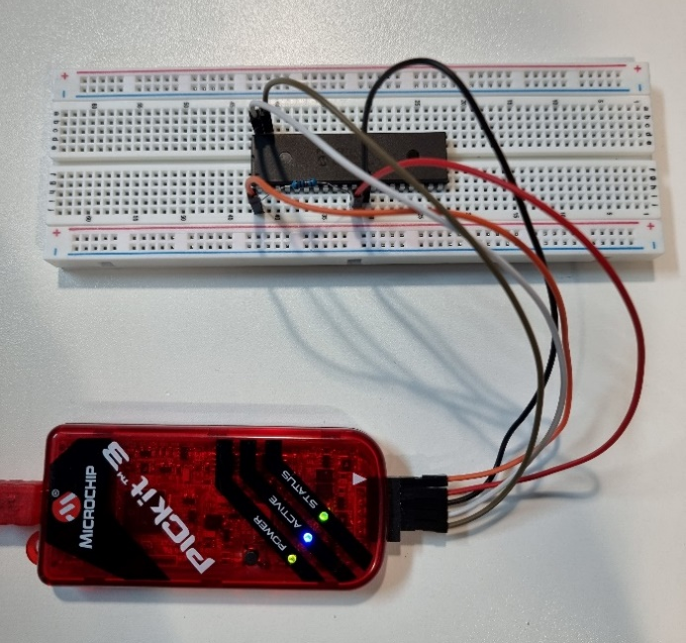
Figure 38 - Using PICkit 3 to Program Microcontroller
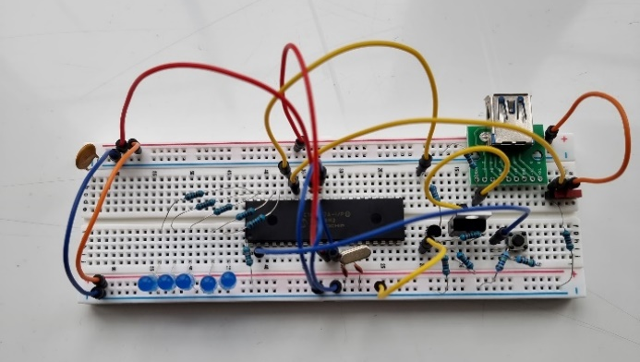
Figure 39 - Temporary Circuit to Test Functionality
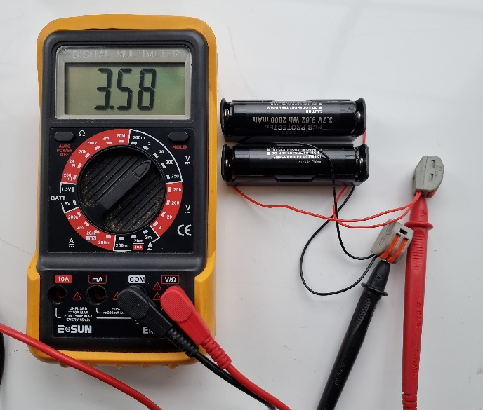
Figure 40 - Testing Battery Voltage
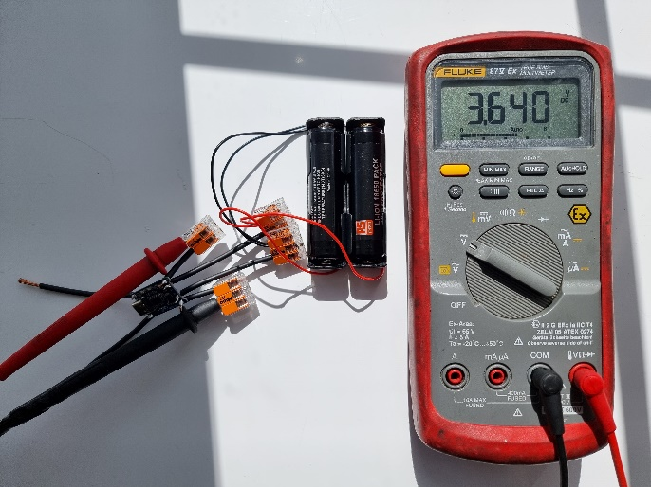
Figure 41 - Battery Connected to TP4056 - Measuring Board Output
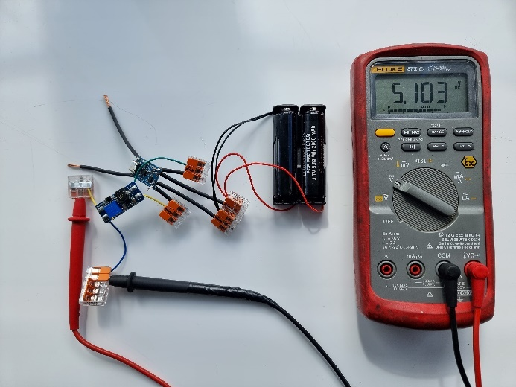
Figure 42 - Setting Output Voltage of MT3608 Boost Converter

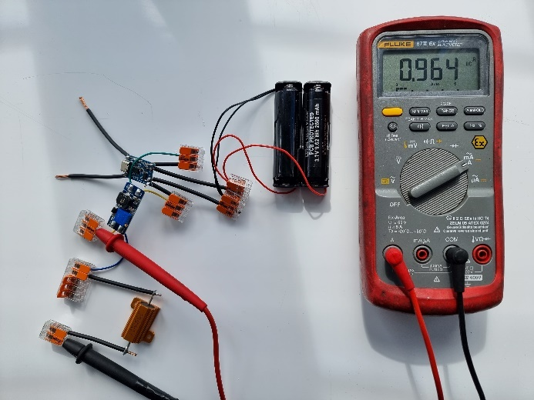
Figure 43 - Measuring Current Output of MT3608 Boost Converter
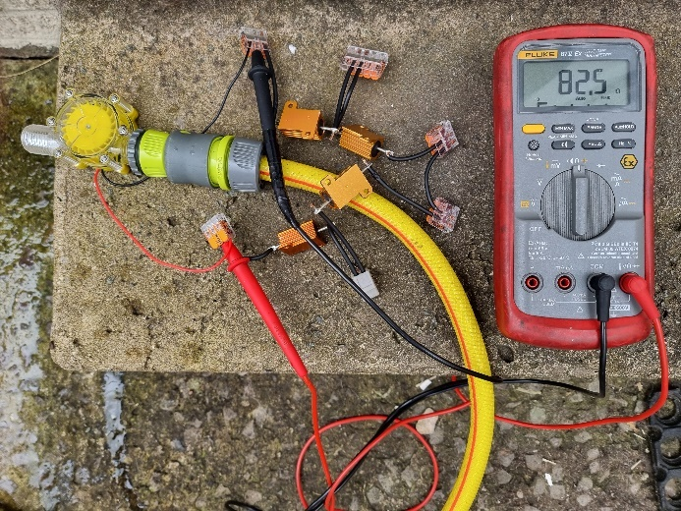
Figure 44 - Turbine Testing - 82.5Ω Load Resistance
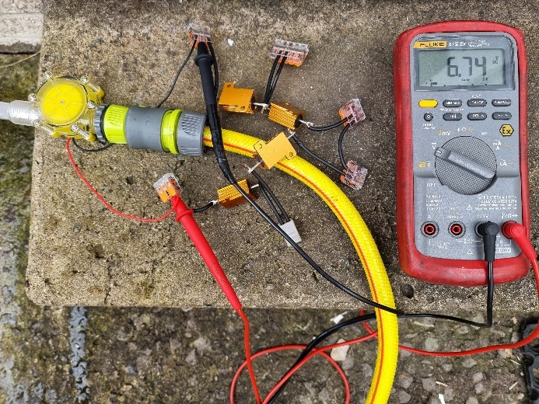
Figure 45 - Turbine Testing - Voltage Output 82.5Ω Load

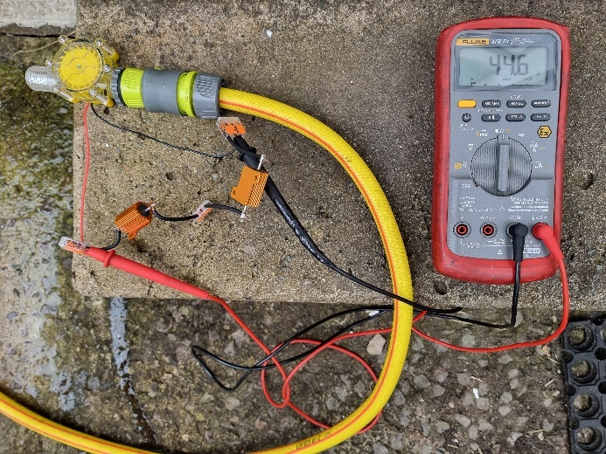
Figure 46 - Turbine Testing – 44.6Ω Load Resistance
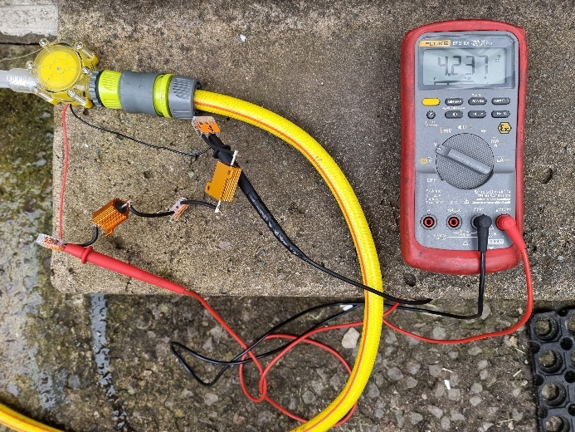
Figure 47 - Turbine Testing – Voltage Output 44.6Ω Load
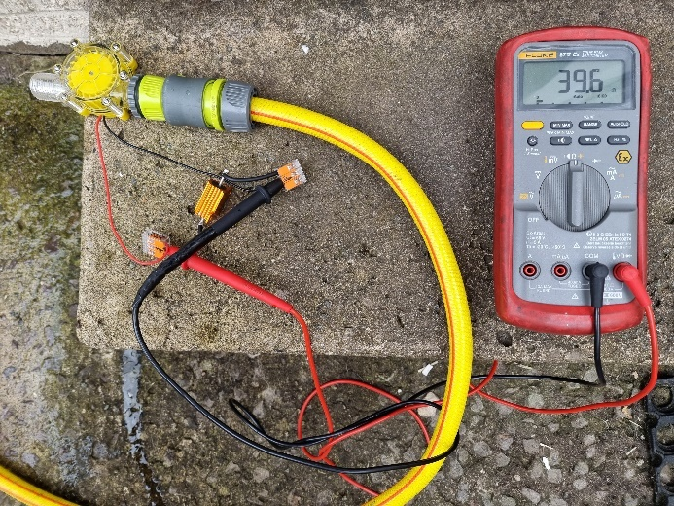
Figure 48 - Turbine Testing – 39.6Ω Load Resistance

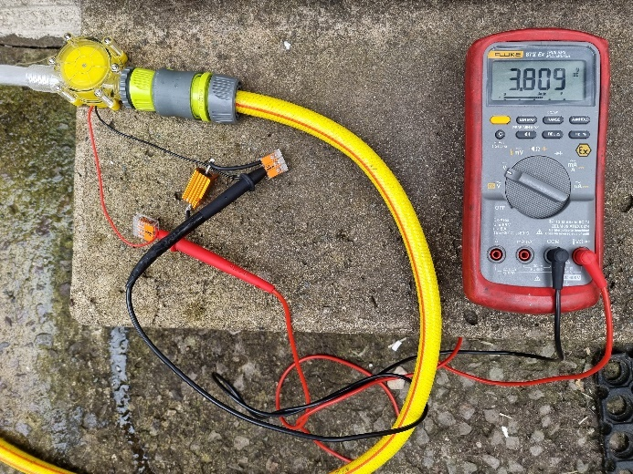
Figure 49 - Turbine Testing – Voltage Output 39.6Ω Load
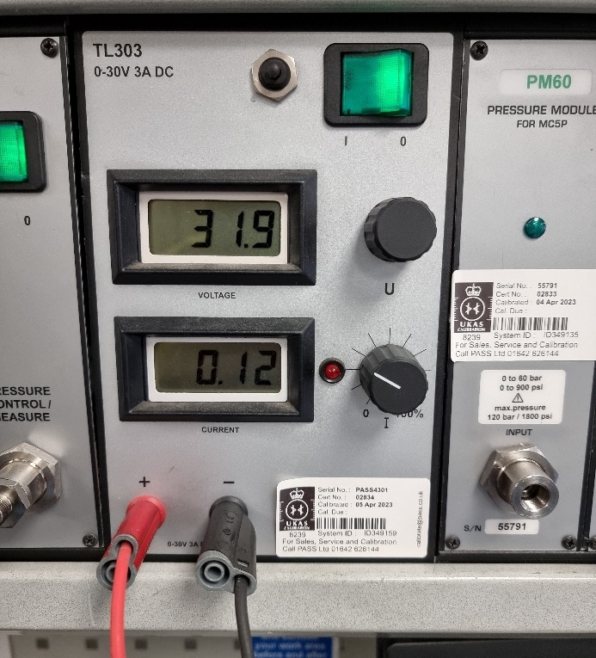
Figure 50 - Beamex DC Power Supply
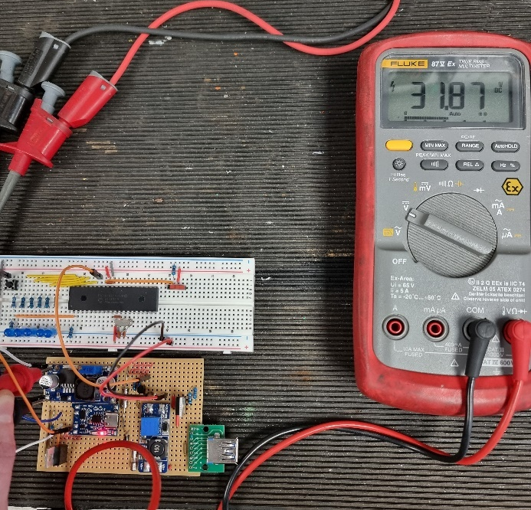
Figure 51 - Testing Supply Voltage to Circuit
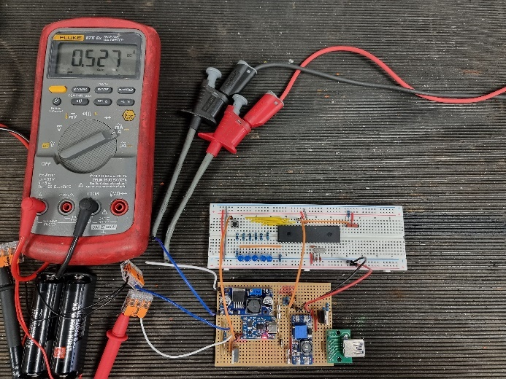
Figure 52 - Testing Battery Charge Current
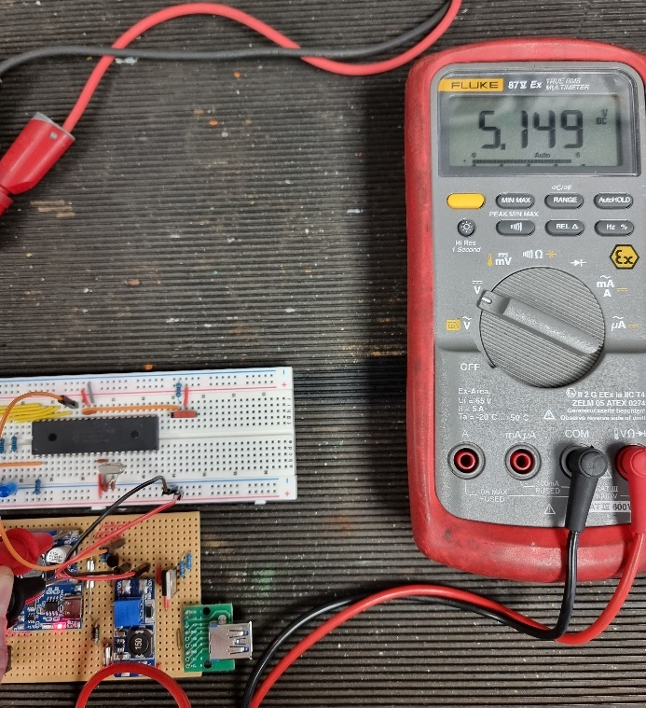
Figure 53 - LM2596 Buck Converter Output Voltage
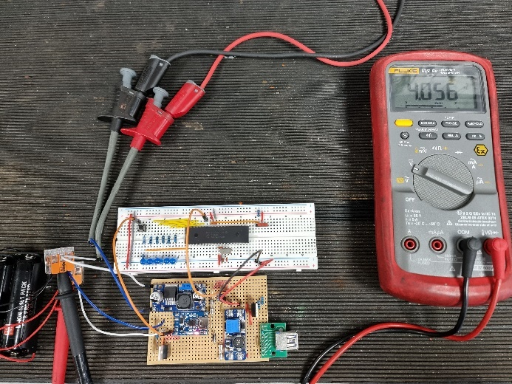
Figure 54 - Battery Voltage During Charging Process
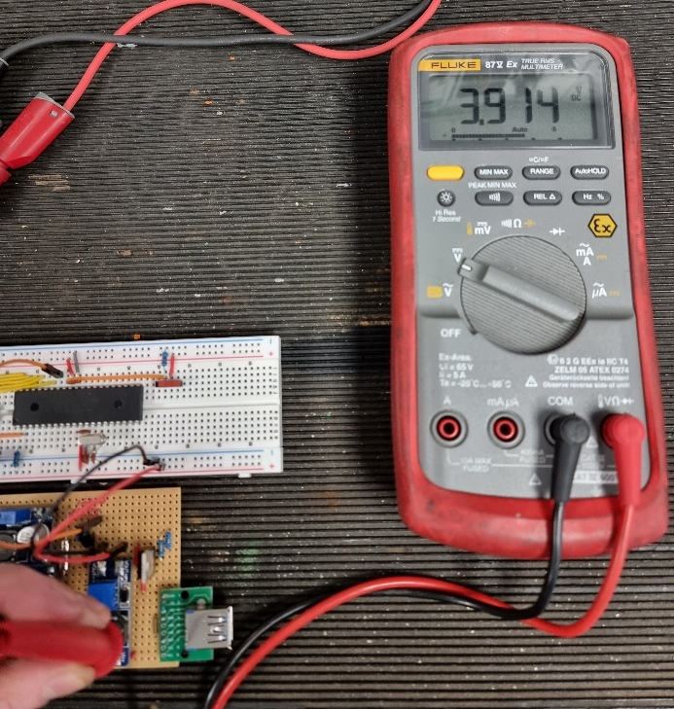
Figure 55 - Voltage Input MT3608 Boost Converter
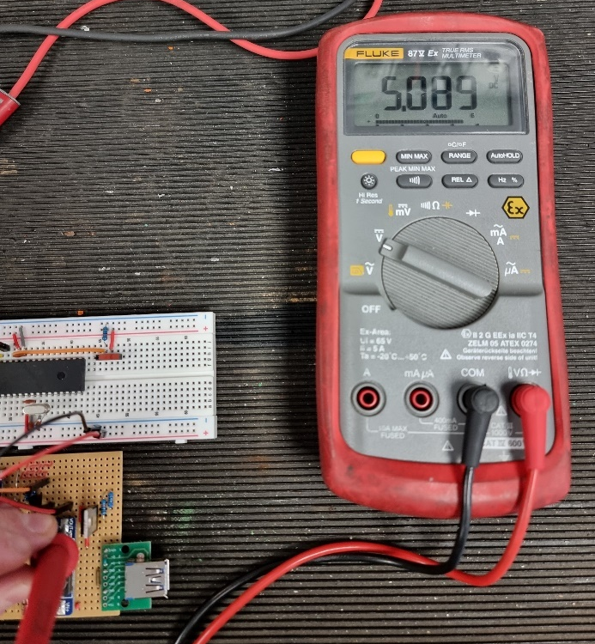
Figure 56 - Voltage Output MT3608 Boost Converter
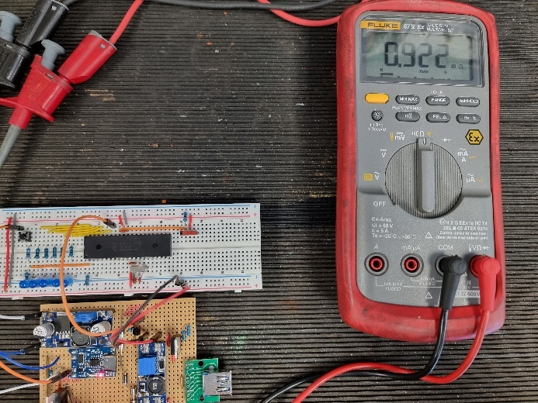
Figure 57 - Drain-Source Resistance of Load Sharing MOSFET During Charging Process
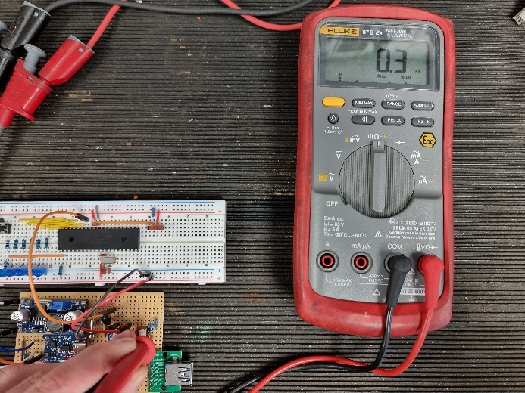
Figure 58 - Drain-Source Resistance of USB Output Port MOSFET When Turned On

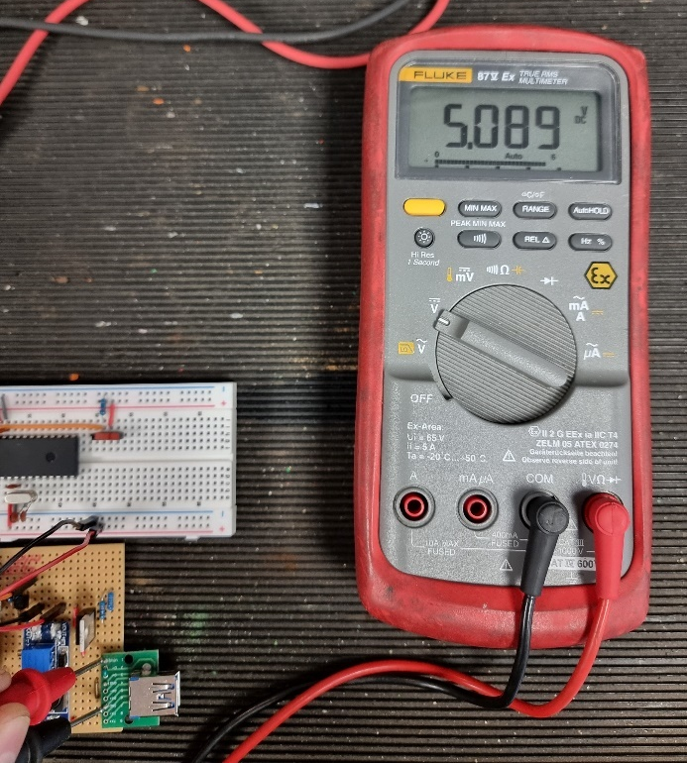
Figure 59 - USB-A Port Voltage Output
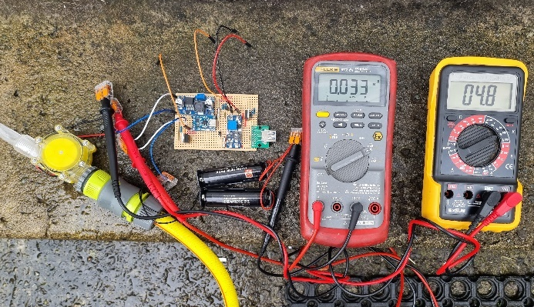
Figure 60 - Testing of Circuit with Turbine Connected (50% flow rate)
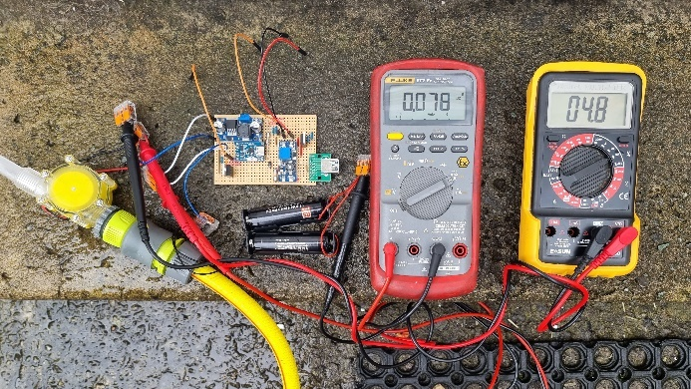
Figure 61 - Testing of Circuit with Turbine Connected (100% flow rate)

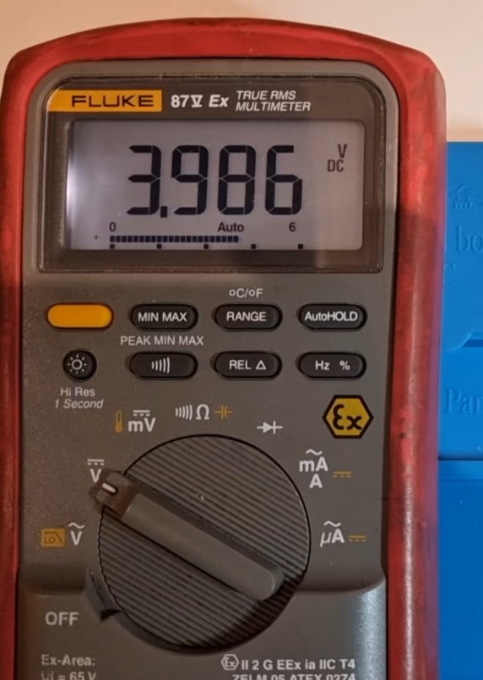
Figure 62 - Battery Voltage Test (79% Charged)
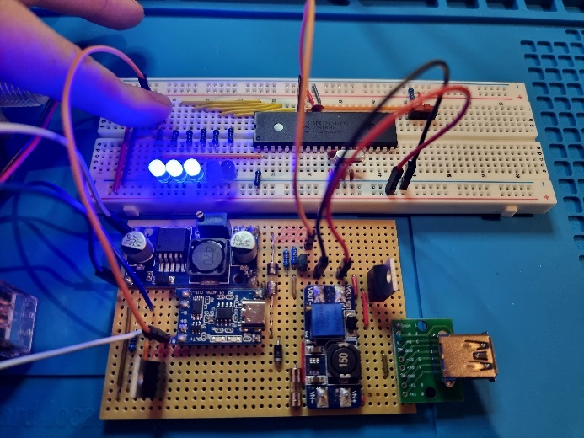
Figure 63 - Battery Capacity LED Indication (3 LEDs with 4th Flashing Intermittently)
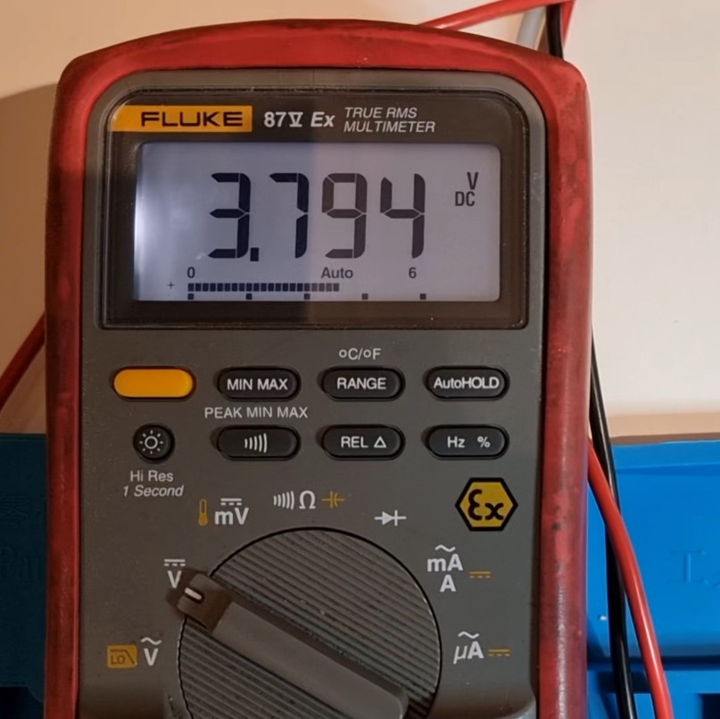
Figure 64 - Battery Voltage Test (59% Charged)
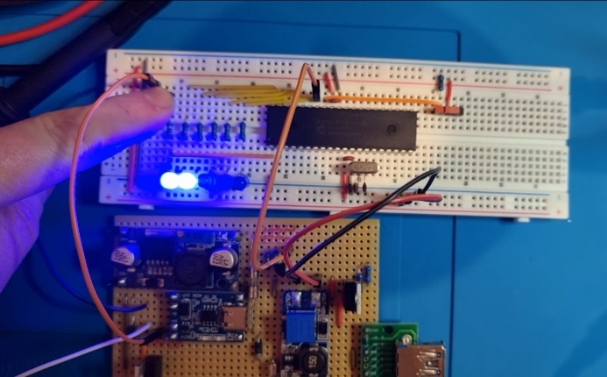
Figure 65 - Battery Capacity LED Indication (2 LEDs with 3rd Flashing Intermittently)
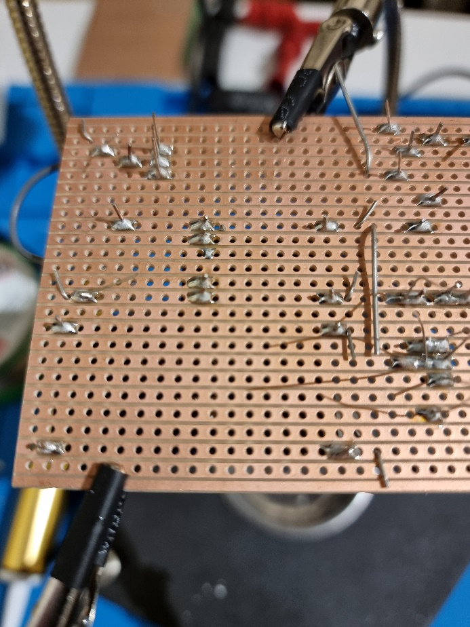
Figure 66 - Soldering Copper Stripboard
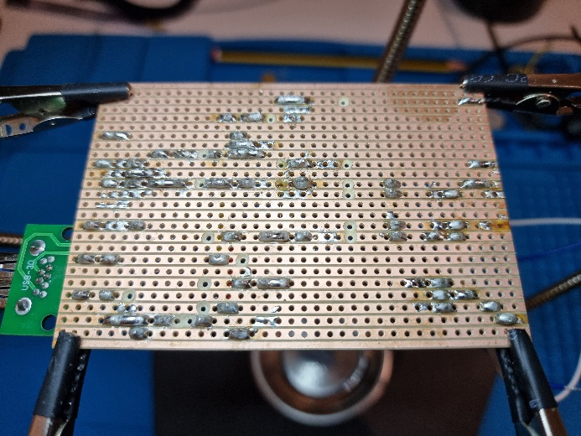
Figure 67 - Copper Stripboard Soldering and Track Cutting

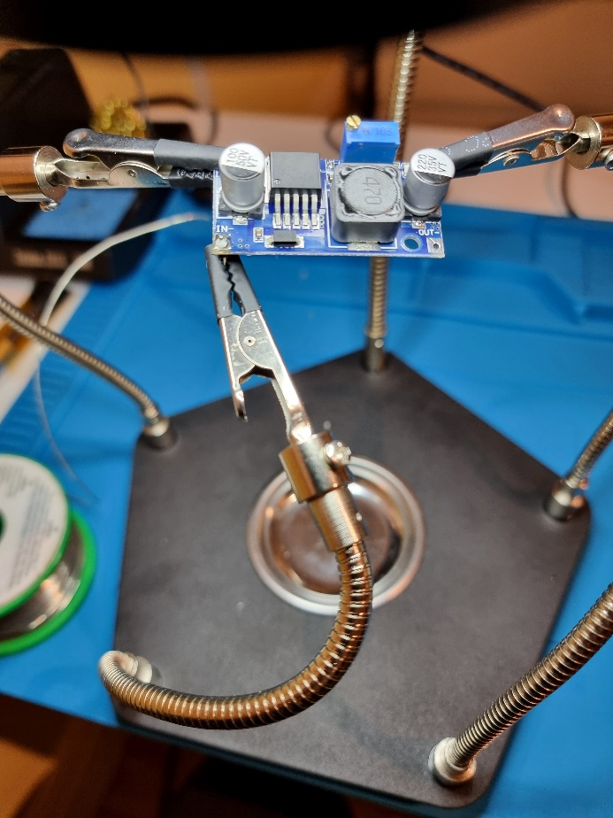
Figure 68 - Soldering Pins to External Modules

Appendix D: Software Code
// PIC16F877A Configuration Bit Settings

// 'C' source line config statements
#include <xc.h>
#include <pic16f877a.h>
#define _XTAL_FREQ 4000000

// Function prototypes
void initializeADC();
unsigned int readADC();
void controlOutputs();

// Configuration settings
#pragma config FOSC = XT // Oscillator Selection bits (XT oscillator)
#pragma config WDTE = OFF // Watchdog Timer Enable bit (WDT disabled)
#pragma config PWRTE = OFF // Power-up Timer Enable bit (PWRT disabled)
#pragma config BOREN = OFF // Brown-out Reset Enable bit (BOR disabled)
#pragma config LVP = ON // Low-Voltage (Single-Supply) In-Circuit Serial Programming Enable bit (RB3/PGM pin has PGM function; low-voltage programming enabled)
#pragma config CPD = OFF // Data EEPROM Memory Code Protection bit (Data EEPROM code protection off)
#pragma config WRT = OFF // Flash Program Memory Write Enable bits (Write protection off; all program memory may be written to by EECON control)
#pragma config CP = OFF // Flash Program Memory Code Protection bit (Code protection off)

void initializeADC()
{
// Configuring ADC
ADCON0 = 0b01000001; // Selecting ADC channel 0, ADC ON
ADCON1 = 0b10000000; // Using VCC and VSS as voltage reference
}
unsigned int readADC()
{
GO_nDONE = 1; // Start ADC conversion
while (GO_nDONE); // Wait for conversion to finish
return ((ADRESH << 8) + ADRESL); // Combine the high and low register values
}
void controlOutputs() {
unsigned int adcValue = readADC();

// Define multiple thresholds for LED levels
unsigned int threshold1 = (unsigned int)((1.58 / 5.0) * 1023); // 0% charge
unsigned int threshold2 = (unsigned int)((1.68 / 5.0) * 1023); // 20% charge
unsigned int threshold3 = (unsigned int)((1.78 / 5.0) * 1023); // 40% charge
unsigned int threshold4 = (unsigned int)((1.88 / 5.0) * 1023); // 60% charge
unsigned int threshold5 = (unsigned int)((1.98 / 5.0) * 1023); // 80% charge
unsigned int threshold6 = (unsigned int)((2.08 / 5.0) * 1023); // 100% charge

// Determine which LED to light up based on the voltage level
if (adcValue >= threshold6) {
RB2 = RB4 = RB5 = RB6 = RB7 = 1; // Turn on RB2, RB4, RB5, RB6, and RB7
} else if (adcValue > threshold5 && adcValue < threshold6) {
RB4 = RB5 = RB6 = RB7 = 1; // Turn on RB4, RB5, RB6, and RB7
// Flash RB2 intermittently
RB2 = 1; // Turn on RB2
__delay_ms(500); // Delay for 0.5 seconds
RB2 = 0; // Turn off RB2
__delay_ms(500); // Delay for 0.5 seconds
} else if (adcValue > threshold4 && adcValue < threshold5) {
RB5 = RB6 = RB7 = 1; // Turn on RB5, RB6, and RB7
// Flash RB4 intermittently
RB4 = 1; // Turn on RB4
__delay_ms(500); // Delay for 0.5 seconds
RB4 = 0; // Turn off RB4
__delay_ms(500); // Delay for 0.5 seconds
} else if (adcValue > threshold3 && adcValue < threshold4) {
RB6 = RB7 = 1; // Turn on RB6 and RB7
// Flash RB5 intermittently
RB5 = 1; // Turn on RB5
__delay_ms(500); // Delay for 0.5 seconds
RB5 = 0; // Turn off RB5
__delay_ms(500); // Delay for 0.5 seconds
} else if (adcValue > threshold2 && adcValue < threshold3) {
RB7 = 1; // Turn on RB7
// Flash RB6 intermittently
RB6 = 1; // Turn on RB6
__delay_ms(500); // Delay for 0.5 seconds
RB6 = 0; // Turn off RB6
__delay_ms(500); // Delay for 0.5 seconds
} else if (adcValue > threshold1 && adcValue < threshold2) {
// Flash RB7 intermittently
RB7 = 1; // Turn on RB7
__delay_ms(500); // Delay for 0.5 seconds
RB7 = 0; // Turn off RB7
__delay_ms(500); // Delay for 0.5 seconds
} else if (adcValue < threshold1) {
RB2 = RB4 = RB5 = RB6 = RB7 = 0; // Turn off all LEDs
}
}
void main() {
// Initialisation code
initializeADC();

// Configure pins
TRISB0 = 1;
TRISB1 = 0;
TRISB2 = 0;
TRISB4 = 0;
TRISB5 = 0;
TRISB6 = 0;
TRISB7 = 0;

TRISA = 0b00000001; // Set RA0 as an input, and the rest of the pins in PORTA as outputs
PORTA = 0b00000000; // Set all pins in PORTA to logic low
TRISC = 0b00000000; // Set all pins in PORTC as outputs
PORTC = 0b00000000; // Set all pins in PORTC to logic low
TRISD = 0b00000000; // Set all pins in PORTD as outputs
PORTD = 0b00000000; // Set all pins in PORTD to logic low
TRISE = 0b00000000; // Set all pins in PORTE as outputs
PORTE = 0b00000000; // Set all pins in PORTE to logic low

while (1)
{
controlOutputs();

// Check the state of RB0
if(PORTBbits.RB0 == 1) {
// Set RB1 high to turn on USB output
PORTBbits.RB1 = 1;
} else {
// Set RB1 low to turn off USB output
PORTBbits.RB1 = 0;
}
}
return;
}

