  Component One: Student Journal (learning log) 750 words +/- 10%  Contribution to Overall Module Assessment: 25% | Student  No: | Oana-Andreea Puscuta  2232738
 | Module Title: | Hotel Placement – Operating Hotel Facilities
 | Module Code: | BMIH4006
 | Lecturer: | Natalie Brailsford,Dan Payne,Lisa Bassler, GiuliaChifari, Ben Chong, Scott James
Gibbs's reflective model is a prolific tool to evaluate the experience as it provides proper guidance in terms of writing reflection while minimizing difficulties of evaluation and analysis (Aneeis Hashim et al., 2023). Therefore, with the fruitful implementation of the Gibbs reflective model, I will evaluate my placement experience at Hilton Garden Inn Doncaster. This approach will aid me to enhance my skills further by shedding light on my experience to explore how competent I am to work as a hotel staff.

Description
Housekeeping staff is the support system of the hotel as it delivers multiple tasks along with the cleanliness of the hotel it also manages the inventory, keeps up the accommodation, and performs all the valuable chores to satisfy the customer (Bhatnagar and Dheeraj, 2019). I have a placement as a member of staff at the Hilton Garden Inn Doncaster and currently I have completed my job in the food and beverage department. Now as part of job rotation I will be performing task at front desk and after that I will be doing housekeeping tasks. The overall experience is worth it as I have learned many things and most importantly the staff at the hotel is calm and patient along with the pleasant work environment.
Feeling
Lack of motivation contributes to low morale which impacts the productivity of the staff (Clarke, et al., 2018). However, I received motivation from my manager and ample support from my colleague but still there were times when my productivity ratio was not appropriate. I was satisfied with my job but the unusual events that often happen related to guest queries and complaints affected my feelings. My coworkers used to help me whenever I felt low and was not able to complete my tasks. Whenever any guest or my manager used to appreciate my work then I used to feel energetic and those days my work used to be admirable.

Evaluation
Being the food and beverage staff, I explored myself in terms of evaluating my abilities as an employee of such a competitive business. I noticed that I was good enough to communicate efficiently with the guests. Along with this, I have multitasking skills which were really useful for my job, and it shows that I can manage my time effectively. Multitasking enhance the skills to cope with the changing environment (Lee and Taatgen, 2019). However, I was not able to deal with the problems progressively and I figured out that I have to improve my problem-solving skills. However, problem-solving skills could be improved through playing video games (Dindar, 2018).
Analysis
Problem-solving skills are the ability to understand the environment and the issues related to it in regard to solving it with effective outcomes (Fissore et al., 2021). However, problem-solving skills are a vital factor in building customer satisfaction along with other elements. Guest satisfaction could be achieved through good quality rooms and effective employee interaction (Padma and Ahn, 2020). Therefore, the fruitful solutions or strategies provided to the guest's problem create a positive impact on the guest regarding the staff member and hotel as well. Therefore, I must improve my problem-solving skills in regard to service with better solutions in such situations with could be seen as confusion or problem.
Conclusion
In a nutshell, up till now I had a positive experience related to my food and beverage staff member job as I was able to polish my skills and the environment taught me many new skills to be integrated as an employee. Individual’s personality is also the key factor which enhance the employee performance (Grobelna, 2019). Being part of the competitive business of the hospitality industry improved my ability to see the professional world with a broader lens. Furthermore, as the job mentor for the ethics of serving as a hotel employee, I also provided the chance to interact with individuals who belong to dissimilar cultural backgrounds. This enhanced my knowledge related to the cultural preferences of the different social backgrounds. Therefore, in regard to concluding I had an overwhelming experience as being the part of Hilton Garden Inn Doncaster hotel staff, however, there is always scoped to improve.
Action plan
Although I have served effectively as a hotel staff there are a few weaknesses that I should accommodate regarding performing prolifically. Therefore, the following are a few initiatives that I have to incorporate into my learning to improve my skills further.
- I have to research related to dissimilar cultures in regard to understanding the guest’s requirements.
- I need to attend workshops related to problem-solving skills.
- I have to effectively focus on small details to avoid misunderstandings.
- I can work on my time management skills further to perform tasks before time.

Component Two: Health and Safety Guide
Contribution to Overall Module Assessment: 25%

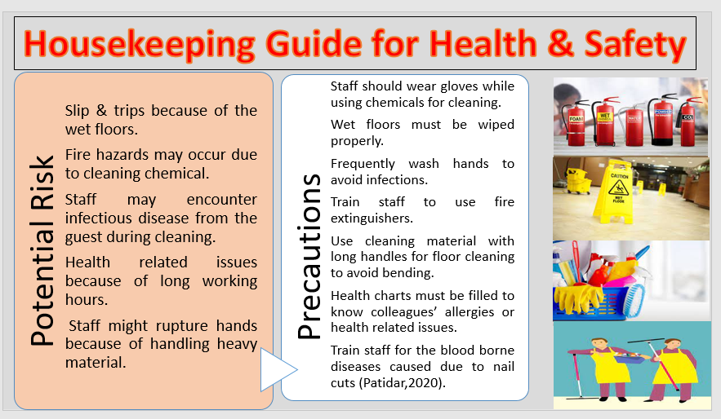
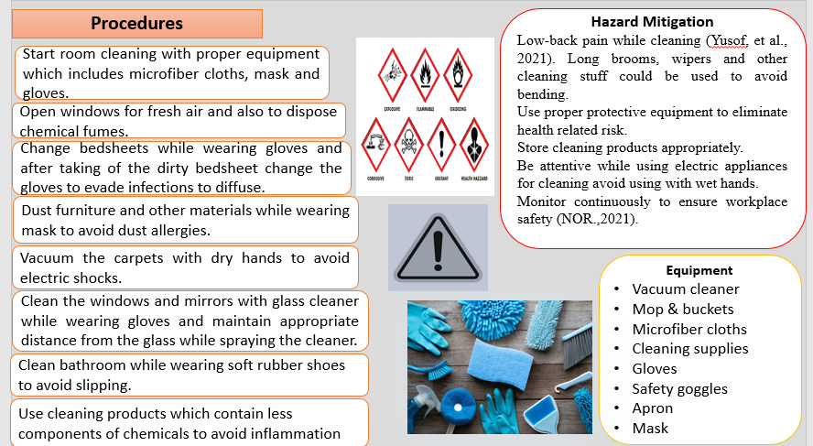

Reference List

Aneeis Hashim, S.N., Yaacob, A., Suryani, I., Mohd Asraf, R., Bahador, Z. and Supian, N. (2023). Exploring the Use of Gibbs’ Reflective Model in Enhancing In-Service ESL Teachers’ Reflective Writing. [online] Social Science Research Network. doi:https://doi.org/10.2139/ssrn.4497558.
Bhatnagar, E. and Dheeraj, N. (2019). Impact of Housekeeping Services and Practices on Customer Satisfaction and Repeat Business. Prabandhan: Indian Journal of Management, [online] 12(8), p.46. doi:https://doi.org/10.17010/pijom/2019/v12i8/146417.
Clarke, J., Robinson, O. and Mayo, C. (2018). Trouble in Hotel Paradise Housekeeping Department: A Case Study. 7(1), pp.34–41. doi:https://doi.org/10.1177/216499871800700104.
Dindar, M., 2018. An empirical study on gender, video game play, academic success and complex problem solving skills. Computers & Education, 125, pp.39-52.
Fissore, C., Marchisio, M., Roman, F. and Sacchet, M. (2021). Development of Problem Solving Skills with Maple in Higher Education. Communications in Computer and Information Science, pp.219–233. doi:https://doi.org/10.1007/978-3-030-81698-8_15.
Grobelna, A., 2019. Effects of individual and job characteristics on hotel contact employees’ work engagement and their performance outcomes: A case study from Poland. International journal of contemporary hospitality management, 31(1), pp.349-369.
Lee, F.J. and Taatgen, N.A., 2019, April. Multitasking as skill acquisition. In Proceedings of the twenty-fourth annual conference of the cognitive science society (pp. 572-577). Routledge.
NOR, S.D.F.B.M., 2021. A STUDY ON WORKPLACE HAZARDS AMONG BUILDING MAINTENANCE PERSONALS.
Padma, P. and Ahn, J., 2020. Guest satisfaction & dissatisfaction in luxury hotels: An application of big data. International Journal of Hospitality Management, 84, p.102318.
Patidar, D.D., Patidar, K. and Sikaligar, H.K., 2020. A Study to Assess the Effectiveness of Structured Teaching Programme on Knowledge regarding Blood Borne Disease and Universal Precaution among House keeping Staff in selected hospital of Mehsana District. International Journal of Advances in Nursing Management, 8(1), pp.89-92.
Yusof, M.F.M., Mohammad, R. and Ismail, S.H. (2021). Work-Related Low Back Pain Among Hotel Housekeeping Workers At Kuala Lumpur. Journal of Advanced Research in Applied Sciences and Engineering Technology, [online] 25(1), pp.80–93. doi:https://doi.org/10.37934/araset.25.1.8093.

