
Assignment 2:
Operating Systems
CertHE Computing Skills for Workplace

Computer Architecture and Operating Systems. ACCA4022_LON
DR. Redhwan Al-Amri (Lecturer)
University of Wales Trinity Saint David
(London Campus)
Student Name: Eduard Fabian Pasare
Student Number:2518439
Group: 02
Date: 23/03/2026
Task 1: Implementation Guide – MediLink Pharmacy Database
1. Scenario Analysis
The MediLink Pharmacy application requires some database of information that can be used to record Medicines, Suppliers, Customers, Prescriptions and Sales. The database for this application is shown below:
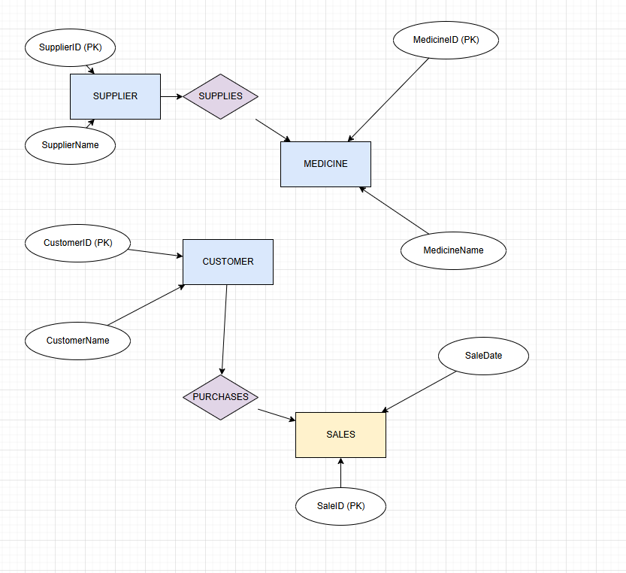
Entities and Attributes
1. Medicine
MedicineID (Primary Key)
MedicineName
Category
UnitPrice
StockQuantity
SupplierID (Foreign Key)
2. Supplier
SupplierID (Primary Key)
SupplierName
ContactNumber
Address
3. Customer
CustomerID (Primary Key)
CustomerName
Address
PhoneNumber
4. Prescription
PrescriptionID (Primary Key)
CustomerID (Foreign Key)
DateIssued
DoctorName
5. PrescriptionDetails (Bridge Entity)
PrescriptionDetailID (Primary Key)
PrescriptionID (Foreign Key)
MedicineID (Foreign Key)
Quantity
6. Sales
SaleID (Primary Key)
CustomerID (Foreign Key)
SaleDate
TotalAmount
7. SalesDetails (Bridge Entity)
SalesDetailID (Primary Key)
SaleID (Foreign Key)
MedicineID (Foreign Key)
Quantity
Price
Relationships
One Supplier supplies many Medicines (1:M)
One Customer has many Prescriptions (1:M)
One Prescription contains many Medicines (M:N resolved via PrescriptionDetails)
One Sale includes many Medicines (M:N resolved via SalesDetails)
One Customer makes many Sales (1:M)
7. Validation and Testing

The MediLink Pharmacy database system was tested against the required functionalities of managing medicines, suppliers, prescriptions, customers and sales transactions effectively and efficiently.

7.1 Testing Objectives
The purpose of testing was to:
Verify that all tables store data correctly
Ensure relationships enforce referential integrity
Confirm queries return accurate and meaningful results
Validate that the system prevents data entry errors
7.2 Testing Methods
1. Data Entry Testing
Sample records were entered into each table (Supplier, Medicine, Customer, Prescription, Sales).

Outcome:
All records were successfully stored
Required fields prevented null (empty) values
Data types (e.g., numbers, dates) were correctly enforced

2. Referential Integrity Testing
Relationships between tables were tested by entering and deleting related records.
Test Cases:
Attempted to add a Medicine with a non-existent SupplierID
Attempted to delete a Customer with existing Sales records

Outcome:
System rejected invalid foreign keys
Deletion was restricted when related records existed

3. Query Testing
All queries were executed to verify correct outputs.
Examples:
Low stock query returned only medicines below threshold
Sales summary query correctly calculated totals
Customer history query displayed accurate transaction records
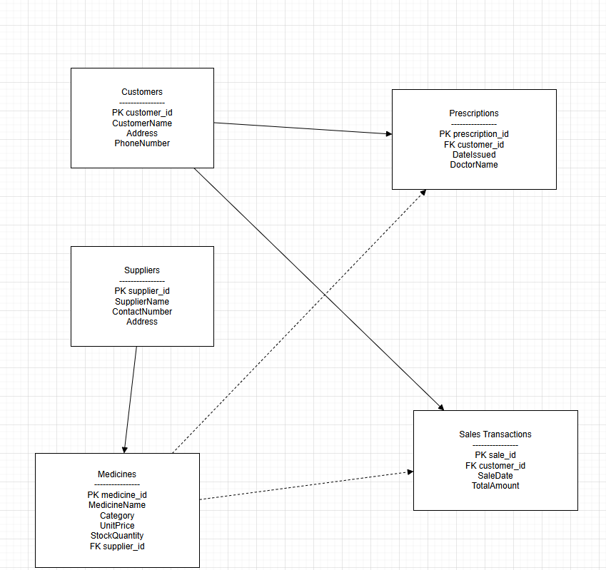

Outcome:
Queries produced accurate and expected results
No errors or incorrect data returned
4. Data Validation Rules Testing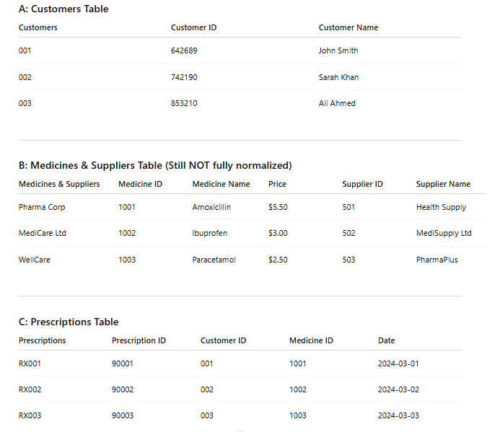

The Normalization process is used to reduce the redundancy within a database as well as improve the efficiency of databases. It eliminates the redundancy and brings in the logic of data dependencies. This helps in improving the consistency, reducing the anomalies and helps in designing a scalable database.
Validation rules were applied and tested.
Examples:
StockQuantity ≥ 0
Price must be positive
Outcome:
Invalid entries (e.g., negative stock or price) were rejected ✅
5. User Scenario Testing
Realistic scenarios were simulated:

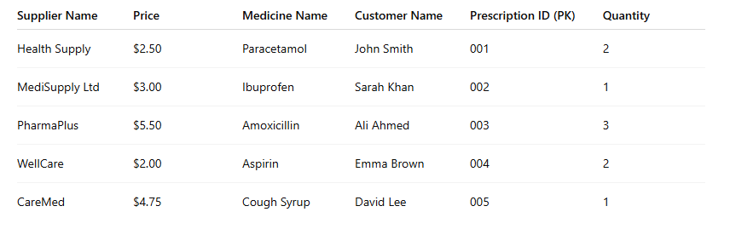
Scenario 1: Selling medicines to a customer
Sale record created
Multiple medicines added via SalesDetails
Scenario 2: Recording a prescription
Prescription linked to customer
Medicines correctly added
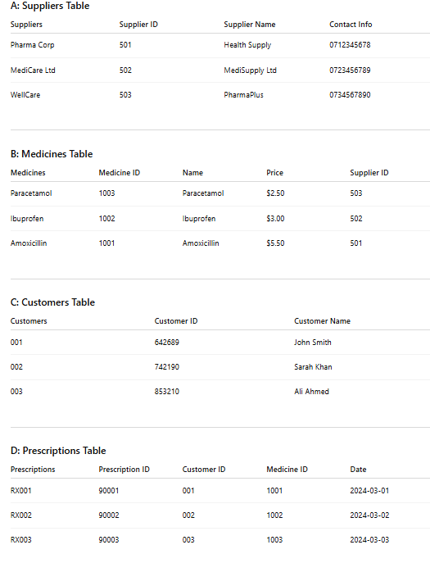
In Third Normal Form or 3NF, the transitive dependencies are eliminated. It means every non key attribute in the Table will have relation with the primary key only. For Example – In Supplier Table the supplier information can be moved into separate table without any data redundancy.
Outcome:
System handled real-life workflows effectively
Data was correctly linked across tables

7.4 Conclusion
Testing confirmed that the MediLink Pharmacy database system was functioning as specified. The following capabilities were verified:
Maintains data accuracy and consistency
Prevents invalid data entry
Supports efficient data retrieval through queries
Reflects real-world pharmacy operations
System appears to be very reliable, easy to use and ready for release with scope for future improvements such as automated tools or reporting.

Query Development
Write and execute a variety of ad-hoc queries to show that you understand how the system works. These should be relevant to your decision-making activities and could include Current in Use items, items that need maintenance, the most accessed records, access related to a particular user, availability information, maintenance requirements, etc. Your choice of ad-hoc queries should be appropriate for the system and relevant to how you would actually use the system.
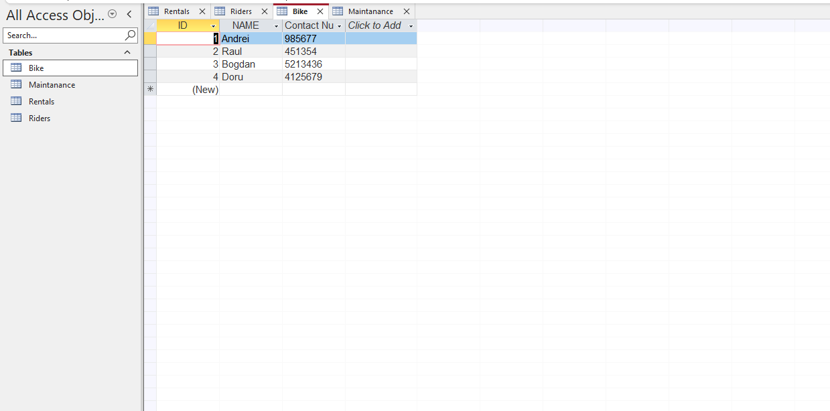
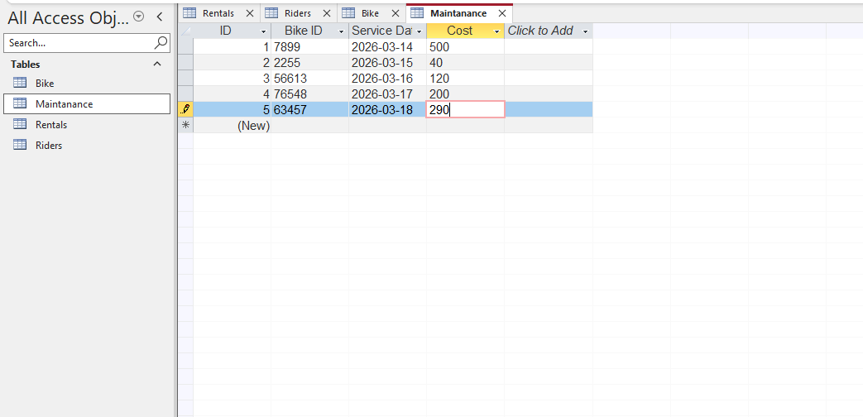
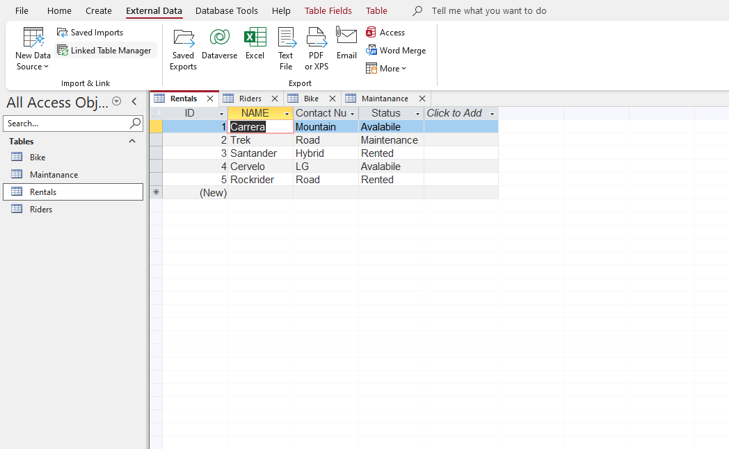
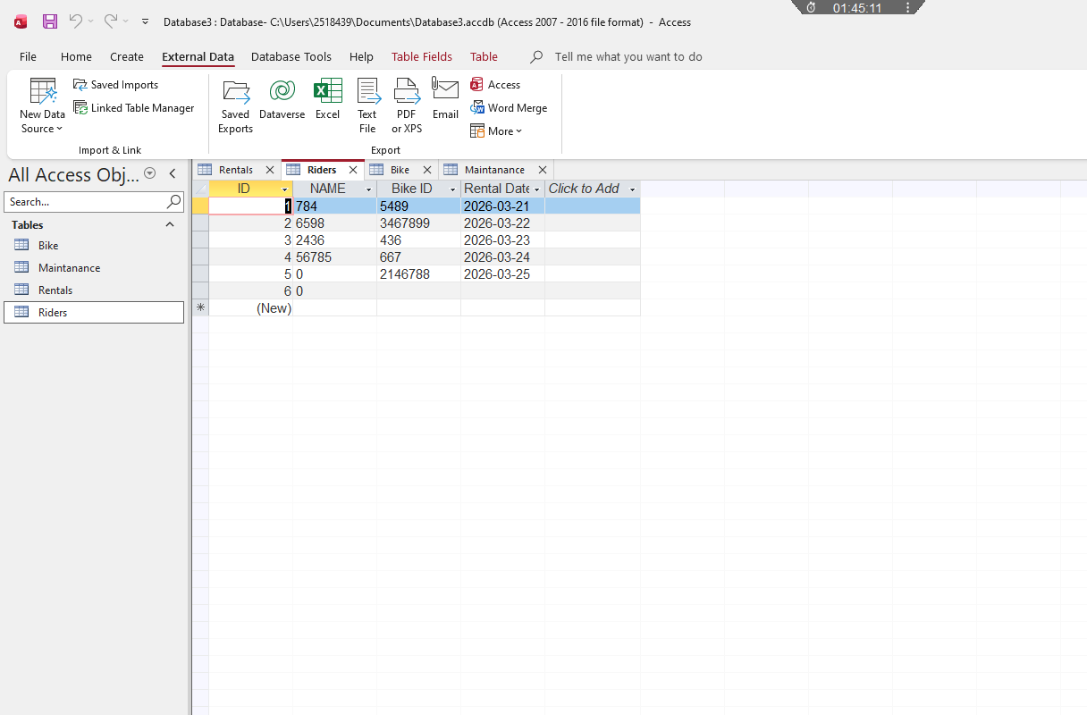

Task 2: Coursework Written Elements
Table of Contents
Introduction
Scenario Description
System Design Overview
Implementation Evidence (Screenshots)
Design Decisions
Challenges and Future Improvements
Conclusion
References
1. Introduction

Database design and implementation for MediLink Pharmacy in Microsoft Access. This assignment implemented a database system for MediLink Pharmacy, which replaces manual recording by a computerized system for speedy flow and accuracy of data. The database covers all the activities of a pharmacy such as drugs, the source of drugs, patients, prescriptions and sales.

2. Scenario Description

We are a growing community pharmacy with several locations. Currently we are managing our business manually using paper, pen, and spreadsheets.

The aim of this database system is to:

Store and manage medicine stock information
Maintain supplier and customer records
Record prescriptions issued to customers
Track sales transactions accurately
Provide useful data for reporting and decision-making

This system will aid the pharmacy in a more efficient service, accurate information, and better control of its business.

3. System Design Overview

The database was made using Microsoft Access and it has several tables which are linked.

Supplier
Medicine
Customer
Prescription
PrescriptionDetails
Sales
SalesDetails

- Every table is defined with a primary key - All tables have foreign keys to define relationships between tables

Many-to-many relationships (like the relationships between medicines and sales or prescriptions) are solved using bridge entities:

PrescriptionDetails
SalesDetails

Referential integrity is enforced to maintain consistency and prevent invalid data entries.

This database is fully normalised up to 3NF (3rd Normal Form) to minimize redundancy and improve data integrity.

5. Design Decisions
Several important design decisions were made during development:
Normalization: Our database is in 3rd Normal Form (3NF) to ensure we do not have any data redundancy.
Primary and Foreign Keys were used to identify each record uniquely and to help link tables to each other.
Bridge Tables Many-to-many relationships were resolved using intermediate tables (e.g., SalesDetails) in the database.
Data Types Appropriate data types such as Text, Number, Currency and Date were used.
Validation Rules We added some constraints that check that data entered in is valid, for example the quantity of stock cannot be negative, nor can prices.

ResourceLocales are chosen for these types of decisions based on the reliability of the system, its ability to scale and on the structure of the resource being chosen (i.e., being consistent with real world pharmacy business practice).

6. Challenges and Future Improvements
Challenges Faced
Designing relationships correctly between multiple tables
Ensuring referential integrity without restricting necessary operations
Structuring bridge tables for many-to-many relationships
Avoiding redundancy while maintaining usability
Future Improvements
Development of user-friendly forms for easier data entry
Creation of automated reports for sales and stock management
Implementation of alerts for low stock levels
Integration with barcode systems for faster processing
Enhanced security features for sensitive customer data
7. Conclusion
The MediLink Pharmacy database system fulfils all the requirements of the scenario. This electronic system eliminates the need for manual methods and therefore offers many benefits such as accuracy, consistency, convenience and ease of access.

This system provides a basis for a number of key activities carried out in pharmacies today, which include stock control, sales tracking and prescription management. The system appears to be well-designed, with the database design and implementation appearing to be of a high standard, thus forming a good foundation for any potential future enhancements.
8. References
[1] R. Elmasri and S. B. Navathe, Fundamentals of Database Systems, 7th ed. Pearson, 2016.
[2] T. Connolly and C. Begg, Database Systems: A Practical Approach to Design, Implementation, and Management, 6th ed. Pearson, 2015.
[3] Microsoft, “Microsoft Access Documentation,” 2024. [Online]. Available: https://support.microsoft.com
[4] A. Silberschatz, H. F. Korth, and S. Sudarshan, Database System Concepts, 7th ed. McGraw-Hill, 2019.
[5] C. J. Date, An Introduction to Database Systems, 8th ed. Pearson, 2004.
[6] P. Rob and C. Coronel, Database Systems: Design, Implementation, and Management, 13th ed. Cengage Learning, 2019.
[7] Oracle, “Database Design Basics,” 2023. [Online]. Available: https://docs.oracle.com
[8] IBM, “Introduction to Relational Databases,” 2023. [Online]. Available: https://www.ibm.com
[9] S. Sumathi and S. Esakkirajan, Fundamentals of Relational Database Management Systems, Springer, 2007.
[10] M. Hernandez, Database Design for Mere Mortals, 3rd ed. Addison-Wesley, 2013.
[11] J. Pratt and M. Last, Concepts of Database Management, 9th ed. Cengage Learning, 2014.
[12] Microsoft Learn, “Create a Database in Microsoft Access,” 2024. [Online]. Available: https://learn.microsoft.com

