

Module Name: Problem Solving and Innovation
Module code: (BMSW4014)
Assessment 1: AI Washing (Conclusion)
Student name: Khalil Ullah
Student number: 2508657
Lecturer: Chris Wilkin
Deadline: 12th June 2026
Table of Contents
Speaker Notes: 3
Presentation: Conclusion for RCA of AI Washing 5
References 9

Speaker Notes:
In this presentation, the topic of AI washing in the technology sector has been covered, and the reasons, effects, and remedies for this problem have been discussed. The Root Cause Analysis was used to determine that AI washing is not a single cause but multiple causes of human, organisational and regulatory factors.

From the consumer perspective, there is a lack of understanding regarding AI, and it can be difficult to separate AI from marketing hype. This information void also makes it possible for companies to over-hype the use of AI in their offerings. At the company level, there is strong competition in the tech industry, along with investor pressure and a desire to raise company valuation, which can pressure companies to promote themselves as AI-powered even if the technology implemented is weak. Lastly, the lack of robust regulations and universal standards for AI definitions hinders the ability to enforce accountability for false claims from organisations.

AI washing also has massive implications, as the analysis pointed out. Misrepresentations can lead to unrealistic expectations and loss of faith on the part of consumers when products don't provide the capabilities that consumers expect. AI washing can also have an adverse effect on business valuations and drive poor investment decisions for investors, resulting in misinterpretations of technology's capabilities. The other way those employees can be impacted is by the falsehoods that may circulate about automation and job changes. At a broader level, society can also be harmed by the repetition of AI washing, leading to a loss of trust in new technologies and lower adoption rates (Joo, 2025).

An example of such difficulties was the Amazon 'Just Walk Out' case. Although the technology was marketed as an AI-powered autonomous shopping solution, reports revealed substantial human involvement in transaction verification. This disconnect between the public image and reality of operations led to criticism and questions of transparency and accountability (Bridle, 2024). The case illustrates the risks to reputation when organisations' marketing messages outpace their technological capacity.

Several recommendations were put forth to address these issues. Transparency is crucial by clearly outlining the use of AI and steering clear of marketing jargon. Regulators should make disclosure requirements more robust, create clear definitions of AI, and implement more robust enforcement measures to deter inaccurate statements. Furthermore, both consumers and investors need to become more AI-literate, enabling them to better assess messages about AI in marketing and make informed choices.

In conclusion, AI washing is a major hurdle in the future of AI development. The commercial benefits of associating products with AI might be short-lived, as this approach can lead to trust loss, reputational harm, and regulatory attention over time (Elhajjar and Itani, 2025; Sharma et al., 2025). Ethical governance, transparency and accountability are essential beyond technology to ensure sustainable success in the AI era. Organisations have a role to play in supporting and maintaining trust in AI through promoting open dialogue and the responsible use of the technology.

Presentation: Conclusion for RCA of AI Washing

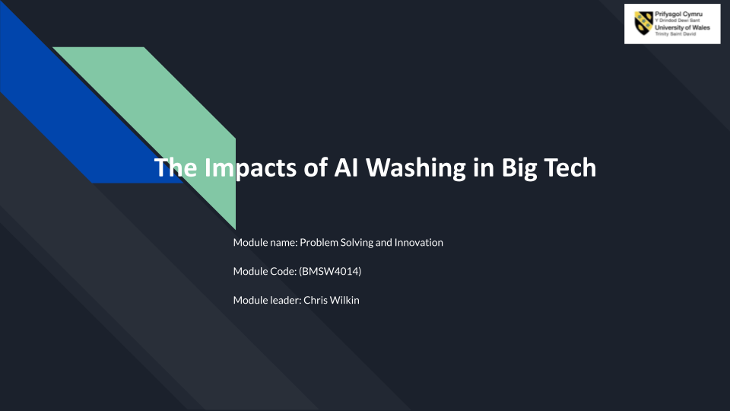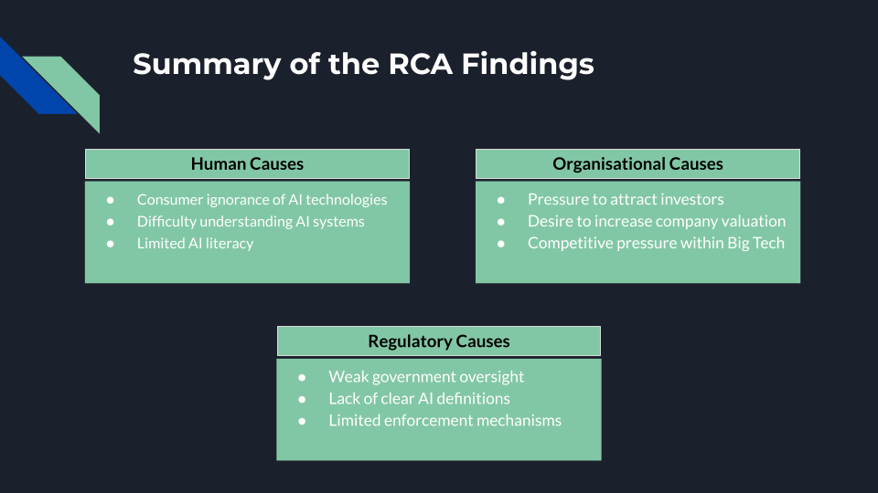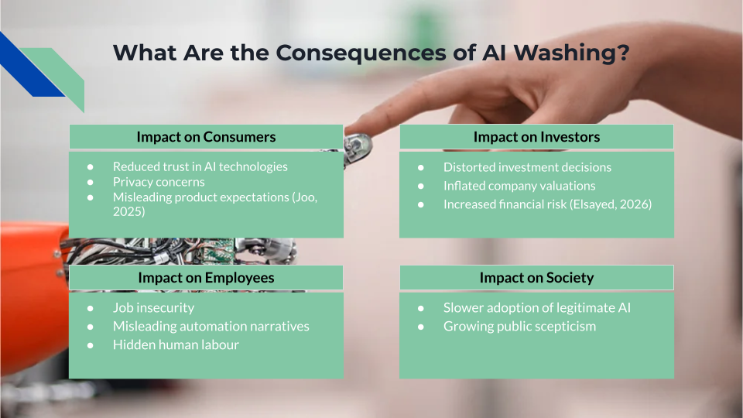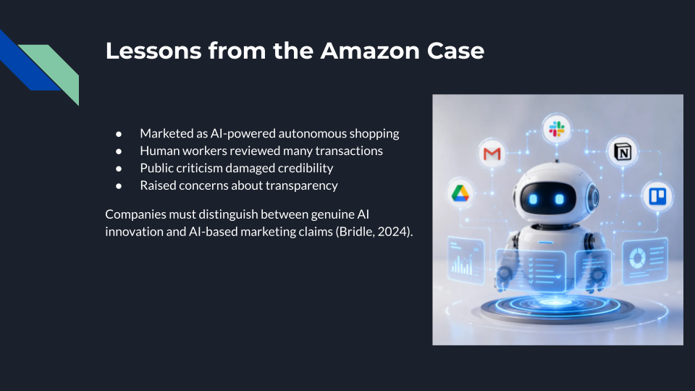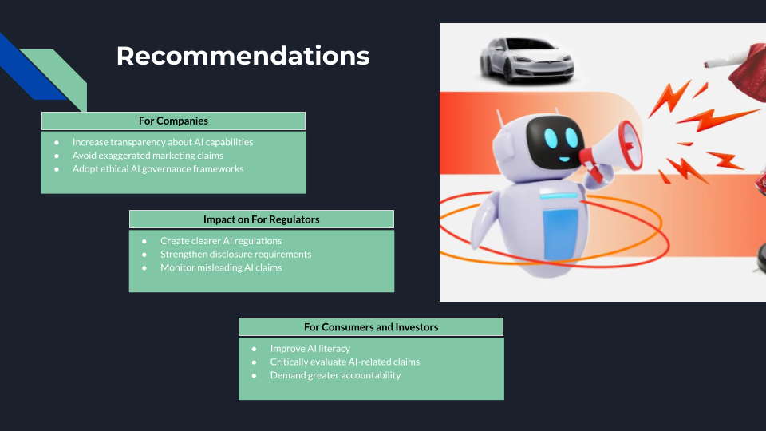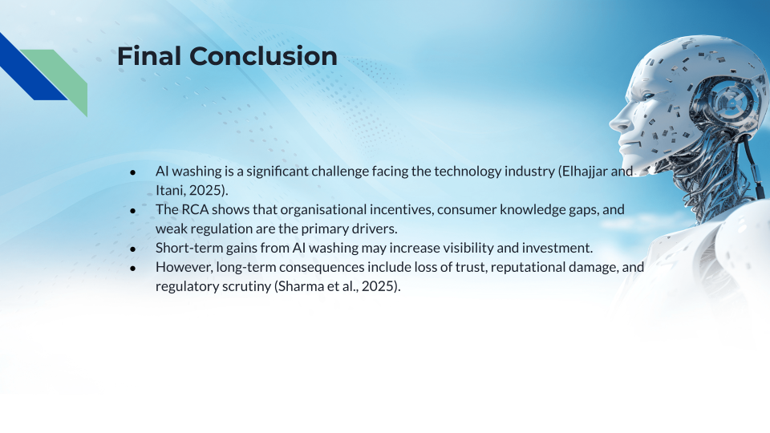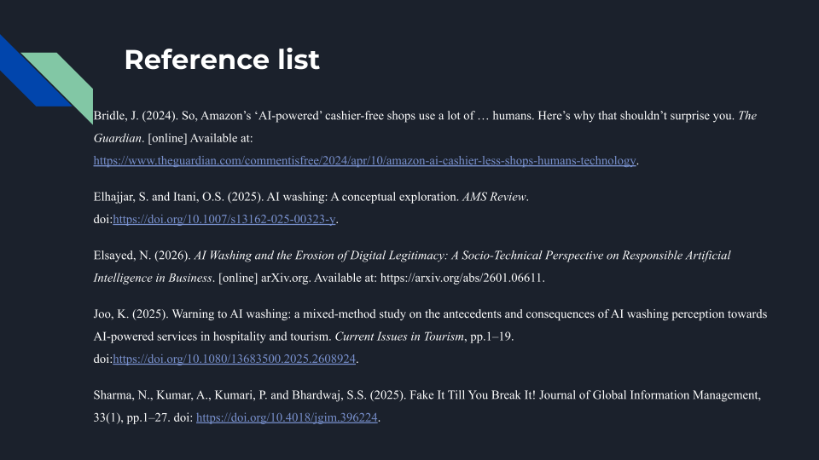

References
- Bridle, J. (2024). So, Amazon’s ‘AI-powered’ cashier-free shops use a lot of … humans. Here’s why that shouldn’t surprise you. The Guardian. [online] Available at: https://www.theguardian.com/commentisfree/2024/apr/10/amazon-ai-cashier-less-shops-humans-technology.
- Elhajjar, S. and Itani, O.S. (2025). AI washing: A conceptual exploration. AMS Review. doi:https://doi.org/10.1007/s13162-025-00323-y.
- Elsayed, N. (2026). AI Washing and the Erosion of Digital Legitimacy: A Socio-Technical Perspective on Responsible Artificial Intelligence in Business. [online] arXiv.org. Available at: https://arxiv.org/abs/2601.06611.
- Joo, K. (2025). Warning to AI washing: a mixed-method study on the antecedents and consequences of AI washing perception towards AI-powered services in hospitality and tourism. Current Issues in Tourism, pp.1–19. doi:https://doi.org/10.1080/13683500.2025.2608924.
- Sharma, N., Kumar, A., Kumari, P. and Bhardwaj, S.S. (2025). Fake It Till You Break It! Journal of Global Information Management, 33(1), pp.1–27. doi: https://doi.org/10.4018/jgim.396224.

