Nathan J Morris

The below is a technical report addressing certain construction details for a single, two storey detached domestic building, including graphical representation of certain building elements
New build dwelling
Technical report with drawings

Contents
Introduction 2
1. Annotated drawings 3
i) The Ground floor Construction, detailing and junctions with external walls. 3
ii) The First floor Construction, detailing, junctions with external walls and restraints. 5
iii) Eaves detailing and roof covering – indicating appropriate weathering, fixing and laps. 7
iv) The main roof structure. Construction, detailing and fixing. 8
2. The main advantages and disadvantages of a pitched trussed roof construction with metal sheeting finish versus an alternative method of construction 9
3. Ventilation and its importance 10
i) Causes of condensation and its effects on building fabric 10
ii) Methods of ventilation to reduce condensation within this building 10
Conclusion 11
References 12
Bibliography 12

Introduction

The following report has been developed for a client who has received planning permission for a single, two storey detached domestic building.
The dwelling is to be built on a level but reclaimed site which, prior to advanced ground works, had been used as agricultural land. There is a retaining wall structure to the south of the site and the Ground investigation report suggests a suitable raft foundation be constructed for the property.
The building is a timber framed construction where the inner skin of the ‘cavity wall’ is 140mm thick insulated C16 timber frame.
The outer skin consists of stack bonded facing brick work and blockwork with a smooth render finish. Additional PIR insulation is contained within the cavity to improve the thermal performance.
There is to be an insulated ground floor with underfloor heating in the screed and the upper floors are to be traditional solid timber with tongue and groove softwood flooring.
Windows and external doors are to be powder coated aluminium; windows are triple-glazed units.
Roof structure is to be trussed rafters with a metal profile sheeting finish installed over OSB sheathing boards.
The client has asked for a technical report addressing some of the construction details required as they are unfamiliar with timber frame construction.
The following report will aim to clarify these concerns and provide a brief overview including illustrations of what each section of the build will require.
Where appropriate the relevant British standards have been quoted, these are available at https://www.bsigroup.com/en-GB/standards/ for reference.

Annotated drawings

The Ground floor Construction, detailing and junctions with external walls.

A brief overview of this method of ground floor construction: Timber frame construction with raft foundations is essentially the same process for traditionally constructed houses (Riley & Cotgrave, 2018). The main differences are as follows, a timber sole plate which has been treated with a preservative to prevent damp / rot is secured to the lower wall section of the raft. This is then set onto a damp-proof membrane and forms the base in which the wall panels can be attached, having secured the sole plate the wall panels are then nailed directly on to it. (Riley and Cotgrave, 2018)

The image on the page below (figure 1) details the ground floor construction and how this interacts with the external walls, the numbering reference system underneath the drawing corresponds with the annotations on the drawing and explains the relevant features. British Standards (BS) have been quoted and brief information on dimensions provided for certain details.

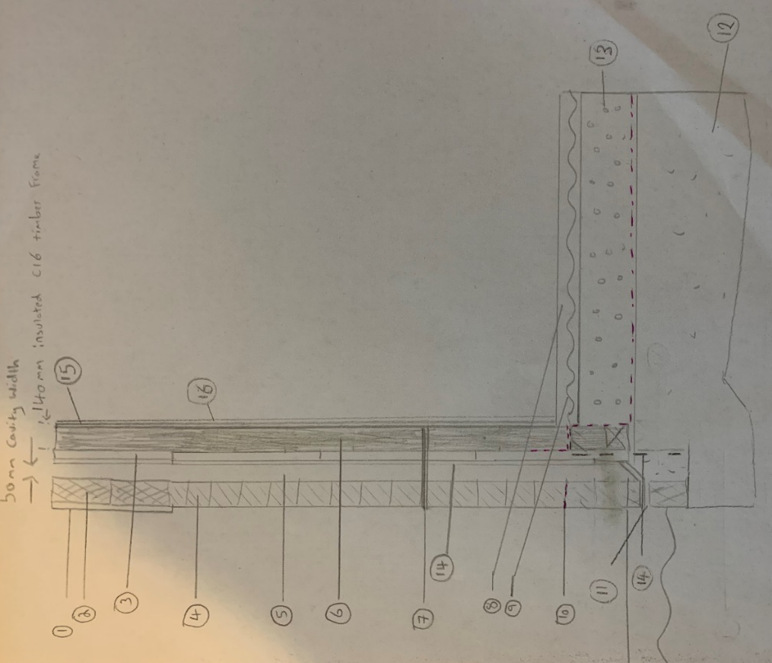
Figure 1 – Ground floor construction
- Smooth render finish compliant with BS EN 13914
- Standard concrete block 440mm x 100mm x 215mm designed to BS EN 1996 (BS EN 771 where fixed to timber)
- PIR insulation board
- Stack bonded facing brickwork 215mm x 102.5mm x 65mm with 10mm mortar joint designed to BS EN 1996
- 50mm cavity gap to comply with British standard BS EN 1996-1-1 extended to 150mm below dpc
- 140mm thick insulated C16 timber frame compliant with BS 8417
- Wall tie fixed through sheathing to studs, compliant with BS EN 845 spaced maximum of 600mm horizontally and 450mm vertically
- Screed with minimum of 25mm cover over highest point of pipes – BS 8204
- Underfloor heating element compliant with BS EN 1264-2
- Damp proof membrane at minimum height of 150mm above ground level
- Weep hole or open perp ends to prevent water build up in cavity
- Raft foundations to comply with BS EN 1991/1992,1997-1,10175
- Insulation board with Vapour check layer (VCL) on concrete slab compliant with BS 5250
- Non corrodible holding down strip on floor sill secured into raft foundations
- Vapour check layer on warm side of building to prevent interstitial condensation
- Internal lining compliant with BS 8212 and BS 5492

The First floor Construction, detailing, junctions with external walls and restraints.

As in traditional building methods the upper floor construction of a timber framed house is very similar, with the main difference lying in the connection of the wall panels. The floor joists bear directly onto the head binder of the lower wall panels (Riley and Cotgrave, 2018). The joists of the upper floor rest directly onto the head binder and head rail which act as a double strength section of support for the joist. (spacing of studs and joists are generally 600mm or 400mm maximising the efficiency of plaster board sheets for finishing) (Riley and Cotgrave, 2018)
Figure 2 below details how the first floor of this building will look.
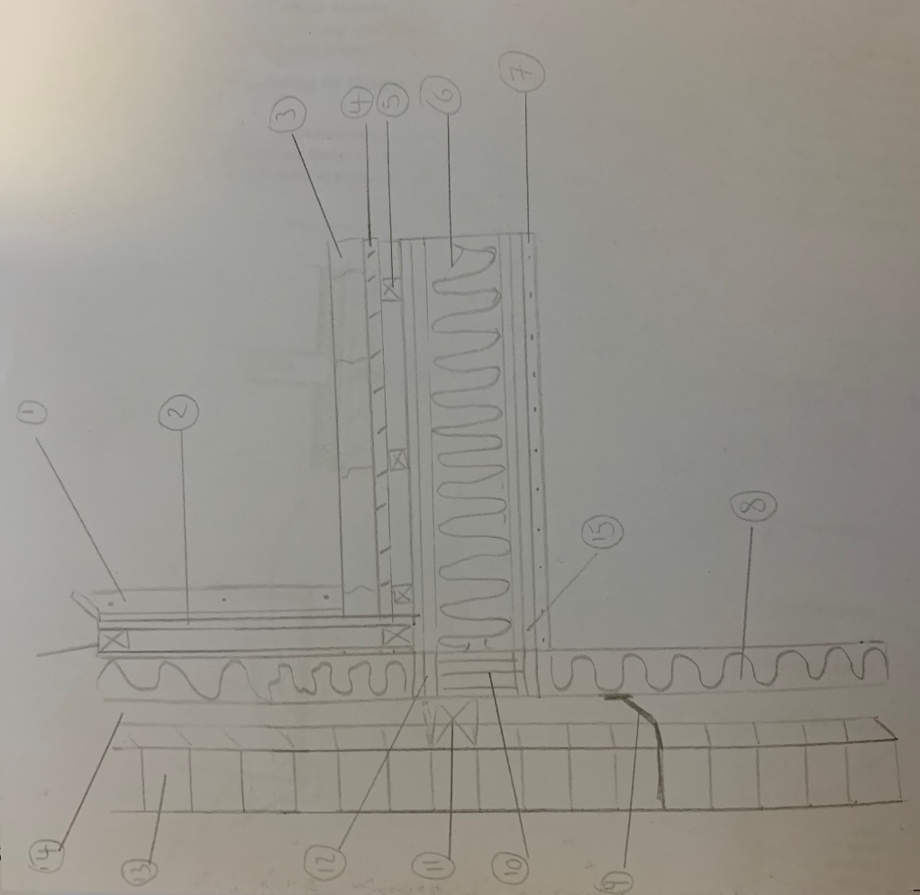
Figure 2 – first floor construction
- Plasterboard and plaster compliant with BS 8212 and BS 5492 respectively
- Stud – not less than 37mm wide and maximum 600mm centres
- Solid timber tongue and groove flooring compliant with BS 8201
- Structural floor deck to meet BS EN 1991-1-1
- Resilient batten
- Insulation board
- Plasterboard on ceiling compliant with BS 5492
- 140mm insulated c16 timber frame compliant with BS 8417
- Wall tie fixed through sheathing to studs compliant with BS EN 845 spaced maximum of 600mm horizontally and 450mm vertically
- Double joist compliant with BS EN 1995-1-1, BS EN 338,14081-1,4978
- Cavity barrier
- Floor sill / joist compliant with BS EN 338,14081-1,4978 not spaced greater than 600mm
- Stack bonded facing brickwork 215mm x 102.5mm x 65mm with 10mm mortar joint
- 50mm cavity gap to comply with British standard BS EN 1996-1-1
- Head rail / joist in accordance with BS EN 1995-1-1

Eaves detailing and roof covering – indicating appropriate weathering, fixing and laps.

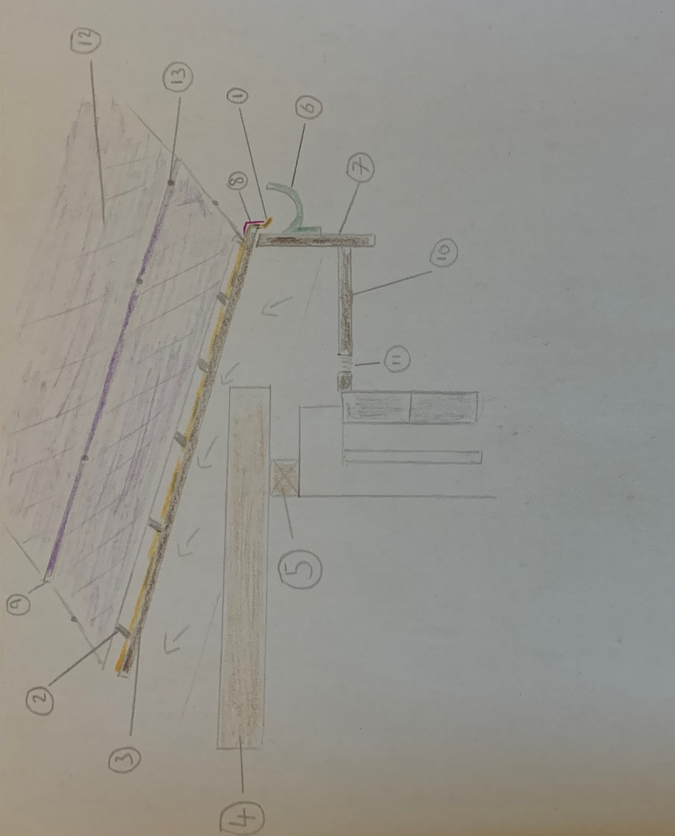
The development in question is opting for a pitched roof with metal profile sheeting finish over an OSB board, this type of roof covering will need to meet BS EN 506:2000 (British Standards - Sheeting & Cladding, 2021) and is not as popular as other more traditional methods of finishing. The roofing type below is what is referred to a cold roof construction in which the insulation is beneath the roof and overlaid upon the ceiling of the house and not directly underneath the roof sheeting.
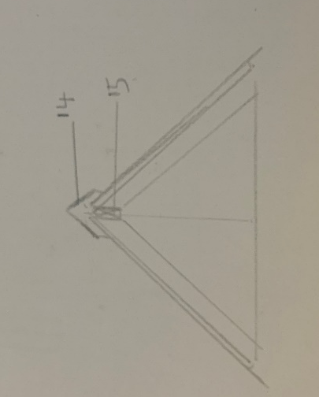
Figure 3 below outlines the detailing and covering for this roofing type.

Figure 3 – Eaves detailing and roof covering
- Vapour control layer overlapped onto OSB board into gutter (40mm-50mm overhang minimum)
- Rock bar for mounting metal sheeting, fixed to OSB board
- OSB board to standard BS EN 300
- Ceiling joist compliant with BS EN 338,14081-1,4978
- Wallplate minimum 75x50mm
- Gutter
- Plywood fascia to standard BS EN 636
- Eaves lead flashing to standard BS 1178 code 4
- Seam overlap join of roof sheet
- Plywood Soffit boarding to standard BS EN 636
- Soffit vent to allow airflow and to prevent condensation
- Metal profile sheeting with fall of not less than 1:30
- Plastic / rubber coated aluminium rivets to standard BS 1202
- Ridge flashing to standard BS 1470 secured by above mentioned rivets
- Longitudinal bracing member at ridge node point

The main roof structure: Construction, detailing and fixing.

The roof structure for this build is a pitched roof with a trussed rafter construction, these are almost standard in modern day house building due to their cost, factory assembly and how they transfer the loads easily to the outside walls of the house. A trussed rafter design replaces the need for a heavy purlin by replacing it with internal bracing, eliminating the need of a ridge board by using a gang nail plate instead (Riley and Cotgrave, 2018). This enables trussed roof structures to be factory made rather than on site assembly, saving time and money. Assembly is also much simpler and can be done by using only two operatives. The trussed type below is what’s called a “Fink” trussed design but there are many variants to choose from. (Riley and Cotgrave, 2018). The trusses are typically placed at 600mm intervals and a trussed roof design should comply with BS 5268.
The below diagram (figure 4) outlines the detailing and fixing of this method of construction.

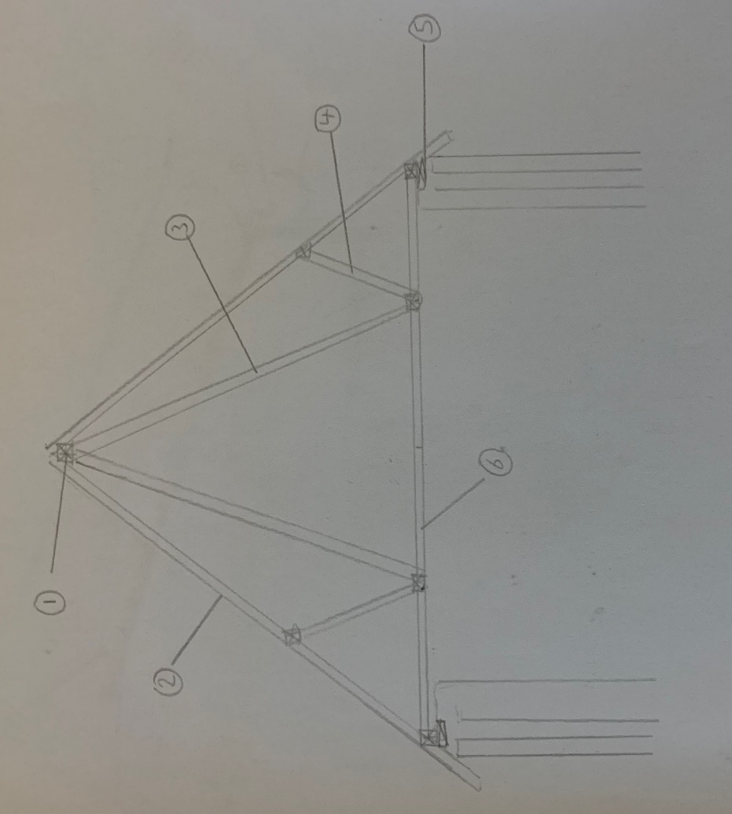
Figure 4 – Main roof structure
- Timber connectors / gang nail plate (all timber to be BS EN 1995-1-1 compliant)
- Rafter spaced no greater than 600mm apart
- Tie (in tension)
- Strut (in compression)
- Wallplate of minimum 75x50mm with nails into rafter (3.35mm x 65mm minimum galvanised round nails)
- Celling joist compliant with BS EN 338,14081-1,4978 and hangers meet BS EN 845

The main advantages and disadvantages of a pitched trussed roof construction with metal sheeting finish versus an alternative method of construction

There are many advantages and disadvantages to this type of roof construction, a brief overview of both are discussed below.
Pitched roof construction will generally require much less maintenance. Due to their nature, precipitation and snow will slide off rather than pool on top. They also provide greater structural stability than a flat roof, for example, as loads are transferred to the outside walls of the house. They can also maximise the space within the loft cavity for storage or even an additional room. (Riley & Cotgrave, 2018).
They do however require a longer install time and cost much more than their flat roof alternative.
If the pitched roof is made up of a trussed rafter structure it will be extremely strong and are ideal for larger jobs as the roof is designed and manufactured off site enabling a good level of quality control. Potential downsides to this could be manufacturer lead time delays and the transport and storage issues of these large structures, also depending on the type of truss design loft space may be compromised slightly with the struts (Riley and Cotgrave, 2018).
With a finish of metal sheeting, this will be a much more durable, low maintenance, energy efficient option over felt for example. The lightweight panels allow a quick installation of a large area and can be made available in many colour options to allow a very aesthetically pleasing finish. (Residential Metal Roofing: Advantages and Disadvantages, 2021)
There are however some disadvantages such as cost, noise compared to some other alternatives and require a professional competent installer to ensure a good watertight fit due to the complex connection of sheets. These types of sheeting can also cause potential issues due to snow and its danger of large accumulations falling off and creating a potential hazard to members of public below.
An alternative method of construction could be a flat roof construction with a felt covering, the advantages in disadvantages of this type of construction and finish are as follows.
The main advantage of a flat felt roof construction is its cost, flat roofs require fewer materials and are structurally simpler than a pitched roof which also leads to a faster install over its pitched roof counterpart (Riley and Cotgrave, 2018). Felt is also much cheaper than other roofing finishes and is relatively straightforward to install. Flat roofs can also look more aesthetically pleasing with their minimalist design especially on more modern homes. (Chudley and Greeno, 2020).
The main disadvantages of flat felt roofs are that they require more maintenance and weathertightness and can have up to 3 to 4 times the amount of trouble compared to a pitched roof (Riley and Cotgrave, 2018). The main problem tends to occur with the covering and its degradation or from condensation of water vapour within the fabric of the roof itself. Felt roofs especially suffer from solar degradation and can older forms especially suffer with limited lifespan (Chudley and Greeno, 2020).

Ventilation and its importance

i) Causes of condensation and its effects on building fabric

There are two main types of condensation, Surface condensation and Interstitial condensation.
Surface condensation is what most of us see daily where humid air meets a cold surface, such as in a bathroom when we have a warm shower and the bathroom window steams up. This can be a problem on things like plaster where dampness may impact the finish or mould growth may occur on surfaces over time (Fundamentals of construction lecture, 2021).
The second type which is more serious and causes a lot of problems within lightweight building enclosures is Interstitial condensation, this is where warm moist air from within the building structure moves into a wall, cools down and forms water droplets (reaching the dew point) within the core of the wall causing damp, mould growth and timber rotting, most of the damage is already done once signs of this start to appear. (Interstitial Condensation - All the Latest Preservation Insight, Peter Cox, 2021)

ii) Methods of ventilation to reduce condensation within this building

To prevent these types of condensation from occurring there are several things that we can do when designing our buildings. Some basics can include improving heating and ventilation, vapor checking on the warm side of the insulation and ventilating the construction to the fresh air if there is a vapour trapping membrane on the outside (Chudley and Greeno, 2020).
As our building is of a timber framed construction it is even more important to ensure good ventilation within the building such as in window strip vents, extractor fans within bathrooms and natural ventilation within the loft itself as illustrated in figure 3, where soffit vents enable air flow into the cavity space within the cold loft area preventing condensation build up.
One key component of this build as it is a timber frame construction is the importance of installing vapour control layers on the walls and floor too as illustrated in figure 5.
Figure 5 details how the vapour control layer (VCL) can be installed in relation to the other building components, this VCL allows the building to breathe while reducing the amount of water vapour allowed to pass into the cavity of the building avoiding damage to the timber and insulation boards. These VCL sheets can be placed on the warm side of the insulation boards between stud walls and the structural timber and placed on the underside of floor joists. They can also be placed beneath the screed and above the insulation boards on the ground floor preventing the large temperature variation and therefore reducing the temperature difference where saturation occurs (Chudley and Greeno, 2020).

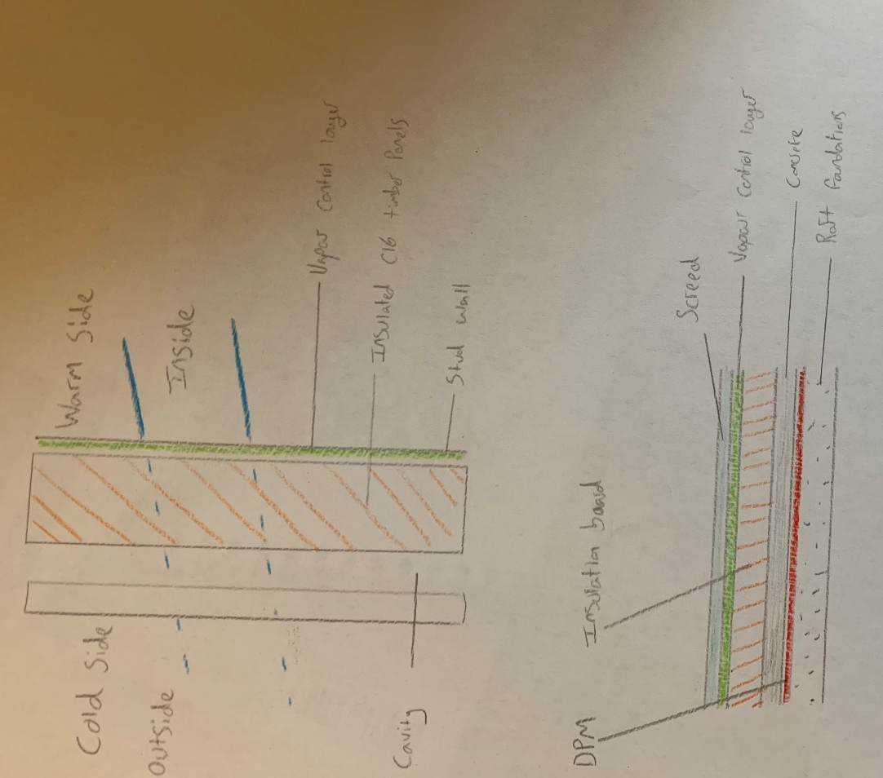

Figure 5 – Vapour control examples

Conclusion

To conclude, the above report aimed to clarify some common issues with constructing a timber framed house and the intricacies and differences from a more traditional masonry building. Timber frame construction has continued to grow in the UK since 1960 with various benefits such as predictability of delivery timescales, off site manufacture and quality control and predicable costs making this type of construction more and more common (Fundamentals of construction lecture, 2021). There are many complex issues when undertaking a build of this nature and it is essential that all construction methods comply with UK building legislation and government regulations.

References

All Roofing Solutions. 2021. Residential Metal Roofing: Advantages & Disadvantages. Available at: https://allroofingsolutionsde.com/metal-roofing-advantages-disadvantages/ [Accessed 20 January 2021].
Chudley, R. and Greeno, R. (2020) Building construction handbook. 12th edn. Oxford: Routledge.
Peter Cox. 2021. Interstitial Condensation - Blog | All The Latest Preservation Insight | Peter Cox. Available at: https://www.petercox.com/blog/interstitial-condensation/ [Accessed 21 January 2021].
Riley, M. and Cotgrave, A., (2018). Construction Technology. 4th edn. Palgrave
Roofconsult.co.uk. 2021. British Standards - Sheeting & Cladding. Available at: http://www.roofconsult.co.uk/standards/bsisheeting.htm [Accessed 21 January 2021].
Traylor, G. 2021. Fundamentals of construction technology – superstructures. [online lecture] University of Wales Trinity Saint David. 5th January 2021

Bibliography

Bsigroup.com. 2021. Standards - Information & Benefits. Available at: https://www.bsigroup.com/en-GB/standards/ [Accessed 07 January 2021].
GOV.WALES. 2021. Building Regulations: Roof | GOV.WALES. Available at: https://gov.wales/building-regulations-roof [Accessed 14 January 2021].
NHBC Foundation. 2021. Home - NHBC Foundation. Available at: https://www.nhbcfoundation.org/ [Accessed 14 January 2021].

