
Module Name: Academic Skills in the Digital Era
Module Code: BMSW4013
Assessment 1: E-Portofolio
Student Name: Aurelia-Mirela Sterian
Student Number: 2238113
Lecturer: Ffion Cumberpatch
Deadline: Friday 27th February 2026

Wordcount: 1500 words
AI Acknowledgement

I acknowledge the use of ChatGPT (https://chat.openai.com) on 28 of January 2026 for a romanian explination on how this assessment should be done.

I confirm that I have not presented any AI-generated text as my own work. I confirm that I have retained copies of drafts, notes, and resources used before and after the use of AI tools.
Contents
Component 1 – Development of Academic Skills (500 words) 4
Component 2 – Application of Academic Skills (1,000 words) 6
Component 3 – Academic Poster 8

Component 1 – Development of Academic Skills (500 words)

1. Evaluating Academic Sources Using the CRAAP Test
Source 1: Thapa, P. Sharma, P. Goundar, S. Tsirkas, P. Valamontes, A. Adamopoulos, I.(2025) “Digital Distraction in the Classroom Among Students: A Cross-Sectional Study” .
This source was found Preprints.org (Google Scholar)
This article was posted on 24th February 2025, making it highly current and relevant to contemporary digital learning environments.
It directly examines digital distraction among students, a key issue in higher education.
The authors are academic researchers, but the article is posted as a preprint and is not peer-reviewed, which limits the credibility.
The findings are drawn from a cross-sectional study and are supported by analysed data and academic references.
The purpose is to investigate how digital distraction affect learning and explore strategies related to device management.

Source 2: Cottrell, S. (2024) “The Study Skills Handbook” (6th edition), this source was found in the University library (online access).
The 6th edition was published in 2024, which means is up to date.
This book focuses on academic challenges faced by students in higher education (time management and independent learning skills.
Stella Cottrell is a academic author and the book is used in universities.
The content is evidence based and supported by educational research and academic practice.
The purpose is to support students in developing effective academic and study skills to succeed in higher education.

2. Synthesis of Academic Sources
Both sources focus on challenges students face when learning in digital higher education environments. Thapa et al. (2025) examine how digital distractions, such as mobile device use, reduce students concentration and affects negatively academic performance. In contrast, Cottrell (2024) talks about students are struggling with managing time and adapting to independent learning.
Although the sources approach the topic from different perspectives, they complete each other. Thapa et al. (2025) provides research-based evidence showing how digital distraction interrupt learning, while Cottrell (2024) explain why students may find it difficult to organise their study time and independent learning. Together, the sources suggest that digital distraction and time management are some of the challenges the students are facing in higher education.
By combining these perspectives, a deeper understanding of digital learning is achieved,
demonstrating that effective learning in higher education depends on both: controlling digital distraction and developing strong independent learning and time management skills.

3. Identifying a Key Challenge and Opportunity
One key challenge for students in the digital era is poor time management and difficulties with independent learning. Cottrell (2024) explains that higher education requires students to manage their workload independently and meet multiple deadlines. Many students struggle to adjust to this level of responsibility. This challenge is made more difficult by digital distractions, which can reduce focus and productivity during study time Thapa et al. (2025).
A key opportunity for students is the development of self-regulations skills. Thapa et al. (2025) suggests that managing digital device use can help reduce distraction, while Cottrell (2024) highlights the importance of planning and organise study time. Together, these skills can support more effective and independent learning.

4. Academic Planning
Component 2 will focus first on time management and independent learning, as these skills are very important. Further attention will be given to academic concepts discussed in lectures, including study planning and effective use of digital learning tools. Component 2 will begin with an introduction, followed by selections on academic challenges and possible solutions and then end with a conclusion. This approach will ensure the work is clearly organised and aligned with academic expectations.

Timeline
Task | Date/ Deadline
Finish research | 29.01.2026
Draft first section | 5.02.2026
Complete first draft | 17.02.2026
Final editing | 20.02.2026

Reference List – Component 1
Source 2
Cottrell, S. (2024) The Study Skills Handbook. 6th edn.
Available at: https://ebookcentral.proquest.com/lib/trinity/reader.action?docID=31357862&c=RVBVQg&ppg=1

Source 1.
Thapa, P., Sharma, P., Goundar, S., Tsirkas, P., Valamontes, A. and Adamopoulos, I. (2025) Digital distractions in the classroom among students: A cross-sectional study.
Preprints.org, pp. 1–12.
doi:10.20944/preprints202502.1931.v1.

Component 2 – Application of Academic Skills (1,000 Word Report)
Introduction (100–150 words)
Digital learning is now an important part of higher education, as students use online platforms, digital tools, and electronic resources for studying, communication, and assessment. While these technologies offer many benefits, they also create new challenges for students. Research show that students must develop strong academic skills in order to succeed in digital learning environments (Cottrell, 2024). At the same time, studies highlight that digital distraction, such as mobile device use during study, can negatively affect concentration and academic performance (Thapa et al., 2025)
This report will examine key challenges students face in digital era, as well as opportunities provided by digital tools. It will also propose strategies students can use to improve their academic skills and succeed in higher education.

Challenges for Students in the Digital Era (150–200 words)
One key challenge students face in the digital era is managing digital distraction. Researched by Thapa et all. (2025) shows that the use of mobile devices during study can reduce concentration and interrupt learning. Notifications, social media, and constant online access can make it difficult for students to stay focused on academic tasks. This can negatively affect academic performance, as students may spend less time actively engaging with their studies.
Another important challenge is time management and independent learning. According to Cottrell (2024), higher education requires students to organise their own workload, meet deadlines, and study independently. Many students find this difficult, especially when they are also dealing with digital distraction. Poor time management can lead to stress, missed deadlines, and lower academic achievements.
These challenges directly link to academic skills taught in class, such as study planning, focus, and self-management. Without developing these skills, students may struggle to succeed in digital learning environments.

Opportunities in the Digital Era (150–200 words)
Although digital learning creates challenges, it also provides important opportunities for students. One key opportunity is the use of digital tools to support organisation and study planning. Cottrell (2024) explains that effective planning and structured study habits help students manage their workload and meet academic expectations. Digital tools such as calendars, learning platforms, and note taking can support these skills by helping students organise deadlines and learning materials.
Another opportunity is access to online academic resources. Digital learning environments allow students to access journals, e-books, and lecture materials at any time. This flexibility can support independent learning and allow students to study at their own peace. Thapa et al,.(2025) suggest that when digital devices are used in a controlled and purposeful way, they can support learning rather than distract from it.
However, the effectiveness of these opportunities depends on how students use them. Simply having access to digital tools does not guarantee success. Students must develop academic skills such as self-regulation, planning, and critical use of technology in order to benefit from digital learning.
How Students Can Adapt to Succeed (200–250 words)
One important strategy is improving time management through structured study planning. That involves using schedules, setting priorities, and breaking tasks into smaller steps. This strategy develops organisational skills and supports independent learning. Cottrell (2024) explains that students who plan their study time are more likely to meet deadlines and manage academic pressure effectively. Good time planning also reduces stress and helps students stay focused on their academic goals.
A second strategy is controlling digital distraction during study. This can include turning off notifications, limiting social media use, and studying in distraction free environments. This strategy develops self-regulation and concentration skills. Thapa et al,.(2025) show that uncontrolled device use can interrupt learning, while managing digital behaviour can improve focus and academic performance. By reducing distractions, students can spend more time engaging actively with their studies.
A third strategy is using digital tools in a purposeful way to support learning. This includes using online platforms, digital note-taking tools, and academic resources to organise information and improve understanding. This strategy develops digital literacy and independent learning skills. When use effectively, digital tools can support planning, revision and access to academic content (Cottrell,2024).
Together, these strategies help students manage challenges and make better use of digital learning opportunities.

Conclusion (100–150 words)
In conclusion, digital learning environments present both challenges and opportunities for students in higher education. Digital distraction and difficulties with time management can negatively affect student’s focus, organisation, and academic performance (Thapa et al., 2025; Cottrell, 2024). However, digital tools and online resources also offer valuable support for independent learning and study organisation when used effectively.
This report has shown that students can improve their academic success by developing key skills such as time planning, self-regulation, and purposeful use of digital technology. By applying these strategies , students can reduce the negative effects of digital distraction and make better use of learning opportunities. Developing these academic skills is essential for adapting to modern digital learning environments and succeeding in higher education.

Reference List – Component 2

Cottrell, S. (2024) The Study Skills Handbook. 6th edn.
Available at: https://ebookcentral.proquest.com/lib/trinity/reader.action?docID=31357862&c=RVBVQg&ppg=1

Thapa, P., Sharma, P., Goundar, S., Tsirkas, P., Valamontes, A. and Adamopoulos, I. (2025) Digital distractions in the classroom among students: A cross-sectional study.
Preprints.org, pp. 1–12.
doi:10.20944/preprints202502.1931.v1.

Component 3 – Academic Poster

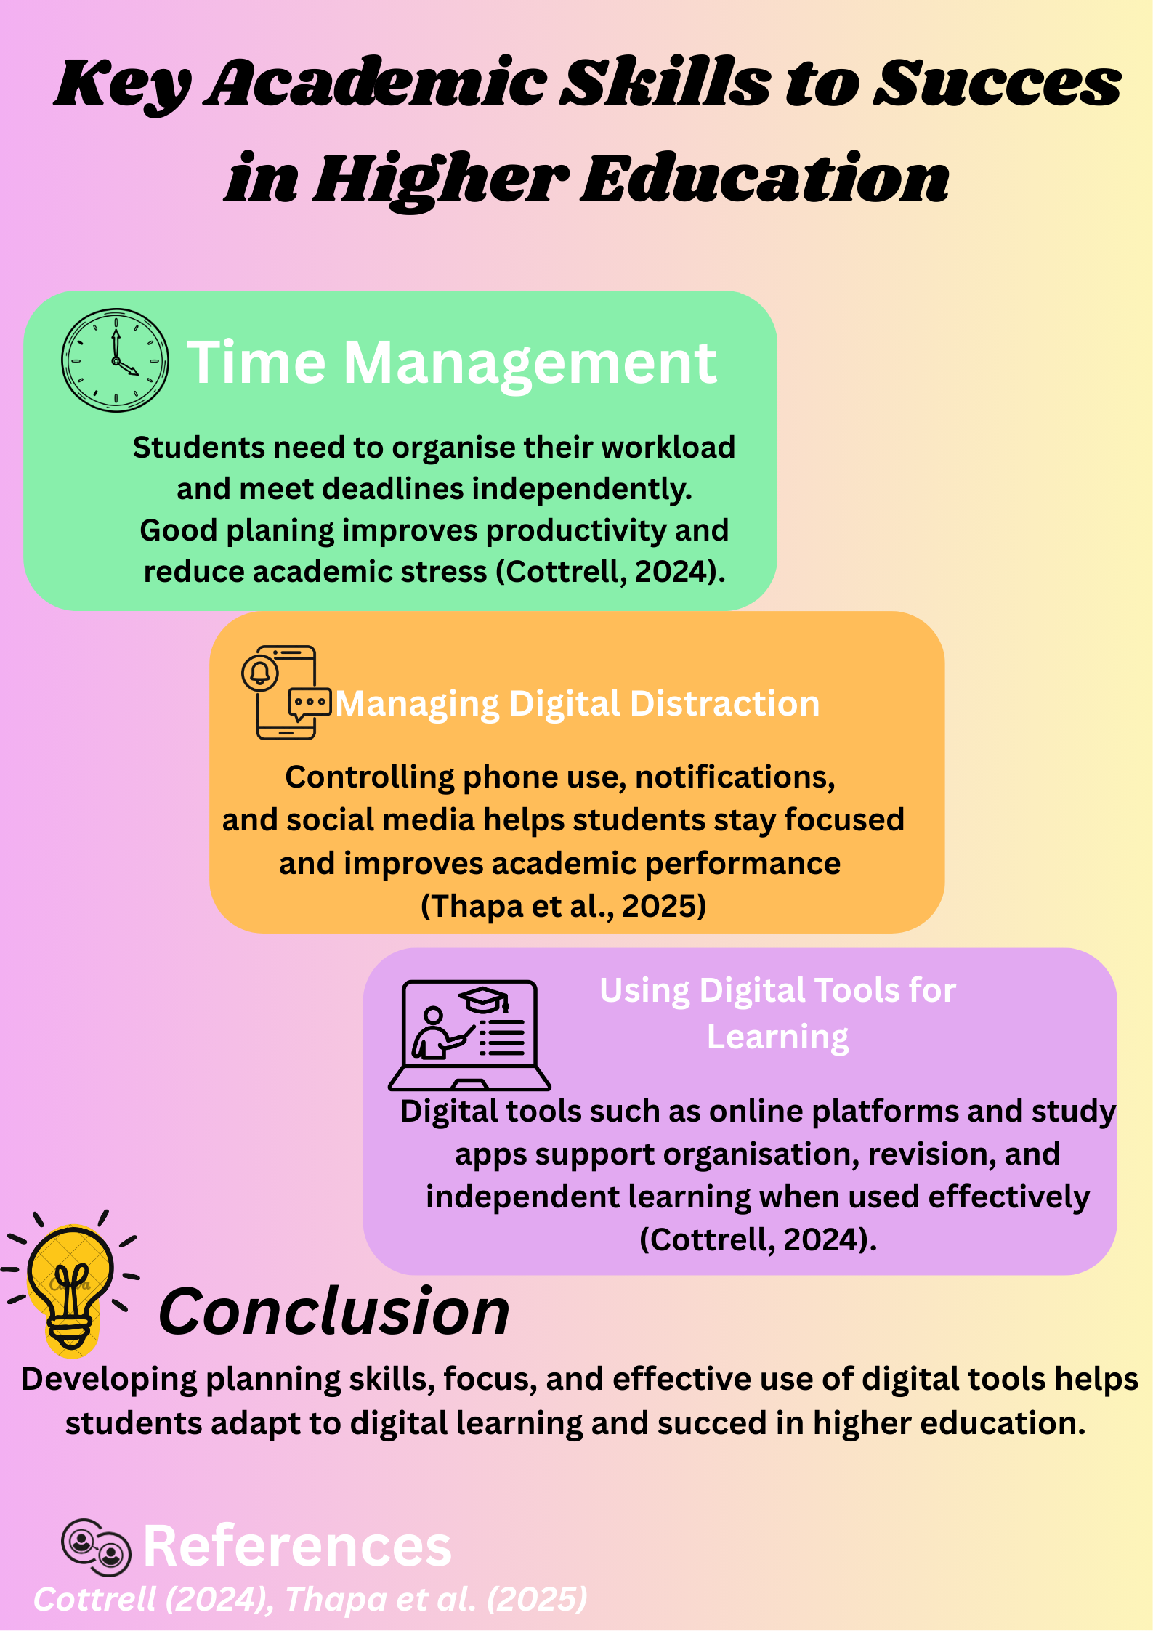

Reference List – Component 3
Cottrell, S. (2024) The Study Skills Handbook. 6th edn.
Available at: https://ebookcentral.proquest.com/lib/trinity/reader.action?docID=31357862&c=RVBVQg&ppg=1
Thapa, P., Sharma, P., Goundar, S., Tsirkas, P., Valamontes, A. and Adamopoulos, I. (2025) Digital distractions in the classroom among students: A cross-sectional study.
Preprints.org, pp. 1–12.
doi:10.20944/preprints202502.1931.v1

