Go to https://remotepc.uwtsd.ac.uk
- Login using your email address and university password for Moodle, email etc.
- Find the IQ building picture, click on Dashboard
- In the left-hand side of the window, browse to the lab you want (e.g., IQ 206 or IQ208 ), from the right-hand side of the window, click on a PC and choose Connect
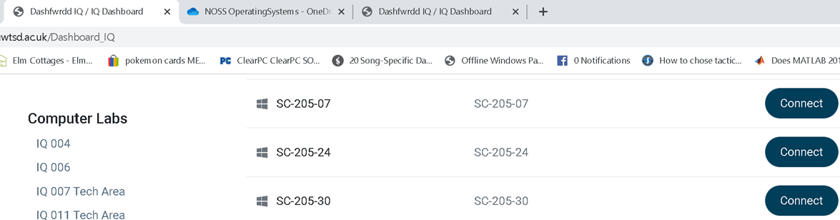

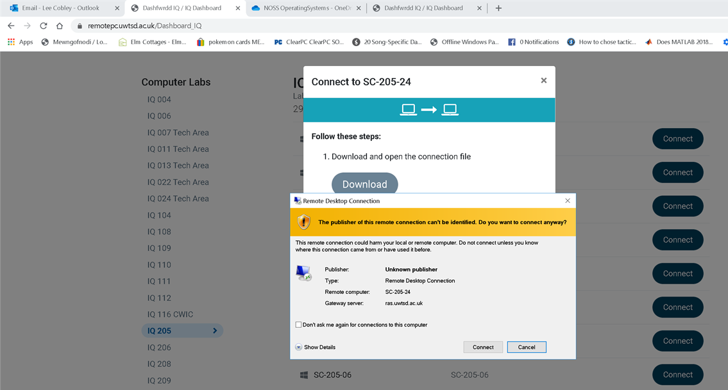

- Click Download BUT DO NOT YET CLICK CONNECT, INSTEAD CLICK CANCEL and then close the Remote Desktop Connection window that overlays this one (shown above). The RDP file we've just downloaded needs to be edited.
- Go into your Downloads folder (in Windows) and find the RDP file (in the instance above it is SC-205-24).
- Right click the file and choose Edit.
- Go to the Advanced tab, click on the Settings button and make sure the options look like this: It is important that the Use my RD Gateway credentials for the remote computer is checked off (see my example in the screen shot below)
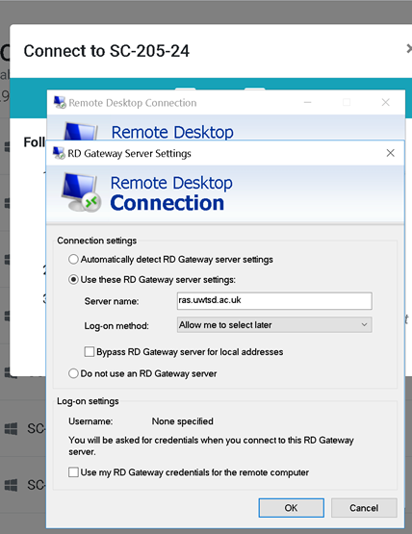

- Click Ok and then Connect.
- When prompted enter your full university student email address and the password you use for accessing Moodle.
- You should now receive an MFA notification from Microsoft Authenticator on your mobile phone, approve this as you usually do (proceed to step 12). If you DO NOT receive an MFA notification to your phone, you need to setup MFA here: https://www.uwtsd.ac.uk/mfa/
- Now, you will be prompted again in Windows for your SoAC login details.
- This time click More Choices, then click where it says Use a Different Account enter your SoAC username and password:
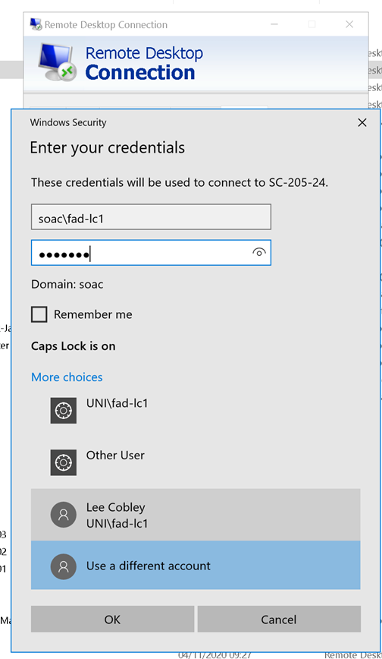

- Choose Ok Connect and 'Accept' any further connection prompts.
- You should now be logged into the SoAC system.
- NOTE, IF YOU ARE USING A MAC COMPUTER PLEASE FIRST GO TO THIS LINK: https://www.uwtsd.ac.uk/onlinelearning/
- UNDER THE REMOTE PC FREQUENTLY ASKED QUESTIONS SECTION, CLICK ON HOW DO I CONNECT, USING REMOTE PC
- CLICK REMOTE PC MAC OS TO WINDOWS CONNECTION GUIDE, THIS WILL OPEN UP A SHARED DOCUMENT/GUIDE.
- You need to scroll to Page 8 of the guide to the section entitled, "Connecting to a non uni.local device (SoAC.local), now carefully follow the steps presented in the guide.

