University of Wales Trinity Saint David
Community engagement
Organisational analysis

STUDENT NAME: Aygyul Shakirova, ID 1818045

2020

CONTENT

Introduction............................................................................................................3
Discussion..............................................................................................................6
The role of the employees within the organization…………………………………………..6
Staff training and development and why this is important for organization………8
The importance of the manager's role for the organization..................................9
The skills and knowledge that the manager must have in order to perform his activity……………………………………………………………………………………………………………..11
Manager training and development plan………………………………………………………….12
SWOT analysis………………………………………………………………………………………………….14
Conclusion..............................................................................................................16
References..............................................................................................................17

Introduction

Joshi (2018, p.7) gives defined to organizations “ an organization is the structure and process by which a cooperative group of human beings allocates its tasks among its members, identifies relationships and integrates its activities towards common objectives".

Italian restaurant Uno is one of those organizations. ( Link: unorestaurant)

Liberto ( 2019), states that “The European Union (EU) offers clearer definitions, characterizing a small-sized enterprise as a company with fewer than 50 employees and a medium-sized enterprise as one with less than 250 employees. In addition to small and mid-size companies, there are micro-companies, which employ up to 10 employees.”

Restaurant Uno is small size company with fewer than 50 employees.

Different types of organizations identified by their product are industrial or commercial, commercial type organizations could be services - one of this service is catering sector. (Joshi, 2018, p.25).

Restaurant Uno is commercial, service type organization, who is operating in catering sector.

UNO restaurant staff structure.

General Manager
Assistant Manager
Bookkeeper
Head Chef
Bartender
Kitchen Porter
Chefs
Cleaner
Waiter Staff
Head Waiter

( Link: unorestaurant)

Uno Restaurant covers a wide range of different types customers as families with children, singles, college or students, business people, tourists, vegetarians, authentic Italian food lovers, regular customers. ( Link: unorestaurant).
Definitions of good and service are explained in business dictionary : ” The most basic products of an economic system that consist of tangible consumable items and tasks performed by individuals. Many business portfolios consist of a mix of goods and services that they offer to potential consumers via a sales force.”
(link businessdictionary).

The expectations of the customers from the Uno restaurant are in two aspects:
-goods - authentic Italian food, preparation with fresh, organic ingredients, vegetarian menu, homemade pasta and bread.
-services - professional service - adaptive, positive, informative staff, providing a cozy and pleasant surroundings. ( Link: unorestaurant).

Whittington associates describe that: “Your mission is the business reason for your organization’s existence. It is an element of the charter. It doesn’t describe a specific outcome and contains no time limit or measurement. The mission statement provides the basis for setting your goals and is used to allocate resources.”
Restaurant Uno has mission to offer the best in classical Italian cuisine and in contemporary Italian fine dining with the friendliest, most professional service, in the most elegant of surroundings.
Whittington associates states about value statement that : “Values are the beliefs behind your vision and mission. A worthy vision is guided by worthy values. Values give dignity and direction to your mission. They are the moral compass and expected behaviors during your vision quest”
The values of the restaurant are: the process of using the freshest, authentic Italian and organic ingredients, homemade pasta and bread, friendly, most professional service,
Goals must be defined in accordance with your vision, mission and strategic directions.
( Link: Whittingtonassociates).

Uno has the following goals:
- preparing and offering the best authentic Italian food;
- providing high standard of professional service to achieve maximum customer satisfaction;
- offering pleasant and cozy setting. ( Link: unorestaurant).
Discussion
The role of the employees within the organization
The obligations to the staff are set in the job description, which the manager compiles and uses.
The manager directly manages the restaurant. He is responsible for activities. His main task is ensuring efficiency in the activities of the restaurant, which are corresponding to the category of the best quality of service.
Assistant manager manages the restaurant when the manager is absent. He is responsible for:
- managing and controlling the overall organization of the service;
- organizing the preparation of the trade hall, instructs and distributes the work of the waiters.
- controlling the appearance, behavior during work and the level of staff service, as well as the hygiene of the trade hall and the entrance. -welcoming, accommodating and sending guests. If necessary, provides assistance to the waiters, participating directly in the service of guests. -accepting orders for pre-booking seats in the hall of one or more guests, at whose request, he compiles and offers a suitable menu for the occasion.
The head waiter manages the waiter staff and replaces the bartender when he is absent.
Waiters are the main figures in the trading hall. They participate in almost all stages of service - welcoming, accommodating and sending the guest and serving. The quality of service most depends from them.

The bartender makes hot drinks, cocktails and prepares any drinks.

Head Chef is the leader of a team preparing food in the restaurant. He leads the processes to prepare foods and cook dishes, and he monitors the suitability, quantity and quality for all those dishes. He prepares the menu and provides the staff all the recipes used in the kitchen. The head chef organizing and distributes the responsibilities among the staff. He is a materially responsible in the kitchen, also he is responsible to control hygiene in the kitchen during production and storage of food products.

Chefs prepare foods and cook dishes alone or under the guidance of a head chef, they have to comply with the technology of cooking process. They are responsible for the quantity and quality of the products used in the cooking process as they have to work in accordance with the established recipes. They are responsible for the quality and taste of prepared food and cooked dishes.

Kitchen porter is responsible for:
- taking delivery of products;
-helps to chefs with the preparation of products;
-dishwashing kitchen stuff;
-cleans all kitchen and keeping cleanliness the kitchen area;

Cleaner cleans and keeps in a clean condition the trade hall (when there are no guests in it) and the entrance section, incl. the toilets.
( Link: unorestaurant)

Staff training and development and why this is important for organization

The training and development of the employees is of essential importance for every organization as they are most valuable asset of the organization. The quality of the products and services, the satisfaction of the clients, retaining previous customers and attracting new ones depend on these employees. Without training and development, employees could not be able to use their full potential in performing their tasks. Also the training and development help employees to becoming more motivated, productive, satisfied and innovative in their work. (Walters and Rodriguez, 2017).

The manager requests to head waiter to train newly appointed waiters. Head waiter explains to them internal rules of the restaurant which are about orientation of restaurant policies and procedures and he shows them some skills such as welcoming customers, presenting menu and wine list, proper serving, sending customers.
Head chef has to train newly appointed chefs. He must introduce to them main restaurant policies and procedures, main duties in kitchen, how to handle cooking process and their main tasks.
Head waiter has to train the cleaner. He trains the cleaner about how to provide daily high standard of cleanliness throughout the restaurant.

There is no staff development program in this restaurant, although there are needs for staff development in different areas.

The importance of the manager's role for the organization

The figure below shows the importance of the role of the restaurant manager. He must controls and balances more than a few influences at the same time.

Manage the Boss

Manager

Manage the Team
Manage the shareholders

(Elly. R and Kamugisha, 2017, p.16)
The skills and knowledge that the manager must have in order to perform his activity
The main duties of the manager in the restaurant are:
-Provides the necessary utensils and other equipment for the trade hall.
- Draws up a schedule.
- Selects and appoints staff.
-Controls the level of service.
-Researches consumer demand.
-Introduces new, progressive forms of service.
-Looks for opportunities and implements various activities to increase customers and efficiency of trade halls.
-Welcomes and sends, sometimes participates directly in the service of official guests.
- Prepares a menu together with the head chef and controls its implementation.
The manager to be able to do his job successfully, he has to learn and has to get skills for these topics:
- to knows regulation about “health and safety in catering industry”. ( Link:gov.uk/catering).
- “guide: catering and food service, allergen guidance for the hospitality industry, catering guide: industry guide to good hygiene practice.”(link:ukhospitality).
- to has got skill to implementation the following 5 function: 1.planning - setting goals and find the right way to achieve them;
2. organizing- indicating the urgent tasks that must be completed in order to achieve the goals;
3. commanding - giving instructions to his subordinates to perform the assigned tasks;
4.coordinating-balancing the activities of individuals and groups into the organization to help the organization to improve and achieve its goals;
5. controlling-ensuring the completion of the work according to the plan through continuous monitoring of all activities in the organization. (Elly. R and Kamugisha, 2017, p.11).

- to learns the following skills:
strategies for managing conflicts – conflict management is important to ensure a balanced and successful work process for employees; Elly. R and Kamugisha, 2017, p.20).

time management – the activities must be organized and graded according to their urgency and importance ,needing to cope with procrastination – method to avoid that, is setting SMART – (specific, measurable achievable, timed and targeted) goals. (Elly. R and Kamugisha, 2017, p.22).

Manager training and development plan

The manager of the Uno restaurant worked as a head waiter for 5 years. During these 5 years he trained to work in every department of the restaurant. In restaurant Uno there is no development plan for Manager.
The Uno manager needs to improve his knowledge and skills. This is achievable when the manager implements the following training and development plan:

Training plan - need to train him to be able effectively and correctly to perform the 5 functions:
1. Planning;
2. Organizing;
3. Commanding;
4. Coordinating;
5. Controlling.
He has to learns skills about conflict management and time management

Development plan – he has to develop:
1. recruitment skills –Bryant (Link: article- how to hear the right person ) gives three principles that can help to hire the right person:
1.1“ Be creative” - not to use the classic questions for an interview but you find an alternative way to understand how the other person thinks;
1.2“Be challenging”- choose situations in which the candidate can best repent of his nature;
1.3. “Allow your employees to help”- request advice from those employees whom you trust.
2. Skills for effective complaint handling:
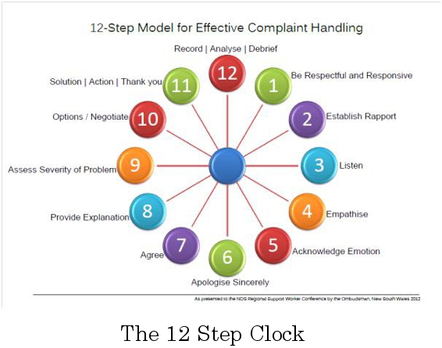
(Gpsbenchmarking, 2013)

SWOT analysis
SWOT is useful method to help processes of understanding and decision making for all type circumstances in the business or organization. (Link:businessballs).

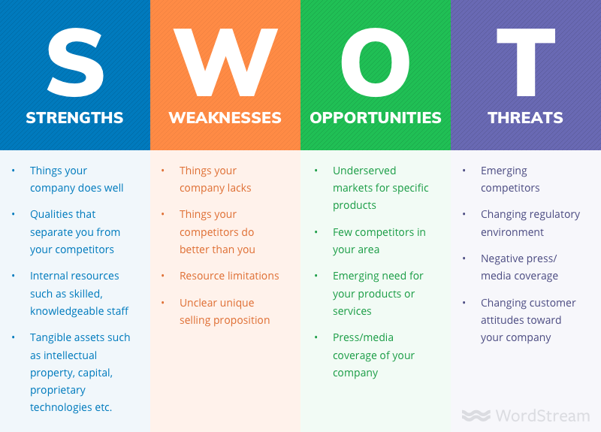
( Shewan, 2020)

SWOT analysis for the restaurant UNO
Competitors to open a new Italian restaurant nearby and offer low prices or attractive promotional packages.
The head chef who has many years of good experience in making Italian food to get a better job offer.
Improving advertising for the restaurant - sharing more information, showing good feedback. Increase customers by offering gluten-free foods, providing delivery services, offering a promotional package for regular customers, students or a children's menu.
Menu prices are not the cheapest, lack advertising, lack staff's motivation program, high staff turnover, lack clearly definition
there is no motivation program for the staff
lack clearly defined program for staff training and development.
Offers traditional and unique experience since 1997 in making authentic Italian food using fresh and organic ingredients
The head chef of the restaurant has the best experience and culinary knowledge in the preparation of Italian food.
Good location in the heart of Pimlico - there is many hotels in the area where many tourists stay.
Offers vegetarian food
provides a pleasant and cozy atmosphere

T
THREATS
O
OPPORTUNITIES
W
WEAKNESSES

S
STRENGTHS

Conclusion

Conclusion
Uno restaurant owing to its traditional, long experience has coped to build and maintain its brand in the chain of restaurants offering Italian food.
The restaurant has the ability to develop a successful business and to be more attractive by improving its activities, attracting new customers for this purpose it is necessary to manage processes that will help to overcome the weaknesses of the restaurant and will contribute to the realization of its capabilities.

References
1. Elly,R. and Kamugisha,T. ( 2017) The basics of business management -Vol I: Leadership, Financial Management and Economics. 1st edition. [e- book]. Available at: http://online.kottakkalfarookcollege.edu.in:8001/jspui/bitstream/123456789/1214/1/the-basics-of-business-management-vol-i.pdf [Accessed: 20th March 2020].
2. Joshi, M. (2018) Organisatios. 1st edition.[e- book]. Available at: https://bookboon.com/en/organisations-ebook [Accessed: 20th March 2020].
3. Bryant, A. “How to hire the right person” . The New York times business. [Online]. Available at:https://www.nytimes.com/guides/business/how-to-hire-the-right-person [Accessed: 16th April 2020].
4. Liberto, D. ( 2019) “Small and mid - size enterprise”. [Online]. Available at: https://www.investopedia.com/terms/s/smallandmidsizeenterprises.asp [Accessed: 20th April 2020].
5. Rodriguez, J. and Walters, K. ( 2017) “ Importance of training and development in employee performance and evaluation”. International Journal. [ Online]. Available at: https://www.researchgate.net/publication/332537797_The_Importance_of_Training_and_Developmet_in_Employee_Performance_and_Evaluation [Accessed: 20th April 2020].
6. Business dictionary, (2020) Definition of goods and services [Online]. Available at: http://www.businessdictionary.com/definition/goods-and-services.html [Accessed: 10th April 2020].
7. Businessballs, (2019) “SWOT analysis”. [Online]. Available at: https://www.businessballs.com/strategy-innovation/swot-analysis/ [Accessed: 17th April 2020].
8. Gov.uk, “health and safety in catering industry” [Online]. Available at: https://www.hse.gov.uk/catering [Accessed: 10th April 2020].
9. Gpsbenchmarking, ( 2013) “Model for Effective compliant handling”.[Online]. Available at: https://www.qpsbenchmarking.com/news/the-12-step-clock-model-mclean-care/ [Accessed: 17th April 2020].
10. UK Hospitality “guidance for the hospitality industry”. [Online]. Available at: https://www.ukhospitality.org.uk/page/GuidesandToolkits [Accessed: 16th April 2020].
11. Whittington associates “Vision,mission, values, goals and objectives”.[Online]. Available at:
https://www.whittingtonassociates.com/2016/12/vision-mission-values-goals-objectives/ [Accessed: 10th April 2020].
12. Shewan, D. (2020) “How to do a SWOT analysis”. [Online]. Available at: https://www.wordstream.com/blog/ws/2017/12/20/swot-analysis)[Accessed: 18th April 2020].
13. http://www.unorestaurant.co.uk/

