

Flor de Maria Galindo Manuel de Killick
Student Number: 2124309

Module: Effective Teamworking and Communication (Health and Social Care)

Module code: BMSW4002
Lecturer: Balendran Kandasamy

Table of contents

- Introduction…………………………………………………………………………1
- Communication Models …………………………………………………………..2
- Communication Skills………………………………………………………………3
- The Advantages and Disadvantages of Communication Technology.............4
- Conclusion………………………………………………………………………......5
- References………………………………………………………………………......6

- Introduction
This report has the objective of helping me understand why communication is so vital in the workplace. First, I must understand the definition: Communication includes giving, receiving, and exchanging messages through chatting, writing, listening, and reading. Efficient communicators listen carefully to others, speak or write clearly and treat others with respect. (Media, 2020). Communication in the workplace is essential because it helps to give employees morale, engagement, productivity, and happiness. Teamwork can lead to collaboration and cooperation as well as better results for individuals, teams, and organizations. Strong communication skills are important in becoming a manager who can motivate their teams to perform better with fewer misunderstandings because if they don't have great communication skills, it can affect the message and the potential outcomes of poor communication. (Cooks-Campbell, 2022).

- Models of Communication

  - Shannon and Weaver (1948/49)

- This communication model is a linear theory that was created to ensure effective communication between sender and receiver. However, components such as "noise" affect the processing of the message during delivery. The components of the model are the sender (source of information), the encoder (transmitter), the channel (noise), the decoder (receiver) and the receiver (destination). The data is stored at the information source. The message is encoded into signals so that it can be transmitted to its destination. Once encoded, the message passes through the channel to which the signals have been adapted for transmission. The channel, in turn, carries any noise that may cause the signal to receive information different from that of the source, as in the practical case of "Maria and Pedro", where the noise of the construction site could have altered the message that Maria and Pedro heard. Instead of "chicken", use "kitchen". After going through the channel, the message was transmitted to the receiver, but the noise distorted it. (David, 2022).

(Drew, 2022)
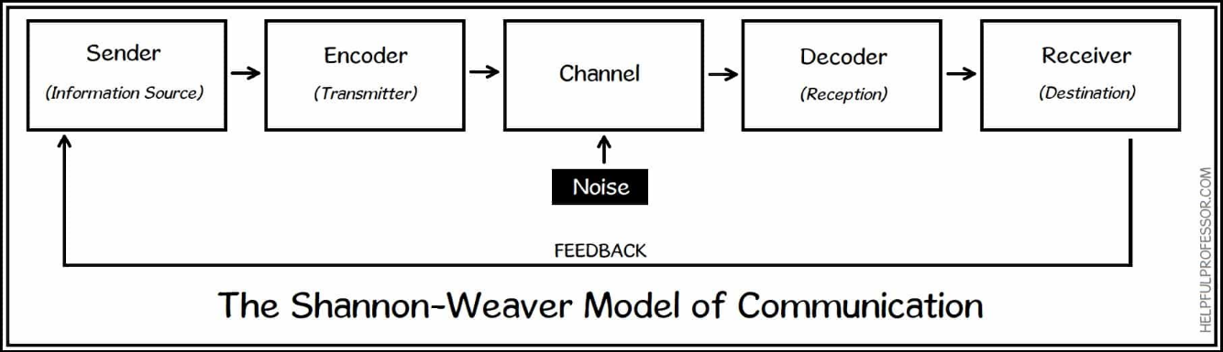

- The limit of the model is the noise that will distort the message.
- The model does not explain how to avoid misunderstandings because when the information is delivered to the recipient, the communication ends; that is, no feedback is given.
- At my workplace, the manager called to inform the staff that at 11 in the morning he had to give 1 antibiotic to a patient, but since they were making too much noise, he understood that it would be at 12 in the day, so at that time, he gave him the medicine. As there was a lot of noise, he gave him the medicine at the wrong time. The noise was the problem.
2.2. Schramm (1954)

- Schramm's communication model, which was inspired by the Shannon-Weaver model, was created in 1954. However, Osgood was the first to propose that communication is a circular model rather than a linear one, which Schramm adapted and cited in his book. According to this model, communication is a circle in which information is constantly sent between sender and recipient. It is made up of four parts: an encoder or emitter, a decoder or receiver, an interpreter, and a message. According to this guide, information travels from sender to receiver, but when the recipient returns a message to sender, the roles are reversed. The transmitter transforms into the recipient and vice versa. However, communication is not complete in this model until the sender gets information from the recipient. (Bhasin, 2021).

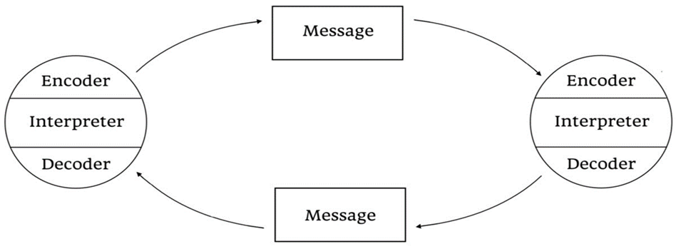
(Drew, 2022)

- In Pedro and Mary’s case study, he could have called her and asked if she said, “chicken or kitchen”.
- Schramm's communication model is a circular model since it is considered a bilateral process. (Bhasin, 2021).
- Giving feedback will reduce interference since this type of communication makes it easier for the sender to identify whether or not the message was received, clarified, and understood by the recipient. The sender might choose to confirm that the message was received and understood by the intended recipient.(Bhasin, 2021).

2.3. Berlo (1964)
The SMCR model is another name given to Berlo's communication model and it was developed from the Shannon and Weaver model but in this model each part of the communication process is impacted by the emotional content of the message and is responsible for emphasize any possible encoding and decoding that occurs between sender and receiver. This model is simple and considers all the main factors that are part of any communication process, as well as the factors that affect them. In some cases of purer forms of communication, such as person-to-person communication, this model is still used. The limitation of this model is noise, which causes any message to be interrupted and lost, so this model does not consider noise or feedback. (Bhasin, 2021).
Berlo's model describes the communication process through four components: SMCR, which stands for Sender, Message, Channel, and Receiver, and these components are also affected by other circumstances. (Bhasin, 2021).
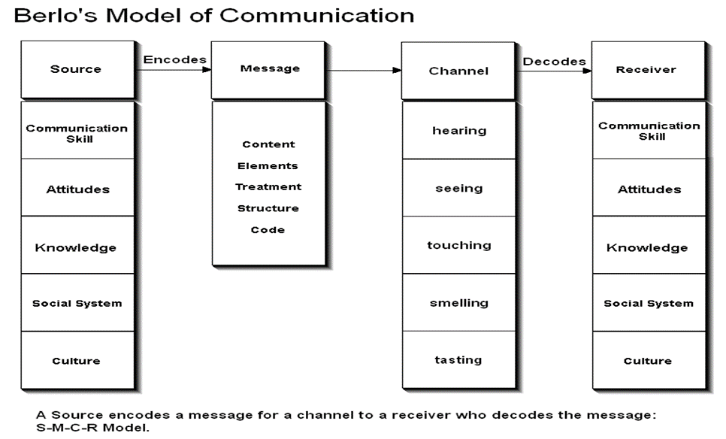
(Anon., 2018)

S-Sender
The sender is the person or source that originates the message and sends it to the receiver. There are five factors related to the sender: firstly, the person must have the ability to communicate, because ineffective communication will make the receiver unable to receive the message, secondly the person must have attitude because the effect of the message will be created by the attitude of the sender as well as the receiver, thirdly there is the knowledge of the communicator, if the person knows the subject the messages will be sent effectively, fourthly we have the social systems, such as values, opinions, regulations, rules, norms, religion and a whole series of elements that will influence the way a message is communicated and fifthly we have culture, this factor will cause the messages to have different cultural variants that could be misinterpreted by the receiver. (Communication, 2018).
M-Message
A message is a source that the sender sends to the receiver through various means such as voice, audio, text, sending videos or other types of channels. The main elements that influence the message are: The content that goes from start to finish and its content is the message, secondly we have the non-verbal elements such as gestures, signs and languages that accompany the content, thirdly we have the treatment, which is the way the message is delivered to the recipient and this has an impact on the recipient's feedback, fourthly we have the structure, because the effectiveness of the message is influenced by the way it is organized and fifthly there is the code, the message is sent in the form of code and can take the form of language, writing, video or other media. (Communication, 2018).
C-Channel
A channel is a medium by which communication is transmitted, such as the telephone or the Internet. However, in communication in general, it is our five senses that are the channels through which communication travels and influence its effectiveness, first we receive the word through listening, second we obtain non-verbal information when we see. Non-verbal communication also includes holding hands, the third is smell, where we collect information through smelling, and lastly taste that conveys information and can be used to convey a message. (Communication, 2018).

R-Receiver
The receiver is the individual who gets the message delivered throughout the process; nevertheless, the receiver must also have excellent listening abilities and other characteristics comparable to the sender: Communication abilities, attitudes, knowledge, social systems, and culture are all important. (Communication, 2018).
Case study
In the case of the study "The Professor and The Village People," the communication due to the educational level of the teacher was not understood by the villagers, who did not understand that the word "conflagration" was the same as saying "fire. Communication-Face to-Face-Receiver. (b, 2019).
Using Schramm's (1954) circular model, the professor, seeing that people did not understand what he was saying, could have shouted "fire" instead of "conflagration". Feedback- face-to-face- receiver.

- Communication Skills

  - Verbal Communication:

The goal of good verbal communication is to get your message across clearly and directly in a few words, whether in person, on the phone or by email. Your audience will lose interest or be unclear about what you want if you talk too much. Avoid over-communicating and confusing your audience by first thinking about what you are going to say before you speak. (Doyle, 2021)
  - Non-Verbal Communication
Body language, eye contact, hand gestures and the tone of voice used to convey information are examples of non-verbal communication. Eye contact gives the other person the assurance that you are listening to what they have to say. Others will communicate openly with us if we adopt a pleasant, open and relaxed tone and posture. We will also see non-verbal signals when we talk to people. Non-verbal signals often reveal a person's true feelings (Doyle, 2021).
  - Listening
One of the best skills to communicate effectively is to be a good listener and give people time to express themselves so you can understand what they are saying. Spend some time honing your active listening skills to make sure the other person understands and can respond correctly. Active listening means paying close attention to what they say, asking clarifying questions, and reinforcing what they have said. (Doyle, 2021). Empathetic listening, even if you disagree, listen carefully to what the other person has to say. Put yourself in the other person's shoes and avoid asking direct questions. (Team, (n.d.)).
In my workplace the manager told me to clean the residents' rooms with special disinfectants, she explained all about the technique to me, however, I did not understand what she said because she spoke very fast, she finished giving me the instructions and left without asking me if I understood and you can't do what you told me because I didn't understand. If the manager had asked me if she understood, she would have avoided confusing me and done my job.

- The Advantages and Disadvantages of Communication Technology

Advantages:
- higher productivity.
- This is a quicker way to communicate in an emergency.
- having global communication capabilities.
- Communication across a distance is simpler. (Jones, 2012).
Disadvantages:
- Older generations may find it more challenging to utilise it.
- Cyberstalking and cyberbullying.
- It makes interaction less private.
- It is not always clear to whom you are speaking. (Jones, 2012).

- Conclusion
By doing this report, I have understood and am more aware of how I am going to improve my communication skills so that I can better express myself to those around me. Throughout the writing of this report, I have learned about the importance of communication, its models and skills, and the advantages and disadvantages of communication technology. Learning about all these communication topics contributes to having more knowledge. I also received help from the professor, who instructed us on how to do our presentations and reports and gave us a lot of feedback and support.

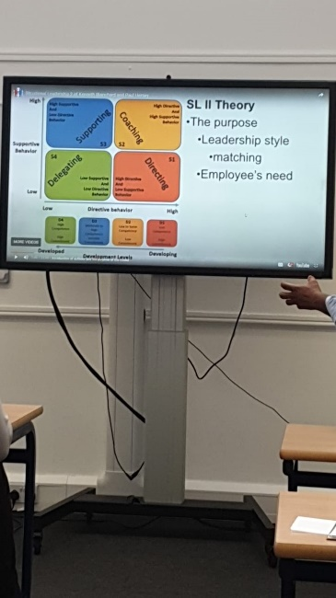
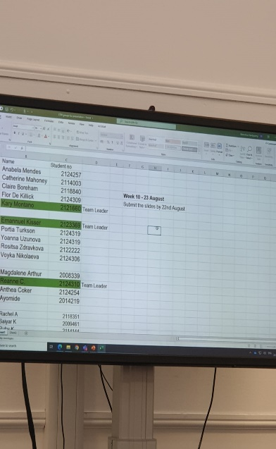
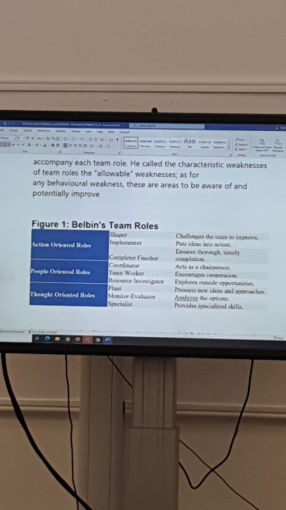

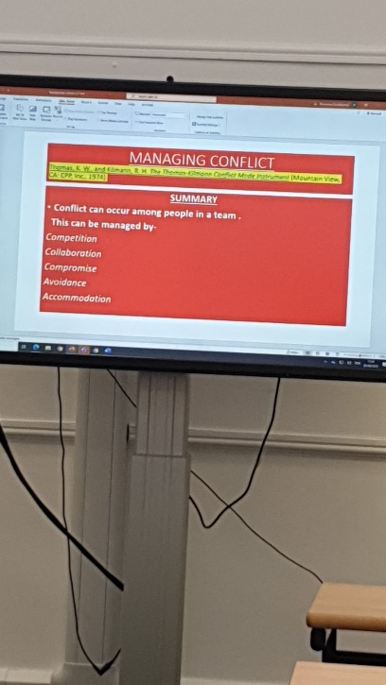
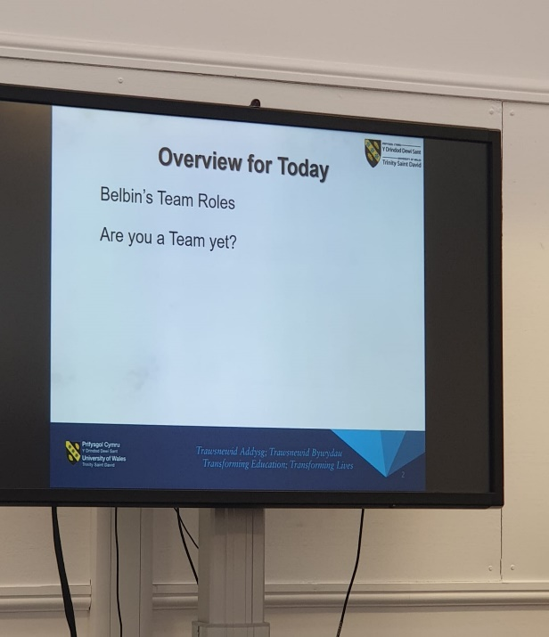

References
- Alison, D. (2021) "Communication Skills for Workplace Success". [Online] Available from: https://www.thebalancecareers.com/communication-skills-list-2063779 (Accessed: 27 August 2022).

- Businesstopia in Communication. (2018) "Berlo’s SMCR Model of Communication". [Online] Available from: https://www.businesstopia.net/communication/berlo-model-communication (Accessed: 26 August 2022).

- Allaya, C. (2022) "Communication is key in the workplace. Here's how to improve". [Online] Available from: https://www.betterup.com/blog/why-communication-is-key-to-workplace-and-how-to-improve-skills (Accessed: 24 August 2022).

- Hitesh, B. (2021) "Schramm’s Model of Communication | Elements, Advantages & Limitations". [Online] Available from: https://www.marketing91.com/schramms-model-of-communication/ (Accessed: 25 August 2022).

- MacKenzie, J. (2012) "Communication of Technology: Advantages and Disadvantages". [Online] Available from: http://mackenziejones212.blogspot.com/2012/02/google-chrome-advantages-and.html
(Accessed: 27 August 2022).

- Chris, D. (2022) "Shannon Weaver Model of Communication – 7 Key Concepts". [Online] Available from: https://helpfulprofessor.com/shannon-weaver-model/#:~:text=The%20Shannon%20and%20Weaver%20Model,noise%2C%20decoder%2C%20and%20receiver (Accessed: 25 August 2022).

- Chris, D. (2022) "Osgood-Schramm Model of Communication – Pros & Cons". [Online] Available from: https://helpfulprofessor.com/osgood-schramm/ (Accessed: 25 August 2022).

- Common Sense Media. (2020) "What is communication?". [Online] Available from: https://www.commonsensemedia.org/articles/what-is-communication (Accessed: 10 August 2022).

- CFI Team. (2022) "Communication Skills". [Online] Available from: https://corporatefinanceinstitute.com/resources/careers/soft-skills/communication/ (Accessed: 11 August 2022).

