

LOCATION: Swansea | LLEOLIAD: abertawe
LEVEL 5 | LEFEL 5
EXAMINATION PERIOD | CYFNOD ARHOLIADAU
MAy 2026 | 2026

MODULE CODE: ACDC5009
Electromagnetic Radiation

Programme:
B.Eng. in Embedded Electronic Systems

TIME: 2 HOURS
answer ALL questions

Equipment or materials required – Calculator
Adnoddau neu ddefnyddiau sydd eu hangen - Cyfrifiannell

ANSWER ALL QUESTIONS

Question 1 [25 Marks]
- Describe the fundamental properties of Electromagnetic waves. [6 Marks]
Answer:
- They does not require any medium for propagation.
- Electromagnetic waves can be reflected, refracted, absorbed, diffracted, scattered and produce interference patterns.
- They are transverse in nature.
- Electromagnetic waves travel with a constant velocity in vacuum. The speed of the waves is 3x10⁸m/s.
- They obey the equation $C = fλ$, f is the frequency in Hertz and λ is the wavelength in metres. C= $3×$10⁸ m/s. From this relation, the electromagnetic waves travel with the speed of light regardless of wavelength and frequency.
- The oscillating electric field and magnetic field are in the same phase.
- They may be polarised. [ Each point 1 mark, maximum of 6 marks]
- Given the speed of light in vacuum is $C=3×{10}^{8}m/s$, Calculate the refractive index of a medium if the speed of the light in the medium is $2.5×{10}^{8}m/s$. [4 Marks]
Answer:
$n=\frac{c}{v}=\frac{3×{10}^{8}}{2.5×{10}^{8}}$ [2 Marks]
$n=1.2$ [2 Marks]
- Describe the following terms used in Electromagnetic radiation
- Diffraction [2 Marks]
- Numerical Aperture [2 Marks]
- Dispersion. [2 Marks]
Answer:
- Diffraction,
Diffraction is defined as the interference or bending of waves around the corners of an obstacle or through an aperture into the region of geometrical shadow of the obstacle /aperture. The diffracting object or aperture effectively becomes a secondary source of the propagating wave. [1 Mark]
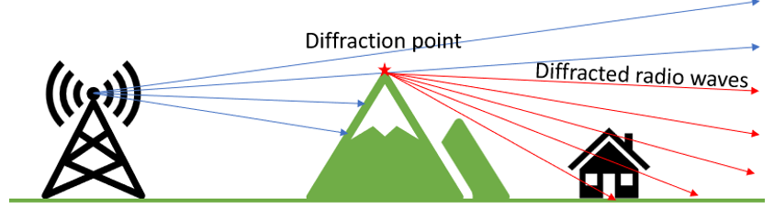 [1 Mark]
- Numerical Aperture
Numerical Aperture (NA) is a dimensionless number that characterizes the range of angles over which an optical system can accept or emit light. It is related to the light-gathering ability and resolution of the optical system. [2 Marks]
$$NA=\sqrt{n_{1}^{2}-n_{2}^{2}}$$
- Dispersion.
Dispersion refers to phenomenon where different wavelengths of light travels with varying velocities as they travel through the fiber. It causes pulses of light to spread out over time, leading to signal degradation and limiting the transmission capacity of the fiber. [2 Marks]
- An optic fiber has a numerical aperture (NA) of 0.48, and the refractive index of the cladding is 1.45. Apply appropriate computational techniques to calculate the refractive index of the core and the acceptance angle, assuming light enters the fiber from air. [5 Marks]
Answer:
NA=0.48
$n_{2}=1.45$
Refractive index of air (n)=1
$NA=\sqrt{n_{1}^{2}-n_{2}^{2}}$ [1 Mark]
$0.48=\sqrt{n_{1}^{2}-{1.45}^{2}}$
$n_{1}^{}=\sqrt{{1.45}^{2}+{0.48}^{2}}$ [1 Mark]
$n_{1}=1.53$
$θ_{a}={Sin}^{-1}\left(\frac{NA}{n}\right)$ [1 Mark]
$θ_{a}={Sin}^{-1}\left(\frac{0.48}{1}\right)={28}^{0}.69$ [2 Marks]
- Explain Active Radar Homing. [4 Marks]
- The missile has its own onboard radar transmitter and receiver.
- It detects, locks onto, and tracks the target independently without relying on the launching aircraft.
- Fire and Forget, the launching aircraft does not need to maintain radar lock, allowing it to engage multiple targets.
- Longer Engagement Range – ARH missiles can engage targets beyond visual range (BVR), typically over 100km [3 Marks]
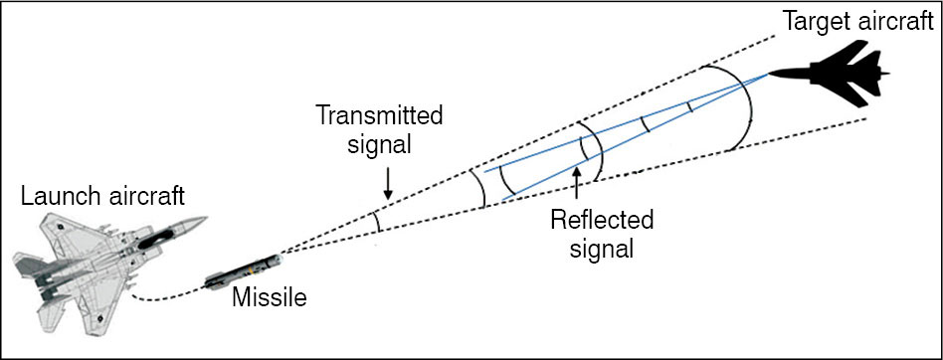
[Rough sketch 1 Mark]
Question 2 [25 Marks]
- A conductor located at a point $P\left(-0.2,0,-2.3\right)m$ is influenced by an electric field generated by a nearby point charge of $+7nC$ placed at $Q\left(0.2,0.1,-2.5\right)m$ in air. Calculate the electric field intensity vector at the conductors position, applying appropriate mathematical principles. [13 Marks]
Answer:
$\overline{E}=\frac{Q}{4πε_{0}d^{2}}\overline{a}$
$\overline{P}=-0.2{\overline{a}}_{x}+0{\overline{a}}_{y}-2.36{\overline{a}}_{z}$ [1 Mark]
$\overline{Q}=0.2{\overline{a}}_{x}+0.1{\overline{a}}_{y}-2.5{\overline{a}}_{z}$ [1 Mark]
${\overline{d}}_{QP}=\overline{P}-\overline{Q}=-0.4{\overline{a}}_{x}-0.1{\overline{a}}_{y}+0.2{\overline{a}}_{z}$ [1 Mark]
$\left|{\overline{d}}_{QP}\right|=\sqrt{{(-0.4)}^{2}+{(-0.1)}^{2}+{(0.2)}^{2}}=0.46$ [2 Marks]
$\overline{a}=\frac{{\overline{d}}_{QP}}{\left|{\overline{d}}_{QP}\right|}=\frac{-0.4{\overline{a}}_{x}-0.1{\overline{a}}_{y}+0.2{\overline{a}}_{z}}{0.46}=-0.87{\overline{a}}_{x}-0.22{\overline{a}}_{y}+0.43{\overline{a}}_{z}$ [2 Marks]
$\overline{E}=\frac{7×{10}^{-9}}{4π×8.85×{10}^{-12}×{0.46}^{2}}[-0.87{\overline{a}}_{x}-0.22{\overline{a}}_{y}+0.43{\overline{a}}_{z}]$ [2 Marks]
$\overline{E}=297.46[-0.87{\overline{a}}_{x}-0.22{\overline{a}}_{y}+0.43{\overline{a}}_{z}]$ [2 Marks]
$\overline{E}=-258.79{\overline{a}}_{x}-65.44{\overline{a}}_{y}+127.91{\overline{a}}_{z}$ N/c [2 Marks]
- A light ray travelling in a medium with a refractive index of 1.6 strikes the surface of a block of glass at an angle of incidence of ${45}^{o}$. The glass block has a refractive index of 1.5. Calculate the critical angle for total internal reflection at the interface. [5 Marks]
Answer:
Refractive index of unknown medium ($n_{m})=1.6$
Refractive index of glass ($n_{glass})=1.5$
Angle of incidence $={45}^{o}$ [1 Mark]
Critical angle $θ_{c}=\sin^{-1}\left(\frac{n_{glass}}{n_{m}}\right)=\sin^{-1}\left(\frac{1.5}{1.6}\right)$ [3 Marks]
$θ_{c}={69}^{o}.64$ [1 Mark]
- What is signal modulation? Describe the benefits of modulating a signal in RF communication system. [7 Marks]
Answer:
Modulation is the process of varying one or more properties of a periodic waveform called the carrier signal, based on the message signal that contains information to be transmitted. [3 Marks]
The Benefits are
- Efficient Antenna Size
- Long-Distance Transmission
- Bandwidth Efficiency
- Multiplexing
- Noise Immunity [Each point 1 mark, maximum of 4 Marks]
Question 3 [25 Marks]
- Describe the functions of each component in a Parasitic Array Antenna with necessary diagram. [10 Marks]
Answer:
Driven Element: The Yagi antenna has one active element called the driven element, which is connected to the transmitter or receiver.
Parasitic Elements: The antenna also includes one or more passive elements known as parasitic elements. These are typically longer or shorter than the driven element and are arranged in a specific pattern.
Reflector Element: The rearmost parasitic element acts as a reflector. It reflects the incoming waves back towards the driven element, enhancing the overall antenna performance.
Director Elements: The parasitic elements in front of the driven element act as directors. They focus the electromagnetic waves in the desired direction, providing directionality to the antenna.
Boom: The element on which all these are placed is called a boom. It is a non-metallic structure which provides insulation, so that there will not be any short circuit between the other elements of the array. [Each component 2 marks, maximum of 10 marks]
- What is Frequency Hopping Spread Spectrum? List any two applications. [4 Marks]
Answer:
Frequency Hopping Spread Spectrum (FHSS) is a wireless communication technique in which the transmitted signal rapidly changes between different frequency channels within a larger frequency band, following a predefined pseudo-random sequence known to both the transmitter and receiver. [4 Marks]
This hopping helps avoid interference and makes the signal more secure and robust.
Because the signal does not stay on one frequency for long, it can be harder to detect using simple spectrum monitoring methods. [2 Marks]
- Using principles of magnetism, analyse the magnetic force per unit length between two parallel wires carrying currents of 3A and 6A in the same direction, placed 5cm apart in free space. Given that the permeability of free space is$4π×{10}^{-7}H/m$. Calculate the force per unit length between the wires. [6 Marks]
Answer:
$F=\frac{μI_{1}I_{2}l}{2πd}$
$F=\frac{μ_{0}μ_{r}I_{1}I_{2}l}{2πd}$ [1 Mark]
For free space, $μ_{r}=1$
Force per unit length
$\frac{F}{l}=\frac{μ_{0}μ_{r}I_{1}I_{2}}{2πd}$ [1 Mark]
$\frac{F}{l}=\frac{4π×{10}^{-7}×3×6}{2π×5×{10}^{-2}}$ [2 Marks]
$\frac{F}{l}=72×{10}^{-6}=72μN/m$ [2 Marks]
- A continuous wave radar system operates with a speed of light of velocity $3×{10}^{8}m/s$. If the radar measures a time delay of $5×{10}^{-6}seconds$. Calculate the distance to the target. [5 Marks]
Answer:
$∆t=\frac{2R}{c}$
R- distance to the target
$R=\frac{∆t. c}{2}$ = $\frac{5×{10}^{-6}×3×{10}^{8}}{2}$ [3 Marks]
$R=750m$ [2 Marks]
Question 4 [25 Marks]
- A radar system transmits a signal with a frequency of 2 GHz. The system detects a moving target with a radial velocity of 1000m/s. Calculate the Doppler frequency shift observed by the radar system. [5 Marks]
Answer:
$v=\frac{λf_{dop}}{2}$
$f_{dop}=\frac{2v}{λ}$ [1 Mark]
$λ=\frac{c}{f}=\frac{3×{10}^{8}}{2×{10}^{9}}=0.15m$ [1 Mark]
$f_{dop}=\frac{2v}{λ}=\frac{2×1000}{0.15 }$ [2 Marks]
$f_{dop}=13333.33Hz=13.33kHz$ [1 Mark]
- Define the following Maxwell’s equation
  - Gauss Law of Electricity [3 Marks]
  - Faradays Law of induction [3 Marks]
Answer:
Gauss Law of Electricity
Gauss’s Law states that the total electric flux through a closed surface is equal to the total charge enclosed within the surface, divided by the permittivity of free space. [2 Marks]
$\oint{E.dA=\frac{Q_{enc}}{ϵ_{0}}}$ [1 Mark]
Where,
$E$ - electric field,
$dA$- differential area vector on the closed surface,
$Q_{enc}$​-total enclosed charge,
$ϵ_{0}$- permittivity of free space.
Faradays Law of induction
Faraday’s Law of Induction states that the electromotive force (emf) induced in a circuit is equal to the rate of change of the magnetic flux linkage in the circuit. [2 Marks]
$∇×E=-\frac{∂B}{∂t}$ [1 Mark]
∇×E - Curl of the electric field
$\frac{∂B}{∂t}$- rate of change of the magnetic field with time.
- Describe the function of a 3 port circulator in RF communication [5 Marks]
Answer:
- It allows signal to travel in one direction, circulates the power entering a port to the next one.
- A signal applied to port 1 will be passed to port 2. A signal input to port 2 will pass to port 3, but not back to port 1.
- The ideal circulator will transfer all the power from one port to the required port, and none to any other. [Each point 1 marks, maximum of 3 marks]

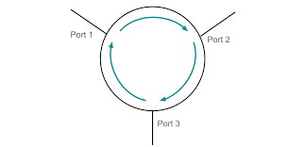
[2 Marks]
- Given two vectors $\vec{A}=\left(3,2,-1\right)$ and $\vec{B}=\left(-9,4,2\right)$. Find the vector that is perpendicular to both the vectors and verify the resulting vector is perpendicular to $\vec{A}$and $\vec{B}$ [6 Marks]
Answer:
$\vec{A}×\vec{B}=\left|\begin{matrix}{\vec{a}}_{x} & {\vec{a}}_{y} & {\vec{a}}_{z} \\ 3 & 2 & -1 \\ -9 & 4 & 2\end{matrix}\right|$ [1 Mark]
$\vec{A}×\vec{B}=\vec{R}=8{\vec{a}}_{x}+3{\vec{a}}_{y}+{30\vec{a}}_{z}$ [3 Marks]
To prove $\vec{A} and \vec{B}$ $are perpendicular to \vec{R}$
$\vec{A}.\vec{R}=0$
$\vec{B}.\vec{R}=0$
$\vec{A}.\vec{R}=\left(3×8\right)+\left(2×3\right)+(-1×30)$=0 [1 Mark]
$\vec{B}.\vec{R}=\left(-9×8\right)+\left(4×3\right)+(2×30)$=0 [1 Mark]
- Apply appropriate computational techniques to calculate the frequency of a laser emitting light with a wavelength of 800nm. (Hint: ${C=3×10}^{8}m/s$) [3 Marks]
Answer:
$f=\frac{c}{λ}$ [1 Mark]
$f=\frac{{3×10}^{8}}{{800×10}^{-9}}$ [1 Mark]
$f=375.000{×10}^{12}Hz$ [1 Mark]

Diwedd/End

