

BUSINESS SKILLS FOR INTERNATIONAL HOTEL INDUSTRY

Student name: Manolis Areza

Student number: 1813603

Module title:
Business Skills for International Hotel Industry

B4X 01917

Assignment Title: SWOT and PDP

Your Module Lecturer’s Name:
Dale Clarke

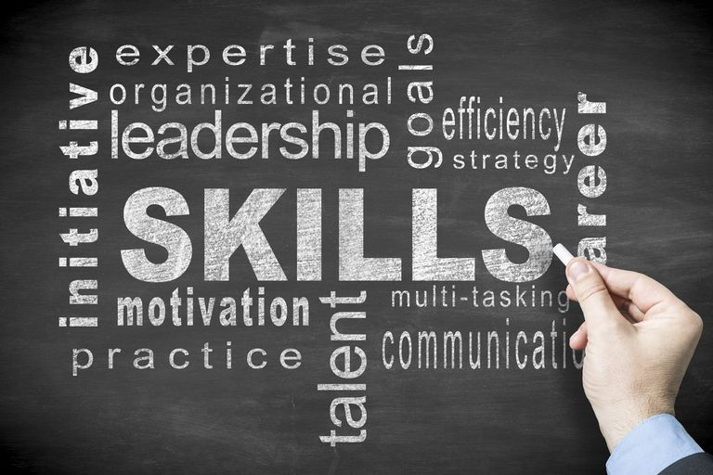

Contents

Introduction…………………………………………………………………

Skills……………………………………………………………………………..

Swot Analysis………………………………………………………………..

Personal Development Plan…………………………………………..

Objectives………………………………………………………………………

Conclusion……………………………………………………………………..

References……………………………………………………………………..

INTRODUCTION

As part of this assignment I am going to write about my current Academic International Hotel management skills. I will also look at skills that I would like to improve at the future. The way in which I will do this is that I will create my personal SWOT where I will write about My Strengths and my weaknesses. When I am done with that after I will write about how I’m gonna improve and develop my weaknesses to success and strengths.

I’m 19 years old and at this time I don’t have a job but I am working on it to find something at Hotels. So when I was 16 I was working as a waiter at beach bars for three years and I think I have gotten a lot of experience at this kind of job. I have seen a lot Managers that they weren’t good at their job so that was that it guides me to Hotel management because I want to be a very good Hotel Manager

For this work, I will write about the current academic skills that I possess and the skills that I need to develop in order to gain employment, including the completion of this module.
I will use my SWOT analysis which displays my personal strength, weakness, opportunity and threats.
As part of this work I plan to use my SWOT as a tool to analyze my current academic qualities and my personal development plan to monitor and address my academic skills to develop.
My personal development plan will help me in my current employment and in putting a target date in place for achieving my degree.
Applying these resources in my daily life is a huge benefit.
One of my goals for the future is to manage one of the best Hotels in Europe and make the people who are coming at this hotel happy.
With this I will then be able to present SMART goals and targets so that I will then accomplish my overall aim, in managing my own business.

My Current academic skills
- I’m good on organizing some events , Achieving a goal that I want and keeping deadlines to myself
- Taking notes for something , I am asking the right questions that help to understand better and be well organized
- Quick thinking , Predicting , searching for info
- Set some clear and some difficult goals

Current Academic Skills

You will identify my SWOT report below. The report gives me the opportunity to outline my current academic skills. I plan to use this in reporting detail to show how my strengths will assist me become be competitive in the working environment and enhance my employable opportunities. It has also supported me in identifying my weaknesses which I have converted into my own Personal Plan. According to Fine, L (2009), Personal development plan will help to achieve individual goals.

Strengths:  - Team work/player  - Passion For the perfect thing  - Can effective when under pressure  - Strong communication with my team  - Organize  - Stick to the plan  - Adaptable to Changes.  - Management and leadership  - Easy to solve problems | Weakness:  - I want to improve my English language at speaking and listening as well  - Easily affected  - Poor academic knowledge  - I am anxious and stressful person
Opportunities:  - Achieve better academic writing skills  - Achieve my degree in three years  - CPU(training)  CPD(training)  - Improving my English language  - Improve my computing skills | Threats:  - Personal health  - Family  - Time

Academic skills I want to Improve
- To be more quicker at IT , Power Point and everything that include the Pc
- Presentation Skills – Speaking to the audience and to make them to listen carefully about what I am talking about
- To improve my English language

My current Employability skills
- Team work – I love working on something with my teammates
- Leadership-I think I am a good leader
- Solving a problem- To solve a problem all together with my team
- Interpersonal Skills – Like building a rapport with peers, colleagues, client’s and also like meeting their expectations

Professional Development Plan

Plans to build these altitudes is for have I better living life for me and my future family.

GOAL | OBJECTIVE | EVIDENCE | TARGET/DATE
Improving my Digital Skills | Spend 1-2 in front of the laptop | Delivering power point Presentations | Every week
Stress/Anxiety | Think more positive | Thinking more positive you feel better | Everyday
The English language | Doing practice on English grammar | Having conversations with other people | Everyday

Personal Objectives
Short term (12 months)
My aim is to speak perfectly the English language and to be more easier to more easier the essays or what other things the lecturer wants

Medium Term (2-3 Years)
I would aim the 2nd year For a Higher Hotel Management skills

Long Term (3 years on-going)
I would like to take my degree with high marks to go more easier at the job that I am interested in

Conclusion
So with extensive research I have summed up my targets are to finish my studies to take my degree with good marks and to have a great job to a great hotel and to give my hundred per sent to achieve my other goals

References

Huntsman International SWOT Analysis. (n.d.). .
SAIC, Inc. SWOT Analysis. (n.d.). .
Sanofi-Aventis SWOT Analysis. (n.d.). .
Bell, C., Grason, J. and Newell, A. (1972). Designing computers and digital systems using pdp 16 register transfer modules. Maynard, Mass.]: Digital Press.
PDP 11/45 processor handbook. (1974). Maynard, Mass.: The Corporation.
Xue, J. (1989). Input/output system of minicomputers. Singapore: World Scientific.

