DS 1 Template

My Screenshots/Photos
- Please add 4–6 screenshots or photos of your digital life.
- You can use your phone or laptop.
- For each screenshot, write one or two sentences explaining what it shows.

Screenshot/Photo 1
[Insert Photo/Screenshot below]

You tube is my favourite digital learning tool because it helps me improve my knowledge through educational videos and podcasts. It allows me to learn independently and develop new skills.

Screenshot/Photo 2
[Insert Photo/Screenshot below]

I use Duolingo every day to improve my English vocabulary and grammar. It helps me practice regularly and track my progress.

Screenshot/Photo 3
[Insert Photo/Screenshot below]

Microsoft Word was the first digital tool I learned to use, and it has been very useful in my daily, professional, and academic life. I use it to create and organise documents such as assignments and reports. It has helped me improve my writing skills, format my work clearly, and produce more professional documents. Through using Word, I have become more confident in managing and presenting written information effectively.

Screenshot/Photo 4
[Insert Photo/Screenshot below]
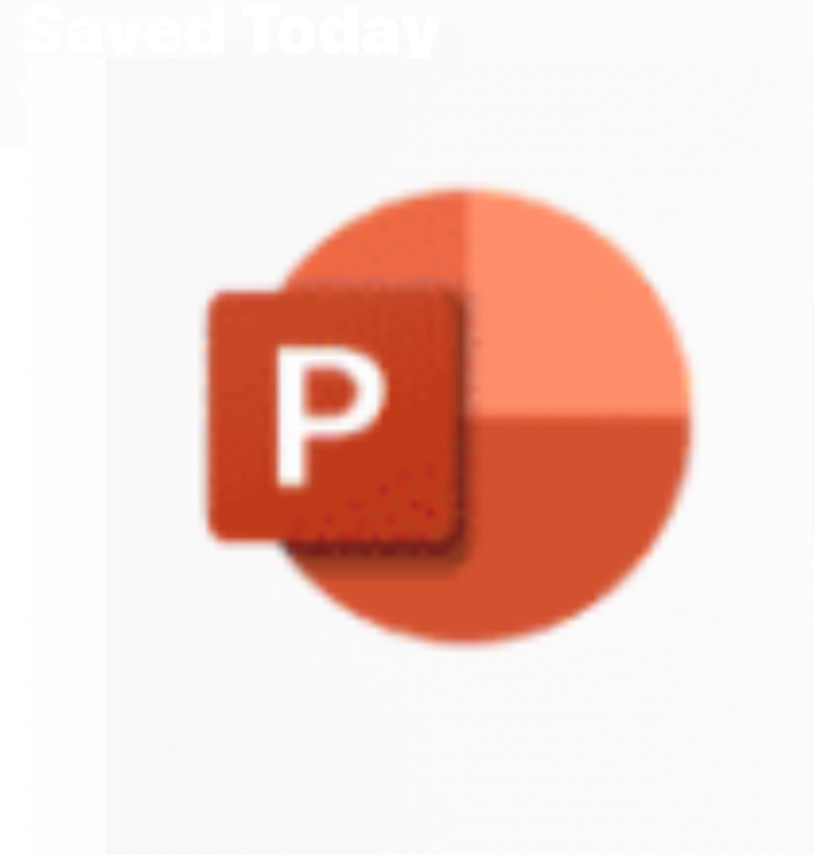

I discovered the value of using PowerPoint for presentations, as I had previously relied on Microsoft Word. It helped me organise ideas clearly and visually. At first, I lacked confidence, but through practice I became more comfortable using it.
PowerPoint improved my communication and presentation skills, although I still need to explore more of its features. This experience showed me the importance of digital tools, and I plan to continue practising to deliver more effective presentations.

Screenshot/Photo 5
[Insert Photo/Screenshot below]

I initially found Microsoft Excel challenging when creating advanced charts such as radar diagrams. Through practice, I gradually became more confident in using its advanced features. This helped me improve my ability to analyse and compare data visually, which is an important skill for data analysis. I plan to continue practising and develop my Excel skills further.

Screenshot/Photo 6
[Insert Photo/Screenshot below]

Microsoft Teams has been a valuable digital tool for me, especially for teamwork and communication. It helped me collaborate with others, share screens, discuss ideas, and exchange information effectively. Through using Teams, I enhanced my ability to work as part of a team in an online environment and improved my digital communication skills.

My Short Reflection
- Write 5–8 simple sentences about your digital life.
- You can use the sentence starters below if helpful.
I use digital tools to improve my learning, communication, research, and digital skills. My digital skills have improved significantly, especially in digital learning, communication, writing, and using digital tools. I feel more confident using tools such as PowerPoint and other applications to present ideas and complete tasks effectively. I want to improve my time management, source management, and explore more advanced features of digital tools. Sometimes I need more time to understand new features, but practice helps me become more confident. Digital skills are important for me because they support my professional development and personal growth.

Sentence starters
- I use digital tools to …
- I feel confident when I …
- I want to improve …
- I often use these tools: …
- I sometimes feel nervous about …
- I hope this module will help me …
- Digital skills are important for me because …
You can write more if you want.

Submission Checklist
Before you submit, please check:
​​​ ☐ I added 4–6 screenshots
☐ I wrote short sentences for each screenshot
☐ I wrote my short reflection
☐ My work is my own
☐ My file opens correctly
​​☐ My file opens correctly

