

Report on the challenges HRM is now facing on Talent Management 2019

December 13, 2019

University of Wales Trinity Saint David
Programme: Master of Business Administration
Authored by: Jeffery Chan (student no. 1912529)

Executive Summary

Talent Management
This report is intended to review the challenges that Human Resources Management is facing nowadays in terms of talent management and how it can be resolved. The resolution can then bring value to the overall strategic plan of a corporation.

In the first part of this report will use primary data to illustrate the practical situation of the two different companies what they are facing and how they are resolving:

Target Insurance Company Ltd. – a 40 years well established General Insurance Company with around 70 staffs
Convoy Global Holding Ltd. – a 10 years evolving Financial Institution with over 300 staffs and 1,700 independent financial advisors.

Then we collect all the useful and extensive information from reliable and relevant sources and academic studies to reveal the current development of Human resources management in a wider and broader scope in resolving the changing challenges internally and externally.

This is measured against the findings from the two different companies and find out if they are applying useful and practical method to address their two common challenges on talent management.
- Talent recruitment
- Talent retention

Then, I will try to summarize, conclude and recommend solutions on the challenges based on the findings so that HRM can be established as a strategic driver of organizational success.

Contents
Executive Summary 2
Talent Management 2
Findings after interview with two HR managers 4
Interview questions 4
Company – Selected for the interview 5
Research from studies and journals 7
CONCLUSIONS AND RECOMMENDATIONS 13
References 15
Appendix 1 – Acknowledgements of Target Insurance Company, Ltd. and Convoy Global Holdings Ltd. for the HR interviews 16

Findings after interview with two HR managers

Interview questions
What is the impact of their challenges may influence the interests of different stakeholders of a company?
- Talent Management – How do your company working on the talent recruitment?
- What are the challenges you faced in talent management?
- Who initiate the job opening in your company? What is the role of HRM in this respect?
- What are the difficulties HR is facing to recruit the right talent?
- How to retain good talent for the company?
- Do you consider HRM as a cost center or profit center? Why do you think so?
- Do you follow the Competency Models as described below for the Talent Management? If not, what is the standard model / procedure you are following and implementing?

Competency Models
- Recruitment and Hiring selection
- Performance Review management
- Training
- Career development
- Talent pool development
- Succession planning
- Workforce planning

Company – Selected for the interview
A – Target Insurance Company Ltd.

B – Convoy Global Holdings Ltd.

The Human Resources Manager (HRM) prevailed the following during the interview:

Challenges | Company A | Company B
How to recruit the right Talent? | Sources:  - Job posting on Websites, online hiring platforms e.g. Jobs DB &etc.  - Search & Surf Technical Websites e.g. Linkedin.  - Head Hunters  - Referral  Methods:  - Application – selection  - Face to face interview  - Writing test  Difficulties:  - Generation Z (internet)  - Branding – local insurer  - Compete with other international general Insurers  - High costing  - High demand  - Hire right and smart people | Sources:  All of A’s ways and including fresh graduate from University. Target group – second tier instead of the top tier to avoid arrogant attitude who are studying the popular topics e.g. Medical, Accounting, Law & etc..  Methods:  - All of A’s methods  - Mini MBA to improve the existing potential staff  - Graduation Trainee Program – 18th month program for Nexties (also a corporate branding exercise) to be the future leaders.  Difficulties:  - Generation Z (internet)  - Branding  - High costing  - Hire right and smart people
How to retain the recognized Talent? | Difficulties:  - 10% turnover rate  - New joined employees more vulnerable  - Culture difference  Solutions:  - Salary – close to market but not willingly to junior  - Better and friendly working environment – pantry with snacks and drinks.  - Clearer Career Path for senior staff of profit centers  - Succession Plan  - Workload and pressure  - Branding articulation | Difficulties:  - Productivity  - High Turnover rate since 2017 due to the court cases  - Stubborn mindset and strong character of experienced people  Solutions:  - Salary - higher than average for the top talent  - To maintain the HR costing with lesser people but better paid individually.  - Employee Benefits  - Paid Leave  - Healthcare Benefits  - Career Development  - Work-Life Balance  - Nurture own workforce – graduate trainee program (5 years – middle management from junior)  - HRM on Workforce planning including % composition on young graduate vs experience expertise  - Employment Branding  - HRM is working with University or become a University

Research from studies and journals
In order to resolve the challenges (not just two mentioned), it has been studied and researches have been widely conducted since the decades when corporations realized HRM is playing a very important role in the strategic transformation and sustainability development of the company.
Selected paper:
(1) Holistic Human Resource Management Model towards Sustainable and Sophisticated Business (Lapiņa I., Maurāne G., Stariņeca O. (2013) )
This paper illustrated various HR models has been coming out and here below is the comparison of HR models. 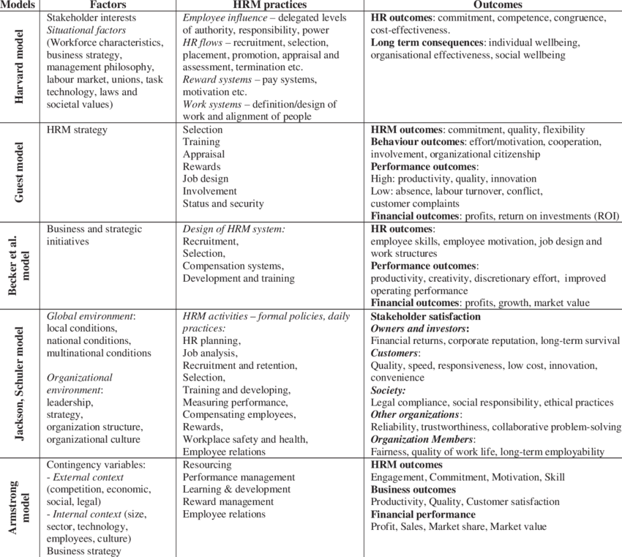

The conceptual research and historical analysis show the factors, practices and results of different models; developed the holistic model; and to draw conclusions regarding importance of HRM practices, the analogy of human resource management and sustainability.

The best choice of the contributing factors is shown in Jackson and Schuler’s model. The models outcomes are summarized and is appended as below diagram.

Therefore, the author concluded that the closet to Holistic approach are Jackson and Schuler’s Contextual and Dynamic Framework for Strategic Human Resource Management. Schuler stated that: “Strategic Human Resource Management is to integrate, consolidate then to adapt. The main mission is to ensure that: (1) human resources management is to be incorporated the strategy and business needs of the corporation; (2) human resources policies run through both policy scope and ranking / grading structure/ reporting line; and (3) human resources practices are adapted, accepted and used by managers and employees in the daily works”

It was concluded that the holistic HRM model can ascertain the accomplishment of the well planned organizational goals as well as each employee’s individual goals taking the consideration of both the external and internal environments.

(2) The Future Trends For Human Resources'management: Challenges And New Directions. Globsyn Management Journal, 6(1), pp. 81-87. (JOSHUA, O.M., 2012)
This paper is originated in social science and tested by reputable headman practically:
(1) To identify the prefect planned actions that enable the best possible result;
(2) to engage the employee towards perfection;
(3) to increase staff competence or skill so that the more prefect actions can be taken,
which substantiates HR as a strategic driver of organizational success.

The objective of organizations is to satisfy the demands of stakeholders, namely the profitability, market leadership and sustainability. A model constituting two halves integrate organization ambitions via well planned goals, strategies plus well-defined HR-KPIs equipped with the necessary and sufficient psychological factors to provide clear commitment including self-esteemed motivation.

The theory of HRM should be more than adequate to address the current perspective, which includes improving performance and obtaining better results from the factors shaping behaviour (Rousseau 1995; Peel & Boxall 2005).

HRM is always blamed that it has not been well aligned with strategic management, performance review management in the board of directors (Boxall & Purchell 2003; Redman & Wilkinson 2006).
- how can human resources management added-value to organization?
- what are the skills of a strategic partner and who has the skill?
- how can HR managers ascertain that the talents remain committed during times of upheaval and stormy situations? (Larsen & Brewster 2003).

It is therefore important for HRM begins to take up the responsibility and accountability to address the above issues to improve the result and create added-value going forward. The whole process should now include building the company culture for performance and to empower the staff to perform to produce good results.

SHRM is defined by little (2003) as the process of achieving the best possible alignment of personnel behaviour with the organization’s strategy and hence align with the results in the short and long term. The personnel behaviour-strategy relationship should be on going because it changes as the environment changes.

Key issues arising from the model
- the role structure is the main performance aspect of the model and has the greatest impact.
- the organizational structure is derived by identifying the goals in the strategy.
- the business processes will influence the role structure.
- the role structure and business processes establish the setup of the organization into which personnel are located by assigning responsibilities, said to 'populate' the organization.

Human Resources Key Performance Indicators (HR-KPIS) – the measurement of the performance of individual employee and their commitment of the identified ideals.
- Professionalism and the key cultural
- Separation of performance and success
- Engagement as visualization
- Tightened definition of key organizational factors

(3)Talent management as a source of competitive advantage. Journal of Asian Business Strategy, 5(9), pp. 208-214. RABBI, F., AHAD, N., KOUSAR, T. and ALI, T., 2015.

Talent management is becoming of great importance for all organizations today. This paper illustrated how Talent Management is necessary for the corporations in building up winning teams to be formed by the talents.

Organization is to acquire the capability to identify the right talent and hence to create value for the delivery of distinctive advantage for the organization.

The demand for executive type talented staff is high because those are the persons who can lead the organization to success, articulate organization image and hence its profitability and sustainability. This is the reason why the organizations are fighting for the best talent and maintaining the competent staff.

Two basic theories are emerged as follows:
- Talent based theory states that the talent is the genuine resource which can help to acquire and maintain the competitiveness. Hence it is necessary to put the focus to attract and maintain the talented work force.
- Resource based theory says that the competitiveness should rest upon the worthy, rareness and hard to copy resources that incorporated in the organization and human resource is definitely one of those.

Critical factors of Talent Management
- Talent management should be aligned to people and culture of the organization. These are the heart of the organization for propagating the successful talent management strategy. The biggest challenge for the managers to manage talent is the cultural one.
- Another important issue about the talent management is the reward and compensation system. The incentive should be granted to the right talent employee who share talent rather than the sharing of knowledge. (The Banker, 2004).

There are three main component of talent management
- Talent attraction and selection
  - The right hiring of talent is the ultimate important mission of the talent management process. The talent pool is a group of staffs that are the potential executives of the organization.
  - There two sources to create the talent pool, internal and external.
  - The internal recruitment of talents from the exiting employees as they are familiar the culture and mode of working in the organization and it can escalate the morale of the employees if their position is promoted (Davis et al., 2007).
  - The external source may be the best way of gathering a talent when organization wants to have the cultural change and innovation (Ballesteros & Inmaculada, 2010).
- Talent Retention
  - Intrinsic and extrinsic rewards. Intrinsic incentive includes some non-monetary rewards that can satisfy employee’s mental needs while the extrinsic rewards are the monetary rewards to fulfill employee’s financial needs.
  - Extrinsic as the monetary reward is recognized an essential tool to keep talent workers (Vaiman & Vance, 2008).
  - A good rewards system is essential to retain the talent in the organization. This can motivate the employees, resulting in high performance of the organization (Mendez & Stander, 2011)
- Talent development
  - Gaining knowledge and career development of the talented employees can improve organizational performance. Talent development is the process of improving the technical skills, behavior and attitude of the employees.
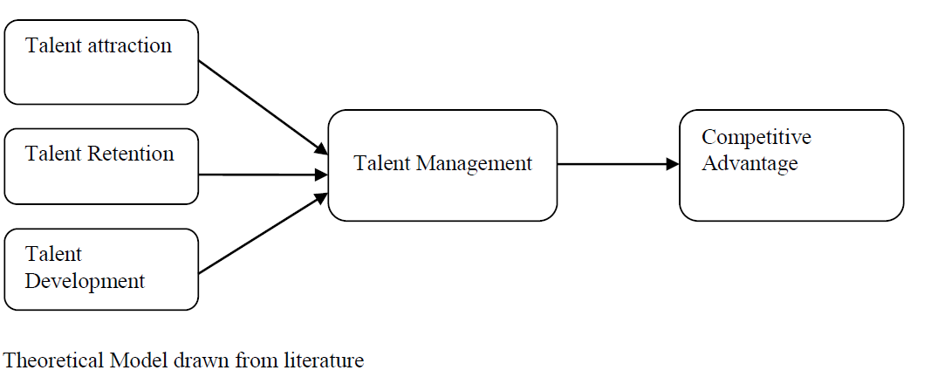

CONCLUSIONS AND RECOMMENDATIONS

Paper 1 - Holistic HRM model
To achieve its objectives to increase organizational effectiveness and capability, the company should create an good business plan, choose a human resource management model and methods in its unique approach, establish good system for performance evaluation, define measurable results, and understand which of the HRM functions is the most important in building sustainability.

HRM objectives is to build the capability of an organization to achieve its goals by making the best use of the human resources i.e. their employees.

Paper 2 – Future Trends of HRM
Strategic Human Resources Management is crucial for the success if an organization and then the HR-KPIs measure if the managers are implementing the necessary and sufficient strategic HR processes within their team.

The role of HR departments to ensure that supervisors and managers have the skills to implement defined strategic HR processes and to monitor that the processes are being implemented and then SHRM emerges as a strategic driver of the organization.

The model provides business leaders with an established and proven structure to manage personnel performance effectively throughout the process for the achievement of the organization's objectives.

Paper 3 – Talent Management model
In this changing and competitive business regime, organizations are facing challenges in talent management. Talent management of talented worker is necessary for the organizations in the evolving business environment. The demand for smart executive with talent is strong since those are the persons who can manage and bring the organization to the peak.

Organization should build up its capability to identify the right people and their ability to add value and deliver the competitive advantage for the organization.

Talent management aims at developing and deploying the right people for the right job on the right time and providing them the right environment to demonstrate their capabilities to contribute for the organization.

Recommendation
Based on the primary data – findings after the interviews with the two selected HR managers of Company A and B plus the above-mentioned conclusions drawn upon the 3 papers. I would like to recommend that the corporation to implement the following “Talent Management Framework” in order to overcome the two challenges as identified namely “hiring the right Talent” and “retain the potential Talent” for the success of the organization to face the current and future (internal & external) environments.
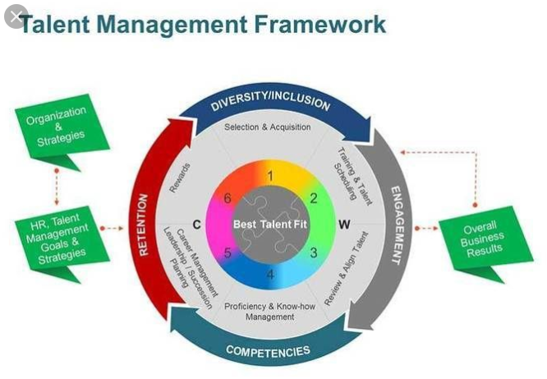

References

Holistic Human Resource Management Model towards Sustainable and
Sophisticated Business. Lapiņa I., Maurāne G., Stariņeca O. (2013)

S.E. Jackson, R.S. Schuler, Managing Human Resources through Strategic Partnerships. 8th ed., Cincinnati, OH: South-Western, 2003.

JOSHUA, O.M., 2012. The Future Trends For Human Resources'management: Challenges And New Directions. Globsyn Management Journal, 6(1), pp. 81-87.

SEHRISH, K.S., PENG, H., AKRAM, U., MUHAMMAD, S.K. and MEMON, S., 2017. Investigation of talent, talent management, its policies and its impact on working environment. Chinese Management Studies, 11(3), pp. 538-554.

TAFTI, M.M., MAHMOUDSALEHI, M. and AMIRI, M., 2017. Critical success factors, challenges and obstacles in talent management. Industrial and Commercial Training, 49(1), pp. 15-21.

RABBI, F., AHAD, N., KOUSAR, T. and ALI, T., 2015. Talent management as a source of competitive advantage. Journal of Asian Business Strategy, 5(9), pp. 208-214.

LI, J., HEDAYATI-MEHDIABADI, A., CHOI, J., WU, F. and BELL, A., 2018. Talent management process in Asia: a multiple case study. European Journal of Training and Development, 42(7), pp. 499-516.

Appendix 1 – Acknowledgements of Target Insurance Company, Ltd. and Convoy Global Holdings Ltd. for the HR interviews




