Luca Dellanna (1815591)

Roads Policing: Fatal Road Traffic Collisions – Is police presence and prosecution the solution in South Wales?

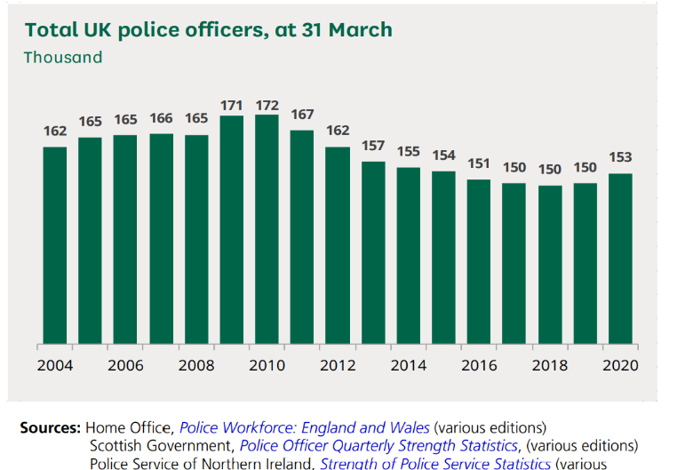
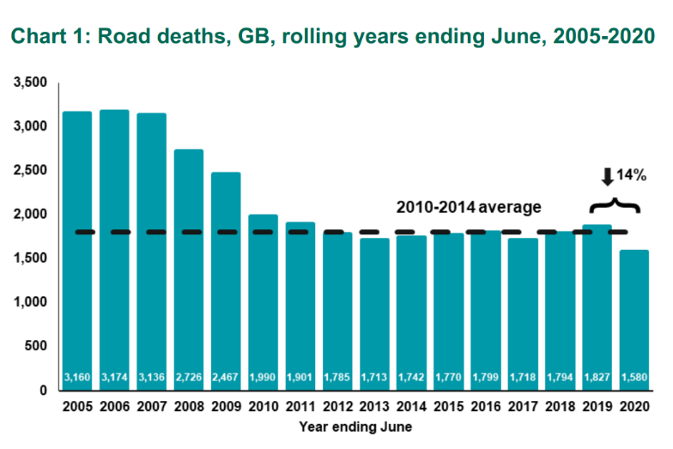
In the early 2000’s the term Road Traffic Accident (RTA) changed in the policing context and shortly after became widely accepted by the general public as the term Road Traffic Collision (RTC). This change came following a key observation by those investigating collisions defined under the Road Traffic Act 1988 of the simple fact that there is almost always someone at fault (Sharma, B.R et al, 2001). This is contrary to the very definition of the term ‘accident’, which implies no one is at fault. So, it begs the question if Road Traffic Collisions are almost always primarily down to the driver attitude, behaviour, skill and experience (Evans, 1996), then what is the key to reducing the number of Road Traffic Collisions; especially those that result in serious injury and death?

Chart 1 produced by the Department for Transport (January 2021) shows a dramatic drop in the number of road deaths in the United Kingdom from 2007 to 2010. This drop in road deaths coincides with the highest number of police officers in the last 20 years (G. Allen, Y. Zayed, 10 February 2021). This simple observation without analysis would suggest the highest presence of police officers has resulted in the lowest number of road deaths.

Over the next decade from 2010 the number of police officers in the UK plummeted however, in that same time frame the number of road deaths remained relatively consistent year on year. If the number of police officers patrolling and prosecuting for Road Traffic Offences has declined and road deaths remain statically consistent, this would contradict the view point that more officers on patrol would result in a decline in road traffic collision.
Research Rationale
Michael ELLIS MP, on behalf of Department of Transport (July 2019), boasts that the United Kingdom has some of the safest roads in the world. It also found that the UK was third safest in Europe in 2017. Whilst the government takes the lead in improving road safety there is a clear requirement for co-ordination and team work across ‘government agencies, the devolved administrations, local government, enforcement authorities and a host of other public and private bodies’ (Department of Transport, July 2019). There is a joint effort across all public agencies in maintaining and improving road safety with the police taking priority in investigating and prosecuting the vast majority of reported road traffic collisions across the UK.
It is undeniable that within every industry worldwide, there is a developing pressure to increase performance with less resources. In relation to the police specifically, the Mayor of London, Sadiq Khan, in the Guardian (2020) warns of a “new era of austerity” in response to rising concerns over budgets that will not allow for the recruitment of 20,000 police officers promised by the government. With less officers increasing performance with less resources requires a strategic sorting of priorities (Forbes, Dec 2014).
The aim of this research therefore is to critically assess the following question;
How can the police and its resources effectively be maximised to assist in the joint goal across UK agencies in reducing fatal and serious injury road traffic collisions in the South Wales Policing Area?
It is estimated that there is approximately 4130 miles of road (StatsWales, July 2019) within the South Wales Police force area. This complex roads network consists of all road types including a section of M4 motorway and arterial roads most notably A470 and A465. To put that into context 1.44 billion vehicle miles were travelled in Rhondda Cynon Taff Borough of South Wales in 2019 alone (Department of Transport, April 2021). Every single vehicle mile travelled however runs the risk of becoming involved in a fatal and/or serious injury RTCs. Due to the vastness of this roads network, it is fair to summarise that it would be impossible to police all of the roads all of the time, even with a surge of resources.
It is accepted that as road condition and environment improves in line with current technological advances there is going to be an inherent effect on road safety. It can be argued this will have a positive impact and potentially reduce road collision statistics combined with ever increasing ‘crashworthiness’ of vehicles (Weijermars, Wegman, 2011). With that key observations noted currently policing focuses on detecting and deterring what has been identified as the ‘fatal five’ with the slogan ‘stay alive, get to know the fatal five’ (Road Safety Wales, 2018).

The five offences; drink/drug driving, careless driving, speeding, not wearing a seatbelt and using a mobile phone, have been identified as key contributors to the cause of road traffic collisions. All of these offences can be prioritised and robustly prosecuted especially when evidenced first hand by police officers. A focus of this investigation is to assess the enforcement of these offences and evaluate the impact this may have on roads policing.
Methodology and Objectives
The objective of this research is to investigate the key factors resulting in fatal and serious injuries road traffic collision in the South Wales Policing area from the point of view of those investigating such collisions. By obtaining first-hand experience including thoughts and opinions from those at forefront of understanding the cause and effect of road traffic collision should provide a valuable insight into what can be done to continue keeping the UK’s roads safe.
The goal of this research is to conduct an in depth interview with members of the South Wales Police Roads Policing Unit, specifically those working within the ‘Serious Collision Investigation Team’. The information and evidence yielded from these interviews will then be cross referencing with secondary data seeking to identify the key causes of serious RTC’s in the South Wales Policing area. Furthermore, this evidence can also be used as an indication as to what key geographical and causal areas could be targeted.
Although qualitative research is a priority in this investigation through interview; a thorough literature review of current academic writing around the topic. This research will include data from across the UK and similar geographically areas to compare and contrast against my findings in South Wales Area. The purpose of this review is to assess if current knowledge on the topic coincides with findings and analysis of any discrepancies that may arise.
Ethics, Reliability and Validity
As evidenced, various research methods will be utilised to gain a balanced and fair view of the topic. The main focus of the research is through qualitative methods; consideration will also be given to the potential that interviewees may have a degree of bias towards certain elements of road traffic collision causes. To combat this, approved interview techniques will be used to achieve the best possible evidence. This will include the use of open questioning, ensuring not to ask leading questions however probing questions will be used to develop specific topics if required.
It is acknowledged research in this area may be limited as the targeted interviewee sample size in relatively small due to the structure of the serious collision investigation unit and its demand. Within this unit experience may also be limited to a degree as some of the colleagues taking part in the sample may only have a brief number of incidents to recall from. This may also mean that interviewees have an extensive knowledge of the area but then only draw on experience personal to them resulting in a more biased view point.
Interviewee’s will be drawing on experiences that are particularly stressful, traumatic and may have had a serious impact on their wellbeing. Interviewee’s welfare will be considered at all times allowing them to take breaks if required and confirming they are aware that they can withdraw from the research at any time. Interviewee’s will be protected with no personal data relating to them or the specific instances they refer too being shared in this work. If welfare concerns do arise with interviewee’s this will be recognised and acted upon through relevant means.
In conclusion this investigation ultimately, is to critically evaluate the impact policing really has on preventing, detecting and deterring offences that are the key causes of serious injury and fatal road traffics collisions. This rational being that over 98% of collisions are caused by human error with a mere 2% caused by unavoidable issues, such as mechanical failure (Devon and Cornwall Police, 2019). The goal of the investigation is obtain the knowledge and expertise of specialised roads policing and serious collision investigation team officers through use of detailed interviews combined with current literature to provide a balanced of overview of the topic.
Resource and Time Management
Time is limited due to work and family commitments therefore it is essential to maintain a schedule time frame. The below table has been produced that coincides with submissions dates as an anticipated programme to monitor progress in relation to time management.
No | Submission Section | Year: 2021
No | Submission Section | Apr | May | June | July | Aug | Sept | Oct | Nov
1 | Proposal
 | Define research aims goals and objectives
2 | Literature Review
 | Carry out extensive research
 | Present findings / submission
3 | Research Methodology
 | In-depth plan for obtaining primary evidence research
 | Obtaining primary research
4 | Analysis of results
 | Analyse interviews
 | Collate & analyse findings
 | Review feedback
5 | Findings and Conclusions
 | Proof reading and finalisation
 | Submission

Word Count – 1470

Referenced
Devon and Cornwall Police (27 March 2019) ‘The fatal five’, available at; https://www.devon-cornwall.police.uk/advice/on-the-road/the-fatal-five/
Evans, L., 1996. The dominant role of driver behaviour in traffic safety. American Journal of Public Health, 86(6), pp.784-786.
Guardian (1 July 2020) Police in England and Wales facing ‘new ear of austerity’ by Vikram Dodd, available at; https://www.theguardian.com/uk-news/2020/jul/01/police-warn-of-cuts-to-funding-even-worse-than-in-austerity-years (accessed 21/06/21)
Grahame Allen and Yago Zayed (10 February 2021) House of Commons Library, Briefing Paper – Police Office Strength, pp 1 – 44
Road Safety Wales (24 August 2018) ‘Stay alive get to know the fatal 5’, available at; https://www.roadsafetywales.org.uk/news/posts/2018/august/stay-alive-get-to-know-the-fatal-5/?Language=undefined
Sharma, B. R. et al. (2001) ‘Road-Traffic Accidents - A Demographic and Topographic Analysis’, Medicine, Science and the Law, 41(3), pp. 266–274. doi: 10.1177/002580240104100311.
Stats Wales (July 2019) Road Length (KM) by type of road and local authority, Wales, available at; https://statswales.gov.wales/Catalogue/Transport/Roads/Lengths-and-Conditions/roadlength-by-typeofroad-localauthority-year
The Department of Transport (July 2019) ‘The Road Safety Statement 2019’, available at; https://assets.publishing.service.gov.uk/government/uploads/system/uploads/attachment_data/file/817695/road-safety-statement-2019.pdf
The Department of Transport (28 January 2021) Reported road casualties in Great Britain, provisional estimates: year ending June 2020, available at; https://www.gov.uk/government/statistics/reported-road-casualties-in-great-britain-provisional-estimates-year-ending-june-2020
The Department for Transport (28 April 2021) Road Traffic Statistics, available at; https://www.gov.uk/government/collections/road-traffic-statistics
Weijermars, W. and Wegman, F. (2011) ‘Ten Years of Sustainable Safety in the Netherlands: An Assessment’, Transportation Research Record, 2213(1), pp. 1–8. doi: 10.3141/2213-01.

