

Module: Introduction to Research
Module Code: BMHP5005
Student number:2101094
Lecturer: Jodie Croxall，Kalee Thomas

Youth smoking status and causes of youth smoking

ABSTRACT
Smoking has become a worldwide social problem, and tobacco is one of the most serious public health problems in the world today. According to the World Health Organisation, 3 million people die from tobacco each year in the world, and 1.1 billion people smoke worldwide. Smoking is not only harmful to the smoker's own health, but also to the non-smokers, causing cancer, coronary heart disease, stroke and emphysema and many other diseases. Youth smoking is a particular concern. Youth smoking is a serious health hazard and has been a concern of the entire society.

In recent years, with the development of global tobacco control, adult smoking rates have continued to decline in many developed countries, but youth smoking rates are increasing, and the age at which teenagers start smoking is decreasing each year. Some surveys have found that the number of young people smoking is increasing, and the reasons for this are that young people's smoking behaviour is influenced by a number of factors. Studies have shown that most smokers start smoking as adolescents and eventually become long-term smokers, and how to effectively prevent and control youth smoking has become a pressing social issue in the world, which is key to reducing overall smoking rates.

The purpose of this literature review is to analyze the current status of adolescent smoking and to find out why they start to smoke. I used Google Scholar, NHS official website, WHO etc for literature search and data acquisition. According to the literature, I found that smoking among adolescents is mainly related to social atmosphere, family education, school control, awareness of smoking, and the influence of people around them. At the same time, I also put forward some suggestions and recommendations for preventing adolescents from smoking. We need to create a smoke-free environment for them.

SECTION 1: INTRODUCTION AND RATIONALE

Basic information on youth smoking

（i）The overall situation of youth smoking
The majority of adolescents start smoking in secondary school and university. The proportion of adolescents who consume cigarettes is 18.5 percent of the total. Of these, 35.8 percent of boys and 1.06 percent of girls smoke, showing a significant difference in the number of male and female smokers. With the increase in world trade and the female emancipation movement, smoking prevalence among females is rising.

（ii）The current state of smoking behaviour among young people
The current situation of smoking behaviour among adolescents is not very serious, but it has been rationalised. The majority of adolescents (69.2%) smoke one to two packs of cigarettes per week, and generally smoke mid-range cigarettes (61.1%), with 66.5% spending around $50 per month. (Mausner, B and Platt, E. S, 1971). 36.2% smoked in the dormitory, 19.5% in the bathroom, and the rest at random places where they would not affect others. Addionally, opposition to smoking among adolescents has weakened, with 52.4% of parents of adolescents who smoke only telling them to smoke less, 22.2% of parents who initially opposed it and later admitted to it, and only 8.1% of family members who were very opposed to it.

（iii） Adolescents' perceptions of smoking
The differences between adolescents who smoked and those who did not smoke were not significant in terms of their perceptions of the people around them who smoked. The categorisation of the answers to the open-ended questions reveals young people's perceptions of the advantages and disadvantages of smoking. They believed that smoking had both advantages and disadvantages. Benefits: 1. for the individual, it is good for socialising, regulating the atmosphere, refreshing, calming, relieving stress, relaxing, inspiring, spiritual support. 2. for society, it increases national tax revenues, promotes the tobacco industry, expands employment opportunities, and adapts to social development. (Wong, L.P and Hoe, V , 2019). Disadvantages: damage to the physical and mental health of others and themselves, pollution of the environment, waste of money, fires, and other illegal and disorderly behaviour.

（iv）The inadequacy of the previous studies
① Different studies define the smoking behavior of adolescents from different perspectives, leading to different research results on the relationship between adolescent smoking behavior and various factors. Most of the studies analyze the smoking behavior of adolescents from a single perspective. This literature review integrated previous studies from multiple perspectives.
② Most of the current studies on adolescent smoking behavior focus on vocational schools and junior colleges, and few involve the smoking behavior studies of ordinary middle school or high school students. This literature review will focus on the analysis of smoking behavior in high school students (adolescents).
③ Most of the existing studies only examined the relationship between one or two social factors and adolescent smoking behavior, less combining the combined effects of social and individual factors. This literature review synthesizes multiple perspectives, including personal, social and other perspectives. In conclusion, the aim and objective of this literature review is to find the reasons why adolescents start to smoke and what factors influence them, finally prevent in smoking.

SECTION 2: METHODOLOGY & METHODS

The main sources of data for this article are the NHS, WHO official website, google scholar, lol my theis, etc. In searching for relevant data and information to be used in this article, the key words I selected are: Asian region, adolescent smoking, China, Japan and South Korea, 2000-2020, Asia and Europe, from which I will write this paper. Additionally, this is the narrative literature review. The specific literature review will be presented in SECTION 3, where I will screen relevant data from the Lancet Child and Adolescent Health and Lancet Public Health articles, and combined with the references in this article to analyze the current situation of adolescent smoking and the reasons for smoking, the specifics are as follows:

Subjects and Methods

- Subjects of the survey
The data for this survey were collected from the data of a study conducted in Taichung City, Taiwan, China, using a multi-stage stratified whole-group sampling method, in which all students in selected classes were surveyed. A total of 2,480 students from 47 classes in 25 middle schools in the city were surveyed, 2,480 questionnaires were collected, and 2,420 valid questionnaires were returned, of which 58% were boys and 48% were girls.

This study explored youth smoking behavior using the method defined by Yu and Whitbeck (2016), asking subjects to report their smoking status: i) never smoked, with an occasional puff; ii) smoked once or twice a year; iii) Smoked less than once a month; iv) smoked once a month; v) smoked -- once a week; vi) smoked almost every day.

- Content of the survey
The survey used standard sampling methods and questionnaires from the Global Youth Tobacco Survey (GYTS), a tobacco survey of school-based youth aged 13 to 15 initiated by the World Health Organization, a globally standardized methodology that facilitates survey data objectivity. (Perkins, K.A et al, 2008). The questionnaire included tobacco use, tobacco dependence and cessation, exposure to secondhand smoke, access to and prices of tobacco products, tobacco control, and knowledge and attitudes about tobacco .

Results

There were 2420 students surveyed in this study, 1258 male and 1162 female. The percentage of students who had tried smoking (including just one puff) was 29.21%, with 42.53% of males and 14.80% of females.
Research and discussion

Multi-factor analysis of adolescent smoking behaviour

The results of this study showed that the risk of smoking behaviour among female adolescents was 0.298 times higher than male adolescents, and that students who were more aware of the difficulties of quitting smoking had a lower risk of smoking behaviour. While those who had a parent who smoked, who had a friend who smoked and who saw a teacher smoking were 1.35, 2.911 and 1.320 times more likely to smoke respectively. (Smoking and addiction, 1996). The importance of peer education and training in tobacco control skills among secondary school students is illustrated by the fact that best friends smoking is the most significant factor influencing adolescent smoking behaviour.

Youth smoking behaviour survey discussion

Findings suggest that tobacco experimentation is more common among Asian adolescents, especially in East Asia. Data from a survey (GYTS) conducted by the School of Public Health of Kyoto University of Medicine in 200 middle schools in Shikoku, Yokohama, Osaka and other provinces and cities in Japan from May to July 2015 showed that the prevalence of tobacco experiments among middle school students accounted for 22.5%, and boys Accounted for 32.5%, girls accounted for 13.5%. (Lloyd, B.B and Lucas, K, 1998). A survey in Yokohama, one of the more representative areas, showed that 29.4% of adolescents tried smoking, of which 42% were male, higher than the national average in the 2010 survey and the 2010 the average level of the Asia-Pacific region in the annual survey. It shows that Asian teenagers are more likely to try smoking, and health education and tobacco control capacity building for teenagers should be strengthened.

There are several and complex factors influencing adolescent smoking behavior, including individual factors, peer influence, adult role models and social climate. Peers are smokers, which has a serious impact on the students' smoking behavior. Analysis of the survey showed that adolescents whose parents smoked, those whose friends smoked, and those who saw a teacher smoke were 1.35, 2.91 and 1.32 times more likely to smoke than other adolescents respectively. In addition, students who know that quitting is difficult are less likely to be at risk for smoking. Therefore, creating smoke-free homes, schools and business units in families, schools and communities, banning smoking in public places, reducing the smoking behavior of people around students, creating an environment conducive to the healthy growth of adolescents and other activities will be very beneficial to the prevention and control of adolescents smoking.

SECTION 3: MAIN BODY OF THE LITERATURE REVIEW AND FINDINGS

(i) Review of the literature on smoking behaviour of adolescents in Asia and Europe

- Current status of adolescent smoking in Europe and the United States
Smoking has become a globally recognized independent risk factor for chronic diseases such as cardiovascular disease and lung cancer, and it is also the main cause of premature death. According to the World Health Organization, around 6 million people worldwide die each year from tobacco-related diseases. The increase in the number of smokers and the downward trend in the age of the smoking population are worrying, with young people becoming an important group of smokers (Gilbert, D.G, 1995). About 90% of smokers are reported to be younger than 18 years of age when they first start smoking, and about 100,000 adolescents start smoking every day. Notably, the tobacco epidemic has shifted from high-income countries to low and middle-income countries (LICs) in recent years. A study of adolescent smoking in 68 low- and middle-income countries showed that adolescents in low and middle-income countries now have an average tobacco use rate of 13.6% and an overall second-hand smoke exposure rate of 55.9%, which varies widely. Studies have shown that in most countries boys use tobacco more than girls and smoking rates at 14-15 years than at 12-13 years: adolescents also smoke more heavily, influenced by parental smoking and effects of secondhand smoke exposure.

- Current status of youth smoking in Asia
Most countries in Asia are low and middle-income countries, with hundreds of millions of smokers, and the number of smokers is increasing rapidly at an average annual rate of 7%. For example, in China, according to the 2011 China Tobacco Control Report, more than 1 million people die each year from tobacco-related diseases, which is more than the number of people who die from AIDS, tuberculosis, traffic accidents, and suicide combined (Li, M.D, 2018). There are 25 million young smokers in China, more than 60 million people who have tried smoking, and 85 million young people are exposed to the hazards of second-hand smoke, and the trend is increasing year by year. Additionally, nicotine is so addictive that approximately 80 percent of teenage smokers continue to smoke as adults and have difficulty quitting. Young people are less likely to try smoking for the first time, more likely to become smokers and, for young people, less likely to quit.

（ii） Comparison of the Asian and European literature on adolescent smoking behavior

In 1998, the World Health Organization (WHO), the American Centers for Disease Control and Prevention (CDCP) and the Canadian Public Health Association (CPHA) collaborated to develop the Global Tobacco Surveillance System (GTSS) to help 192 WHO member states collect data on adolescents and adult tobacco use. The Global Youth Tobacco Survey (GYTS) is a school-based survey to improve the effectiveness of countries' efforts to monitor youth smoking, guide youth smoking prevention and assess the implementation of tobacco control programmes. It includes the following issues: adolescents perceptions and attitudes about smoking, the influence of media and advertising on youth smoking, tobacco access and smoking cessation, and as of 2010, 163 of the 192 WHO Member States had completed the GYTS.

With the gradual expansion of the number of young people smoking globally, joint research between Asia, Europe and the United States has become a trend. For example, based on data from the Global Youth Tobacco Surveys (GYTSs) from 2010 to 2018, the team of Professor Xi Bo from China produced the first updated map of the spatial distribution of youth tobacco use in 143 countries around the world. Adolescents smoking rates have declined in most countries, but use of other tobacco products (hookah, e-cigarettes) has remained constant or increased. The literature's definition of youth tobacco use as "at least 1 day of tobacco use in the past 30 days" is a little high. Final finding is that global youth tobacco use rates remain high, these findings demonstrate that the youth tobacco control situation remains dire and need to strengthen global youth tobacco control.

（iii）Analysis of the causes of youth smoking

- Curiosity and imitation. It showed that most of the adolescents started smoking because they were curious. 58% of the students who smoked reported that they smoked because they thought it was fun. Many teenagers are persuaded to smoke by their partners. Among secondary school students who smoke, 55.89% got their first cigarette through a friend of their classmate. 53.32% of smokers asked their best friend to smoke, while only 12.50% of non-smokers asked their best friend to smoke. This suggests that smoking partners have a strong influence on secondary school students starting to smoke.

- Blurred perceptions. Some adolescents believe that smoking is cool and fashionable, and they think smoking is a method to show off to their friends. About half of secondary school students, especially high school students, believe that it is easier to get along with people by smoking, so these students are significantly more likely to smoke than other students. (Murray, M, 1988). In addition, some secondary school students also believe that smoking can relieve their sorrows and refresh their minds.

- Parents' attitudes are unclear. For adults to smoke, some people have made a survey of 100 families, which found that 50% of parents consider that underage smokiong should not be allowed; 10% of parents allow minors, especially underage boys to smoke; 20% of parents do not query underage smoking; 10% of parents never care about this aspect of their children. It is clear that more than half of the parents have no objection to their children smoking.

- Social tolerance. In today's society, it is not strange to see not only male teenagers smoking , but also female teenagers smoking in public, and people only look at them for a moment . A survey conducted by Dongfang in 2005 in China showed that although the majority of people were "strongly opposed to adolescent smoking", 22.75 per cent still consider it was allowed to do occasionally. In-depth research shows that even those who are "strongly opposed" to minors smoking may not intervene when they see it, creating an unregulated social environment.

- Media influence. The influence of the mass media on adult smoking is mainly in the form of visuals such as films and television. Turn on the television, alcohol advertising, and even cigarette brand advertising can often be seen. In television dramas and films, images of people smoking and drinking are even more frequent. (BBC, 2014). In this commonplace environment, minors and adolescents are gradually being subliminally influenced to try smoking and drinking when certain conditions trigger them.

SECTION 4: CONCLUSION AND RECOMMENDATIONS

Judging from the above related content, the smoking behavior of adolescents is affected by family environment, school environment, attitudes, risk perception, self-esteem and school identity, internal and external influences. Environmental interaction leads to adolescent smoking behavior. In general, this study mainly discusses the following issues: the current status of adolescent smoking behavior and the reasons that lead to adolescent smoking.

Therefore, in summary, we found that adolescent smoking behavior is closely related to social traditions, family support for smoking, and learning content. Therefore, families, schools, and society should pay attention to the psychological and behavioral aspects of adolescent smoking and help them to create a smoke-free environment together, the specific recommendations are as follows.

- Establish strict school rules and regulations
Schools should establish rules and regulations and set rewards and penalties to ensure that they are strictly enforced and that coaches and teachers are not allowed to smoke in their work environment. Create a "smoke-free dormitory", "smoke-free classroom" and "smoke-free school" environment where "smokers quit and non-smokers refuse to smoke", and improve students' self-awareness. The school should strengthen its efforts to educate students about tobacco use.

- Schools should strengthen health education for students
Schools should actively develop health education programmes, hold regular health speeches, and actively create a tobacco-free learning and living environment so that students can receive health education in a subtle way. Students should also be equipped with the skills to cope with different types of stress and be taught refusal techniques so that they can consciously say goodbye to cigarettes and stay away from tobacco as a chronic drug.

- Promote a tobacco-free home environment
The behavioural development of students depends to a large extent on family factors, and the way their parents behave will have a direct impact on their children. (Johnson, B, 2019). Therefore, parents should lead by example at home, do not smoke in front of their children, guide children to develop good habits in daily education, arrange rich activities, and reduce the occurrence of smoking behavior. To sum up, adolescence is an important period for the formation of healthy lifestyles and behaviors. Controlling student smoking requires the joint efforts of families, schools and society, and all-round intervention.

④Restraint in the sale of tobacco

Increasing the selling price of tobacco products can partially cut off the source of tobacco for young people. In the United States, legislation at the state or national level has raised the price of tobacco products by imposing higher taxes on them. Studies have shown that this approach is effective in reducing smoking rates among minors (13-18 years old) and young people.

In recent years, people have become more and more aware of the importance of no smoking , and the governments of various countries have listed a series of laws and regulations, clearly stipulating the prevention and control of smoking among adolescents in schools, families and society. (Boddewyn, J.J, 1986). However, the existing legal system still needs to be improved. Therefore, on the basis of a legal system, focusing on schools, families and communities can cooperate and participate together to achieve better tobacco control effects.

The above mentioned status of adolescent smoking behavior, influencing factors and intervention models of youth smoking behavior has largely promoted the prevention of youth smoking behavior, and made the research on youth smoking behavior develop in a deeper and broader direction. However, there are also some gaps. There are few studies on specific groups of adolescents, and there is a lack of research on specific groups of students with a college degree or above. For example, there are few studies on medical students, a special group who will become health workers and the main advocates and educators of tobacco control in society, and even less research on members of the social elite, such as medical masters and doctoral students. Future public health workers, their words and deeds will directly affect the people around them. Medical students are a relatively well-educated group of young people, but in the current health care environment, they bear the burden of studying and working. Stress, especially when dealing with clinical patients, thus has its own unique social and occupational characteristics, and further studies of smoking behavior in the future need to take this into account.

In the future, research on adolescent smoking behaviour, influencing factors, prevention and interventions should be deepened and extended to different specific groups, and different interventions should be developed and adopted according to the age, social background and occupational characteristics of the different groups, taking into account our cultural traditions and etiquette, so that the interventions can be effective and can really delay or reduce adolescent smoking behaviour, thus achieving prevention and intervention. The aim is to prevent and intervene in smoking.

REFERENCING：

Ashton, H. and Stepney, R. (1982) Smoking : psychology and pharmacology. London: Tavistock.

BBC (2014) Burning desire: the seduction of smoking Part 1. Available at: https://www.bbc.co.uk/mediacentre/proginfo/2014/21/burning-desire

Boddewyn, J.J., Children's Research Unit and International Advertising Association (1986) Why do juveniles start smoking : an international study of the role of advertising & other contributory factors in Australia, Hong Kong, Norway, Spain & the United Kingdom. New York: International Advertising Association.

Chien, Y.N. et al. (2019) ‘Electronic Cigarette Use and Smoking Initiation in Taiwan: Evidence from the First Prospective Study in Asia’, Int J Environ Res Public Health, 16(7),1145.

Gilbert, D.G. (1995) Smoking : individual difference, psychopathology, and emotion. 1st edn. London

Hayashi, I. (2012) Smoking health effects, psychological aspects and cessation. Hauppauge, N.Y.: Nova Science Publishers, Inc.

Johnson, B. (2019) Addiction Medicine E-Book: Science and Practice. 2nd edn. Elsevier Health Sciences

Lindson-Hawley, N. et al. (2013) The importance of practitioner smoking status: A survey of NHS Stop Smoking Service practitioners. Elsevier.

Li, M.D. (2018) Tobacco Smoking Addiction: Epidemiology, Genetics, Mechanisms, and Treatment. 1st edn.

Lloyd, B. and Lucas, K. (1998) Smoking in adolescence : images and identities. 1st edn. London: Routledge.

Mausner, B. and Platt, E.S. (1971) Smoking : a behavioral analysis. Pergamon general psychology series ; 12. Elsevier

Murray, M. (1988) Smoking among young adults. Aldershot: Avebury.

Mohammed. J, Christopher. M and Rima. N. (2021) ‘Tobacco-control challenges among adolescents in the Eastern Mediterranean region’,The Lancet Child & Adolescent Health, 5(4), pp. 234-235.

Perkins, K.A, Conklin, C. A. and Levine, M. D. (2008) Cognitive-behavioral therapy for smoking cessation : a practical guidebook to the most effective treatments. 1st edn. New york

Rajer, M. (2018) Smoking Prevention and Cessation. BoD – Books on Demand

Royal College of Physicians of London, (1992) Smoking and the young. London: Royal College of Physicians.

Smoking and addiction (1996). (Newsnight).

Sloan, F.A., Smith, V. K. and Taylor, D. H. (2003) The smoking puzzle : information, risk perception, and choice. Cambridge, Mass. ; London: Harvard University Press.

Schreuders, M et al. (2019) ‘Adolescent Smoking in Secondary Schools that Have Implemented Smoke-Free Policies: In-Depth Exploration of Shared Smoking Patterns’, Int J Environ Res Public Health,16(12),2100.

Wong, L.P. and Hoe, V. (2019) Smoking : prevention, cessation and health effects. 1st edn. London

APPENDICES

date accessed | database/search name | search terms | no of results | links to：title，aim，objective no | my note
16.12.22 | NHS | smoking statistics in korea | 25000 | Main body information | Helped me find statistic in korea in the last 5yrs on smoking
16.12.22 | China Tobacco Society "Fact Speaking Report" | Big data of smoking: Survey of smoking status in China | 10000 | Reference case | Learn about the smoking status and smoking control attitudes of Chinese people
16.12.22 | Kaggle | 2008-2018 WHO global smoking data | 149 | Main body information | To know the global implementation of tobacco control policies and the smoking rate in developed countries
17.12.22 | Google scholar | smoking statistics in taiwan | 11750 | Reference case | Taiwan data for smoking data in Asia
17.12.22 | WHO official website | Smoking data among Asian youth | 10000 | Main body information | Help us to analyze the difference of smoking data in different regions
17.12.22 | WHO official website | Table of smoking rates for different age groups | 13 | Reference case | Learn about smoking trends at different ages
20.12.22 | Google scholar | Smoking rates of the total population under 30 years as compared to women under 40 years: | 256 | Reference case | Learn about smoking at a fixed age
25.12.22 | Google scholar | Prevalence and trends in tobacco use among adolescents aged 13–15 years in 143 countries, 1999–2018: findings from the Global Youth Tobacco Survey: |  | Reference case | Learn about teenagers smoking in a fixed time range
25.12.22 | UNCTAD | World data on youth smoking data | 15000 | Main body information | Official UN data have learned of the current smoking conditions
25.12.22 | LOL MY THEIS | Smoking conditions among young people around the world | 23 | Reference case | Smoking was discussed through data analysis of Harvard College students
26.12.22 | Linggle | Young people smoke | 240000 | bibliographic reference | English search engines search for current smoking data
27.12.22 | NHS | —— Teenagers from China, Japan and South Korea who smoke in Asia | 130 | Reference case | The three countries comparison, a better analysis of the overall situation of youth smoking in Asia
28.12.22 | NHS | Asian men and women who smoke cigarettes | 14000 | Main body information | Helped in the framework of the article through the analysis of gender smoking differences
27.12.22 | WHO official website | Youth smoking situation changes in Asia 2000-2020 | 2000 | Main body information | Provided data guidance and paper direction guidance
27.12.22 | Ministry of health，labour and welfare | Teenagers are smoking in major Japanese cities | 7 | Reference case | Through the smoking situation of teenagers in large Japanese cities as an example to provide reference for the article

Table of smoking rates for different age groups:
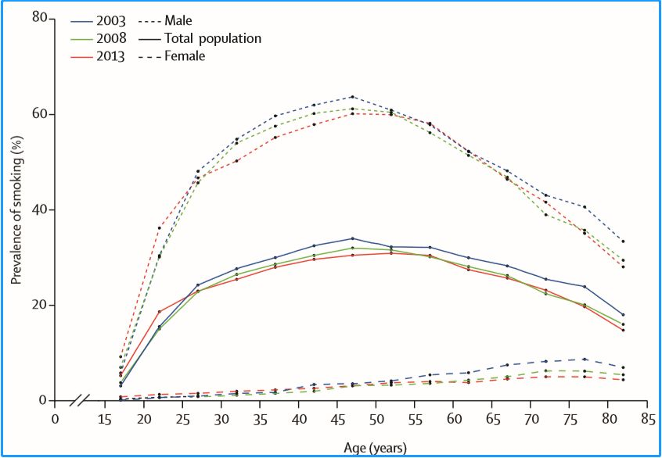

Smoking rates of the total population under 30 years as compared to women under 40 years:

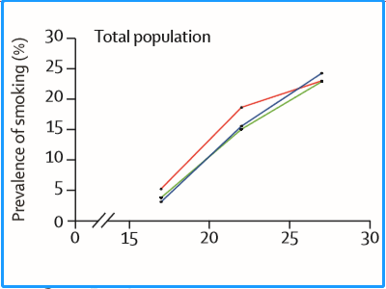

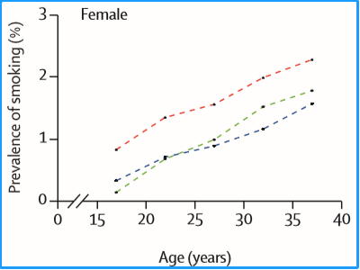

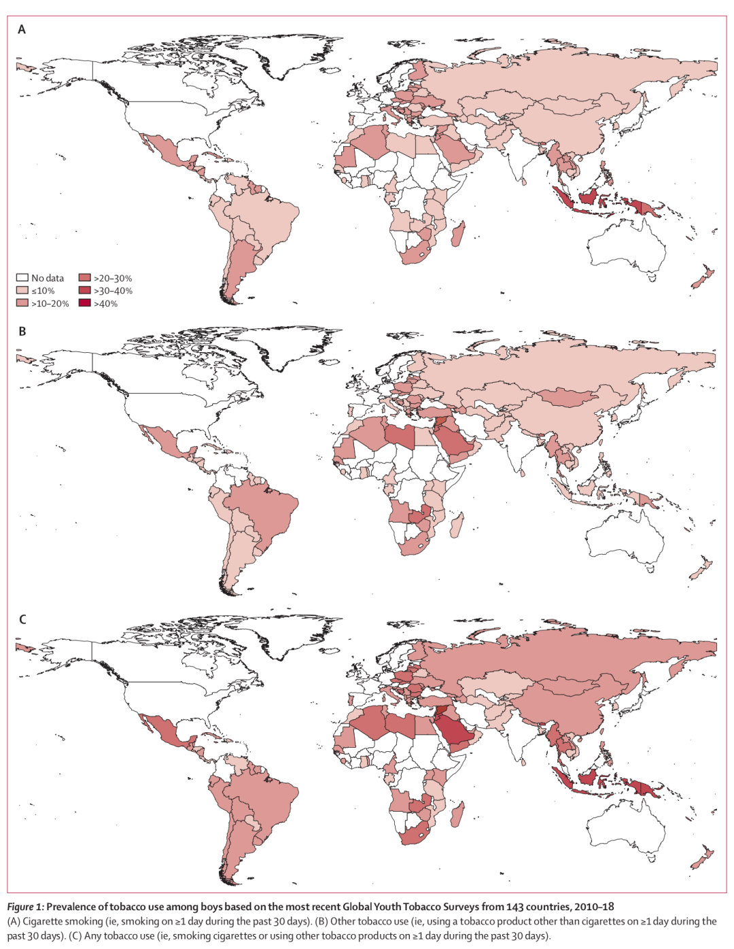
Prevalence and trends in tobacco use among adolescents aged 13–15 years in 143 countries, 1999–2018: findings from the Global Youth Tobacco Survey:

