Master of Business Administration

Module: Human Capital Management (LCMB7023)
Assessment Component 1: Individual Report
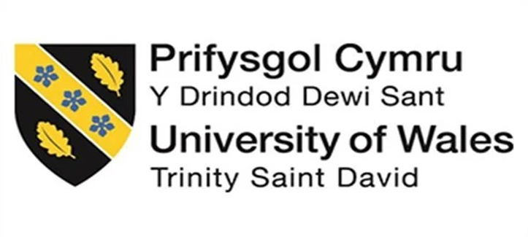
Designing a Human Capital Architecture for Strategic Renewal
Helios Urban Mobility (HUM)
Student name: Yaatri Ramesh bapodra
Student ID number: 2536592

Lecturer: Gladius Kulothungan (London) / Eno Maycock (Birmingham)
Internal Verifier: Vasilios Tavlaridis / Hoang Nguyen
Word count: Approx. 2,539 words (excluding title page, contents, lists, figures, tables and references)
Submission date: 19 June 2026

Table of Contents
List of Abbreviations 3
List of Tables 4
List of Figures 4
Introduction 5
1. Task A: Socialisation, Identity and Business Activism 6
1.1 Critical evaluation of onboarding and organisational socialization 6
1.2 Structured socialisation framework for Helios 8
1.3 Cultivating organisational identification, ethical professionalism and business activism 11
2. Task B: Job Design 13
2.1 An integrated job design strategy for Helios 13
2.2 How the design stimulates intrinsic motivation and innovation 17
3. Task C: Reflective report 18
3.1 Using AI as a decision-support tool 18
3.2 Personal capability development plan 19
References 20

List of Abbreviations

Abbreviation | Meaning
AI | Artificial intelligence
HUM | Helios Urban Mobility
HRM | Human resource management
JCM | Job Characteristics Model
KPI | Key performance indicator
SDT | Self-determination theory
WEF | World Economic Forum

List of Tables

Table 1. Critical comparison of traditional onboarding and strategic organisational socialisation
Table 2. Helios socialisation framework from pre-boarding to year one
Table 3. Integrated job design strategy for Helios
Table 4. Personal capability development plan for Task C

List of Figures

Figure 1. Helios socialisation timeline
Figure 2. Integrated job design architecture
Figure 3: Job Characteristics Model
Figure 4. Evidence dashboard for strategic renewal

Introduction

Helios Urban Mobility (HUM) are experiencing human capital issues that are interlinked, slow employee integration, decreasing employee engagement and high graduate turnover. These problems indicate that growth of organisations is overtaking people management systems. Knowledge-intensive organisations need more than one-off HR interventions to achieve success in the long term they rely on socialisation, job design and ongoing capability development. In a fast-evolving business landscape, these challenges are gaining more and more importance. The global employee engagement percentage is reported at 21% for 2024 (Gallup, 2025), and 39% of the current employee skills are projected to shift by 2030 (World Economic Forum, 2025). Innovation and competitiveness are essential for HUM's future and a key part of this is having an engaged, adaptable and strategically aligned workforce.
The report has three sections.
- Task A compares and contrasts onboarding and strategic organisational socialisation and suggests a model of three stages: pre-boarding, the first 90 days and the first year.
- Task B: Design an integrated job design approach which includes Job Characteristics Model, job crafting and a skills-based architecture.
- Task C looks at how AI can complement, not replace, the human capacity to make decisions and establishes an individual plan for capacity development for future employability.

Task A: Socialisation, Identity and Business Activism

1.1 Critical evaluation of onboarding and organisational socialization
Traditional onboarding is usually process driven and doesn't necessarily create a strong sense of commitment. Van Maanen and Schein (1977) suggest that it is via socialisation tactics that the values, identity and expected behaviour of newcomers to the organisation are shaped. But a lot of organisations only provide onboarding in the form of compliance activities, policy presentations and induction sessions. This can aid in operational efficiency, but does not necessarily build a sense of belonging and organisational attachment. There is growing evidence that onboarding that leads to adjustment, social integration and active learning is more effective than onboarding that is focused on information transfer (Didion et al., 2024).
In the same way, Pinco et al. (2025) highlight that onboarding can be thought of as a process of socialisation and not as a one-time organisational affair. The length of the ramp-up time for HUM is the result of a more serious psychological contract breach, not just a poor onboarding process. Employees hear early messages as cues to how they are being supported, developed and treated fairly in an organisation according to Rousseau (1995). With unclear expectations, lacking career opportunities and inconsistent guidance, trust and commitment can fall rapidly when faced with graduates. This challenge is compounded in a hybrid multi-national context where informal learning is not always even. Mazzei et al., 2023, discovered that low socialisation support leads to low commitment and low organisational attachment of newcomers. In other words, employees are unlikely to become attached to an organization when they feel that they are not working together smoothly, and there is less involvement from the leadership. Ashforth and Mael (1989) indicate that meaningful membership is crucial in order to gain commitment and help keep people involved.
Table 1. Critical comparison of traditional onboarding and strategic organisational socialisation
Dimension | Traditional onboarding | Strategic organisational socialisation
Purpose | Complete induction and compliance tasks | Build commitment, identity and long-term attachment
Timing | Starts on day one and ends after orientation | Begins before arrival and continues through the first year
Learning focus | Rules, systems and job mechanics | Culture, expectations, networks and purpose
Employee role | Passive recipient of information | Active participant in meaning-making and adaptation
Risk for HUM | Fast admin completion but weak commitment | Requires more design effort, but reduces attrition and accelerates ramp-up

Source: Author's own synthesis, informed by Van Maanen and Schein (1977), Rousseau (1995), Ashforth and Mael (1989) and Bauer et al. (2007).

1.2 Structured socialisation framework for Helios

A more effective response is a staged socialisation architecture that begins before day one and continues through the first year.

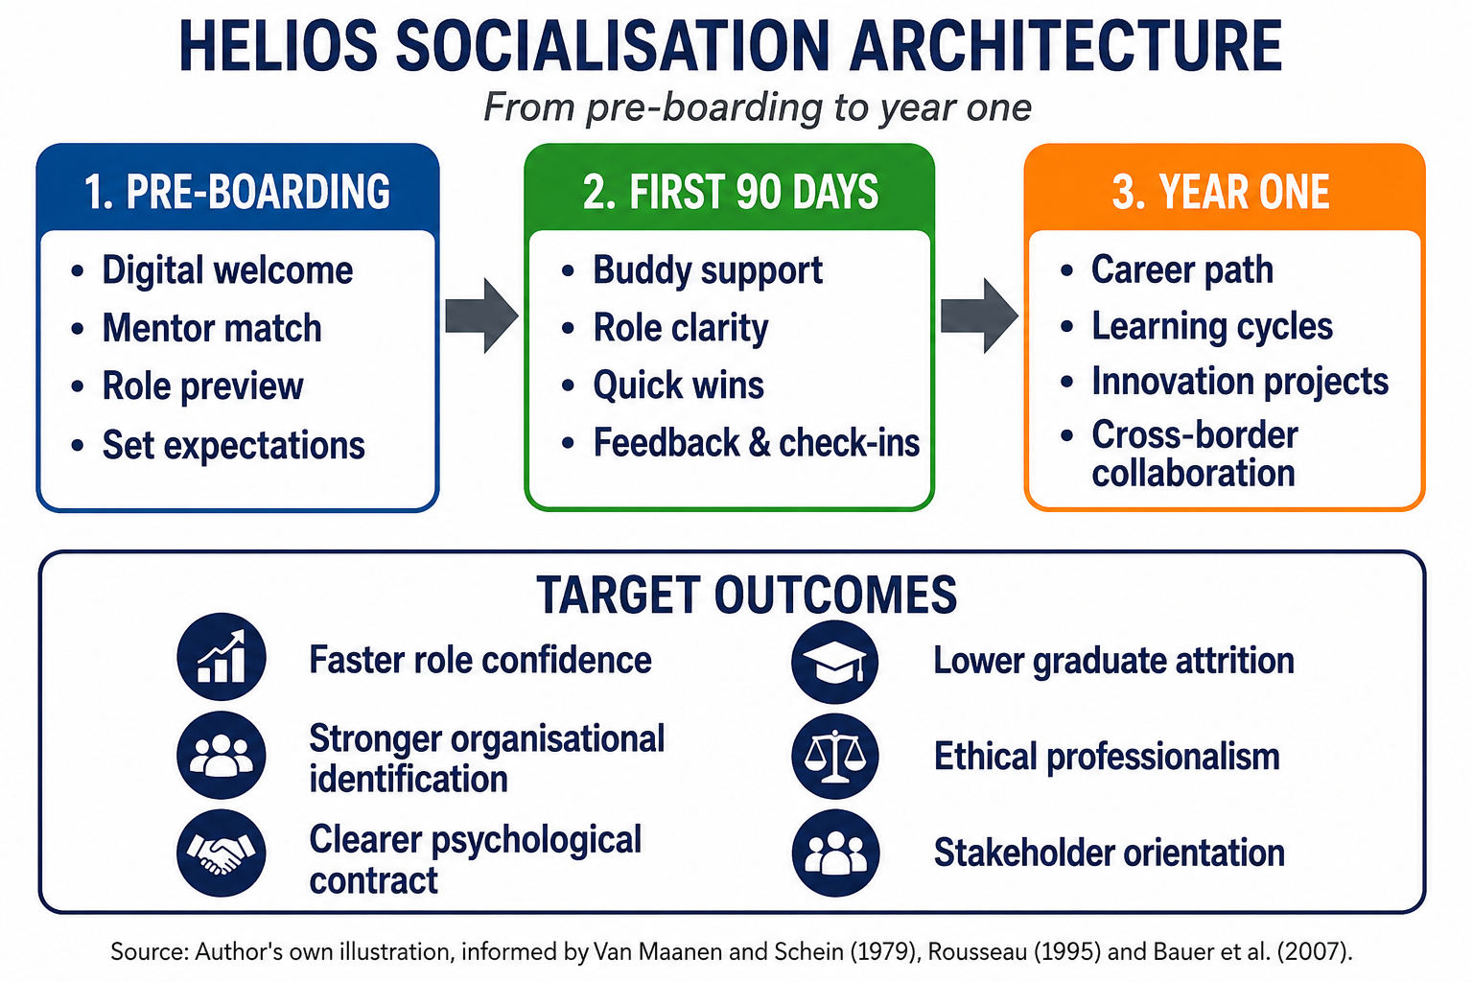

Figure 1. Helios socialisation timeline.
Source: Author's own illustration, informed by Van Maanen and Schein (1977), Rousseau (1995) and Bauer et al. (2007).

Pre-boarding should be a way to communicate the employer brand in terms of expectations. HUM should provide a digital welcome pack, a role preview, a named mentor and a short description of how the person's role fits in at city level in terms of contributing to city-level mobility outcomes. It isn't all about hospitality. It is to minimize uncertainty, increase perceived support and provide a psychologically valid contract prior to arrival of the employee to the job. Bauer et al. (2007) demonstrate that planned, structured and socially facilitated socialisation is beneficial to newcomer adjustment.
The first 90 days should focus on social integration and role clarity. The newcomer could find out how the organisation works by having a buddy system, weekly meetings with the line manager and brief introduction with other functional managers. This is also important because start-up environments are often more about the race to the market, leaving to new entrants the task of figuring out the rules and norms. This strategy can work with a small founding team, but is not going to work at 450 people in three countries.
The first year should be one of settling in to one of commitment building. At this point, cross-border projects and innovation sprints, structured career conversations should be part of the employee's experience. But HUM should also provide ethical and civic learning, particularly as the AI systems it provides affect the public infrastructure and governance of the city. This leads to a wider professional identity; that employees are not only technical specialists but are holders of socially relevant technology.

Table 2. Helios socialisation framework from pre-boarding to year one
Phase | Key actions | Theoretical logic | Indicative success measure
Pre-boarding | Digital welcome pack, mentor allocation, role preview and city-impact narrative | Reduces uncertainty and sets a realistic psychological contract | Clearer expectations before day one
First 90 days | Buddy support, weekly manager check-ins, quick-win project and cross-functional introductions | Strengthens role clarity, belonging and early competence | Shorter ramp-up and stronger confidence
Year one | Career conversations, innovation sprints, ethics sessions and cross-border project participation | Turns adjustment into identity and commitment | Higher engagement and lower graduate attrition
Source: Author's own design.

1.3 Cultivating organisational identification, ethical professionalism and business activism
There is a need to insure the mechanisms of identification, ethical professionalism and business activism in HUM by targeted actions. Leadership visibility, purpose-driven story-telling and employee recognition programmes can all help to increase organisational identification. Frequent town hall meetings, leadership development and leadership development communication connecting the dots between each employee's work and sustainable urban mobility achievements would enable employees to understand how their work contributes to the organisation's overall mission. These types of initiatives help to improve employees' sense of belonging and attachment, and create a sense of identity with the organisation (Ashforth and Mael, 1989).
As the technologies of HUM impact on public infrastructure and mobility systems, it is crucial that the employees are aware of ethical consequences of technical and operational decisions. These are mechanisms which foster informed judgement, accountability and professional responsibility, and not just compliance. In line with Ulrich's strategic HR, employees should be encouraged to be a part of any organisational strategy and not merely task performers (Ulrich,1996). This strategy is based on stakeholder capitalism, which places an increased emphasis on value creation for customers, communities, governments, employees and the environment as opposed to shareholder-oriented value creation (Freeman, 1984). This results in the employees being active contributors to the creation of sustainable value and the strategic renewal and responsible innovation.

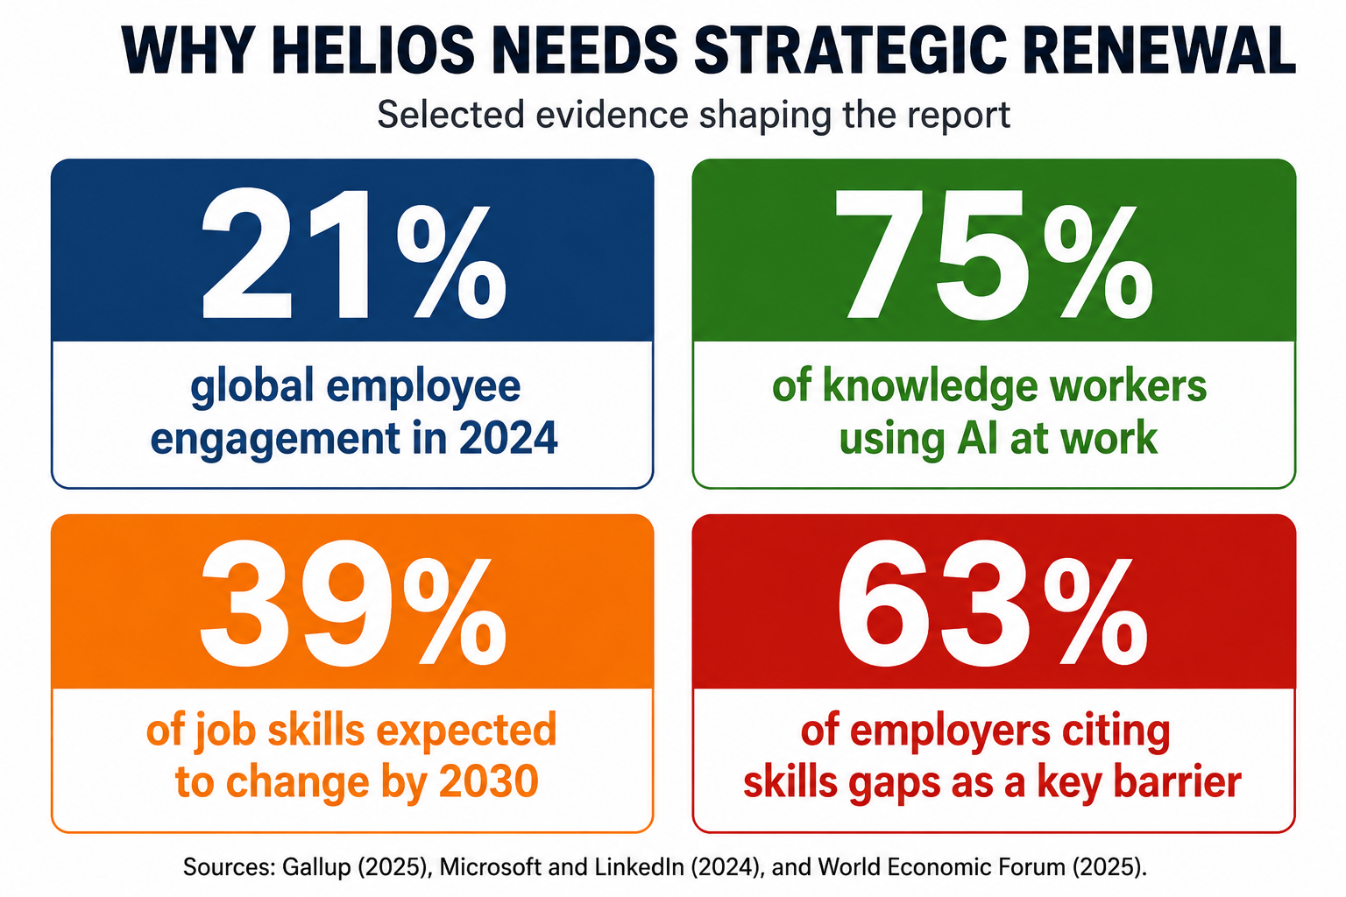

Figure 2. Evidence dashboard for strategic renewal.
Source: Gallup (2025), Microsoft and LinkedIn (2024) and World Economic Forum (2025).

2. Task B: Job Design

2.1 An integrated job design strategy for Helios
HUM should not consider job design a given organogram. Task boxes are the bottlenecks in a technology driven start-up. The Job Characteristics Model is still useful because it can help to understand why some jobs energise individuals, and others deplete the person.
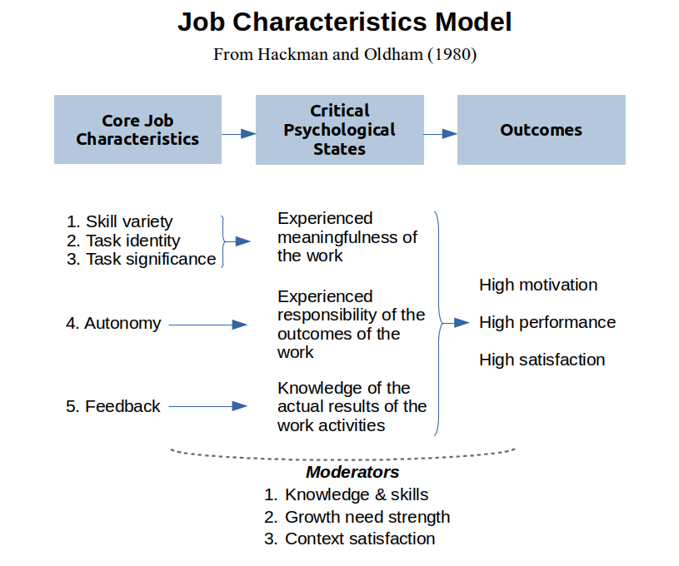
Figure 3: Job Characteristics Model
Source: (Hackman and Oldham,1976)
Skill variety, task significance, task identity, autonomy and feedback are the factors that affect the internal work motivation, according to Hackman and Oldham (1976). The challenge that HUM faces is to revise roles to allow workers to observe a fuller cycle of their work, to apply a broader range of skills and to get immediate feedback on the performance of their work. For instance, a data analyst should not just be tasked with cleaning dashboards, rather, reviewing and interpreting product reviews and client interpretation sessions should be a part of the data analysts' job where the data analysts' work is visible and meaningful. Likewise, a project engineer should be able to suggest consideration of process improvements, instead of just carrying out instructions.
The Job Characteristics Model (JCM) proposes that if the jobs have more skill variety, task identity, task significance, autonomy and feedback, then the intrinsic motivation and job satisfaction of the individual is increased. Wrzesniewski and Dutton (2001) demonstrate that individuals make tasks, relationships and meaning to improve their person-job fit. In recent literature, such as Demerouti et al. (2026), the importance of job crafting to promote engagement and innovation under the condition of organisational boundaries is confirmed. Most important, HUM would develop the concept of “crafting within guardrails”: Crafting combinations within projects, making up of short-term problem solving squads, extending relationships among functions, with guardrails in place core deliverables and ethical standards are maintained.
The third element of this is a talent marketplace and skills-based architecture. The significance of the change is apparent. 63% of employers already see skills gaps as a significant obstacle (World Economic Forum 2025) and 39% of job skills will transform by 2030 (World Economic Forum 2025). Microsoft and LinkedIn (2024) further point out that AI is already reshaping the way knowledge work is done, and HUM requires talent fluidity and not job silos. A skills-based architecture would be capable of mapping the skills across the workforce, discover the hidden talent, and link people to projects, gigs and vacancies based on evidence of skills and not just on job titles or years of service.
Table 3. Integrated job design strategy for Helios
Design lever | Application at Helios | Theory basis | Expected organisational effect
Broadened job scope | Combine technical tasks with client, data and project exposure | Hackman and Oldham (1976) | Greater autonomy, task significance and motivation
Job crafting within guardrails | Allow employees to adjust task mix and relationships around defined outcomes | Wrzesniewski and Dutton (2001) | Higher person-job fit and innovation
Internal talent marketplace | Match people to gigs, projects and vacancies using skills data | Skills-based architecture and LinkedIn (2024) | Faster internal mobility and retention
AI-enabled matching | Use analytics to identify hidden capabilities and project fit | Microsoft and LinkedIn (2024); WEF (2025) | Better workforce agility and resource allocation
Source: Author's own synthesis, informed by Hackman and Oldham (1976), Wrzesniewski and Dutton (2001), LinkedIn (2024), Microsoft and LinkedIn (2024) and World Economic Forum (2025).
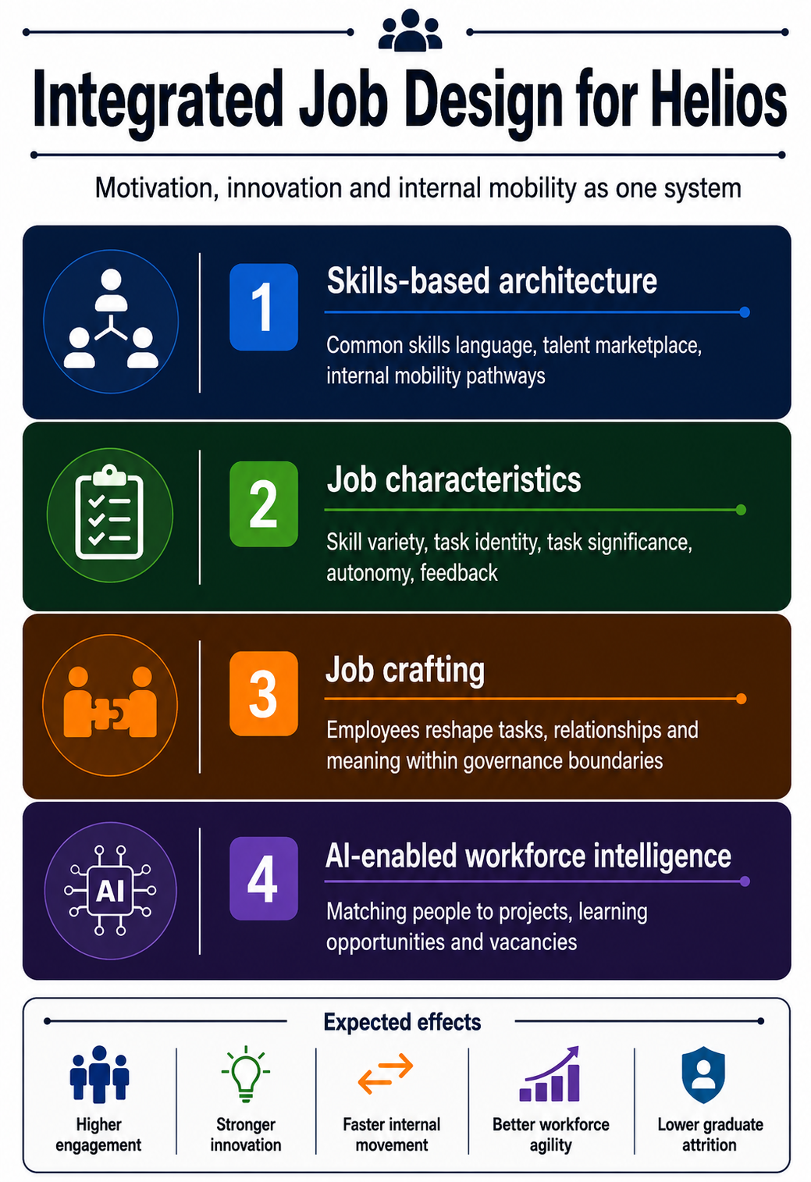
Figure 4. Integrated job design architecture.
Source: Author's own illustration, informed by Hackman and Oldham (1976), Wrzesniewski and Dutton (2001) and LinkedIn (2024).

2.2 How the design stimulates intrinsic motivation and innovation

This design is likely to be one that can promote intrinsic motivation as it mirrors Autonomy, Competence and Relatedness simultaneously. The greater the level of autonomy, the more that employees are able to influence a portion of their task and find a way to access other internal opportunities. Increasing interactions and clear steps to mastery increases competence. Job Crafting is related to the level of relatedness, when it is not individualistic, but related to cross functional job and shared innovation problems. These psychological needs are the bases of self-determined motivation, so HUM should consider job design as a motivational system instead of a scheduling exercise, Deci and Ryan (2000) explain. The innovation factor is also of great importance. The more people are exposed to other functional areas and have a broader role identity, the more likely they will recombine knowledge. That in smart mobility, where the need to provide technical, regulatory and client-facing insights requires reuniting and combining those resources quickly.
A talent marketplace can also save on the experimentation expense since workers can work on projects without a formal role modification. This provides an organisational learning with maintaining agility. However, the major risk to them is fragmentation. Accountability is diffused when all employees are constantly flexible. HUM should therefore take care to have clear governance with every project having a sponsor, outcome measures and ethical review points. Flexibility doesn't replace discipline; it's a way of promoting it.

Task C: Reflective report

3.1 Using AI as a decision-support tool
My personal experience with using AI is that it would not replace the decision-maker in my practice it would be used as a tool to support the decision-maker. The appeal of AI is clear: it can streamline the analysis of data and identify trends, while saving hours of tedious manual work. As of today, there is no doubt that AI is present in the day-to-day life of knowledge workers, as Microsoft and LinkedIn (2024) demonstrate, making it no longer a question of whether but rather how to govern AI in HR work. My point would be that the result of AI should be considered as tentative conclusions. When a model proposes a list of candidates (short list, performance risk or mobility match), I would still check the model's logic in light of context, fairness and potential missing data. That discipline is required due to the fact that algorithms can re-create historical bias a lot even more effectively than man can fix it. This would therefore be considered a responsible use of AI: Triangulation, auditability, human accountability. I would look at the dates that the information presented has been gathered and if it is up to date; whether sensitive information is being over-weighted; and whether the recommendation can be explained to the individual involved. Legitimacy is a factor in HR as important as efficiency. HR processes can be enhanced by AI, but not without proper governance and professional judgement, Dima et al. (2024) say. For this reason, I would never let AI take any final decisions on hiring or promotion/redundancy without a human eye. The aim is to augment. The field of attention should be broadened with AI; responsibility should not be narrowed.

3.2 Personal capability development plan

My capability development plan is based on that perspective. I want to be a more data literate person and be able to interrogate dashboards instead of just absorb them. Also need AI augmentation skills to be able to come up with better prompts, understand limitations of models and bias. Strategic influencing is also very important; evidence will only lead to practice change when it is translated into decisions by senior leaders that are credible. Lastly, global mobility awareness is important as the future HR professional will need to function across markets, cultures and employment regimes. International sensitivity isn't an option, it's part of good judgement, and as HUM itself stretches London, Berlin and Singapore, it's an essential ingredient. I would like to outline in the following table how I would be building these capabilities going forward over the next 12 months.
Table 4. Personal capability development plan for Task C
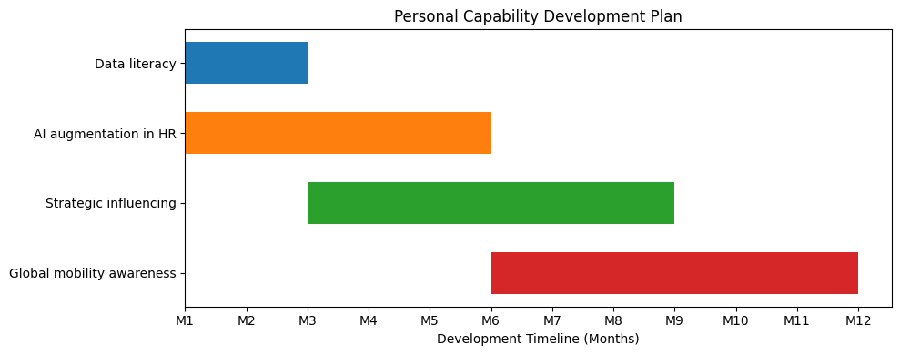
Source: Author's own plan.

References

Ashforth, B.E. and Mael, F. (1989) Social identity theory and the organization. Academy of Management Review, 14(1), pp. 20-39.
Bauer, T.N., Bodner, T., Erdogan, B., Truxillo, D.M. and Tucker, J.S. (2007) Newcomer adjustment during organizational socialization: a meta-analytic review of antecedents, outcomes, and methods. Journal of Applied Psychology, 92(3), pp. 707-721.
Deci, E.L. and Ryan, R.M. (2000) The "what" and "why" of goal pursuits: Human needs and the self-determination of behavior. Psychological Inquiry, 11(4), pp. 227-268.
Didion, E., Perello-Marin, M.R., Catala-Perez, D. and Ambrosius, U. (2024) Mapping the organizational socialization and onboarding literature: a bibliometric analysis of the field. Cogent Business & Management, 11(1), 2337957.
Demerouti, E. et al. (2026) Job Crafting Revisited: Current Insights, Emerging Challenges, and Future Directions. Annual Review of Organizational Psychology and Organizational Behavior.
Dima, J. et al. (2024) The effects of artificial intelligence on human resource management: a systematic review. Public Administration and Policy.
Freeman, R.E. (1984) Strategic Management: A Stakeholder Approach. Boston: Pitman.
Gallup (2025) Global engagement falls for the second time since 2009. Gallup.
Hackman, J.R. and Oldham, G.R. (1976) Motivation through the design of work: Test of a theory. Organizational Behavior and Human Performance, 16(2), pp. 250-279.
LinkedIn (2024) Workplace Learning Report 2024. LinkedIn Learning.
Mazzei, A., Ravazzani, S., Butera, A., Conti, S. and Fisichella, C. (2023) The affective commitment of newcomers in hybrid work contexts: a study on enhancing and inhibiting factors and the mediating role of newcomer adjustment. Frontiers in Psychology, 13, 987976.
Microsoft and LinkedIn (2024) AI at Work Is Here. Now Comes the Hard Part. Work Trend Index Annual Report.
Pinco, O., Salanta, I.I., Beleiu, I.N. and Crisan, E.L. (2025) The onboarding process: a review. Vilakshan - XIMB Journal of Management, 22(1), pp. 2-13.
Rousseau, D.M. (1995) Psychological Contracts in Organizations: Understanding Written and Unwritten Agreements. Thousand Oaks, CA: Sage.
Ulrich, D. (1996) Human Resource Champions: The Next Agenda for Adding Value and Delivering Results. Boston, MA: Harvard Business School Press.
Van Maanen, J. and Schein, E.H. (1977) Toward a theory of organizational socialization. In: Staw, B.M. (ed.) Research in Organizational Behavior, 1. Greenwich, CT: JAI Press, pp. 209-264.
World Economic Forum (2025) The Future of Jobs Report 2025. Geneva: World Economic Forum.
Wrzesniewski, A. and Dutton, J.E. (2001) Crafting a job: revisioning employees as active crafters of their work. Academy of Management Review, 26(2), pp. 179-201.

