- Business Opportunity Haverfordwest
- Property to let

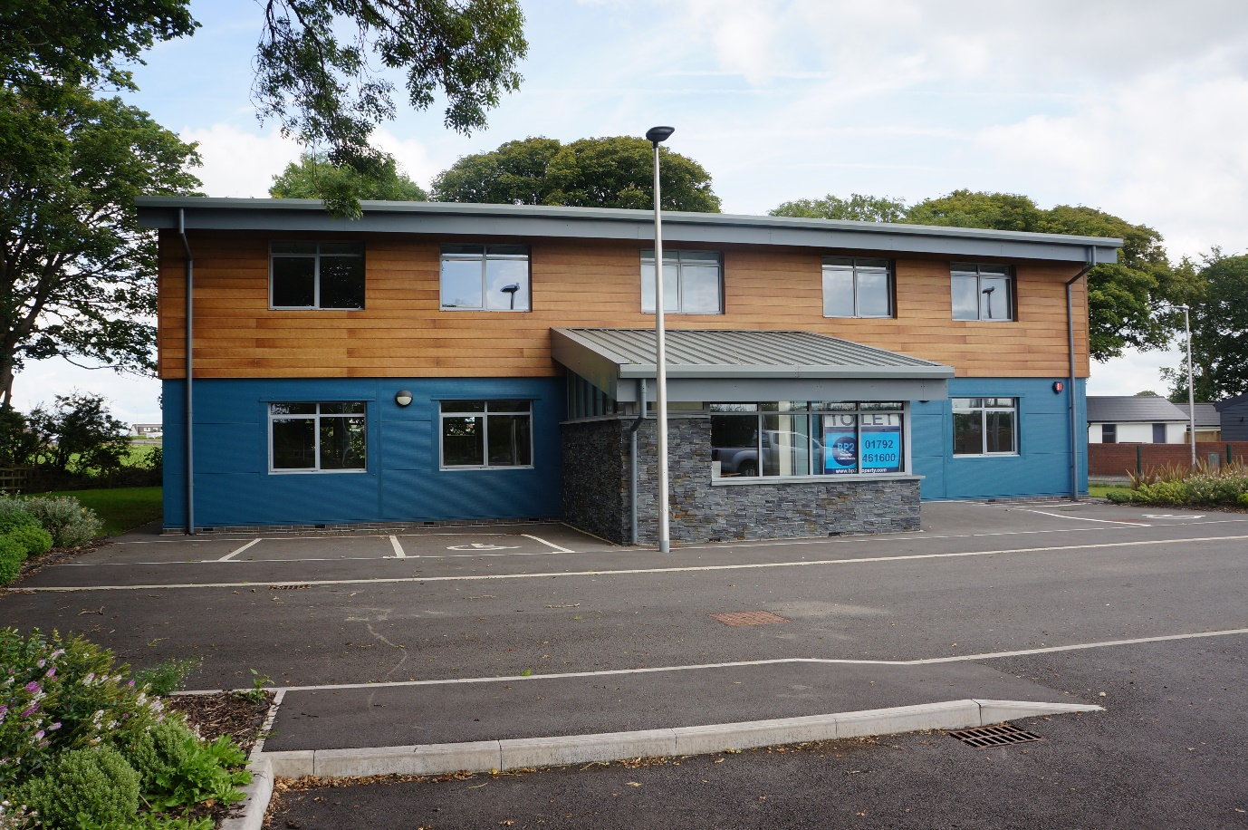

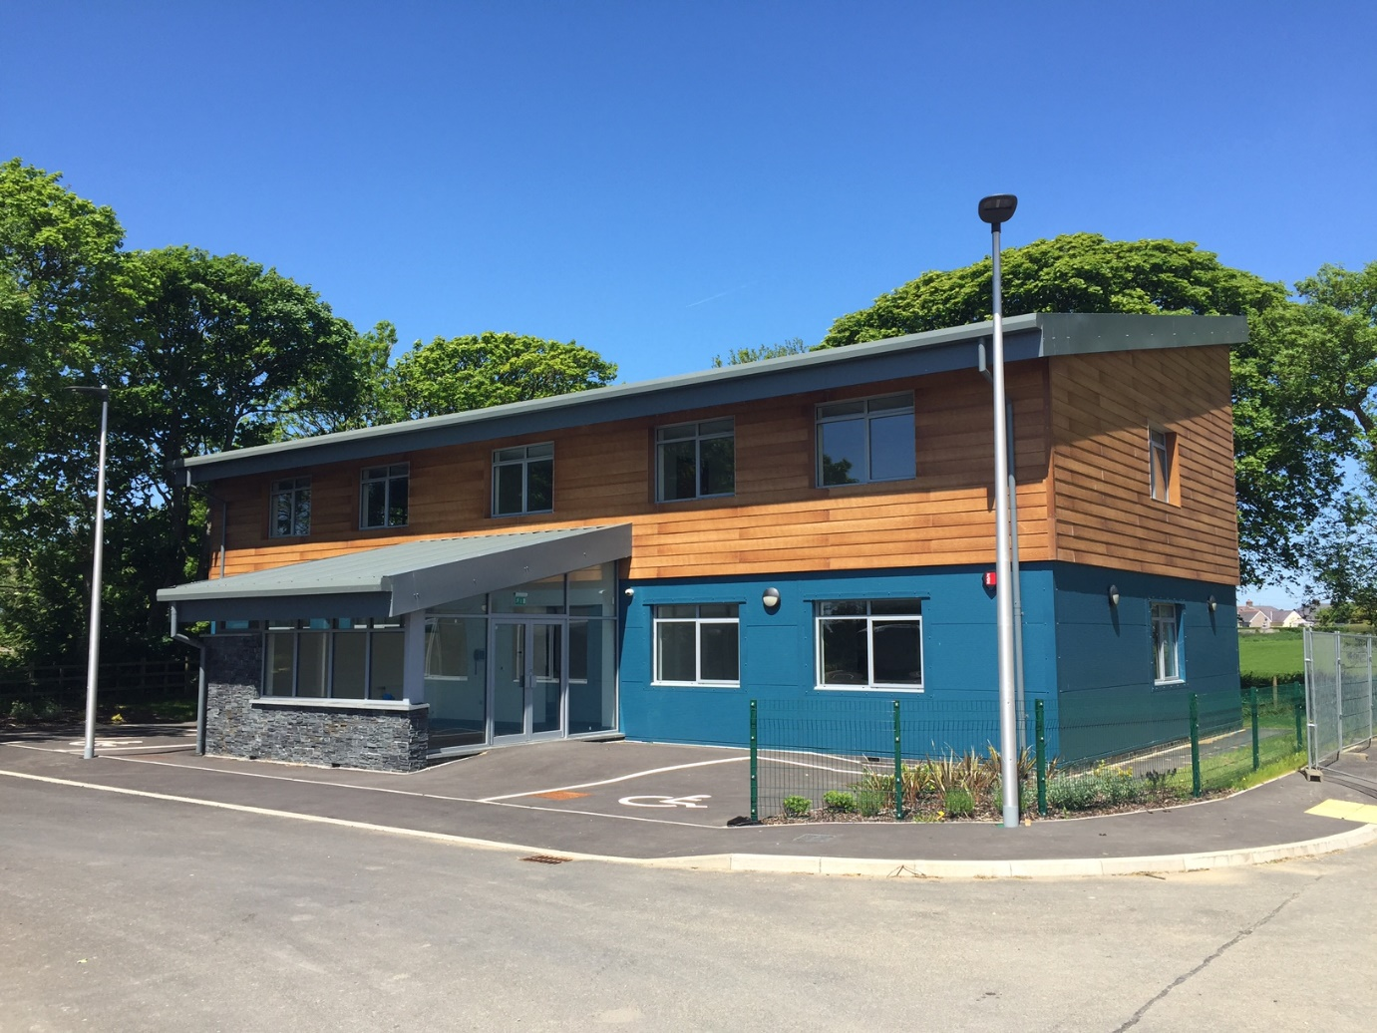

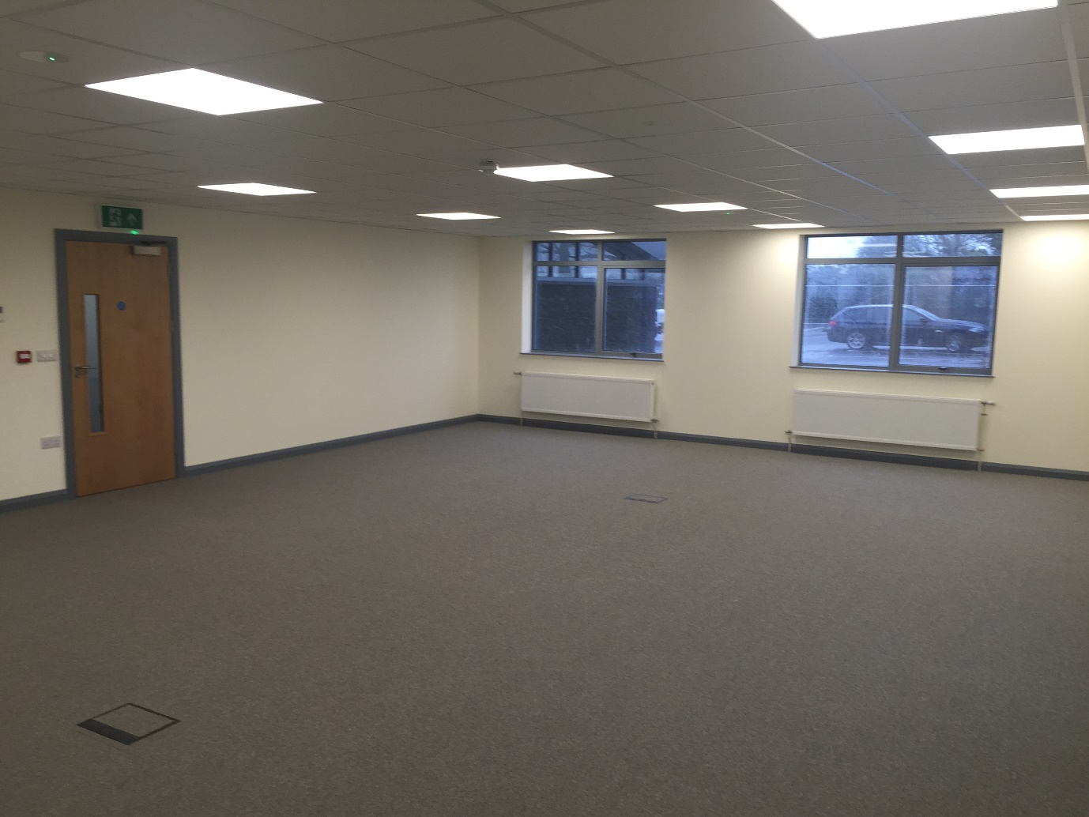

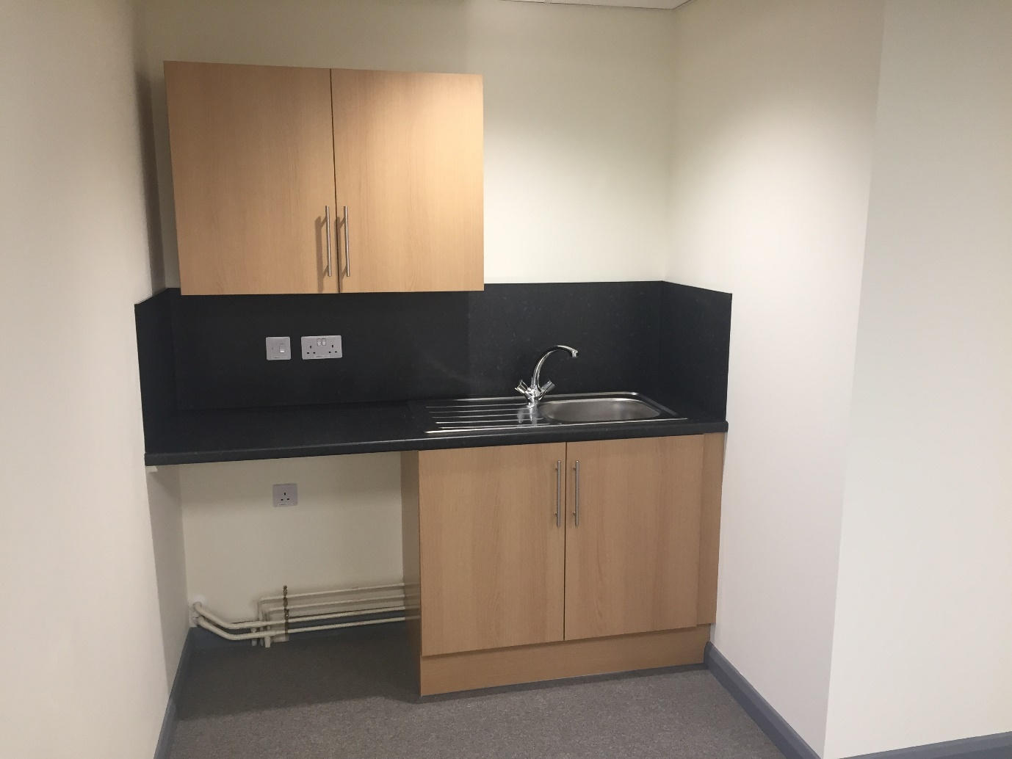

£8,921 pa (£743 pcm) Fixed price

Office to let
Hayston View, Johnston, Haverfordwest SA62
Brand new offices located in Fredrick House, Johnston providing quality breeam accommodation. Flexible space available with shared meeting room facility.
- Johnston (Pembs) (0.4 miles)
- Milford Haven (3.0 miles)

Features
- Unfurnished
- Central Accessable Location
- On Site Car Parking
- Available Immediately
- High Specification
- High Energy Efficiency

Description
Main Description
Specification
The building benefits from the following specification:
- breeam construction very good (excellent for Energy)
- Raised fully carpeted flooring with floor boxes
- Recessed lighting & platform lift
- Oil fired central heating
- Male, female and disabled wc's & shower facilities
- Bike storage
Accommodation
Ground Floor Suite: 85 Sq M / 915 Sq ft.
TenureThe accommodation is available by way of a new effective full repairing and insuring lease via a service charge. Terms
Leasehold - £9.75 per sq ft
Service Charge
tbc.
Planning
The unit currently benefits from B1 planning consent for office use. We would encourage interested parties to make their own enquiries with the local planning authority in this regard.
Business Rates
To be assessed.
EPC

Available on Enquiry.
VAT & Legal Costs
All prices, premiums and rents are quoted exclusive of VAT. Each party is responsible for their own legal costs incurred in any transaction.
Viewing & Further information
For further information, or if you would like to arrange a viewing, please contact our agents.
Accommodation
Accommodation
The property currently holds the following Net Internal Areas.
SuiteSq ftSq mgf 1 A91585GF 2LET let ff 1LET let ff 2LET let Total 91585
The property benefits from ample on-site car parking.
Terms And Conditions
TenureThe accommodation is available by way of a new effective full repairing and insuring lease via a service charge. Terms
Leasehold - £9.75 per sq ft

Local Amenities
- Johnston C P School 0.4 miles
- Milford Haven School 2.1 miles
- Johnston (Pembs) 0.4 miles
- Milford Haven 3 m

