

Effective Team work

Module: BMSW4002

Student Number: 2016547

Elayne Gaspar Pires Dos Santos Da Cruz

Abdi Rahman

Introduction

Teamwork is proposed as a dynamic process involving two or more healthcare professionals with complementary backgrounds and skills, sharing common health goals, and exercising concerted physical and mental effort in assessing, planning, or evaluating patient care. This is accomplished through interdependent collaboration, open communication, and shared decision-making, and generates value-added patient, organizational and staff outcomes.
Interprofessional teamwork is defined as a dynamic process involving two or more healthcare professionals with complementary backgrounds and skills, sharing common health goals and exercising concerted physical and mental effort in assessing, planning, or evaluating patient care Interprofessional teamwork is increasingly recognized as important due to the complex and dynamic nature of healthcare organizations, the growing specialization of healthcare professions and the increasing complexity of healthcare. Interprofessional teamwork is essential in improving coordination of care, reducing duplication of work, and enhancing patient safety and quality of care. Furthermore, it may lead to improved well-being and job satisfaction among employees while poor intra- and interprofessional teamwork is associated with higher rates of missed care, medical errors, and patient adverse events.
The significance of effective interprofessional teamwork to improve the quality of care has been widely recognized. Effective interprofessional teamwork calls on good collaboration between professionals and patients, coordination between professionals, and the development of teamwork over time. Effective development of teams also requires support from the wider organizational context.

Characteristics of teamwork

Teamwork comprises a set of behaviors that are both unknown and difficult to implement day after day, but that contributes to the achievement of organizational results as it enhances the ability to innovate and solve problems through collaborative attitudes of team members. A group of people with complementary skills, working together in the same activity, with common purposes and objectives, committed to each other and with quality of relationships and results. The work team is an organized group, committed to the individual, whose members share the same intention to accomplish a common goal.

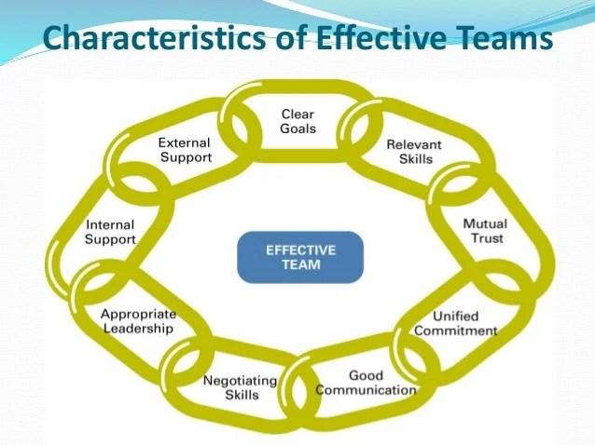

Source: https://www.careercliff.com/characteristics-of-effective-team/

Problems teamwork:

- Lack of trust
- Conflict and tension
- Not sharing information
- Personality conflicts
- Poor Communication
- No Plan

Model of teamwork
Tuckman’s Model 1965 developed by Bruce Tuckman in 1965 a professor philosophical, psychological, and comparative studies Ohio state university.

The stages include:
- Forming
- Storming
- Norming
- Performing
- Adjourning 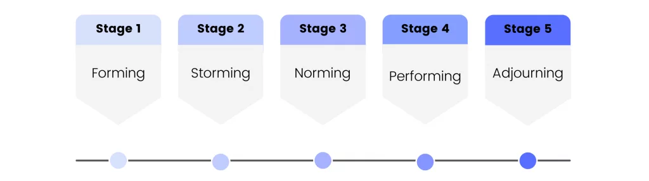 Source:https://fellow.app/blog/management/stages-of-team-development-and-how-to-navigate-them-smoothly/

Forming stage: it is characterized by a great deal of uncertainty about the team’s purpose structure, and leadership. It’s also common for team performance to dip a bit in the storming stage as members can sometimes disagree on goals, strategy, responsibilities, and roles.
Think of the forming stage like the first day of school or the first day at a new job. There’s excitement in the air and everyone is ready to roll up their sleeves and get started on the project. Usually, group dynamics and roles have yet to be established, a team leader will typically emerge and take charge and direct the individual members.

- Team members meet for the first time
- Team members wonder what is expected of them and how to behave
- Members “test the waters “to determine what type of behaviour are acceptable.
- Team Leader should
- Break the ice-Introduce team members to each other
- Build relationship
- Use appropriate communication
- Create psychological safety-create an environment where individuals feel comfortable to express themselves.

Storming stage:

There is internal tension during the storm period. Despite recognizing the existence of the team, members oppose the limitations it places on individuality. Who will be responsible for the team is a source of contention. There will be a very distinct leadership hierarchy within the team once this stage is complete.
It’s also common for team performance to dip a bit in the storming stage as members can sometimes disagree on goals, strategy, responsibilities, and roles.

- Encourage unity and cooperation
- Know each team member's personality and strengths.
- Toss out obligations and roles.
- Effective conflict resolution
- Develop a growth mindset

Role for creating effective teams

For your team members to understand what is expected of them, it is crucial that you take some time in defining roles distinctly. This is going to steer you in the direction of team success, team satisfaction, and you’ll see your goals and objectives being met a lot more effectively.
Too much ambiguity about team roles and responsibilities in the workplace can cause a lot of confusion and stump productivity. In contrast, knowing exactly what is expected of you, allows for more effective and productive work.
Team roles and responsibilities refer to the tasks associated with a person’s job description, and therefore their role within the organization. Because each team member holds several different duties and is responsible for completing a similar theme of tasks each day, it’s important that responsibilities are clearly defined.

Tips to define team roles and responsibilities:

- Understand your teams strengths,
- Determine what needs to get done,
- Meet to discuss priorities on an ongoing basis,
- Give people ownership over specific areas,
- Ask employees about their long-term goals,
- Align roles and responsibilities with their goals.

Impact of effective teamwork on team success

Effective teamwork is an important aspect of any organization’s success. There are many benefits of teamwork, most notably, an increase in motivation from your employees.
The most important building block to develop and effective team is communication, so it is imperative to develop the necessary skills to communicate effectively with each other.

Learning to communicate effectively is not a simple one step process and requires work from all sides. It is a great idea to have weekly meetings in which the manager is present to see how the team interacts with each and offer feedback on their achievements, as well as how the team meetings are running.

Working in teams and encouraging effective teamwork among your staff can bring many benefits and competitive advantages to your business.

Advantages of effective teamwork:

Increased productivity: this can lead to happier, productive, and more motivated staff.

Deadlines met: individuals working on their own can only achieve so much in a certain amount of time.

Problem solving: a few people coming together to consider a problem can often be more effective at finding solutions than one person working alone.

New ideas and opportunities: teamwork can spark creativity among your staff, which can lead to the development of innovative new ideas, products or services as well as identifying new business opportunities.
Support network: in the face of business challenges people in a team can support one another by helping each other out especially if an individual in the group is facing difficulties.
Conflict resolution skills - there is often the potential for personality clashes between individual team members but collaborating towards shared goals often enables employees to work out how best to resolve disagreements for the benefit of the team.

An effective team is one that has cohesion, to do this your team members need to exhibit the following skills:
Openness – Team members need to be willing to get to know each other and open up about themselves, so they realized that they all have diverse backgrounds and interests.
Trust – Team members need to trust each other enough to be comfortable with sharing ideas and feelings.
Respect – It is important for the team not to focus on who to blame when something goes wrong, instead they need to work out how to fix it and how to learn from the mistake.

Conclusion

Praising the value of teamwork without a common understanding of what this concept represents endangers both research into this way of working and its effective utilization in practice. The proposed definition helps reconcile discrepancies between how this concept is understood by nurses and doctors, as well as allied health professionals. A common understanding can facilitate communication in educational, research and clinical settings and is imperative for improving clarity and validity of future research.
The overall take-home message is that teamwork training is an effective way to foster teamwork and team performance. These effects appear to be evident across a range of samples, utilizing numerous intervention methods, and when considering various measurement characteristics. Interventions appear to be particularly effective when they target multiple dimensions of teamwork and include experiential activities for team members to actively learn about, practice, and continually develop teamwork.

Reference:

West MA. Effective teamwork: Practical lessons from organizational research. Blackwell Publishing; 1994.

Dinius J, et al. Inter-professional teamwork, and its association with patient safety in German hospitals-A cross sectional study. PLoS One. 2020;15(5): e0233766.

van Dijk-de Vries A, van Dongen JJ, van Bokhoven MA. Sustainable interprofessional teamwork needs a team-friendly healthcare system: Experiences from a collaborative Dutch programme. J Interprof Care. 2017;31(2):167–9.

War, A. V. (2002). Team Development: an approach through distance education technologies. Master's thesis in Production Engineering, Federal University of Santa Catarina, Florianópolis.

Tuckman,B.W.(1965) Developmental sequence in small groups, Psychological Bulletin, 63, 384-399.
Pasleau, P., (2017), Tuckman Model: Understanding the stages of team formation, [video], Available at: https://www.youtube.com/watch?v=2QbXc6E08H4 (Accessed: 19 June 2020).
[2] Stein, J. Using the Stages of Team Development [online]. Available here. [Accessed 30 October 2020]
/content/advantages-effective-teamwork

