

cove



Learning in the digital era

Beata Orlowska ACCA4025
ID: 2520903 Malik Muhmood

TASK 1 4
1.a Essentials: Academic and employment skills for future employment 4
Task 1b – similarity reflection on my work in Turnitin 5
TASK 2 6
2a Mind Map 6
2b professional academic poster [7] 7
TASK 3 8
3a Virtual Collaboration 8
3b How do I use RefWorks 9
TASK 4- E-portfolio 10
References 12

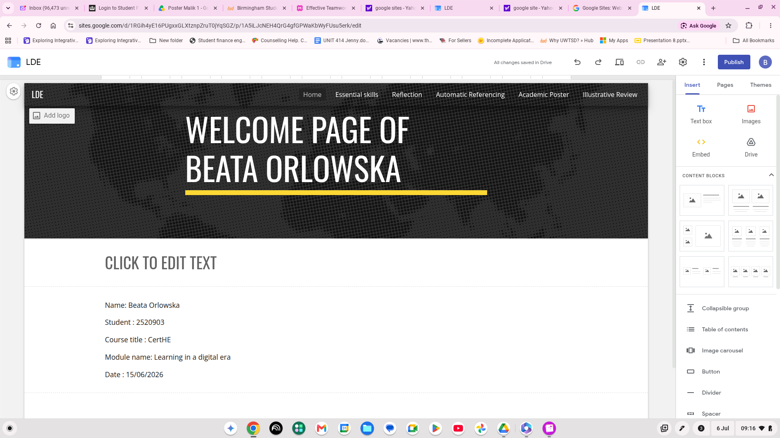

https://sites.google.com/view/bea-lee/home

TASK 1

1.a Essentials: Academic and employment skills for future employment

As I continue my placement as a trainee counsellor, I'm also developing IT skills for my future workplace. Both counselling and IT are important for my studies and future employment. Alongside this, I’m also a qualified Security Officer, and these study experiences are helping me combine various techniques to build a unique set of skills.

The most important thing I've developed over my years of study as a counsellor is my ability to communicate with others. Working as a counsellor requires strong listening skills, empathy, and the ability to build a trusting, professional relationship with clients. Through working with people from different backgrounds, I have improved my ability to communicate professionally and respond appropriately to individual needs. l of these skills is transferable and can be applied in both counselling and security roles. [1]

Learning IT skills is very valuable and important in today’s workplace. I gain experience using various computer systems, emails, Microsoft Office applications, and online learning platforms. All these skills are improving my efficiency and helping me manage all information accurately. These days, we find technology everywhere, and it is used across many industries, including counselling and security, making these skills valuable for any future employment. [2]

As a Qualified Security officer, I've developed skills in observation, problem-solving, professionalism, and dealing calmly and appropriately with any given and sometimes challenging situation. These skills integrate well with each other as both require good communication skills, confidentiality, and the ability to support people professionally.

Time management as an organisation is one of the vital essentials we all should have if we choose the professions in our working life. Balancing university studies, counselling placements, IT training, and security work demands careful planning and commitment. Having developed these skills was a help with keeping on top of deadlines, prioritized task efficiently and maintaining professional standards. Good time management also reduce stress and improve productivity, enabling individuals to achieve their goals more efficiently. [3]

I hope that after graduation, the combination of these skills, IT knowledge and security experience will increase my employment opportunities. Together these skills will help me work effectively with diverse range of people and use workplace technology confidently and adapt to different professional environments. By continuing to develop both my academic and practical skills, I aim to become a competent and adaptable professional who can contribute positively to future workplace. [4]

Team work [5]

Task 1b – similarity reflection on my work in Turnitin

Turnitin show after submitting my work that the similarity score was 4% and, on that fact, i don't believe you could have any lower percentage as this text will have to be totally unique and very original. I'm very happy with this as I've have used my own reflective understanding of this work and tried to use suggested words on various websites. We can always have higher score in similarity as when we copy or don't research more words which will describe or insinuate different meaning. However, this score is a reflection on my own work and that I have NOT copy or seek help by anyone who is doing the same assignment as well.
In my case as a foreign national i need to have big supply of vocabulary to effectively communicate with people around in my close circle of friends and family. I’m very surprised that my score is so low and very proud to have achieved that.
Although I've achieved low similarity score, next time I could improve further by using a wider range of academic sources, paraphrasing more confidently in my own words and checking all referencing carefully before submitting it. I will also ensure every citation follow the

IEEE referencing style correctly and will be more confident to do so as i already have the basic knowledge to do so.

Marks will be allocated based on how well the student has met the generic assessment criteria in each task. | Marks available | Marks  awarded
1. Engagement with Literature Skills

I’m doing well as having Dyslexia it may hinder me in fully understanding what’s being said in class, so I must carefully go over it again at home | 20 | 15
2. Knowledge and Understanding Skills

Even though I thought I knew how to work on the computer I found it very challenging to learn new words, functions and theory’s to grasp this, however by asking questions and having support from tutor’s and fellow students it was very easy to get full understanding of what’s required | 20 | 15
3. Cognitive and Intellectual Skills

I have a lot of experience as I’ve worked in many different professions over the years and as long, I can put things into perspective what need doing I’m confident I can achieve the goal | 20 | 20
4. Practical Application Skills

I’m very confident that tasks at hand can be achieved as with careful listening and interaction with student and tutors it became easier to do so | 20 | 18
5. Transferable Skills for Life and Professional Practice
I’m an excellent communicator, I’m always on time never absent and always engage with my fellow student in the class and outside of it, so with these skills I know that I’m capable and can integrate and work in any task | 20 | 20

TASK 2

2a Mind Map

The Mind Map was created individually using click the ling below:

https://mm.tt/map/4035304653?t=s6c4yAgOIQ

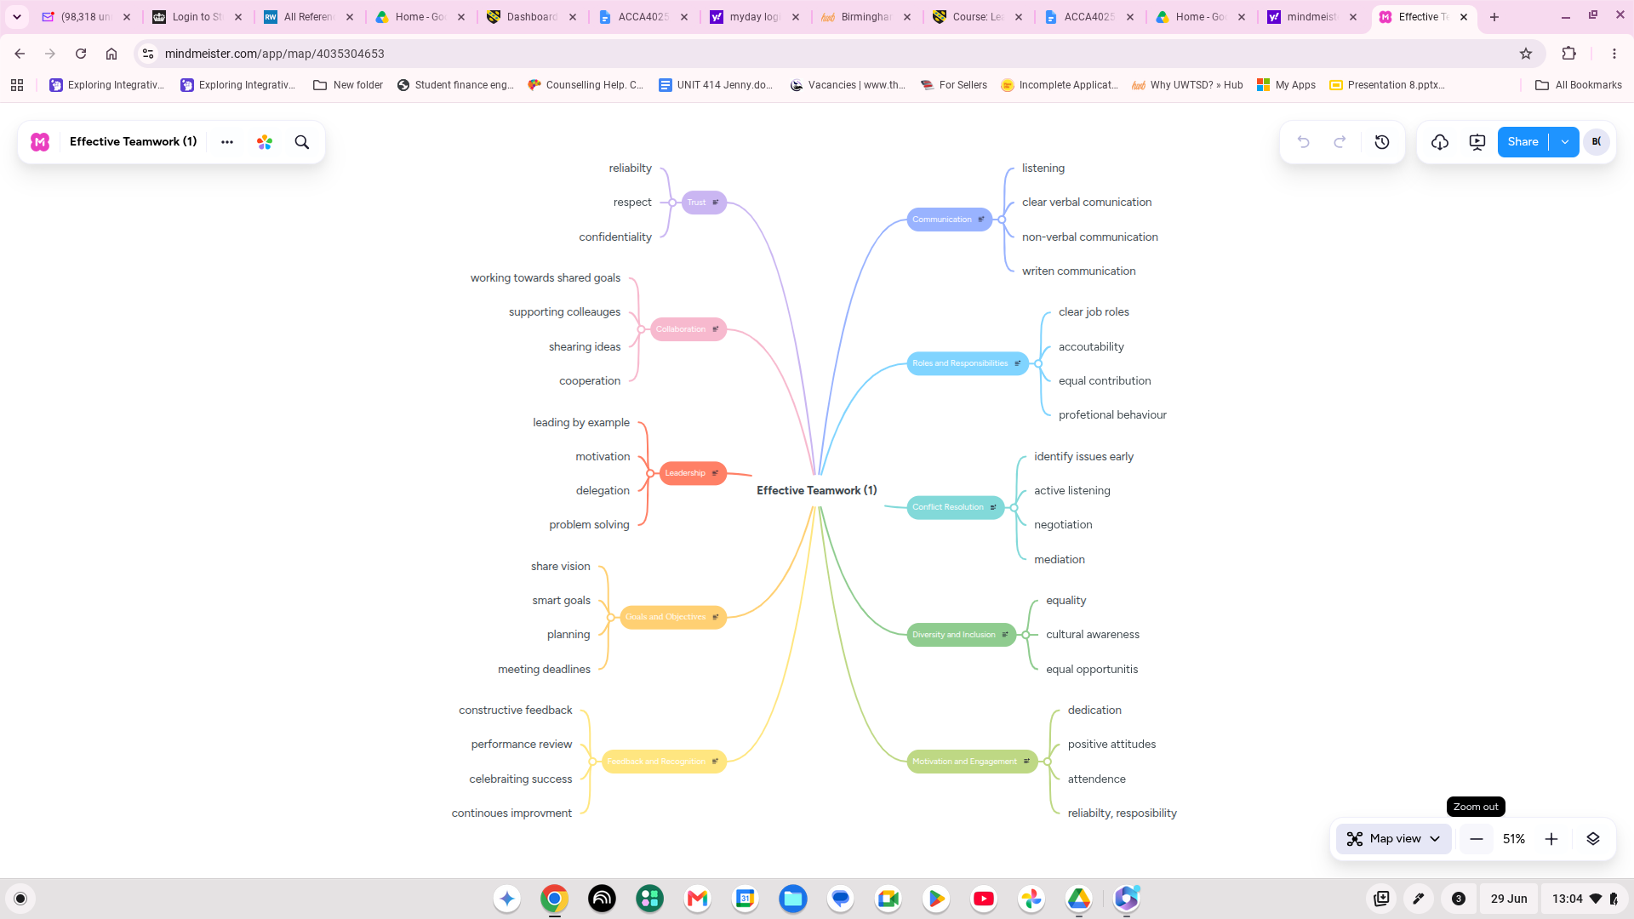

2b professional academic poster [7]

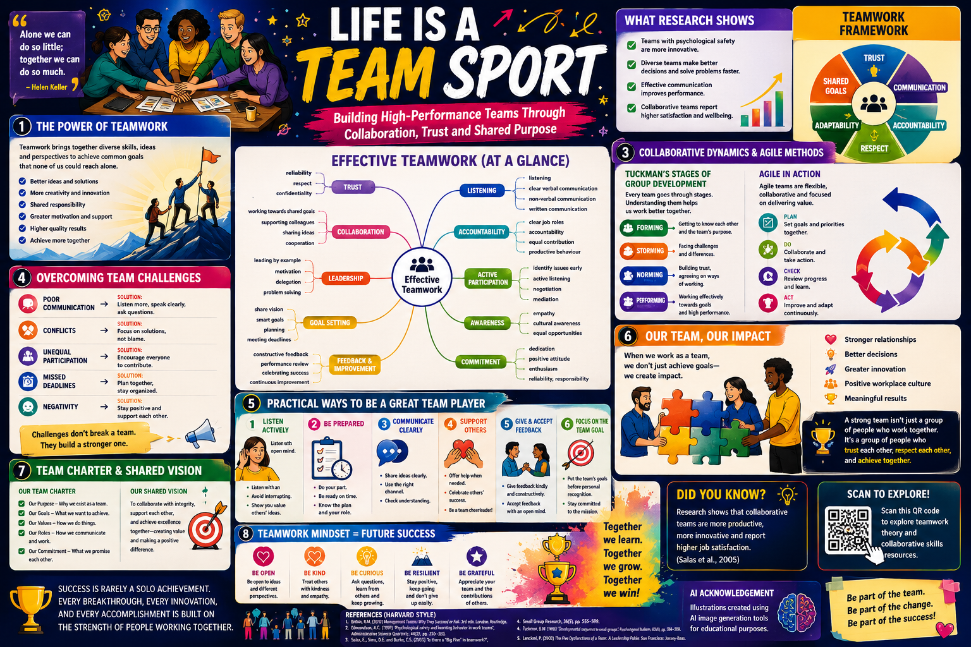

Essential team skills:
- Effective communication
- Trust and psychological safety
- Adaptability and resilience
- Problem-solving abilities
- Shared responsibility
- Leadership and accountability
Overcoming challenges
- Resolve conflict constructively
- Encourage open communication
- Clarify team roles
- Build mutual trust
- Celebrate team success
Benefits of Teamwork

- Increased creativity
- Better decision making
- Higher productivity
- Greater innovation
- Stronger relationships

TASK 3

3a Virtual Collaboration ( lights, camera, action)

Virtual collaboration refers to the process of individuals working together through digital technologies rather than in the same physical location. In recent years, virtual collaboration has become increasingly important in both higher education and in professional environment due to technological advancements and the growing use of remote working practices. It allows individuals and teams to communicate, share information, and complete tasks efficiently while being in different geographical locations.
One of the majors’ benefits of virtual collaboration is flexibility as team members can work at distances like different countries, or time zones while still contributing to common objective. This flexibility reduces cost of traveling and saves time while it allows businesses and educational institutions to benefit from diverse skills, experiences, and gives all a different perspective.
For us students, virtual collaboration provides opportunities to take part in group activities, communicate with peers and lecturers, and develop important digital proficiency that are valued in modern workplace.
Effective virtual collaboration requires strong communication, organization, and teamwork skills. Team members need to have clear goals, allocated tasks, and must maintain regular communication to ensure that all assignments are successfully completed. Digital communication platforms such as Microsoft Teams, Zoom, Google Meet, and cloud-based storage system support collaboration by enabling everyone in the team to share documents, hold meetings, exchange ideas, and monitor projects progress in real time. In addition, trust, accountability, and active participation are essential factors that contribute to successful virtual teamwork. [6]
As many advantages it brings, they are also several challenges. It can be unreliable internet connection, different time zones, and communication barriers can negatively affect teamwork performance and productivity. As the face-to-face interaction cause misunderstandings, reduces engagement, and difficulty in developing strong interpersonal relationships between team members. Cultural differences and varying levels of digital skills can also create obstacles within virtual teams. To address these challenges, teams should establish clear communication procedures, schedule regular meetings, set realistic deadlines, and make sure that all the members of the team have access to digital resources and support.
Finally, virtual collaboration has become an essential part of contemporary education and professional practice. The ability to work effectively within a virtual team improves the development of communication, problem solving, leadership, and digital skills. As organizations increasingly adopt technology-driven working practices, virtual collaboration will continue to play a significant role in encouraging productivity, innovation, and successful teamwork across a range of business and organisations. [7]

3b How do I use RefWorks

Opening “RefWorks”

Ive started by login into the “RefWorks” at the UWTSD Library. The software allowed me to collect and organize references in one place as it makes it easier to prepare assignments.
Adding References

I select “Add References” and enter the publication details manually. This includes the author's name, title, publication year and source of information and by saving each reference created I'm building my own personal library that I can use whenever I require.

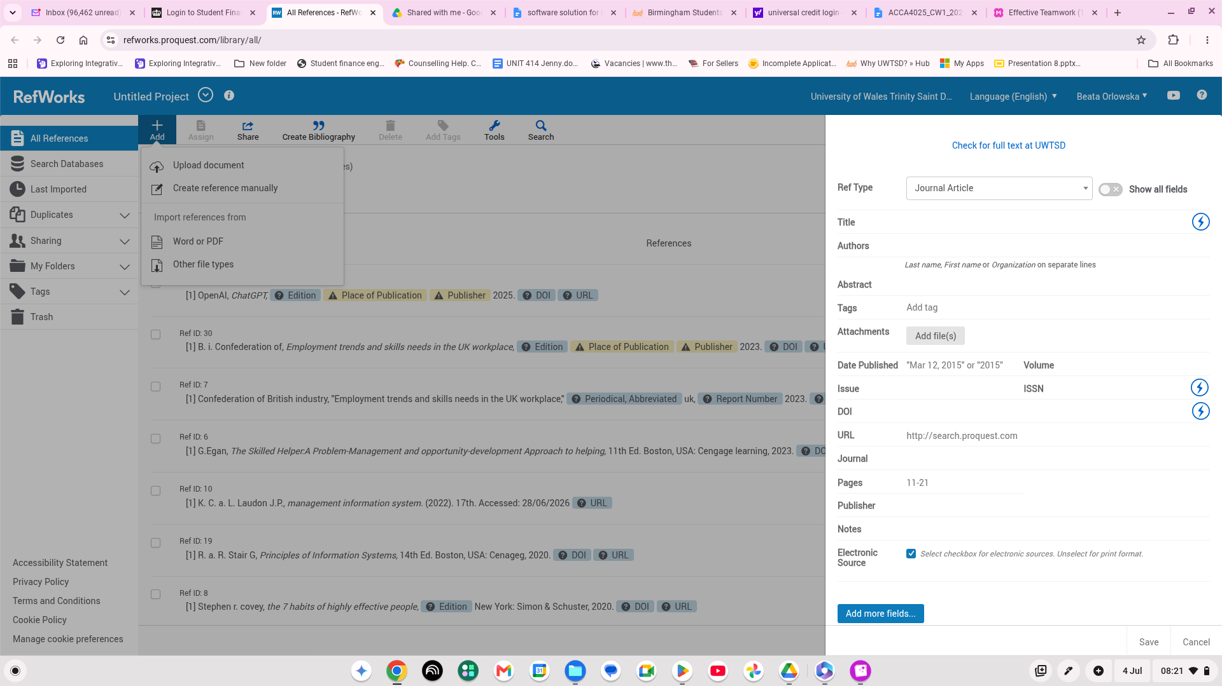

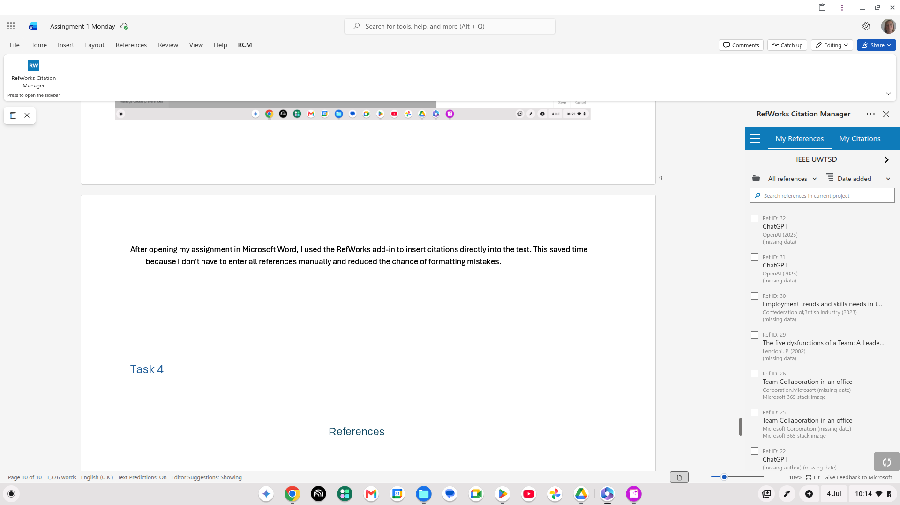
After opening my assignment in Microsoft Word, I used the RefWorks add-in to insert citations directly into the text. This saved time because I don't have to enter all references manually and reduced the chance of formatting mistakes.

TASK 4- E-portfolio

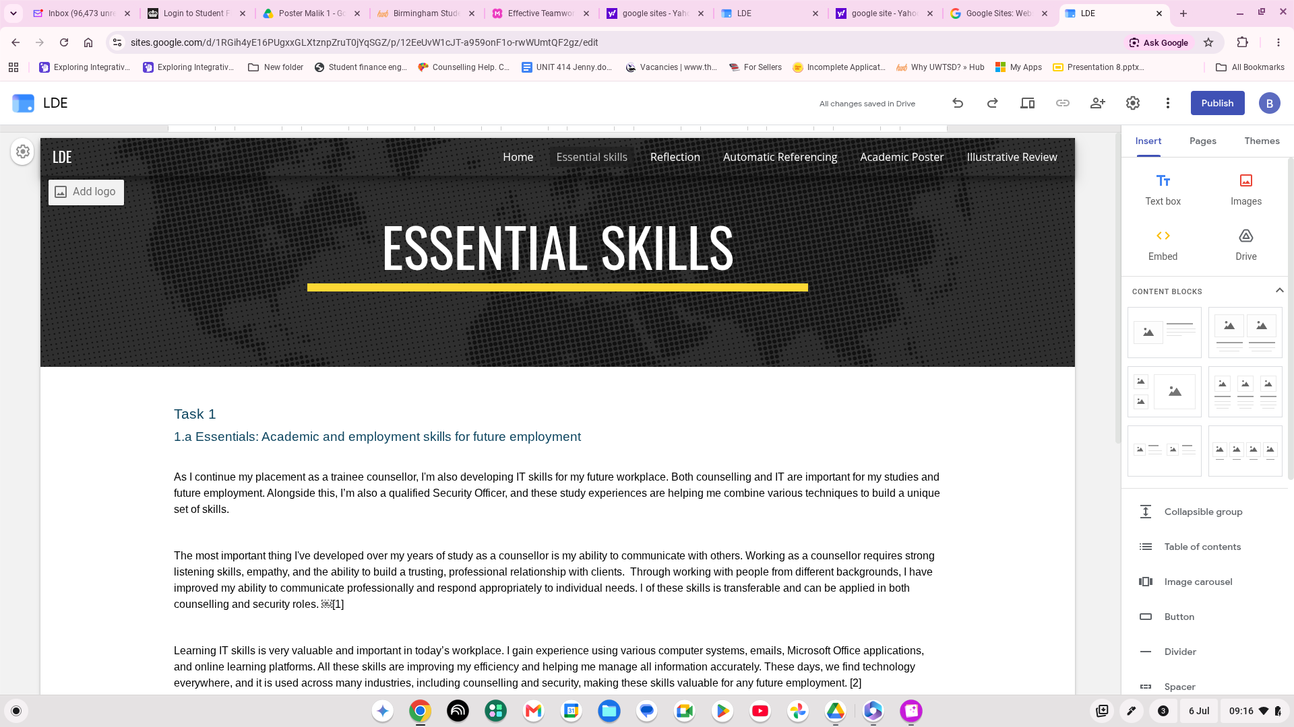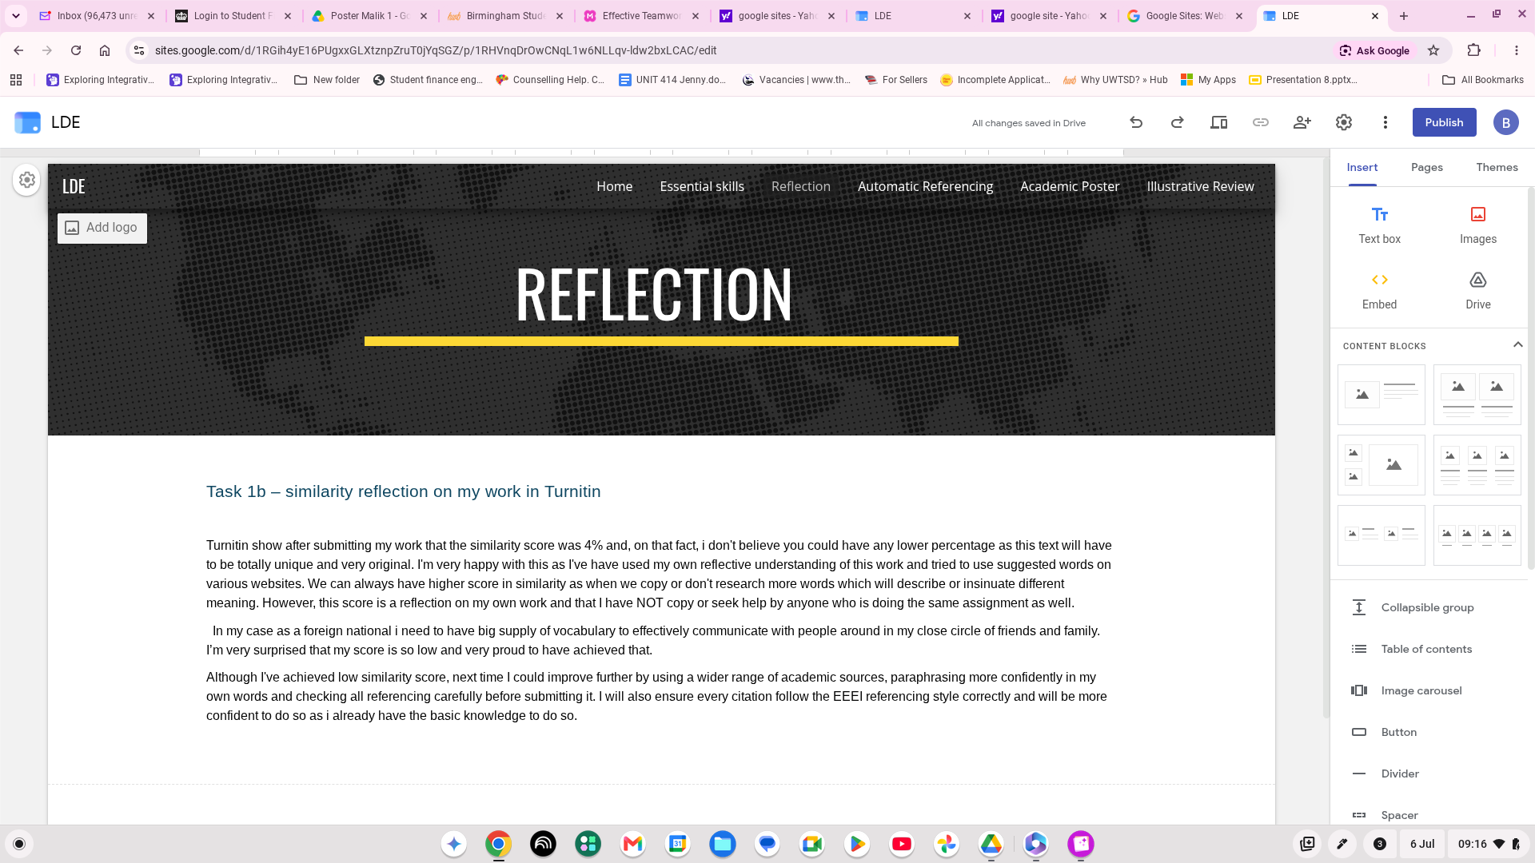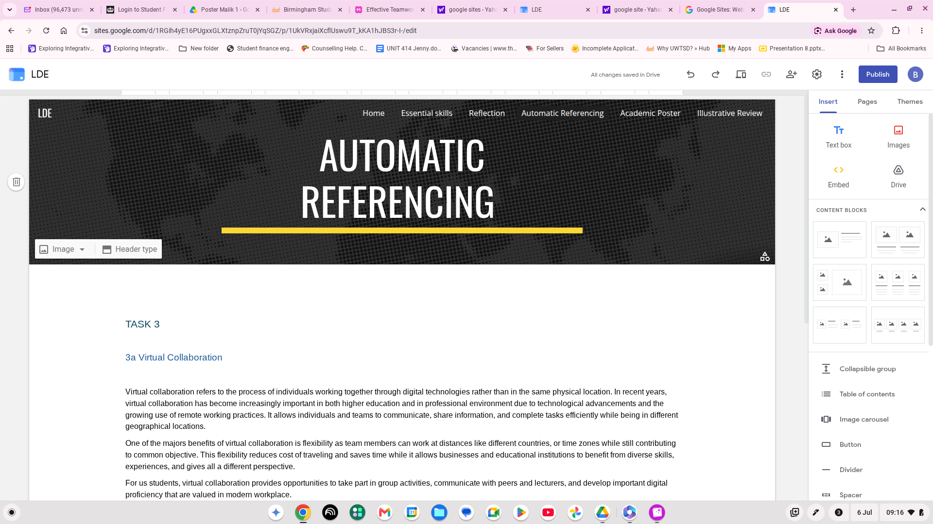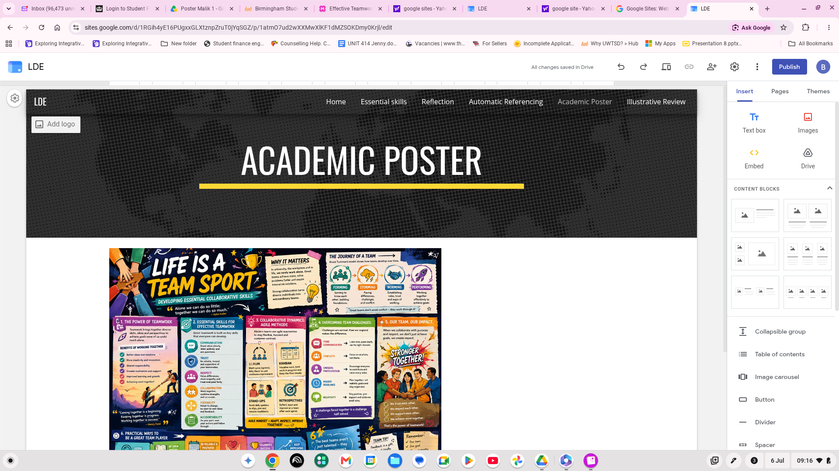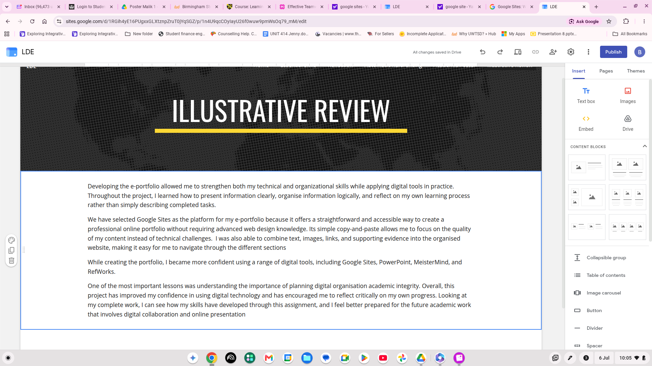

References

References
[1] G.Egan, The Skilled Helper:A Problem-Management and opportunity-development Approach to helping, 11th Ed. Boston, USA: Cengage learning, 2023.
[2] Confederation of British industry, "Employment trends and skills needs in the UK workplace," uk, 2023. Accessed: 03/07/2026.
[3] Stephen r. covey, the 7 habits of highly effective people, New York: Simon & Schuster, 2020.
[4] Jo Pool and Peter Sewell, "The key to employability: Developing a practical model of graduate employability," vol. 49, no. 4, pp.277–289, 2007,
[5] microsoft. "Stock images." www.microsoft.com/image gallery. Accessed: accessed july 2026. [Online]. Available: https://www.microsoft.com/image gallery
[6] P. Lencioni, The five dysfunctions of a Team: A Leadership fable, San-Francisco: Jossey-Bass, 2002.
[7] paul A . Kirschner, collaborative learning in higher education, San Francisco, CA, USA: Jossey-Bass, 2002.

