ASSESSMENT 2: INDIVIDUAL REPORT: MARKETING FUNDAMENTALS EXTERNAL ANALYSIS & EVALUATION
NAME:BIANCA-FLORENTINA MIRICA
STUDENT ID:2030299
LECTURER:PIYUMIKA GAMAGE
MODULE CODE:LCBB4004

Table of Contents
Introduction 3
External analysis of your chosen company, future recommendations for the company should also be considered 3
Conclusion 13
Reference list 14

Introduction
The contemporary business environment is very dynamic and can pose various uncertain things. For an organization, it is very important to ensure that it understands the contemporary business environment rightly. Improper understanding of the contemporary business environment can lead an organization to various kinds of issues. The business environment includes two different kinds of environments. External and internal are those kinds two kinds of environments. The external environment of an organization includes various factors which are uncontrollable. Uncontrollable factors can pose various threats to an organization. Therefore, it is the responsibility of an organization to analyze the external environment rightly and find out factors that can impact the business. Findings will be helpful for the organization to devise various strategies for the business. Due to the presence of uncontrollable factors in the external environment, the environment has high importance in businesses. An organization should analyze and understand the external environment properly to ensure better outcomes for the business. In this report, an external analysis will be conducted to find out various external environmental factors. Also, some recommendations will be outlined for the chosen organization.
Vodafone is a British multinational organization that offers telecommunication services to its consumers. The organization is headquartered in Berkshire, England. The organization has great dominance in the markets of Asia, Europe, Africa, and Oceania. The organization was founded in 1991. The organization includes various kinds of services such as mobile telephony, broadband, digital television, fixed telephony, etc. There are multiple numbers of Vodafone available in the market. Vodafone Australia, Vodafone Germany, and Vodafone UK are some of those subsidiaries. In 2022, in the organization, 104,000 employees were employed. In 2022, €45.580 billion was the revenue of the organization. In 2022, the operating income of the organization was €5.664 billion.

External analysis of your chosen company, future recommendations for the company should also be considered
The external environment of an organization is the outside factor that is not controllable. Due to the uncontrollable nature of these factors, the importance and value of the external environment get increased. As an organization cannot fix these external environmental factors, therefore the organization needs to devise strategies to encounter those factors. Here, the external environment analysis of Vodafone will be conducted.
PESTLE analysis:
PESTLE analysis is one of the most used external environment analysis tools. This framework includes various components which are extremely important. Those components help an organization determine various factors that can impact the business of that organization. Different factors included in the PESTLE analysis are
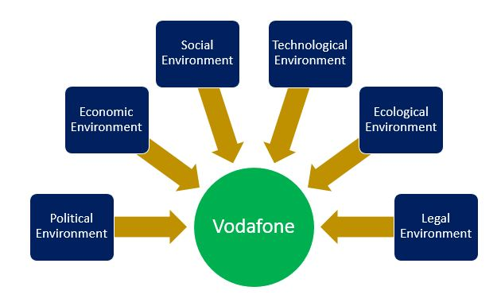
Figure: PESTLE analysis
Source: (Christodoulou and Cullinane, 2019)
Political factors:
- The impact of Brexit has caused various kinds of damage to organizations. Every business sector is suffering due to Brexit. Britain has exited the European Union. Therefore, the concept of free trading in the EU has been prohibited. Due to this reason, organizations are unable to extend their business in the EU. EU has regulated various kinds of tariffs which need to be obeyed rightly. This political uncertainty can impact the business of Vodafone.
Economic factors:
- Economic uncertainties cause fluctuations in the inflation rate, and exchange rates and that can impact the business of Vodafone. Due to continuous fluctuations in the inflation rate Vodafone has been unable to maintain and perform its business operations rightly. Vodafone operates worldwide, therefore exchange rates also trouble the business of the organization. These economic uncertainties can impact the business of Vodafone in negative terms Christodoulou and Cullinane, 2019).
Social factors:
- Increased use of the internet is one of the social trends which can generate flourishing results for Vodafone. The organization has broadband service and as the demand for internet is increasing, therefore the organization can generate benefits from this trend. After the pandemic happened many organizations used remote ways to conduct business operations. Therefore, the necessity of the internet has also increased.
- People shifting their lives toward a digital life can impact the business of Vodafone positively. People use smartphones, using the internet, using social media to stay updated. The demand for these factors can impact the business of Vodafone positively. Increased use of these technologies can ensure better outcomes for the business (Nandonde, 2019).
Technological factors:
- Investment in the 5G network can offer great benefits to the organization. The latest trend in the telecommunication industry is the 5G network. The network is new in the market and also very fast, and reliable. Due to these reasons, consumers are intending to use this network. Investment in this network can help the organization to ensure better profits from the business and the organization will be able to increase its consumers in the business.
- The use of the latest technologies such as artificial intelligence, and machine learning can help the organization increase efficiency in business operations. The use of artificial intelligence and machine learning can help Vodafone to increase efficiency and effectiveness in business operations. Increased efficiency and effectiveness can offer better consequences to Vodafone (Cox, 2021).
Environmental factors:
- The United Kingdom government has regulated legislation which is related to environmental issues and this factor can impact the business of Vodafone in either a positive or negative way. The United Kingdom government has regulated Environment Act where the government has restricted various activities which are causing serious harm to the environment. The organization by using this law can increase sustainability which will increase the reputation of the organization. If the organization fails to obey this law, then it might face legal issues.
Legal factors:
- The United Kingdom government has regulated various kinds of rules which are needed to be obeyed by an organization and these rules can impact the business of Vodafone. Various types of laws such as child labor laws, minimum wage laws, employment equity laws, gender equity laws, etc need to be obeyed by the organization. If the organization fails to obey any of these laws, then it can face various kinds of legal issues. Also, disobedience of these laws can cause a loss of trust and reputation in front of consumers of the organization (Sabourin and Jabo, 2022).
Porter's five forces:
Porter's five forces is also an external environment analysis tool. In this framework there are multiple components are included. These components can pose serious threats to an organization. Therefore, understanding and analyzing these threats can be fruitful for an organization. Those components of Porter's five forces model are
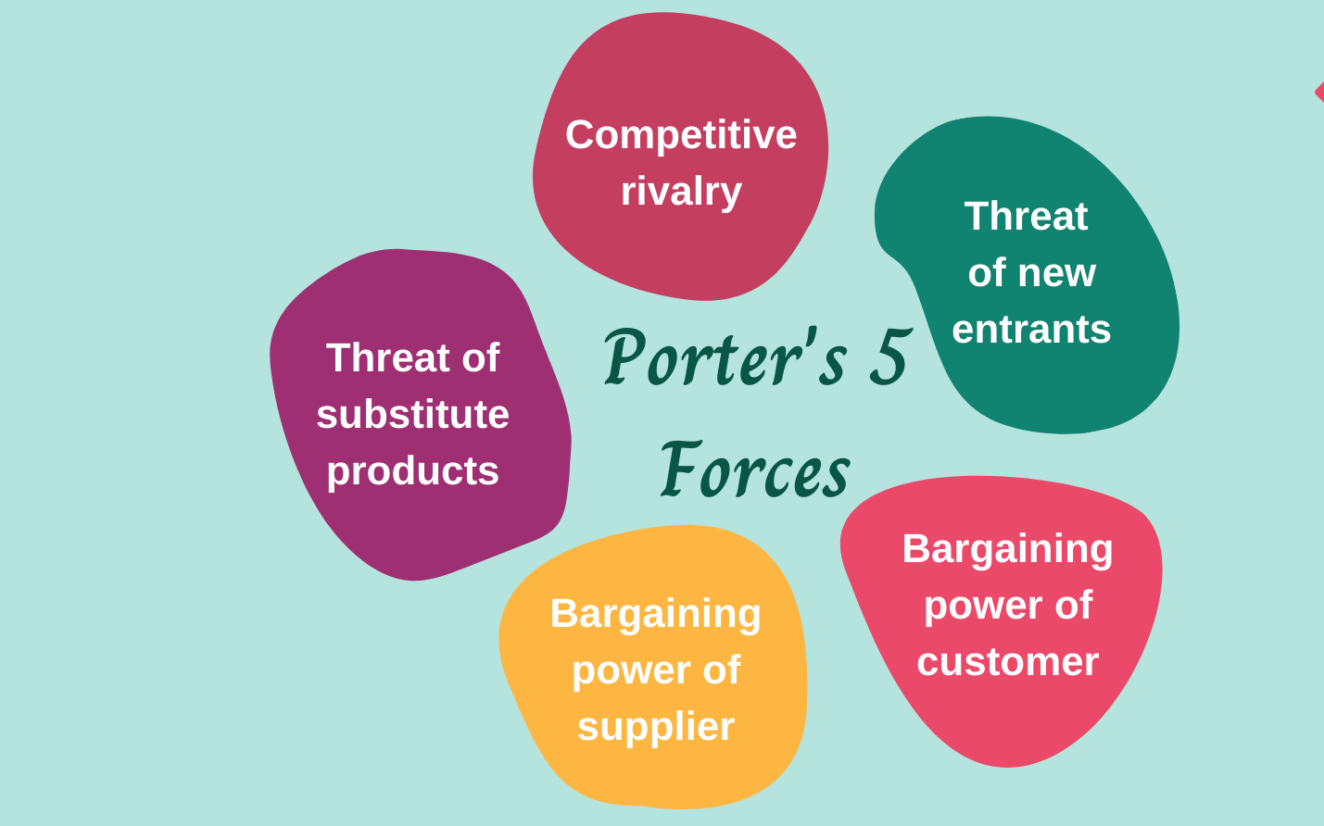
Figure: Porter's five forces model
Source: (Isabelle et al., 2020)
The threat of new entrants:
The threat of new entrants to Vodafone is low. There are various reasons behind the low threat of new entrants. Vodafone is a globally established organization that offers telecommunication services to its consumers. The organization has been able to create trust among consumers and has included numerous loyal customers. Also, the organization has a great presence in the global market. Therefore, an organization that has newly entered the telecommunication industry might not be able to give trouble the organization. Also, entering the telecommunication industry is not easy as the high financial capacity is required, various legislations that need to be obeyed, etc. Due to all these reasons the threat of new entrants for Vodafone is very low (Anastasiu et al., 2020).
Bargaining power of consumers:
The bargaining power of consumers is high for Vodafone in the industry. There are multiple reasons behind the high power of consumers. The increasing number of consumers is one of the positive factors for any telecommunication organization. As the number is increasing, therefore the power of influence is increasing also. If consumers collectively decide to boycott or leave an organization it can pose severe problems to that organization. Also, the availability of telecommunication organizations in the industry. Various organizations such as O2, and Everything Everywhere is strongly competing. As the switching or shifting cost is low, therefore consumers can easily shift from one to another organization. These reasons increase the bargaining power of consumers high for Vodafone. If the organization fails to satisfy its customers, then it can cause various issues for the organization which may lead to high losses in the business (Mugo, 2020).
Bargaining power of suppliers:
The bargaining power of suppliers for Vodafone in the telecommunication industry is also high. There are multiple reasons behind the high bargaining power of suppliers. In the telecommunication industry availability of suppliers is low. Materials and types of equipment that are required in the telecommunication industry are not available everywhere. Due to this low availability of suppliers, the bargaining power of suppliers is high in the industry. Another reason for the high bargaining power of suppliers is the availability of telecommunication organizations. Various organizations such as Vodafone, and O2 are operating in the industry. Therefore, if a supplier does not feel profitable with an organization, then it can shift to any other organization in the industry. The availability of organizations and lower availability of suppliers increase the bargaining power of suppliers (Mugo, 2020).
The threat of substitute products:
The threat of substitute products for Vodafone is high. The organization operates in the telecommunication industry. The telecommunication industry includes various organizations which offer similar services to their customers. There is slight differentiation in products and services offered by various organizations. similar service is offered by various organizations, therefore the chance of consumers' shifting always remains a crucial factor. Another factor is the switching cost is low in this industry. As the availability of organizations is high and also the shifting cost is low, therefore if a consumer does not feel satisfied then can shift from one to another organization. The availability of similar services has increased the threat of substitute products for Vodafone.
Industrial rivalry:
The threat of industrial rivalry is also very high for Vodafone. The telecommunication industry of the United Kingdom has included various big organizations. Organizations such as BT Group, Talk Talk Group, Virgin Media, and EE limited are very trusted by their consumers. Due to the availability of consumers, organizations' industrial rivalry is posing high threats to the organization. If the organization fails to please its consumers, then it can easily shift to other trusted brands. Therefore, the target of the organization should be to please consumers, otherwise, it will fail to hold its consumer base (Alharbi et al., 2019).
SWOT analysis:
SWOT analysis is a framework that includes both internal and external factors. In external factors, this analysis helps to determine various types of opportunities and threats that are available for the organization. The determination of threats and opportunities helps the organization devise strategies for threats and opportunities. Appropriate strategies help to encounter threats and get benefits of opportunities.
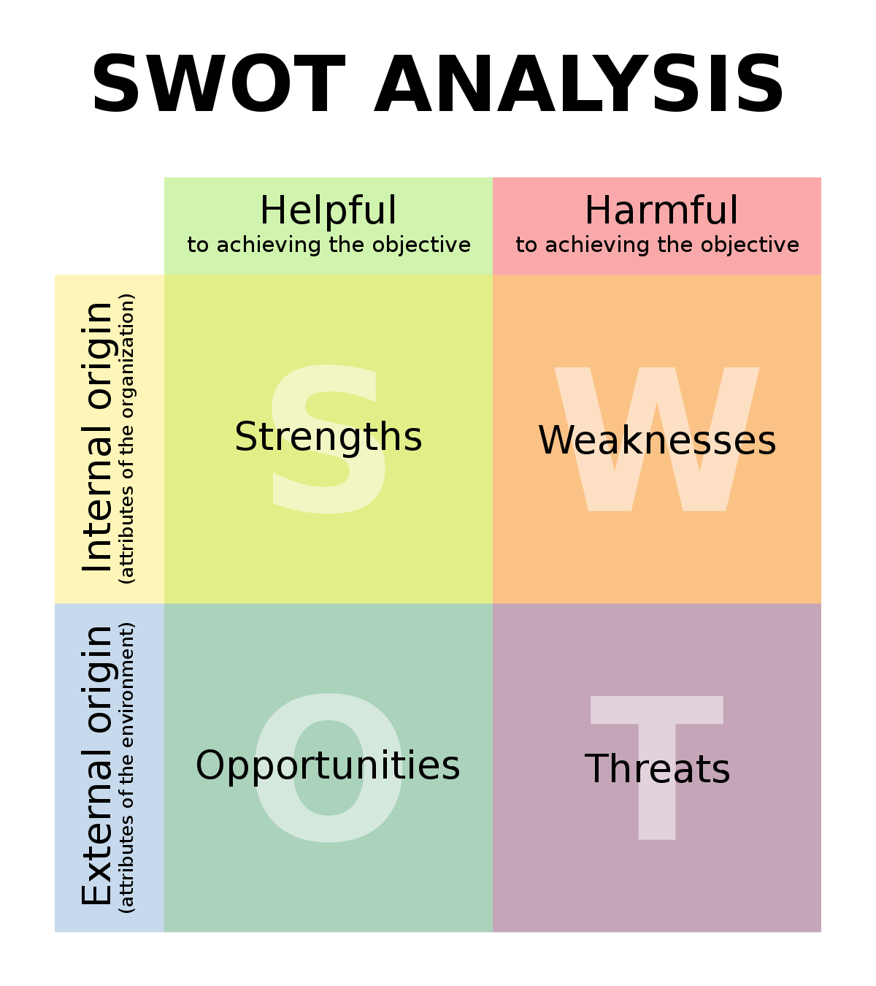
Figure: SWOT analysis
Source: (Teoli et al., 2019)
Strengths:
- Increased market presence in the global market along with good market share is one of the major strengths of Vodafone. The organization operates worldwide. In various markets, the organization has been able to dominate the market prominently. Also, in these markets, the market share of the organization is very good. A high presence in the global market and a good amount of market share help the organization to become more successful (Benzhagta et al., 2021).
- Increasing the revenue streams of the organization is another strength of the organization. The organization operates worldwide. Therefore, the organization has been able to generate great revenue from different markets. Offering good service, and valuing consumers helped the organization to build a comprehensive response among consumers of the organization.
- Innovative and successful marketing strategies of the organization are also a strength of Vodafone. The organization has been able to promote the brand in innovative ways in front of consumers. Innovative advertising helps the organization to position itself in a unique way in the mind of consumers.
Weaknesses:
- Vodafone is losing subscribers in the USA market and it is one of the weaknesses of the organization. The organization has not been able to perform good business operations in this market. Other competitors such as AT&T and Verizon Wireless. The organization should look to ensure better services for consumers in the market (Pyut et al., 2021).
- The organization is failing to maintain brand valuation due to the loss of subscribers and it is one of the weaknesses of the organization. The organization is rapidly losing subscribers in various markets and therefore the value of the brand is getting reduced. For example, in India, the organization has failed to maintain its consumer base which can lead the organization towards business losses.
- Below average performance in the European market is another weakness of the organization. Due to Brexit business operations are facing troubles in the European market. Also, other factors cause further complexities for Vodafone. The organization is failing to perform the business rightly in the market. This factor can also lead the organization towards various kinds of losses.
Opportunities:
- Investment in the 5G network can ensure greater growth for the organization. 5G network will ensure seamless communication and it will drive high developments in the communication world. If the organization successfully invests in a 5G networking system then it will be able to generate profitable outcomes from this investment (Kalam, 2020).
- Opportunities for generating benefits from various emerging markets are available to the organization. The organization operates worldwide, therefore there are various numbers of emerging markets that can offer profitable outcomes for the business. Investment in those markets will ensure a higher growth rate for the organization.
- Metaverse offers opportunities of serving consumers to experience a digital community. The concept of Metaverse is providing opportunities to the organization. The organization can generate better sales if people use Metaverse fluently. Metaverse can offer higher growth to the organization (Lott and Sinha, 2019).
Threats:
- High competition in the industry is one of the threats to Vodafone. The organization operates in multiple markets and all markets have different regional and global competitors. In the United Kingdom Virgin Media, O2 offers high-level competition. In the USA market, Verizon Wireless and AT&T offer tough competition. If the organization fails to compete then it will not be able to generate profit for the organization.
- Brexit is causing different kinds of threats to the business of Vodafone. Due to Brexit various kinds of tariffs are now regulated. Also, the concept of free trading in the EU has gone. All these factors can impact the business of Vodafone in negative terms and can cause harmful consequences m
- Loss of market share in some markets due to various reasons is also a threat for Vodafone. The organization is losing market share in the USA market, and India market. Losing a share in the global market can cause serious problems for the business of the organization. The organization should look to improve this factor (Kalam, 2020).
Recommendations:
Here, some recommendations will be outlined for encountering various threats and generating positive outcomes from opportunities.
Using customer-centric approaches can be a positive way of avoiding the loss of consumers in the business of Vodafone. Consumers are very smart and demanding nowadays, therefore they have diff kinds of demands. An organization by fulfilling consumers' demands can increase the level of satisfaction of consumers. Satisfied consumers will help the organization build a loyal consumer base.
The inclusion of the latest technologies in the organization will be helpful for Vodafone. The inclusion of the latest technologies will increase the efficiency, and effectiveness of business operations. Increased efficiency will help the organization satisfy its consumers. Pleasing consumers will help Vodafone to gain competitive advantages in the business.
Creating an effective workforce through recruitment and selection can help the organization gain a competitive advantage. An effective workforce will help the organization manage supply, production, etc. Managing consumers will be also an advantage of an effective workforce. Different areas of an effective workforce can be helpful for Vodafone to manage the business. Ultimately, an effective workforce will be able to bring multiple advantages to the organization.
Extending the business to other product lines can also be an excellent way of reducing dependency on the existing service. As the telecommunication industry has included high competition, therefore any kind of dispute can cause a huge impact on business of Vodafone. Vodafone will be able to use the existing brand reputation and valuation in the new product line to create awareness.
Using social media can be beneficial for Vodafone in numerous ways. The organization will be able to interact regularly with its audience, also the organization will be able to know various kinds of insight about consumers. The organization will be able to promote the brand on social media to create brand awareness. Ultimately, using social media effectively will help the organization to ensure great outcomes for the business.
Gaining competitive advantages for the business in various ways can be beneficial for Vodafone. The organization operates in the telecommunication industry and the industry has included high competition. Therefore, gaining competitive advantages by increasing loyal customers, increasing pleasing rates for consumers, and offering value for the service can be helpful for the organization. The organization will be able to encounter high competition with these competitive advantages

Conclusion
The external environment of a business organization has the utmost priority. The external environment of an organization includes various kinds of factors that can impact the business but those factors are uncontrollable. Due to this reason, the impact always remains higher. It is necessary for an organization to determine different factors related to the external environment. Proper identification of these factors can help an organization ensure better outcomes for the business. Understanding these factors helps to devise strategies to encounter these impacting factors. The purpose of this report was to conduct an external environment analysis for Vodafone to understand the impact of the external environment on the business. Based on those factors some recommendations have been made. Firstly, in the pestle analysis, it has been identified that the political environment of the UK has included uncertainty. The uncertainty has been caused by Brexit. Due to Brexit, various organizations are facing problems. Also, it has been identified that the increasing use of the internet can impact the business of Vodafone positively. Further, Porter's five forces model has outlined that the threat of new entrants is low for Vodafone. As the organization is globally established, therefore new entrants will be unable to impact the organization. The threat of industrial rivalry is high for Vodafone as there are organizations like O2 operating. These big organizations can cause severe threats to Vodafone. Finally, the SWOT analysis of the organization has determined that there is an opportunity of investing in the 5G network. Also, the organization can face high competition and inefficiency can lead the organization toward loss of profit, market share, etc. Finally, it has been recommended that the organization can increase its product line to avoid threats and risks of the organization.

Reference list
Alharbi, M., Dowling, P.J. and Bhatti, M.I., 2019. Strategic planning practices in the telecommunications industry: evidence from Saudi Arabia. Review of International Business and Strategy, 29(4), pp.269-285.
Anastasiu, L., Gavriş, O. and Maier, D., 2020. Is human capital ready for change? A strategic approach adapting Porter’s five forces to human resources. Sustainability, 12(6), p.2300.
Benzaghta, M.A., Elwalda, A., Mousa, M.M., Erkan, I. and Rahman, M., 2021. SWOT analysis applications: An integrative literature review. Journal of Global Business Insights, 6(1), pp.55-73.
Christodoulou, A. and Cullinane, K., 2019. Identifying the main opportunities and challenges from the implementation of a port energy management system: A SWOT/PESTLE analysis. Sustainability, 11(21), p.6046.
Cox, J., 2021. The higher education environment driving academic library strategy: A political, economic, social and technological (PEST) analysis. The Journal of Academic Librarianship, 47(1), p.102219.
Isabelle, D., Horak, K., McKinnon, S. and Palumbo, C., 2020. Is Porter's Five Forces Framework Still Relevant? A study of the capital/labour intensity continuum via mining and IT industries. Technology Innovation Management Review, 10(6).
Kalam, K.K., 2020. Market segmentation, targeting and positioning strategy adaptation for the global business of Vodafone Telecommunication Company. International Journal of Research and Innovation in Social Science, 4(6), pp.427-430.
Lott, J. and Sinha, M., 2019. M-Pesa’s Failure in India: Why Couldn’t Vodafone Replicate its Kenyan Success? An International Marketing Case Study (Addendum by Former and Current Executives at the Vodafone Group). The Kennesaw Journal of Undergraduate Research, 6(2), p.2.
Malhotra, G. and Batra, S.K., 2019. Customer-switching behaviour for telecom service provider. International Journal of Business and Economics, 4(2), pp.1-17.
Mugo, P., 2020. Porter’s five forces influence on competitive advantage in telecommunication industry in Kenya. European Journal of Business and Strategic Management, 5(2), pp.30-49.
Nandonde, F.A., 2019. A PESTLE analysis of international retailing in the East African Community. Global Business and Organizational Excellence, 38(4), pp.54-61.
Puyt, R.W., Lie, F.B. and Wilderom, C.P., 2023. The origins of SWOT analysis. Long Range Planning, p.102304.
Sabourin, V. and Jabo, J.T., 2022. IoT Benefits and Growth Opportunities for the Telecom Industry: Key Technology Drivers for Companies. CRC Press.
Teoli, D., Sanvictores, T. and An, J., 2019. SWOT analysis.
Titov, A. and Trotsik, A., 2021. FORMATION OF COMPETITIVE ADVANTAGES OF TELECOMMUNICATIONS INDUSTRY COMPANIES: APPLICATION OF METHODS FOR ASSESSING COMPETITIVENESS. Polish Journal of Science, (40), pp.20-24.

