

University of Wales Trinity Saint David

BA Business Management

Dissertation
Research Topic:
The role of salary level as a motivator
for employees amid a cost-of-living crisis

Student Name: Valentina Ivanova
Student ID: 2023164
Name of the University: University of Wales Trinity Saint David
Submission date: 02.01.2024

Declaration
I declare that the work presented in this dissertation titled
"The role of salary level as a motivator for employees amid a cost-of-living crisis “is my own work, based on my personal study or research and that I have acknowledged all material and sources used in its preparation, whether they be books, articles, reports, lecture notes, and any other kind of document, electronic or personal communication.
The work in this dissertation was carried out in accordance with the requirements of the University’s Research Ethics and Integrity Code of Practice which is published on the website and that it has not been submitted for any other academic award. Except where otherwise indicated, this dissertation is my own work.

Date: 02.01.2024
Signed: V. Ivanova

Abstract
The study explored the current trends in the field of employee motivation. Amid a cost-of-living crisis, the centre of the research attention was purposefully placed on studying the potentially increasing role of financial compensation on employee motivation. The analysis of the existing theories and literature clearly demonstrated the decisive impact of having motivated employees. The latter were found to influence organisational performance due to improved engagement, innovativeness, retention and other key factors. Moreover, the discussion identified the complexity of employee motivation, as it depended on many determinants. To explore the UK case in more detail and with the most contemporary data, the study organised an employee survey with a total of 36 participants with diverse backgrounds. The quantitative primary data facilitated the understanding of the main trends in the field of employee motivation. Research findings indicated that employees could experience different motivation levels based on contextual factors, such as type of employment, age and duration of employment. Nevertheless, the most important determinant of employee motivation has proved to be the size of the received financial compensation. Moreover, the importance of money was shown to be increasing amid the cost-of-living crisis. Thus, the findings clearly demonstrated the value of delivering attractive financial compensation and rewards. Respectively, a set of suggestions was identified to boost the performance in the key field.

Acknowledgements
I would like to express my gratitude to my family and friends who unconditionally supported me during the preparation of the study.

Table of Contents
Declaration 2
Abstract 3
Acknowledgements 4
List of tables 7
List of figures 8
Chapter 1: Introduction 9
1.1 Introduction 9
1.2 Background of the study 9
1.3 Problem statement 9
1.4 Aims, objectives, research questions, hypotheses, propositions 9
1.5 Rationale/Importance of the research 10
1.6 Methodology 10
1.7 Scope of the study/demarcation 11
1.8 Structure of the dissertation 11
1.9 Summary 11
Chapter 2: Literature review 12
2.1 Introduction 12
2.2 Background aspects to the concept 12
2.3 Theoretical frameworks and models 13
2.4 Previous studies and lessons learnt 15
2.5 Identified gaps 17
2.6 Summary 17
Chapter 3: Methodology 18
3.1 Introduction 18
3.2 Philosophical position 18
3.3 Paradigm 18
3.4 Research approach 18
3.5 Methodological stance of the research 19
3.6 Research strategy and design 20
3.7 Research sample and population 20
3.8 Data collection and data analysis tools 21
3.9 Ethical considerations 21
3.10 Summary 22
Chapter 4: Data analysis and discussions 23
4.1 Introduction 23
4.2 Analysis and discussion of findings 23
4.3 Summary 34
Chapter 5: Conclusions, limitations and recommendations 35
5.1 Introduction 35
5.2 Conclusion on each research objective/proposition 35
5.3 Conclusion on the research problem 35
5.4 Summary of the research findings and outcomes 36
5.5 Original contribution of the research 36
5.6 Limitations of the research 36
5.7 Recommendations and areas for future research 36
5.8 Summary 37
Reference list 38
Appendix I: Survey questionnaire 42
Appendix II: Consent form 45
Appendix III: Ethics form 46

List of tables
Table 1 – Correlation analysis of satisfaction, motivation and retention 28
Table 2 – Regression analysis results 31

List of figures
Figure 1 - Hierarchy on Needs 14
Figure 2 - Two-Factor theory 15
Figure 3 – Pay satisfaction across age cohorts in the UK 16
Figure 4 - Gender-based pay gap in the UK 17
Figure 5 - Stages of the deductive reasoning 19
Figure 6 – Age 23
Figure 7 – Gender 24
Figure 8 – Type of employment 24
Figure 9 – Duration of current employment 25
Figure 10 - Type of company 26
Figure 11 – Level of satisfaction 27
Figure 12 – Motivation 27
Figure 13 – Employee retention 28
Figure 14 – Determinants of employee motivation (mean scores, range from 1 to 5) 30
Figure 15 – Motivational changes based on existing background differences 32
Figure 16 – Importance of financial compensation than a year ago 33
Figure 17 - Demanded financial compensation improvements by employees 34

Chapter 1: Introduction

1.1 Introduction
This section provides key background information regarding the topic of employee motivation and the importance of financial compensation.

1.2 Background of the study
Currently, the UK has a significant cost-of-living issue. In October 2022, the inflation level reached its highest point at 11.1% annually (Trading Economics, 2023). Presently, the rate of inflation is declining, however it remains at a rate of 3.9% - still almost twice as high as the desired objective of 2% per year set by the official regulator the Bank of England (BoE) (BoE, 2023; Trading Economics, 2023). The considerable price increases have resulted in significant rises in living expenses. The actual decline in discretionary income has heightened price sensitivity among many UK employees, leading to a greater inclination to demand higher pay, as seen by the recent strikes in the UK.

1.3 Problem statement
The present study aims to explain the potential changes in employee choices regarding the elements of motivation in the workplace. It is essential to examine current trends and determine if financial compensation level has a greater impact on employee motivation and retention. It is intriguing to investigate how the cost-of-living issue may have influenced employees' priorities and perceptions of value in the workplace.

1.4 Aims, objectives, research questions, hypotheses, propositions
The key aim of the research paper is to evaluate the role of salary and pay in general as a potential factor motivating employees.
There are several research objectives, as follows:
- To understand the role of employee motivation for business organisations.
- To outline the main drivers of employee motivation.
- To collect primary data from employees to evaluate the relative importance of salary as a motivator at work.
- To propose effective and evidence-based suggestions for human resource management (HRM) improvements.
The research questions of the study include the following items:
- What is the role of salary and financial compensation as a determinant of employee motivation?
- How does the role of salary differ across employees with diverse backgrounds?
- How can human resource (HR) specialists modify HRM policies and practices according to the contemporary changes in employees’ preferences?
Based on the above-mentioned aim, objectives and research questions, it is hypothesised that the importance of salary has increased. Most likely, employees have become more sensitive to pay levels given the cost-of-living crisis. To reject or accept the hypothesis, it is important to explore the evidence from the UK employees.

1.5 Rationale/Importance of the research
Given the dynamic external conditions, employers need to reassess their compensation strategies and align salary levels with the prevailing economic conditions. Retaining the current staff and preventing employee turnover is crucial for firms, since it poses a significant risk (Hook and Jenkins, 2019). Furthermore, the subject is highly important, since dissatisfaction with salary levels can lower employee motivation - a primary cause of reduced productivity, lack of involvement, and workplace disputes (Hook and Jenkins, 2019). The current UK unemployment rate is at a mere 4.3%, resulting in a scarcity of available labour (ONS, 2023). Therefore, companies must devise effective policies to keep and motivate their employees to ensure long-term performance and competitiveness. The subject of equal, fair, and inspiring pay levels is highly significant for human resource management (HRM) professionals considering current economic and labour market difficulties. Hence, the study can examine a contemporary problem and deliver important information which can improve the quality of the HRM process in general.

1.6 Methodology
The study collects primary quantitative data among diverse employees in the UK. An online survey is conducted with 36 respondents to explore the factors of motivation at work with a focus on financial compensation. The analysis includes quantitative measures and statistical tests to outline the role of financial compensation, as well as the potential differences between employees with different backgrounds.

1.7 Scope of the study/demarcation
This is a national study exploring evidence from the UK only. The lack of time and financial resources prevents the conduct of an international large-scale research.

1.8 Structure of the dissertation
The dissertation includes several thematic sections. Chapter 1 sets the background of the study, its rationale, key goals and other important aspects. Chapter 2 is a literature review including a secondary data analysis. The literature review investigates the main theories of employee motivation, empirical evidence regarding the role of pay, as well as the existing knowledge gaps. Chapter 3 is methodology which explains all key aspects of the current data collection and analysis processes. Chapter 4 presents the research findings from the survey in detail. A critical discussion is also included in the chapter. Finally, the content of chapter 5 elaborates the main conclusions, limitations and recommendations stemming from the research findings.

1.9 Summary
The introduction chapter clarified the main directions of the current research. Given the stated aim and objectives, the study continues with an exploration of the literature focused on motivation in the workplace.

Chapter 2: Literature review

2.1 Introduction
This part of the dissertation provides a review of the main theoretical and empirical sources of secondary information in connection with the studied topic of employee motivation.

2.2 Background aspects to the concept
The concept of employee motivation has been studied by many scholars (Sulaiman et al., 2022). Initially, motivation was defined as individual willingness to perform a task, so that specific needs are met (Whiseand and Rush, 1988). More recently, motivation is seen as a major force which energises one to achieve worthy goals (More et al., 2003). Fuller et al. (2008) view motivation as a mix of individual direction, intensity and persistence of efforts in achieving a specific goal. Saraswati (2011) also associates motivation with extensive eagerness to make efforts, so that relevant organisational goals can be achieved. Considering all, motivation in the workplace can involve conscious and unconscious desire to perform actions toward the accomplishment of an objective (Sulaiman et al., 2022). In this context, motivation is a relevant and often powerful stimulant shaping employee behaviour at work.
According to Varma (2017), every employee may have specific values and attitudes which influence behaviour in the workplace. Business organisations face a challenging task to be aware of individual specifics and develop effective HRM policies and practices which reflect not only individual context, but also foster team-based efforts toward the accomplishment of worthy goals (Varma, 2017). For HR specialists, it is necessary to understand the factors shaping individual motivation, so that employees are kept committed and engaged to deliver efforts at work (Sulaiman et al., 2022).
Given these considerations, it is also quite relevant to identify the outcomes of maximum employee motivation. Since motivation contributes to commitment and engagement, it can be seen as a key factor affecting the overall performance of organisations (Thompson and McHugh, 2002; Sekhar et al., 2013). In addition, employees with a high level of motivation are also more satisfied at work (Hook and Jenkins, 2019). Motivation also positively affects the level of retention; thereby strengthening loyalty (Imran et al., 2016). As discussed, the low level of unemployment in the UK makes labour scarce (ONS, 2023). Barny (1991) clarifies that employees constitute a key factor of production and competitiveness. Therefore, the achievement of high employee retention is a requirement for maximum performance of business organisation.
Moreover, the loss of employees, especially difficult to be replaced, can have quite financial and performance implications for organisations (Hook and Jenkins, 2019). Enrich (2023) estimates that the process of recruiting, selecting and training of a new employee together with the experienced productivity losses from replacing an experienced organisational member with a new can be quite costly. Depending on the job position and other specifics, the replacement cost can reach up to 50%-60% (Enrich, 2023).
Considering all, the background information demonstrates the holistic impact of employee motivation, as it determines to a different extent individual and organisational performance, engagement, creativity, loyalty, operational costs and overall competitiveness. Thus, the concept is quite relevant, and the next section explores the determinants which may affect employee motivation.

2.3 Theoretical frameworks and models
This part of the literature review evaluates the role of two key theories of employee motivation. As explained by Ramlall (2004), the existing models are divided into two categories – process and content theories. The discussion focuses on content models only, as they deliver specific factors or determinants suggested to influence employee motivation in the workplace (Ramlall, 2004).
The first model belongs to Maslow (1943) and his Hierarchy of Needs. The theory suggests that humans have five groups of needs which tend to have a different level of priority and a sequence of being addressed, as explained by the pyramid-shaped model below (Goyal, 2015). Humans have physiological, safety, belonging/love, esteem and self-actualisation needs (Maslow, 1943). Meeting the needs takes place on a systematic level from the bottom to the top of the pyramid (Goyal, 2015). Maximum employee motivation is suggested to be an outcome of meeting all five distinctive groups of needs; hence, HR specialists must devise extensive and adapted policies and practices in the workplace (Hook and Jenkins, 2019).

Figure 1 - Hierarchy on Needs
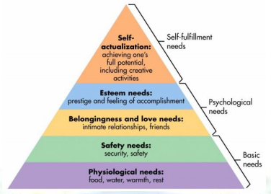
Source: Goyal (2015)
Given the research focus on financial compensation, it is important to discuss its specific role as a need by employees, rather than explaining the entire theory in full detail. As suggested by Goyal (2015), financial compensation delivers security and safety at work; thereby, being a basic need. Thus, salary and bonuses largely determine a company’s ability to meet the existing safety needs of employees, although financial bonuses can also be considered as a form of reward – a strategy to recognise one’s achievement at work (esteem needs). Considering this, the lack of effective financial compensation can inhibit progress along the upper levels of the pyramid and undermine the effectiveness of the performed HRM policies and practices to motivate workforce members.
The role of financial compensation is also discussed by the second theory – Herzberg’s Two Factor model, as shown below (Kunchala, 2017). In general, Herzberg (1987) categorises all factors into two groups: hygiene and motivators. Job satisfaction is an outcome of meeting the elements from the group of motivators, as suggested by the theory (Herzberg, 1987). According to the model, salary belongs to the group of hygiene factors (Herzberg, 1987). Hygiene factors do not contribute to an improved level of employee motivation; however, the lack of proper HRM policies and practices regarding hygiene factors can lead to job dissatisfaction (Kunchala, 2017). This means that inadequate financial compensation may be a major problem inhibiting the achievement of optimal job satisfaction and motivation in the workplace.
Figure 2 - Two-Factor theory
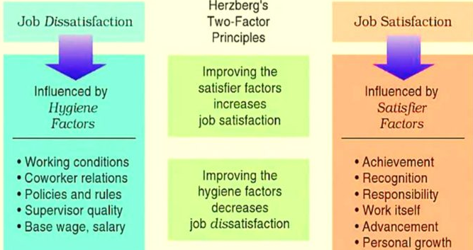
Source: Kunchala (2017)
Given the theoretical findings, financial compensation plays a key role as an element of employee management. Money per se does not cause higher motivation, but the lack of money can lead to major performance issues in the field of HRM. Thus, financial compensation is theoretically suggested to be a relevant factor in the HRM process.

2.4 Previous studies and lessons learnt
This part of the literature review explores some key empirical findings regarding the role of financial compensation in determining employee motivation. As stated by Kalleberg (2011), pay compensation plays a crucial role in both attracting and keeping employees, as well as boosting their workplace performance. In the UK and other advanced economies, remuneration is frequently linked to performance by delivering financial bonuses and other incentives (Dong and Loang, 2023). Research has shown that this method effectively enhances employee motivation and work satisfaction, resulting in enhanced performance (Milkovich and Newman, 2013).
Delaney and Huselid (1996) argue that organisations which allocate greater resources towards employee remuneration and benefits, also tend to experience high satisfaction and employee retention levels. In a similar fashion, Cerasoli et al. (2010) find a positive correlation between pay satisfaction and employee job satisfaction, commitment, and performance in the US case. Kramar et al. (2014) suggest a direct correlation between salary and employee work satisfaction, organisational commitment and desire to remain with the company.
Currently, only 39% of the UK employees consider their salary fair, whereas 41% are not satisfied with the currently received pay level (Formations, 2023). The satisfied employees are almost equally distributed between males (39%) and females (37%) (Formations, 2023). There are also some fluctuations related to pay satisfaction across age cohorts, as shown below (Formations, 2023).
Figure 3 – Pay satisfaction across age cohorts in the UK
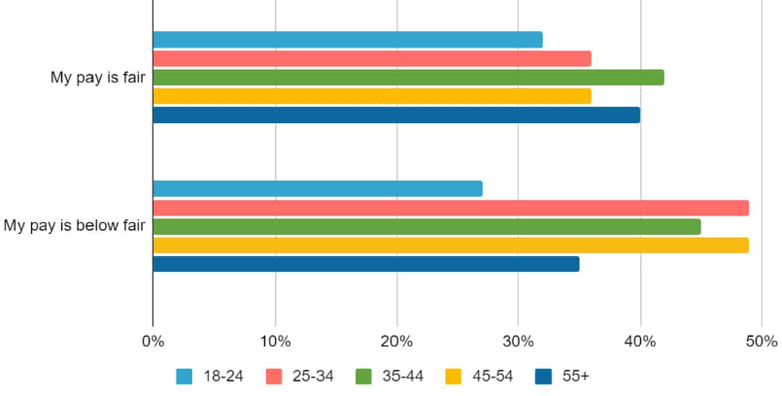
Source: Formations (2023)
Despite the high share of dissatisfied employees, 61% do not consider asking for a pay rise in the next 12 months (Formations, 2023). It also worth noting that males are almost twice more likely to negotiate a pay increase than females (Formations, 2023).
The inactivity of females to ask for higher salaries may also explain the considerable gender-based pay gap in the UK which reaches more than 14% and is considered one of the worst among the advanced economies (Francis-Devine and Brione, 2023). The pay gap is mainly a problem among full-time employees, as suggested by fig. 4.
Figure 4 - Gender-based pay gap in the UK
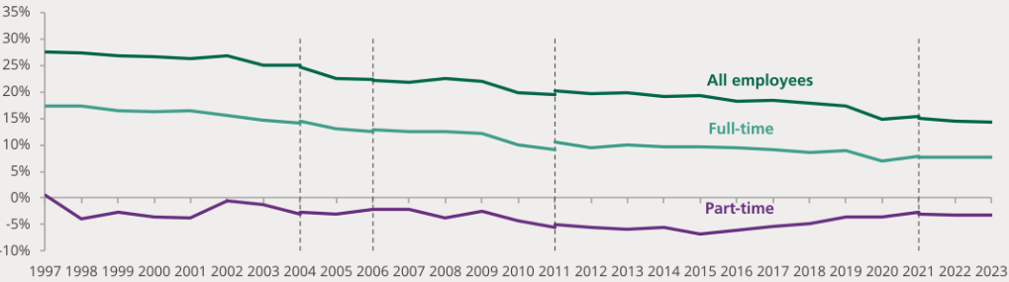
Source: Francis-Devine and Brione (2023)
Certainly, this is also a factor inhibiting the perception for fair payment among some female employees.

2.5 Identified gaps
There are two main gaps stemming from the analysis of the available literature. The first gap is related to the lack of contemporary data regarding the role of financial compensation. The cost-of-living crisis is a contemporary and still evolving development. Hence, research is needed to assess the potentially changed priorities of employees in 2022 and 2023.
The second gap considers the scope of the effects. If employees indeed have higher priorities for financial stimuli, it is unclear whether the impact is equally distributed across all employee groups. This shows the importance of studying the cost-of-living crisis and its effects across sectors, income groups and other background factors, so that more specific evidence can be delivered.

2.6 Summary
The analysis of the literature identified the complexity of employee motivation and its determinants. HR specialists must be aware of the different factors and their dynamic changes to promote relevant changes in each setting. The evidence also identified the relevance of meeting the financial needs of employees, even though motivation depends on many factors beyond financial compensation.

Chapter 3: Methodology

3.1 Introduction
This part of the dissertation explains in detail the design of the methodology. The decisions made are motivated by arguments in favour of conducting a survey among employees according to the strictest ethical principles.

3.2 Philosophical position
The research philosophy selected is positivism. The latter is used in social science study due to its several significant advantages. Positivism postulates the presence of an independent and verifiable reality (Saunders et al., 2009). This assumption has significant implications because the studied phenomenon is examined through empirical facts, disregarding the author's subjective ideas and judgements. Therefore, it is argued that positivism can provide study findings that are more objective and contributing to the achievement of reliable and valid findings (Saunders et al., 2009).
It is also important to mention that positivism predisposes for a generalisation of findings (Saunders et al., 2009). This is quite relevant in the current study because the results from a sample of employees can be extrapolated to most of the UK employees. In addition, positivist research often utilises quantitative approaches for collecting and analysing data, which further enhances the objectivity of the findings (Saunders et al., 2009).

3.3 Paradigm
According to Saunders et al. (2009), positivism explains reality as independently existing and explainable with evidence. Therefore, from an epistemological standpoint, it is crucial to utilise objective and exact instruments for measuring to correctly depict reality. This also explains the utilisation of quantitative and structured analytical techniques, as explained in more detail hereafter.

3.4 Research approach
Deductive reasoning is applied to create new knowledge to understand the role of financial compensation. The deductive research approach suggests a top-down method of investigating the problem starting from the main theory and proceeding to the specific case (Dudovskiy, 2023). The evidence from the UK employees is then used to enrich the general understanding of the factors of employee motivation and specifically the role of salary (Dudovskiy, 2023). As shown below, deductive reasoning flows from the general to the specific – an approach which allows for using previous theories and knowledge in the examination of the current case (Dudovskiy, 2023).
Figure 5 - Stages of the deductive reasoning
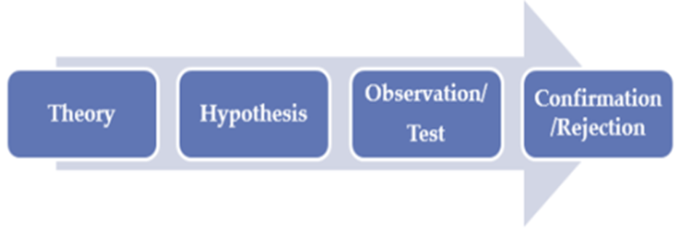
Source: Dudovskiy (2023)
In the context of the deductive reasoning, the information from the literature review is applied to examine the current case of the UK employees. This approach is expected to boost the validity of findings, as the general theoretical and empirical information suggests specific themes to be explored in the current study.

3.5 Methodological stance of the research
To be successful, the research must collect and objectively analyse extensive data. The literature review already involved many theoretical and empirical secondary data sources. Thus, the use of secondary data facilitated the ability to create a relevant context of the problem and specific themes to be explored in the current study. While secondary data are accessible, mostly free of cost and able to provide a wide scope of relevant information, they lack specifics regarding the UK case and the most contemporary trends (Bryman, 2016).
Considering this drawback of secondary data, the research also employs primary data. This is a necessity to get a more detailed understanding of the current trends in employee motivation amid the cost-of-living crisis. The primary data are quantitative – a purposeful decision to identify the main trends and conduct an objective analysis based on scalable evidence (Bryman, 2016). The next chapter provides more detail regarding the strategy of accessing primary quantitative data.

3.6 Research strategy and design
The research strategy employs a survey with a diverse group of employees located across the UK. There are several key benefits motivating the choice of a survey. In general, surveys are often utilised for gathering extensive data from many relevant respondents (Sekaran and Bougie, 2016). The results obtained are less prone to bias due to the large sample size of surveys. Additionally, the primary data consists of quantitative information, as mentioned, which enables a more objective study using various numerical and statistical approaches (Sekaran and Bougie, 2016). Surveys are also known for their time and cost effectiveness, which makes them suitable for the current resource deprived project (Saunders et al., 2009). The widespread use of surveys and the guarantee of individual confidentiality are important aspects that indicate the attainment of a high response rate, which is a critical success factor of the study.

3.7 Research sample and population
The sample technique in this survey refers to snowball sampling. At the first stage of the data collection process, survey questionnaires are initially provided to a group of identified participants and subsequently shared by them with their friends, family members and coworkers during the second phase. When re-distributed, the questionnaire must recruit only relevant respondents – employees in the UK. For this purpose, the first group of participants is instructed to carefully select the next respondents, so that only relevant individuals are recruited. The snowball sampling method largely contributes to a rapid increase in the size of the sample and the ability to reach respondents who were previously unknown by the researcher (Bryman, 2016). This is highly favourable because of the capacity to expand and diversify the sample in the context of the limited time and financial resources for the research.
According to Francis-Devine et al. (2023), the UK labour force is slightly more than 33 million people. The current sample of 36 employees is not representative, as it accounts for 0.000091% of all employees in the UK. Nevertheless, the sample has its benefits based on diversity of respondents and adequacy of information – key factors for reliable and valid findings. Moreover, the response rate was quite high – 78.2%, since 36 out of 46 invitations for participation were satisfied. These are key success factors of the current data collection process.

3.8 Data collection and data analysis tools
Primary data are collected by an online-based survey. This approach utilises modern technologies by completely replacing paper-based surveys and the need to meet people in person. Respondents can be easily accessed irrespective of their geographical location by sending them an online link to the survey (Svoboda, 2020). Moreover, survey participants enjoy an enhanced level of flexibility to select the time and location for answering the questions. Upon completion, surveys are securely kept in a secure environment, safeguarded by a password and encryption (Svoboda, 2020). Online surveys benefit from the availability of sophisticated analytical tools, which enhance their time-efficiency and scope.
Another data collection tool refers to the survey questionnaire. It is composed of twenty questions divided into four sections. The sections address the background of employees, an assessment of the current performance, the motivators and the intended changes in the future. The questions are closed, so that maximum control is maintained over the direction of the data collection process (Saunders et al., 2009). Moreover, the use of a Likert scale, as explained later in the analysis, facilitates the quantification and statistical analysis of the primary data. Full details of the survey are shown in the appendix.
Quantitative approaches are used to analyse the primary data. These encompass descriptive statistics, correlation and regression analyses. Relevant visual representations such as charts, graphs, and tables are included as needed.

3.9 Ethical considerations
Strict adherence to current ethical standards is necessary when including humans. Participation in the survey is optional and contingent upon an agreement with the informed consent. The voluntary nature of the survey is also respected by avoiding any stimuli which can trigger a higher level of participation. Harm avoidance is achieved by the enforcement of safety standards and the avoidance of sensitive questions (Saunders et al., 2009).
In addition, the selection process purposefully avoids vulnerable individuals and people below the age of 18 years, even though both groups can be actual employees delivering important knowledge (Saunders et al., 2009). Strict measures are also taken to ensure the preservation of confidentiality and anonymity throughout participation since employees may share information regarding the practices of their employers. Data security is guaranteed by using encryption and a password-protected system, as mentioned earlier (Svoboda, 2020).
Secondary data sources are duly referenced and acknowledged in alignment with the principle of justice in secondary data analysis (Saunders et al., 2009).

3.10 Summary
The discussion outlined the main aspects of the applied methodological framework. Thus, the results from the survey, as discussed in the next part of the study, are based on a well-motivated and detailed methodological plan.

Chapter 4: Data analysis and discussions

4.1 Introduction
This part of the dissertation presents the results from the survey with 36 employees. The demographic characteristics of the sample are initially discussed, followed by the analysis of employee performance, the determinants of motivation and the possible improvements demanded by employees in financial compensation.

4.2 Analysis and discussion of findings
The sample is composed of employees of different ages (fig. 6). Most employees belong to the age group between 31 and 40 years (38.9%), followed by the youngest cohort below 30 years (27.8%). The older age cohorts have relatively lower shares. The sample is diverse, but the young employees are overrepresented.
Figure 6 – Age
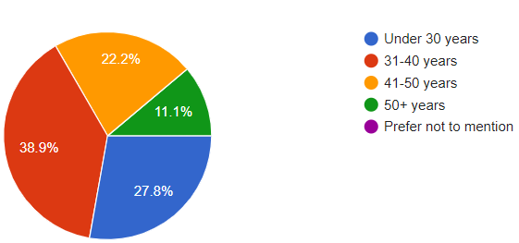
In terms of gender, the sample is considerably more balanced. The shares of female and male employees are 52.8% and 47.2%, respectively (fig. 7). All survey participants provided a binary response to the gender question.

Figure 7 – Gender
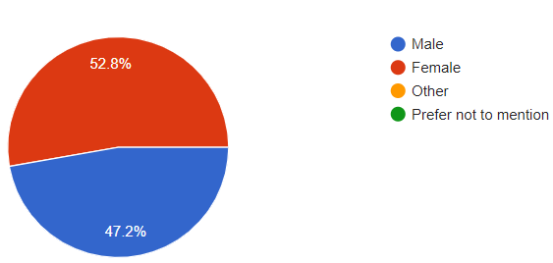
The sample is quite interesting in terms of employment type. The evidence from fig. 8 shows that there is a considerable number of part-time employees (30.6%). The remaining 69.4% are employed on a full-time basis. Although the share of part-time employees is higher than normal, it is mainly associated with the high number of young employees under the age of 30 years. The sample characteristics also allow for a comparison of both groups later in the analysis.
Figure 8 – Type of employment
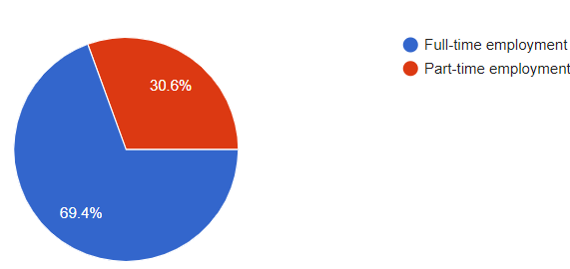
Another key background factor refers to the duration of current employment (fig. 9). The sample is diverse, as it includes not only newly higher employees of less than a year of experience (19.4%), but also loyal employees with more than five years of current employment (36.1%). The largest group, which accounts for 44.5% of the sample, is composed of employees with a duration of employment between one and five years (fig. 9).
Figure 9 – Duration of current employment
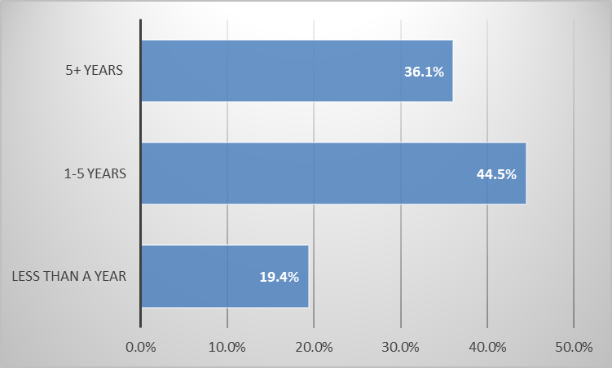
It is also worth noting that the survey participants have a different background in relation to the organisational size. The largest group of employees are hired by small companies (33.3%). Micro companies with fewer than ten employees also account for a relatively large share of employment – 25%. The remaining are distributed between medium-sized and large companies with respective shares of 22.2% and 19.5%. Thus, the results are quite diverse and demonstrate the importance of all types of companies for generating employment in the UK. Respectively, it is quite interesting to assess the motivation of employees from different companies.

Figure 10 - Type of company
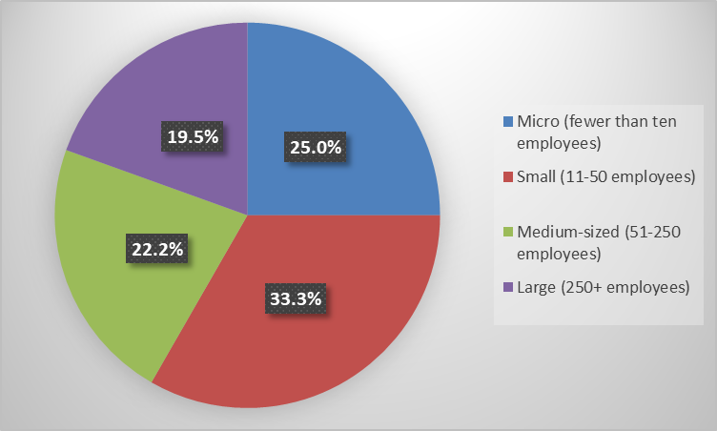
Overall, the sample is diverse due to the inclusion of employees of different age, gender, type of employment work experience and origin. Even though the sample does not precisely reflect the population of the UK employees, research findings can be quite indicative of the main trends and opinions across groups of employees.
After the discussion of the sample features, the discussion proceeds with the measurement of three key HRM indicators, satisfaction, motivation and retention. The measurement is done by following a 5-step Likert scale. The minimum value of 1 indicates strong dissatisfaction, whereas the maximum value of 5 represents the highest possible level of satisfaction. Respectively, the value of 3 should be considered as a neutral opinion.
As indicated by the results from fig. 11, the surveyed employees are generally satisfied in the workplace. In total, 63.9% of participants share positive opinions, whereas 16.7% are neutral. The weight of the dissatisfied employees accounts for only 19.5%.

Figure 11 – Level of satisfaction
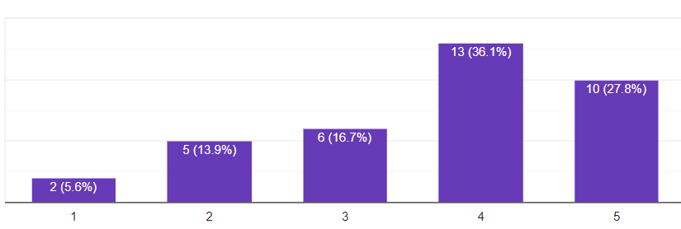
In a similar fashion, the surveyed participants also have a generally positive opinion regarding motivation in the workplace. The cumulative share of the motivated employees, as indicated by the scores of 4 and 5, reaches 48.4%, whereas the neutral opinions are 25%. Once again, demotivated employees constitute a minority share of just 16.7% (fig. 12). In general, the results in terms of work motivation are slightly worse in comparison to job satisfaction.
Figure 12 – Motivation
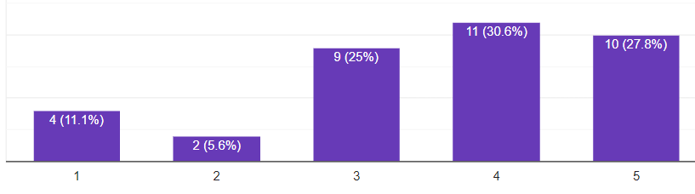
The results regarding employee retention are more mixed. Most employees are loyal, as indicated by 52.8% of the survey participants (fig. 13). Neutral opinions have a low share of just 11%. It is worth noting that the disloyal employees reach a total share of 36.1%, as indicated by the cumulative share of 1 and 2. This means that employee retention rates are quite problematic for many organisations in the UK.

Figure 13 – Employee retention
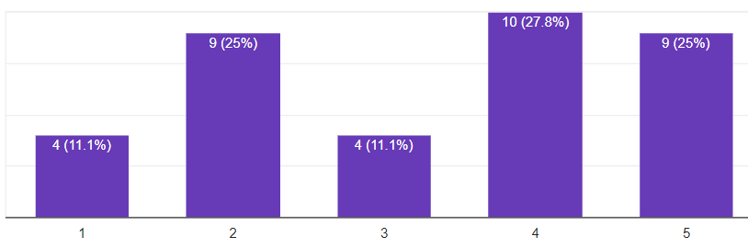
A correlation analysis is also performed to evaluate the behaviour of satisfaction, motivation and retention. The analysis indicates the dynamic changes across the three key HRM performance indicators. The Likert scale allows for converting the opinions in numeric values and calculating the respective changes in the opinions of every survey participant.
The results from table 1 indicate the existence of a positive and very strong correlation between the three key factors. Satisfaction and motivation at work have the highest correlation coefficient of 0.84. The correlation between satisfaction and retention is 0.75, whereas a correlation coefficient of 0.78 represents the relationship between motivation and retention. Despite the observed differences in the correlation coefficients, results are quite consistent. They confirm the earlier discussed relationships from the literature review (see Hook and Jenkins, 2019). From a practical perspective, these results also suggest the key role of employee motivation. An increase in the level of employee motivation is likely to be associated with improved job satisfaction and enhanced loyalty.
Table 1 – Correlation analysis of satisfaction, motivation and retention
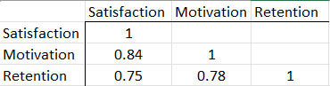
Therefore, the analysis of employee motivation, its determinants and the specific role of financial compensation appears to be quite important for delivering sustainable HRM improvements.
The next figure shows the overall performance across a set of motivation determinants. Given the earlier mentioned 5-step Likert scale, the mean scores are presented in relation to every determinant. Thus, the means score shows the performance of employers, as evaluated by the selected surveyed employees (fig. 14). All indicators are above the neutrality threshold, as indicated by the value of three. The results are quite consistent given the relatively insignificant fluctuations. More specifically, the score differences between the best performing indicator (working conditions) and the worst one (career advancement) is just 0.92 points. As a result, it can be suggested that business organisations have a generally positive and effective HRM performance which explains the observed relatively high employee motivation levels from fig. 12.
Nevertheless, there are some fluctuations across the studied indicators. Working conditions and coworker relations are the best performance areas with mean scores of 4.14 and 4.11, respectively. Policies and rules, as well as supervision quality are also strong performance areas with respectively mean scores of 3.69 and 3.75. It is worth nothing that financial compensation has one of the lowest means scores of just 3.42 (fig. 14). Therefore, it is a problematic performance area worth improving in the future.
Another key observation suggests that the group of hygiene factors (working conditions, policies and rules, financial compensation, supervision quality and coworker relations) has a generally better performance in comparison to motivators which include recognition, achievement, responsibility, career advancement and personal growth.

Figure 14 – Determinants of employee motivation (mean scores, range from 1 to 5)
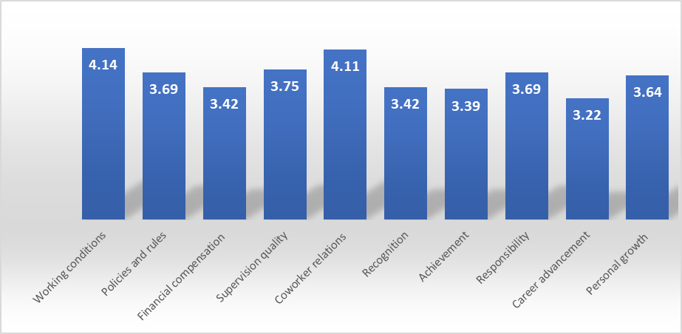
The analysis also elaborates a multiple regression analysis. The purpose of the advanced statistical test is to find cause-and-effect relationships. Multiple regression explores the statistical significance of the included independent variables. In this case, the determinants of employee motivation are selected to be independent variables, whereas the actual motivation score is the respective dependent variable in the model. Thus, it is estimated the degree to which changes in the reported motivation score depend on the changes in the list of independent variables from fig. 14. The applied 5-step Likert scale facilitates the quantitative analysis of the results.
The outcomes of the regression model are shown below (table 2). The value of the adjusted R-squared is 0.773. This is quite a high value showing that 77.3% of the observed fluctuations in employee motivation can be attributed to the list of determinants. The model is also statistically significant given the F-test of 0.000, far below the confidence interval of 0.05. These findings suggest that the model is appropriate; thereby confirming the theoretical suggestions, as earlier explained by the concepts by Maslow (1943) and Herzberg (1987). Thus, employee motivation can be explained by a set of indicators, as tested in the current model.

Table 2 – Regression analysis results
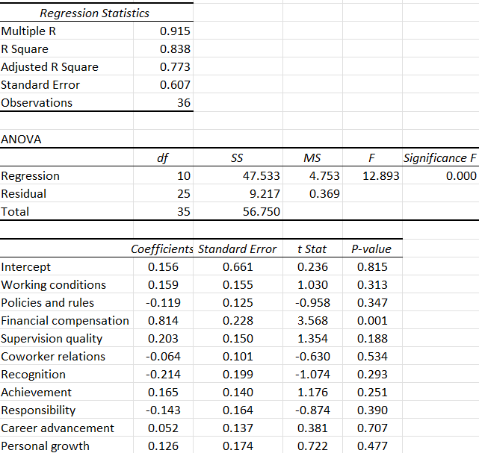
The conventional confidence interval of 0.05 is applied to indicate the existence of statistical significance. In this case, only one determinant qualifies as statistically significant – financial compensation (p-value = 0.001). Therefore, this is the single and most influential variable affecting employee motivation in the workplace. The coefficient size of financial compensation is also quite high: 0.814. This is practically the highest and positive coefficient suggesting that a point increase in the score of financial compensation leads to a 0.814 increase in the value of the reported motivation if all other factors are kept constant. Taken together, the evidence suggests that salary is far more important than any other of the selected determinants of employee motivation.
Since the regression model has an explanatory power of 77.3% (see table 2), there might be some other factors affecting motivation. The insignificance of the included determinants motivates the exploration of the role of employee background. Figure 15 shows the mean score of employee motivation across employee groups. Type of organisation is an insignificant background factor affecting employee motivation. In contrast, the type of employment appears to be quite important. The considerably lower scores among part-time employees can be explained by restricted financial benefits and other HRM-related advantages which are otherwise received by full-time employees. This outcome poses a challenge in effectively managing part-time employees. Moreover, given the fact that the younger employees are also more likely to work on a part-time basis, it is not surprising that employee motivation generally increases together with the increase in age. Regarding the duration of employment, any conclusions can be premature since long-term employees are self-selected to be also the most motivated ones. In general, the information from fig. 15 shows that background factors can also affect motivation, beyond the studied motivators from table 2.
Figure 15 – Motivational changes based on existing background differences
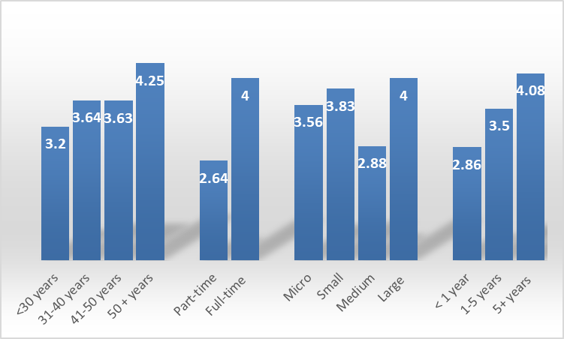
Given the importance of financial compensations, the survey also measures its dynamic change according to the respondents’ perceptions. Exactly two-thirds of respondents agree that financial compensation is more important than a year ago. The share of hesitating employees is 16.7%, whereas 16.7% do not see financial compensation being of increasing importance (fig. 16). These results undoubtedly show the relevance of delivering better financial rewards as a way of boosting employee motivation and respectively satisfaction and loyalty.
Figure 16 – Importance of financial compensation than a year ago
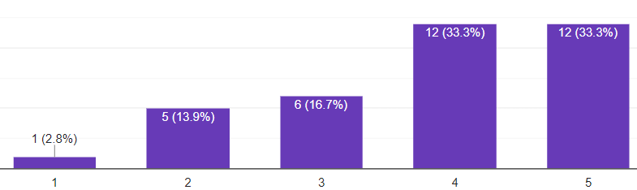
The last question of the survey explores the preferences of the survey participants in relation to possible financial rewards. Multiple responses are allowed. According to 13.9% of participants, all areas must be improved, whereas 11.1% of employees do not demand any changes. Team-based bonuses and shares in the company are two quite insignificant areas. The main preferences stem from the need for a significant one-time increase in the base salary (58.3%) and performance-based bonuses (44.4%). Inflation-adjustment of income and paid time-off are also popular choices for improvement, as suggested by 36.1% of participants in each of the two cases. To some extent, financial compensation can also be improved by offering a higher payment for working overtime or during weekends (22.2%), higher pension benefits (27.8%), as well as material rewards and higher insurance payments with respective shares of 16.7%.

Figure 17 - Demanded financial compensation improvements by employees
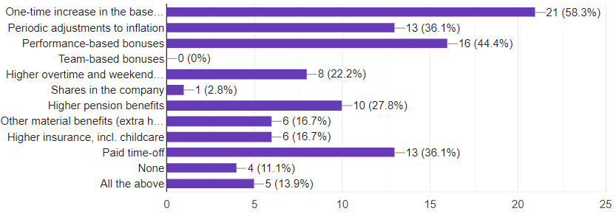
The possible options for financial improvement are different and depend on the specific background of employees. For example, older employees are more inclined to seek for higher pension contributions, whereas insurance payments and childcare are popular among the group of young female employees. Overall, most preferences are focused on adjusting the level of base salary and performance-based bonuses.

4.3 Summary
To sum up, the results indicate the key role of financial compensation, although this is not the single factor affecting employee motivation at work. Research findings provide relevant directions for future improvement based on the evidence. The key role of employee motivation aligns with the earlier discussed theories and empirical findings in the literature review.

Chapter 5: Conclusions, limitations and recommendations

5.1 Introduction
This chapter summarises all main findings from the research paper.

5.2 Conclusion on each research objective/proposition
The study had several objectives. The first one focused on understanding the role of employee motivation. The evidence suggests that motivation is a key success factor which contributes to high levels of job satisfaction and loyalty in the workplace.
The second objective explored the main drivers of employee motivation. Research findings demonstrated the decisive role of financial compensation as the single most important determinant of employee motivation. In addition, the type of employment, duration of employment and age can also affect the reported levels of employee motivation.
The third objective required the collection of primary data from employees. The survey with 36 diverse employees contributed to reliable findings.
The last objective regarding the areas of potential improvement is addressed later in the chapter.
The study also incorporated three research questions. Based on the evidence, it can be suggested that salary and other forms of financial compensation play a decisive role in determining employee motivation levels. The role of salary – as investigated by the second research question – is broad and affects all types of employees. Respectively, HR specialists must modify their policies and procedures based on the new evidence. The recommendations list delivers some meaningful suggestions in this respect.

5.3 Conclusion on the research problem
The study had the main aim to evaluate the role of financial benefits for employee motivation. Research findings demonstrated the decisive impact on financial compensation on employee motivation. Recently, the cost-of-living crisis has also increased the importance of financial compensation. Therefore, this factor cannot be ignored, as it serves as a foundation for all other HRM policies in the field of motivation, job satisfaction and loyalty.

5.4 Summary of the research findings and outcomes
The results from the study confirmed the initial expectations regarding the growing importance of financial compensation. To some extent, the results from the survey surpassed the initial expectations since all other determinants of employee motivation showed insignificance. In this context, UK employees have specific needs, which must be met, prior to proceeding to the other factors of employee motivation. Although temporary, the increased financial needs must be addressed accordingly. The increased financial costs of the expanded financial rewards (salary, bonuses and other rewards) can be seen as a reasonable investment given the high costs of employee turnover and the extra value extracted from satisfied and motivated employees at work.

5.5 Original contribution of the research
The study contributed with the most contemporary data regarding the role of financial compensation. Thus, it can be concluded that salary and other financial rewards have an increasing importance for the UK employees. Financial compensation is also a critically important factor of employee motivation which largely offsets the role of the other theoretically suggested determinants. This is quite new and poses considerable implications for the HRM process.

5.6 Limitations of the research
The research is limited in terms of time and resources. Therefore, the sample size is relatively small – just 36 employees. This limitation may lead to biased results. The scope is limited in terms of geography, as well (UK only). Limitations also stem from the choice of a single strategy for data collection – only a survey. Thus, triangulation cannot be reached given the absence of primary qualitative data. The current study is also a cross-sectional one which limits its time scope to the current moment only.

5.7 Recommendations and areas for future research
Business organisations must implement HRM changes in several areas. First, it is important to increase salaries at least to match the general price increases, as suggested by the inflation rate. Second, business organisations must apply more transparent practices of financial compensation, as well. Third, financial compensation must be adapted according to specific individual needs. For example, older employees may appreciate higher pension contributions, whereas goal-oriented employees may demand performance-based bonuses. The customisation of benefits can deliver maximum impact on motivation by maximising the use of financial resources. Business organisations are thus required to be better aware of their employees’ specific needs. Fourth, part-time employees must not be overlooked. Businesses must integrate them accordingly, as well as meet financial and other needs without any discrimination. Finally, business organisations must also consider investments in new technologies, training and development, process improvements and other innovations to boost employee productivity and repay the investments made in higher financial compensation. The proposed recommendations may have different effects depending on the specific context of each organisation.
Future research must address the current resource constraints. Larger sample sizes, analysis across sectors or countries, inclusion of qualitative data, as well as researching the topic over a considerable period can be quite relevant suggestions to gather more reliable, detailed and valid findings.

5.8 Summary
With these key conclusions, the study is considered completed.

Reference list
Bank of England (BoE) (2023) Interest rates and Bank Rate, [online] Available: https://www.bankofengland.co.uk/monetary-policy/the-interest-rate-bank-rate [Accessed: 15 December 2023]
Barney, J. (1991) Firm Resources and Sustained Competitive Advantage, Journal of Management, Vol. 17, pp. 99-120.
Bryman, A. (2016) Social Research Methods. 5th edition, London: Oxford University Press
Cerasoli, C., Nicklin, J. and Ford, M. (2010) Intrinsic motivation and extrinsic incentives jointly predict performance: A 40-year meta-analysis, Psychological Bulletin, Vol. 136(4), pp. 690-721.
Delaney, J. and Huselid, M. (1996) The impact of human resource management practices on perceptions of organizational performance, Academy of Management Journal, Vol. 39(4), pp. 949-969.
Dong, W. and Loang, O. (2023) The Influence of Salary Compensation on Employee Performance In Shengshitongda: A Qualitative Investigation, Journal of Islamic, Social, Economics and Development (JISED), Vol. 8(53), pp. 100-113.
Dudovskiy, J. (2023) Deductive Approach (Deductive Reasoning), [online] Available: https://research-methodology.net/research-methodology/research-approach/deductive-approach-2/ [Accessed: 17 December 2023]
Enrich (2023) The Cost of Replacing an Employee and the Role of Financial Wellness, [online] Available: https://www.enrich.org/blog/The-true-cost-of-employee-turnover-financial-wellness-enrich#:~:text=Research%20by%20SHRM%20suggests%20that,overall%20losses%20to%20the%20company [Accessed: 11 December 2023]
Formations (2023) Employee Satisfaction Statistics UK 2023, [online] Available: https://www.1stformations.co.uk/blog/employee-satisfaction-statistics/ [Accessed: 20 December 2023]
Francis-Devine, B. and Brione, P. (2023) The gender pay gap, [online] Available: https://commonslibrary.parliament.uk/research-briefings/sn07068/ [Accessed: 18 December 2023]
Francis-Devine, B., Buchanan, I. and Powell, A. (2023) UK labour market statistics, [online] Available: https://researchbriefings.files.parliament.uk/documents/CBP-9366/CBP-9366.pdf [Accessed: 18 December 2023]
Fuller, M. Valacich, J. and George, J. (2008) Information Systems Project Management: A Process and Team Approach. Upper Saddle River, New Jersey: Pearson Prentice Hall
Goyal, P. (2015) Motivation: Concept, Theories and Practical Implications, International Research Journal of Commerce Arts and Science, Vol. 6(8), pp. 71-78.
Herzberg, F. (1987) One more time: how do you motivate employees? Boston: Harvard Business School
Hook, C. and Jenkins, A. (2019) Introducing Human Resource Management. 8th edition, Pearson: UK
Imran, R., Allil, K. and Mahmoud, A. (2016) Teacher’s Turnover Intentions: Examining the Impact of Motivation and Organizational Commitment, International Journal of Educational Management, Vol. 31, pp. 828-842.
Kalleberg, A. (2011) Good jobs, bad jobs: The rise of polarized and precarious employment systems in the United States, 1970s to 2000s. Russell Sage Foundation
Kramar, R., Stredwick, J. and Spicer, D. (2014) Human resource management in a global context: A critical approach. Palgrave Macmillan
Kunchala, R. (2017) Herzberg’s Two-Factor Theory of Motivation, [online] Available: https://www.mbahelp24.com/herzbergs-two-factor-theory-motivation-hygiene-satisfier/ [Accessed: 14 December 2023]
Maslow, A. (1943) A theory of human motivation, Psychological Review, July, pp. 370-396.
Milkovich, G. and Newman, J. (2013) Compensation. McGraw-Hill Higher Education
More, H., Wegner, F. and Miller, L. (2003) Effective Police Supervision. Cincinnati: Anderson Publishing Co.
Office for National Statistics (ONS) (2023) Unemployment rate (aged 16 and over, seasonally adjusted): %, [online] Available: https://www.ons.gov.uk/employmentandlabourmarket/peoplenotinwork/unemployment/timeseries/mgsx/lms [Accessed: 12 December 2023]
Ramlall, S. (2004) A review of employee motivation theories and their implications for employee retention within organizations, Journal of American Academy of Business, Cambridge, Vol. 5(1), pp. 52-63.
Saraswathi, S. (2011) A Study on Factors that Motivate IT and Non-IT Sector Employees: A Comparison, International Journal of Research in Computer Application and Management, Vol. 1(2), pp. 72-77.
Saunders, M., Lewis, P. and Thornhill, A. (2009) Research Methods for Business Students. 5th edition, Pearson, New York
Sekaran, U. and Bougie, R. (2016) Research Methods for Business: A Skill Building Approach. 7th edition, United Kingdom: Wiley
Sekhar, C., Patwardhan, M. and Singh, R. (2013) A literature review on motivation, Global Business Perspective, Vol. 1, pp. 471-487.
Sulaiman, N., Mohd, J., Saari, N., Zanal, A., Zainal, A., Mohd, N. and Mohd, Z. (2022) The Importance of Employee Motivation and Job Satisfaction, International Journal of Accounting, Finance and Business (IJAFB), Vol. 7(42), pp. 71-79.
Svoboda, T. (2020) Obsurvey - surveys made easy for iOS, [online] Available: https://download.cnet.com/Obsurvey-surveys-made-easy/3000-2064_4-76486749.html [Accessed: 17 December 2023]
Thompson, P. and McHugh, D. (2002) Work Organisations. 3rd edition, Basingstoke: Palgrave
Trading Economics (2023) Inflation Rate, [online] Available: https://tradingeconomics.com/country-list/inflation-rate [Accessed: 17 December 2023]
Varma, C. (2017) Importance of Employee Motivation & Job Satisfaction for Organizational Performance, International Journal of Social Science & Interdisciplinary Research, Vol. 6(2), pp. 10-20.
Whiseand, P. and Rush, G. (1988) Supervising Police Personnel: Back to Basics. Prentice Hall, New Jersey

Appendix I: Survey questionnaire
Section I: Background
1. What is your age?
- Under 30 years
- 31-40 years
- 41-50 years
- 50+ years
- Prefer not to mention
2. What is your gender?
- Male
- Female
- Other
- Prefer not to mention
3. What is your current employment status?
- Full-time employment
- Part-time employment
- Prefer not to mention
4. How long have you worked for your current employer?
- Less than a year
- 1-5 years
- 5+ years
- Prefer not to mention
5. What is the company you work for?
- Micro company (fewer than ten employees)
- Small business (11-50 employees)
- Medium-sized company (51-250 employees)
- Large company (250 + employees)
- Prefer not to mention
Section II: Performance
6. I am satisfied at work?
- Strongly disagree
- Disagree
- Neutral
- Agree
- Strongly agree
7. I am motivated at work?
- Strongly disagree
- Disagree
- Neutral
- Agree
- Strongly agree
8. I am loyal to my current employer?
- Strongly disagree
- Disagree
- Neutral
- Agree
- Strongly agree
Section III: Determinants of motivation at work
9. Please, evaluate the performance of your current employer in relation to the key factors of employee motivation.
 | Strongly dissatisfied | Dissatisfied | Neutral | Satisfied | Strongly satisfied
9. Working conditions
10. Policies and rules
11. Financial compensation
12. Supervision quality
13. Coworker relations
14. Recognition
15. Achievement
16. Responsibility at work
17. Career advancement
18. Personal growth
19. Financial compensation is more important to me than a year ago.
- Strongly disagree
- Disagree
- Neutral
- Agree
- Strongly agree
Section IV: Desired changes
20. What changes would you like to occur in relation to financial compensation? (more than answer possible)
- One-time increase in the base salary
- Periodic adjustments to inflation
- Performance-based bonuses
- Team-based bonuses
- Higher overtime and weekend bonuses
- Shares in the company
- Higher pension benefits
- Other material benefits (extra holidays, vouchers, discounts, etc.)
- Higher insurance, incl. childcare
- Paid time-off
- None
- All the above

Appendix II: Consent form
The survey is being conducted as part of a student dissertation that examines the factors affecting employee motivation and the specific role of financial compensation. The survey aims to gather firsthand data about your current experience as employee. Hence, your input should provide crucial and comprehensive up-to-date information to evaluate the extent and efficacy of the applied human resource management practices at your respective current employer. Your thoughts are crucial for the study's completion and for identifying pertinent areas of possible future improvement. Hence, your participation has the potential to enhance your well-being as an employee, although indirectly.
Participation in the survey is entirely optional. There is a lack of incentives to encourage involvement. To obtain objective findings, it is crucial to be motivated and willing to offer true replies to all inquiries. Each participant possesses the prerogative to withdraw from participation or omit one or more questions, should they be deemed unsuitable. This right is unconditional and there is no necessity to offer any justifications for your determination.
Furthermore, your involvement is entirely confidential. The limited number of demographic questions serve analytical purposes, as the poll does not aim to gather any sensitive data. Your replies are securely recorded and safeguarded with a password. Upon completion of the research, all original data will be thoroughly discarded. Participation is ensured to be anonymous. Kindly hit the "proceed" button if you agree with the content of the informed consent. Hence, continuing with the survey will be seen as consent to the terms and conditions for participation.

Appendix III: Ethics form
APPLICATION FOR ETHICAL APPROVAL

In order for research to result in benefit and minimise risk of harm, it must be conducted ethically. A researcher may not be covered by the University’s insurance if ethical approval has not been obtained prior to commencement.

The University follows the OECD Frascati manual definition of research activity: “creative work undertaken on a systematic basis in order to increase the stock of knowledge, including knowledge of man, culture and society, and the use of this stock of knowledge to devise new applications”. As such this covers activities undertaken by members of staff, postgraduate research students, and both taught postgraduate and undergraduate students working on dissertations/projects.

The individual undertaking the research activity is known as the “principal researcher”.

Ethical approval is not required for routine audits, performance reviews, quality assurance studies, testing within normal educational requirements, and literary or artistic criticism.

Please read the notes for guidance before completing ALL sections of the form.

This form must be completed and approved prior to undertaking any research activity. Please see Checklist for details of process for different categories of application.

SECTION A: About You (Principal Researcher)
1 | Full Name: |  | Valentina Ivanova
2 | Tick all boxes that apply: |  | Member of staff: | ☐ | Honorary research fellow: | ☐
 | Undergraduate Student | ☒ | Taught Postgraduate Student | ☐ | Postgraduate Research Student | ☐

3 | Institute/Academic Discipline/Centre: | University of Wales Trinity Saint David - London
4 | Campus: | London
5 | E-mail address: | 2023164@student.uwtsd.ac.uk
6 | Contact Telephone Number: | 07883547072
 | For students:
7 | Student Number: | 2023164
8 | Programme of Study: | BA - Business Management
9 | Director of Studies/Supervisor: | Dr. Mushfiqur Rahman

SECTION B: Approval for Research Activity
1 | Has the research activity received approval in principle?  (please check the Guidance Notes as to the appropriate approval process for different levels of research by different categories of individual) |  | YES | ☐ | NO | ☒
 |  |  |  |  | Date
2 | If Yes, please indicate source of approval (and date where known): Approval in principle must be obtained from the relevant source prior to seeking ethical approval | Research Degrees Committee |  | ☐
2 |  | Institute Research Committee |  | ☐
2 |  | Other (write in) |  | ☐

SECTION C: Internal and External Ethical Guidance Materials
 | Please list the core ethical guidance documents that have been referred to during the completion of this form (including any discipline-specific codes of research ethics, location-specific codes of research ethics, and also any specific ethical guidance relating to the proposed methodology). Please tick to confirm that your research proposal adheres to these codes and guidelines. You may add rows to this table if needed.
1 | UWTSD Research Ethics & Integrity Code of Practice | ☒
2 | UWTSD Research Data Management Policy | ☒
3 | [List any other relevant documents here] | ☐

SECTION D: External Collaborative Research Activity
If there are external collaborators then you should gain consent from the contact persons to share their personal data with the university. If there are no external collaborators then leave this section blank and continue to section E.
1 | Institution
2 | Contact person name
3 | Contact person e-mail address
4 | Is your research externally funded? |  | YES | ☐ | NO |  | ☐
5 | Are you in receipt of a KESS scholarship? |  | YES | ☐ | NO |  | ☐
6 | Are you specifically employed to undertake this research in either a paid or voluntary capacity? | Voluntary | YES | ☐ | NO | ☐
7 |  | Employed | YES | ☐ | NO | ☐
8 | Is the research being undertaken within an existing UWTSD Athrofa Professional Learning Partnership (APLP)? | If YES then the permission question below does not need to be answered. | YES | ☐ | NO |  | ☐
9 | Has permission to undertake the research has been provided by the partner organisation? | (If YES attach copy)  If NO the application cannot continue | YES | ☐ | NO |  | ☐

Where research activity is carried out in collaboration with an external organisation
10 | Does this organisation have its own ethics approval system? | YES | ☐ | NO | ☒
 | If Yes, please attach a copy of any final approval (or interim approval) from the organisation (this may be a copy of an email if appropriate).

SECTION E: Details of Research Activity
1 | Indicative title: | The role of salary level as a motivator for employees amid a cost-of-living crisis
2 | Proposed start date: | 10 September 2023 | Proposed end date: | 23 December 2023
Introduction to the Research (maximum 300 words per section)
Ensure that you write for a Non-Specialist Audience when outlining your response to the points below:
- Purpose of Research Activity
- Proposed Research Question
- Aims of Research Activity
- Objectives of Research Activity
Demonstrate, briefly, how Existing Research has informed the proposed activity and explain
- What the research activity will add to the body of knowledge
- How it addresses an area of importance.
3 | Purpose of Research Activity  The purpose of the research activity was to collect contemporary data from a wide range of employees in the UK. The survey strategy was considered important to identify the main trends in the field of employee motivation. The research activity could also analyse the evidence across employee groups based on the extensive quantitative data from the survey.  (this box should expand as you type)
4 | Research Question  - What is the role of salary and financial compensation as a determinant of employee motivation?  - How does the role of salary differ across employees with diverse backgrounds?  - How can human resource (HR) specialists modify HRM policies and practices according to the contemporary changes in employees’ preferences?  (this box should expand as you type)
5 | Aims of Research Activity  The study mainly aimed to evaluate the drivers of employee motivation and the specific role of financial compensation. The main aim was considered as quite relevant given the high inflation in the UK and the cost-of-living crisis.  (this box should expand as you type)
6 | Objectives of Research Activity  - To understand the role of employee motivation for business organisations.  - To outline the main drivers of employee motivation.  - To collect primary data from employees to evaluate the relative importance of salary as a motivator at work.  - To propose effective and evidence-based suggestions for human resource management (HRM) improvements.  (this box should expand as you type)
Proposed methods (maximum 600 words)
Provide a brief summary of all the methods that may be used in the research activity, making it clear what specific techniques may be used. If methods other than those listed in this section are deemed appropriate later, additional ethical approval for those methods will be needed. You do not need to justify the methods here, but should instead describe how you intend to collect the data necessary for you to complete your project.
7 | The reliance on primary data requires the conduct of a survey among a diverse group of employees. In general, surveys are often utilised for gathering extensive data from many relevant respondents. The results obtained are less prone to bias due to the large sample size of surveys. Additionally, the primary data consists of quantitative information which enables a more objective study using various numerical and statistical approaches. Surveys are also known for their time and cost effectiveness – quite relevant given the restricted time and resources for this research project. The actual data collection took place via an online-based survey.  (this box should expand as you type)
Location of research activity
Identify all locations where research activity will take place.
8 | The study is geographically restricted to the UK only.  (this box should expand as you type)
Research activity outside of the UK
If research activity will take place overseas, you are responsible for ensuring that local ethical considerations are complied with and that the relevant permissions are sought. Specify any local guidelines (e.g. from local professional associations/learned societies/universities) that exist and whether these involve any ethical stipulations beyond those usual in the UK (provide details of any licenses or permissions required). Also specify whether there are any specific ethical issues raised by the local context in which the research activity is taking place, for example, particular cultural and/or legal sensitivities or vulnerabilities of participants. If you live in the country where you will do the research then please state this.
9 | There is no research activity outside of the UK.  (this box should expand as you type)

10 | Use of documentation not in the public domain: Are any documents NOT publicly available? | NO | ☒
10 |  | YES | ☐
11 | If Yes, please provide details here of how you will gain access to specific documentation that is not in the public domain and that this is in accordance with the current data protection law of the country in question and that of England and Wales.  (this box should expand as you type)

 | Does your research relate to one or more of the seven aims of the Well-being of Future Generations (Wales) Act 2015? | YES | NO
12 | A prosperous Wales | ☐ | ☒
13 | A resilient Wales | ☐ | ☒
14 | A healthier Wales | ☐ | ☒
15 | A more equal Wales | ☐ | ☒
16 | A Wales of cohesive communities | ☐ | ☒
17 | A Wales of vibrant culture and thriving Welsh language | ☐ | ☒
18 | A globally responsible Wales | ☐ | ☒
19 | If YES to any of the above, please give details:
 | (this box should expand as you type)

SECTION F: Scope of Research Activity
 | Will the research activity include: | YES | NO
1 | Use of a questionnaire or similar research instrument? | ☒ | ☐
2 | Use of interviews? | ☐ | ☒
3 | Use of focus groups? | ☐ | ☒
4 | Use of participant diaries? | ☐ | ☒
5 | Use of video or audio recording? | ☐ | ☒
6 | Use of computer-generated log files? | ☐ | ☒
7 | Participant observation with their knowledge? | ☐ | ☒
8 | Participant observation without their knowledge? | ☐ | ☒
9 | Access to personal or confidential information without the participants’ specific consent? | ☐ | ☒
10 | Administration of any questions, test stimuli, presentation that may be experienced as physically, mentally or emotionally harmful / offensive? | ☐ | ☒
11 | Performance of any acts which may cause embarrassment or affect self-esteem? | ☐ | ☒
12 | Investigation of participants involved in illegal activities? | ☐ | ☒
13 | Use of procedures that involve deception? | ☐ | ☒
14 | Administration of any substance, agent or placebo? | ☐ | ☒
15 | Working with live vertebrate animals? | ☐ | ☒
16 | Procedures that may have a negative impact on the environment? | ☐ | ☒
17 | Other primary data collection methods. Please indicate the type of data collection method(s) below. | ☐ | ☒
 | Details of any other primary data collection method:  (this box should expand as you type) | ☐ | ☒
If NO to every question, then the research activity is (ethically) low risk and may be exempt from some of the following sections (please refer to Guidance Notes).

If YES to any question, then no research activity should be undertaken until full ethical approval has been obtained.

SECTION G: Intended Participants
If there are no participants then do not complete this section, but go directly to section H.

 | Who are the intended participants: | YES | NO
1 | Students or staff at the University? | ☐ | ☒
2 | Adults (over the age of 18 and competent to give consent)? | ☒ | ☐
3 | Vulnerable adults? | ☐ | ☒
4 | Children and Young People under the age of 18? (Consent from Parent, Carer or Guardian will be required) | ☐ | ☒
5 | Prisoners? | ☐ | ☒
6 | Young offenders? | ☐ | ☒
7 | Those who could be considered to have a particularly dependent relationship with the investigator or a gatekeeper? | ☐ | ☒
8 | People engaged in illegal activities? | ☐ | ☒
9 | Others. Please indicate the participants below, and specifically any group who may be unable to give consent. | ☐ | ☒
 | Details of any other participant groups:  (this box should expand as you type) | ☐ | ☒

Participant numbers and source
Provide an estimate of the expected number of participants. How will you identify participants and how will they be recruited?
10 | How many participants are expected? | The number of participants is 36.  (this box should expand as you type)
11 | Who will the participants be? | The participants are employees engaged at part- and full-time basis. The participants are hired by different types of business organisations: micro, small, medium-sized and large.  (this box should expand as you type)
12 | How will you identify the participants? | The participants are adults above the age of 18. There are no vulnerable participants. The recruited participants have experience as employees and can share important insights regarding their experience at work.  (this box should expand as you type)

 | Information for participants: | YES | NO | N/A
13 | Will you describe the main research procedures to participants in advance, so that they are informed about what to expect? | ☒ | ☐ | ☐
14 | Will you tell participants that their participation is voluntary? | ☒ | ☐ | ☐
15 | Will you obtain written consent for participation? | ☒ | ☐ | ☐
16 | Will you explain to participants that refusal to participate in the research will not affect their treatment or education (if relevant)? | ☒ | ☐ | ☐
17 | If the research is observational, will you ask participants for their consent to being observed? | ☐ | ☒ | ☐
18 | Will you tell participants that they may withdraw from the research at any time and for any reason? | ☒ | ☐ | ☐
19 | With questionnaires, will you give participants the option of omitting questions they do not want to answer? | ☒ | ☐ | ☐
20 | Will you tell participants that their data will be treated with full confidentiality and that, if published, it will not be identifiable as theirs? | ☒ | ☐ | ☐
21 | Will you debrief participants at the end of their participation, in a way appropriate to the type of research undertaken? | ☒ | ☐ | ☐
22 | If NO to any of above questions, please give an explanation
 | (this box should expand as you type)

 | Information for participants: | YES | NO | N/A
24 | Will participants be paid? | ☐ | ☒ | ☐
25 | Is specialist electrical or other equipment to be used with participants? | ☐ | ☒ | ☐
26 | Are there any financial or other interests to the investigator or University arising from this study? | ☐ | ☒ | ☐
27 | Will the research activity involve deliberately misleading participants in any way, or the partial or full concealment of the specific study aims? | ☐ | ☒ | ☐
28 | If YES to any question, please provide full details
 | (this box should expand as you type)

SECTION H: Anticipated Risks

Outline any anticipated risks that may adversely affect any of the participants, the researchers and/or the University, and the steps that will be taken to address them.

If you have completed a full risk assessment (for example as required by a laboratory, or external research collaborator) you may append that to this form.
1 | Full risk assessment completed and appended? |  | Yes | ☐
1 |  |  | No | ☒
2 | Risks to participants  For example: sector-specific health & safety, emotional distress, financial disclosure, physical harm, transfer of personal data, sensitive organisational information
 | Risk to participants:  (this box should expand as you type) | How you will mitigate the risk to participants:  Avoidance of sensitive questions. No harm in the process of data collection. Exclusion of vulnerable and under-aged participants.  (this box should expand as you type)
3 | If research activity may include sensitive, embarrassing or upsetting topics (e.g. sexual activity, drug use) or issues likely to disclose information requiring further action (e.g. criminal activity), give details of the procedures to deal with these issues, including any support/advice (e.g. helpline numbers) to be offered to participants. Note that where applicable, consent procedures should make it clear that if something potentially or actually illegal is discovered in the course of a project, it may need to be disclosed to the proper authorities
 | (this box should expand as you type)
4 | Risks to the investigator  For example: personal health & safety, physical harm, emotional distress, risk of accusation of harm/impropriety, conflict of interest
 | Risk to the investigator:  (this box should expand as you type) | How you will mitigate the risk to the investigator:  There are no risks to the investigator.  (this box should expand as you type)
5 | University/institutional risks  For example: adverse publicity, financial loss, data protection
 | Risk to the University:  (this box should expand as you type) | How you will mitigate the risk to the University:  Given the fact that all ethical standards are met, there is no risk of eroding the reputation of the university.  (this box should expand as you type)
6 | Environmental risks  For example: accidental spillage of pollutants, damage to local ecosystems
 | Risk to the environment:  (this box should expand as you type) | How you will mitigate the risk to environment:  The online nature of the survey ensures that minimum paper is used in the research. There is also a restricted carbon footprint due to the lack of travelling to meet respondents in person.  (this box should expand as you type)

 | Disclosure and Barring Service
 | If the research activity involves children or vulnerable adults, a Disclosure and Barring Service (DBS) certificate must be obtained before any contact with such participants. | YES | NO | N/A
7 | Does your research require you to hold a current DBS Certificate? | ☐ | ☒ | ☐
8 | If YES, please give the certificate number. If the certificate number is not available please write “Pending”; in this case any ethical approval will be subject to providing the appropriate certificate number.

SECTION I: Feedback, Consent and Confidentiality

1 | Feedback  What de-briefing and feedback will be provided to participants, how will this be done and when?
This is done via an informed consent form prior to the actual participation in the survey. The informed consent form is attached at the appendix of the study. It is important to provide all information in advance, so that potential survey participants can make an informed decision to fill the survey questionnaire.

(this box should expand as you type)
2 | Informed consent  Describe the arrangements to inform potential participants, before providing consent, of what is involved in participating. Describe the arrangements for participants to provide full consent before data collection begins. If gaining consent in this way is inappropriate, explain how consent will be obtained and recorded in accordance with prevailing data protection legislation.
As mentioned, the consent is received prior to the actual participation in the survey. The consent is explicit. There is no doubt, as proceeding with the survey requires pressing the “agree” button which shows the free will of participants and their explicit agreement.

(this box should expand as you type)
3 | Confidentiality / Anonymity  Set out how anonymity of participants and confidentiality will be ensured in any outputs. If anonymity is not being offered, explain why this is the case.
Confidentiality and anonymity are protected by excluding any sensitive questions collecting personal details. Moreover, survey participants have the option to skip a question, if considered too sensitive or inappropriate. The collected surveys are also stored in a password-protected environment; thereby, limiting the access to the primary data. Once the study is completed, all primary data will be discarded.

(this box should expand as you type)

SECTION J: Data Protection and Storage

 | Does the research activity involve personal data (as defined by the General Data Protection Regulation 2016 “GDPR” and the Data Protection Act 2018 “DPA”)? | YES | NO
1 | “Personal data” means any information relating to an identified or identifiable natural person (‘data subject’). An identifiable natural person is one who can be identified, directly or indirectly, in particular by reference to an identifier such as a name, an identification number, location data, an online identifier or to one or more factors specific to the physical, physiological, genetic, mental, economic, cultural or social identity of that natural person. Any video or audio recordings of participants is considered to be personal data. | ☐ | X☐
 | If YES, provide a description of the data and explain why this data needs to be collected:
2 | (this box should expand as you type)
 | Does it involve special category data (as defined by the GDPR)? | YES | NO
3 | “Special category data” means sensitive personal data consisting of information as to the data subjects’ –  (a) racial or ethnic origin,  (b) political opinions,  (c ) religious beliefs or other beliefs of a similar nature,  (d) membership of a trade union (within the meaning of the Trade Union and Labour Relations (Consolidation) Act 1992),  (e) physical or mental health or condition,  (f) sexual life,  (g) genetics,  (h) biometric data (as used for ID purposes), | ☐ | X☐
 | If YES, provide a description of the special category data and explain why this data needs to be collected:
4 | (this box should expand as you type)

 | Will data from the research activity (collected data, drafts of the thesis, or materials for publication) be stored in any of the following ways? | YES | NO
5 | Manual files (i.e. in paper form)? | ☐ | ☒
6 | University computers? | ☐ | ☒
7 | Private company computers? | ☐ | ☒
8 | Home or other personal computers? | ☒ | ☐
9 | Laptop computers/ CDs/ Portable disk-drives/ memory sticks? | ☐ | ☒
10 | “Cloud” storage or websites? | ☐ | ☒
11 | Other – specify: | ☐ | ☒
12 | For all stored data, explain the measures in place to ensure the security of the data collected, data confidentiality, including details of backup procedures, password protection, encryption, anonymisation and pseudonymisation:
Survey findings are protected with a password.

(this box should expand as you type)

 | Data Protection
 | Will the research activity involve any of the following activities: | YES | NO
13 | Electronic transfer of data in any form? | ☐ | ☒
14 | Sharing of data with others at the University outside of the immediate research team? | ☐ | ☒
15 | Sharing of data with other organisations? | ☐ | ☒
16 | Export of data outside the UK or importing of data from outside the UK? | ☐ | ☒
17 | Use of personal addresses, postcodes, faxes, emails or telephone numbers? | ☐ | ☒
18 | Publication of data that might allow identification of individuals? | ☐ | ☒
19 | Use of data management system? | ☐ | ☒
20 | Data archiving? | ☐ | ☒
21 | If YES to any question, please provide full details, explaining how this will be conducted in accordance with the GDPR and Data Protection Act (2018) (and any international equivalents, where appropriate):
 | (this box should expand as you type)
22 | List all who will have access to the data generated by the research activity:
 | (this box should expand as you type)
23 | List who will have control of, and act as custodian(s) for, data generated by the research activity:
 | (this box should expand as you type)
24 | Give details of data storage arrangements, including security measures in place to protect the data, where data will be stored, how long for, and in what form. Will data be archived – if so how and if not why not.
 | (this box should expand as you type)
25 | Please indicate if your data will be stored in the UWTSD Research Data Repository (see https://researchdata.uwtsd.ac.uk/ ). If so please explain. (Most relevant to academic staff)
 | (this box should expand as you type)
26 | Confirm that you have read the UWTSD guidance on data management (see https://www.uwtsd.ac.uk/library/research-data-management/) | YES | ☒
27 | Confirm that you are aware that you need to keep all data until after your research has completed or the end of your funding | YES | ☒

SECTION K: Declaration
The information which I have provided is correct and complete to the best of my knowledge. I have attempted to identify any risks and issues related to the research activity and acknowledge my obligations and the rights of the participants.

In submitting this application I hereby confirm that I undertake to ensure that the above named research activity will meet the University’s Research Ethics and Integrity Code of Practice which is published on the website: https://www.uwtsd.ac.uk/research/research-ethics/
1 | Signature of applicant: | Valentina Ivanova | Date:  23/12/2023

For STUDENT Submissions:
2 | Director of Studies/Supervisor: | Dr Mushfiqur Rahman | Date:  23/12/2023
3 | Signature: | Dr Mushfiqur Rahman | Date:  23/12/2023

For STAFF Submissions:
4 | Academic Director/ Assistant Dean: |  | Date:  23/12/2023
5 | Signature: |  | Date:  23/12/2023

Checklist: Please complete the checklist below to ensure that you have completed the form according to the guidelines and attached any required documentation:
☒ | I have read the guidance notes supplied before completing the form.
☒ | I have completed ALL RELEVANT sections of the form in full.
☒ | I confirm that the research activity has received approval in principle
☒ | I have attached a copy of final/interim approval from external organisation (where appropriate)
☐ | I have attached a full risk assessment (where appropriate) ONLY TICK IF YOU HAVE ATTACHED A FULL RISK ASSESSMENT
☒ | I understand that it is my responsibility to ensure that the above named research activity will meet the University’s Research Ethics and Integrity Code of Practice.
☒ | I understand that before commencing data collection all documents aimed at respondents (including information sheets, consent forms, questionnaires, interview schedules etc.) must be confirmed by the DoS/Supervisor, module tutor or Academic Director.

RESEARCH STUDENTS AND STAFF ONLY
All communications relating to this application during its processing must be in writing and emailed to pgresearch@uwtsd.ac.uk , with the title ‘Ethical Approval’ followed by your name.
You will be informed of the outcome of your claim by email; therefore it is important that you check your University and personal email accounts regularly.
STUDENTS ON UNDERGRADUATE OR TAUGHT MASTERS PROGRAMMES should submit this form (and receive the outcome) via systems explained to you by the supervisor/module leader.

This form is available electronically from the Academic Office web pages: https://www.uwtsd.ac.uk/academic-office/appendices-and-forms/

