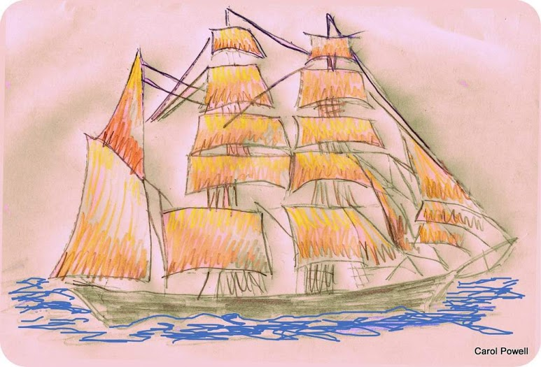
The Old Cape Horners of Mumbles

by Carol Powell M.A.

A Copper Ore Barque, c19
In the nineteenth century, many Mumbles men worked in the main local industries of oysterdredging, quarrying and farming. However, not all the seafarers were employed locally, indeed Mumbles was known for its contribution to the Swansea copper-ore trade with Chile and for voyages to other distant parts of the world.
With industrialization in the 1800s, Swansea had become a thriving centre both for coal and shipping, but it was in copper smelting that it excelled. One of the Cambrian Newspaper's reporters, John Lewis in his The Swansea Guide, 1851 revealed that out of the 200,000 tons of copper smelted annually in the UK, 90% was manufactured in Swansea. The works themselves were employing some 10,000 men out of a rapidly expanding population of 15,000 early in the nineteenth century and by the 1880s, the Vivians had 3,000 in their works. Logically, as it took four tons of coal to smelt one ton of copper, it was cheaper to bring the copper to the coal of which Swansea had plenty, rather than the reverse.
To supply the works, sailing ships known as Barques (pictured) embarked from Swansea's new North and South Docks on long arduous voyages round South America via Cape Horn (before the Panama Canal was made) to Chile and south to South Africa, bringing back the copper ore, for processing in the twenty or so works in the lower Swansea Valley, a journey often taking more than a year. There were several main copper-barque-owning families involved in the area, the RICHARDSONS originally from the South Shields area and the BATHS, Quakers from Falmouth in Cornwall, who settled in 'Rosehill' in Mumbles.
The barques were three-masted ships, square rigged on the foremast and mainmast and fore and aft rigged on the mizzen while below decks ore was carried in trunks and not on the bottom of the ship. Barques such as the 'Cuba', the 'Elizabeth George' and the 'Jessie' made the long voyage and many such as the 'Fleetwood' and the 'Annie Baker' were lost due to the weather, while others such as the 'Golondrina' carrying coal, foundered off Cape Horn due to fire on board.
Many men did not survive and were buried at sea or in Santiago, which became known by the dubious name of the 'Swansea Graveyard' In 1869, Mumbles man, JOHN DAVIES fell overboard from the barque, the 'Bertha' and drowned, the location of his death being recorded as '49º.52 South and 81º.51 West'. (i.e. off the coast of Chile)
Those of the crews who did survive the tempestuous seas, cramped conditions, disease and poor food, which might consist of a daily ration of ' a pound (of meat) and a pint (of water)' plus some bread if the weather was good enough for baking, gained the accolade of 'Swansea Cape Horners.' Swansea boasted more 'Horners' than any other British port and counted amongst its crews, a generous sprinkling of Mumbles names.

It was said in the Mumbles Methodist Church (pictured c1880, when the sea came up the road) that if the Preacher were to close his eyes and throw his bible into the congregation, it would be bound to hit a ship's captain, as so many of them attended his church'. Among these was Cape Horner, GEORGE TUCKER, holder of master certificate number 11167, the grandson of its founder, 'a large man with a stately presence but a curious modesty of carriage and a shrinking and nervous speech.' Among his many voyages, he captained the barque, the 'Vigil' on two occasions, one from Iquique to Plymouth in 1876.and the other from Pisagua back to Glasgow in 1877. A deeply religious man, he often told his fellow members of how throughout all the perils on the sea, he was conscious of Divine protection. He eventually settled down in the cottage next door to the Church.
Another was CAPTAIN DAVID MORGAN, 'a man of medium height and compact build', who first sailed the Cape Horn in 1861 and made thirty-three voyages, crossing 'that stormy headland sixty-six times' and ten times around the Cape of Good Hope. During his career, he became captain and commanded the copper barques, the 'Huasco' (named after the port and mine in Chile of that name) the 'Serena', the 'Langland' and the 'Gamma', where among his crew on a voyage in 1878 from Iquique, Chile to Liverpool, were two Mumbles men, THOMAS LEWIS, aged 28 and SOLOMON HIXSON, 23. He retired from the sea in 1892 and in February 1930, the 'Mumbles Press' reported that 'he was still alive, aged ninety-four.' He passed away later that year on 4 September.
Other Mumbles 'Cape Horners' included ABRAHAM ACE, born 1841 at Mumbles Lighthouse, who was a crew member on board the barque, the 'Pathfinder' on her voyage back home from Caldera in Chile to Swansea in 1864. The barque, the 'Emily Waters', sailed from Swansea to Valparaiso in 1876 with JOHN PERRY, 23, RICHARD HULLIN, 22 and WILLIAM MICHAEL, 27 as part of her crew. WILLIAM LLEWELLYN, 20 went on the 'Glynwood', from Swansea to Santa Vincento and to the West Indies, North and South America in 1880. BENJAMIN BEVAN, 21 went to Antofagasta in northern Chile on board the 'Zeta,' finishing back at Swansea in 1880.
Valparaiso was the destination for brothers, THOMAS 46 and JOHN MICHAEL, 37 (sons of Thomas and Eleanor) and JAMES GAMMON, 21 (son of William and Margaret) on board the barque, the 'Vigil' in 1875. WILLIAM GAMMON, his brother, a ship's carpenter voyaged from Lota, Chile to Swansea on the same ship in 1880. JOHN KNIGHT CLEMENT was an apprentice on the 'Serena' on her voyage back from Carrizal Bajo to Swansea in 1877. DAVID JONES, who lived at Forgefield Terrace, Norton and was eventually father to five children, made at least six voyages around the Horn on the 'Hinda', the 'Ocean King' and the 'Tacna'. He died in his eighty-second year at home in July 1928.
JOHN WEBBORN, baptised 1832 was part of the crew on the 'Capricorn' on her voyage from Swansea to Caldera in Chile in 1866 and WILLIAM WEBBORN, born 1835, was one of her crew on the voyage from Caldera to Swansea in 1866. ARTHUR WILLIAM WEBBORN, son of John (possibly the one above) and Eliza was born in Mumbles in 1870 and sailed on the 'Agnes Lilian' on her return voyage from Iquique to Hamburg in 1891.
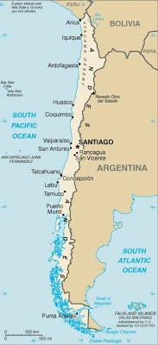
A map of Chile, showing major citiesWikimedia Commons
His brother, another WILLIAM 'BILLY' WEBBORN, born 1867 ran away to sea when he was twelve. He spent over fifteen years at sea, working his way up to be a Ship's Carpenter, when his pay would have been about £2..15s per month and his duties would have included responsibility for all woodwork, boats, masts, spars, anchor and windlass as well as checking the level of bilge water and that the barrels of food and fresh water were still serviceable. Billy had a wooden chest on board, in which he would have kept his tools such as hammers, planes, bits drill, screwdrivers, saws and chisels. The chest although not the tools, resides today in his granddaughter's attic.
It was when he was home on land that he fell in love with Annie Short, a native of Gloucestershire but 'in service' in Mumbles, and gave up the sea, as she said she would not marry him if he was going to be away on trips that could take months. They married at All Saints' Church on 22 March 1892 when he was 28 and she, 26 eventually settling at 19, Gloucester Place where Annie opened their home as a guesthouse. From there, Billy 'stocky of stature and handsome of face' used his carpentry skills to make stair rails, half decks, carved cupboards and knife boxes, as well as taking their visitors on trips around the bay in his boat the Viola.
As with many an old 'salt' he would later keep his granddaughter, Barbara entertained with sea shanties and 'tall' sea-farers' tales of seeing mermaids and being ship-wrecked on his voyages to Chile. Barbara remembers hearing her Grannie remarking on several occasions to her Grampi that 'she had saved him from the Swansea Graveyard', but until now, had not understood what she meant (see above). She was allowed to play with Grampi's little ivory statues and to look at his seal-skin slipper, a 'scrimshaw' which was an elaborately-engraved tusk and a model 'ship in a bottle' of Henry Bath's the 'Zeta', a sailing-cum-steam ship, the first of its kind to sail out of Swansea.
THOMAS WEBBORN (a brother to John above) was the son of David, a mariner and Sarah (nee Howell) and was baptised at All Saints' Church on 24 February 1850. He ran away to sea in 1864 and made several visits to South America and the Far East. He eventually became a skilled sail-maker, his tools being stored in a large seaman's trunk. Among his tools were an awl, a tool used to make holes in the heavy canvas, needles and bodkins (large thick needles); a Sail Palm, which was an oversized thimble, secured round the thumb and wrist and used to drive the needles through the heavy canvas; a Grease Horn, a convenient way for sail-makers to carry the grease needed to lubricate and protect their steel needles from rust; a Serving Mallet, a tool used when serving a rope when maximum tautness was required. Its curved area would hold the rope, while the small grooves at the top would hold the lashing as they were wound around the rope; Rubber used to flatten or smooth down the seams of the sails after sewing; a knife, sou'westers and boots. During the voyage, if the weather was calm, known as 'in the doldrums' their trunks, many of them decorated with carvings and paintings under the lids, would be brought on deck to air the contents and to act as seats and worktops and where Thomas would often play his piccolo. This, together with his trunk and tools are today housed in the Maritime Museum. One his more unenviable tasks as sail-maker, would have been to sew any deceased crew members into a canvas shroud, prior to their burial at sea.
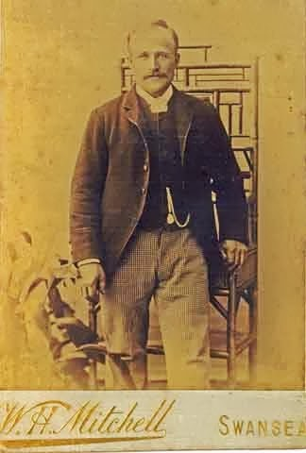
William Webborn
From Barbara Fisher
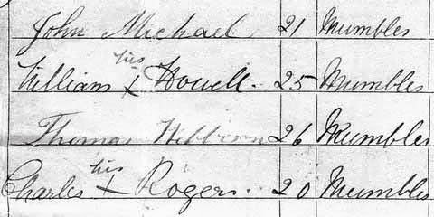
Some signatures of the crew of the 'Glynllifon'
From -'The Agreement and Account of the Crew, March 24 1874' concerning the 'Glynllifon'
'The Agreement and Account of the Crew, March 24 1874' concerning the 'Glynllifon' reads as follows, 'From Swansea to Para [sic] thence to any port or ports in the West Indies or North or South America trading to and fro to any of the above ports or any other ports in the known world for a period not exceeding twelve months. Voyage to terminate in the United Kingdom or continent of Europe'. Amongst this crew were Mumbles men THOMAS WEBBORN, 24, JOHN MICHAEL, 21, WILLIAM HOWELL, 25 and CHARLES ROGERS, 20.
THOMAS also went East, sailing on the barques, the 'Kate Helena' from Rangoon to London in 1878 and the barque, the 'Hinda' from Port Nolloth, South Africa, a town which had been established as a small-vessel harbour in 1854 for the copper-mining industry, back to Swansea in 1880. His other voyages included one on Captian Shand's the 'Aladdin', a 1,640 ton, single decked iron sailing vessel leaving Swansea in April 1885, arriving in Calcutta in late July and returning to London in December 1885 under Captain Manson on board the 'Gilroy'. She was a 1,678 ton, two-decked ship with accommodation for fifty seamen and Thomas' wages were £3..00..00d per calendar month Among the fascinating details revealed in the log book are the ration of provisions for the crew. Every day they would receive 1lb of bread, 3 quarts of water, 1/8 oz of tea, ½ oz coffee and 2 oz sugar. On alternate days, there would also be 1½ lb beef, 1¼ lb pork, ½ lb flour and 1/3 pint of peas.
A list of punishments shows that 'For misdemeanours on board there were fines of 5/- for assaulting any person on board and 5/- for being in possession any 'spirituous liquors. Fines for drunkenness were 5/- for a first offence and 10/- for any subsequent offence'. Thomas' discharge papers show that he finished his time on the 'Gilroy' on 12 December 1885.
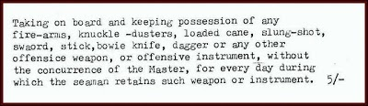
Excerpt from the Offences included in the Log and Crew List of Sailing Vessel 'Gilroy'
Several other local men went on voyages round the other Cape, the Cape of Good Hope in those pre-Suez canal days. THOMAS LEWIS, 25, REUBEN GUY, 18, CHARLES MACNAMARA, 25 and DAVID JONES, 25, voyaged to Port Nolloth and to the Colonies and to the Indian and Atlantic Oceans on a round trip from Swansea and back on the 'Tacna' by 1873.
SOLOMON HIXSON travelled on the 'Hinda' when, according to the record of the 'Agreement and Account of the Crew' she was to sail to the Cape of Good Hope and onwards to Australia, New Zealand, Red, Arabian, China and Eastern Seas, Indian, Pacific and Atlantic Oceans West and East coast of South America, Mediterranean, North Sea and Baltic and back to the United Kingdom, the voyage not to exceed two years.
WILLIAM LLEWELLYN landed back in London on 29 May 1880, after a voyage on the 'Glynwood' from Salt River, Jamaica and the West Indies. He then applied for an advance and a railway ticket warrant to get back to Swansea as the fare was 18/-, but was advanced 10/-.
In September 1886, while living at 23, Princess Street, Swansea, THOMAS WEBBORN, by now aged 36, met and married Margaret Jenkins, three years his junior and henceforth became a teetotaller and gave up the sea. His best man was John Webborn. By 1901, Thomas, aged 51 and Margaret, 47, were living in Albert Row, Mumbles with their children, Reuben, Thomas, (who was to die in 1913), David, Priscilla, Eunice and Leah, (who died 1914). Baby Lois had died in infancy. They had to move from Albert Row when the Council decided to demolish their home to widen the road at Gower Place and managed to get rehoused in the top floor of a large house in Overland Road before their move to William Street where they stayed for many years. Thomas was employed for some years as a roadman by the old Oystermouth UDC, the wages being one guinea per week, plus 5/- for lighting the urinal at the bottom of Village Lane and at Langland, although these gas lamps could blow out in the wind, which was a regular source of complaints to the Council.
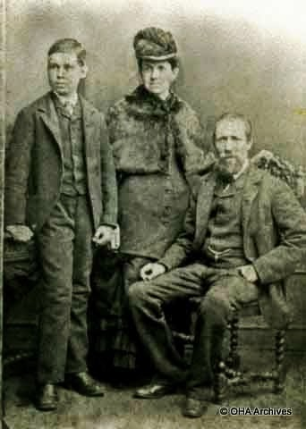
Thoma Webborn and Margaret Jenkins, on the occasion of their marriage, with Best Man, John Webbon
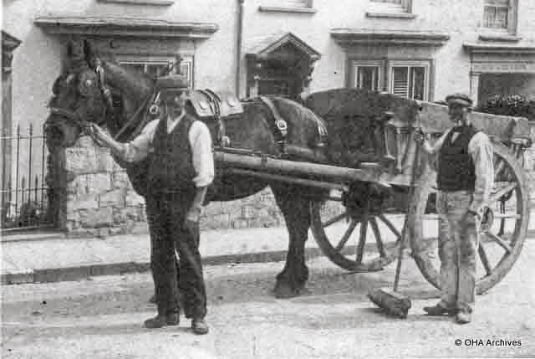
Thomas Webborn on the right, outside John Beynon's Dairy when working for Oystermouth Urban District Council
Thomas became a regular worshipper at the Christadelphian Synagogue in The Dunns, where his funeral was held in May 1936. The service was conducted by Mr. John Knight Clement and his family comprising his sons, Reuben and David Webborn; John Webborn, William Webborn and Harold Bragge, nephews; Sidney Bragg, brother-in-law; and John Timothy, attended. He also left a widow and two daughters. His interment took place at Oystermouth Cemetery on Saturday 23 May. The Mumbles Press announced that 'Mr. Thomas Webborn of 12, William Street, Mumbles died in May 1936, aged 86 and was said to be one of the last Cape Horners in the area'.
DAVID JOHN GAMMON was born in Mumbles in January 1872, the son of James, a Cape Horner, mentioned earlier, and Elizabeth of Rock Terrace. During the rapid decline of the oyster industry, in the 1870s, Skiff owners endeavoured to sell their dredgers, but many remained unused as their owners could not afford to operate them, but could not find buyers either. One owner, William Burt eventually managed to sell his skiff, the 'Secret' to a Montagu Hales (who had it transported to South America) where he employed David, by then still only nineteen years of age, as Skipper, trading in provisions around Punta Arenas on the Magellan Strait. David returned to Mumbles around the turn of the century and was married soon after to Sarah Malyn, a widow with several children, David and she going on to have five more.
David was involved in the 1903 Mumbles lifeboat disaster, when the crew were called out to the Waterford steamer the 'Christina' which was in distress off Port Talbot. Six lifeboat men, George Michael, James Gammon, Robert Smith and David John Morgan, a survivor of the 1883 disaster, as well as Tom Rogers (coxswain) and Daniel Claypitt, (2nd Coxswain) lost their lives and eight - Sam Gammon, William Jenkins, Tom Michael, Hedley Davies, David J. Howell, Richard Gammon, Charles Sully Davies, and David John Gammon survived.
The funerals took place in All Saints' Parish Church on Thursday 5th February 1903 at 3.30p.m. The music was provided by the Swansea Postal and Telegraph Band, which, with the Choir, Clergy and Ministers, preceded the bodies to the cemetery, where 1000s had gathered to witness the interments. The survivors of the disaster, clad in their life-belts, stood by the open graves. The service concluded with the hymn ‘Nearer my God to Thee’.
David John died in January 1929, aged 56.
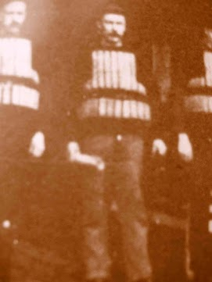
David John Gammon
From Neil Gamon
These then were just some of the men who literally sailed the seven seas in the nineteenth century and who hailed from the small fishing village of Mumbles.
The copper-smelting industry (apart from the ruins of the Morfa Copperworks rolling mill in Landore) has long gone and the Swansea Valley has been 'greened', but one sign of its past, which still remains can be seen in the sea wall - those large black blocks of waste copper 'slag' used to reinforce the sea defences in the 1890s.

