Authenticity and the Role of the Leader
by Huws Bosher
Student number: 2031072
Module number: BMPF7021

Introduction
I have been employed by the Welsh Ambulance Service (WAST) for fifteen years, having gone through a major change of career at the age of 28 due to redundancy. Prior to my commencement with WAST, I was employed by Sony Manufacturing UK for almost ten years. During this time, I undertook several roles including production line and quality control work. When Sony announced the closure of the Bridgend plant in 2005, I embarked on a one-year Certificate of Education in Introduction to Secondary Teaching course whilst working part-time in a Tropical Fish retail outlet, where I was employed as a deputy manager.
In September 2006 I began my WAST journey, entering the service as a Trainee Emergency Medical Technician (TEMT). This involved an intensive training course followed by a one-year trainee period that included quarterly examinations. I successfully passed this year to become a fully qualified Emergency Medical Technician.
In May 2009, I was successful in obtaining a position on an intensive Paramedic training course. Once this course was completed, I worked as a fully qualified Paramedic within the Cwm Taf locality on both Emergency Ambulances (EA’s) and Rapid Response Vehicles (RRV’s). This work involved responding to a wide range of emergency medical and trauma conditions and mentorship of student Paramedics.
Throughout my career, I have experienced a wide variety of extremely traumatic situations in work and in my personal life. A series of similar incidents from 2018 to 2020, where I was required to take a leadership role at extremely challenging scenarios, led to me applying for a three-month Clinical Team Leader (CTL) development role which took place from October 2020 to January 2021. This development role, in turn, led to me applying for a position as a Senior Paramedic (SP) which is the role I am currently employed in.
Throughout this writing I will critically evaluate several Leadership Theories and their relevance to WAST, explore and critically reflect on my own leadership style and behaviours and interpersonal skills and describe how these impact workplace relationships. I will also create a personal development plan with a focus on leadership skills.

A Critical Analysis of Leadership Theory

Introduction

Throughout history employers, the military and organisations have one thing in common; the utilisation of leaders to control and guide their workforce. Since the establishment of the NHS in 1948, management and leadership in healthcare has undergone several changes (Rivett, 2021). Following the Griffiths’ Report in the 1980’s, General Managers were developed due to the report finding that business-like principles were required in the NHS to oversee ‘planning, implementation and the control of performance’. Griffiths’ vision was that the adoption of management techniques found in industry would lead to significant and lasting changes in the NHS (Lewis, 2016).
The Clinical Strategy 2020-2025 document highlights the importance clinical leadership plays within the Welsh Ambulance Service (WAST) and builds on the operational and clinical structures implemented from 2017-18 (Killens, et al., 2020).
There is a broad range of leadership styles described in literature, ranging from Autocratic to democratic. In 1958 and later updated in 1973, The Leadership Continuum was written by Tannenbaum and Schmidt. The continuum depicts a broad range of leadership styles ranging between the two extremes (Juneja, 2010)
Fig.1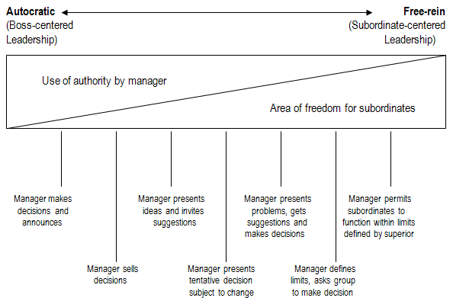
Fig.1 Continuum Leadership Behaviours (Juneja, 2010)
The purpose of this section is to provide a critical analysis of five separate Leadership theories. The theories will be briefly described, including how each relates to Abraham Maslow’s Hierarchy-of-Needs (McLeod, 2020) and their relevance within WAST. The theories will be ordered starting with the most autocratic.
Maslow’s Hierarchy-of-needs lists 5 basic human goals and proceeds from the most basic to more complex. The lower needs of the hierarchy need to be met to progress towards the ultimate goal of self-actualisation and this corresponds with ascension through the continuum of leadership behaviours. Everyone has the potential to reach the goal of self-actualisation if their more basic needs are met (Johnson, 2019)
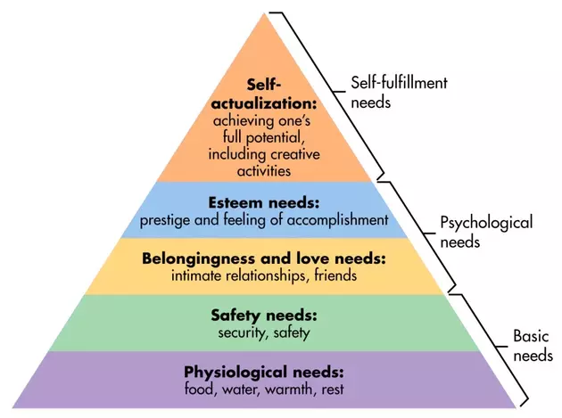
Fig.2 Maslow’s Hierarchy of needs (McLeod, 2020)

The Great Man Theory of Leadership
The Great Man Theory of Leadership became popular during the 19th century, the concept being that ‘leaders are born, not made’. During the 1840’s the Scottish writer and philosopher, Thomas Carlyle, presented the theory in a series of lectures. At this time, leadership was thought to be a male quality, particularly in the military. Therefore, the theory was named ‘the great man theory.’ Leadership positions were seen as a birth right and often included aristocratic rulers. People of lesser social status had few opportunities to achieve leadership positions, and this contributed to the idea that leadership is an inherited ability (Cherry, 2020).
This theory centres on two main assumptions; a person is born possessing certain traits that enable them to become great leaders and great leaders can arise when there is a need for them. The traits a person possesses, such as charm, persuasiveness, commanding personality, high degree of intuition, judgement, courage, intelligence, aggressiveness and action orientation (Chand, n.d.) allows them to become leaders in one of six classes; Divinity, prophet, poet, priest, king or man of letters (Lindberg, 2021). Great man theory remained popular until the mid-20th century.
As behavioural sciences grew, so did the understanding that leadership can be learned and nurtured. Modern theorists totally reject Great man theory, but it does, however, still have some relevance today. For example, the notion of a divine right for a King or Queen to rule over their subjects on a perpetual hereditary basis (Chand, n.d.).
This theory, thankfully, holds no relevance within WAST and would be difficult to align with Malsow’s Hierarchy of needs due to the lack of direction expressed. Staff of all grades, from cleaners to Chief Executive, are employed based on their education, experiences, and abilities, irrespective of social background. Where it may be true that some people possess inherent leadership qualities, these qualities can be acquired by anyone through education, training and exposure.
The great man theory of leadership does not put ‘the best person for the job’ and, historically, there have been many great failures as a result. One controversial example would be Field Marshal Douglas Haig who commanded the British army at the Battle of the Somme. Haig was extremely optimistic and believed the German army to be close to surrender and on July 1, 1916, ordered his men ‘over the top’. He did not consider German machine guns, and this resulted in around 60000 British casualties in the first day. He continued to view this tactic as the most effective strategy and this resulted in a total of around 420000 British casualties at the Somme and another 275000 at Passchendaele (Ray, n.d.)

Transactional Leadership
Transactional leadership is and autocratic concept and is often seen as an outdated, managerial style. It does, however, still have practical applications in the modern world. The concept of this theory is that managers ‘give employees something they want in return for taking something they need.’ It focuses heavily on results using existing structures and conformity. It appeals to the self-interest of employees and uses positive and negative reinforcement, in the form of rewards for achieving targets and penalties/punishments for failing them. It presumes that workers require structure, instruction and monitoring to complete tasks and that they are not self-motivated.
A Transactional leader values order structure and aren’t necessarily a good fit for places where creativity and innovative ideas are valued. They are driven by policies and procedures and are opposed to change. They set criteria for their team, maintaining routine by managing individual and group performance, using performance reviews and close supervision (University, 2014).
Transactional leadership appeals to the most basic needs on Maslow’s Hierarchy of needs, providing only for the physiological and safety needs of workers (McLeod, 2020)
Within WAST, Transactional leadership has limited potential but has been used to varying degrees of effectiveness in recent years. For example, during the winter pressures of 2019, overtime incentives were offered to operational staff. These incentives involved extra financial reward in return for working a set number of overtime shifts in a set period and which also met certain criteria, such as night shift over the weekend period. This incentive program was successful in increasing Unit Hour Production (UHP) and was continued for several months. This is an example of positive reinforcement.
Despite the success of the example highlighted above, another incentive involving double time overtime was offered for Rapid Response Vehicle (RRV) cover from 14:00-02:00 throughout August. RRV cover is predominantly provided by Paramedics and occasionally Emergency Medical Technicians (EMTs) and is unavailable to staff of lower grades. This incentive proved to be extremely controversial with a detrimental effect on moral for those staff members who were not eligible to work the shifts. A Facebook post relating to incentive was posted on the closed Team WAST group and garnered a huge amount of negative feedback.
Certain Key Performance Indicators (KPI’s), such as mobilisation times and handover to clear at hospital, are regularly monitored by management. Deviation from the target timing is highlighted in Performance and Development Reviews (PADRs) and occasionally with contact from a Duty Operations Manager (DOM). This is an example of negative reinforcement.
I believe that Transactional Leadership could be seen as an outdated management style, linked to industry and manufacturing. However, it can be remarkably effective at achieving short term goals and still has its place in the modern world. By providing unambiguous structure and clear definition for employees, employees know exactly what is expected of them and what they need to do to achieve rewards or avoid penalties. However, it is also inflexible and does not encourage free thinking. It may also prove to be extremely demotivating to staff if rewards are unattainable or appear to be unfair. Used as a sole leadership model, Transactional leadership may also lead to worker apathy or burnout as highlighted by a study caried out by W. Lloyd Warner and Elton Mayo during the Hawthorne Experiments (Perera, 2021).

Transformational Leadership
Transformational leadership is a style that can inspire positive changes in the workforce. Transformational leaders are passionate, enthusiastic, and energetic about results and in helping every member of their team succeed (Cherry, 2020). They trust trained employees to take authority over decisions related to their assigned jobs without micromanaging their teams (White, 2018)
This leadership concept was first introduced by James V. Downton in 1973 and was later expanded on by James MacGregor Burns in 1978. In 1985, Bernard M. Bass further expanded the concept further (White, 2018) to include ways of measuring its success and that there are four different components that a transformational leader needs to exhibit to be effective (Cherry, 2020)

Idealised Influence: Transformational leaders earn the trust and respect of their team by acting as role models, putting the teams needs over their own and demonstrating high standards of ethical conduct.
Individualised Consideration: Transformational leaders team members with tasks according to their knowledge and talents allowing them to maximise their performance (Patel, 2015). Lines of communication are kept open for the free sharing of ideas and to offer direct recognition of teammates contributions.
Inspirational Motivation: Transformational leaders promote a clear vision and help their team experience the same motivation to fulfil the task at hand. They nurture a spirit of teamwork and commitment by providing their team with a sense of meaning and challenge.
Intellectual Stimulation: Transformational leaders encourage innovation and creativity in their team. They do not foster a culture of blame and never criticise their team publicly when mistakes are made.
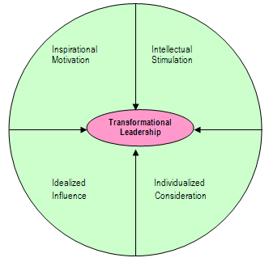
Fig.3 Model of Transformational leadership (Juneja, n.d.)
Transformational leadership is an upward move on Maslow’s Hierarchy of needs compared to Transactional leadership, appealing to the psychological needs and potentially self-fulfilment. The concepts of each are polarising, as shown in the table below, but they may also significantly augment one another if used effectively, resulting in an increase of individual, team, and organisational performance (Patel, 2015)

Transactional Leadership | Transformational Leadership
- Leadership is responsive  - Micro-manages a team to ensure targets are met  - Avoids changes from pre-set routine  - Concerned with process over ideas  - Objectives are achieved using punishment/rewards | - Leadership is proactive  - Public and private acknowledgement of achievements  - Delegates tasks and allows team to work autonomously  - Encourages change and innovation  - Concerned with ideas over process  - Objectives are achieved by motivation to be better for the good of the group
Fig.4 Transactional and transformational leadership comparison (Patel, 2015)
Transformational leadership has enormous potential as a leadership model within WAST due to the complex and varied nature of pre-hospital emergency care. Staff of all grades continually work without direct management intervention and require the autonomy to make challenging decisions in relation to the treatment of patients. The Clinical Strategy 2020-2025 recognises the usefulness of the four components of transformational leadership through the provision of education, autonomy, support, and the introduction of clinical leadership (Killens, et al., 2020).
Transformational leadership has the potential to bring unity to a team, boost morale and motivation within an organisation by seeking to bring out the best in individuals through coaching and encouragement. The concept is an effective way to facilitate change in an organisation by encouraging staff input and innovation using excellent, consistent communication.
There are also potential disadvantages to transformational leadership. If morale is low within an organisation to begin with, it can take a huge amount of work to rectify it. If communication is not frequent and consistent enough, gains may not be achieved. Too much communication could also lead to staff burnout and apathy.
Where staff are not highly motivated, tasks my not be completed on time or in a manner consistent with organisational desires. An example of this, taken from personal experience, involves providing cover to facilitate breaks during the long hospital delays currently being experienced pan Wales. Staff returning to their base station frequently take advantage of the situation, driving slowly, making stop offs or not contacting control when they arrive as per policy. This often leads to a 30-minute break taking more than two hours to complete.
Transformational leadership also carries a high potential for abuse or misdirection. A leader’s vision of ‘the right way’ may turn out to be the wrong way. For example, Adolf Hitler could be regarded as an example of a transformational leader (Thompson, 2019).
Authentic Leadership

Authentic Leadership describes leadership that is morally grounded , transparent and responsive to the teams needs and values (Northouse, 2021) and was first discussed in the 1960’s having been developed and evolved out of frustration with modern leadership and was popularised by the publishing of the book ‘Authentic Leadership’ by Bill George in 2003 (Robinson & O'Dea, 2014). It offers a replacement for the old ‘top down’ style of management and encourages engagement and commitment from staff.
This model is not clearly defined and is in the formative phase of development. It is also a complex theory with similarities to other rational styles of leadership, particularly Transformational Leadership. There are five dimensions to authentic leadership, and each has a related characteristic that a leader has or can develop: Purpose and passion, values and behaviour, relationships and connectedness, self-discipline and consistency, and heart and passion (Powlus, 2017).

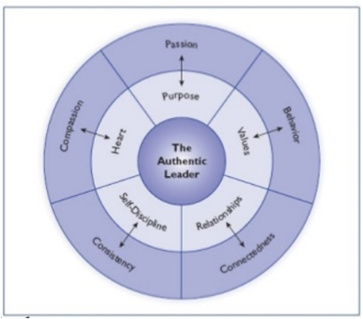
Fig. 5 Bill George’s Authentic Leadership Model (Northouse, 2021)

Authentic leaders:
- have a keen sense of purpose that manifests itself as passion for the task they are involved in. Passionate people are intrinsically motivated and care about the work they are doing
- know who they are and do not compromise their values. They behave towards others based on these values and do not compromise them when faced with demanding situations
- build relationships with others. They have the capacity to open themselves up and establish connections with their team
- possess self-discipline which gives them focus and determination to reach their goals. This self-discipline allows the leader to remain calm and consistent in stressful situations
- have heart which shows in their compassion and sensitivity to the needs of others
(Northouse, 2021)

These factors may all be influenced and by an individual’s life experiences and education, both positively and negatively. Critical life events can stimulate growth in individuals and help them to become stronger leaders. From personal experience, several difficult and traumatic incidents from both work and personal life. These events had a profound effect on my life and set me on the course to attaining a leadership position in WAST.
The humanistic approach afforded by transformational leadership has potentially positive implications WAST, including improved patient experience and improved motivation, job satisfaction, collaboration and knowledge sharing for staff (Johnson, 2019). This places the theory into the higher needs of Maslow’s Hierarchy.
Although authentic leadership appears appealing on the surface, several questions still need to be addressed about the theory. The reliance on a leaders’ individual experiences makes it difficult to predict the course of action they may take, what they judge to be moral based on personal experience may differ wildly from societal norms. In some instances, authenticity may even be an undesirable trait. This would be particularly true if a person expresses what’s on their mind if this is contradictory to the thoughts of others (Northouse, 2021).

Compassionate Leadership

Compassion is a core value of the NHS as a whole and is the primary behaviour in WAST’s ‘Being our Best’ campaign of 2016. Figure 6 (see appendix) is a poster that is present on all Emergency Ambulances and Ambulance stations. Sustaining a culture of compassionate care requires compassionate leadership at all levels, from local teams to national leaders (West & Bailey, 2019). The immense pressures created by the Covid-19 pandemic makes this especially valid at the present time.
The literal translation of compassion is ‘to suffer together’ and is defined by Greater Good Magazine as ‘the feeling that arises when you are confronted with another's suffering and feel motivated to relieve that suffering’ (unknown, 2021). It can be understood to have four components: attending, understanding, empathising, and helping (West, et al., 2017). In the context of health care, compassion involves the following steps:
- Communicating with the patient and noticing their suffering – attending
- Making an appraisal of and understanding the cause of distress – understanding
- Relating to the other persons distress – empathising
- Taking appropriate action to relieve suffering – helping
In the context of leadership, these steps can be expanded on further:
- Attending. Compassionate leaders listen, withhold judgement, and explore challenges in depth. Empathy with team members establishes strong and lasting bonds
- Understanding. Compassionate leaders work in conjunction with their team to understand the challenges they face. The approach is not hierarchical but supportive and engaging which enhances self-worth.
- Empathising. Leaders who can empathise with their teams through shared experience and knowledge are able to increase their team’s motivation and commitment.
- Helping. A compassionate leader can support their team by taking thoughtful and intelligent action, when needed, whilst engaging their team in the decision-making process.
(West, et al., 2017)
Healthcare professionals generally enter their roles with an intrinsic motivation to be good at their work and to help others. Despite being an innate human capability that is at the forefront of health workers personalities, compassion is vulnerable to several factors that can readily eclipse it. These include burnout/overload, external distractions, ‘difficult’ interactions with people, complex situations, fear, stress, and depression (Zulueta, 2015).
A compassionate leader recognises each team member as an individual and as an integral member of the entire team or organisation. ‘Where intrinsic motivation and staff engagement are nurtured, compassionate patient-centred staff can flourish’ (Zulueta, 2015). There is no room for a culture of blame, only one of learning and support. This has the potential to be a highly desirable leadership model in healthcare with the ability to boost morale, build resilience, foster a team spirit, and contribute to a lower staff turnover (unknown, 2021). Once again, this model concentrates on the higher needs of Maslow’s hierarchy.
However, if staff are feeling deeply negative around their role, a compassionate leader could be seen as weak and left open to abuse. I have experienced this recently whilst investigating a clinical concern. Moral within WAST is extremely low amongst front-line staff now and the staff member became extremely defensive and forceful when approached for a statement. This was extremely difficult to deal with and required a great deal of tact and compassion to avoid inflaming an already volatile situation. Taking a gentle approach calmed the staff member but also delayed the clinical review by several weeks.

Conclusion
Leadership theory is a continuously evolving phenomenon. Throughout this study I have outlined five theories and provided a critical analysis of each. I have ordered them according to when they were conceived, from oldest to most modern and aligned them to Maslow’s hierarchy of needs.
From the information provided, I believe that no single leadership theory can be fully effective when used in isolation and the combination of several models may have the potential to enhance an organisations performance. Different models have relevance to various situations and people might also react favourably to one leadership style over another. The overuse of either extreme of The Leadership Continuum may be undesirable, leading to low moral or lack of productivity. A successful leader needs to be able to model their behaviour to that which is most appropriate at a particular time.
In order to model behaviour to a particular interaction, the effective use of transactional analysis can help determine which of the three ego states the communicator is utilising and an appropriate response can then be formulated (Morad, 2018).
Within WAST and the NHS as a whole, morale is particularly low at the moment due to the extreme pressures as a consequence of the Covid-19 Pandemic. At this time, vaccination programs appear to be attributable to lower covid hospital admissions, but we are now faced with a backlog of other health issues which is keeping demand high. Effective and compassionate leadership is more important now than ever.
The leadership models used by a leader may also be influenced by their personality. For instance, my own personality is nurturing and affable which means I favour a more democratic leadership style. I would consider my own leadership style to be compassionate/transformative and find autocratic dealings to be exceedingly difficult. Having worked in WAST for over 15 years and built a rapport with my colleagues prior to engaging on the route to leadership, I hope that I would also be considered to be an authentic leader. My own leadership style will be explored further in the next section.

A Critical Evaluation of Leadership Qualities

Introduction
My role as a Paramedic has delivered a wide variety of challenges over the years, both professional and personal, all of which have motivated me to further develop my clinical skills. I regularly mentored student paramedics, student doctors and newly qualified EMTs and all these factors combined, eventually led to the realisation that I was inadvertently displaying leadership qualities that were recognised by senior management within the locality in which I work.
In September 2020, following several discussions with the management team, I applied and was successful in obtaining a Clinical Team Leader development role. This eventually led to me entering the stringent application process for a new to WAST position as a Senior Paramedic (SP), a role that I commenced in April 2021. My duties within this role include an enhanced scope of clinical practice and the provision of front-line clinical leadership to EMS staff including Paramedics and EMTs.
My embarking on a leadership role has also coincided with the Covid-19 Pandemic, which has presented a huge challenge to the National Health Service (NHS) as a whole. Within WAST, the immense workload, elevated levels of sickness and excessive delays handing patients over at hospital, have led to low levels of moral amongst staff.
Within this section I will describe using the Gibbs model of reflection, and critically reflect on one specific leadership challenge that I have been presented with during the brief period that I have been in a leadership role. This scenario has been protracted over several months and remains ongoing.
Gibbs reflective cycle is one of the best-known cyclical models of reflection that is frequently used within WAST to reflect on scenarios that Paramedics encounter during the course of their duties. This allows extended learning and an opportunity to reflect on what are often highly emotive experiences. It leads the author through six stages:
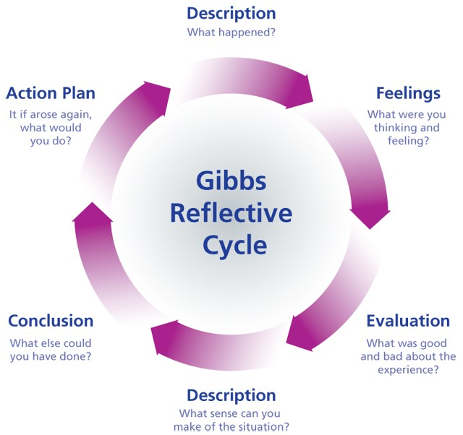 (Gibbs, 1988)

Description
For many years, staff teams within my locality have gone relatively unchanged, with small numbers of newly qualified staff being introduced annually. The past 12 months have seen huge changes in this dynamic with several long serving members retiring and a large influx of newly qualified EMTs
One of these new EMTs who will be referred to as X, has been brought to my attention from the onset of my SP position as struggling with the role. Several people stated to me that X does not seem to ‘get’ the job, despite coaching, and does not recall how to conduct basic observations or recognise when a patient is seriously ill. I was also told that X ‘is too nice for our job but would be perfect for a non-clinical patient transport role.’ Prior to these concerns being raised, I had only briefly met X once and had not had the opportunity to work with her.
Having listened to their concerns, my first action was to arrange a clinical ride out with X. Clinical ride outs are part of my regular duties as an SP and are to be conducted for all members of my team over the course of the year. I prioritised X to distinguish the reasoning for the teams concerns and also to provide support to X. I decided that I would enter this shift without any preconceived assumptions about X’s working practices to give a fair, open, and honest feedback.
During the twelve hours ride out shift with X, I was unable to identify any clinical concerns. Contrary to this, X displayed exceptional levels of care to the patients and families that we were presented with during the shift and her Patient Clinical Records (PCRs) were completed to a good standard.
I spent a great deal if time chatting with X, during which time she revealed that she had only been working for WAST for eighteen months. She had started her career as an Urgent Care Assistant (UCA) before successfully applying for promotion to EMT. Whilst working as a UCA, X had suffered with the loss of her third child at birth which, understandably, led to her missing time from work. Immediately following her EMT course, X had fallen pregnant again and tragically this child had also died within the first few weeks of life as a result of a genetic abnormality. X and her partner had separated, and X had then entered an abusive relationship with another man. In all, out of eighteen months service, X had only been operational for a noticeably brief amount of time.
I was able to witness X’s nervousness first-hand when working on a Rapid Response Vehicle (RRV), where I was backed up by X and one of the strong personality Paramedics who were crewed on an Emergency Ambulance (EA). The call involved a male patient who had fallen off a motorbike and sustained multiple injuries, mainly as a result of not wearing a helmet or other protective gear. He was laying extremely awkwardly over a kerb, and we suspected spinal and pelvic injuries, both of which are potentially life threatening/changing. The Paramedic had previously worked with X on several occasions and expressed his concerns to me and, on this occasion, appeared impatient with X. This resulted in X becoming more nervous and attempting to distance herself from the paramedic, compounding the impatience.
X was on a relief position when she joined our team. This meant that she had no set rota pattern or regular partner and worked with whoever the resource department put her with on any given day. X stated to me that instability associated with this pattern of working was proving extremely challenging for her since ‘everyone seems to do things differently’. I delivered an appraisal of the shift to X and offered to compile a series of Continuing Professional Development (CPD) sessions to help develop her clinical skills, prioritising lifesaving interventions such as resuscitation and airway management along with basic skills such as drug preparation and administration. Conducting this kind of exercise would be difficult during shift time so I offered to meet with X outside of work hours if needed; we would both be able to claim this time back in the form of additional leave or claim CPD hours as per WAST policy.
X did not engage with the CPD sessions and staff continued to express concerns about her. I arranged to work three supportive shifts with her over the course of a weekend. Once again, X’s care and compassion towards the patients and families that we encountered was exemplary but, when faced with one patient who was particularly unwell, X seemed almost overwhelmed. We discussed this incident afterwards and X disclosed that she feels extremely nervous when faced with an incident like this and that some people she had worked with in the past have made her more nervous through their actions.
Following the weekend, I hypothesised that X would benefit from the extra support and stability that could be afforded by working with a regular partner of a higher clinical skill set i.e., a Paramedic, for at least a few weeks. I discussed this situation with the locality manager, and we formulated an action plan based around the long-term sickness of several staff who have permanent rota positions. X was to be teamed up with one of two paramedics, an experienced male who is renowned for being difficult to work with or a female Newly Qualified Paramedic (NQP) who had qualified only nine months previously.
We decided that X would struggle to work with the male paramedic due to clash of personalities and that the situation would worsen as a result. With this in mind, we created another rota line and linked X with the NQP after discussing this with her. Extra support was offered to the NQP, and regular appraisals of the situation arranged.
This arrangement has been in action for approximately two months and X has recently passed her midpoint examinations. Recent staff retirement/resignation has also enabled an indeterminate extension to the timescale involved. The NQP regularly feeds back any concerns that she identifies, and the actions that she has taken at the time, to enable me to monitor the situation and provide support as needed.

Feelings
The situation surrounding X is extremely challenging to deal with. I have been increasingly annoyed at the lack of empathy displayed by various staff when they are referring to X. Based on experiences of working with her during the supportive ride out shifts, X has the potential to be a huge asset to WAST. Despite being employed in an EMS role for almost two years, X remains inexperienced due to her personal circumstances.
When dealing with any aspect of this case, I have been conscious of not expressing my own feelings prematurely. Due to having little prior contact with X, I felt it important to impartially evaluate the situation by listening to the concerns of all involved, including X, before formulating any replies or action plans.
I can empathise with the staff that have experienced sub-standard capability when they have worked with X but also with the challenging circumstances X has found herself in. Morale amongst operational staff in WAST is extremely low at the moment; the ongoing pandemic, extended hospital delays and extreme workloads, all of which are regularly covered by local and national News, are putting a great deal of pressure on staff.
Verbal statements made by some of her colleagues, implying that X is ‘too nice for this job’ are, in my opinion, absurd, and unfounded. How could a person possibly be ‘too kind’ when attending to, and caring for, the often extremely vulnerable, unwell, and injured patients that we attend? The only exception I can envisage would be in dangerous circumstances involving violence and aggression, in which case a friendly demeanour can be disarming but would require the crew to withdraw to a safe distance.
With regards to X’s possible clinical shortfalls, I passionately believe that these are not through inability on her part but more through lack of confidence. This will be self-rectifying given adequate nurturing, time, and experience.

Evaluation
The whole experience of dealing with this scenario has been higly emotive. I can empathise with both the staff who have expressed their concerns regarding X’s clinical practice, and with X herself. I do not, however, believe that any of those involved have handled the situation correctly prior to my involvement. For those who expressed concerns about X, notifying management of these concerns without gossiping would have been far more beneficial. Likewise, X could have been more forthcoming in looking for extra support – not an easy task for someone so new to their role.
I believe that my own inexperience of being in a leadership role has resulted in this situation continuing for longer than necessary. Constraints of my sp role mean that I have limited time to spend supporting a single team member. Operational ride outs are currently arranged for when a staff member is single manned on an EA to minimise disruption and are carried out with every member of my team. In the case of working with relief staff, including X, this means finding an oportunity when an EA is completely unmanned. As such, this extended the wait time to perform the initial clinical ride out.
The supportive weekend that I spent with X came about as a result of me noticing she wasn’t crewed with anyone. I used my initiative to alter my own working pattern, cancelling pre-arranged RRV shifts in favour of working with X. I feel that this was a good decision on my part, one that X was appreciative of. Again, there was a protracted period before this became available and, ideally, I would like to have altered X’s shift pattern to facilitate this sooner.
Arranging the rota position alongside the NQP has been highly positive in my opinion. X appears more confident and settled in her work. The NQP is happy to convey any concerns she may have and I advise her as appropriate. I believe the mentorship being provided by the NQP will benefit them both greatly in the long run.
My aim in handling this experience has been to maintain a feeling of positivity, maintain the dignity of all involved and to coach all parties to better handle similar situations in the future. By making myself accessible to the whole of my team, I feel that they are comfortable in approaching me with concerns and this has been evident in my experience of this case.
The situation is still ongoing but I believe it is vastly improved from my first contact with it six months ago. I will continue to monitor and offer support for as long as necessary.

Analysis
On embarking on my new role as an SP, I have been surprised by the change in dynamic between my colleagues and myself. I have worked alongside many of these colleagues throughout my fifteen-year career and have noticed how most now seem comfortable in approaching me for assistance, some relationships have gone unchanged, but a very few staff have become quite aggressive towards me since they now see me as ‘management.’ This became increasingly evident during the case highlighted above where some staff expressed concerns in a professional manner, some seemed to be ‘jumping on the band wagon’ and spreading gossip, and others were demanding that X be taken off front line duties or asking questions such as ‘what are you going to do about her.’
When conversing with my team, particularly the more aggressive members, I attempt to use Transactional Analysis. Wikipedia describes Transactional Analysis as a psychoanalytic theory and method of therapy, which analyses social interactions to determine the ego states of the communicator and was developed by Eric Berne in the 1950s (Foundation, 2019). Berne theorised that every person is made up of three ego states during communication: parent, child, and adult.
- Parent – Taught, formed by influences and events during our formative years, this is our voice of authority and used to give orders.
- Child – Felt, our internal reaction to events, manifesting as anger or despair. The child ego state also seeks to receive instruction as opposed to free thinking.
- Adult – Thought, our ability to think and determine actions for ourselves. The adult ego state operates in the here and now, rationally processing thoughts based on facts.
There is no general rule regarding the effectiveness of each ego state in a given situation; some people get results by being dictatorial (Parent to Child), or by having temper tantrums, (Child to Parent), but for a balanced approach to life, Adult to Adult is generally recommended (Businessballs, 2021). Crossed transactions e.g., parent to parent or child to child may lead to breakdown in conversations and as such, I attempt to modify my own ego state accordingly. This often proves difficult, particularly when dealing with more awkward team members who flit between ego states. As described later in this text, my own personality is not well suited to an authoritarian style of leadership and, as such, I often default to the adult or child ego states. Occasionally, this is not an ideal situation, and I am working on being more assertive when the situation is appropriate.
When attempting to address the case of X, I decided to dissect the situation into distinct categories. Firstly, I wanted to put a stop to the increasing gossip that surrounded X and secondly, I recognised the need to provide X with additional support, not just from a work/clinical capacity but also for her mental health following the tragic experiences she had encountered in the past eighteen months.
I believe that to become an effective leader, a person first needs to understand their own personality. Use of personality profiling tools such as the Insights Preference Evaluator (insights, 2021) can help enable this by identifying eight personality traits (reformer, director, motivator, inspirer, helper, supporter, coordinator, and observer) and aligning these with one of four colour energies based on responses to set questions. These colours describe our own behaviours but do not define us as a person (Samuel, 2021)
The result of Insights evaluator that I conducted for myself are given in the Appendix section and proved extremely enlightening and accurate based on my self-knowledge. It indicated that my personality type is a Helping Supporter and that my colour energy is centred towards Earth Green. This indicates that my dominant personality traits are caring, encouraging, sharing, patient and relaxed and that I find confrontation, impatience, and insensitivity difficult to deal with.
In his article for Harvard Business Review, Leadership That Gets Results, Daniel Goleman states that ‘a leader’s sole purpose is to achieve results’ and describes a survey filled out by employees of 3781 executives. The result of this survey suggests that ‘50-70 percent of employees perception of a working climate is linked to the emotional intelligence characteristics of the leader (Goleman, 2000). Goleman also describes six distinct leadership styles, their emotional intelligence competencies, impact on work climate, objective and when each are appropriate. These styles are:
- Visionary
- Affiliative
- Democratic
- Coaching
- Coercive
- Pacesetting
(Cherniss & Goleman, 2001)
How I consider myself as a leader is directly linked to my personality profile. I believe that I possess a high degree of emotional intelligence and am highly democratic in my leadership style. Having conducted a brief Emotional Intelligence questionnaire on the Mindtools website (Mindtools, 2021), my score was given as 59/75 This indicates “You're an emotionally intelligent person. You have great relationships, and you probably find that people approach you for advice. However, when so many people admire your people skills, it's easy to lose sight of your own needs.” This test focused on five key areas: Self-awareness, self-regulation, motivation, empathy, and social skills and scored each area accordingly. It highlighted an area of improvement being my social skills, particularly my communication skills.
I spend a great deal of free time alone, taking comfort in my own company as I conduct my pass times of gardening, walking, and fishing. I often feel that I have some difficulty in communicating, often feeling extremely shy with others, and have gone to great efforts to improve this over the years. The Mindtools website also has a short communication skills quiz. The result of this quiz indicated that I am “a capable communicator, but you sometimes experience communication problems. Take the time to think about your approach to communication, and focus on receiving messages effectively, as much as sending them. This will help to improve your ability to communicate” (Mindtools, 2021). The feedback for this quiz, given in the appendix section, shows that I could improve my communication skills by better planning of the message I wish to convey.
My main aim with my team is to create and maintain a harmony, motivate them during stressful times and to help improve employee and team performance. As such, I would describe my leadership style as a mixture off affiliative and coaching which would align with the Compassionate and Transformational Leadership theories.
In addressing the gossip that was taking place around X, my first instinct was to attempt to not engage in this line of conversation with the staff members involved, thinking it was idle gossip. However, as more people approached me with the same concerns, I quickly decided that I needed to isolate the facts from the gossip and deal with each accordingly. The station where X is based has a high number of long serving staff with strong personalities. These often present as intimidating to new members of staff, which was evident in this case. All agreed that X was exceptionally kind and caring but also criticised her clinical knowledge and nervousness when faced with challenging situations.
In an article written for Walden University, Dr Barbara Benoliel describes five conflict management styles. Of these, the collaborating style best aligns to my own personality type, and I feel best suited the needs of this case. Dr Benoliel defines the collaborating style of conflict management as:
A combination of being assertive and cooperative, those who collaborate attempt to work with others to identify a solution that fully satisfies everyone’s concerns. In this style, which is the opposite of avoiding, both sides can get what they want, and negative feelings are minimized. “Collaborating works best when the long-term relationship and outcome are important—for example, planning for integrating two departments into one, where you want the best of both in the newly formed department,” (Benoliel, 2017)
During the clinical ride out, as described earlier, I was unable to observe and shortcomings with X’s clinical practice during the shift and I was impressed with the exceptional level of care she afforded the patients and family we encountered. Having an open conversation with X did reveal the personal issues she had faced and the difficulties she was experiencing in work. She informed me that her personal problems were common knowledge on station and consented that I could refer to them if approached by staff in the future.
In 1981, James Dozier provided an example of what emotional intelligence is following his kidnap at the hands of an Italian terrorist group. By calming himself and expressing this calmness through his actions, he was able to influence the increasingly agitated and irrational captors who began to calm down and become more rational themselves. He had previously learned in an executive development program that ‘emotions are contagious, and a single person can influence the emotional tone of a group by modelling’ (Cherniss & Goleman, 2001).
I have always believed that my general attitude has a direct link to my behaviour and endeavour to always remain positive. This is not always easy or practical to do but, particularly in relation to my position as a patient facing SP, I believe that leadership by example can influence great improvements for patient care and moral within my team. The Betari Box model perfectly illustrates this mind set:
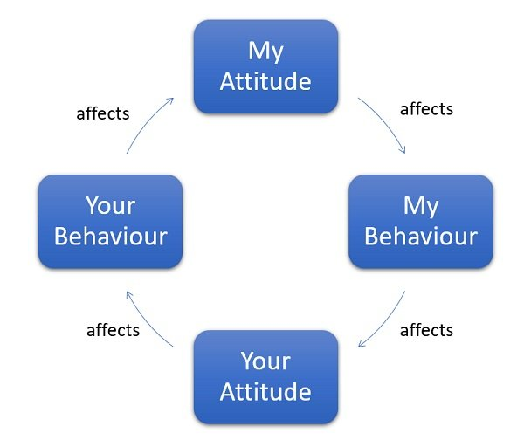 (Farmer, 2019)
I believe that the gossip surrounding X is tantamount to bullying in the workplace and would liken this behaviour to the terrorists described above. As stated previously, morale in WAST during this time was extremely low and this seemed to nurture negative feelings towards X which needed to be stopped as soon as possible. I understand people’s concerns and conclude that X would need additional support but people pre-judging her capabilities prior to working with her was creating a toxic working environment. X’s tragic personal circumstances would require a certain degree of emotional intelligence for all parties involved.
The resolution of the gossiping was too slow on my part. In my attempt to diplomatically resolve the situation, staff continued with the behaviour, compounded by X remaining in her relief position and continuing to work with multiple colleagues. Assertiveness does not come naturally to me and dealing with demanding situations often creates a great deal of frustration by my inability to exert my opinion over those of others. I was eventually able to speak to all parties involved and have calmed the gossip significantly.

The second facet to resolving the issues surrounding X was the provision of additional support for her. As described previously, X did not engage with the offer of one-to-one CPD sessions, so I arranged to work three successive shifts with her. During these supportive days, I attempted to ascertain the learning style that best suited her and would best facilitate any training I could offer in my capacity as an SP.
In 1986, Peter Honey and Alan Mumford published the Honey and Mumford learning styles (Expert Program Management, 2020). The theory of their work being that one (or two at most) of four learning styles will be preferred by each of us. These four styles are:
- Activist
- Theorist
- Pragmatist
- Reflector
Prior to the supportive shifts, I taken part in an eighty-question questionnaire to determine my own favoured Honey Mumford learning style. The result of this quiz indicated that my learning preference is as a reflector. Expertprogrammanagement.com offers the following description of the reflector learning style:
Reflectors are people who learn best when they can observe others and think about what they have just observed. They avoid jumping straight in and prefer to watch first.
They like to collect data from many sources and perspectives, then think about it thoroughly before reaching any conclusion. They are cautious and like to consider all the angles before committing to action.
Reflectors learn best when:
Given time to think before they have to take action.
Given time to investigate before they have to take action.

Reflectors learn least when:
Aggressive deadlines rush them.
They have to do things without having adequate time to prepare.
Forced to take the lead in a group situation.

Activities suited to reflectors:
Observing others perform activities.
Paired discussions.
Receiving feedback from others.
Coaching.
(Expert Program Management, 2020)
This description of my own favoured learning style is perfectly accurate although I do have some activist qualities in that I like to ‘get my hands dirty’ and learn by performing an action.
I was not able to offer X an opportunity to complete a questionnaire during the time I spent working with her due to operational demands but, from speaking with her, I decided that she would respond to a similar learning style to my own. I spent time with X covering a wide range of topics and practical skills. I identified X was having some difficulty with setting up some less frequently used equipment so spent time demonstrating and encouraging her repeat the exercises to ensure she understood what she was doing. I also provided her with equipment to practice these procedures at home.
My next course of action was to attempt to arrange a more stable working pattern. To facilitate this, I met with the local Health Board Clinical Lead (HBCL) and Locality Manager (LM) to suggest a period of mentorship for X to work alongside a Paramedic. Within WAST it is standard practice for NQP’s to work a 300-hour mentorship period with an experienced Paramedic to reaffirm their clinical skills and allow them time to settle into their new role. This mentorship is not currently afforded to TEMT’s and is proving to be a less than ideal situation.
Due to the Covid-19 pandemic, TEMT training is conducted in a distance learning capacity with minimal face-to-face contact. As such, once the course is finished, TEMT’s are put straight into their relief working positions with no regular partner or working pattern. From personal experience with a number of these new recruits, they often struggle with some of the practical elements of the role. Some can adapt quickly to this way of working but for others, including X, I feel extra support is needed.
In an article written for Essentiallifeskills.net, Z. Hereford describes five steps to critical thinking in relation to problem solving:
- Identify the problem. Determine whether a problem exists and decide whether it is a problem or a misunderstanding.
- Analyse the problem. Look at the problem from several perspectives to deduce its nature and cause.
- Consider possible solutions. Problems often have several solutions, consider the benefits and implications of each.
- Decide which solution best fits. Take time to determine which solution will work best for the problem at hand. One solution usually does not fit all.
- Take action. Implement your solution. Every problem has a solution; even if it is to accept the situation and move on.
(Hereford, 2021)
Using these steps, I was able to determine that X was finding difficulty with some aspects of her role and that these difficulties were because of her training, inexperience and unstable working practices. I determined that the best course of action was to provide X with at least a period of mentorship and stability in the form of a regular, paramedic colleague.
The decision to team X with the NQP has been successful to date and I feel was the correct decision. Ideally, I would have preferred to have been able to team X with a more experienced paramedic, particularly one with a patient and nurturing personality. To achieve this would be almost impossible, especially under the current circumstances with high levels of staff sickness. The current arrangement does benefit both parties, however, by providing them with a regular and predictable work pattern.
The NQP is continually providing feedback about X’s progress and spends time mentoring and assisting her. X had previously failed her mid-point examination on two occassions. She has recently passed this and I attribute this success to the stability and mentorship the current arrangement is providing her.

Conclusion
Throughout this text, I have described one specific scenario that has been multi-faceted and complex to deal with. I have described the scenario in full and critically evaluated the actions I took to create a resolution.
Dealing with this scenario has been useful in embedding me in my new leadership role. I have learnt a great deal regarding my dealing with challenging and complex problems and in my communicating with my team. My team is comprised of a wide ranging skill set and personality type, and I now feel more confident in approaching each from a leadership position. I also feel that my team is developing and becoming more comfortable in approaching me with professional problems and queries.
The diplomatic approach I usually utilise when dealing with people and I feel that I need to develop a more assertive manner for when the situation dictates. I am very conscious of not becoming too assertive so my team no longer regard me as a person with which they can confide.
As my experience in the sp role, and the role itself develops over the coming months I feel that my ability to deal with scenarios similar to this will greatly improve. At the moment I am learning what is available and possible in terms of staff support and I will continue to converse with my senior colleagues for guidance when needed.

Action plan
The knowledge and experience I have gained from this scenario will benefit me greatly in my ability to communicate with my team in a more concise and professional manner. When faced with ‘difficult’ staff I will be able to utilise the knowledge gained to adapt my communication accordingly to arrive at a suitable resolution to the issues posed.
If a similar scenario manifests in the future, I would handle it similarly to the way I dealt with this case. I would make improvements by closing down channels of gossip whist recording the concerns of those staff who are expressing direct experiences. I would then act on these concerns in a more timely manner, as operational pressures allowed, by conducting a clinical ride out and making note of any issues identified. If necessary, I would also liaise with the WAST training department to seek further support.
In order to progress within my role as an SP, I have devised a Personal Developmant Plan (PDP) as shown in Appenxix H, following the SMART principles; Specific, Measurable, Achievable, Realistic, Time-based. Until very recently, I had no ambition to embark on the leadership route within WAST. My ambition when I joined WAST originally was to become a Paramedic. Once I achieved this goal, my intention was to maintain and improve on my clinical knowledge and subsequent care of my patients. Having successfully been appointed to the SP role, I now have to adjust these goals to encompass being the best I can be within the role and possibly progress to further clinical roles within WAST.

Conclusion
Throughout the preceding chapters I have described and critically evaluated five different leadership theories and likened the theories that most suit my leadership style to me personality traits using a range of self assessment tools. I have also described and critically evaluated one challenging scenario, using the Gibbs model of reflection, that I have encountered during the course of my leadership duties.
Through researching and writing this assignment, I have obatained a great deal of insight into my own personality and leadership traits whilst highlighting a few key areas for improvement. By creating a PDP, I now have a specific set of goals and methods to achieve these goals.

References

Benoliel, D. B., 2017. What's your conflict management style. [Online]
Available at: https://www.waldenu.edu/news-and-events/walden-news/2017/0530-whats-your-conflict-management-style
[Accessed 27 October 2021].
Businessballs, 2021. Transactional analysis - Eric Berne. [Online]
Available at: https://www.businessballs.com/building-relationships/transactional-analysis-eric-berne/
[Accessed 15 June 2021].
Chand, S., n.d. great man theory and trait theory leadership. [Online]
Available at: https://yourarticlelibrary.com/leadership/great-man-theory-and-trait-theory-of-leadership/28004
[Accessed 7 August 2021].
Cherniss, C. & Goleman, D., 2001. The Emotionally Intelligent Workplace. First ed. San Francisco: Jossey-Bass.
Cherry, K., 2020. The Great Man Theory of Leadership. [Online]
Available at: https://www.verywellmind.com/the-great-man-theory-of-leadership-2795311
[Accessed 7 August 2021].
Cherry, K., 2020. Transformational Leadership. [Online]
Available at: https://www.verywellmind.com/what-is-transformational-leadership-2795313
[Accessed 31 August 2021].
Crossman, J., 2021. Leadership and Authenticity WAST day 5. Saint Davids: UWTSD.
design, S., 2016. Being our Best. [Art] (WAST).
Expert Program Management, 2020. Honey and Mumford Learning Styles. [Online]
Available at: https://expertprogrammanagement.com/2020/10/honey-and-mumford/
[Accessed 27 October 2021].
Farmer, C., 2019. what is the betari/betaris box. [Online]
Available at: https://corporatecoachgroup.com/blog/what-is-the-betari-box
[Accessed 3 November 2021].
Foundation, W., 2019. Transactional analysis. [Online]
Available at: https://en.wikipedia.org/wiki/Transactional_analysis#:~:text=Transactional%20analysis%20(TA)%20is%20a,a%20basis%20for%20understanding%20behavior.
[Accessed 27 October 2021].
Gibbs, G., 1988. Learning by doing: A guide to teaching and learning methods. London: Further education unit.
Goleman, D., 2000. Leadership That Gets Results. Harvard Buisness Review, March, pp. 78-92.
Hereford, Z., 2021. How to Think Critically. [Online]
Available at: https://www.essentiallifeskills.net/thinkcritically.html
[Accessed 29 October 2021].
insights, 2021. Insights Discovery. [Online]
Available at: https://insights.com
[Accessed 24 May 2021].
Johnson, S. L., 2019. authentic leadership theory and practical applications in nuclear medicine. [Online]
Available at: https://tech.snmjournals.org/content/47/3/181
[Accessed 4 September 2021].
Juneja, P., 2010. continuum of leadership behaviour. [Online]
Available at: https://www.managementstudyguide.com/continuum-leadership-behaviour.htm
[Accessed 4 August 2021].
Juneja, P., n.d. Transactional leadership theory. [Online]
Available at: https://managementstudyguide.com
[Accessed 9 July 2021].
Killens, J., Lloyd, D. B., Roche, C. & Swinburn, A., 2020. Delivering Clinical Excellence in Wales, s.l.: Welsh Ambulance Service NHS Trust.
Lewis, M., 2016. The general management 'mistake'. [Online]
Available at: https://www.kingsfund.org.uk/blog/2016/12/general-management-mistake?
[Accessed 31 August 2021].
Lindberg, C., 2021. great man theory of leadership explained. [Online]
Available at: https://youtube.com/watch?v=8GL9EfM3Alk
[Accessed 7 August 2021].
McLeod, D. S., 2020. Maslow's Heirarchy of Needs. [Online]
Available at: https://www.simplypsychology.org/maslow.html
[Accessed 18 July 2021].
Mindtools, 2021. how good are your communication skills. [Online]
Available at: https://www.mindtools.com/pages/article/newCS_99.htm
[Accessed 3 November 2021].
Mindtools, 2021. how immotionally intelligent are you. [Online]
Available at: https://www.mindtools.com/pages/article/ei-quiz.htm
[Accessed 3 November 2021].
Morad, N., 2018. how to use psychology to communicate better nd avoid conflict. [Online]
Available at: https://medium.com/@NataliMorad/how-to-communicate-better-with-transactional-analysis-d0d32f9d50da
[Accessed 3 July 2021].
Northouse, P. G., 2021. Leadership Theory and Practice. 9th ed. London: Sage Publications Ltd.
Patel, W., 2015. Transactional verses transformational leadership. [Online]
Available at: https://ausae.org.au/news/3290920
[Accessed 2 September 2021].
Perera, A., 2021. What is the hawthorne effect. [Online]
Available at: https://www.simplypsychology.org/hawthorne-effect.html
[Accessed 31 August 2021].
Powlus, A., 2017. Five characteristics of an authentic leader. [Online]
Available at: https://sites.psu.edu/leadership/2017/04/09/15415/
[Accessed 4 September 2021].
Ray, M., n.d. 9 worst generals in history. [Online]
Available at: https://britannica.com/list/9-worst-generals-in-history
[Accessed 7 August 2021].
Rivett, D. G., 2021. The History of the NHS. [Online]
Available at: https://nuffieldtrust.org.uk/health-and-social-care-explained/the-history-of-the-nhs
[Accessed 31 August 2021].
Robinson, S. & O'Dea, V., 2014. Authentic leadership - to thine own self be true. [Online]
Available at: https://www.insights.com/media/1107/authentic-leadership.pdf
[Accessed 4 september 2021].
Samuel, N., 2021. Personal Impact and Insights Discovery, St Davids: UWTSD.
Thompson, J., 2019. Advantages and disadvantages of transformational leadership. [Online]
Available at: https://smallbusiness.chron.com/advantages-disadvantages-transformational-leadership-20979.html
[Accessed 2 September 2021].
University, S. T., 2014. what is transactional leadership. [Online]
Available at: https://oneline.ste.edu/articles/education/what-is-transactional-leadership.aspx
[Accessed 9 July 2021].
unknown, 2021. Compassionate Leadership: 5 Essential Traits That Inspire Work Environments in Crisis. [Online]
Available at: https://www.inspiringleadershipnow.com/compassionate-leadership-inspire-work-environments/#:~:text=Leading%20with%20compassion%20builds%20resilience,of%20commitment%20to%20their%20organization.
[Accessed 5 September 2021].
unknown, 2021. what is compassion?. [Online]
Available at: https://greatergood.berkeley.edu/topic/compassion/definition
[Accessed 5 September 2021].
West, M. & Bailey, S., 2019. Five myths of compassionate leadership. [Online]
Available at: https://www.kingsfund.org.uk/topics/organisational-culture/compassionate-inclusive
[Accessed 5 September 2021].
West, M., Eckert, R., Collins, B. & Chowla, R., 2017. Caring to change how compassionate leadership can stimulate innovation in healthcare. [Online]
Available at: https://www.kingsfund.org.uk/sites/default/files/field/field_publication_file/Caring_to_change_Kings_Fund_May_2017.pdf
[Accessed 5 September 2021].
White, S. K., 2018. What is transformational leadership? A model for motivating innovation. [Online]
Available at: www.cio.com/article/3257184/what-is-transformational-leadership-a-model-for-motivating-innovation.html
[Accessed 1 September 2021].
Zulueta, P. C. d., 2015. Developing compassionate leadership in health care: an integrative review. [Online]
Available at: https://www.ncbi.nlm.nih.gov/pmc/articles/PMC5741000/
[Accessed 5 September 2021].

APPENDIX

Appendix A
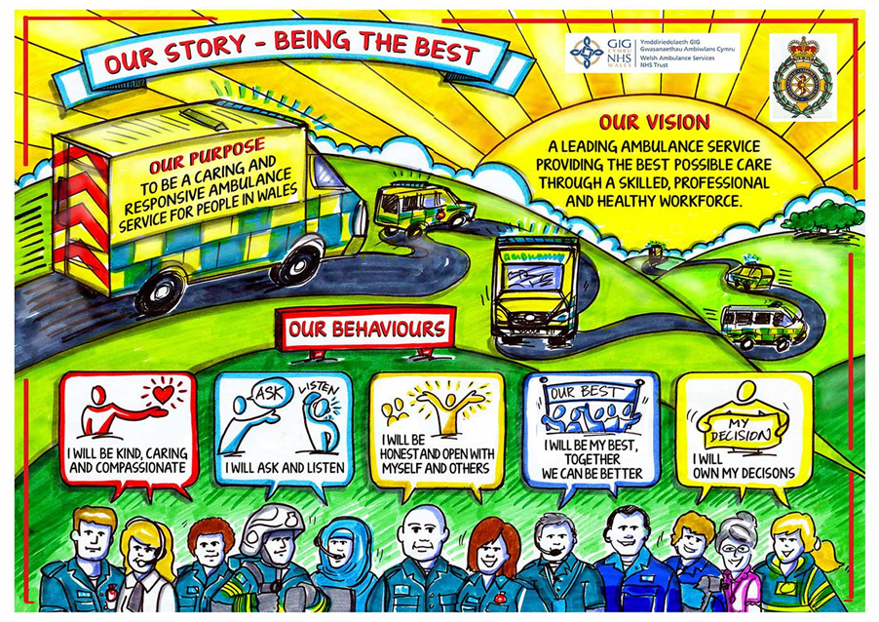
Fig.6 WAST Behaviours (design, 2016)

Appendix B
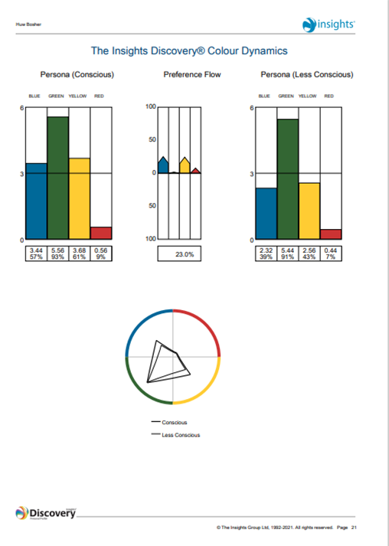

Appendix C
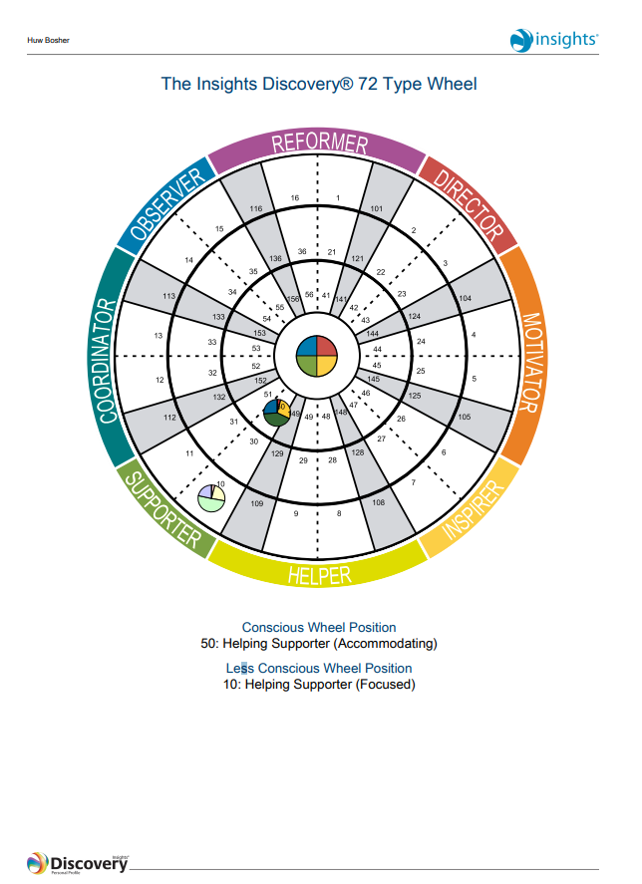

Appendix D
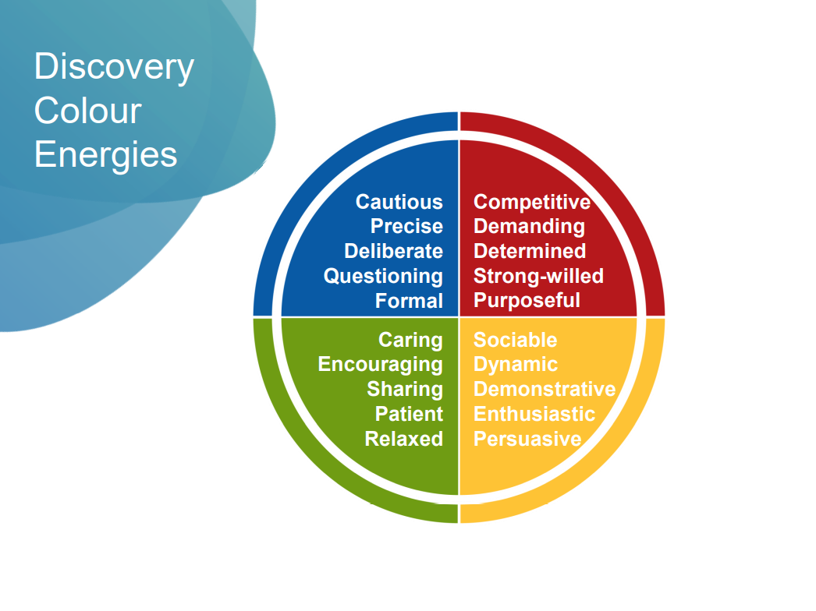
Appendix E
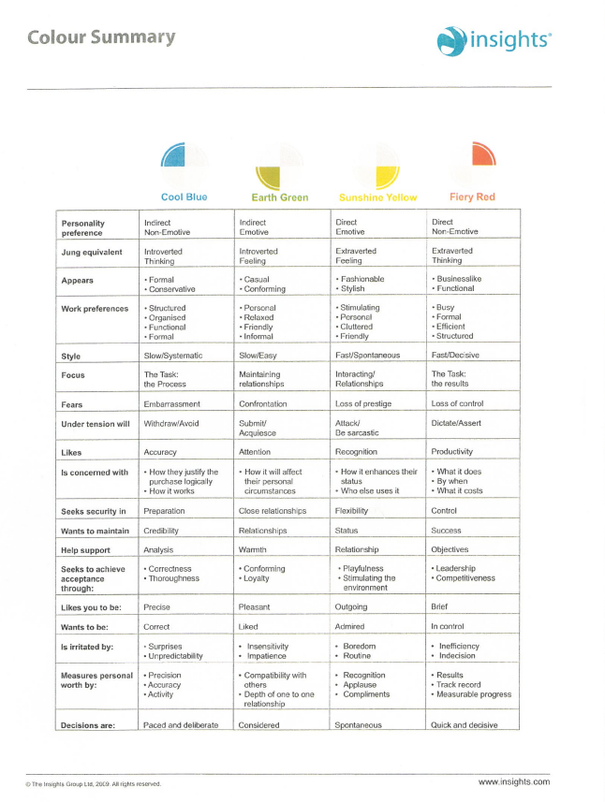
Appendix F
Characteristics of Emotional Intelligence
Psychologist Daniel Goleman identified five elements that make up emotional intelligence. These are:
- Self-awareness.
- Self-regulation.
- Motivation.
- Empathy.
- Social skills.
Terms reproduced by permission of Bloomsbury Press.
Let’s look at how you can develop good skills in each area.
Self-Awareness
(Questions 1, 8, 11)
Your score is 13 out of 15
In his 1995 book "Emotional Intelligence: Why it can Matter More Than IQ," Goleman explained that people with high self-awareness are "aware of their moods as they are having them."
To increase self-awareness , learn about mindfulness . This involves focusing on the present moment – including how you're feeling. And keep a journal in which you write about and analyse the emotional situations you experience from day to day.
You also need to understand your strengths and weaknesses to build self-awareness. Do a personal SWOT analysis , and ask for feedback from your boss, friends, and trusted colleagues to find out how you can improve further.
Self-Regulation
(Questions 2, 4, 7)
Your score is 11 out of 15
Self-regulation is about staying in control. To develop your skills in this area, learn how to manage your emotions effectively.
If you often get angry , note what triggers this feeling, and think about why this happens. Use techniques such as deep breathing to calm yourself down, and give yourself time to pause before you respond to emails or requests, so that you don't say something that you'll later regret. (See our article on anger management to learn more about this.)
You may also be affected by other negative feelings and emotions, such as anxiety and stress . So, do what you can to manage these feelings effectively.
Accountability is another important element of self-regulation. Take responsibility for your actions and behaviours, and make sure that these align with your values .
Motivation
(Questions 6, 10, 12)
Your score is 14 out of 15
Self-motivation is strongly affected by your emotions. When you're distracted by your emotions, you may find it hard to see tasks through.
Boost your motivation levels by developing self-discipline , and by looking for and celebrating small wins – simple jobs that, when you've completed them, give you a sense of achievement.
Also, set yourself longer-term goals . When you decide what you want to achieve, you'll focus on what really matters to you. This can be highly motivating, especially when you connect personal goals with career-related ones.
If you're still struggling to get motivated in your current role, take some time to rediscover your purpose .
Empathy
(Questions 3, 13, 15)
Your score is 12 out of 15
Empathy is the ability to recognize other people's emotions and understand their perspectives. Goleman calls this aspect of EI "the fundamental people skill."
To develop empathy , start by simply thinking about other people's viewpoints. Imagine how they may be feeling and use active listening skills to understand them fully when they express their emotions to you.
Try not to interrupt or talk about your own feelings during the conversation. Look at their body language , too: it can tell you a lot about their emotions. If you watch and listen to others, you'll quickly become attuned to how they feel. (The Perceptual Positions technique can give you a particularly sharp insight into what other people may be thinking and feeling.)
Tip:
If you're a leader, read our article "What's Empathy Got to do With it?" for tips on using empathy in leadership.
Social Skills
(Questions 5, 9, 14)
Your score is 9 out of 15
Even if you're not a natural "people person," it is possible to develop better social skills.
Start by taking our quiz to see which communication skills you need to improve on. Then, find out how you can develop trust and rapport with people – this is an essential part of building good working relationships .
Don't shy away from negative situations, either. Learn how to deal with conflict and other difficult situations effectively.
If you're uncomfortable with social situations, work on building self-confidence . Start slowly, but then look for opportunities to practice your skills with bigger groups. For example, you could offer to attend conferences on behalf of your team.

Appendix G
Communication skills
Score Interpretation
Score | Comment
15-35 | You need to keep working on your communication skills. You are not expressing yourself clearly and you may not be receiving messages correctly, either. The good news is that, by paying close attention to the way in which you communicate, you can improve your effectiveness at work and enjoy better working relationships with your colleagues! The rest of this article will direct you to some great tools for improving your communication skills. (Read below to start.)
36-55 | You're a capable communicator, but you sometimes experience communication problems. Take the time to think about your approach to communication, and focus on receiving messages effectively, as much as sending them. This will help to improve your ability to communicate. (Read below to start.)
56-75 | Excellent! You understand your role as a communicator, both when you send messages and when you receive them. You anticipate problems, and you choose the right channel to communicate. People respect you for your ability to communicate clearly and they appreciate your listening skills. (Read below for more.)
Detailed Interpretation
Whenever you communicate with someone else, you each follow the steps of the Communication Process (see figure 1, below).
Figure 1. The Communication Process
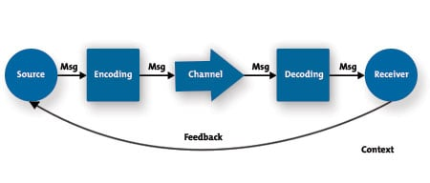
During this process, the person who is the source of the communication encodes it into a message and transmits it through a channel. The receiver decodes the message, and, in one way or another, feeds back his or her understanding or a lack of understanding to the source.
By understanding the steps in the process, you can become more aware of your role in it, recognize what you need to do to communicate effectively, anticipate problems before they happen, and improve your overall ability to communicate effectively.
The sections below help you do this and improve the way that you communicate at each stage of the process.
The Source – Planning Your Message
(Questions 2, 11)
Your score is 4 out of 10
Before you start communicating, take a moment to figure out what you want to say, and why. Don't waste time conveying information that isn't necessary – and don't waste the listener or reader's time either. Too often, people just keep talking or writing because they think that by saying more, they'll surely cover all the points. Often, however, all they do is confuse the people that they're talking to.
To plan your communication :
- Understand your objective. Why are you communicating?
- Understand your audience. With whom are you communicating? What do they need to know?
- Plan what you want to say, and how you'll send the message.
- Seek feedback on how well your message was received.
When you do this, you'll be able to craft a message that will be received positively by your audience.
Good communicators use the KISS ("Keep It Simple and Straightforward") principle. They know that less is often more, and that good communication should be efficient as well as effective.
Encoding – Creating a Clear, Well-Crafted Message
(Questions 1, 5, 8, 10, 15)
Your score is 16 out of 25
When you know what you want to say, decide exactly how you'll say it. You're responsible for sending a message that's clear and concise. To achieve this, you need to consider not only what you'll say, but also how you think the recipient will perceive it.
We often focus on the message that we want to send, and the way in which we'll send it. But if our message is delivered without considering the recipient's perspective, it's likely that part of that message will be lost. To communicate more effectively:
- Understand what you truly need and want to say.
- Anticipate the other person's reaction to your message.
- Choose words and body language that allow the other person to really hear what you're saying.
With written communication , make sure that what you write will be perceived the way you intend. Words on a page generally have no emotion – they don't "smile" or "frown" at you while you're reading them (unless you're a very talented writer, of course!)
When writing, take time to do the following:
- Review your style.
- Avoid jargon or slang.
- Check your grammar and punctuation.
- Check also for tone, attitude, nuance, and other subtleties. If you think the message may be misunderstood, it probably will. Take the time to clarify it!
- Familiarize yourself with your company's writing policies or style guides.
Another important consideration is to use pictures, charts, and diagrams wherever possible. As the saying goes, "a picture speaks a thousand words." Our article on charts and graphs has some great tips that help you to use these to communicate clearly.
Also, whether you speak or write your message, consider the cultural context . If there's potential for miscommunication or misunderstanding due to cultural or language barriers, address these issues in advance. Consult with people who are familiar with these types of barriers and do your research, so that you're aware of problems you may face. See our article on Effective Cross-Culture Communication for more help.
Choosing the Right Channel
(Questions 7, 11, 13)
Your score is 13 out of 15
Along with encoding your message, you need to choose the best communication channel to use to send it. You want to be efficient, while also making the most of your communication opportunity.
Using email to send simple directions is practical. However, if you want to delegate a complex task, an email will probably just lead to more questions, so it may be best to arrange a time to speak in person. And if your communication has any negative emotional content, stay well away from email! Make sure that you communicate face to face or by phone, so that you can judge the impact of your words and adjust your message appropriately.
When choosing the right channel for your message, consider the following:
- The sensitivity and emotional content of the subject.
- How easy it is to communicate detail.
- The receiver's preferences.
- Time constraints.
- The need to ask and answer questions.
Decoding – Receiving and Interpreting a Message
(Questions 3, 6, 12, 14)
Your score is 14 out of 20
It can be easy to focus on speaking: we want to get our points out there, because we usually have lots to say. However, to be a great communicator, you also need to step back, let the other person talk, and listen.
This doesn't mean that you should be passive. Listening is hard work, which is why effective listening is called active listening . To listen actively, give your undivided attention to the speaker:
- Look at the person.
- Pay attention to his or her body language.
- Avoid distractions.
- Nod and smile to acknowledge points.
- Occasionally think back about what the person has said.
- Allow the person to speak, without thinking about what you'll say next.
- Don't interrupt.
Empathic listening also helps you decode messages accurately. To understand a message fully, you have to understand the emotions and underlying feelings that the speaker is expressing. This is where an understanding of body language can be useful.
Feedback
(Questions 4, 9)
Your score is 7 out of 10
You need feedback, because without it, you can't be sure that people have understood your message. Sometimes feedback is verbal, and sometimes it's not. We've looked at the importance of asking questions and listening carefully. However, feedback through body language can also help you to assess the impact of your message. By watching the facial expressions, gestures, and posture of the person you're communicating with, you can spot:
- Confidence levels.
- Defensiveness.
- Agreement.
- Comprehension (or lack of understanding).
- Level of interest.
- Level of engagement with the message.
- Truthfulness (or lying/dishonesty).
As a speaker, understanding your listener's body language can give you an opportunity to adjust your message and make it more understandable, appealing, or interesting. As a listener, body language can show you more about what the other person is saying. You can then ask questions to ensure that you have, indeed, understood each other. In both situations, you can better avoid miscommunication if it happens.
Feedback can also be formal. If you're communicating something really important, it can often be worth asking questions of the person you're talking to make sure that they've understood fully. And if you're receiving this sort of communication, repeat it in your own words to check your understanding.
Key Points
It can take a lot of effort to communicate effectively. However, you need to be able to communicate well if you're going to make the most of the opportunities that life has to offer.
By learning the skills, you need to communicate effectively, you can learn how to get your ideas across clearly and effectively and understand much more of the information that's conveyed to you.
Whether you're a speaker, a listener, a writer, or a reader, you are responsible for making sure that messages are communicated accurately. Pay attention to words and actions, ask questions, and watch body language. These will all help to ensure that you say what you mean and hear what is intended.

Appendix H
Personal Development Plan
Area for improvement | Completion date | Where I am now: | I will achieve this by: | How I will measure success: | Progress:
 |  | Dislike confrontation | Improving communication | Increased confidence
Assertiveness | Dec-22 | Avoid delegating tasks | Increasing staff CPD sessions | Team feedback
 |  | Defensive when challenged | Partake in ops commander CPD | successful completion of NARU and JESIP
 |  | Provide too much detail | Partake in ops commander CPD | Team feedback
Communication | Dec-22 | Provide unnecessary chatter | Increasing staff CPD sessions | Team participation
 |  | Not structured content | Practice scenarios | Smooth running of cardiac arrest
 |  | Good standards | Enrolling on clinical degree | Achieving degree
Clinical knowledge | Aug-23 | Paramedic NVQ level 4 | Partake in training courses | Increased confidence
 |  | Maintained CPD | Maintain CPD

.

