Hotel Placement- Hotel Administration & Front Desk
Forest of Arden Marriot Hotel & Country Club
Department: Housekeeping
M401920_BIRM
Mubaraca Mombassa- 1905613
Week: 1 & 2
Work Undertaken
- Introduction to Housekeeping/Attend HKP morning meeting
- Housekeeping Marriott Brand standards (Guest access, lost key, do not disturb, lost & found...)
- Explanation Housekeeping checklist
- Training Housekeeping Trolley (stock)
- Linen Room Procedures
- Guest amenities ( Bathroom, coffee/tea, Standard – notepad/pen, Bible, TV& Channels, phone, lighting, iron/board, hairdryer and heat/Ac)
- Meeting with Manager
- Linen – Rejects/Dirty Linen procedures
- Public Area evening sheet
- Evening Public Area Daily Checklist
- Request/Additional Tasks ( Vac121-125 daily)
- Vac stairs from reception to first floor colonnade
- Lift to be checked and cleaned regularly
- Vac entrance mat in reception
- Clean the cluster office by 117
Self – Appraisal
Strengths:
Last two weeks when I started the cleaning service at the Marriott hotel, I had no idea how much one should appreciate the quality of work offered at the Forest of Arden Marriott hotel. The duties and responsibilities in standard hotels like Marriott. Is the proportion of a maid for 16 rooms, which shows how hard and responsible your standard is. Leaving the room organized, changing the bedding, bathroom and replacing supplies are some basic functions that I learned and should happen regularly.
At first, it was complicated and difficult to clean following the program and schedule of the Hotel, but with Vanessa's help, it was possible to overcome my fears and improve the quality of the work done there day by day. For example jobs like:
.The carpet was in excellent repair and cleaned
• Furnishing, chairs, and tables was free of spots, dust, stains, and marks and cleaned.
• Ledges and baseboards were in good condition and free of dust.
• Lamp fixtures, decorative objects were free of dust
• Drawers inside were free of dust
• Picture frame glass was free of spots and dust on frames
• All mirror glass was undamaged, free of streaks and dust
• TV LCD/LED screen was free of streaks, spots, all wires, and cords were orderly hidden behind the furnishing
• Bed tightly and neatly made.
• Mattress and box springs were aligned
• Bedspread and skirting were in good condition, not worn, free of stains, hair, and debris.
• Bed sheets were in good condition, not worm or damage, free of stains.
• Sufficient supplies were provided
• Pillowcases were in good worn or damaged, free of stains.

In the second week my work it was continuing doing some tasks at the housekeeping department and work in Public areas. I learned and gained more skills such as using Hoover, swept floor, mop floor, clean sinks, and all surfaces. Cleaning mirrors, clean toilets, stock all tissue papers, clean PHS bins, clean baby change unit, clean hand dryer and finally check all toilets after two hours Upper conference – Ladies & Men, Reception toilets – Ladies & Men, and Zest toilets – Ladies & Men). Working with Janice and Beata was amazing and helpful.
Weaknesses:
My difficulties were related to how to make beds following the rules of the Hotel and more quickly. I didn’t know how to put bed sheets, Mattress and box springs if was aligned but this was soon resolved when I got given a sheet with all procedures and saw how to do. I also didn’t know how to put in order all supplies of bathroom following the standard of Marriott. However, my solution to this is just to have more attention, take pictures and notes to learn how to do properly. In addition, the cleaning service must always be programmed respecting the privacy of the guests, as soon as requested.

Lost Opportunities
After two weeks of work in the cleaning department, my satisfaction is good and the professionals I worked with were fantastic and always attentive to me. I intend to book an extra week with the manager of housekeeping when can I get Towel Art training.
Plan for next week
- Continue improving in all basic and functions at housekeeping
- Search to be so faster, changing the bedding, and bathroom cleaner
- Next week I intend to book a meeting with Cast iron Restaurant manager
- Book an extra week with Housekeeping manager to have Towel art training.

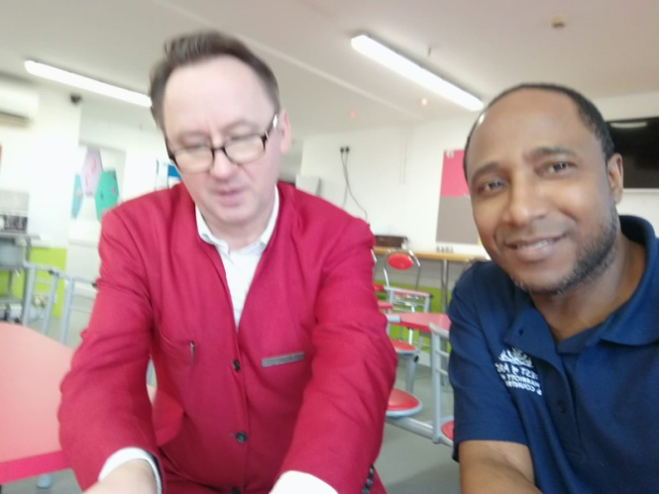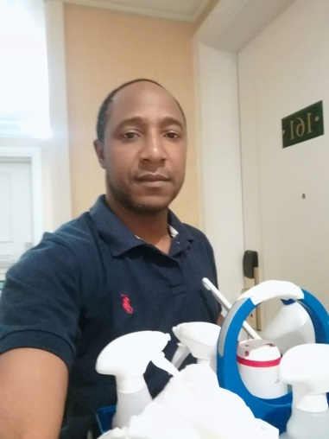
Red jacket Stefan Housekeeping
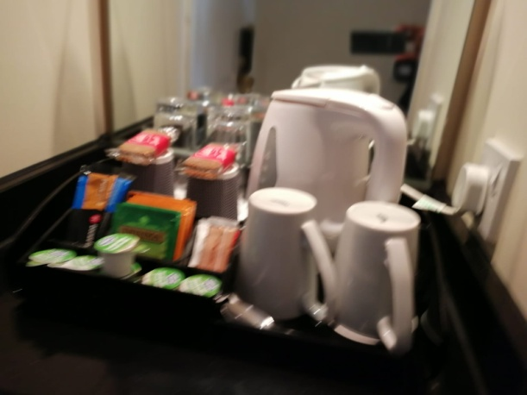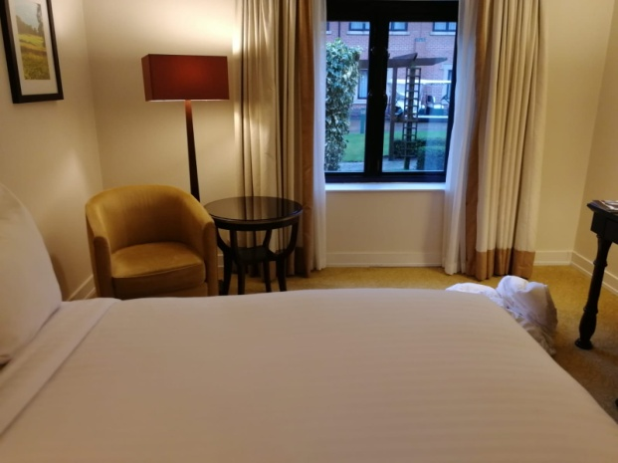
Amenities NK (king size Room)
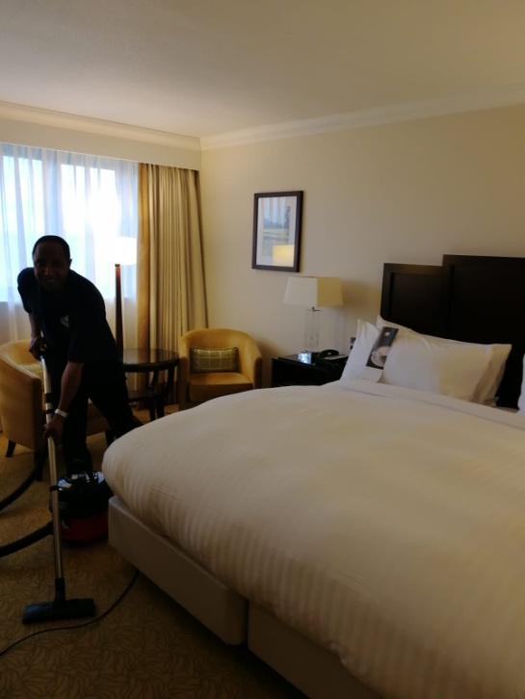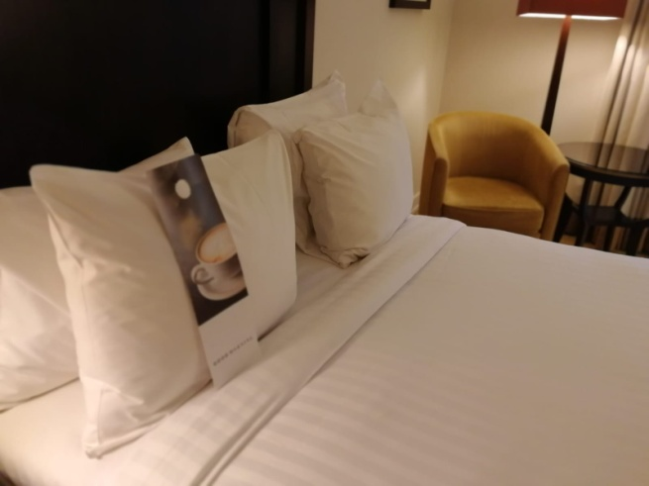
Working with the vacuum cleaner
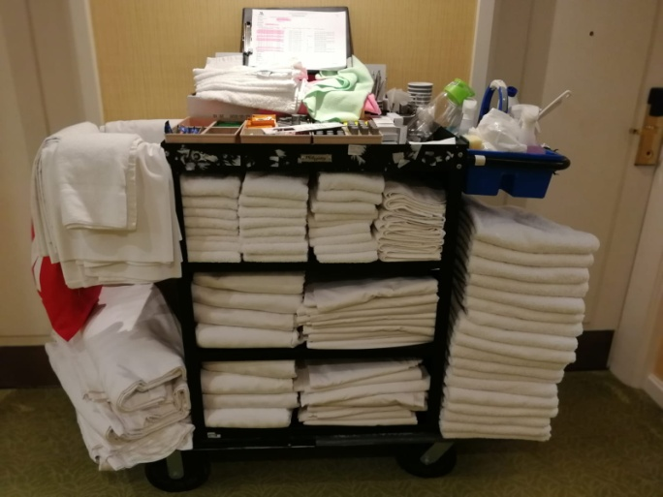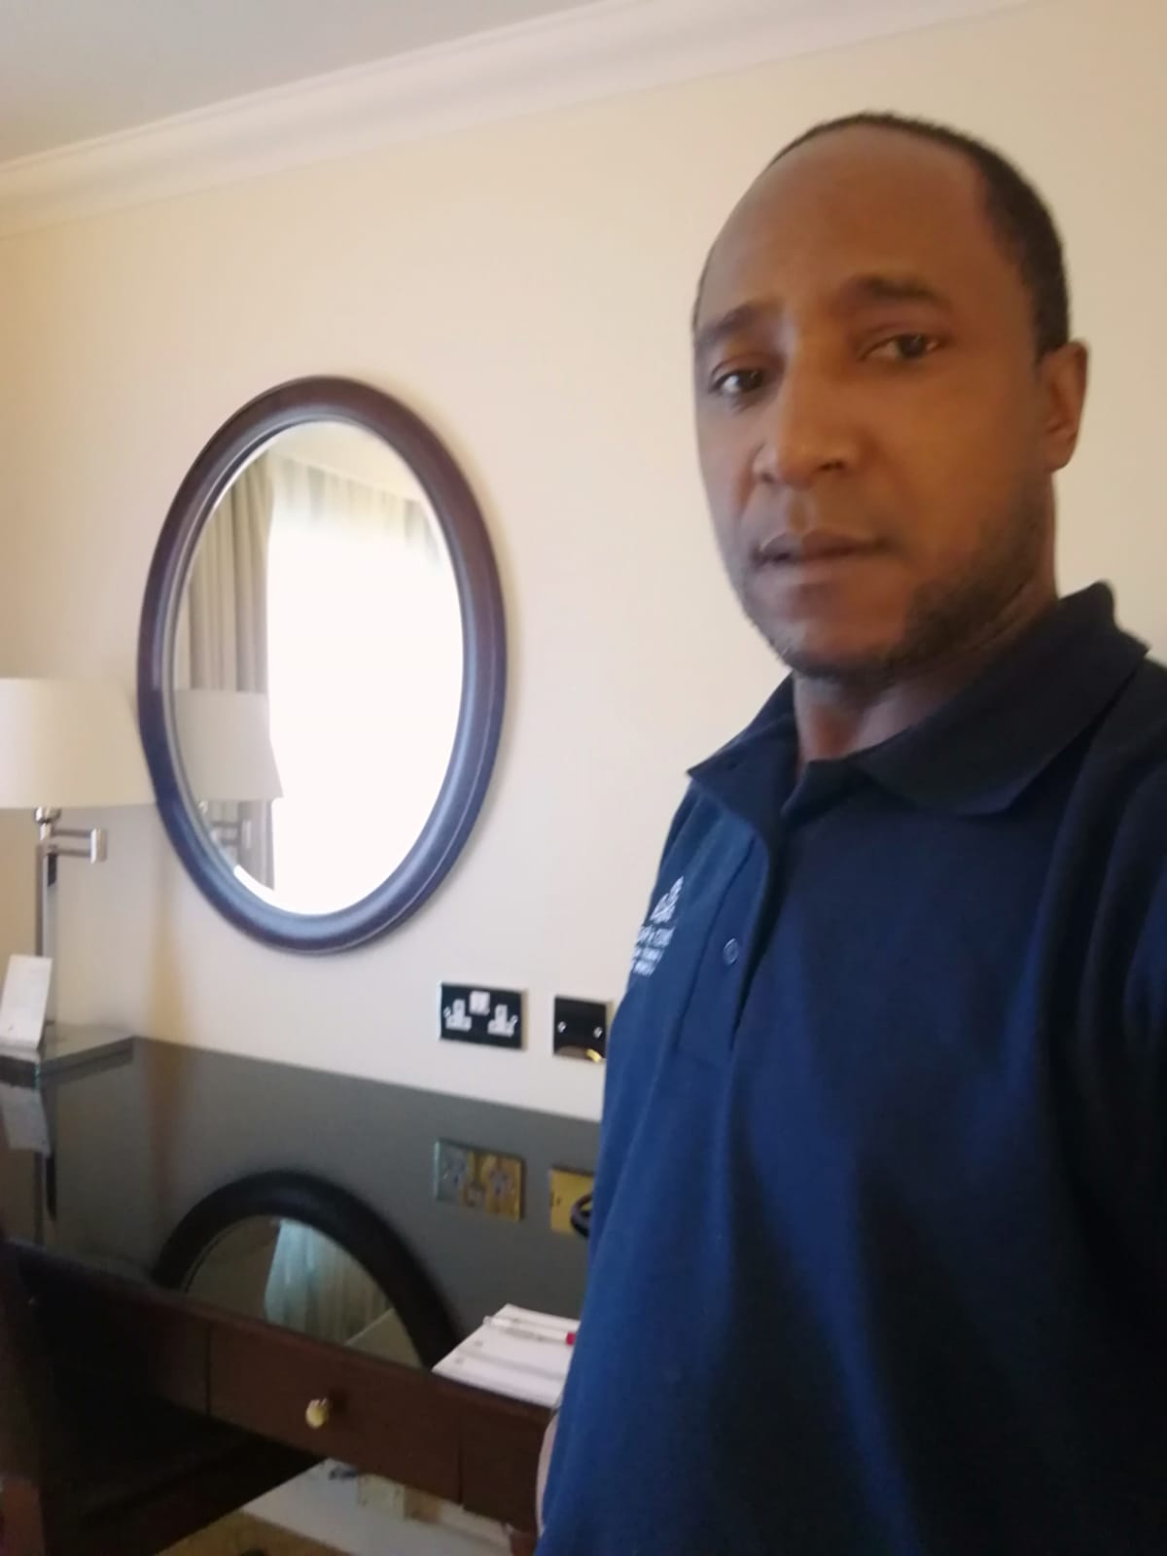
Trolley

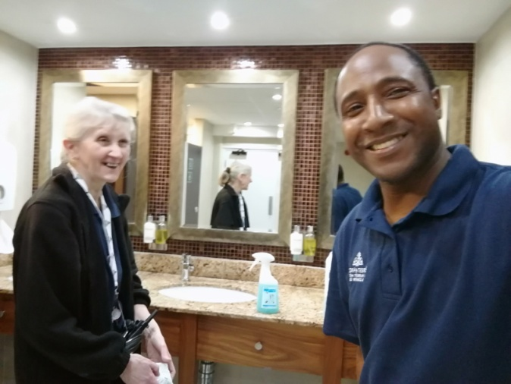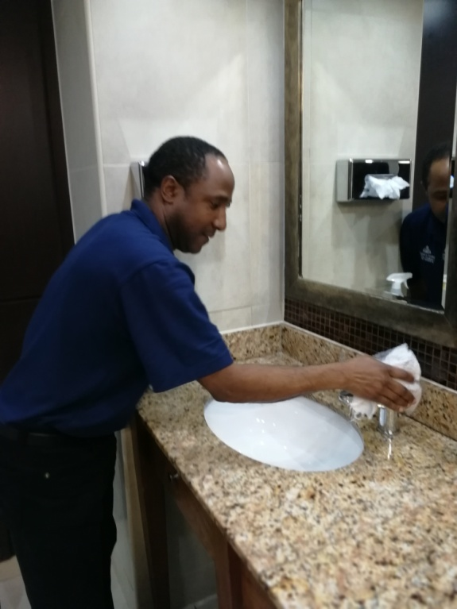
Public Area
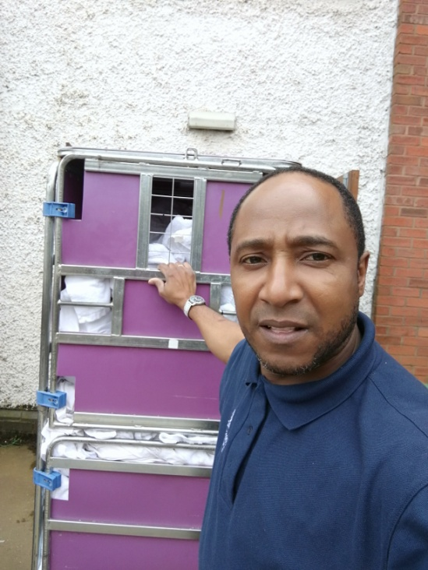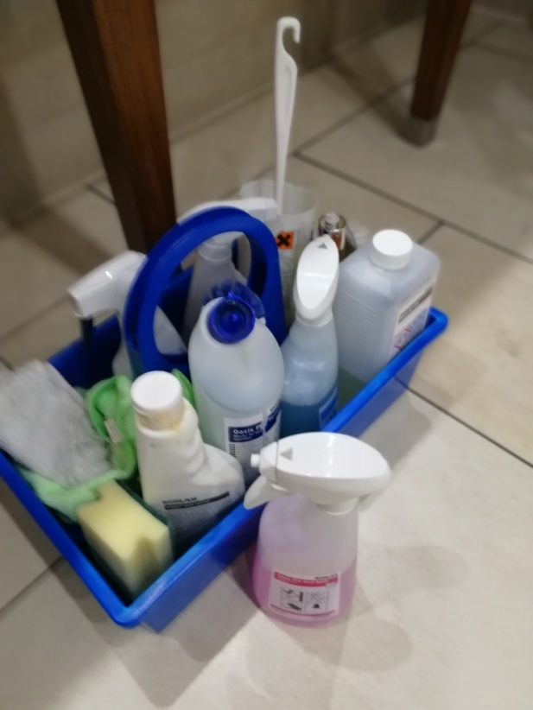
Laundry area Items used at toilets
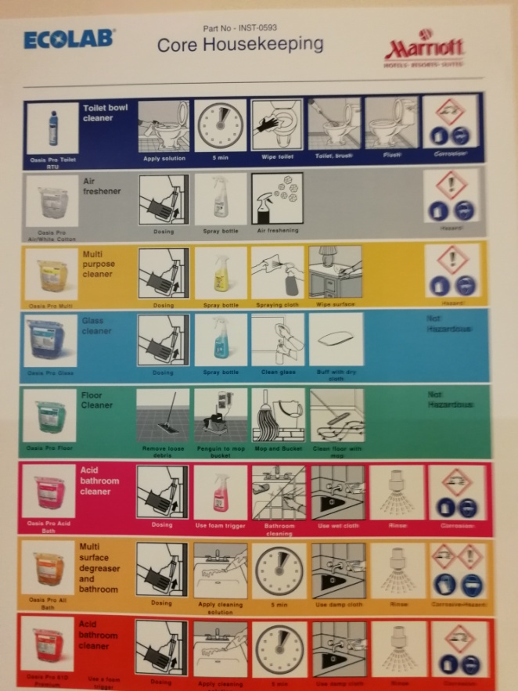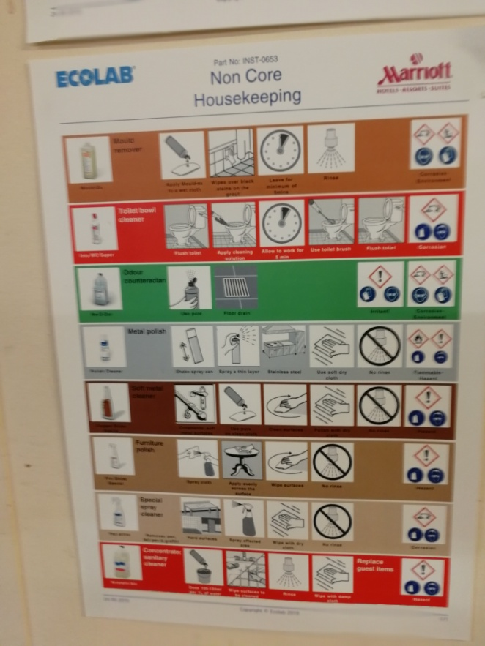
Detergent used at Marriott Hotel

