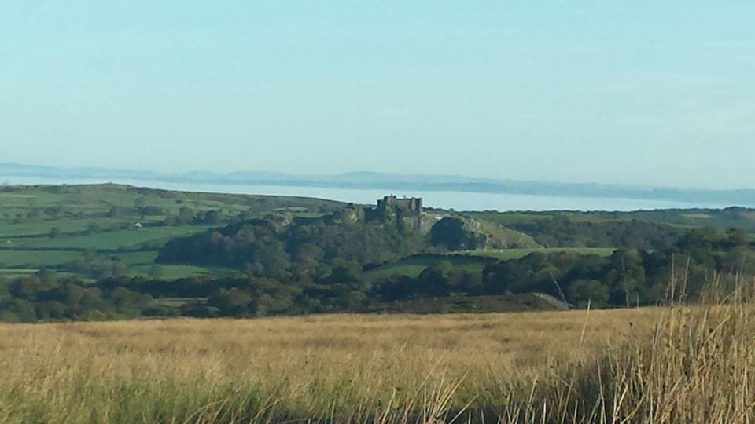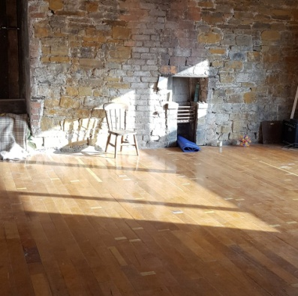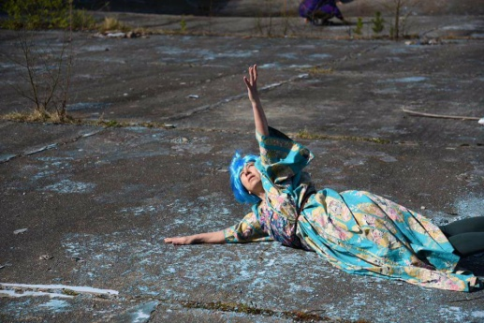

Spring Escarpment – A One day Dance/ Movement Workshops

with Jess Lerner Visual Movement Artist
April 28 2018 10.30am -4pm
At Jessica’s movement studio, 35 Station Rd, Brynaman Sa18 1SH and on the nearby Mynydd Du - Black Mountain.
In this workshop we will engage with a large terrain of Mountain on the Southern end of the Brecon Beacons National Park. Corresponding with Its changing weather and reflecting within a warm purpose built studio.
Situated within my home, I am grateful to share this new resource with you to launch this as a movement research venue.
The vast open and sometimes harsh but also generous and empathic mountain landscape offers a labyrinth of imaginative possibilities.
We will be using movement improvisation techniques towards connecting with the body movement and breath in our own time and space. Then I will introduce some ways in to experience others movement and presence.
My interest and enquiry in working with the mountain is to dance across distance, engaging with an ancient site where levels of visibility and relationship are explored and dancing takes on a wider variety of meanings. We use forms to hold or witness the movement of life in this particular landscape.
Throughout the day there will be opportunities to speak about your experiences as well as engaging and processing through writing and drawing.
http://www.axisweb.org/p/jessicalerner/ or https://www.facebook.com/Jessica-Lerner-Visual-Movement-Artist-621457164651960/ "
Cost: Early Bird before April 1st £5 off £40-£30 sliding scale Details will be email to you.
For more information and to book, telephone 01269 820731 jesslerner66@gmail.com
There s accommodation available at a low cost.

