Coursework Title
Module Name: Computer Architecture and Operating Systems
Module Code: ACCA4022
Name: Saman koiek
Student ID:2523416
Lecturer Name: Dr Md Shantanu Islam

Submission date: 19/07/2026

Contents
Introduction 4
Key functions of a general operating system 4
Task Management: 4
Application/Program Management: 5
File/Directory Management: 5
Device Management: 6
Security Management: 7
Use of Windows OS CLI commands 7
Example 1: 8
Example 2: 8
Example 3: 9
Example 4: 9
Example 5: 10
Example 6: 10
Example 7: 11
Example 8: 11
Example 9: 12
Example 10: 12
Example 1: 13
Example 3: 14
Example 4: 15
Example 5: 15
Example 6: 16
Example 7: 16
Example 8: 17
Example 9: 17
Example 10: 18
Use of Windows OS scripts 18
Example 1: 18
Example 2: 19
Use of Linux OS scripts 20
Example 1: 20
Example 2: 21
Conclusion 22
References 23
Appendices 24

Introduction
This report explores operating systems, focusing on Microsoft Windows and Linux. It covers how they manage tasks, applications, files, devices, and security. It highlights command-line interfaces, demonstrates commands and outputs, and introduces scripting techniques such as Windows batch and Linux Bash for automating tasks. The coursework combines theory with practical command-line activities essential for administration and troubleshooting, using examples, screenshots, and analysis. It underscores the importance of understanding core OS operations to build technical skills and advance in computing.

Key functions of a general operating system
Microsoft Windows is a widely used graphical operating system first introduced by Microsoft in 1985. It is important because it provides a user-friendly interface and manages hardware, software, files, users and security [1]. Modern Windows systems support multitasking, networking, device control and command-line administration.

Task Management:
Task management in Windows controls programs, background processes, and system services by allocating resources such as CPU and memory, thereby enabling multitasking. Task Manager shows active processes, usage stats, and allows ending unresponsive programs, aiding troubleshooting and performance maintenance [2]. Effective management keeps Windows stable, responsive, and productive.
Figure 1

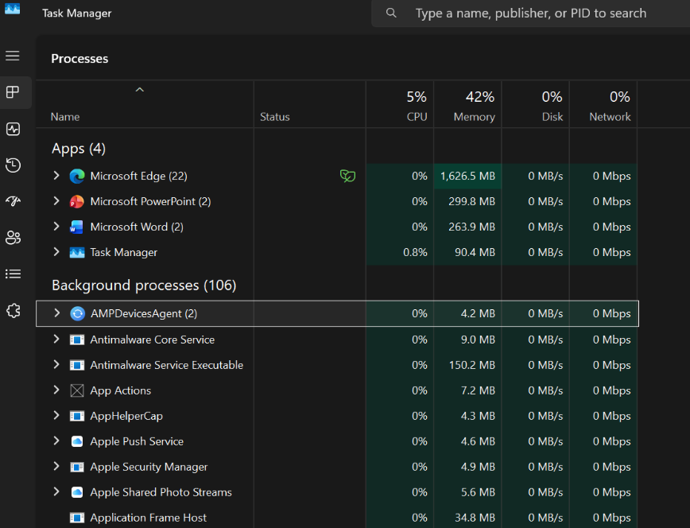

Application/Program Management:
Application management in Windows involves installing, updating, running, and removing software safely using tools like Settings, Control Panel, Microsoft Store, and Task Manager. Windows loads applications into memory, manages access to files and hardware, and isolates processes to prevent damage. Users can set default apps, repair, install software, and manage startup programs. This ensures software functions correctly and maintains system performance and reliability [3].
The screenshot shows how Windows displays installed applications for managing storage, settings, and system efficiency. According to Microsoft, Windows offers user-friendly interfaces and tools to simplify program management and increase productivity.
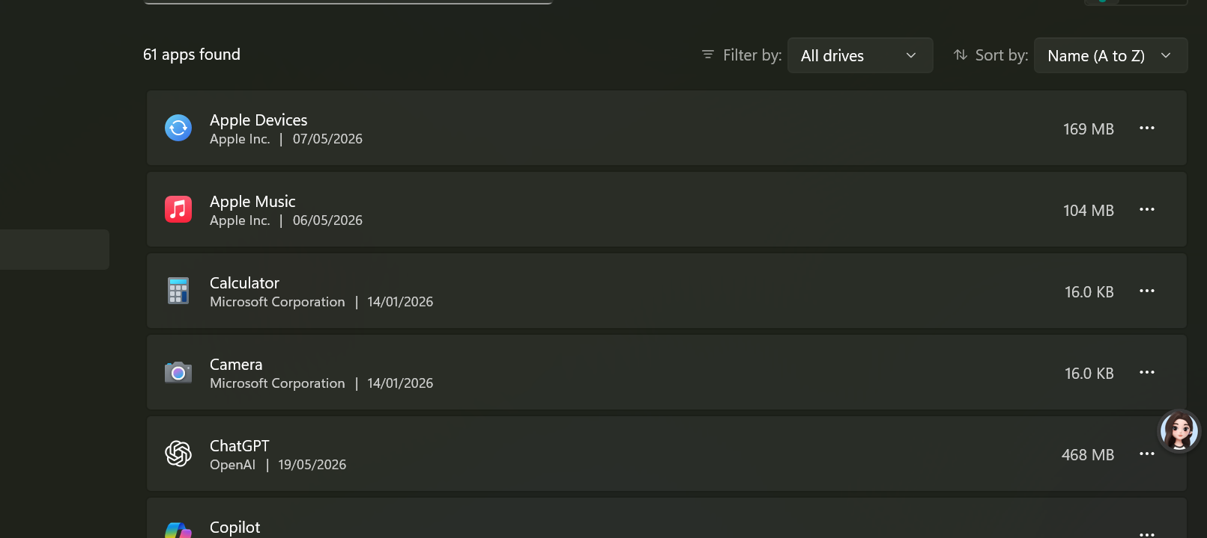
Figure 2

File/Directory Management:
File and directory management in Windows enables users to create, store, organise, rename, copy, move, and delete files and directories. File Explorer offers a graphical way to browse drives, folders, and files, while Command Prompt and PowerShell perform the same tasks via commands. Windows uses file systems like NTFS to manage permissions, metadata, and storage. Directories group related files for easier access. Good management boosts productivity, secures data, and controls access.
The screenshot shows the Installed Apps interface, where users manage software, check installation details, and free disk space. This helps control file hierarchy and resources, improving system stability and productivity. Microsoft states that Windows provides both graphical and command-line options for thorough file and directory management [4].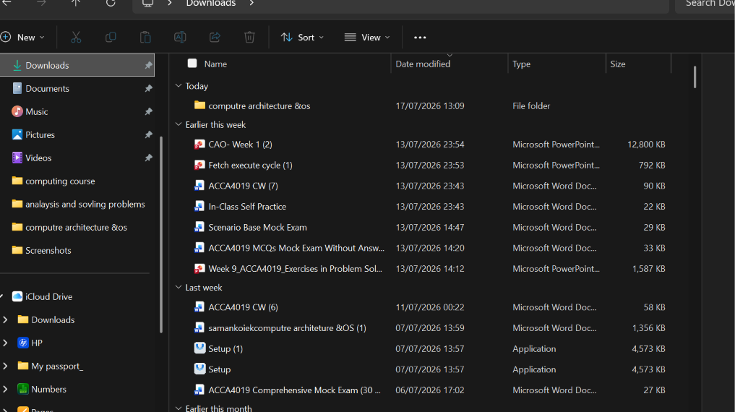

Figure 3

Device Management:
Device management in Windows controls hardware like keyboards, printers, displays, drives, network adapters, and sound cards. Windows uses device drivers for communication between OS and hardware [5]. Device Manager is key for viewing devices, updating drivers, disabling hardware, uninstalling devices, and checking errors [6]. Faulty or outdated drivers can cause hardware issues or system instability. Proper device management ensures hardware is recognised, configured, and functioning correctly.
This screenshot shows Windows Device Manager, the tool used to view and control all connected hardware components. The open properties window confirms that the HP IR Camera is correctly recognised and functioning without errors. This utility helps users check device status, update drivers, troubleshoot issues, and ensure hardware works properly with the operating system.

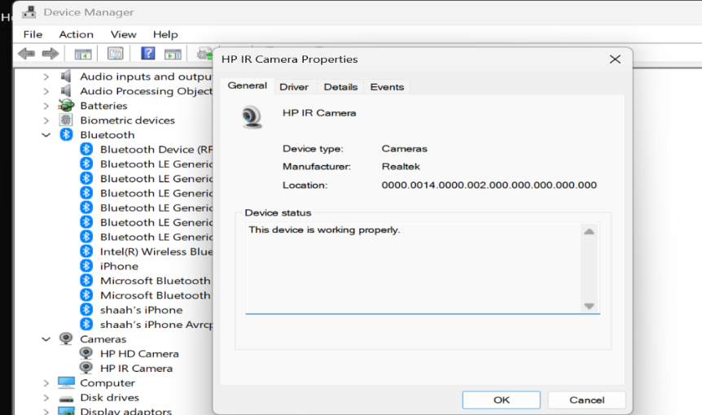

Figure 4:

Security Management:
Security management in Windows protects the computer, user accounts, files and network connections from unauthorised access and malware. Windows includes security features such as user accounts, passwords, permissions, Windows Defender, firewall settings, encryption and update management [7]. Administrators can control access rights, so users can only use the resources they are authorised to use. Regular updates fix known vulnerabilities and improve protection. Security management is essential because operating systems store personal data, run important applications and connect to networks where threats may exist.

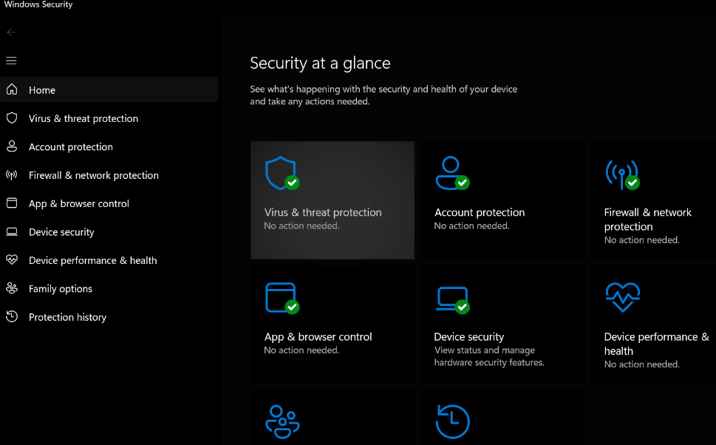
Figure 5

Use of Windows OS CLI commands
The Windows Command-Line Interface allows users to communicate directly with the operating system by typing commands. Command Prompt and PowerShell can manage files, folders, networks, users and system settings [8]. CLI tools are useful for troubleshooting, automation and administration because commands can be repeated in scripts.

Example 1:
The dir command lists all files and directories in the current folder. The output shows names, creation dates, and available disk space, helping users navigate and manage their file system.
Command executed: dir in C:\Users\shaah, the Windows directory. Drive info shows Drive C (labelled Windows) with serial number 28FC-A9B4. The directory contains 15 subdirectories (no files), including typical user folders such as Apple, Contacts, Documents, Downloads, Favourites, iCloud Drive, iCloud Photos, Links, Music, OneDrive, Saved Games, Searches, Videos. Free space available is 397.28 GB. Timestamps indicate most folders were created or modified between January and June 2026.
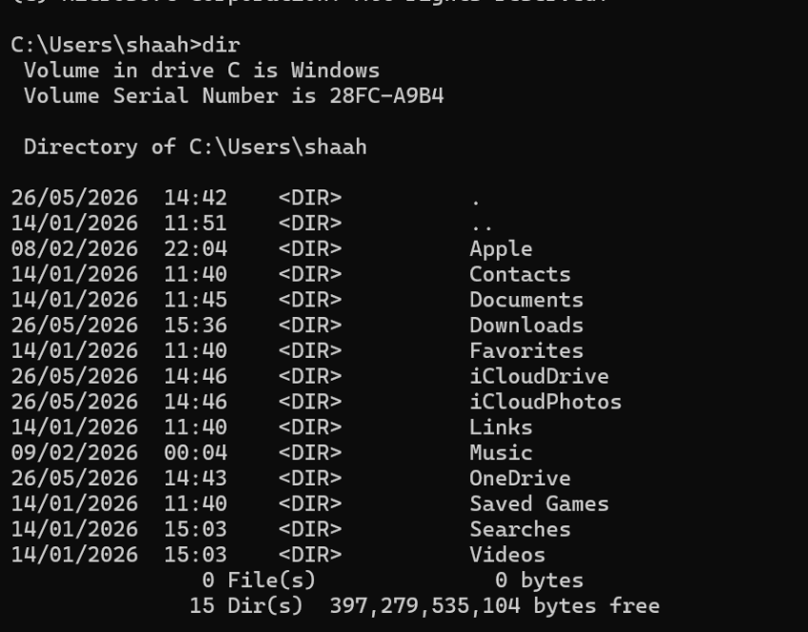
Figure 6

Example 2:
I ran mkdir folder to create a new folder named folder in C:\Users\shaah\Contacts.
Then ran dir to list the folder’s contents. The output confirms that the new folder was created alongside an existing folder named new; there are no files in it, and 397 GB of space remains free on the C: drive. 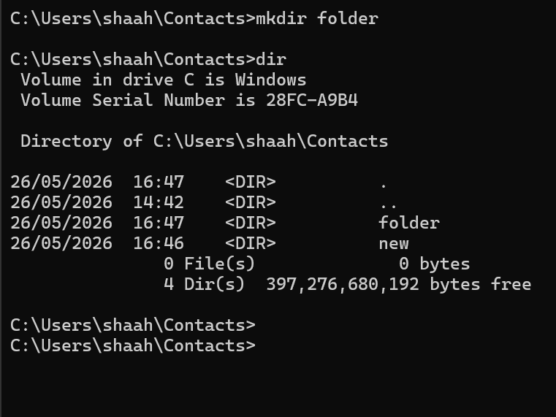

Figure 7

Example 3:
The commands mkdir and rmdir are used to create and remove folders. The output confirms whether a new directory was added or an existing one was deleted at the chosen location.
Adding or removing folders
First, the dir command lists the contents of C:\Users\shaah\Contacts, showing 2 existing folders, a folder named new, 0 files, and roughly 397.28 GB of free space.
Next, the rmdir new command deletes the new folder. Running dir again confirms this, showing only 2 folders remaining and a small increase in available free space.
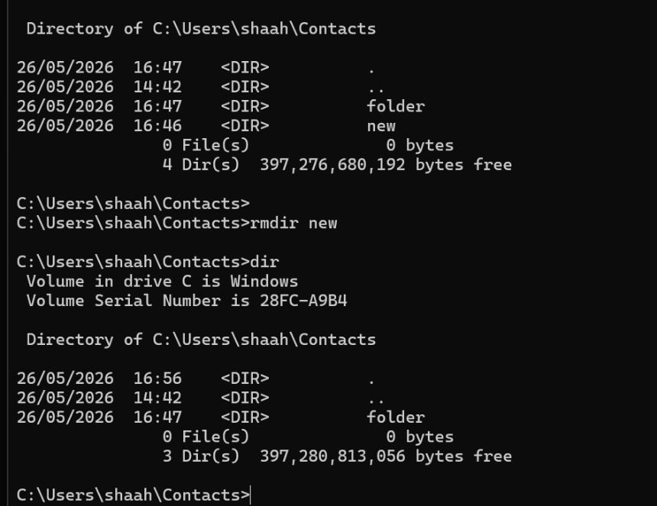
Figure 8

Example 4:
The echo "this is Saman" > new.txt command creates a new text file named new.txt and writes the text this is Saman into it. The dir command then confirms the file was successfully created, showing it listed in the folder with a size of 18 bytes.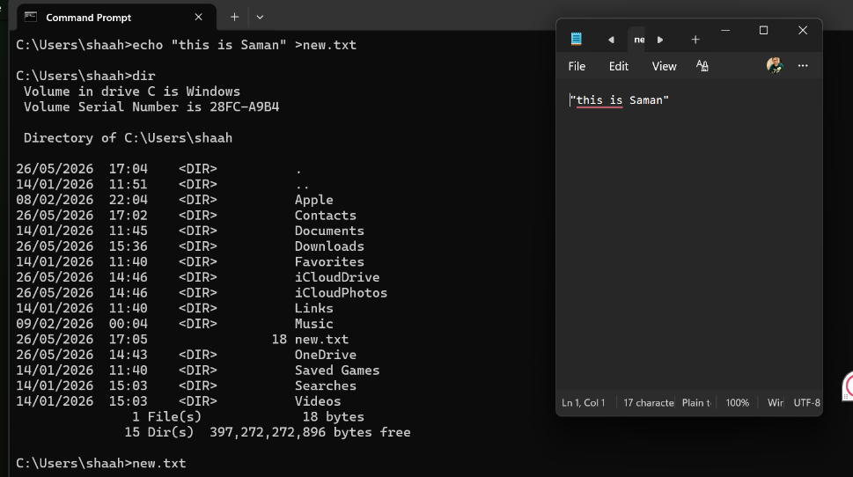

Figure 9

Example 5:
I tested the arp -a command, which lists all devices on my local network, showing their IP addresses, unique hardware (MAC) addresses, and connection types, with 192.168.0.1 being my router. The netstat -ano command displays active network connections and the ports my computer is using, including listening ports and their associated Process ID (PID) numbers. Together, these commands let me see which devices are connected to my network and what network activity my PC is engaged in.
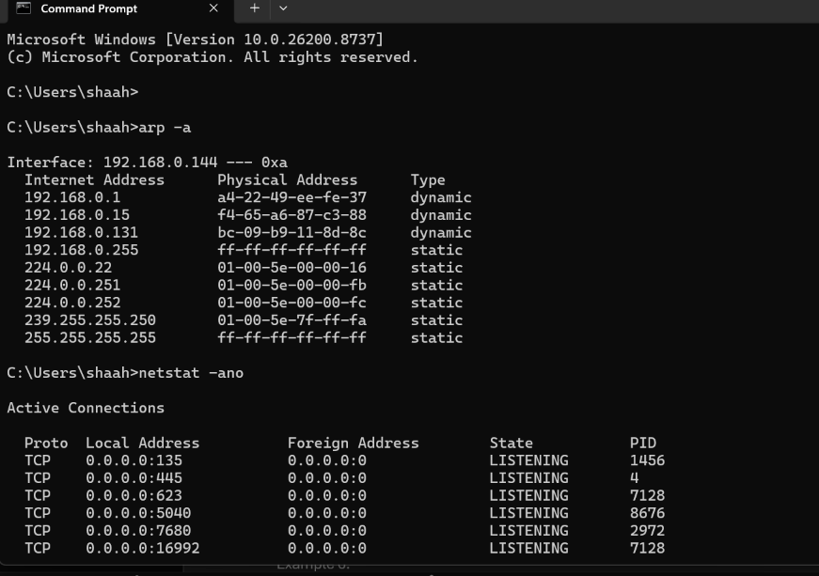
Figure 10

Example 6:
I used the sfc /scannow command, which launches the System File Checker, which scans all protected Windows system files for corruption, missing data, or errors. In this result, the scan completed successfully and found damaged files, which it repaired automatically. It also notes that full details of the scan and fixes are saved in a log file for later review if needed.
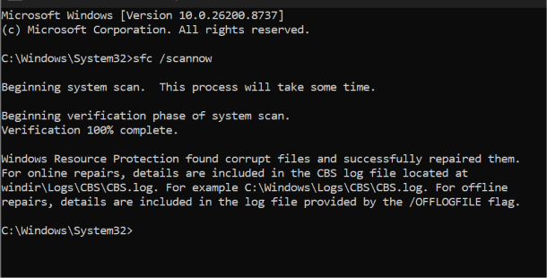

Figure 11

Example 7:
The command ping tests network connectivity to another device or website. The output shows replies, response times and packet loss information.
I have tested the ping google.com command, which tests connectivity to Google’s server by sending 4 small data packets. It shows all replies were received successfully, with response times between 18ms and 20ms and no data lost. The summary confirms a stable connection, with an average response time of 19 milliseconds.
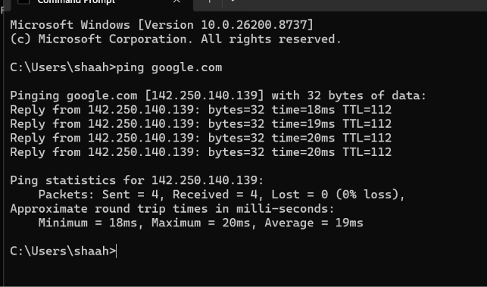
Figure 12

Example 8:
The tasklist command lists all programs and services currently running on my Windows system. It displays key details for each process, including its name, unique Process ID (PID), session type, and the amount of memory it uses. This output helps me monitor system activity, identify resource-heavy tasks, and manage running applications.
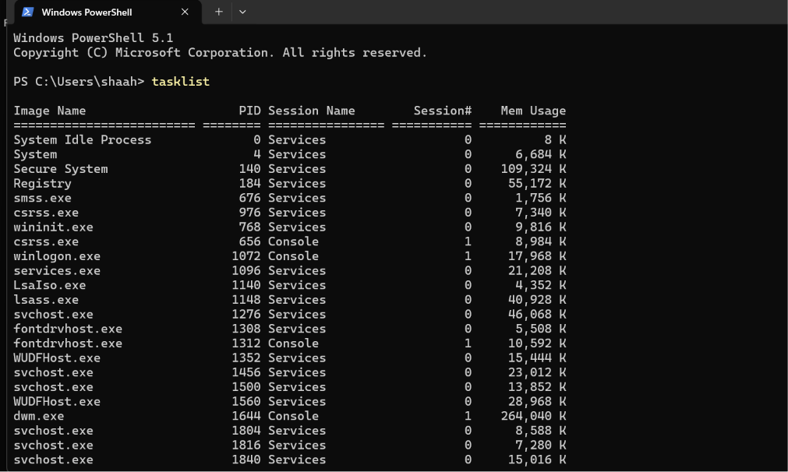

Figure 13

Example 9:
The systeminfo command displays detailed configuration and hardware information for my Windows computer. It shows key details such as the operating system version, computer model, processor, memory size, install date, and system boot time. This output gives a complete overview of my system’s specifications and setup in one place.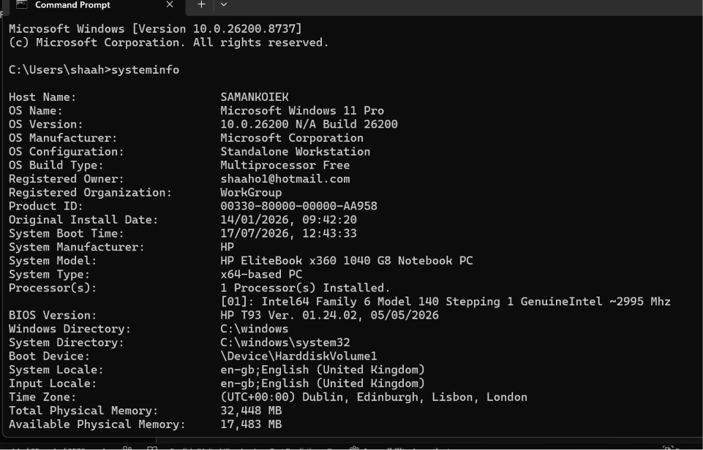
Figure 14

Example 10:
The driver query command lists all device drivers installed by the Windows system. It shows each driver’s filename, display name, type (here, mostly kernel-level drivers that interact directly with hardware), and the date it was added or updated. This output confirms that my laptop's hardware components are recognised and that the required software is installed to operate correctly.
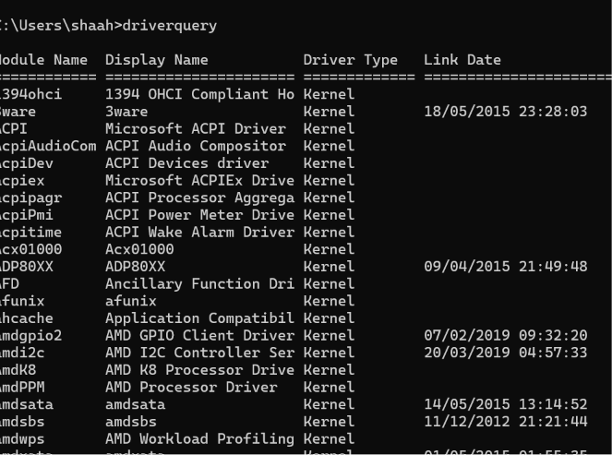

Figure 15
Use of Linux OS CLI commands
The Linux command line interface allows users to manage the operating system using text commands. It is commonly used for file management, permissions, software installation, process control and networking. Linux CLI is powerful because commands can be combined, automated and used remotely through terminals. [9].

Example 1:
The su command in Linux is used to switch from one user account to another, most commonly to gain administrative privileges from the root user back to the regular sysadmin account. This tool lets the user change their identity within the same terminal window without fully logging out.
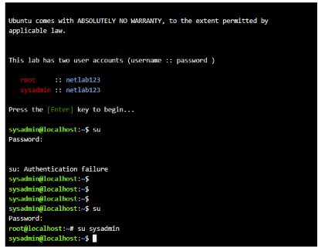

Figure 16
Example 2:
The ls -a command lists all items in the current folder, including hidden files and folders whose names start with a dot. The ls -l command displays detailed information in a long format, showing permissions, owner, size, and modification date for each visible item. Finally, ls -la combines both options to show a full, detailed list of all files and folders, including hidden system and configuration files.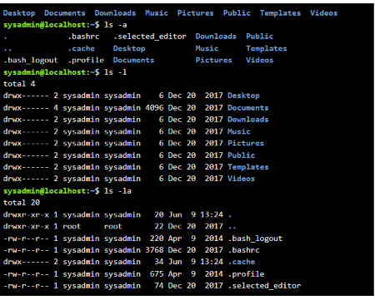
Figure 17: Description

Example 3:
The cd Desktop/ command changes the current working directory from the user’s home folder to the Desktop folder. The prompt updates to /Desktop to confirm I have successfully navigated to this new location.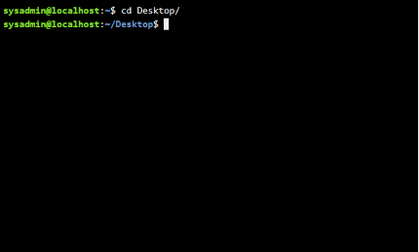

Figure 18

Example 4:
The pwd command stands for Print Working Directory. It shows the full, exact path of the folder I am currently in, confirming for me that it is /home/sysadmin/Desktop.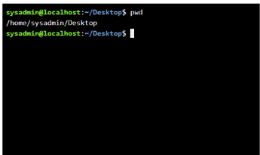
Figure 19: Description

Example 5:
The mkdir new command creates a new empty folder named new in the current Desktop directory. The ls command then lists the contents of the folder, confirming that the new folder was successfully created.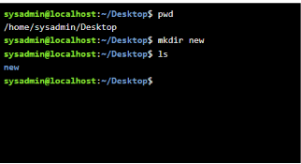

Figure 20

Example 6:
The rmdir new command deletes the empty folder named new from the current Desktop directory. Running ls afterwards confirms the folder is gone, as it no longer appears in the directory listing.
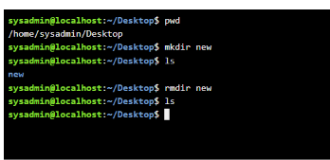
Figure 21

Example 7:
The touch new.txt command creates a new empty text file named new.txt in the current Desktop folder. The ls command then lists the directory contents, confirming that the file was successfully created.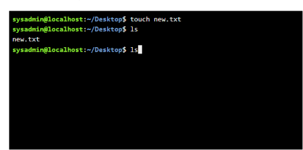

Figure 22

Example 8:
The echo hello > new.txt command writes the text "hello" into the file new.txt, replacing any existing content. The cat new.txt command then displays the file's contents directly in the terminal to confirm it was saved correctly.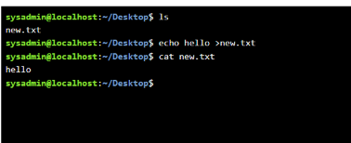
Figure 23

Example 9:
The ifconfig command shows all network interfaces and their configuration details on a Linux system. It displays my main network card’s IP address, MAC address, and data transfer statistics, as well as the local loopback address used for internal system communication.
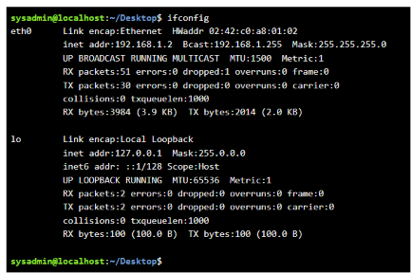

Figure 24

Example 10:
The whoami command displays the username of the account currently logged in to the terminal, confirming that I am working as a sysadmin. The date command displays the system’s current date, time, and time zone, allowing me to verify the system clock setting.
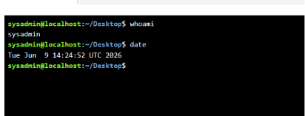
Figure 25

Use of Windows OS scripts
Batch scripting uses text files with commands that run in Windows Command Prompt. A batch file usually has a .bat or .cmd extension. It is useful for automating repetitive tasks such as creating folders, copying files, displaying messages, launching programs, and performing simple system administration tasks. [10].

Example 1:
Explain the script and output.
This batch script illustrates fundamental arithmetic operations and user engagement within the Windows Command Prompt. It starts with @echo off to hide command outputs, ensuring a tidy display. The script then employs set /p to ask the user for two numeric values, which are stored in the variables number1 and number2. The line set /a sum=%number1%+%number2% performs addition, calculates the total, and assigns it to the variable sum. The command echo "The sum is %sum%" displays the calculated result, followed by pause, which keeps the window open until a key is pressed. The output includes prompts for both numbers, shows the sum, and concludes with "Press any key to continue . . ." indicating successful execution.

This example demonstrates how batch scripts can handle user input, perform calculations, and generate formatted output effectively. It showcases the ease and utility of Windows batch scripting for automating minor tasks and conducting quick mathematical operations interactively.
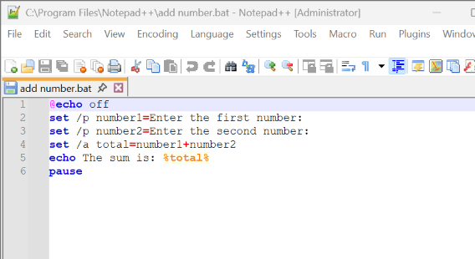
Figure 26
This batch script asks for two numbers, and when they are entered, it will sum them up
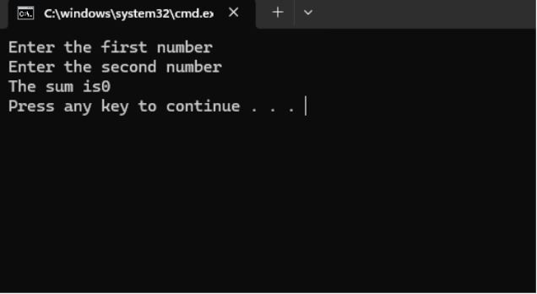
Figure 27

Example 2:

For this task, I developed a straightforward Bash script that prompts the user to enter two numbers, adds them, and displays the result. The script uses the read command for input and the $(( )) syntax for arithmetic. This example deepened my understanding of how Linux can support simple calculations through shell scripting. This batch script hides the command prompt, asks for your age, checks whether you are 18 or older to confirm voting eligibility, and pauses so you can see the result. 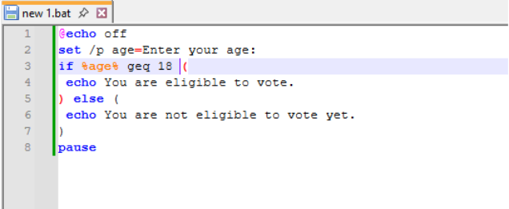

Figure 28: Description
This batch program successfully checks the entered age, showing the correct voting eligibility message for both 18 and 9, then waits for a key press before closing.
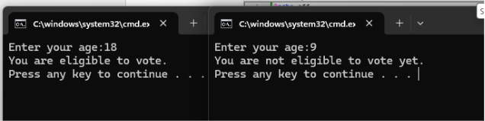
Figure 29

Use of Linux OS scripts
Bash scripting involves text files that contain Linux shell commands. Typically, Bash scripts begin with a shebang line like #!/bin/bash. They are primarily used to automate various tasks on Linux, such as managing files, performing backups, prompting users, running loops, setting permissions, updating software, and monitoring systems [11].

Example 1:
This Bash script prompts the user to enter their age, stores the value, and uses a conditional check to display whether the user is old enough to vote (18 or older).z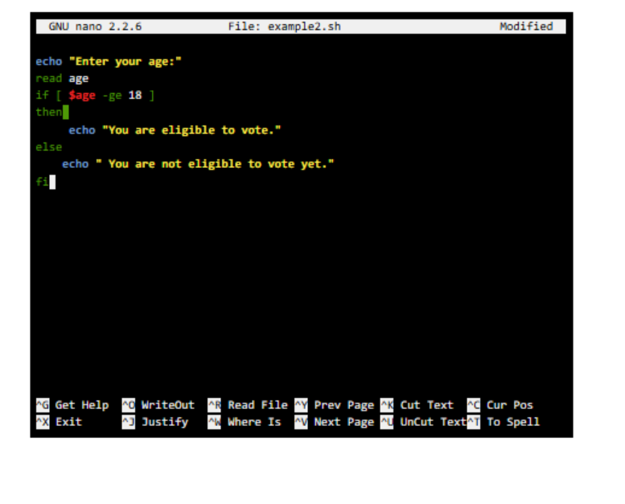

Figure 30
I have created and run two Bash scripts: the first takes two numbers as input and correctly outputs their sum, while the second checks the entered age and confirms eligibility to vote at age 23
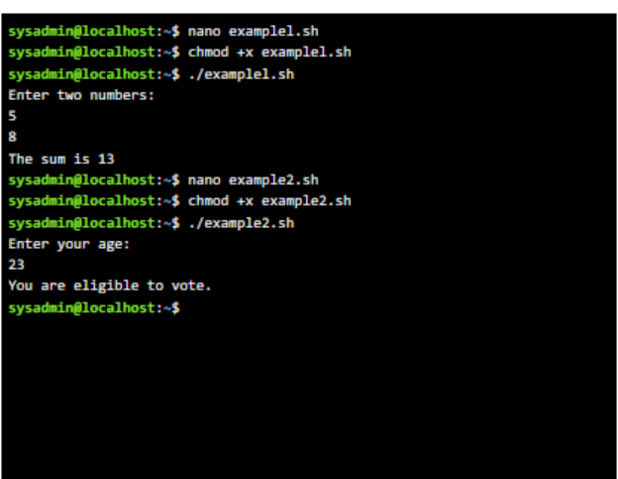
Figure 31

Example 2:
This Bash script uses a for loop. It asks the user how many times to run, reads the input, then counts from 1 up to the entered number, printing each value.

Figure 32
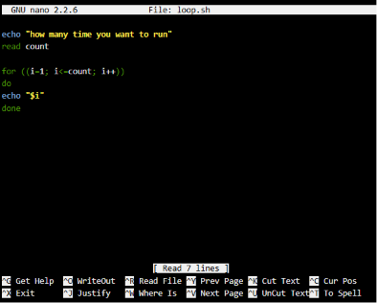

Figure 33: Description
This output shows the script being made executable with chmod +x, then run. It asks how many times to run; the user enters 15. The loop counts and prints numbers from 1 up to 15, demonstrating how repetition works in Bash.
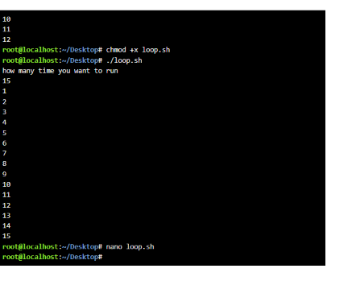

Conclusion
This report explained the main functions of operating systems and showed how Windows and Linux can be controlled using command-line tools. It also demonstrated how batch and Bash scripts automate repeated tasks. From these activities, I understand that operating systems manage resources and provide practical tools for efficient administration.

References

[1] | Banoth, Rajkumar and Godishala, Aruna Kranthi, uilding a Secure Infrastructure: The key Procedures for System Network Security, Springer, 2026, pp. {19--106}.
[2] | Hussain, Fatima and Hussain, Rasheed and Hassan, Syed Ali and Hossain, Ekram, “Machine learning in IoT security: Current solutions and future challenges,” hussain2020machine, pp. 1686--1721}, 2020.
[3] | I. a. F. I. Costa, “The use of AI in resources management sector in Microsoft,” open Access Libr, pp. 1--21, 2025.
[4] | B. Dauti, dauti2025windows, Packt Publishing Ltd, 2025.
[5] | Shimonski, Robert and Solomon, Michael G, Security strategies in windows platforms and applications, Jones \& Bartlett Learning, 2023.
[6] | Russinovich, Mark E and Solomon, David A and Ionescu, Alex},, “Windows internals, part 2,” in russinovich2012windows , Pearson Education, 2012.
[7] | ozaffari, Maryam and Yazdinejad, Abbas and Dehghantanha, Ali, “Windows-APT 2025: A dataset for APT-inspired attack scenarios on windows systems,” Elsevier, p. 112569, 2026.
[8] | K. A. Cochran, ompTIA A+ Certification Companion: Hands-on Preparation and Practice for Exams 220-1101 \& 220-1102, Springer, 2024, pp. 253--278.
[9] | Kofler, Michael and others, Linux: The Comprehensive Guide, Packt Publishing Ltd, 2025.
[10] | B. Knittel, Windows 7 and Vista Guide to Scripting, Automation, and Command Line Tools: Win 7 \& Vista Gd Scrp Au CL, Pearson Education, 2010.
[11] | Ramey, Chet and others, Bash reference manual, 1998: Network Theory Limited.

Appendices
Online Course name: Introduction to Cybersecurity

Figure 34


