INFORMATION ENGINEERING ASSIGMENT

ENTITY RELATIONSHIP DIAGRAM

ENTITIES:
- CUSTOMER ( Customer ID, Name, Address, Number, Email)
- EVENT ( Event ID, Date, Location, Customer ID, Branch ID )
- BRANCH ( Branch ID, Address, Number, Email)
- CUSTOMER INVOICE ( Customer Invoice ID, Customer ID, Date, Buffet ID)
- BUFFET ( Buffet ID, Event ID, Kitchen Staff ID)
- KITCHEN STAFF ( Kitchen Staff ID, Branch ID)
- PRODUCTS ( Product ID, Kitchen Staff ID, Quantity, Date)
- ORDER ( Order ID, Product ID, Date)
- SUPPLIES ( Supplies ID, Order ID, Name, Address, Number, Email)
- SUPPLIES INVOICE ( Supplies Invoice ID, Order ID, Date)

ASSUMPITION:
- One customer can book more than one event
- Each branch can organise more than one event, but they cannot work together to organise one or more events
- In each event customer can require more than one buffet type (meat, fish. vegetarian, vegan)
- Kitchen staff is working only for one brunch

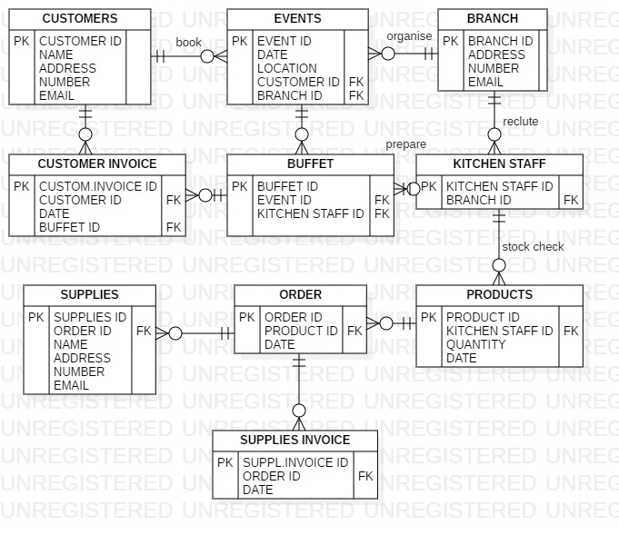

USE CASE DIAGRAM

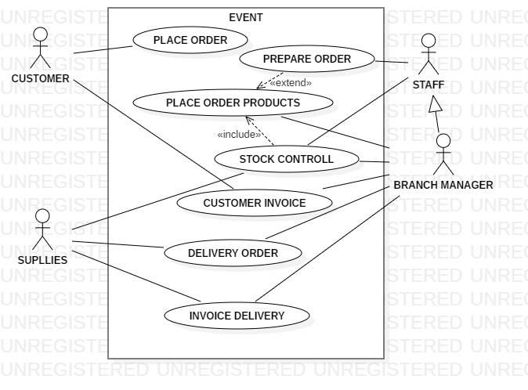

DATA FLOW DIAGRAM

Building this kind of diagram I focused the customer request to build a database about Customer Detail (D1), Record of catering services (D2), Record of income (D5), Purchase record (D4) and Record of suppliers invoice (D6).



