Art Therapy:
Investigating the issue of children’s mental health following a traumatic life experience and the role of art therapy as a successful therapeutic practise.

Roseanna Wilson
Submitted in partial fulfilment of the requirements for the degree of
BA (Hons) Photography in the Arts.
University of Wales Trinity Saint David, Swansea
12th December 2018
Word Count – 4,802
Table of Contents
Page
List of Illustrations ………………………………………………………………….1
Summary ……………………………………………………………………………2
Introduction ……………………………………………………………………….3-4
Chapter 1 ………………………………………………………………………..5-11
Chapter 2 ………………………………………………………………………12-18
Chapter 3 ……………………………………………………………………....19-23
Conclusion ……………………………………………………..………………24-25
Bibliography ……………………………………………………………………26-31
List of Illustrations ……………………………………………………………..32-33

List of Illustrations

Figure 1. Sigmund Freud with a patient in Vienna.
Figure 2. ‘The man is all right’ Massive Transition. (John - Art therapy patient)
Figure 3. I want my ma.
Figure 4. Plato’s Cave.
Figure 5. An horrific face. (David - Art therapy patient)
Figure 6. Sample drawings of one pair of monozygotic twins (left) and one pair of dizygotic twins (right), with the scores the drawings received.
Figure 7. Beyond the Family Album.

Summary

This dissertation will reflect on the progression of art therapy and its application in facilitating psychological healing for traumatised children. Theoretically exploring the repression of traumatic memories and complexities arising when unveiling the unconscious mind, it will examine the role of trauma on psychological development. Understanding art as a form of communication where language fails to facilitate the expression of self and experience, is an integral theme to art as a therapeutic practice and its ability to enable rehabilitation through emotional release. The ultimate objective is to evaluate whether art therapy is a successful therapeutic practice for children experiencing trauma.

Introduction

This dissertation is an attempt to investigate the issue of children’s mental health when faced with traumatic life events and the possible benefits of art therapy being used as a method to recover from such events, both during childhood or indeed into adulthood. Chapter one will consider the origins of art therapy, examining several pioneers who were influenced by the work of Sigmund Freud. The different roles art has in a therapeutic setting will be considered, from assisting the linguistic healing to the artistic process providing the patient with the outlet to heal. Memory will be explored, particularly repressed memories and the biological mechanism that contributes to this phenomenon. Chapter two will examine children’s intrinsic responses to the world around them and how they learn to communicate. Theorists such as John Bowlby, Jacques Lacan and Slavoj Žižek provide insight into the development of children’s psyche within society. An important part of this dissertation is the role of the family in influencing or perhaps haltering a child’s healthy mental growth by concealing the reality of such traumatic events. This will lead onto the role of the therapist in enabling the child to understand their inner reality as a separate entity to the outer reality. Intrinsic to a successful therapeutic outcome is a confidential, trusting relationship between child and therapist and this will be further researched and discussed. Chapter 3 will determine how mental health problems in children are discovered without the use of language. It will consider the impact of art therapy on children who have mental health struggles after experiencing a traumatic event. Following a brief overview of the varying mediums employed in art therapy, the role of phototherapy will be investigated on a deeper level. Looking at photographers past and present who have employed phototherapy in their practice to benefit children and communities.

Chapter 1

In recent years the importance of mental health has begun to be understood whereas historically mental health issues were deemed to be the result of demons (Neugebauer, 1978). It is this increasing understanding that has allowed therapy to progress into what we see today. This dissertation will be focused on art therapy in relation to children struggling with mental health issues, working with the belief that early intervention will help prevent future decline in the patient’s mental health. Traumatic life events drastically affect a child’s mental health in a negative way and this will be further researched throughout.
Trauma is a response, sometimes delayed, to an overwhelming event or events, which takes the form of repeated, intrusive hallucinations, dreams, thoughts or behaviours stemming from the event, along with numbing that may have begun during or after the experience, and possibly also increased arousal to (and avoidance of) stimuli recalling the event. (Nadal and Calvo, 2014, p. 100)

This repetition of negativity within the brain can be a contributing factor to the deterioration of a child’s mental health. Without addressing the traumatic event in a safe environment with a specialist it can remain a problematic experience through a child’s transition into adulthood. The most recent research suggests that 50% of adults suffering from a mental health issue presented symptoms during their childhood (The National Institute of Mental Health, 2009).
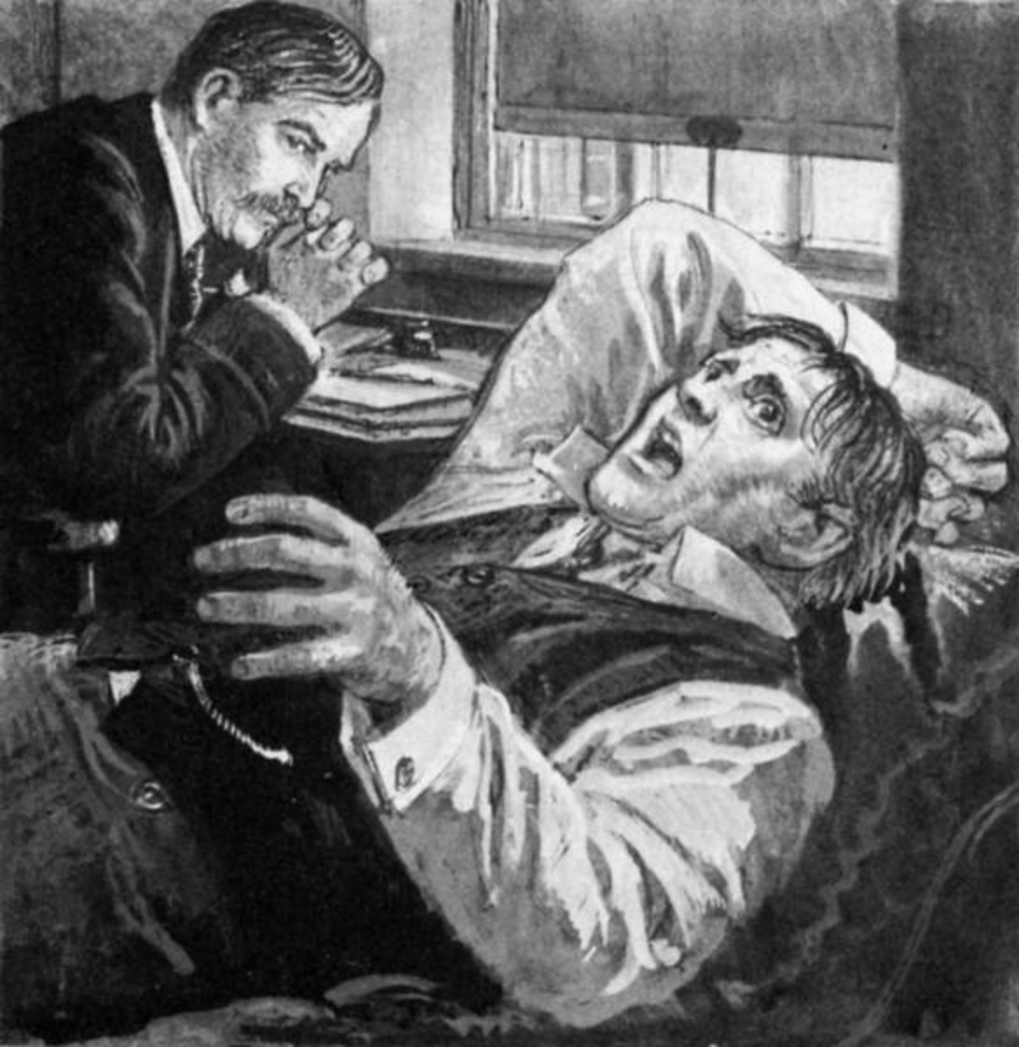
Fig. 1: Sigmund Freud with a patient in Vienna.

Sigmund Freud could be considered the Godfather of therapy, developing the main theory on which therapy was built. Freud established that there are two conflicting forces in the human mind, the conscious and the unconscious, a concept that was previously unthought of and often denied (Mollon, 2000). “Conscious memory consists of recalling or recollecting past experience” (Warnock, 1987, p. 9) Recalling and processing past experiences allows us to create our identity. Memory and identity are often considered to connect with one another; it is our memories that shape us into who we are. Repressed memories also play a role in our identity which can negatively affect children’s development. Art therapy works in a way increasing the speed at which the unconscious reveals itself (Maat, 1997). Some patients may be unaware of repressed memories/events and therefore would struggle to disclose what they’re unaware of. On a literal level art therapy allows these repressed memories which are considered invisible to become visible. The patient’s ability to discuss their inner world with others would become easier with less stigma surrounding mental health issues, as with more understanding comes less stigma. In the unconscious mind there is thought to be repressed experiences, often associated with trauma that can only be accessed when a patient reveals their inner world. Sigmund Freud suspected repression of memories occurred when a severely stressful or traumatic event impacted a person, preventing them from having immediate access to that memory and affecting future recollection. Repression is thought to be important for an individual's survival, “Areas of experience are repressed because they threaten needed emotional ties” (Mollon, 2000, p. 62). This quote specifically relates to children who have been through a traumatic experience at the hands of their caregiver, to continue the relationship and to prevent a breakdown their instincts kick in to repress the memory. However, this does not mean that the occurrence of the event no longer affects the individual and the memory of the event is not considered to be erased. Numerous therapists working in the field believe that with their assistance a patient can recover repressed memories. Conflicting theorists suggest that this is rather false memories being created by the use of suggestive techniques. False memory syndrome details the issues arising from Freud’s theory of repressed memories, mainly its unreliability. Elizabeth Loftus heavily questioned the accuracy of recovered memories from the unconscious mind, believing that memories were never fixed and could be influenced later in life from other sources. Memories without traumatic association are notably still not a precise reflection of the event. Subjectivity along with other contributing factors play a role in how we recall information, the recollection of this information is a mental construction of the event that can never be seen by another. The event will never be fully recreated by the individual and as such memories will never represent an event with 100% accuracy. Loftus also researched and studied the possibility of false memories, for a person to be completely convinced that a fabricated event that never occurred was actually a part of their past. Findings found it was entirely possible for a person to believe that an event had happened even if it were something impossible. These issues are more prevalent when memories are to be trusted by outsiders. Therapy involves healing of the individual and therefore working through memories, even if false will arguably benefit the child.
Art therapy works in two different ways to enhance a patient’s therapeutic healing during therapy. Firstly, it can be seen as a tool at the starting point of therapy, enabling a patient to engage in verbal discussion with more ease but does not take the place of the main source of healing. Art enables us to express things that words often cannot. Employed in a therapeutic setting art allows repressed moments to come to the forefront of discussion providing the client with a means of working through things they otherwise would struggle to explain through language.
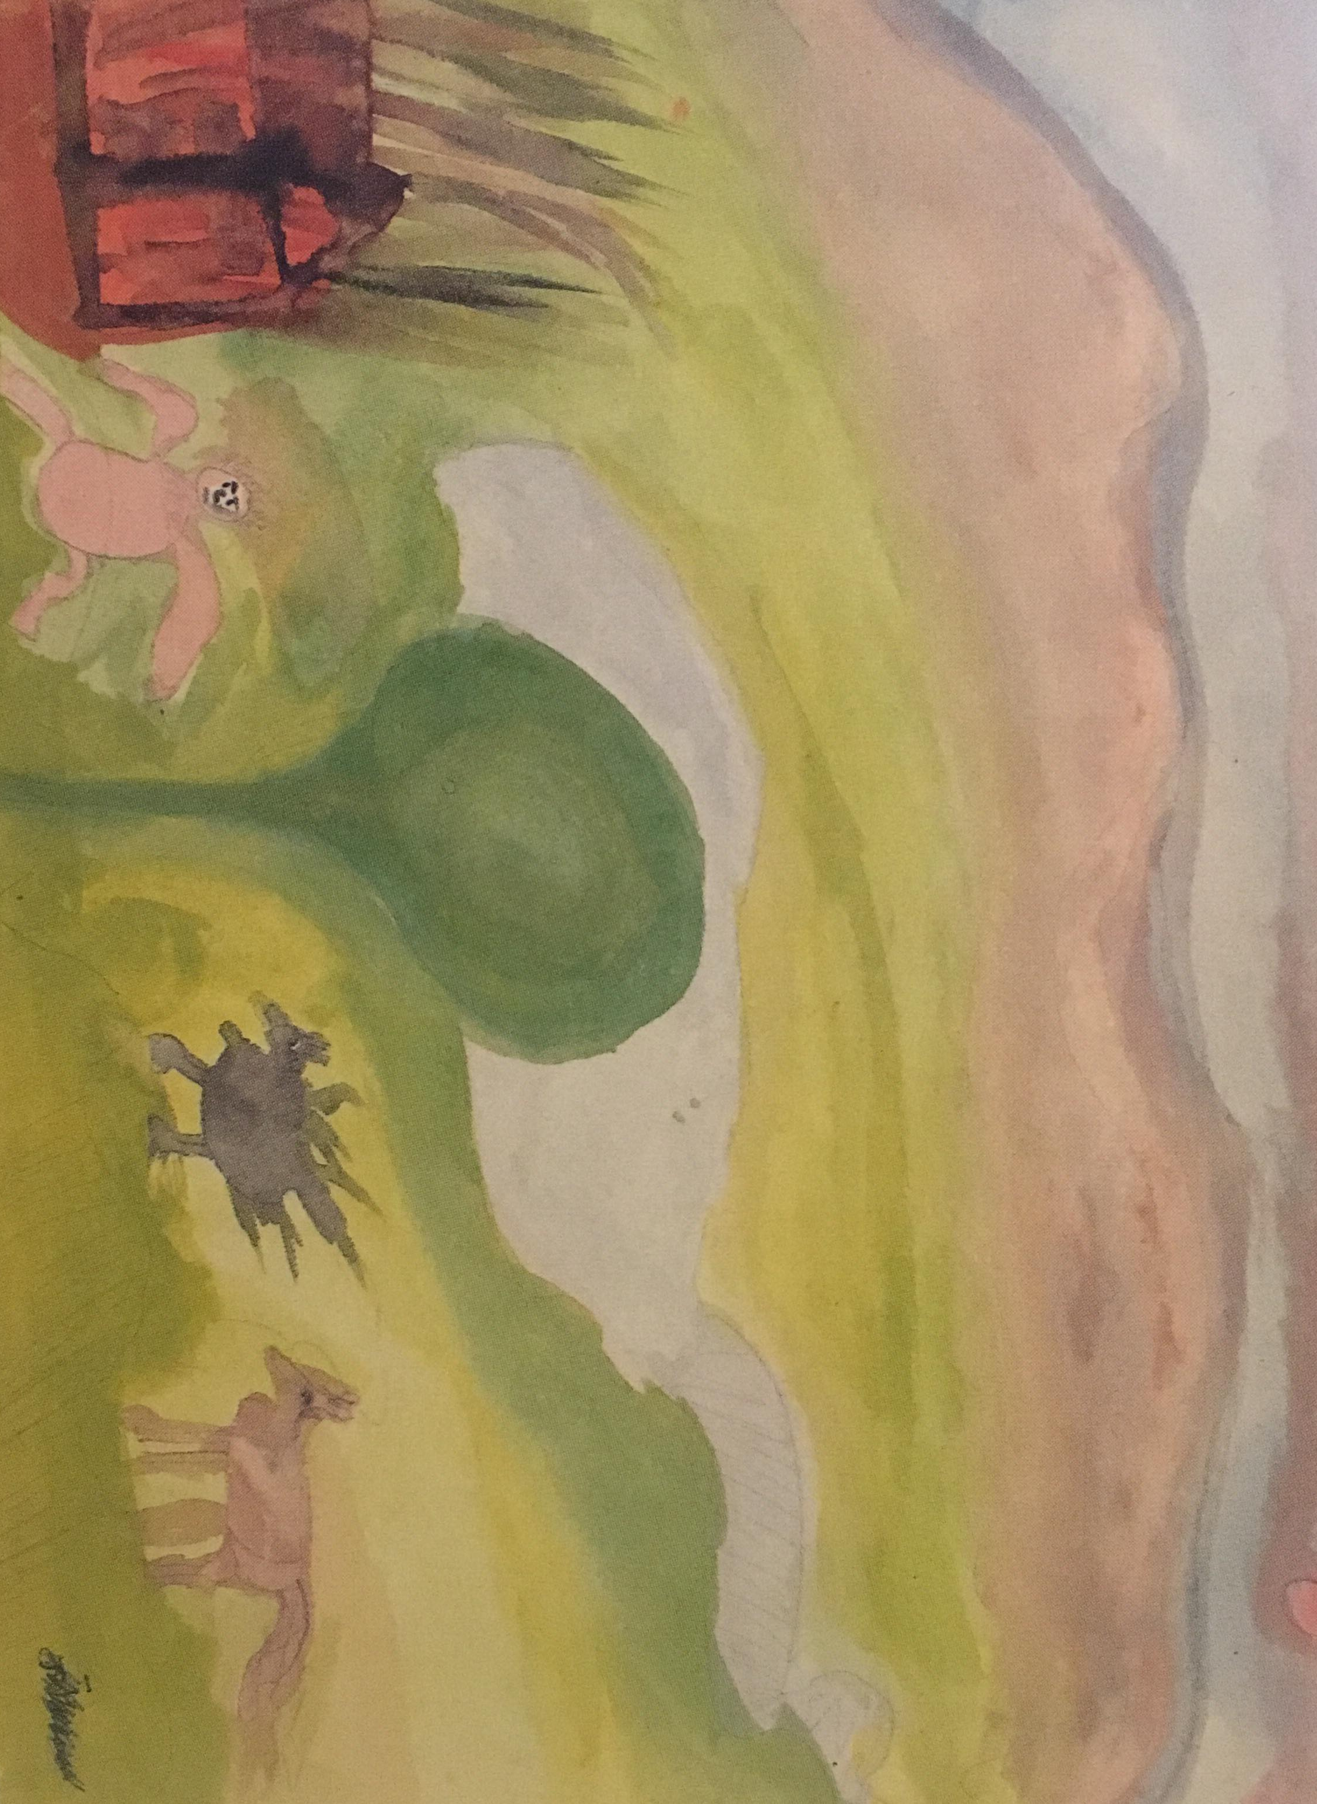
Fig. 2: ‘The man is all right’ Massive Transition.
This is important in a therapeutic setting; for a person to begin to heal they need to go through a process of transference which refers to removing the negative experience and transferring it into positive.
When a patient has seen once or twice how he is freed from a wretched state of mind by working at a symbolical picture he will thenceforward turn to this means of release whenever things go badly with him. In this way something invaluable is won, namely a growth of independence, a step towards psychological maturity. (Jung, 1949, p. 80)

Jung was attributing healthy mental stability with the understanding of the artistic/therapeutic process one has to undertake each time they are faced with negative life events. Once a patient has gone through the progression of creating pictures and applying psychological theory during art therapy with a therapist’s support, they are able in future to undertake this task without assistance. Secondly it can be seen as the therapy, the creative process and the actuality of undertaking the task that clears the patient’s mind and becomes therapeutic.
In art therapy materials provide a tangible medium through which a child can express him or herself. As children often have difficulty in expressing their feelings verbally the process of art provides the child with a less problematic, more spontaneous means of communication. (Dalley, 1990, p. 168)

The release of the individual’s creativity and built up emotions during an art therapy session with no expressive boundaries benefits the patient therapeutically, before any words need to be spoken.

heoryisbuiltontheassumptionthatwithinthehumanpsychethereexist
consciousandunconsciousthoughts.
Freud’s work influenced four pioneers of art therapy; Margaret Naumburg, Edith Kramer, Hanna Kwiatkowska and Elinor Ulman. Naumburg emphasised the importance of psychoanalysis on the individual and the benefits this has on their psyche. Widely considered the founder of art therapy, it was her belief that the unconscious became visible when clients would spontaneously create art. Naumburg expressed that deciphering symbols within the art could help to aid the transference of negative experiences that the conscious would repress. Kramer’s work alternatively was inspired by Freud’s theories on personality development, believing art therapy could help children who were struggling to progress at a normal level. Creating an art piece would enable the children to develop their sublimation defence mechanism to encourage healthy mental growth. Kramer worked with Hanna Kwiatkowska and collectively they helped bring art therapy to the public sphere with a short book Art Therapy in the United States, co-written also by Elinor Ulman. Lastly Ulman wrote her own essays on art therapy creating a book bringing together a collection of essays from various authors that concentrated on art therapy. Ulman was focused on comparing the different approaches presented to art therapy. Collectively these pioneers of art therapy saw the importance of their practice despite slightly different approaches; working with children is something that interested each of them with their understanding of altering abilities of expression between adults and children.

Chapter 2

This focus on a person’s abilities becomes a prevalent issue when working with children, as their language skills continue to develop through the early stages. Children communicate with the world around them naturally from birth; their cry communicates their instinctual needs to the caregiver (Bowlby, 1988).
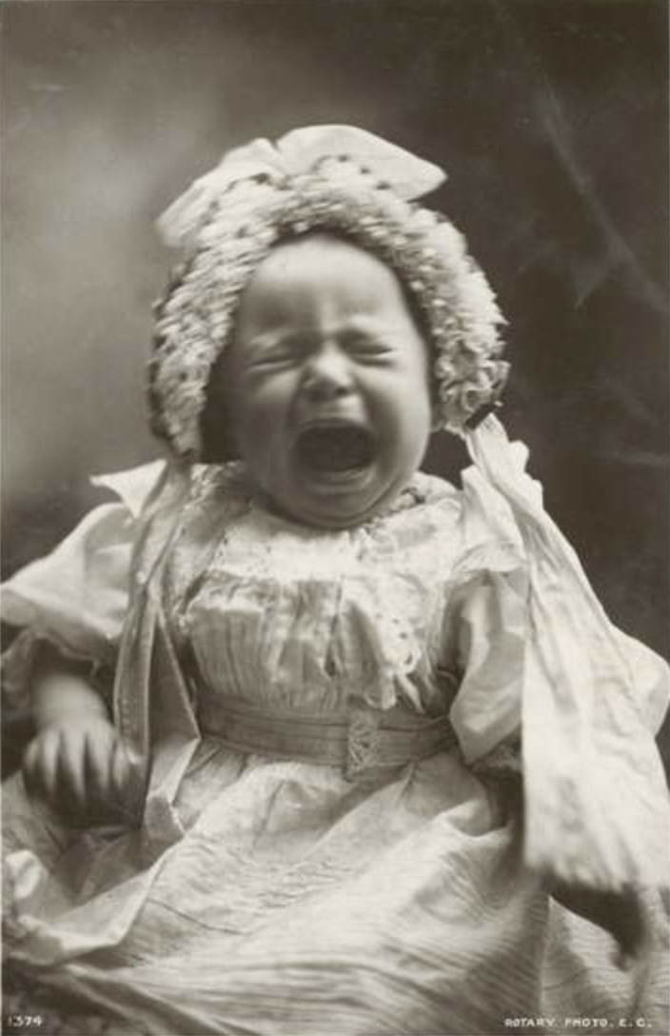
Fig. 3: I want my ma.
In the early stages of childhood children begin to make markings as a form of communication, using any tool available to them. Visual stimulation is a child’s first way of perceiving the world around them, so art therapy acts as a reflection of their experience with the world (Riley, 2001). If communication is haltered in any way this will lead to a build-up of negativity that they cannot themselves organise. Jacques Lacan and Slavoj Žižek look at the Imaginary, Symbolic and Real orders; these can be seen through a child’s development and at different stages compound how the mind processes what children experience. The Imaginary is present in the earliest stages of a child’s development whereas stated previously all a child knows is the visual world which doesn’t correlate to their own abilities or lack of them. An internal conflict could be considered present in the earliest moments of life on this basis and as this forms the ego, it follows us through to adulthood. The Symbolic is the world in all its structures as described in Slavoj Žižek:
For example, most people are inscribed in the Symbolic before they are even born, because they are given a name, belong to a family, a socio-economic group, a gender, a race and so on. (Myers, 2003, p. 22)

Everything in the symbolic is spoon fed to us; a child learns a cat is called a cat because it is taught by an adult that a fluffy carnivorous mammal is called a cat and will rarely bring the symbolic into question. Expression of self relies on what we are taught from the world around us. Each form of expression requires rules and structure to play, to be pictorial and also to employ language.
With language we can communicate our experience, our thoughts, and even our aspirations to others. Language, however is not only for communication. Words allow us to classify objects in the world. By the use of language, we make sense of our experiences in a very structured and elaborate way. (Dubowski, 1990, p. 7)

Lacan believed this then separates us from the real world and we are left stuck with linguistic representations of everything. The conflict this represents for a child is that if they go through a traumatic experience the real event can never be fully described or presented to an outsider through language. The child will always struggle to fully express the encompassing conflict and pain caused by events they have lived through. The internal conflict caused by the Symbolic is that language acts as a separation from the real world. The Real is similar to the unconscious; it is all the things unknown by language. When watching the film Room (2015) this is effectively represented; a five-year-old trapped inside a room his whole life knows nothing of the world we live in and when exposed to the world the child experiences it without prescribed language. As children grow and develop they become more aware of the fact we see the world through the Symbolic system prescribed and no longer see the Real (Myers, 2003). What we are therefore, not taught, restricts our ability of expression. It is important to note that in the early stages of childhood all children are taught from their home environment.
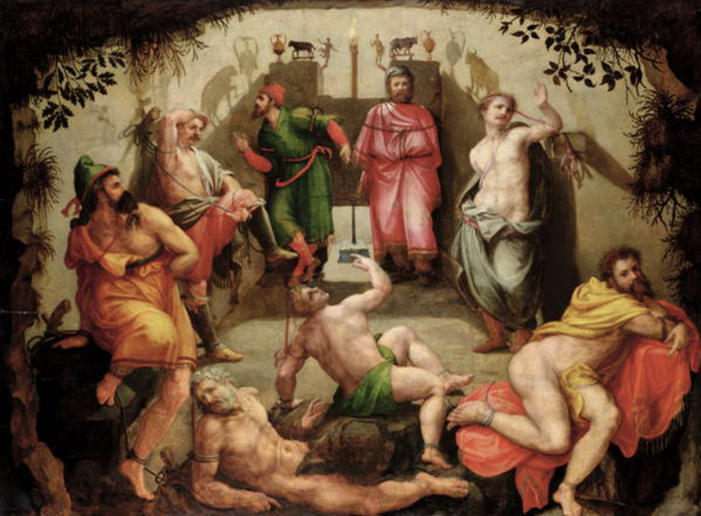
Fig. 4: Plato’s Cave.
This conditioning is mentioned in Plato’s The Allegory of the Cave in which he theorised human’s perception. For the purposes of this essay the argument could be that the child is the prisoner and the home environment is the cave. When children enter environments outside of home life, discussing incidents involving their family may make them uncomfortable. These feelings then build up and can cause a child to carry huge internal burdens. The issues of home life remain unsolved and a child’s mental health begins to suffer. Their dependence on the home environment can leave children and young people feeling secluded. ‘Unvalidated unconscious, overwhelming experiences that could not be named, thought about and spoken about’ (Mollon, 2000, p. 61). Often this experience is unknown to the child; they will not have the cognitive ability to understand the complex nature of their upbringing. Art therapy then can be employed as a useful tool as the therapist is accustomed to symbolic representations that can occur in imagery. They’re the portals for the children to understand their inside reality and outside reality. Therapists can validate the real for children and young people leaving them free to express their internal burdens, growing a sense of independence. A child’s experience inside the cave or the home environment can give them a distorted view of the outside. Similarly, to the prisoners who chose to disbelieve the prisoner who had seen the real, the child may perceive what’s outside the home as overtly threatening and therefore feel more safety remaining in the environment in which they know with certainty (Briere and Elliot, 1994). If a child is lacking awareness of a particular situation, for example if abuse is masked as love then they may be unaware of their actual reality. Their conscious mind is unaware of the abuse and therefore the person is unable to appropriately deal with it. This is often why perpetrators of sexual abuse go unpunished and unrecognised as abusers for so long; they’re able to manipulate the child into silence.
This is analogous to what might be termed the ‘presymbolic unconscious’ – those areas of experience of which we cannot be properly conscious because we have not been able to generate words or any other form of mental representation of them. (Mollon, 2000, p. 9)

As events such as these are often not traumatic in the sense that the trauma, emotional or physical pain is masked and denied, they therefore remain in the patients conscious but cannot be processed in the way they should be to enable the healthy growth of the individual. Examining the core of art therapy, it involves researching how the unconscious reveals itself through the process. Children are encouraged to use art materials during therapy sessions, as this is a practical way for the therapist to gain insight into the child’s emotions. The freedom to be creative, to let everything out can often result in children being messy. There is an importance in the unrestricted creation of art, as the client needs to feel free to construct without judgment from their therapist.
Sexually abused children use art materials symbolically to express feelings of being full of mess inside, of being messed-up, and of trying to find some way to control and handle the mess or poison. These messy feelings may be expressed by play with paint, sand, clay and water. (Sagar, 1990, p. 108)

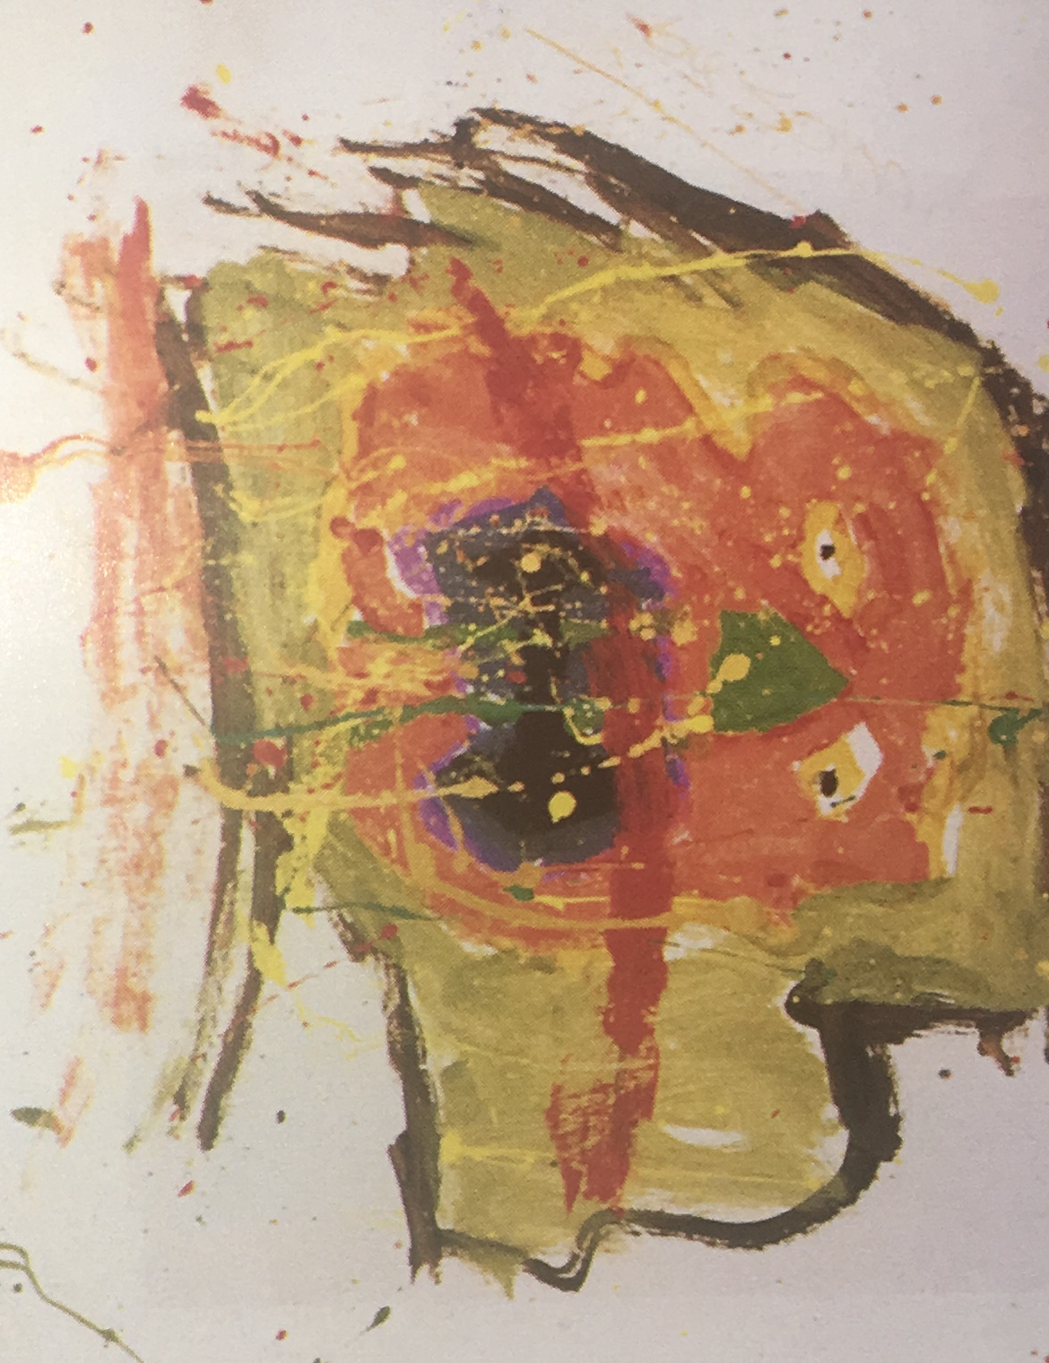
Fig. 5: David: An horrific face.

The patient needs to trust the therapist, for the success of therapy relies on the relationship built. The crux of most therapy is the transference process in which the client projects their unconscious emotions onto their therapist. Without trust it is unlikely the patient would open up to doing this, as to reveal the unconscious would put the patient into a position of vulnerability.
The therapist clears the path for the child to achieve growth. The therapist clears the ‘here and now’ moment between past and future. Thus far and no farther. The child creates the prints that establish that path and can then achieve growth. (Arguile, 1990, p.214)

If the patient can get past this state of vulnerability, they will unstick themselves from their problems. Addressing their issues will enable the child to move past them and the therapist will provide them with the tools to do this if future events prove to be problematic. Exploring this element of trust between client and therapist brings us to the point at which a therapist can be put in a position that could be detrimental to the relationship. “The use of drawings as ‘evidence’ in court, in cases of child sexual abuse for example, places the art therapist in a therapeutic and moral dilemma.” (Case & Dalley, 1990, p. 3). Children can become aware of this dilemma which can put a strain on the relationship between patient and therapist. Children from sexually abused backgrounds have often lost trust in others; the closest people to them are often the ones that have betrayed them. This can lead to the child questioning everyone’s intentions as the traumatic experience of losing the person they trust has made them aware that people may disguise their true objectives (Finkelhor and Browne, 1986). Conscious resistance from the patient halters the therapist being given access to the child’s unconscious mind and are left unable to help or progress in the sessions.
It is essentially through the aesthetic experience that the art therapist can enter and share the client’s world, and that the clients can make themselves known and found (Sagar, 1992, p. 97)

The therapy can only be a success if the child fully engages with the therapist openly and honestly revealing their unconscious, through art. Without engaging in the process of art therapy the therapist remains unaware of events that may be affecting the child’s mental health. However, it is important to comment on the importance of the therapist remaining focused on the benefits of the art therapy for the child internally and mentally. External agencies who consider using the art created during sessions, should always remain a secondary outcome of the art therapy sessions. On this level the trust and bond are always a two-way street; a healthy therapeutic relationship will lead to improved mental health for the patient.

Chapter 3

In order to improve a child’s mental health their psychological issue must first be diagnosed by a doctor before art therapy is made available to them. The progression in this area has been well documented throughout history by psychologists and theorists.
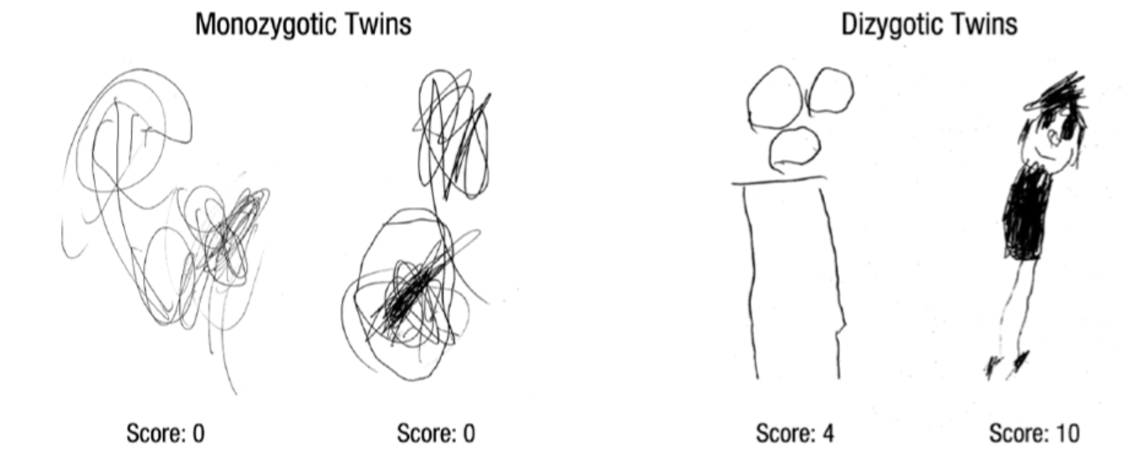
Fig. 6: Sample drawings of one pair of monozygotic twins (left) and one pair of dizygotic twins (right), with the scores the drawings received.
Florence Goodenough developed assessments enabling the understanding of children’s emotions when language was lacking as a form of communication, one such analysis being the Draw-A-Man test. Taking a closer look into children’s drawing abilities showed a correlation with their intelligence levels. Conclusions could then be drawn from this visual information such as a child’s psychological state (Goodenough, 1926). This test is known today as the Draw-A Person test and has been implemented by many psychologists when searching for mental health issues as its objectivity allows it to be employed globally. Elizabeth Koppitz believed it could expose varying mental illnesses in children and young people and help with diagnosing these issues (Farokhi and Hashemi, 2011). Art therapy can be implemented after a child or young person has been diagnosed with a mental health issue enabling them to heal more rapidly than any other form of therapy (Ponomarenko, Yap & Peeran, 2017). Art therapy provides children with the most positive outlook for future progression as previously stated it allows things they could be struggling to verbalise to come to the forefront of conversation earlier which can in turn reduce the period of treatment (Naumburg, 1966). One benefit of art therapy is that it allows the patient to take an active role in their healing. The patient has the ability to control and channel their emotions into their own creation. Additionally, there are now more approaches to art therapy than ever before, this dissertation has heavily looked at how historically a child’s drawings can be used. The progression of art therapy has allowed its adaptation within different mediums; dance movement therapy, dramatherapy, music therapy, phototherapy and visual art therapy are now employed dependant on the most appropriate to a patient’s needs. The focus will now shift to phototherapy as a sub section of art therapy which in itself has many subdivisions. The client is able to express their own preference of the material they would like to work with whether that be; self-portraits, everyday photography, exploring photographic collections and documentary photography that provide a narrative to their own life. Photographs inherently hold many catalysts to meanings often specific to each viewer. The principle remains the same in that when the therapist begins to open up the floor of dialogue to the image it can reveal unconscious experiences that with language alone would be unreachable. The accessibility of photographs in modern day ensures there is an abundance of material for a patient to work with readily available. Critique on this approach would be that therapy in this form reduces the client’s involvement and interaction with the creation of an end object; to create a collage is to engage the conscious mind. The separation of spontaneous mark making to a conscious literal depiction of emotions disconnects the child from the messy processes such as painting which were discussed prior in art therapy’s origins. Another criticism would be that photography is indexical in nature, the way in which an image is physically formed can provide a destabiliser when it comes to art therapy for a patient. The subjects in figure 7 are aware they are being photographed and they therefore change their behaviours; the presence of the signifier alters the signified (Wells, 1997). Photographs can act in a nostalgic way and that brief moment of pause in a time can mask the reality of events, often images are created for others and therefore present childhood in its most innocent and perfect form (Higonnet, 1998). Understanding of the photograph should stem from a view point that what visually makes up an image does not necessarily depict the real and is entirely constructed by the image maker. Without this as a starting point for photo therapy, an internal crisis could potentially be present for the patient.
The ways of the child, long since sealed off for the adult, open up an original dimension in which everything unfolds within the bounds of the right, the true, the good, in a zone of hidden containment which cannot be derogated as ‘pre-ethical’ or ‘unconscious,’ as if the spirit of the child had not yet awakened, or was still at the animal level—something it never was, not even in the mother’s womb. That zone or dimension in which the child lives, on the contrary, reveals itself as a sphere of original wholeness and health (Balthasar, 1991, pp 11-12)
This idea of an ideal childhood is entirely a construct, just as the photograph is. Adults project onto children unrealistic and unattainable ways of living, which is confirmed through imagery, this is especially prevalent in today’s society. One only has to briefly scroll through a social media platform to see this perfect image of childhood being publicised.
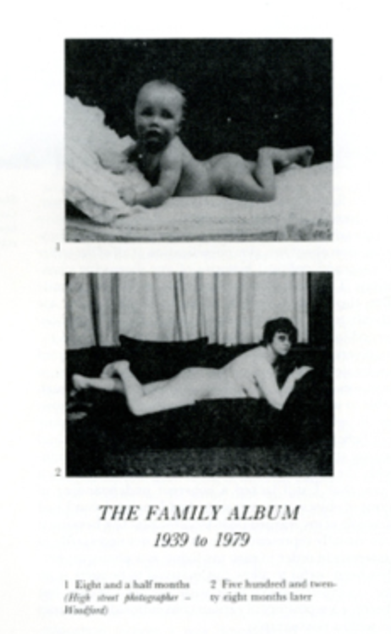
Fig. 7: Beyond the Family Album
In the mid 1980s photographers Jo Spence famously collaborated with Rosy Martin, involving themselves with phototherapy; they used photographs as a physical object from family albums using memory as part of history. Later on, during the 1990’s Spence became interested in exploring the human psyche, an individual’s inner reality and how the mind would wander into daydream like states.
Jo Spence’s work brings to light and subjects to scrutiny the memories and the fantasies of a social class, a gender group, a particular generation – people whose inner lives are commonly dismissed as insignificant, impoverished, even non-existent; and shows us how these permeate our more immediately felt day-to-day lives as children, workers, parents, lovers. (Stanley, 1995, p. 20)
Phototherapy allows the transformation of memory information to be visualised acting as a stepping stone in a patient coming to realise there is very rarely an absolute. Symbols remain present in photographs and enable the uncovering of the unconscious in a patient. Sometimes what is not present in the photograph can be symbolic also, a missing person for example can present the therapist with powerful information for a conversation to begin (Weiser, 1993). Photographs are rich with information as they act as a direct reflection on the visuals in the world; a photo therapist will be trained in noticing details such as events occurring at the time the image was taken rather than the image itself. It is these surrounding moments that have the strongest emotional connection to the patient. How a patient sees the world is pertinent and can be demonstrated if they were told to take photographs of themselves rather than to use imagery already out there. Self-portraits for example would demonstrate to their therapist that they were self-aware.

Conclusion

In closing this dissertation, can conclude that children’s mental health and the links it has to a healthy development can be seen to be of upmost importance. Previously mental health issues in children were not thought to happen but with today’s knowledge and understanding children are able to obtain a diagnosis of a mental health issue. Facing a traumatic life event can be detrimental to a child or young person if left untreated and with successful diagnosis children are now able to access therapy to resolve problematic emotions. Undertaking art therapy allows children a safe environment in which to recover from these traumatic experiences in a setting suitable to their needs. Art therapy encourages the growth of a child’s self-esteem whilst simultaneously addressing the need for their problematic experiences to be shared and in turn improvements to their internal world will be made. Art therapy although not limited to children has the ability to focus on childhood for adults to repair any mental health issues that have arisen at a later date. Pioneers of art therapy dedicated their lives to improving the therapeutic services available to children. Working together in art therapy the therapist and patient are both provided with a tangible body of work that can demonstrate improvements to the patient’s mental health through the course of treatment. Art therapy remains an important element for children to gain an understanding of the connection between their body and mind, through learning to recognise the difference between their inner and outer reality, which is fundamental for ordering the chaos and worry in their mind. Through this dissertation it has become clear that all efforts to communicate with the world around us can only act on a metaphoric level in expressing our inside world to others. Certainty of the past is unobtainable just as is the perfection we put upon ourselves and others.

Bibliography

Allen, P. (1988). A consideration of transference in art therapy. American Journal of Art Therapy, 26, 113–118.
Arguile, R. (1990). ‘‘I show you’: children in art therapy’, in Case, C. and Dalley, T. (eds.) Working with children in art therapy. London: Routledge.
Balthasar, H. U. (1991). Unless You Become Like This Child. San Francisco: Ignatius Press.
Bowlby, J. (1959). Separation anxiety. International Journal of Psycho-Analysts, XLI, 1-25.
Bowlby, J. (1960). Grief and mourning in infancy and early childhood. The Psychoanalytic Study of the Child, VX, 3-39.
Bowlby, J. (1969). Attachment. New York: Basic Books.
Bowlby, J. (1988). A secure base: Parent-child attachment and healthy human development. New York: Basic Books.
Briere, J. and Elliott, D. (1994). Immediate and Long-Term Impacts of Child Sexual Abuse. The Future of Children: Center for the Future of Children, the David and Lucile Packard Foundation.
Browne, A. and Finkelhor, D. (1986). Impact of Child Sexual Abuse: A Review of Research. Psychological Bulletin.
Case, C. and Dalley, T. (1992). The Handbook of Art Therapy. London: Routledge.
Case, C. and Dalley, T.(eds) (1990). Working with Children in Art Therapy. London: Routledge.
Dalley, T. (1990) ‘Images and integration: art therapy in a multi-cultural school’, in Case, C. and Dalley, T. (eds) Working with children in art therapy. London: Routledge.
Dalley, T., Case, C., Schaverien, J., Weir, F., Halliday, D., Hall, P. and Waller, D. (1987). Images of Art Therapy. London: Routledge.
Dubowski, J. (1990) ‘Art versus language (separate development during childhood)’, in Case, C. and Dalley, T. (eds.) Working with children in art therapy. London: Routledge.
Ellenberger, H. F. (1970). The Discovery of the Unconscious. Allen Lane: London
Farokhi, M. and Hashemi, M. (2011). The Analysis of Children’s Drawings: Social, Emotional, Physical and Psychological Aspects.
Gardner, H. (1984). Art, mind, and brain. New York: Basic Books.
Gill, C. (ed) (2000). Time and the Image. Manchester: Manchester University Press.
Goodenough, F. (1926). Measurement of Intelligence by Drawing. George G. Harrap & Co.
Higonnet, A. (1998). Pictures of Innocence: the history and crisis of ideal childhood. London: Thames & Hudson.
https://www.nimh.nih.gov/health/publications/treament-of-children-with-mental-illness-fact-sheet/index.shtml (Acessed: 9th December 2018)
Jung, C.G. (1949) Modern Man in Search of a Soul. London: Routledge.
Karen, R. (1998). Becoming attached: First relationships and how they shape our capacity to love. New York: Oxford University Press.
Levick, M. (1983). They could not talk and so they drew: Children’s styles of coping and thinking. Springfield, IL: Charles C Thomas.
Maat, M. B. (1997). A Group Art Therapy Experience for Immigrant Adolescents. American Journal of Art Therapy, 36(1): 11-20.
MacGregor, J. M. (1989). The discovery of the art of the insane. Princeton, NJ: Princeton University Press.
Machover, K. (1949/1980). Personality projection in the drawing of the human figure. Springfield, IL: Charles C Thomas.
McNiff, S. (1992). Art as medicine: Creating a therapy of the imagination. Boston: Shambhala.
Mollon, P. (2000) Ideas in Psychoanalysis the Unconscious. Cambridge: Icon Books Ltd.
Moon, B. L. (1990/1995) Existential art therapy: The canvas mirror. Springfield, IL: Charles C Thomas.
Morris, M. (2001). Curriculum and the Holocaust: Competing Sites of Memory and Representation. London: Routledge.
Myers, T. (2003). Slavoj Žižek. Oxon: Routledge.
Nadal, M. and Monica, C. (eds). (2014). Trauma in Contemporary Literature: Narrative and Representation. London: Routledge.
Naumburg, M. (1950/1973). Introduction to art therapy: Studies of the “free” art expression of behaviour problem children and adolescents as a means of diagnosis and therapy. New York: Teachers College Press/Chicago: Magnolia Street.
Naumburg, M. (1966/1987). Dynamically oriented art therapy. New York: Grune & Stratton/Chicago: Magnolia Street.
Neugebauer, R. (1978). Treatment of the mentally ill in medieval and early modern England. Journal of the History of the Behavioural Sciences.
Plato. (2003). The Republic of Plato. London: Penguin Books Ltd.
Ponomarenko, A., Yap, J. and Peeran, U. (2017) Investigatigating the Efficacy of Art and Music Therapy with Vulerable Children and Young People: A Systematic Review.
Riley, S. (2001). Art Therapy with Adolescents. Western Journal of Medicine, 175(1): 54-57.
Room. (2015). Directed by Abrahamson, L. [DVD] International: Universal Pictures.
Rossington, M. and Whitehead, A. (2007). Theories of Memory. Edinburgh: Edinburgh University Press Ltd.
Rubin, J. A. (1978/1984). Child art therapy: Understanding and helping children through art. New York: Van Nostrand Reinhold/Wiley.
Sagar, C. (1990). ‘Working with cases of child sexual abuse’, in Case, C. and Dalley, T. (eds.) Working with children in art therapy. London: Routledge.
Simon, R. (1992). The Symbolism of Style: Art as Therapy. London: Routledge.
Stanley, J. (1995). Cultural Snipping: The Art of Transgression. London : Routledge.
The National Institute of Mental Health. (2009). Treatment of Children with Mental Illness. Available at:
Ulman, E., Kramer, E. and Kwiatkowska, H. Y. (1978). Art therapy in the United States. Craftsbury Common, VT: Art Therapy Publications.
Waller, D. E. (1991). Becoming a profession: The history of art therapy in Britain 1940–1982. London: Tavistock/Routledge.
Warnock, M. (1987). Memory. London: Faber & Faber.
Weiser, J. (1993). PhotoTherapy Techniques: Exploring the Secrets of Personal Snapshots and Family Albums. Vancouver, Canada: PhotoTherapy Centre.
Wells, L. (1997). Photography: A Critical Introduction. London: Routledge.
Willats, J. (2004). Making Sense of Children’s Drawings. Mahwah: Taylor & Francis Inc.

List of Illustrations
Figure 1: (20th Century) Sigmund Freud with a patient in Vienna [litho]. Available at: http://www.bridgemaneducation.com (Accessed 6th December 2018).
Figure 2: Simon, R.M. (1992) The Symbolism of Style: Art as Therapy. London: Routledge, pp.114-115, illus.
Figure 3: (20th Century) I want my ma [black and white photograph]. Available at: http://www.bridgemaneducation.com (Accessed: 11th December 2018).
Figure 4: (16th Century) Plato’s Cave [oil on panel] Musee de la Chartreuse, France. Available at: http://www.bridgemaneducation.com (Accessed: 6th December 2018).

Figure 5: Case, C. and Dalley, T. eds. (1990) Working with children in art therapy. London: Routledge. pp.98-99, illus.
Figure 6: (2014) Sample drawings of one pair of monozygotic twins (left) and one pair of dizygotic twins (right), with the scores the drawings received [drawing] London. Available at: https://www.researchgate.net/figure/Sample-drawings-of-one-pair-of-monozygotic-twins-left-and-one-pair-of-dizygotic-twins_fig1_264939641 (Accessed: 12th December 2018).
Figure 7: Spence, J. (1979) Beyond the Family Album [black and white photographs] Available at: http://www.jospence.org/beyond_family_album/b_f_a_1.html (Accessed 12th December 2018).

