

Innovation & Customer Journey

Digital Innovation and Customer Experience in Virgin Media

Student name: Diana Maria Boboc

Student ID number: 2324060

Programme: BA Leadership and Management

Module: Design Thinking and Innovation

Module code: LCLM 6002

Module Leaders: Rexon Nting
Dian Mayasari

Table of Contents
1. Introduction 2
2. Industry & Consumer Trends 3
3. Part 1 – Analysis 5
Innovation Ambition Matrix 5
Core Innovation – Broadband Infrastructure and Connectivity 6
Adjacent Innovation – Bundling and Service Ecosystems 7
Transformational Innovation – AI, Data and Digital Transformation 8
Overall Critical Evaluation 8
Current Customer Journey (Virgin Media) 9
Critical Analysis 10
Key Critical Insight 11
Opportunities for Improvement 11
4. Part 2 – Proposed Digital Transformation 12
AI-Powered Smart Customer Experience System 12
Concept Overview 12
Key Components of the System 13
1. AI-Driven Scheduling and Allocation 13
2. Real-Time Tracking and Proactive Notifications 13
3. Intelligent AI Chatbot with Human Escalation 13
4. Enhanced Mobile App as Central Experience Hub 14
5. Self-Installation and Automation 14
Expected Impact 14
Critical Evaluation 15
Final Insight 15
6. Improved Customer Journey (Virgin Media) 15
Analytical Explanation 16
Key Transformation 17
7. Impact of the Proposed Solution 17
Improved Customer Satisfaction 17
Cost Reduction and Operational Efficiency 18
Reduction in Complaints and Customer Churn 18
Competitive Advantage 18
Key Performance Indicators (KPIs) 19
Critical Insight 20
8. Conclusion 20
9.References list: 22

Introduction

Virgin Media is one of the leading telecommunications providers in the United Kingdom, operating as part of the Virgin Media O2 joint venture. The company delivers a range of digital services, including high-speed broadband, digital television, mobile communications and fixed-line telephony, positioning itself as a fully integrated connectivity provider in a highly competitive market (Virgin Media, 2024).
With approximately 49 million connections across broadband, mobile, TV and home phone services, Virgin Media O2 represents a significant player in the UK’s digital infrastructure, supported by a fibre-rich network capable of delivering gigabit speeds to millions of households (Liberty Global, 2024).
In terms of market position, Virgin Media is consistently ranked among the top three broadband providers in the UK, competing directly with BT and Sky. Recent industry data indicates that the company serves around 5.7–5.8 million broadband customers, representing roughly 20–22% market share, confirming its role as one of the dominant actors in the sector (Ofcom, 2024; Broadband UK, 2025).
The UK telecommunications market itself is experiencing steady growth, with a total value of approximately $35.1 billion in 2024, projected to reach over $54 billion by 2033, driven by increasing demand for high-speed connectivity, 5G adoption and digital services (IMARC, 2024).
Within this context, organisations such as Virgin Media are under constant pressure to innovate, not only in terms of infrastructure but also in customer experience and service delivery.
Virgin Media is particularly relevant for the study of digital innovation because it operates in a sector where customer expectations are rapidly evolving. Modern consumers demand fast, reliable and seamless digital experiences, including real-time service updates, self-service platforms and personalised interactions. However, despite its technological capabilities, the company has faced ongoing challenges related to customer experience, particularly in service delivery and support, highlighting a gap between technological potential and actual customer satisfaction.
This tension makes Virgin Media a highly relevant case for analysing digital transformation. As the organisation shifts from competing purely on speed and infrastructure towards enhancing customer experience and value-added services, it reflects a broader industry transition towards customer-centric digital innovation (ThousandEyes, 2024).
Therefore, this report will critically analyse Virgin Media’s current innovation strategy and customer journey, identifying key gaps and opportunities, before proposing a new digital transformation initiative aimed at improving customer experience and organisational performance.

Industry & Consumer Trends
The telecommunications industry has become a critical component of the digital economy, driven by rapid technological development and evolving consumer behaviour. Digital transformation is no longer optional, as telecom providers must respond to increasing demand for connectivity, data services and seamless digital interaction (Al Awadhi et al., 2021).
One of the most significant trends shaping the sector is the rapid growth in demand for high-speed internet. According to Ofcom (2024), average monthly household data usage in the UK exceeded 500GB in 2023, more than doubling compared to pre-pandemic levels. This surge is largely driven by streaming platforms such as Netflix and YouTube, as well as the expansion of remote and hybrid working models.
This shift raises a critical question: if high-speed broadband is now a basic necessity rather than a premium service, what truly differentiates telecom providers?
From an industry perspective, infrastructure alone is becoming less of a competitive advantage. The UK now has over 72% gigabit-capable broadband coverage, meaning that multiple providers are able to offer similar levels of speed and performance (Ofcom, 2024). As a result, companies such as Virgin Media, BT Group and Sky Group are increasingly competing on customer experience rather than pure technical capability.
Academically, this transition reflects a shift from product-based competition to service-dominant logic, where value is co-created through customer interaction and experience (Ribeiro et al., 2024).
Another key trend is the rise of digital-first and self-service expectations. Research shows that approximately 70–75% of customers prefer using digital self-service channels for routine interactions such as billing or troubleshooting (McKinsey, 2023). However, this creates a significant dilemma: does increased automation enhance customer satisfaction, or does it reduce perceived service quality when human support is needed?
Empirical studies suggest that while digitalisation improves efficiency, it can negatively impact satisfaction if systems are poorly designed or lack flexibility (Al Awadhi et al., 2021). This is particularly relevant in telecoms, where service issues are often complex and require personalised solutions.
Speed and responsiveness have also become critical expectations. According to Deloitte (2023), over 60% of telecom customers cite delays in installation or poor communication as primary reasons for dissatisfaction. This highlights a fundamental issue: telecom companies may optimise operations for internal efficiency, but not necessarily for customer perception.
This leads to another critical question: are telecom organisations measuring success based on operational metrics, or on actual customer experience outcomes?
Customer churn further reinforces the importance of experience. Research indicates that telecom providers experience annual churn rates of approximately 15–25%, with dissatisfaction being a key driver (Ahmad et al., 2019). In highly competitive markets like the UK, where switching barriers are relatively low, even small service failures can result in customer loss.
In addition, the increasing complexity of bundled services (broadband, TV, mobile) has raised expectations for seamless integration. Studies suggest that companies offering integrated services must ensure consistency across all touchpoints, as fragmentation can significantly reduce perceived value (Qasim, 2025).
At the same time, digital transformation enables telecom firms to leverage data and predictive analytics. Real-time analytics can improve customer experience by enabling personalised services and proactive issue resolution (Diaz-Aviles et al., 2015). However, this introduces new challenges related to system integration, data management and organisational capability.
Critically, this raises a final strategic dilemma:
are telecom companies truly transforming their customer experience, or are they simply digitising inefficient legacy processes?
In conclusion, the telecommunications industry is transitioning from a technology-driven model to a customer experience-driven ecosystem. While infrastructure remains important, it is no longer sufficient to ensure competitive advantage. Instead, success increasingly depends on how effectively organisations integrate digital innovation with customer-centric service design. For Virgin Media, this represents both a challenge and an opportunity to move beyond speed as a differentiator and develop a more responsive, transparent and experience-focused service model.

Part 1 – Analysis

Innovation Ambition Matrix
The Innovation Ambition Matrix provides a structured framework for analysing how organisations balance incremental improvements with more radical innovation. In the case of Virgin Media, the matrix reveals a strategy that is relatively strong in core and adjacent innovation, but less developed in transformational initiatives.
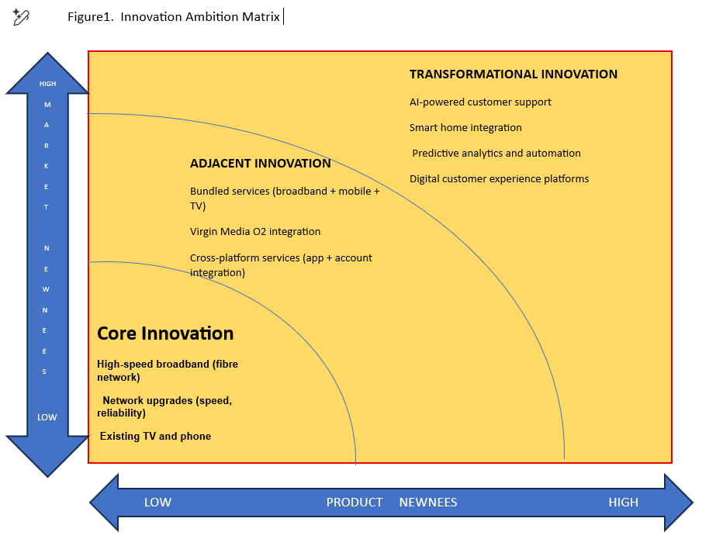

Core Innovation – Broadband Infrastructure and Connectivity
Core innovation within Virgin Media is primarily focused on improving existing broadband services through incremental upgrades in speed, coverage and reliability. The company currently serves approximately 5.7 million broadband customers, with network coverage reaching over 18.7 million UK premises (ThinkBroadband, 2025).
In terms of market position, Virgin Media holds around 21% of the UK broadband market, placing it among the leading providers alongside BT and Sky (Broadband UK, 2026).
However, the UK market is rapidly approaching saturation in terms of infrastructure. Gigabit-capable broadband is now available to approximately 85% of UK premises, significantly reducing differentiation based on speed alone (Ofcom, 2025; Point Topic, 2025).
This raises a critical question:
If most providers can deliver similar speeds, can infrastructure still act as a competitive advantage?
From a critical perspective, core innovation in telecoms is becoming increasingly commoditised. Competitors such as BT Group, through Openreach, are investing heavily in fibre rollout, while alternative network providers continue to expand coverage nationwide (Ofcom, 2025).
Therefore, core innovation remains necessary but insufficient, functioning as a baseline requirement rather than a strategic differentiator.

Adjacent Innovation – Bundling and Service Ecosystems
Adjacent innovation within Virgin Media is strongly reflected in its integration with O2, creating a converged telecom ecosystem. The company now manages approximately 45.8 million customer connections across broadband, mobile and TV services (Virgin Media O2, 2026).
This strategy aligns with broader industry trends, where bundling increases customer retention and average revenue per user (ARPU). The UK market currently includes over 29 million broadband connections, indicating a highly competitive environment where differentiation through standalone services is limited (Uswitch, 2025).
Competitors such as BT and Sky have adopted similar strategies, combining broadband, mobile and entertainment services into integrated packages.
However, this approach introduces a critical dilemma:
Does bundling enhance customer value, or does it increase complexity and reduce transparency?
Empirical observations suggest that customers often face challenges related to:
- complex pricing structures
- fragmented customer service
- difficulty managing multiple services
As a result, while adjacent innovation strengthens market positioning, it can negatively impact customer experience if integration is not seamless.

Transformational Innovation – AI, Data and Digital Transformation
Transformational innovation involves high-risk initiatives that redefine business models and customer experience. Within the telecom sector, this includes AI-driven services, automation and advanced data analytics.
Virgin Media has begun investing in digital transformation initiatives, including AI-based systems and enhanced digital platforms. At an industry level, the UK telecom market is projected to exceed $36 billion by 2031, reflecting the growing importance of digital services and infrastructure (Mordor Intelligence, 2026).
Additionally, 5G infrastructure continues to expand, with coverage reaching approximately 83% of UK premises, enabling new digital services and smart technologies (UK Government, 2025).
Despite these developments, Virgin Media’s transformation appears relatively incremental rather than disruptive.
This leads to a key strategic question:
Is the organisation truly transforming its customer experience, or simply digitising existing processes?
For example:
- AI chatbots may improve efficiency but often fail to resolve complex issues
- automation reduces costs but may diminish perceived service quality
Consequently, transformational innovation requires not only technological investment but also a fundamental redesign of customer experience and service delivery models.

Overall Critical Evaluation
Virgin Media demonstrates a balanced but uneven innovation portfolio, characterised by:
- strong core capabilities
- effective adjacent expansion
- limited transformational impact
The company’s strategic challenge lies in shifting from a network-focused model to a customer experience-driven model, where value is created through service quality, responsiveness and digital interaction.

Current Customer Journey (Virgin Media)
Customer journey mapping is essential for understanding how value is created across multiple touchpoints, rather than a single interaction. In telecommunications, customer experience is shaped by both digital and physical interactions, including online booking, installation and ongoing support (Lemon and Verhoef, 2016).
In the case of Virgin Media, the current journey can be structured as follows:
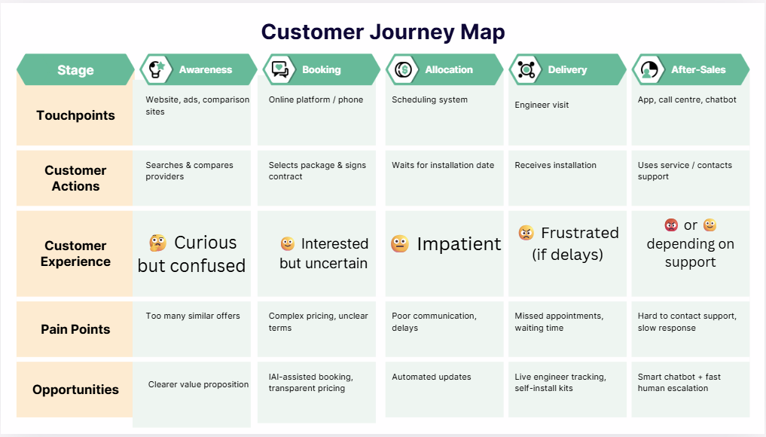
This customer journey highlights a key structural issue: while Virgin Media performs strongly in terms of technical service delivery, multiple friction points exist across communication, transparency and support stages.
The most critical stages are allocation and delivery, where expectations meet reality, and where dissatisfaction is most likely to occur.
This suggests that the main challenge is not technological capability, but experience design and service coordination.

Critical Analysis
At the awareness and booking stages, customers are exposed to a wide range of similar offers, often differentiated only by speed and price. However, in a market with over 29 million broadband subscriptions, this abundance of choice can create confusion rather than clarity (Ofcom, 2025).
This raises a key question:
Are telecom providers simplifying decision-making, or increasing complexity through aggressive competition?
Lemon and Verhoef (2016) suggest that early-stage interactions strongly influence expectations, meaning that unclear pricing or messaging can already reduce perceived value before the service is even delivered.

At the allocation and delivery stages, the journey becomes critical because expectations are tested against actual performance. According to Ofcom (2025), Virgin Media recorded approximately 56 complaints per 100,000 customers, compared to 21 for Sky, indicating weaker performance in service delivery.
This creates an important dilemma:
Is operational efficiency prioritised over customer experience?
Delays, missed engineer visits and poor communication frequently transform initial customer optimism into frustration, negatively impacting trust early in the relationship.

At the tracking stage, customer expectations have evolved significantly. In other industries, real-time updates are standard; however, telecom services often lack this level of transparency. Ofcom (2025) reports that 86% of broadband customer contacts are still handled via telephone, suggesting that digital tracking systems are insufficient.
Why do telecom companies invest in infrastructure but fail to provide visibility to customers?
The absence of real-time updates creates anxiety and a perceived lack of control.

At the after-sales stage, customer experience becomes the primary driver of loyalty. Research indicates that customer experience has a direct impact on churn and retention in telecommunications (Ribeiro et al., 2024).
Does digitalisation improve service efficiency, or reduce human support quality?
Difficult access to support, slow response times and limited app functionality contribute to dissatisfaction, even when the technical service itself performs well.

Key Critical Insight
Virgin Media’s current journey highlights a fundamental imbalance:
- strong technical capability
- weaker customer experience execution
The company delivers high-performance digital services, but not yet a fully seamless digital experience.

Opportunities for Improvement
The analysis of the current customer journey reveals several critical opportunities for improving Virgin Media’s service experience, particularly in areas related to communication, transparency and support. These opportunities are not purely technological but strategic, as they aim to reduce customer effort and enhance perceived service quality.
One of the most significant opportunities lies in the implementation of a more intelligent AI-driven chatbot system. While digitalisation has increased efficiency, existing automated systems often fail to resolve complex issues, leading to customer frustration. Research suggests that digital customer service improves satisfaction only when it is designed around user needs rather than cost reduction (Al Awadhi et al., 2021). Therefore, an effective chatbot should not only handle routine queries but also provide seamless escalation to human agents when necessary.
Another key opportunity is the introduction of real-time engineer tracking during the installation phase. As identified in the customer journey analysis, the delivery stage represents a major source of dissatisfaction due to uncertainty and lack of communication. Providing customers with live updates, similar to those used in logistics or ride-hailing services, would significantly reduce anxiety and improve trust. This aligns with findings that transparency and responsiveness are critical drivers of customer satisfaction in service industries (Lemon and Verhoef, 2016).
In addition, the development of enhanced self-installation kits offers an opportunity to reduce dependency on engineer visits. This would not only improve operational efficiency but also shorten waiting times, which are a key source of customer dissatisfaction. However, this approach must be carefully designed to ensure usability, as poorly implemented self-service solutions can shift complexity from the organisation to the customer.
Furthermore, the implementation of automated notifications and proactive communication systems represents a low-cost yet high-impact improvement. Customers increasingly expect real-time updates regarding service progress, delays and issues. The absence of such communication has been identified as a major weakness in the current journey. Proactive notifications can reduce uncertainty, minimise inbound customer queries and improve overall experience.
Overall, these opportunities highlight a fundamental shift required in Virgin Media’s approach: from reactive service delivery to proactive, customer-centric experience design. Rather than focusing solely on infrastructure and efficiency, the organisation must prioritise transparency, responsiveness and ease of interaction. This transformation is essential for reducing friction across the customer journey and improving long-term customer satisfaction and retention.

Part 2 – Proposed Digital Transformation

AI-Powered Smart Customer Experience System
Based on the analysis of Virgin Media’s current customer journey, a key limitation is not technological capability, but the lack of integration between digital tools and customer experience. Therefore, this report proposes the development of an AI-powered Smart Customer Experience System, designed to reduce friction, improve transparency and enhance responsiveness across all stages of the journey.

Concept Overview
The proposed system integrates artificial intelligence, real-time data and automation into a unified digital ecosystem, enabling Virgin Media to shift from reactive service delivery to proactive customer experience management.
AI is increasingly recognised as a critical driver of customer experience transformation in telecommunications, enabling personalised services, predictive support and real-time decision-making (Chen, 2025; Ofcom, 2026).

Key Components of the System

AI-Driven Scheduling and Allocation
The system would use AI algorithms to automatically schedule installations based on:
- location
- engineer availability
- urgency
- traffic and operational constraints
This reduces delays and improves efficiency. Research shows that AI-driven optimisation can significantly improve operational performance and customer outcomes (McKinsey, 2024).
Critical benefit:
Reduced waiting times → improved first impressions

Real-Time Tracking and Proactive Notifications
Customers would receive:
- live engineer tracking
- estimated arrival times
- automated updates via app/SMS
Transparency is a key driver of customer satisfaction, and lack of visibility has been identified as a major weakness in telecom journeys. AI systems enable real-time responsiveness and improved communication (Wamba, 2022; Ofcom, 2026).
Critical insight:
Visibility reduces anxiety and increases trust

Intelligent AI Chatbot with Human Escalation
The system would include an advanced AI chatbot capable of:
- resolving routine queries instantly
- understanding context
- escalating complex issues to human agents
Studies show that AI-enabled customer support improves response time and efficiency, while hybrid AI-human models increase satisfaction (Hegde, 2023; Oliver Wyman, 2025).
Additionally, 61% of customers expect seamless transition from AI to human support, highlighting the importance of hybrid systems (CSGI, 2025).
Critical dilemma:
AI must enhance, not replace, human interaction

Enhanced Mobile App as Central Experience Hub
The Virgin Media app would become the central platform where customers can:
- track installation
- manage services
- receive updates
- access support
AI-powered personalisation allows telecom firms to tailor services and predict customer needs, improving engagement and retention (Frontier Economics, 2024).
Strategic impact:
From fragmented journey → integrated digital ecosystem

Self-Installation and Automation
For suitable customers, improved self-install kits supported by AI guidance (video, chatbot assistance) would:
- reduce dependency on engineers
- shorten delivery time
- lower operational costs
However, research highlights that self-service must be carefully designed to avoid transferring complexity to customers (Al Awadhi et al., 2021).

Expected Impact
The implementation of this system is expected to generate both operational and customer benefits:
- AI can reduce customer service handling time by up to 70% and improve resolution rates significantly (Oliver Wyman, 2025)
- predictive AI systems can reduce churn by identifying customer issues early (TM Forum, 2025)
- improved customer experience directly increases loyalty and long-term revenue (Ribeiro et al., 2024)
Key transformation:
From reactive problem-solving → proactive experience management

Critical Evaluation
While the proposed system offers significant benefits, it also raises important challenges:
- dependence on data quality and system integration
- risk of over-automation
- need for organisational change and staff training
Critical question:
Is the organisation ready to transform its processes, or only its technology?
Research suggests that the main barrier to digital transformation is not technology itself, but organisational capability and strategic alignment (Chen, 2025).

Final Insight
The AI-powered Smart Customer Experience System represents a shift from:
“service delivery model” → “experience management model”
For Virgin Media, this transformation is essential in order to:
- reduce friction across the journey
- improve transparency and trust
- compete on customer experience rather than infrastructure

Improved Customer Journey (Virgin Media)
Following the identified gaps in the current customer journey, this section proposes an improved journey design based on the implementation of an AI-powered Smart Customer Experience System. The objective is to create a journey that is faster, more transparent and fully digital, reducing customer effort and improving overall satisfaction.
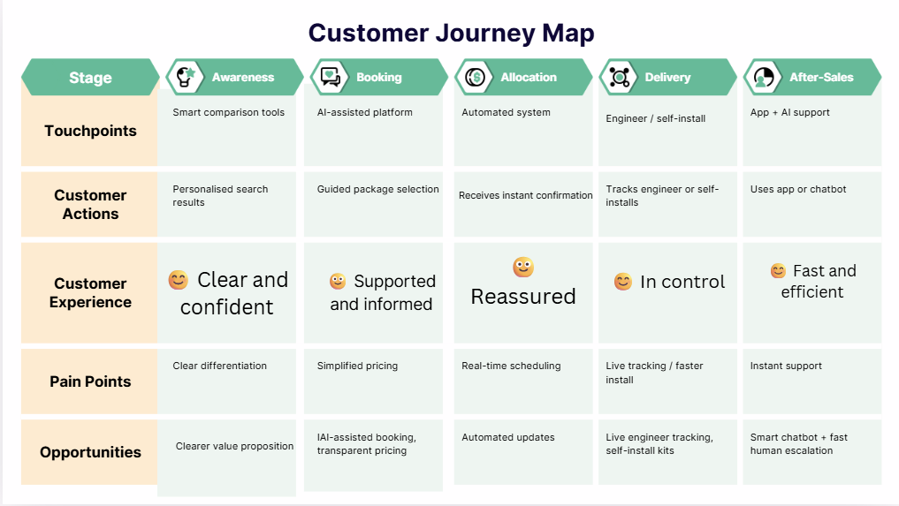

Analytical Explanation

At the awareness and booking stages, the improved journey reduces complexity through AI-assisted decision-making and personalised recommendations. Instead of overwhelming customers with multiple similar offers, the system guides them towards the most suitable package. This directly addresses the issue of information overload identified in the current journey (Lemon and Verhoef, 2016).
At the allocation stage, automation enables instant scheduling and proactive communication. Customers receive clear installation windows and updates without needing to contact support.
👉 This transforms the experience from uncertainty → reassurance
At the delivery stage, the introduction of real-time engineer tracking and improved self-install options significantly reduces waiting time and frustration. Customers gain control over the process, which is a key factor in perceived service quality.
Critical improvement:
From passive waiting → active visibility
At the tracking stage, the mobile app becomes a central hub, providing real-time updates, notifications and service status. This eliminates the need for customers to chase information, addressing one of the major pain points identified earlier.
At the after-sales stage, the combination of an AI chatbot and human escalation ensures fast and effective support. Routine issues are resolved instantly, while complex problems are handled by human agents.
Research shows that hybrid AI-human systems improve both efficiency and satisfaction compared to purely automated systems (Chen, 2025; McKinsey, 2024).

Key Transformation
The improved journey represents a shift from:
Fragmented and reactive journey → Integrated and proactive experience
Strategic Impact
The redesigned journey is expected to:
- reduce customer effort and waiting time
- improve transparency and trust
- decrease complaints and churn
- enhance overall customer satisfaction
Most importantly, it allows Virgin Media to compete not only on infrastructure, but on customer experience, which is becoming the primary differentiator in the telecom industry.

Impact of the Proposed Solution
The implementation of the AI-powered Smart Customer Experience System is expected to generate significant benefits for Virgin Media, both in terms of customer outcomes and organisational performance.

Improved Customer Satisfaction
The proposed system directly addresses key drivers of customer satisfaction, including transparency, responsiveness and ease of interaction. Real-time tracking, proactive communication and AI-assisted support reduce uncertainty and improve the overall service experience.
Research indicates that customer satisfaction in telecommunications is strongly influenced by service quality dimensions such as reliability and responsiveness (Kuo et al., 2009). Furthermore, personalised digital interactions enabled by AI can significantly enhance perceived service value (Huang and Rust, 2021).
As a result, customers are more likely to perceive the service as efficient and trustworthy.

Cost Reduction and Operational Efficiency
The integration of AI and automation is expected to reduce operational costs by optimising resource allocation and reducing reliance on manual processes. AI-driven scheduling systems can improve workforce efficiency, while chatbots can reduce the volume of customer service interactions.
According to McKinsey (2023), AI adoption in telecom operations can reduce customer service costs by up to 30–40%, while improving service speed and consistency.
This enables a transition towards a scalable and data-driven operational model.

Reduction in Complaints and Customer Churn
By addressing critical pain points such as installation delays, lack of communication and limited support access, the proposed system is expected to reduce complaint volumes and improve customer retention.
In the UK market, Virgin Media has been reported to have higher complaint rates compared to competitors (Ofcom, 2025). Reducing these issues is essential for improving brand perception.
Research shows that customer experience has a direct impact on churn behaviour, with poor service interactions significantly increasing switching intentions (Homburg et al., 2017).
Improving the customer journey can therefore lead to lower churn and increased customer lifetime value.

Competitive Advantage
The proposed transformation enables Virgin Media to shift from competing on infrastructure to competing on customer experience. In mature telecom markets, where service offerings are increasingly similar, customer experience becomes a key differentiator (Porter and Heppelmann, 2014).
This allows the company to position itself as a digital service leader, rather than simply a network provider.

Key Performance Indicators (KPIs)
To evaluate the effectiveness of the proposed system, the following KPIs can be used:
- Customer Satisfaction Score (CSAT) → target: increase by 15–20%
- Net Promoter Score (NPS) → target: measurable improvement in customer advocacy
- Average Resolution Time → reduce by 30% through AI support
- Installation Lead Time → reduce waiting time for installation
- Complaint Rate (per 100,000 customers) → decrease from current levels
- Customer Churn Rate → reduce annual churn (currently ~15–25%)
These KPIs provide measurable evidence of whether the transformation delivers real value.

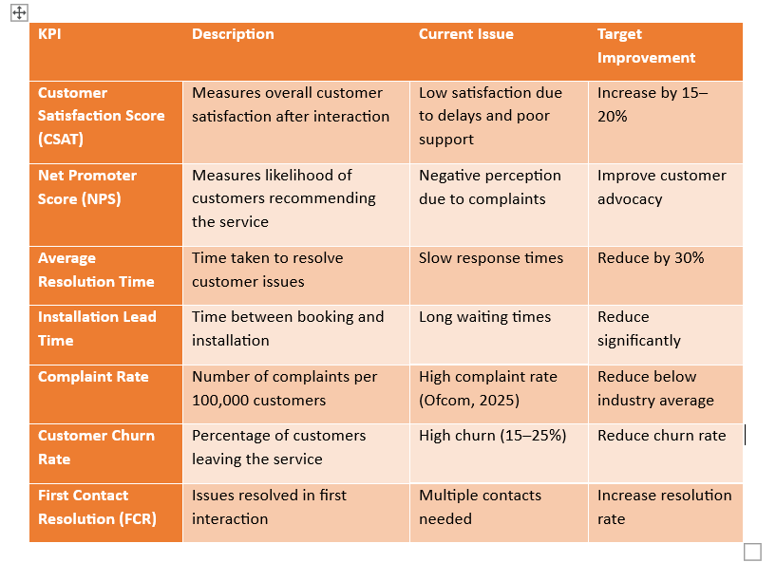

Critical Insight
While the proposed system offers significant benefits, its success depends on effective implementation and organisational readiness.
Key question:
Can Virgin Media align its operational processes and culture with a customer-centric digital strategy, or will technology be implemented without fundamental change?
Research suggests that digital transformation often fails not because of technology limitations, but due to organisational resistance and lack of strategic alignment (Verhoef et al., 2021).

Conclusion
This report has critically analysed Virgin Media’s current innovation strategy and customer journey, highlighting a clear imbalance between strong technical capabilities and weaker customer experience delivery. While the organisation demonstrates solid performance in core and adjacent innovation, particularly through broadband infrastructure and service bundling, it remains less developed in transformational innovation focused on customer-centric digital experience.
The analysis of the current customer journey revealed several key pain points, including delays in installation, lack of communication and limited transparency, which negatively impact customer satisfaction and trust. These issues are not primarily technological, but relate to how services are designed and delivered across touchpoints.
In response, the proposed AI-powered Smart Customer Experience System offers a strategic solution aimed at reducing friction, improving transparency and enhancing responsiveness. By integrating artificial intelligence, real-time tracking and proactive communication, the redesigned journey enables a shift from reactive service delivery to proactive experience management.
Digital transformation is therefore not simply about adopting new technologies, but about fundamentally redesigning the customer experience. As argued by Verhoef et al. (2021), successful digital transformation requires organisations to align technology, processes and customer needs in order to create sustainable value.
In a highly competitive and increasingly commoditised telecom market, the ability to deliver a seamless and customer-centric digital experience represents a key source of competitive advantage. For Virgin Media, this transformation is essential not only to improve customer satisfaction and reduce churn, but also to remain relevant in an industry where experience, rather than infrastructure, is becoming the primary differentiator.

9.References list:

- Ahmad, A., Jafar, A. and Aljoumaa, K. (2019) Customer churn prediction in telecom using machine learning and social network analysis. Available at: https://arxiv.org/abs/1904.00690 (Accessed: 21 March 2026).
- Al Awadhi, J., Obeidat, B. and Alshurideh, M. (2021) The impact of customer service digitalization on customer satisfaction. International Journal of Data and Network Science, 5(4), pp. 815–830. Available at: https://www.growingscience.com/ijds/Vol5/ijdns_2021_301.pdf (Accessed: 21 March 2026).
- Bouraqia, K. et al. (2019) Quality of experience for streaming services: Measurements, challenges and insights. Available at: https://arxiv.org/abs/1912.11318 (Accessed: 21 March 2026).
- Chen, Y. (2025) Integrating Artificial Intelligence and Customer Experience in Digital Services. Available at: https://journals.sagepub.com/doi/10.1177/14413582241252904 (Accessed: 21 March 2026).
- Diaz-Aviles, E. et al. (2015) Towards real-time customer experience prediction for telecommunication operators. Available at: https://arxiv.org/abs/1508.02884 (Accessed: 21 March 2026).
- Homburg, C., Jozić, D. and Kuehnl, C. (2017) Customer experience management. Journal of the Academy of Marketing Science. Available at: https://link.springer.com/article/10.1007/s11747-015-0460-7 (Accessed: 21 March 2026).
- Huang, M.H. and Rust, R.T. (2021) Artificial intelligence in service. Journal of Service Research. Available at: https://journals.sagepub.com/doi/10.1177/1094670520902266 (Accessed: 21 March 2026).
- Kuo, Y.F., Wu, C.M. and Deng, W.J. (2009) Service quality and customer satisfaction. Available at: https://www.sciencedirect.com/science/article/pii/S0747563209000363 (Accessed: 21 March 2026).
- Lemon, K.N. and Verhoef, P.C. (2016) Understanding customer experience throughout the customer journey. Journal of Marketing. Available at: https://pure.rug.nl/ws/files/81733365/Understanding_Customer_Experience_Throughout_the_Customer_Journey.pdf (Accessed: 21 March 2026).
- McKinsey & Company (2024) The network is the product: AI in telecom customer experience. Available at: https://www.mckinsey.com (Accessed: 21 March 2026).
- Mordor Intelligence (2026) UK telecom market report. Available at: https://www.mordorintelligence.com (Accessed: 21 March 2026).
- Ofcom (2024) Communications Market Report. Available at: https://www.ofcom.org.uk (Accessed: 21 March 2026).
- Ofcom (2025) Comparing customer service report. Available at: https://www.ofcom.org.uk (Accessed: 21 March 2026).
- Point Topic (2025) UK broadband market analysis. Available at: https://www.point-topic.com (Accessed: 21 March 2026).
- Porter, M.E. and Heppelmann, J.E. (2014) How smart, connected products are transforming competition. Harvard Business Review. Available at: https://hbr.org/2014/11/how-smart-connected-products-are-transforming-competition (Accessed: 21 March 2026).
- Qasim, D., Bataineh, A. and Alhur, M. (2025) User-driven innovation in telecom. Available at: https://www.sciencedirect.com/science/article/pii/S2096248725000128 (Accessed: 21 March 2026).
- Ribeiro, H. et al. (2024) Customer experience, loyalty and churn in telecommunications services. SAGE Open. Available at: https://journals.sagepub.com/doi/10.1177/21582440241245191 (Accessed: 21 March 2026).
- Subramani, V. (2022) Digital transformation in telecommunications. Available at: https://onlinelibrary.wiley.com/doi/10.1155/2022/9562936 (Accessed: 21 March 2026).
- Verhoef, P.C. et al. (2021) Digital transformation: A multidisciplinary reflection. Journal of Business Research. Available at: https://www.sciencedirect.com/science/article/pii/S014829631830456 (Accessed: 21 March 2026).

