Extending the Campaign Life of Blast Furnace Casthouse Main Iron Runners: A Case Study on Tata Steel UK’s Blast Furnace 4, South Casthouse.

Rhys Stroud
2114318


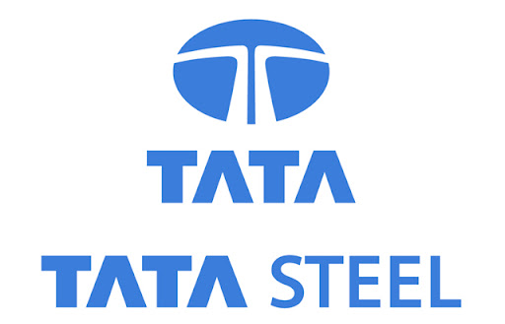

Abstract

This dissertation examines the strategy used to extend the campaign life of the Main Iron Runner(=MIR) in Tata Steel UK’s Blast Furnace 4, South Casthouse. The study will focus on the structural performance and material degradation which influence the lifespan of the MIR under extreme conditions of molten metal flow and slag interaction. Over time, the runner experiences significant wear, due to the harsh conditions but also structural elements. The research investigates the structural improvements made, identifying the root causes of issues and the remedial work conducted to reinstate the casthouse.
Through a detailed case study, the dissertation will assess the performance of existing refractory materials and explore potential improvements in the optimisation and maintenance strategies. Emphasis is placed on understanding the mechanisms of wear and erosion, particularly in high-impact areas exposed to the turbulent environment of the MIR. The study also investigates the impact of structural modifications on enhancing the durability and extending the campaign life of the MIR.
By implementing alternative strategies, the study highlights the significant extension of the campaign life, thereby reducing the associated costs. The findings of this research provide a valuable insight for the future optimisation of Tata Steels global casthouse network and offer practical solutions for the enhancement of blast furnace operations.

Declaration of Authenticity

This dissertation is the result of the author’s original research. It has been composed by the author and has not been previously submitted for examination which has led to the award of a degree.

Signed: R. Stroud
Date: 18/05/2025

Table of Contents
Abstract 2
Declaration of Authenticity 3
Acknowledgements 5
List of figures and tables. 6
Abbreviations. 7
1 Introduction. 8
1.1 Introduction to Blast Furnace Ironmaking. 8
1.2 Introduction to the Casthouse and Runner Systems 10
1.3 Introduction to refractories 12
1.4 Choosing the right refractory 13
1.5 Classification of Refractories 13
1.6 Properties of Refractories. 14
2 Problem statement 15
2.1 Introduction. 15
2.2 Loss Of containment in October 2016. 16
2.3 LoC July 2021. 17
2.4 Cracks in the MIR working linings 18
2.5 Limitations on MIR Campaign life 19
2.6 Structural model of the BF4 South Casthouse 20
3 Literature Review 21
3.1 Main Iron Runner Wear Mechanisms. 21
3.2 Slag attack on Main Iron Runner Refractory Castables 21
3.2.1 Chemical Corrosion 21
3.2.2 Thermal Shock and Oxidation 21
3.3 Creep Mechanisms of Refractory Materials 22
3.3.1 Grain Boundary sliding and Dislocation Creep 22
3.4 Thermal Stress Cycling in Refractory Materials 23
3.5 Mechanical Erosion and Abrasive wear in the MIR 23
3.5.1 Abrasive wear 24
4 Main Content Of Work 25
4.1 Reasons for Movement – In Detail 25
4.2 BF4S MIR Design – Fibre board and Movement 25
4.3 Overstretching of MIR Working Lining 27
4.4 BF4 Expansion Analysis – Comparison Past vs Present Material Use. 28
5 Structural Repairs 30
5.1 Structural Repairs 30
5.1.1 Repair One – August 2021 30
5.1.2 Repair Two – 2023 31
5.1.3 Repair Three & Four 32
5.2 Completion of Structural Work 33
6 Reinstating the Refractory 34
6.1 Zoned Linings 35
6.2 Repair Schedule – As is 37
6.3 Repair Schedule – Following Zoned Lining – Campaign extensions 39
6.3.1 Cost Comparison 40
7 Practice into Reality 42
7.1 Implementation 42
8 Backing the Methodology with Data 44
8.1 Tracking The Data 44
9 Future Potential 45
10 Conclusion 46
11 References 48
12 Appendices 51
12.1 Appendix A—Reinstatment of the refractory linings of the MIR. 51
12.2 Appendix B – Linings recast 52
12.3 Appendix B – Wear profile and scan of the BF4S MIR 53
12.4 Appendix C – TSPT PCM Engineers Thermal Report 54
12.5 Appendix D – Scan Data highlighting potential to go further 55

Acknowledgements

I would like to express my sincere gratitude to Tata Steel Port Talbot for sponsoring my BEng studies. Their support, particularly in allowing me the time to attend lectures and providing the necessary resources throughout my academic journey, it has been invaluable.
A special thanks goes to my line managers, Natalie Philips and Jordan Davies, and to my mentors Dariush Dimech and Matthew C. Davies, whose unwavering support and encouragement made it possible to balance my studies alongside the demands of working within the challenging blast furnace environment.
I am also deeply grateful to my academic supervisor, Dr. Kelvin Lake, for his guidance and expertise. His support was instrumental in helping me develop the academic skills required to complete this dissertation.
Finally, I would like to thank my parents and my fiancé, Caitlin, for their constant encouragement, patience and belief in me. I could not have completed this journey without their support and belief.

List of figures and tables.
Figure 1.0 – The blast furnace feeds in motion (Osborne, 2013). 10
Figure 2 – Illustration of the BF4 South casthouse, highlighted ae the specified runners within the system. 11
Figure 3 – MIR illustration of liquid iron and slag passing under skimmer. 11
Figure 4 – Molten iron exiting the tilter and flowing directly into a torpedo (Pronix, 2024). 12
Figure 5 - LoC of BF4S MIR 16
Figure 6 - Cracks running along the MIR 18
Figure 7 - Cracks in BF4S MIR from report conducted by Vesuivus (Quigley, 2016) 19
Figure 8 - Model of movement created by J&N (Nicholas, 2017) 20
Figure 9 - Generic Creep Curve of Refractory Material (Harrison, 2014) 22
Figure 10 - Grain boundaries with creep (Lea, 2022) 22
Figure 11 - BF4S MIR with Safety lining highlighted 26
Figure 12 - Model of movement (Nicholas, 2017) 26
Figure 13 - BF4S MIR Cross section (J.Jones, 2017) 27
Figure 14 - Overstretching of material (Quigley, 2016) 27
Figure 15 - Material campaign comparison (Fitzpatrick, 2014) 28
Figure 16 - Exposed steelwork of BF4S MIR (Quigley, 2021) 30
Figure 17 - Model of work to be complete (Evans, 2021) 30
Figure 18 - Structural model of Repair two (Evans, 2023) 31
Figure 19 - BF4S MIR Repairs (Quigley, 2021) 31
Figure 20 - BF4S Structural Repairs (Evans, 2023) 32
Figure 21 - BF4S MIR Refractory Install (Vesuvius, 2012) 34
Figure 22.0 - Vesuvius HM38 PD 35
Figure 23.0 - Vesuvius VX281 PD 36
Figure 24 - BF4S Zoned Lining (Fitzpatrick, 2023) 37
Figure 25 - Installation of refractory material within BF4S MIR (Fitzpatrick, 2023) 41

Abbreviations.
MIR – Main Iron Runner
SIR – Secondary Iron Runner
SR – Slag Runner
TSPT – Tata Steel Port Talbot
BF – Blast Furnace
BF4 – Blast Furnace 4
BF4S – Blast Furnace 4 South
TH – Taphole
ILE – Iron Lip End
LoC – Loss of Containment
Kthm – Kilo tone of hot metal
SiC – Silicon Carbide
HM38 – HydraMax 38
VX281 – HydraMax VX281
PLC – Permanant Linear Change
UC – Universal Column
UB – Universal Beam
F/C – Full Campaign
M/C – Mid Campaign

Introduction.

Introduction to Blast Furnace Ironmaking.

A blast furnace (=BF) is a counter-current reactor based on the principle of continuous operations. At the top coke and other burdens are charged sinter, pellets, iron ore (Usually hematite Fe2O3, occasionally the use of magnetite Fe2O4) in alternating layers (Seshadri, 2014). As these charge materials descend under the influence of gravity, at the lower section of the furnace hot blast is injected through the tuyeres as these gases ascend through the furnace the descending burden Figure 1.0 illustrates this in motion. A blast furnace produces ‘pig’ iron from iron ore by the reducing action of carbon (which is supplied through coke) at elevated temperatures in the presence of fluxing agents like limestone. The blast furnace is a high productivity unit which has a main purpose, the rapid production of iron from oxide and ores. (“The Iron Blast Furnace. Theory And Practice [PDF] [2v0ublncj940]”) This reaction between air and the fuel generates carbon monoxide. The gas reduces the iron oxide into iron:
As stated, the introduction of limestone to the process as a key flux, this can be added at ranges from 0.5 inch to 1.5 inch,
Oxide helps to remove some of the acidic impurities that are present within the ore. These impurities are removed and react with calcium oxide to ensure that the liquid slag floats on top of the molten iron.
The production of iron in the blast furnace is a continuous process. The furnace is heated constantly and is recharged with the raw materials from the top of the furnace while being tapped from the bottom at the taphole (=TH).
The blast furnace is well detailed in literature, and the basics is the only detail that’s required. Only the essential aspects of Main Iron Runner (=MIR) in its larger context will be defined below, the location, purpose and functionality explained. The process conditions, and key chemistries of hot metal and slag related to the MIR.
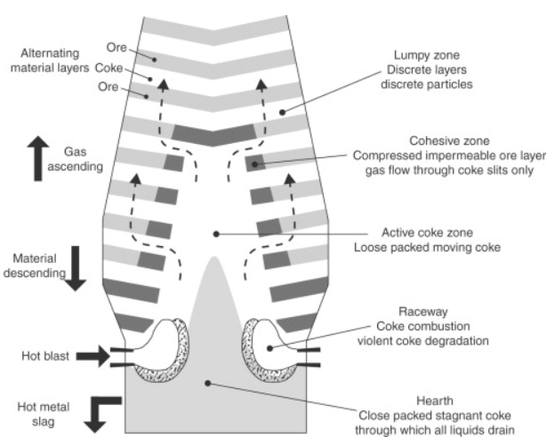
Figure 1.0 – The blast furnace feeds in motion (Osborne, 2013).
This dissertation is aimed to explore the methodology associated with the extended campaign life of the MIR at Tata Steel Port Talbot’s (=TSPT), Blast Furnace 4 (=BF4) South Casthouse record campaign. By analysing the current state, identifying the potential areas of improvement, and implementing specific interventions, the research will provide a thorough case study on the optimisation of casthouse operations on how TSPT accomplished the record campaign.

Introduction to the Casthouse and Runner Systems

In blast furnace (=BF) ironmaking the runner system is instrumental in transporting molten materials; assembled consisting of the Main Iron Runner (=MIR), Secondary Iron Runner (=SIR), Slag Runner (=SR), and a skimmer block; Figure 2 illustrates the casthouse. During the initial tapping of a furnace the function of the MIR is to transport and separate the molten iron and slag after its extraction from the taphole (=TH).
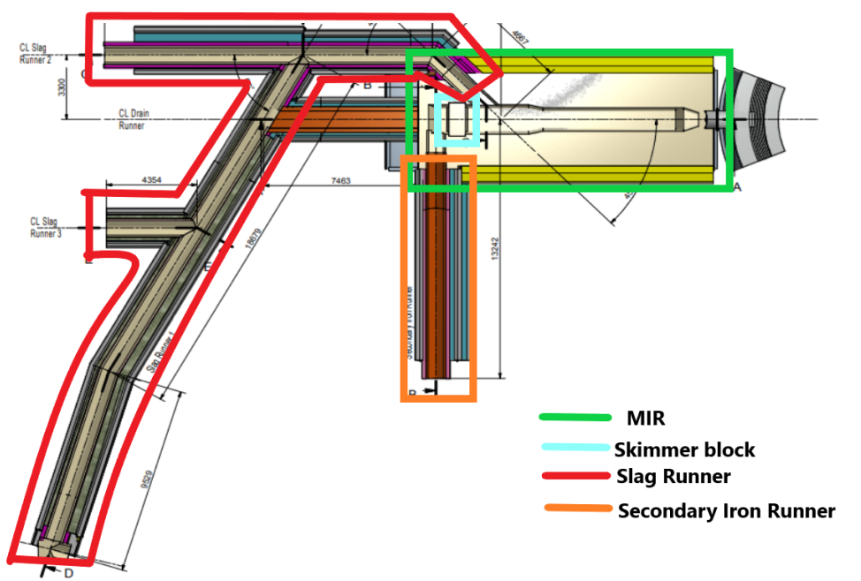
Figure 2 – Illustration of the BF4 South casthouse, highlighted ae the specified runners within the system.
The MIR contains the flow of liquid slag and iron and transports them to the secondary runners. The main function of the MIR is to achieve a separation of slag and iron, this is achieved through the use of the skimmer block which enables that to happen by the differences in specific densities of iron and slag and by the natural force of gravity, Figure 3 illustrates this.
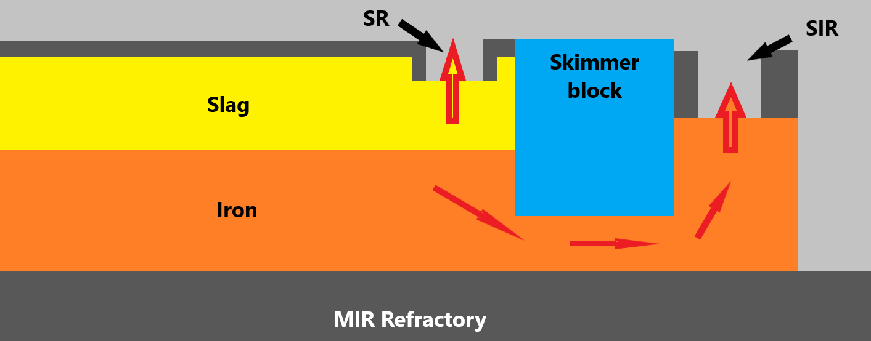
Figure 3 – MIR illustration of liquid iron and slag passing under skimmer.
From a refractory perspective the MIR can be a very challenging area to manage, because of the iron and slags that are present. Within the secondary runners there are refractory materials that are manufactured to deal with the material they are to encounter, different to the MIR as the refractory materials must cover the presence of iron and slag. The wear mechanisms that the MIR encounters will be explained within the literature review section of this dissertation.
After the iron enters the SIR, it flows through and falls off the Iron Lip End (=ILE) into the tilter below where it is then poured off into one of two torpedo ladle cars that are positioned below the casthouse floor, illustrated below in Figure 4.
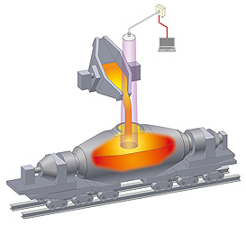
Figure 4 – Molten iron exiting the tilter and flowing directly into a torpedo (Pronix, 2024).
The slag also exits the MIR, through the SR where it eventually ends in one of two places; the granulation plant (Where it is pumped away for processing), or alternatively the slag flows to the abort where it is then poured directly into a pit where it cools and solidifies naturally before being dug and taken when pit levels reach maximum levels.

Introduction to refractories
Refractories are inorganic, non-metallic, porous and heterogeneous materials composed of thermally stable mineral aggregates, a binder, phase and additives. (Bhatia, 2020). Refractories are primarily made from the oxides of silicon, aluminium, magnesium, calcium, and zirconium, in addition to certain non-oxide refractories like graphite, carbides, nitrides, borides, and silicates (IRE, 2017).
Refractories are used by the metallurgy industry in the internal linings of furnaces, runner systems, tilters, and any other vessels that are used in the holding and transportation of molten metal and slag. The listed equipment that the refractories operate within are under high pressures, and operating temperature. Due to the extremely high melting pint of iron metallurgists must raise temperatures to over 1500c (IRE, 2017), how these have effects i.e. abrasion, wear; will be covered within the literature review.

Choosing the right refractory
Refractories generally operate within a band of requirements; this can be summed as:
- The ability to withstand elevated levels of heat and contain that heat within a limited area i.e. a BF, or a runner system.
- The ability to withstand the erosion, abrasion, and other degrading actions of molten materials, hot gasses, and slag erosion etc.
- The ability to resist contamination of the material with which it encounters.
- The ability to maintain dimensional stability at elevated temperatures after/during repeated thermal cycling.
- The ability to conserve heat.

Classification of Refractories
There are different standards, and classifications of refractories, these are based on a number of factors; mineral composition; carbon content, alumina, silicon refractories. The other is the chemical properties, these are the different types of refractory materials; acidic, neutral, and basic refractories. In short, the main difference between the three materials is the main components within the body that distinguish between them, there are categorized as:
Acidic refractories, those are which are attacked by alkalis (basic slags), these are used in areas where slag and the atmosphere are regarded as acidic; examples of these refractories being silica, zirconia and alumina-silicate (Sengupta, 2019).
Neutral refractories, these are chemically stable both in acidic and basic environments. Common examples of this being carbon graphite (inert), chromite, and alumina; these refractory materials are extensively used in metallurgical furnaces, out of those stated graphite is the least reactive to those conditions, meaning it is extensively used throughout those processes (Bhatia, 2020).
Basic refractories, these are those that are refractories that are attacked by acid slags but stable within alkaline environment, since these do not react negatively with alkaline slags, these refractories become considerably important when operating within steelmaking practices. The most sought-after basic refractories are magnesite, dolomite, and magnesia-chrome refractories (Endra, 2013).
Refractories are also classified upon their physical form. These are shaped and unshaped, the former is commonly known as refractory bricks and the latter as a ‘monolithic’ (aggregate, similar to cement) refractories (Bhatia, 2020).
Shaped are those which have a prefixed shape that is desired by the end user, these and be split up into two division: standard and special shapes. Standard shaped are what is conformed and perceived as the industry standards (Bhatia, 2020). Special shapes are specifically made for a required placement, which is not applicable to any other end placement.
Unshaped refractories are without a defined form and are only given their shape upon the end application. The majority of unshaped refractories come in the form of an aggregate, like a cement. It forms a joint less and are better known as a ‘monolithic’ refractory (Bhatia, 2020).

Properties of Refractories.
The properties of refractories, and refractory materials are important and fundamental to the development, improvement, quality and selection of refractory lining. (“Introduction to the Properties of Refractories and Refractory materials”) While the properties of the refractories, or refractory materials don’t alone choose the performance of the given application, comparisons between the properties are frequently used to screen the viability and potential outlook on the given material/s (Endra, 2013). Important properties of the refractories that must be considered are Refractoriness, porosity, bulk density, strength (or Refractories under load), thermal expansion & conductivity, resistance to abrasion & corrosion, permeability and thermal spalling.
Refractoriness, this is generally applicable to measure the melting point of a given refractory. This is usually the melting points that are measured over a magnitude of temperature ranges- perhaps over a several hundred of degree centigrade. The determination of solidus and liquidus temperatures is something that isn’t regarded as useful, as a material that may be partly liquid yet can appear solid. At higher temperatures where portions become liquidous and exceeds the critical value which depends on viscosity, the material will either collapse and appear liquid or pasty, or it will exude liquids and collapse at a later time (Gilchrist, 1977).
Porosity, the ratio of a given materials overall pore volume to that of the bulk, lower porosity materials possess the greatest strength, higher level of thermal conductivity due to the absences of air voids, greater resistance to abrasion & corrosion, but this unfortunately has a negative effect in the resistance to thermal spalling. Highly porous materials reduce the thermal spalling, confine heat due to the presence of insulating air voids, low thermal conducting and low thermal expansion and contraction (Bharati, 2023).
Melting point (melting temperature) is the specification of the materials ability to withstand high temperatures without any chemical and physical change occurring. The melting point of a refractory material is purely related to the composition of the pure state, this can vary from 1,700degC to 3,480degC- these melting points serve as a sufficient bass for the thermal stability, and indicate the maximum temperature in which the chosen materials can operate within (Bharati, 2023).
Bulk density, the bulk density is normally considered in conjunction with apparent porosity, it is the measure of weight of a given volume that includes the pore space of the material (Bhatia, 2020). Bulk density can be regarded as one of the most important characteristics and provides a general indication of the overall quality of the product. An indicated increase in bulk density increases the volume stability, heat capacity, and resistance to abrasion and slag penetration (Schacht, 2004).

Problem statement

Introduction.

Blast Furnace 4 (=BF4) was rebuilt in 1992 including the casthouses physical structures. Based on the available calculations (Nicholas, 2017) it can be evidently concluded that the casthouses were designed within the ‘traditional’ manner. By ‘traditional’ civil/structural perspective is used, without taking into consideration the impact in which refractory could impact the structure other than being a distributed load within. The calculations verify a significant structural modification to the MIR on BF4 South (=BF4S), which is determined as compliant with the BS5950-1:2000. However, the influences of temperature, or the expansion of refractories is an issue that is simply not considered within that report.
BF4 was operational over a 20-year campaign and was rebuilt in 2013, this time however without any substantial work associated with the casthouses. However, with the desire, and requirement to complete the upmost to implement best practices regarding safety. Any movements of the structure have a detrimental effect to the day-to-day operations of the casthouse operators, because everything from the refractory to the gun and drill foundations are integrated within the structure meaning that these are also a moving objects. The movement in guns and drills lead to the increased risk of the gun becoming misaligned with the taphole, this can lead to catastrophic issues occurring such as a ‘failure to plug’ incident, which is an obvious serious safety issue. Another concern, in this case being that the casthouse structure moving more than what is designed, leading to structural failures occurring.
The purpose of this dissertation is to analyse the associated movements that caused considerable issues at TSPT BF4 South casthouse, and how TSPT completed subsequent work that led to extension of the life of the MIR.

The remainder of this chapter will explore/explain the related changes and events over the previous years to give the explanation that ensures that the problem description of this chosen dissertation is in the right context.

Loss Of containment in October 2016.

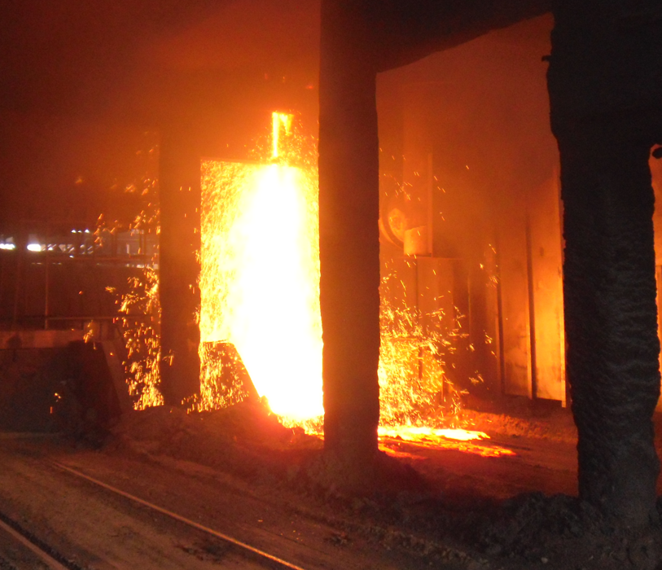
On the 20th of October 2016 a Loss of containment (=LoC) occurred where iron found a weakness in the refractory lining of the BF4 South MIR and onto the rail tracks below the casthouse. As a result of the issue a management investigation was launched (Taylor, 2016) to determine the root cause of the LoC, and how this could’ve possibly occurred. As a result, it was determine that the steel structure of the BF4 South casthouse had failed in multiple areas where, apart from burning away, bolts had sheared under unknown forces. The critical supporting girders of the MIR refractory had failed on the end connection points. It was determined that the total collapse of the MIR structure was imminent. Obviously, the refractory had failed to contain the molten materials also.
Figure 5 - LoC of BF4S MIR
As a result of the incident an investigation was launched, which ultimately resulted in a thorough structural survey to be commenced of the casthouse structure by a local engineering firm Skelton Thomas, this was then assessed by structural experts at James & Nicholas (Nicholas, 2017). Apart from the localised structural issues that were determined in the close proximity to the LoC occurrence, many more compromised structural beams and connections were found away from the area indicating that there were significant movements larger than what the design could allow for. According to the report conducting (Nicholas, 2017), there were defects in the structure found at 71 locations, 42 of them were deemed as a result of expansion issues. The findings (Nicholas, 2017) also concluded that a total of approximately 600MN of force exerted onto the steel structure due to the thermal expansion of the refractory within the MIR. The tensile capacity of the steel structure to constrain the force is approximately 5MN. Within the initial report from James and Nicholas there was an adamant statement made that there was no problem with the structure, just the refractory itself. The work that followed, along with the progressive improvements that enabled the refractory, and the MIR to break records is the key record for the purpose of this dissertation.

LoC July 2021.

In July 2021, a Loss of Containment (LoC) event occurred at the BF4 South Main Iron Runner (MIR) shortly after the furnace was returned to service following an engineering-related outage. The outage lasted eight days, during which the MIR and associated secondary iron runners were placed on flare and covered for 12 hours prior to reactivation. The incident unfolded during the second cast following restart. Approximately 20 minutes after plugging, molten iron was observed leaking from the steel casing and dripping onto the 2 Road area below. Casthouse personnel were immediately notified, and the south side of the furnace was drained as an emergency precaution. A detailed refractory inspection began during the night shift of 12 July, when wrecking operations commenced at the MIR and Secondary Iron Runner (SIR) intersection. Initial observations indicated that molten iron had infiltrated from the well area and travelled between the skimmer and the castable lining.
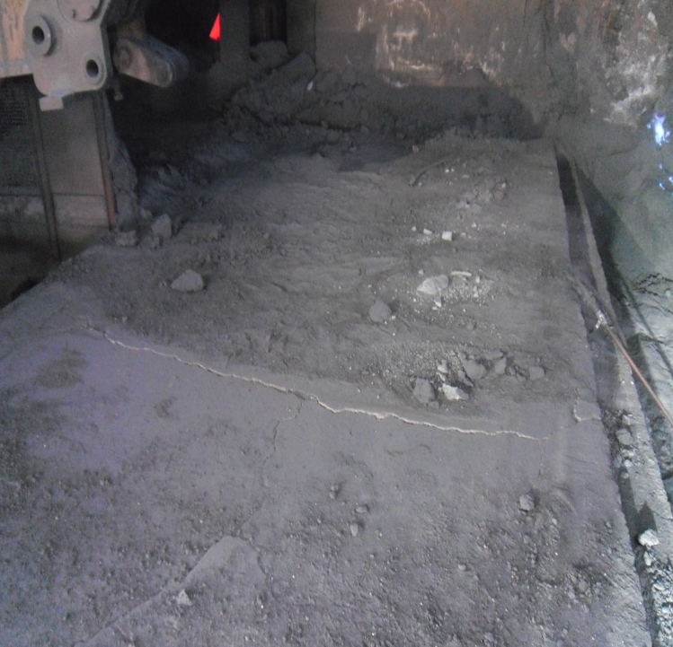
A significant fracture was discovered at floor level within the skimmer, extending laterally toward the MIR and continuing approximately two metres along its path (See Figure 6 For reference to the cracks). Further excavation revealed that the fracture penetrated the full refractory lining system, including the working lining, safety lining, and insulation layer. The pathway of iron infiltration appeared to follow the fracture line from the skimmer wing, progressing between the parted safety and insulation layers and exiting at the upright of the steel casing. Upon exposure of the steelwork, additional structural concerns became apparent. Specifically, the floor beams connecting the MIR and SIR were found to be disconnected and floating, and the corresponding floor plate had lifted from its original position. Notably, these structural deficiencies coincided with the location of the refractory fracture. It is therefore inferred that the movement and instability of the structural interface between the MIR and SIR contributed directly to the initiation and propagation of the fracture within the refractory lining. Given the presence of heavy mobile equipment traffic in the area, it is plausible that structural flexing or vibration imposed mechanical stresses on the refractory, which ultimately compromised the lining’s integrity and allowed molten metal to penetrate the containment system.
Figure 6 - Cracks running along the MIR.

Cracks in the MIR working linings

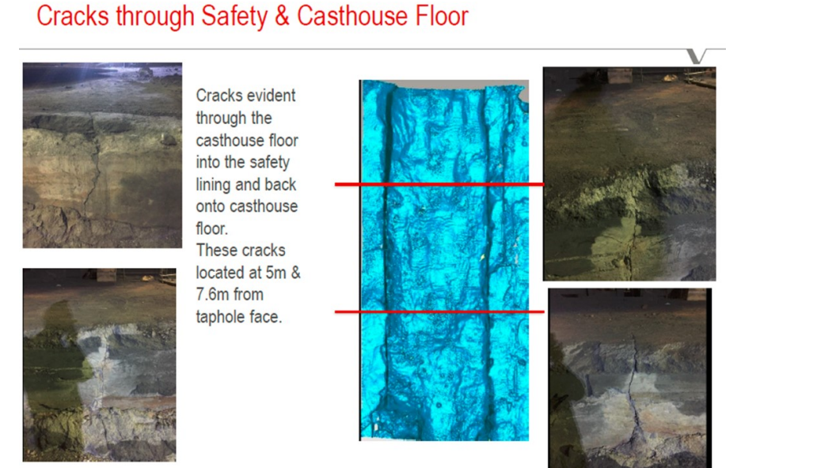
Following an LoC in 2016 it was decided that all refractory campaigns were to be reduced from 250-270kthm (=kilo tonnes of hot metal) to 200kthm because of evidential cracks within the working lining floor, which was believed to be caused by the result of structural movements. Prior to this decision to lower the campaign tonnage limit BF4 South had had an active change to its refractory configuration, the installation of a side skimmer integration in May 2016.
BF4 South had completed one campaign with a total tonnage of 284kthm. However, on its second campaign the MIR suffered from an LoC in October 2016. Following the LoC a deep-rooted investigation was carried out to determine the root cause, during this excavation it unveiled slithers of frozen iron within large cracks of the MIR working lining. These vertical cracks were something that was observed at a regular basis, so weren’t associated with the side skimmer configurational changes but rather the structural movements that was of frequent concern.
Figure 7 - Cracks in BF4S MIR from report conducted by Vesuvius (Quigley, 2016)
The traverse (older design) was re-instated in BF4 South during April 2019. This issue is covered in more detail throughout this dissertation, as it’s a key piece to conforming this work.

Limitations on MIR Campaign life

As a result of the structural issues encountered in 2016, there was a decision made to limit the total campaign tonnage on the BF4S casthouse (Taylor, 2016), as the expansion of the refractory would not reach the detrimental effect, and over expand causing the known structural issues to intensify. The limitations imposed constrained on the overall refractory ability, BF, and the TSPT as a whole.
These effects are captured within later chapters and are the sole purpose of overcoming the known problems to expand upon and improve the ability of the BF4S casthouse and in-turn BF4.

Structural model of the BF4 South Casthouse

TSPT consulted specialist engineering consultants James & Nicholas to conduct Finite Element Modelling to aid in understanding the movements associated with thermal inputs. The model was created not to assess the movement not in relation to the refractory expansion, just purely the behaviour of the structure as a result of induced thermal loads.
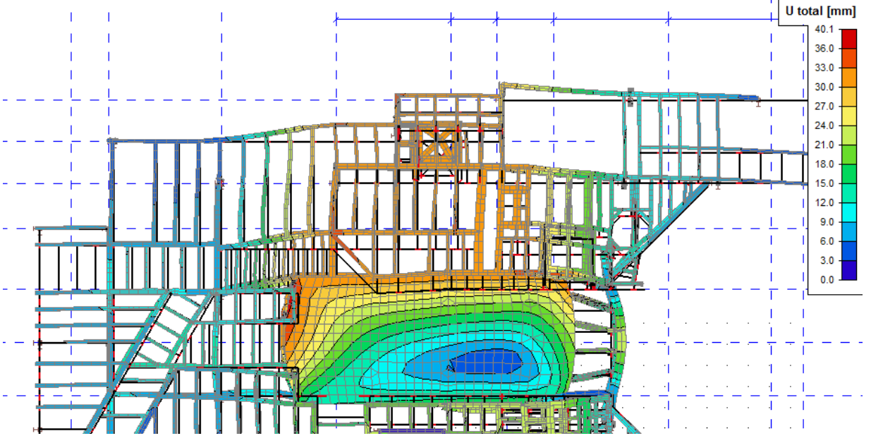
Figure 8 - Model of movement created by J&N (Nicholas, 2017)
The thermal model captured in Figure 8 shows an asymmetric expansion, this is where the outer edges of the casthouse toward the gable ends has the potential to deflect up to twice the amount compared to the inner. As stated, the model doesn’t account for refractory movement, the model therefore indirectly shows strong indications that the refractory expansion has the highest probability in causing the movement problems witnessed throughout the structure.

Literature Review

Main Iron Runner Wear Mechanisms.

There are multiple factors that can lead to refractory wear within the MIR. The mechanisms at play and the degree in which they affect the wear pattern are described in this section. The residual linings form, and overall wear rate have been decreased by the MIR’s design and the advancement of more resilient materials.

Slag attack on Main Iron Runner Refractory Castables

The MIR of an BF is subjected to a range of extreme stresses, including high temperatures, mechanical forces and aggressive chemical reactions. Amongst these is slag attack, a phenomenon that leads to the degradation of refractory materials. (Domiciano, 2014) investigates the failure mechanisms associated with Alumina and Silicon Carbide (=SiC) with a particular focus on wear zones in the MIR. The study breaks down the particular wear mechanisms.

Chemical Corrosion

The mechanism involves the reaction between the various components of molten slag, and refractory oxides that are present in the material. These chemical reactions cause the dissolution of refractory material, leading to gradual erosion of the refractory surface (Lee, 2004). Over time, this corrosion process compromises the integrity of the refractory lining, this results in material loss and a weakened structural strength.

Thermal Shock and Oxidation

The rapid fluctuations in temperature that occur during the operations induce thermal shock, which creates internal stress fractures within refractory material. The fractures that occur compromise the refractory materials ability to withstand the environment in which they operate. Additionally, FeO oxidation plays a significant role in the degradation of carbon-containing refractories (Svantesson, 2020).

Creep Mechanisms of Refractory Materials

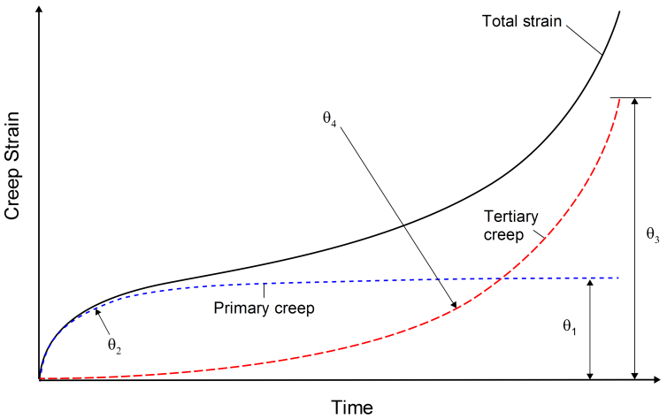
Refractory materials are essential in high temperature applications, particularly in ironmaking, where they endure extreme thermal and mechanical stresses. These materials must maintain their structural integrity within harsh conditions, making the understanding of their deformation mechanisms critical for improving their performance and overall lifespan. In this context, (Mammar, 2016) study into tensile creep behaviour offers valuable insight into the mechanical failure’s mechanisms, stress rupture properties, and microstructural evolution under elevated temperatures. Creep, a time dependent deformation that occurs in materials subjected to constant stress at elevated temperatures, is a significant factor that influences the performance of refractories, and in correlation to the purpose of this report a knock-on effect to the structure.
Figure 9 - Generic Creep Curve of Refractory Material (Harrison, 2014)

Grain Boundary sliding and Dislocation Creep
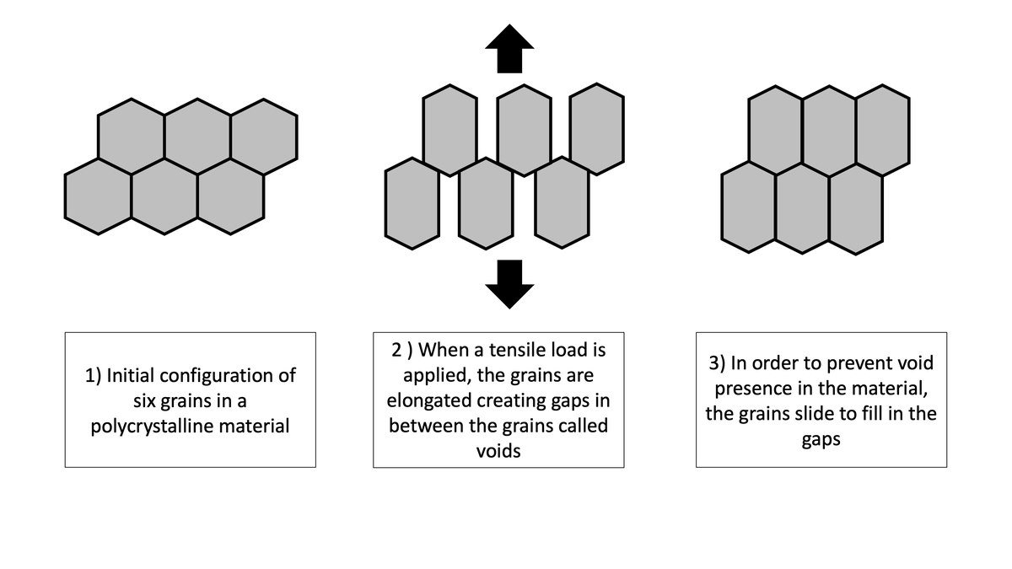
At elevated temperatures, grain boundary sliding becomes a predominant deformation mechanism in refractory materials, especially during the tertiary creep stage. This gives the material the ability to withstand prolonged stresses at high temperatures. Grain boundary sliding occurs when the induvial grains in a polycrystalline material slide past each other along their boundaries under the influence of applied stresses. In (Mammar, 2016) report findings there is a correlation in reference to the significantly influence the initiation of fractures occurring and lead to the failure of the material.
Figure 10 - Grain boundaries with creep (Lea, 2022)

Thermal Stress Cycling in Refractory Materials

(Pandhari, 2017) provides a detailed examination of the thermomechanical behaviour of refractory materials that are subjected to repeated thermal cycling. This phenomenon, commonly referred to as thermal stress cycling, arises from alternating heating and cooling cycles, which result in differential thermal expansion and the progressive accumulation of internal stresses within the material structure. The study identifies three principal mechanisms through which thermal stress cycling impacts refractory performance:
Microcracking and Structural Degradation—the repetitive thermal cycling leads to the initiation and propagation of microcracks within the refractory matrix. Over time, this microstructural damage diminishes the materials mechanical integrity, contributing to the reduction in its load bearing capacity and overall service life.
Stress from thermal gradients—the non-uniform temperature distributions across the refractory body generate localised stress concentrations. These thermal gradients intensify mechanical strain, often accelerating the onset acceleration of cracks and eventual failure.
Phase transformation and chemical reaction; the exposure to high temperatures has the ability to induce phase changes and promote the chemical reactions within the refractory material. These transformations may modify the microstructure and composition, potentially compromising the thermal stability and performance of the material under cyclic loading conditions.

Mechanical Erosion and Abrasive wear in the MIR

(Doubek, 2011) offer an in-depth analysis on the mechanisms of abrasive and erosive wear, with a particular focus on material selection and the practical applications within the industrial setting. Their work provides a valuable insight into the erosion process that occurs within the MIR, where molten materials induce significant wear to the refractory linings. The study characterises the erosion as a progressive material degradation process, influenced by both particle interaction and the dynamics of fluid flow.
High-Velocity Molten Metal Flow: The relentless movement of molten iron, with temperatures exceeding 1500c generates considerable shear stresses on the refractory surface, resulting in gradual material erosion. According to the study, the resistance of the refractory material to such wea is highly dependent on its composition and the surface hardness, with harder materials exhibiting greater resistance to erosion.
Slag Turbulence and Impact Forces: The presence of slag particles suspended in the molten iron creates a turbulent flow condition that contributes to the abrasive wear and surface roughening of the refractory material. (Doubek, 2011) demonstrate that refractories with higher hardness and lower porosity levels offer enhanced resistance to erosion caused by slag turbulence, thereby improving their performance in high-impact zones.

Abrasive wear

Abrasive wear, as identified by (Doubek, 2011), occurs through direct contact between the molten metal and refractory surfaces, leading to material loss via friction and impact forces. The study categorizes abrasive wear into two primary types:
Bound Particle Abrasive Wear: This type of wear occurs when abrasive particles become embedded within the surface of the refractory, resulting in continuous material removal as the particles are gradually worn away by frictional forces.
Free Particle Abrasive Wear: In contrast, free particle abrasive wear involves loose particles that impact the refractory surface, causing localized damage. The impact of these free particles accelerates surface degradation, contributing to the overall erosion of the refractory material.

Main Content Of Work

Reasons for Movement – In Detail

At TSPT the BF4S MIR is regarded as exceptionally wide in comparison to competitor ironmakers MIRs. The addition of this extra width makes sideways expansion of the MIR a significant problem within the BF4S MIR compared to others. As a result of the given forces of expansion at play the thermal expansion of the casthouse floors becomes significant and causes major issues to the integrity of the casthouses physical structure. As stated in chapter 2.2, the forces at play at severe at BF4S.
The Refractory in use within BF4S MIR is a Vesuvius (Refractory supplier) based material, known as HydraMax 38 (=HM38), HM38 through testing operates in a window of around 0.6% reversible expansion at 1000c – 1200c if left free to move. Refractory as a whole will show more Permanent Linear Change (=PLC) normally in the order of -0.2% and +0.2%, as with HM38 and any refractory creep becomes an issue as the pliability of the material increases with temperature, this will be captured in more detail in chapter 8.1.

BF4S MIR Design – Fibre board and Movement

Traditional refractory designs in the MIR only take into account for longitudinal expansion, which is the case for BF4S MIR. During the initial installation of the BF4S safety lining an expansion board was installed at the taphole end of the MIR (see highlighted in red circle in Figure 11. The expansion allowance of the initial board design was 98mm. This fibre expansion board is generally considered as a maximum compression of ~70%, hence, the effective expansion allowance of 0.7*98=69mm.
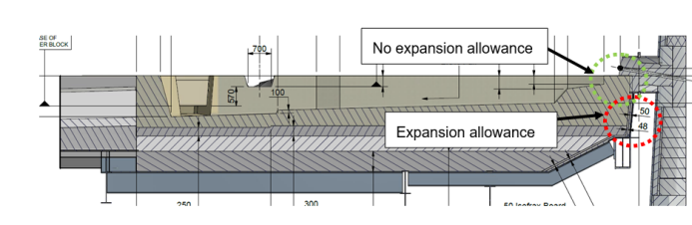
Figure 11 - BF4S MIR with Safety lining highlighted.
The addition of the 98mm board as stated was installed during the BF4 rebuild. What was considered during the design, or in-service phase wasn’t for controlling of the area. When the board cols, the original shape cannot return to its original size due to the compression entailed. Therefore, what was discovered every subsequent installation of new working lining will cause additional compression resulting in permanent deformation of the structure. Although, the likelihood is that at each stage the deformation might be small for each campaign, they ultimately add up until deformation becomes so serve that it leads to additional problems like misalignment, and damage to the critical structure around the MIR.
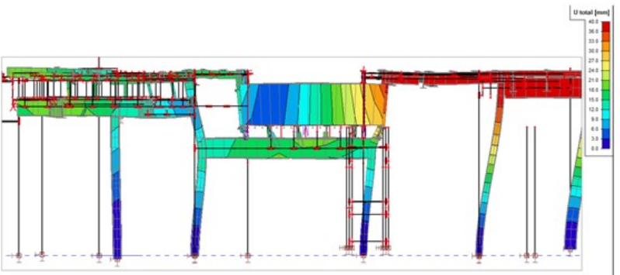
As previously stated, in most cases lateral expansion isn’t normally considered in the design phase of a MIR design because the width of the MIRs working lining isn’t typically large enough to cause significant displacement. However, at TSPT the BF4S MIR is approx. 50% wider in comparison to many competitors. Also, the casthouse floor is directly connected to the MIR steel casing where a more logical design would be to disconnect the floor beams from the steel casing to allow for movement. Figure … is the result of a Finite Element Modelling exercise (created by James & Nicholas) showing a cross section of the total deflections of up to 40mm.
Figure 12 - Model of movement (Nicholas, 2017)
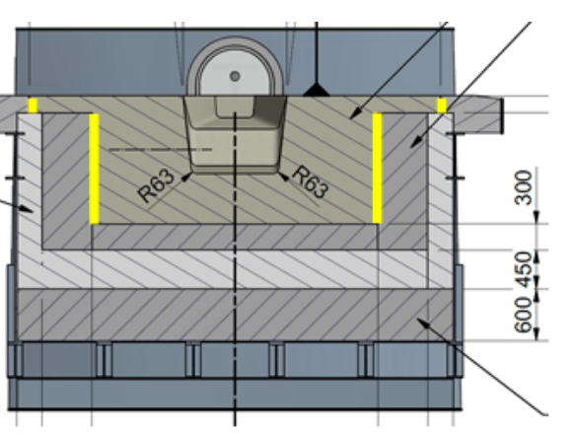
A cross-sectional analysis of the BF4S MIR reveals critical considerations regarding thermal expansion allowances within the refractory design. The MIR structure, with a total width of 5.1 metres, is subject to lateral thermal expansion under operating conditions. Assuming a conservative linear reversible expansion rate of 0.6%, the worst-case scenario would result in a total lateral expansion of approximately 31 mm (0.006 × 5100 mm). To accommodate this movement and prevent stress accumulation within the lining system, strategic placement of expansion materials is essential.
Figure 13 - BF4S MIR Cross section (J.Jones, 2017)

Overstretching of MIR Working Lining

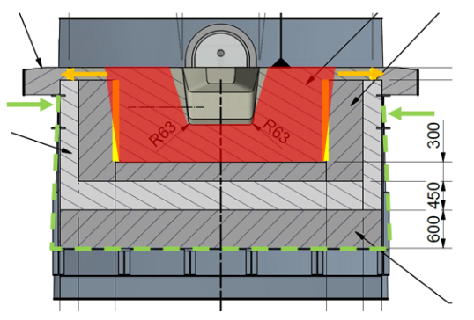
The proposed net allowance for lateral expansion, quantified at 35 mm, appears to be more generous than necessary when considered at first glance. This estimation is derived under the assumption that the entire 5-metre-width of the MIR refractory will undergo uniform thermal expansion of approximately 0.6%. However, it is important to recognize that the steel casing enclosing the refractory will also expand, by an estimated 8 to 10 mm. Despite this, the casing is mechanically constrained at the top by the casthouse floor, as illustrated by the green dotted line and the corresponding green arrows indicating the constraining force. While the thermal expansion of the steel casing may help to relieve compressive stress within the refractory pad at the base, it has minimal influence on the stress conditions at the level of the working lining sidewalls. The geometry of the working lining—characterised by a U-shaped profile—introduces further complexity. This lining is exposed to higher temperatures on the inner surface relative to the outer, cooler surface, resulting in non-uniform thermal gradients. Consequently, the working lining tends to undergo overstretching, as schematically represented by the red outline. This overstretching contributes to additional deflection and induces strain that compounds the inherent compressive stress generated by thermal expansion. Taking into account the cumulative effects of normal thermal expansion, permanent linear change, material creep, and the overstretch phenomenon, it is anticipated that the majority of the refractory sidewall will remain under compressive stress with the proposed expansion allowance. Notably, the bottom section—denoted by the yellow zone where expansion allowance exists but is not intersected by the red overstretch profile—will not be subjected to compression. However, compressive stress in this lower region is not critical, as it does not play a significant role in maintaining crack closure or structural integrity.
Figure 14 - Overstretching of material (Quigley, 2016)

BF4 Expansion Analysis – Comparison Past vs Present Material Use.

One of the hypothesised contributing factors to the Loss of Containment (LOC) incident at BF4 South on 20 October 2016 is the difference in thermal expansion characteristics between working lining castables. In particular, the transition from HydraMax DB20 to HydraMax 38 in August 2014 is of interest, as both materials exhibit distinct thermal and mechanical behaviours under high-temperature conditions.
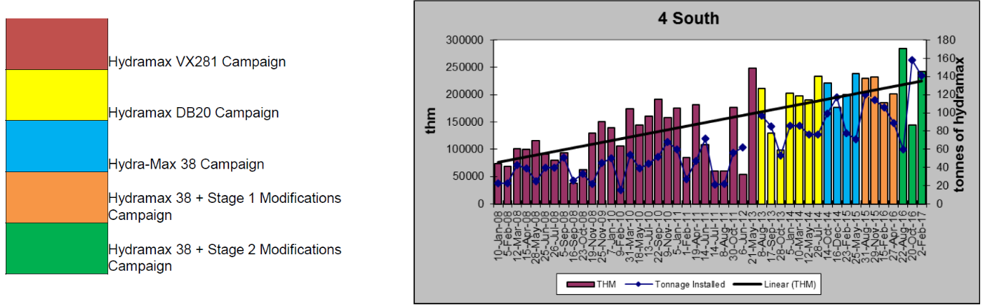
Pre BF4 Rebuild Post BF4 Rebuild
Figure 15 - Material campaign comparison (Fitzpatrick, 2014)
Following the rebuild of BF4, both the South and East furnaces initially operated with HydraMax VX281. From mid-2013, the castable lining was switched to HydraMax DB20, which remained in use until it was replaced by HydraMax 38 in August 2014. These changes are critical when considering thermal compatibility and structural responses within the casthouse, particularly since the original design—dating back to the 1950s—lacks documented allowances for thermal movement.
Although direct dilatation test data for the castables are not available, the maximum expansion (Vr) observed in the Refractoriness Under Load (RUL) test provides a reliable approximation for evaluating free thermal expansion. Both DB20 and 38 conform broadly to the general behaviour of casthouse castables, which typically exhibit reversible linear expansion of 0.6% to 0.9%, and permanent linear changes between -0.5% and +0.5%.
The RUL test results indicate marginal but measurable differences between the two materials:

Material | Vr (Max Expansion) | Deformation Onset Temperature
HydraMax DB20 | 0.77% | ~1280 – 1350c
HydraMax 38 | 0.79% | ~1330 – 1390c

While these differences may appear minor in isolation, over the full length of critical structures such as the 14-meter-long Main Iron Runner (MIR), they translate into significant absolute displacements. Assuming a conservative expansion of 0.6% at 1000°C, the free expansion would be:
0.006×14,000mm=84mm
In practical terms, any incremental increase in expansion—such as the difference between DB20 and 38—may generate additional compressive stress in the absence of structural allowances for movement.
This follows the data gathered regarding the compressive strength of the fibre board installed in Figure … which broadly considered only has a tolerance of 70% compressive strength, or moreover 69mm. This 15mm in expansion has a detrimental effect on the structure and can be attributed to the main cause of the structural issues that occur at TSPT BF4S MIR.

Structural Repairs

Structural Repairs

The BF4S has experienced historic structural failures, attributed primarily to instances of iron breakout as well as compromised end connections. Subsequent inspections conducted from the underside of the casthouse identified several areas of concern that required immediate attention and repair. Due to the specific nature of the damage, the necessary repair work could only be undertaken from beneath the casthouse structure. As such, access to the interior of the iron runner was essential to facilitate these interventions. During a maintenance campaign on the south casthouse, the refractory lining was removed from the trough to enable the completion of the required structural repairs. Due to the nature of the repairs required, it had to be conducted over two different refractory outages.

Repair One – August 2021

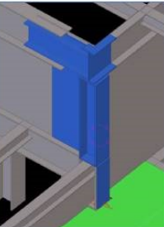
Initial repair efforts were focused on the corner connection of the column located between the South Iron Runner (SIR) and Main Iron Runner (MIR) top beams, as illustrated in Figure [insert figure number].
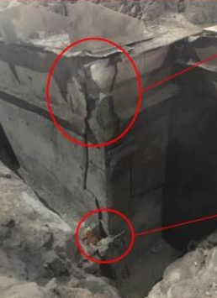
Upon inspection, it was observed that both the SIR and MIR top beams had been extensively damaged by thermal exposure, having effectively burnt away to the extent that they no longer contributed to the structural integrity or support of the corner column. This degradation significantly compromised the stiffness and load-bearing capacity of the area. Furthermore, the base of the corner column, specifically the support element situated on the floor plate, had been entirely consumed, with the damage likely attributable to a prior LoC incident, ref Figure 16. In response, a temporary over-plating solution had been applied; however, this measure was insufficient from a structural engineering perspective, as it provided no substantive load-bearing support. The absence of proper structural continuity and restraint at this junction posed a critical risk to the overall stability of the affected region, necessitating a comprehensive and permanent repair strategy.
Figure 16 - Exposed steelwork of BF4S MIR (Quigley, 2021)
Figure 17 - Model of work to be complete (Evans, 2021)

Repair Two – 2023

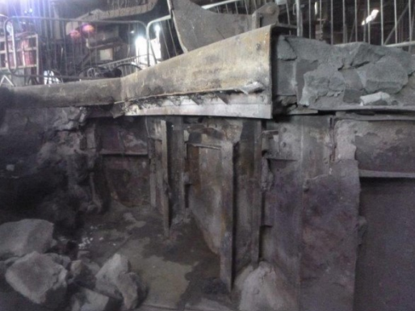
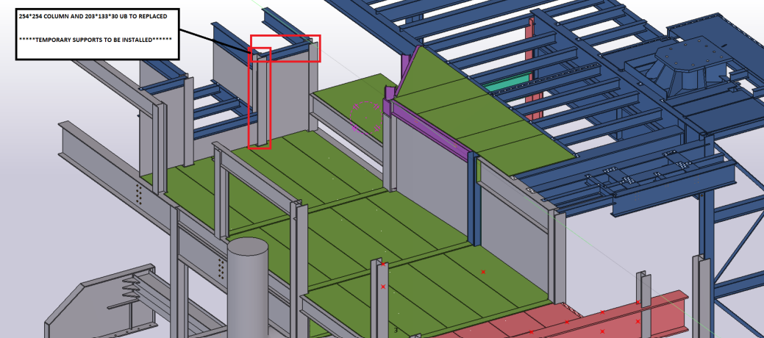
The initial phase of the works involved a comprehensive site inspection and structural survey undertaken by a different structural team, Ingleside Engineering. Following this, Ingleside were responsible for the development and provision of detailed design work required during this outage, as well as temporary works supervision. Subsequently, Kings (Main contractor for repairs) undertook fabrication work of the necessary structural supports. Temporary props and brackets were installed from the underside of the casthouse structure, in accordance with the temporary works design to ensure that the casthouse structure was deemed safe to remove and repair the affected areas.
Figure 18 - Structural model of Repair two (Evans, 2023)
Following the installation of temporary supports, the removal of the existing structural elements ensued. Kings proceeded in the removal of the existing Universal Columns (=UC) by disengaging its connections to the adjoining southern incoming beams and the associated sidewall plates. Additionally, a Universal Beam (=UB) was also installed, which spanned westward from the removed UC. The installation o these elements, reconnected the adjacent beams securing the area ensuring its in compliance with structural integrity and within the design specifications.
Figure 19 - BF4S MIR Repairs (Quigley, 2021)

Repair Three & Four

As part of the broader structural remediation and upgrade programme, two key repair operations—designated as Repair Three and Repair Four—were carried out to address deterioration in floor plate systems and to improve structural support around the main iron runner floor area. These interventions were essential for restoring load distribution efficiency, ensuring structural continuity, and achieving compliance with current performance standards.

Repair Three: Floor Plate and Trimmer Beam Replacement

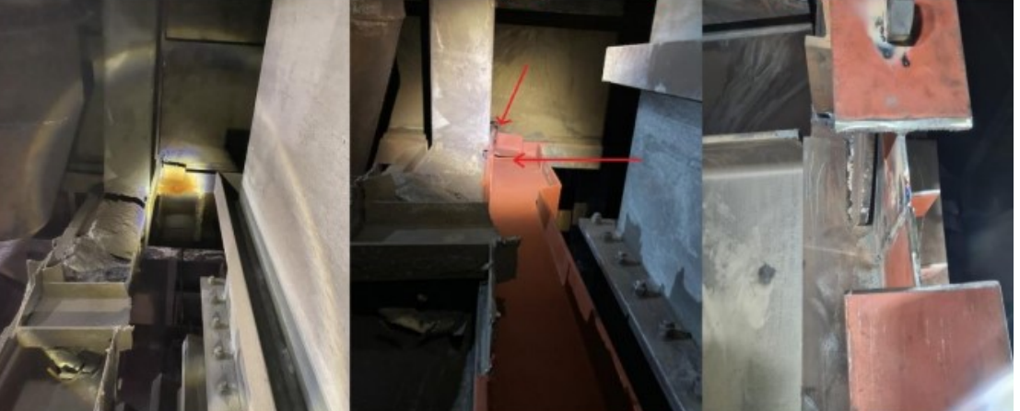
In this phase, Ingleside was responsible for preparing detailed manufacturing drawings, which provided specifications for the fabrication and installation of replacement structural members. Kings subsequently manufactured new steel beams, connection plates, and packers necessary to facilitate the installation of updated trimmer beams.
On-site activities began with the removal of three existing floor plates, providing access to the underlying structural frame. This followed the removal of two existing UB which were deemed structurally deficient or no longer fit for purpose. These elements were dismantled within accordance of the design provisions. Following removal, new structural members were installed in their respective positions: one UB and two UCs. Once the supporting members were in place, three new floor plates were installed to complete the system and reinstate the load path in accordance with revised structural requirements.
Figure 20 - BF4S Structural Repairs (Evans, 2023)

Repair Four: Floor Plate and Universal Beam Replacement

In parallel with the above, repair four addressed the need for improved support beneath the main iron runner floor. Ingleside provided the temporary works design and associated documentation, ensuring the safety and stability of the structure throughout the works.
Kings fabricated and installed four new UBs, intended to reinforce the load-bearing capacity of the floor system. Prior to installation, shear angles were fixed to the webs of existing beams to facilitate the connection of new elements. Once the shear connections were secured, the trimmers were installed and integrated into the existing frame to redistribute loads more effectively across the structure.

Completion of Structural Work

The completion of the substantial repairs 1-4, delivered substantial structural and operational advantages. The replacement and reinforcement of key steelwork elements significantly enhanced the load-bearing capacity and structural integrity of the affected floor systems. By improving load distribution through the installation of new trimmers and shear connections, the risk of localised overstressing was mitigated. These works ensured full compliance with current structural design standards, thereby increasing both the safety and reliability of the facility. Furthermore, the interventions extended the service life of the structural components and reduced the likelihood of future maintenance requirements. Collectively, these improvements contributed to a safer and more resilient operational environment.

Reinstating the Refractory

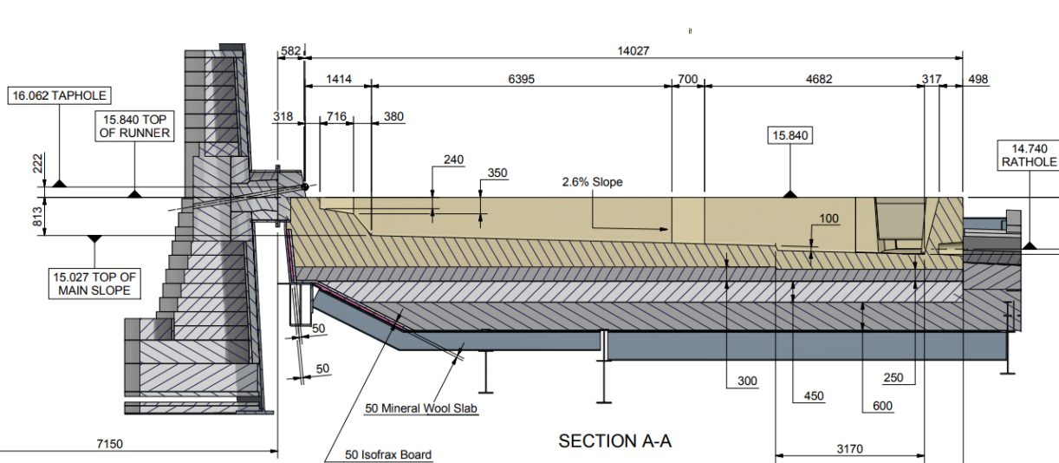
Upon the successful completion of the extensive engineering works, it became apparent that the extension of the operational lifespan of the refractory material within the MIR beyond the 200kthm threshold was essential to fully capitalise on the remaining potential of the existing refractory lining. As previously discussed, the material regardless of its condition were removed and the MIR taken out of operation at 200kthm.
Figure 21 - BF4S MIR Refractory Install (Vesuvius, 2012)
The refractory materials in use were consistently demonstrating their resilience and ability to function under conditions that were deemed far below the required threshold of the materials ability. Prior to the threshold being limited to 200kthm, there was an understanding that the limitations would be seen as ~250kthm and was deemed as a benchmark for when significant wear of the material was demonstrated and necessitate the replacement of the in-service materials. However, given the refractory’s ongoing high-performance levels, extending the operational life of the MIR beyond this point offered significant advantages for TSPT.
As there are obvious historical issues with thermal stresses within the MIR, the reinstatement of refractories must have the ability to withstand these, if the structural issues were to occur again.

Zoned Linings

It is a well-known subject that the refractories within the MIR are susceptible to degrading factors from both iron and slags. Throughout the steel industry zoned linings are not predominately used, more so a singular material; a silicon carbide-based material. Silicon Carbide is a material that performs well in slag environments but is susceptible to dissolution in iron (Banda, 2020). Therefore, it is fundamental to develop a MIR lining that had the potential to counter both iron and slag attacks.
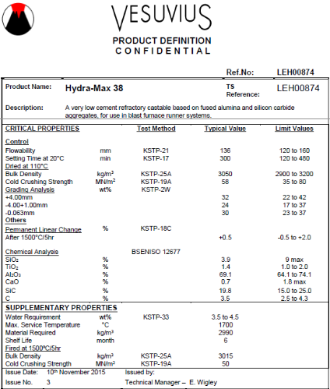
The concept of zoned linings is based upon the premise that different regions of the MIR are subjected to varying intensities and types of wear. Through using a multi-layered approach, these linings can be tailored to provide the optimal protection against specific wear mechanisms. At TSPT, HydraMax 38 (HM38) has consistently served as the sole refractory material, selected for its comprehensive performance in environments exposed to both molten iron and slags. HM38's effectiveness is largely attributed to its advanced hydraulic bonding technology, which significantly enhances its resistance to thermal cycling and thermal shock—conditions frequently encountered in high-temperature operations with fluctuating thermal loads. This bonding mechanism not only improves the refractory's mechanical integrity but also increases its resistance to cracking and spalling under thermal stress. Furthermore, in operational zones subjected to continuous abrasion, such as iron runners and tapping areas where molten metal flows at high velocities, mechanical wear becomes a critical concern. In these regions, HM38 demonstrates notable durability, although gradual material loss through erosion remains a challenge due to the intense and sustained contact with molten iron and slag.
Figure 22.0 - Vesuvius HM38 PD
The higher level of SiC, as illustrated in the Product Definition (=PD) in figure … illustrates through testing the strength of H38 in a slag environment.
Similar to HydraMax 38, HydraMax VX281 is engineered to perform reliably at extremely high temperatures, withstanding conditions as high as 1,500°C while maintaining its structural integrity. Its ability to endure thermal stress and retain its properties during prolonged exposure to elevated heat makes it highly suitable for demanding high-temperature applications.
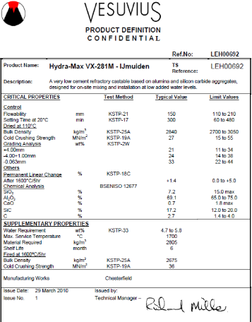
A key feature of HydraMax VX281 is its low-cement castable composition, which results in reduced porosity and enhanced material density. VX281 is a predominately alumina-based material, this formulation improves the material's resistance to iron attack and minimizes the risk of degradation due to chemical attack (Gatti, 1957). Additionally, the lower cement content contributes to superior thermal shock resistance, a critical factor in environments subject to rapid temperature fluctuations.
The slightly lower SiC within VX281 means that it does not correspond the same level of resistance to slag attack, however the material is still more than adequate in repelling lower levels of attack. As per the PD in figure 23

Figure 23.0 - Vesuvius VX281 PD
The installation of the F/C incorporated a zonal lining design for the MIR, strategically installing the materials based on their operational specific conditions. The first 6.0m of the MIR were lined with HM38, a material specifically chosen for the area for its greater resistance to slag attack, as the area is more prone to slag attack, as the area is more susceptible to the abrasive and corrosive nature of BF slag, ensuring that the longevity and performance of the lining within this critical zone.
Conversely, the rear section of the MIR is lined with VX281, selected for its resistance to iron attack, a primary concern in this region.
The dual-zoned approach in the F/C installation not only optimises the performance of the lining system, but also ensures the MIR is equipped with a material best suited to withstand the specific chemical and thermal challenges it faces.
The capability of installing VX281 in a zoned lining is backed by the data received through the years of use within the SIRs both on BF4S and the BF4 East casthouses.
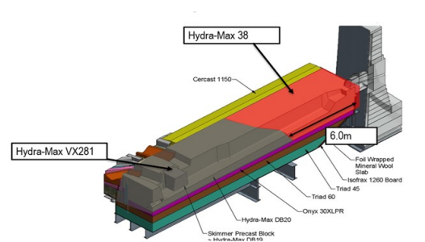
Figure 24 - BF4S Zoned Lining (Fitzpatrick, 2023)

Repair Schedule – As is

As previously mentioned, the current operational parameters set were a cumulative benchmark of 200kthm, before a Full Campaign (=F/C) was initiated. In alignment with these targets, the current repair and maintenance schedule was constructed to facilitate a Mid Campaign (=M/C) every 120kthm, this was based on the degradation evident at these tonnages.
During the period in which this was conducted BF4 operated with two-stove operations, generating approximately 4.5kthm/day. This daily output is, under ideal circumstances, anticipated to be evenly distributed between the two casthouses, ensuring a 1:1 casting ratio. Consequently, each casthouse s expected to maintain a throughput of 2.25kthm/day, assuming no operational delays in the casting process.
However, the actual performance of the THs is subject to side outages that can disrupt the casting schedule. These outages are primarily linked to the following key factors:
M/C Repairs: The scheduled repairs at the 120kthm threshold are expected to cause an average side outage of approximately 36 hours. Over the course of the campaign, the total duration for M/C-related outages are estimated to occur every 53 days. These repairs are crucial for furnace maintenance and repair, ensuring continued performance and avoiding major failures.
F/C Repairs: In addition to the M/C, more prolonged side outages occur during the MIR refractory campaign phase. These outages are typically associated with 168-hour downtime, corresponding to an occurrence every 97 days during a complete refractory campaign.
Together, the operational downtime associated with both M/C and F/C outages represents a significant challenge to the casting throughput, which may lead to a reduction in overall productivity and efficiency if not properly managed. In ideal circumstances, these outages would be minimized or offset through proactive maintenance and operational adjustments. However, in practice, the cumulative effect of side outages—totalling 150 days (36 hours for M/C and 168 hours for F/C)—has a considerable impact on the overall casting schedule, which could lead to deviations from the planned 1:1 casting distribution between the two casthouses.
Therefore, the scheduling of both Mid-Campaign and Furnace Campaign maintenance activities must be meticulously coordinated to balance the need for furnace repairs and the requirement for uninterrupted casting operations. A well-defined strategy for managing side outages is crucial to achieving the optimal throughput of 2.25kthm/day per casthouse while mitigating delays and inefficiencies.

Repair Schedule – Following Zoned Lining – Campaign extensions

In response to operational demands and the ongoing need to maximise furnace longevity and productivity, a revised maintenance schedule was developed for BF4S. This strategy introduced a more refined and proactive approach to campaign management through the integration of critical repair milestones and predictive diagnostics.
Under the revised framework, a Mid-Campaign (M/C) intervention is scheduled at 120kthm, where the skimmer block, dams recast, and MIR refractory sprayed.
The overarching objective of this updated schedule is to safely and effectively extend the operational campaign to approximately 300kthm, which equates to a minimum of 35 additional days of service beyond traditional campaign limits. However, it is important to note that the feasibility of reaching the 300kthm target is dependent on the integrity of the refractory linings, as determined by comprehensive scan data. Historical lining scans conducted at the conclusion of previous F/Cs, presented in appendix D, offer a comparative baseline and illustrate the extent of refractory durability achieved under earlier operational parameters. These scans form the critical evidentiary basis for projecting future campaign limits and evaluating the effectiveness of current maintenance strategies.
TSPT were unfortunately limited at a ~250kthm chokepoint, which was primarily attributed to the inefficiencies in the secondary runners and the skimmer blocks. These components, which play a vital part in directing the molten materials experience heightened wear. As a result, to address this chokepoint and enhance the overall performance, a strategic decision was made to introduce more controlled, additional side outages into the operational schedule. These outages, which are planned periods of downtime, allowed for targeted maintenance and repair activities on the secondary runners and skimmer block. The introduction of these controlled outages, specifically referred to as ‘Campaign Extensions’, aimed to provide a more systematic approach to managing the wear and degradation of these critical components. This phase includes targeted repairs such as skimmer and dam rebuild, MIR spray applications, and remaining working lining evaluations to address localised wear patterns and structural vulnerabilities.
The new maintenance schedule under this revised model is outlined as follows:
- Mid-Campaign (M/C) –Ave. occurrence every 53 days; characterised by an average side outage of 36 hours. This phase is primarily preventative and focuses on stabilising operational parameters.
- Campaign Extension – Ave. occurrence every 97days; also associated with an average side outage of 36 hours. Activities during this period are designed to enhance refractory life and ensure the furnace is fit for extended operation beyond 220kthm.
- Full Campaign Completion (F/C) – Ave. occurrence every 133 days; typically involves an average side outage of 168 hours, reflective of major repairs and potential furnace re-lining to prepare for the next operational cycle.
In turn, this maintenance strategy had broader operational benefits. By prolonging the life of the MIR, the overall availability of the casthouse was significantly increased. The reduced frequency of unscheduled downtimes contributed to a more consistent and uninterrupted production process, which is essential for maintaining high throughput and ensuring efficient molten metal transfer. Moreover, the extended lifespan of the refractory materials not only improved operational efficiency but also contributed to cost savings by reducing the need for frequent replacements of refractory materials. As refractory spending is a substantial operational cost in high-temperature industrial processes, reducing consumption was a significant advantage.

Cost Comparison

As well as the mentioned benefits of the chosen materials being attributed to each area, there is also a significant difference in price between the two materials. HM38 is approximately £2,200/tonne of material, while VX281 has a base price of £1,400/tonne of material. To put this into perspective, without the zoned runner—a MIR F/C reline is typically consisting 110t of material.
Prior to zoning, the MIR consisted solely of HM38-
$$110 \left(ave. tonnes installed\right)×2200 \left(price of HM38\right)≡£242,000$$
With zoning its split with a ratio of 60:40 in favour of VX281-
$$66 \left(60\% of the material cast based on 110t\right)×1400 \left(price of per tonne\right)=£92,400$$
$$44 \left(40\% of the material based on 110t\right)×2200 \left(price of HM38\right)=£96,800$$
This is a saving of £52,800 per F/C.
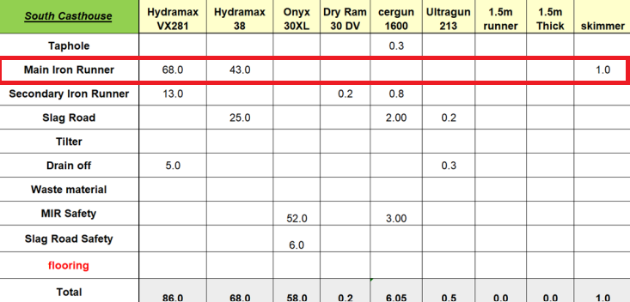
Figure 25 - Installation of refractory material within BF4S MIR (Fitzpatrick, 2023)

Practice into Reality

Implementation
The BF4S MIR concluded its most recent campaign with a total processed tonnage of 331,000kthm—the highest ever recorded during a single campaign in the operational history of BF4. This figure not only exceeds the previous record of 281kthm but also represents a historic benchmark in the casthouses performance.
This achievement can be attributed to the combined impact of two key developments: the implementation of a zonal refractory installation strategy and the adoption of an optimised repair strategy throughout the campaign. The zonal approach involved the targeted selection of refractory materials—specifically engineered to address distinct degradation mechanisms such as slag erosion and iron attack—across different segments of the MIR. This design enhanced the thermal, mechanical, and chemical resilience of the runner, contributing to improved wear resistance and a more uniform degradation profile.
In parallel, the optimised repair strategy played a critical role in maintaining the runner’s integrity over the extended campaign period. By introducing planned, condition-based maintenance interventions, including controlled side outages and frequent thermographic and dimensional assessments, the repair programme enabled early identification of localized wear and proactive remediation. This approach minimized unplanned downtime, extended the functional life of the working lining, and maintained optimal operating conditions throughout the campaign.
In particular, the integration of real-time thermocouple monitoring, 3D laser scanning, and historical wear data analysis allowed for precise assessment of refractory condition, ensuring that repairs were both timely and minimally invasive. These strategic interventions were instrumental in preventing premature failure and in maximising refractory utilisation, thereby facilitating a longer campaign duration without compromising safety or performance.
In conclusion, the record-breaking performance of the BF4S MIR was the result of not only material innovation through zonal lining design but also the implementation of a data-informed, proactive maintenance regime. Together, these measures significantly enhanced refractory longevity, improved casthouse availability, and contributed to a more efficient and cost-effective blast furnace operation.

Backing the Methodology with Data

Tracking The Data

Additional work was completed to safely and effectively complete the campaign extension. This was complete in close coordination with refractory supplier Vesuvius, with every step meticulously planned in conjunction.
During each drainage phase, Vesuvius performed a 3D scanning of the MIR, providing up to date data that enabled TSPT to respond proactively to any changes or potential issues. On a daily basis, the thermocouples installed within the MIR were monitored to detect any abnormal temperature spikes, ensuring that no critical temperature fluctuations would go unnoticed. During this time period TSPT PCM engineers would also provide surveys of the structure to aid in the monitoring of potential hotspots; example of such can be seen in Appendices …
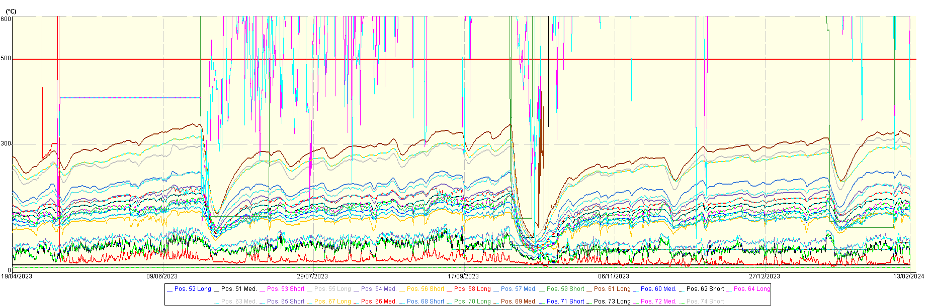
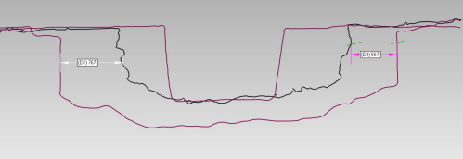
The thermocouple data was also monitored during this period, and later analysed against previous campaigns. Of particular interest was ‘61Long’ thermocouple, which recorded the highest temperature during this period, peaking at 332$℃$. At this point, it was estimated that ~400mm of working lining was remaining within the MIR, based on the available data, and backed by the data received from Vesuvius’ scan data which estimated potential for a remainder of 161kthm if the side could remain in-service.
Figure 26 - Scan data of BF4S MIR with wear profile (Langford, 2023)
Figure 27 - Thermocouple data (Thomas, 2023)

Future Potential
The implementation of a revised repair and maintenance schedule on the BFs at TSPT represents a significant operational advancement with the potential to deliver substantial cost efficiencies. Following the repair schedule has the ability to extend campaign life, with this already being demonstrated as possible within TSPT without compromising safety and efficiency.
Through the use of the repair schedule a benchmark for extension of campaign life can be set and will open up a pathway for dramatic reductions in expenditure. Using BF4S as an example, the repair schedule reduced by one F/C/year, which carries significant capital and operational costs. Again, using BF4S as a practical example, it is estimated that if the repair schedule were to have been able to be introduced earlier, the potential savings were estimated to be around £600,00 per casthouse/year (Based on the reduction of materials and manning). To put this into perspective, at TSPT between the two BFs there were four casthouses, implementing this repair schedule over the four had the potential to save the business an estimated £2.4m.
Beyond the fiscal benefits, the success of the initiative at TSPT can be used as a model for global practice within Tata Steels wider operational network. The data and outcomes from the implementation can be leveraged as a robust case study to inform maintenance and repair strategies across Tata Steels international sites. By benchmarking performance, refining intervention schedules, and aligning campaign goals globally, Tata Steel has the opportunity to drive efficiency, reduce downtime and lower costs of its refractory repairs for its blast furnace operations worldwide. This case study underscores the importance of proactive asset lifecycle management and its capacity to generate measurable business value across a multinational enterprise.

Conclusion
This case study has examined the systematic mechanical and structural repairs undertaken on the TSPT BF4S MIR, with a particular focus on how these interventions catalysed a strategic upgrade of the refractory repair schedule. Through an in-depth analysis of failure modes, thermal stress impacts, material degradation and operational bottlenecks, the project was able to pinpoint root causes of recurrent inefficiencies that had long plagued the reliability and longevity of the BF4S MIR.
The interdisciplinary approach—combining engineering diagnostics, material science, and operational scheduling—led to the implementation of a revised refractory maintenance cycle that is tailored to actual wear profiles, rather than arbitrary timelines. This proactive approach, based on real time data and failure trend analysis, allowed for more accurate maintenance, improved maintenance utilisation, and reduced down time.
The financial implications have been significant. By reducing unplanned downtime, extending refractory life, and optimising man-hour deployment, the business if implemented companywide had the potential to achieve annualised cost savings of approximately £600,000 per casthouse. These savings are not merely monetary but reflect deeper operational resilience and process efficiency—key benchmarks in any steelmaking environment.
This case exemplifies the value of aligning engineering insight with business strategy. As Tata Steel continues its journey toward global excellence, this documented success serves as a replicable model for similar blast furnace operations worldwide. It encourages all operational units within the Tata Steel network to re-evaluate localised maintenance regimes using data-driven methodologies and to pursue the potential to unlock substantial cost and efficiency benefits.
Ultimately, this project reinforces a broader strategic imperative: continuous improvement through precision engineering and collaborative innovation. By sharing this case study globally, Tata Steel strengthens its position as a knowledge-driven organisation, committed to excellence in operations and sustainable profitability across its international footprint.

References
Banda, W., 2020. The Journal of the Southern African Institute of Mining aAn investigation into the wearmechanisms of carbon- and siliconcarbide-based refractory materials by silicomanganese alloy. Journal of the Southern African Institute of Mining and Metallurgy, 120(5), pp. 1-17.
Bharati, P., 2023. Basics of Refractories, s.l.: LinkedIn.
Bhatia, A., 2020. Overview of Refractory Materials, Fairfax: PDHOnline.
Domiciano, V., 2014. CHALLENGES OF BLAST FURNACE CASTHOUSE: FAILURE ANALYSIS OFMAIN RUNNER REFRACTORY CASTABLE, Brazil: International Technical Conference on Refractories.
Doubek, P., 2011. Abrasive and erosive wear of technical materials, MENDELIANAE: ACTA UNIVERSITATIS AGRICULTURAE.
Endra, S., 2013. ISpatGuru. [Online]
Available at: https://www.ispatguru.com/introduction-to-the-characteristics-of-refractories-and-refractory-materials/.
[Accessed 02 02 2025].
Evans, R., 2021. COmplete installation guidelines, s.l.: Inglesdide Engineering .
Evans, R., 2023. Repair Two Schedule, Port Talbot: Ingleside .
Fitzpatrick, J., 2014. BF4S MIR Material Changes, Port Talbot: Vesuvius.
Fitzpatrick, J., 2023. BF4S MIR Casting Report, Port Talbot: Vesuvius.
Fitzpatrick, J., 2023. BF4S Zoned Lining Rebuild, Port Talbot: Vesuvius.
Gatti, A., 1957. Iron-Alumina Materials, New York: General Electric Co. Research Lab.
Gilchrist, J., 1977. Fuels, furnaces and refractories. In: J. Gilchrist, ed. Fuels, furnaces and refractories. Oxford: Pergamon, pp. 240-252.
Harrison, W., 2014. A Model of a Creep and Creep Damage Curve, s.l.: Reserach Gate.
Hoyland, I., 2012. Tata Steel Port Talbot BF4 Main Iron Runner Design for 2012 Rebuild, Port Talbot: Vesuvius.
IRE, 2017. Institute of Refractory Engineers. [Online]
Available at: https://www.refractoriesinstitute.org/tri-pages/tri-what-are-refractories.asp
[Accessed 20 01 2025].
J.Jones, 2017. BF4S MIR Install, Port Talbot: Vesuvius.
Langford, C., 2023. BF4S Scan data, Port Talbot: Vesuvius.
Lea, J., 2022. Effect of serrated grain boundary on tensile and creep properties of a precipitation strengthened high entropy alloy, Hsinchu, Taiwan: Taylor and Francis .
Lee, W., 2004. Direct and indirect slag corrosion of oxide and , Sheffield: University of Sheffiled.
Mammar, S., 2016. Investigation of high temperature tensile creep of refractories, Leoben: University of Leoben.
Nicholas, J. &., 2017. Structural interpretation of Skelton Thomas Inspection report, s.l.: J&N.
Osborne, D., 2013. The Coal Handbook: Towards Cleaner Production, s.l.: Elesiver.
Pandhari, A., 2017. Modeling of Thermal Stress Cycling in Refractory Materials, Vancouver : University of British Columbia.
Pilli, V., 2015. Study on the alumina - silicon carbide - carbon based trough castable.. 1 ed. s.l.:s.n.
Pronix, A., 2024. Torpedo Car. [Online]
Available at: https://www.wadeco.co.za/microwave/appli/appli1_2.html
[Accessed 10 03 2025].
Quigley, J., 2016. BF4S LoC, s.l.: Vesuvius.
Quigley, J., 2021. BF4S MIR Repairs, Port Talbot: Vesuvius.
Schacht, C., 2004. Refractories Handbook. 1 ed. Raton: CRC Press.
Sengupta, P., 2019. Classification and Features of Different Types of Refractories. In: Refractories for the Cement Industry. s.l.:Springer, pp. 25-35.
Seshadri, S., 2014. Process fundamentals. Elsevier, 1(1), pp. 2-88.
Svantesson, J., 2020. Study of dynamic refractory wear by slags containing very high FeO contents, Stockholm: Institute of Technology, Department of Materials Science and Engineering.
Taylor, W., 2016. Management Investigation Report into A Loss of Containment of BF4S MIR, Port Talbot: Tata Steel Port Talbot - Internal .
Thomas, R., 2023. Thermogrpahy of BF4S MIR , Port Talbot: Tata Steel Port Talbot - Internal.
Vesuvius, 2012. BF4S MIR Refractory Installation, Port Talbot: Vesuvius.

Appendices

Appendix A—Reinstatment of the refractory linings of the MIR.
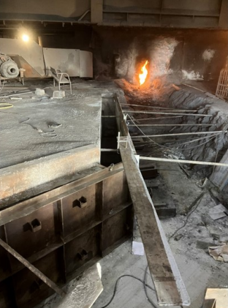
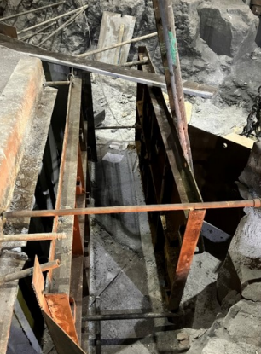
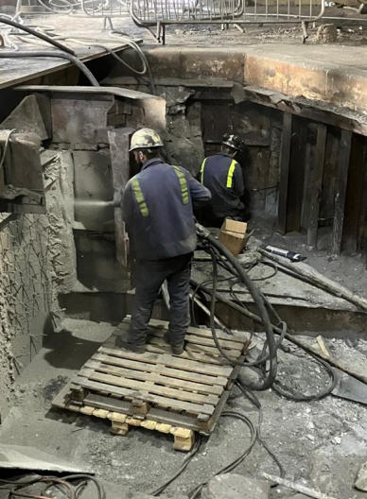

Appendix B – Linings recast
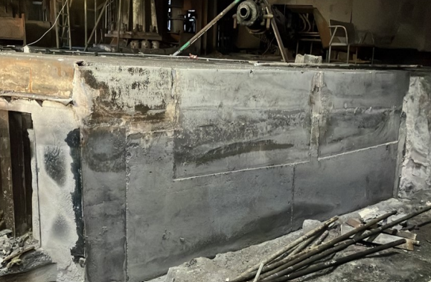
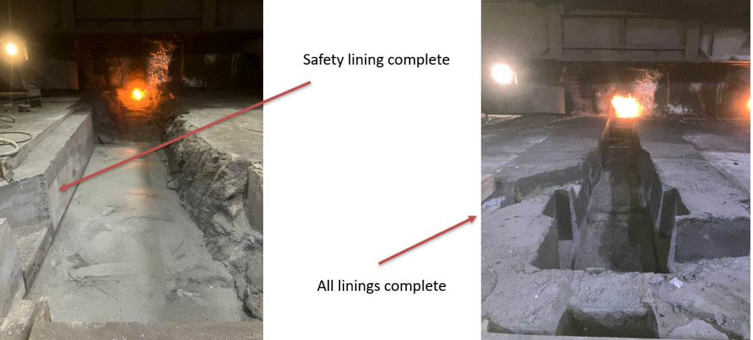

Appendix B – Wear profile and scan of the BF4S MIR

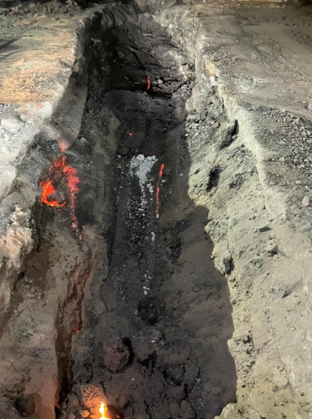

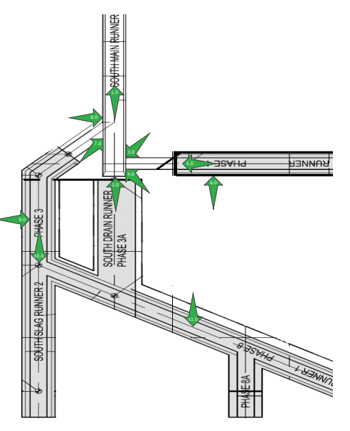
Appendix C – TSPT PCM Engineers Thermal Report
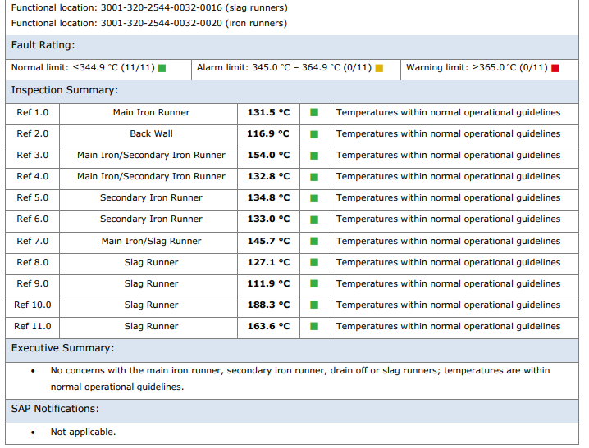
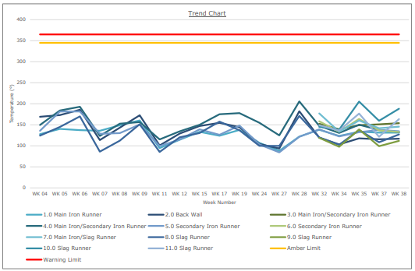

Appendix D – Scan Data highlighting potential to go further



